**Program: database_tables.php**

<?php

//establishing connection here

/*$conn=mysqli_connect("localhost","root","");

if($conn)

echo "<br>connection successfull";

else

echo "<br>connection failed";

//creating database first

$databaseQuery="CREATE DATABASE cryptic";

$relateDatabaseQuery=mysqli_query($conn,$databaseQuery);

if($relateDatabaseQuery)

echo "<br>database CRYPTIC created successfully";

else

echo "<br>AXCEL CRYPTIC cannot be created";

mysqli_close($conn);*/

/*$conn=mysqli_connect("localhost","root","","cryptic");

if($conn)

echo "<br>connection successfull";

else

echo "<br>connection failed";

$tableQuery1="CREATE table MENTOR_DETAILS(

email varchar(30) PRIMARY KEY,

fname varchar(15),

lname varchar(20),

gender varchar(8)

)";

$relateTableQuery1=mysqli_query($conn,$tableQuery1);

if($relateTableQuery1)

echo "<br>table MENTOR_DETAILS created successfully";

else

echo "<br>table MENTOR_DETAILS cannot be created";*/

//inserting mentor details

$conn=mysqli_connect("localhost","root","","cryptic");

if($conn)

echo "<br>connection successfull";

else

echo "<br>connection failed";

$insertQuery="INSERT into MENTOR_DETAILS

(email,fname,lname,gender)

values('asd@gmail.com','asd','xyz','male')";

$relateinsertQuery=mysqli_query($conn,$insertQuery);

if($relateinsertQuery)

echo "<br>record inserted successfully";

else

echo "<br>record insertion error";

?>

**Program: home.html**

<html>

<head>

<style>

.t1{

text-align: center;

font-size: 100px;

color: blue;

margin: 10px 10px 10px 10px;

}

body{

background-image: url(home_pic.jpg);

}

.relative_block{

position : relative;

border : 3px solid deeppink;

height : 600px;

width : 900px;

margin : 50px;

border-width : thick;

top: 0px;

}

.absolute_relative{

position : absolute;

}

ul{

list-style-type: none;

border: 1px solid;

padding: 0;

width: 50%;

margin-left: 10px;

}

li a{

display: block;

text-decoration: none;

padding: 20px 20px 20px 20px;

font-size : 28;

text-align: center;

font-family: cursive;

border: 1px solid;

}

</style>

</head>

<body>

<hr>

<h1 class="t1">DECRYPT</h1>

<hr>

<div class="relative_block">

<div>

<!-- verticle navigation -->

<ul class="absolute_relative">

<li><a href="home.html">Post Query</a></li>

<li><a href="home.html">Solve Query</a></li>

<li><a href="mentor_details.php">Choose Mentor</a></li>

</ul>

</div>

</div>

</body>

</html>

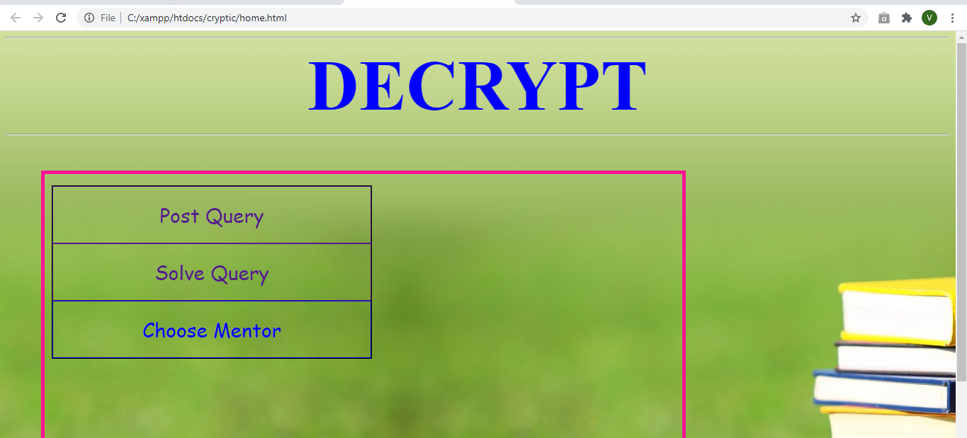

**Program: mentor_details.php**

<html>

<head>

<style>

table{

border : 1px;

}

a:link, a:visited {

background-color: cadetblue;

color: black;

padding: 14px 25px;

text-align: center;

text-decoration: none;

display: inline-block;

}

</style>

</head>

<body style="background-image: url(home_pic.jpg)">

</body>

</html>

<?php

$conn=mysqli_connect("localhost","root","","cryptic");

$conn=mysqli_connect("localhost","root","","cryptic");

$selectQuery="SELECT * from MENTOR_DETAILS";

$relateSelectQuery=mysqli_query($conn,$selectQuery);

echo "<table style='border: solid 1px black;font-size:30;margin:10px 10px 10px 10px;text-align:center'>

<tr>

<th style='border:1px solid black;margin:10px'>Email-Id</th>

<th style='border:1px solid black;margin:10px'>First-Name</th>

<th style='border:1px solid black;margin:10px'>Last-Name</th>

<th style='border:1px solid black;margin:10px'>Gender</th>

</tr>";

while($info=mysqli_fetch_array($relateSelectQuery))

{

echo "<tr style='border:1px solid black;'>

<td style='border:1px solid black;margin:5px'>".$info['email']."</td>

<td style='border:1px solid black;margin:5px'>".$info['fname']."</td>

<td style='border:1px solid black;margin:5px'>".$info['lname']."</td>

<td style='border:1px solid black;margin:5px'>".$info['gender']."</td>

</tr>";

}

echo "</table>";

mysqli_close($conn);

?>