**ASSIGNMENT**

NAME : AITEZAZ AKHTAR

ROLL # : 2017-BSCS-131

SECTION : 3-C

SUBJECT : OOP

Q : What is GIT ?

Git is a rendition control framework for following changes in PC documents and planning take a shot at those records among different individuals. It is principally utilized for source code administration in programming improvement, yet it can be utilized to monitor changes in any arrangement of records. As a circulated update control framework it is gone for speed, information integrity,and bolster for conveyed, non-straight work processes.

Q : What is the difference between GIT & SVN ?

SVN is a Centralized Revision Control System, whereas GIT is a Distributed Revision Control System (DVCS).

SVN has a model where there is a master from which users check out a copy of the code, make changes and then check the changes back in, merging those changes with others that have been made by other users since the first checkout, whereas Git stores a complete copy of the repository history. There is no canonical repository. Users can branch, commit and merge locally. Then, they can merge or clone with a remote branch.

Q : Write a command to commit your work in GIT ?

If we want to commit our work in GIT we would write this command :

* git commit -m "first commit"

Q : Create a repository with your name with unique roll number in Github?

You can create a new repository on your personal account by using following steps :

* Create or Login your account on github.com
* In the upper-right corner of any page, click ,+ and then click **New repository**.
* In the Owner drop-down, select the account you wish to create the repository on.
* Type a name for your repository (name with your roll number )
* You can choose to make the repository either public or private. Public repositories are visible to the public, while private repositories are only accessible to you, and people you share them with. Your account must be on a paid plan to create a private repository.
* You can create a README, which is a document describing your project.
* You can create a *CODEOWNERS* file, which describes which individuals or teams own certain files in the repository.
* You can create a *.gitignore* file, which is a set of ignore rules.
* You can choose to add a software license for your project.
* When you're finished, click **Create repository**.

Q : What are the advantages of using GIT ?

One of the biggest advantages of Git is its branching capabilities. Unlike centralized version control systems, Git branches are cheap and easy to merge. This facilitates the feature branch workflow popular with many Git users.Other advantages are Data redundancy and replication, High availability, Only one.git directory per repository, Superior disk utilization and network performance, Collaboration friendly, Any sort of projects can use GIT.

Q : What is GIT Clone ?

Git clone is a Git command line utility which is used to target an existing repository and create a clone, or copy of the target repository.When you clone a repository you will get all branches and all commits that can be reached from any of those branches.You will however not get a local branch of any other branch than master. The other ones are there as remote branches and you can check out any of those whenever you want. git will then set up tracking between the remote branch and the local one that you created when you did the check out.

Q : What is the command to delete branch ?

* To delete a local branch we use :

git branch -d the_local_branch

* To delete a remote branch we use :

git push origin :the_remote_branch

Q : Explain the architecture of GIT ?

General Git workflow is as follows:

* You clone the Git repository as a working copy.
* You modify the working copy by adding/editing files.
* If necessary, you also update the working copy by taking other developer's changes.
* You review the changes before commit.
* You commit changes. If everything is fine, then you push the changes to the repository.
* After committing, if you realize something is wrong, then you correct the last commit and push the changes to the repository.

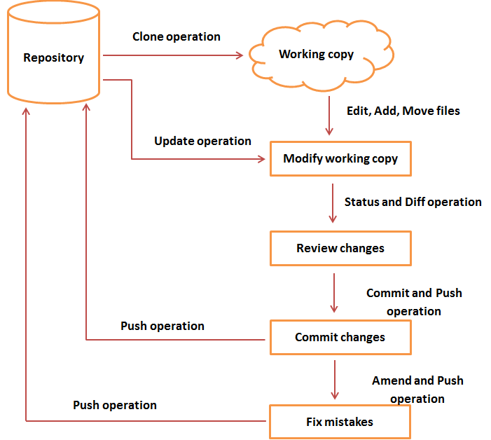

Q : How to resolve conflicts in GIT ?

To resolve a merge conflict caused by competing changes to a file, where a person deletes a file in one branch and another person edits the same file, you must choose whether to delete or keep the removed file in a new commit.

For example, if you edited a file, such as README.md, and another person removed the same file in another branch in the same Git repository, you'll get a merge conflict error when you try to merge these branches. You must resolve this merge conflict with a new commit before you can merge these branches.

Q : Name the different vendors that are working on VCS ?

* CVS
* SVN
* Git
* Mercurial
* Bazaar
* Monotone