Report linking predictions to sustainable farming practices

The machine learning model we've built predicts the optimal crop to grow based on various environmental factors, including soil nutrients (Nitrogen, Phosphorus, Potassium), temperature, humidity, soil pH, and rainfall. By analysing these input features, the model recommends the most suitable crop for specific conditions. This helps farmers improve crop yield, reduce resource waste by recommending crops that thrive in the existing environment, and minimize the need for excessive inputs like fertilizers and water.
We have built our Machine Learning models by Ensemble and Stacking together four different models.
The input features are directly linked to environmental sustainability:
NPK Nutrients: Balanced NPK levels are crucial for plant growth. The model helps identify areas with nutrient deficiencies or excesses, guiding farmers to apply fertilizers precisely, reducing runoff and environmental pollution.
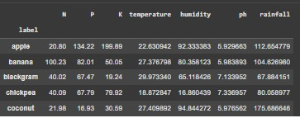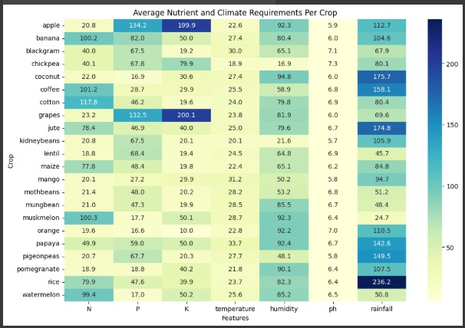
Rainfall: Understanding the rainfall requirements of different crops allows for efficient water management. Recommending drought-tolerant crops in low-rainfall areas or water-intensive crops where water is abundant helps conserve water resources.
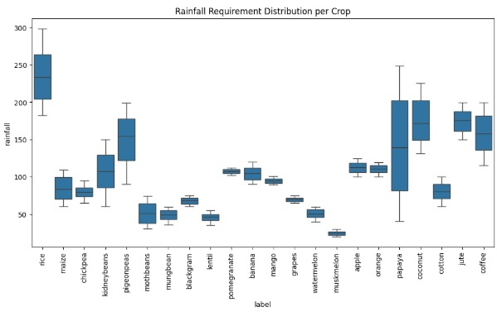
Soil pH: Soil pH affects nutrient availability. The model can help recommend crops that are suited to the existing soil pH, reducing the need for soil amendments that can sometimes have negative environmental impacts.
Temperature and Humidity: These factors influence crop growth cycles and susceptibility to pests and diseases. The model's recommendations can help select crops that are more resilient to local climate conditions, reducing the need for pesticides and other chemical interventions.
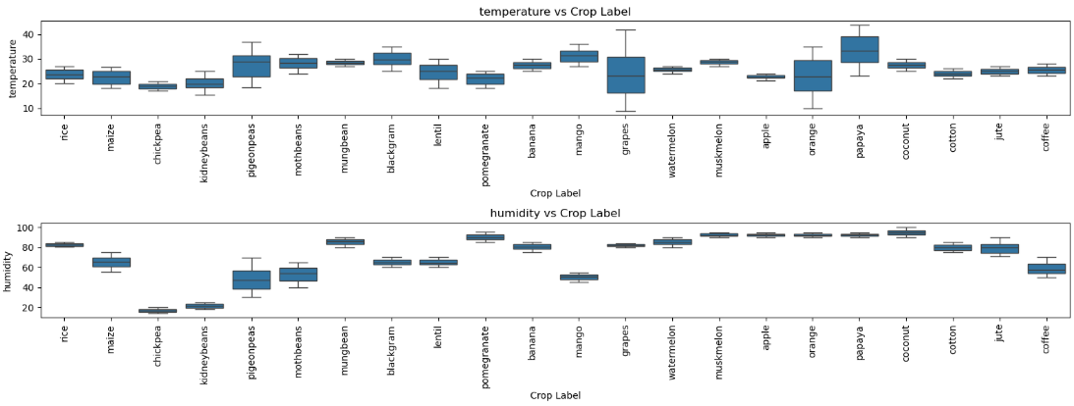
By providing recommendations based on these factors, the model promotes sustainable land use and minimizes negative environmental impacts.
Interpretation of Predictions
The predicted crop type for different soil and weather conditions provides valuable insights for farmers.
For example:
If the model predicts rice for a specific area, it indicates that the NPK levels, temperature, humidity, pH, and rainfall in that area are suitable for rice cultivation.
If it predicts coffee, it suggests a different set of optimal conditions.
Selecting suitable crops based on these predictions helps reduce land degradation and soil erosion by promoting the growth of crops that are well-suited to the environment. It also reduces dependency on harmful agrochemicals by minimizing the need for interventions to compensate for unsuitable growing conditions.

Sustainable Practices Derived from Predictions
The model's predictions can inform several sustainable farming practices:
Crop Rotation and Diversification: By understanding which crops are suitable for their land under different conditions, farmers can implement effective crop rotation and diversification strategies to maintain soil fertility and reduce pest and disease pressure.
Precision Agriculture: The model's insights can guide precision agriculture techniques, allowing farmers to apply fertilizers, water, and other resources more efficiently and only where needed.
Water-Saving Irrigation: Recommendations based on rainfall data can inform the adoption of water-saving irrigation methods, such as drip irrigation, in areas with limited water availability.
Organic Amendments: The model can highlight nutrient deficiencies, guiding farmers to use appropriate organic amendments to improve soil health and reduce reliance on synthetic fertilizers.

Validation & Impact
The accuracy and reliability of the model are crucial for its adoption. We have validated the model using metrics like accuracy and F1-score, and cross-validation to ensure its robustness.
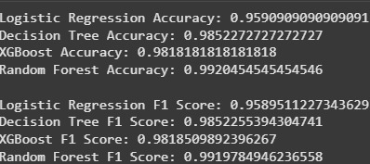


Visual Aids
To better understand the relationships between features and their environmental relevance, we can use visual aids:
Heatmaps: The heatmap of feature correlations helps visualize which environmental factors are most strongly related to crop types.
Feature Importance Graphs: These graphs show which features have the most significant impact on the model's predictions, highlighting the key environmental drivers for optimal crop growth.
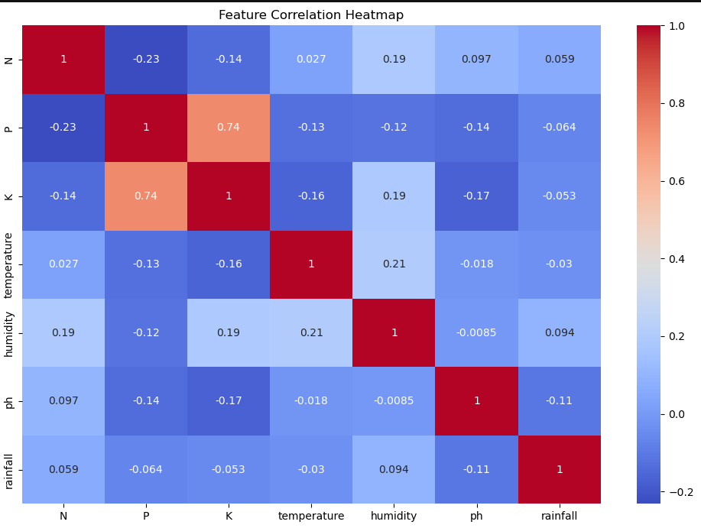
Nutrient vs Rainfall Correlations: Plotting correlations between nutrients and rainfall can illustrate how these factors interact and how managing them together is essential for sustainable resource management.

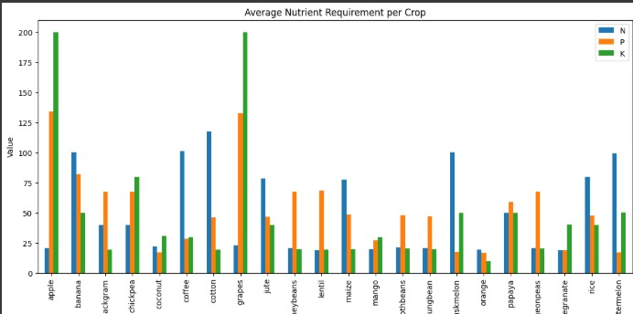

Conclusion
In conclusion, an ML-driven crop recommendation model serves as a powerful tool to guide farmers toward sustainable, efficient, and eco-friendly farming practices. By leveraging data on soil and climate conditions, the model enables informed decision-making that optimizes resource use, minimizes environmental impact, and contributes to long-term agricultural sustainability. Future developments could include integrating real-time data from soil sensors and weather forecasts for even more dynamic and precise recommendations.

