LAPORAN PRAKTIKUM 6

ANALISIS ALGORITMA



DISUSUN OLEH:

NAMA : Aithra Junia Bouty

NPM : 140810180054

Program Studi S-1 Teknik Informatika

Departemen Ilmu Komputer

Fakultas Matematika dan Ilmu Pengetahuan Alam

Universitas Padjadjaran

2020

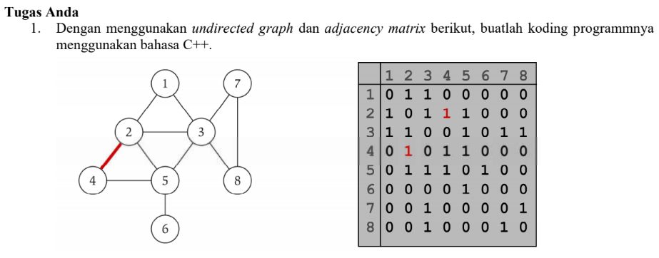

**Source code**

#include <iostream>

#include <cstdlib>

using namespace std;

#define MAX 20

class AdjacencyMatrix

{

private:

int n;

int **adj;

bool *visited;

public:

AdjacencyMatrix(int n)

{

this->n = n;

visited = new bool [n];

adj = new int* [n];

for (int i = 0; i < n; i++)

{

adj[i] = new int [n];

for(int j = 0; j < n; j++)

{

adj[i][j] = 0;

}

}

}

void add_edge(int origin, int destin)

{

if( origin > n || destin > n || origin < 0 || destin < 0)

{

cout<<"Invalid edge!\n";

}

else

{

adj[origin - 1][destin - 1] = 1;

}

}

void display()

{

int i,j;

for(i = 0;i < n;i++)

{

for(j = 0; j < n; j++)

cout<<adj[i][j]<<" ";

cout<<endl;

}

}

};

int main()

{

int nodes, max_edges, origin, destin;

cout<<"Enter number of nodes: ";

cin>>nodes;

AdjacencyMatrix am(nodes);

max_edges = nodes * (nodes - 1);

for (int i = 0; i < max_edges; i++)

{

cout<<"Enter edge (-1 -1 to exit): ";

cin>>origin>>destin;

if((origin == -1) && (destin == -1))

break;

am.add_edge(origin, destin);

}

am.display();

return 0;

}

**Screenshot:**

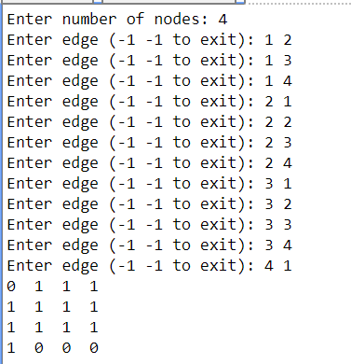

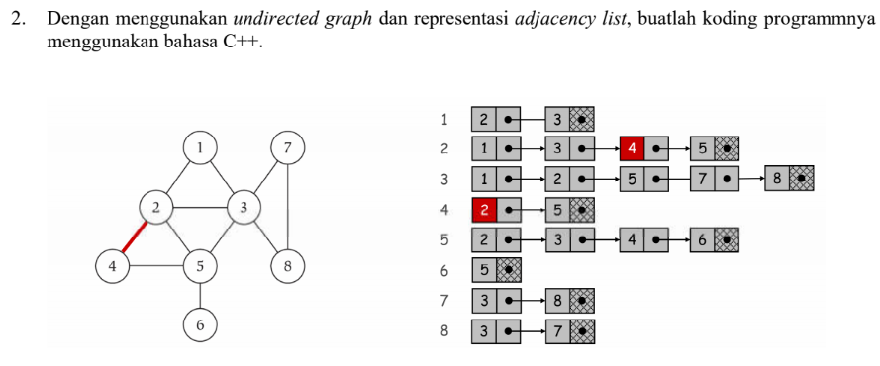

**Source code:**

#include <iostream>

#include <cstdlib>

using namespace std;

struct AdjListNode

{

int dest;

struct AdjListNode* next;

};

struct AdjList

{

struct AdjListNode *head;

};

class Graph

{

private:

int V;

struct AdjList* array;

public:

Graph(int V)

{

this->V = V;

array = new AdjList [V];

for (int i = 0; i < V; ++i)

array[i].head = NULL;

}

AdjListNode* newAdjListNode(int dest)

{

AdjListNode* newNode = new AdjListNode;

newNode->dest = dest;

newNode->next = NULL;

return newNode;

}

void addEdge(int src, int dest)

{

AdjListNode* newNode = newAdjListNode(dest);

newNode->next = array[src].head;

array[src].head = newNode;

newNode = newAdjListNode(src);

newNode->next = array[dest].head;

array[dest].head = newNode;

}

void printGraph()

{

int v;

for (v = 1; v < V; ++v)

{

AdjListNode* pCrawl = array[v].head;

cout<<"\n Adjacency list of vertex "<<v<<"\n head ";

while (pCrawl)

{

cout<<"-> "<<pCrawl->dest;

pCrawl = pCrawl->next;

}

cout<<endl;

}

}

};

int main()

{

Graph gh(8);

gh.addEdge(1, 2);

gh.addEdge(1, 3);

gh.addEdge(2, 4);

gh.addEdge(2, 5);

gh.addEdge(2, 3);

gh.addEdge(3, 7);

gh.addEdge(3, 8);

gh.addEdge(4, 5);

gh.addEdge(5, 3);

gh.addEdge(5, 6);

gh.addEdge(7, 8);

// print the adjacency list representation of the above graph

gh.printGraph();

return 0;

}

**Screenshot:**

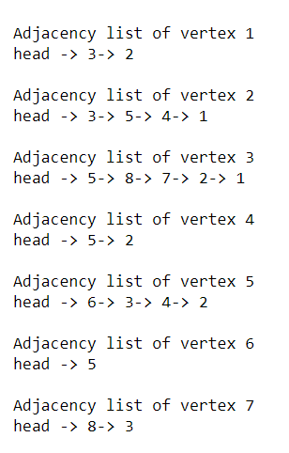

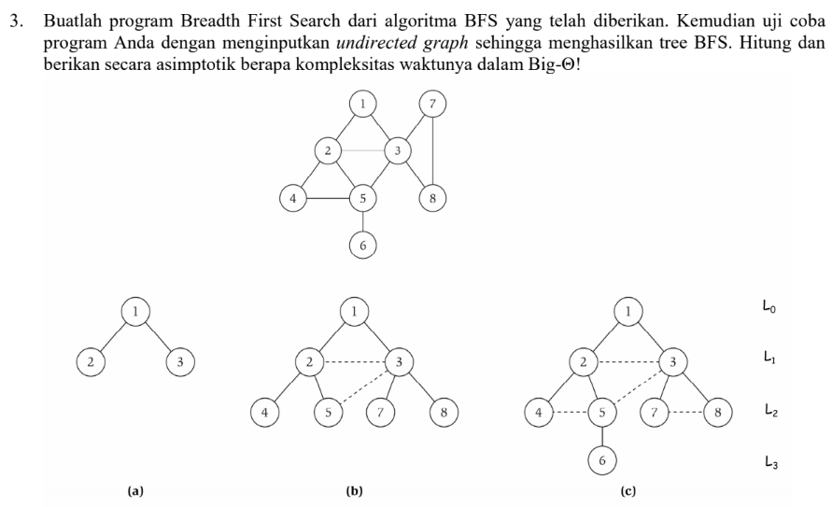

**Source code:**

#include<iostream>

using namespace std;

int main(){

int vertexSize = 8;

int adjacency[8][8] = {

{0,1,1,0,0,0,0,0},

{1,0,1,1,1,0,0,0},

{1,1,0,0,1,0,1,1},

{0,1,0,0,1,0,0,0},

{0,1,1,1,0,1,0,0},

{0,0,0,0,1,0,0,0},

{0,0,1,0,0,0,0,1},

{0,0,1,0,0,0,1,0}

};

bool discovered[vertexSize];

for(int i = 0; i < vertexSize; i++){

discovered[i] = false;

}

int output[vertexSize];

discovered[0] = true;

output[0] = 1;

int counter = 1;

for(int i = 0; i < vertexSize; i++){

for(int j = 0; j < vertexSize; j++){

if((adjacency[i][j] == 1)&&(discovered[j] == false)){

output[counter] = j+1;

discovered[j] = true;

counter++;

}

}

}

cout<<"BFS : "<<endl;

for(int i = 0; i < vertexSize; i++){

cout<<output[i]<<" ";

}

}

**Screenshot:**

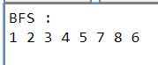

BFS adalah metode pencarian secara melebar, jadi mencari di 1 level dulu dari kiri ke kanan. Kalau sudah dikunjungi semua nodenya maka pencarian dilanjut ke level berikutnya. Worst case BFS harus mempertimbangkan semua jalur (path) untuk semua node yang mungkin, maka nilai kompleksitas waktu dari BFS adalah O( |V| + |E| ). Karena Big-O dari BFS adalah O(V+E) dimana V itu jumlah vertex dan E itu adalah jumlah edges maka Big-O = O(n) dimana n = v+e. Maka dari itu Big-Ө nya adalah Ө(n).

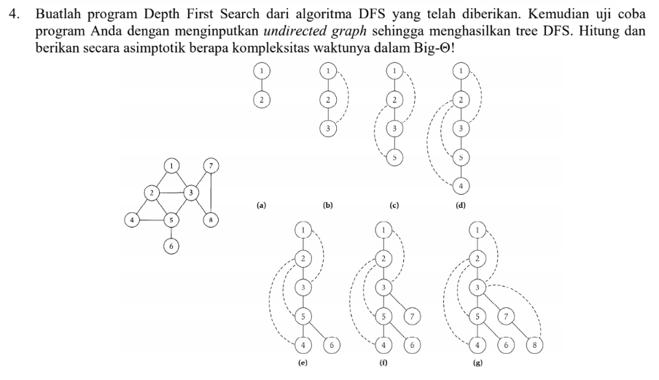

#include <iostream>

#include <list>

using namespace std;

class Graph{

int N;

list<int> *adj;

void DFSUtil(int u, bool visited[]){

visited[u] = true;

cout << u << " ";

list<int>::iterator i;

for(i = adj[u].begin(); i != adj[u].end(); i++){

if(!visited[*i]){

DFSUtil(*i, visited);

}

}

}

public :

Graph(int N){

this->N = N;

adj = new list<int>[N];

}

void addEdge(int u, int v){

adj[u].push_back(v);

}

void DFS(int u){

bool *visited = new bool[N];

for(int i = 0; i < N; i++){

visited[i] = false;

}

DFSUtil(u, visited);

}

};

int main(){

Graph g(8);

g.addEdge(1,2);

g.addEdge(1,3);

g.addEdge(2,3);

g.addEdge(2,4);

g.addEdge(2,5);

g.addEdge(3,7);

g.addEdge(3,8);

g.addEdge(4,5);

g.addEdge(5,3);

g.addEdge(5,6);

g.addEdge(7,8);

cout << "\nDFS Traversal Starts from Node 1" << endl;

g.DFS(1);

return 0;

}

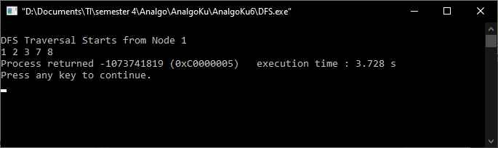

DFS merupakan metode pencarian mendalam, yang mengunjungi semua node dari yang terkiri lalu geser ke kanan hingga semua node dikunjungi. Kompleksitas ruang algoritma DFS adalah O(bm), karena kita hanya hanya perlu menyimpan satu buah lintasan tunggal dari akar sampai daun, ditambah dengan simpulsimpul saudara kandungnya yang belum dikembangkan.