**Creating A Gallery to store all the Images**

**[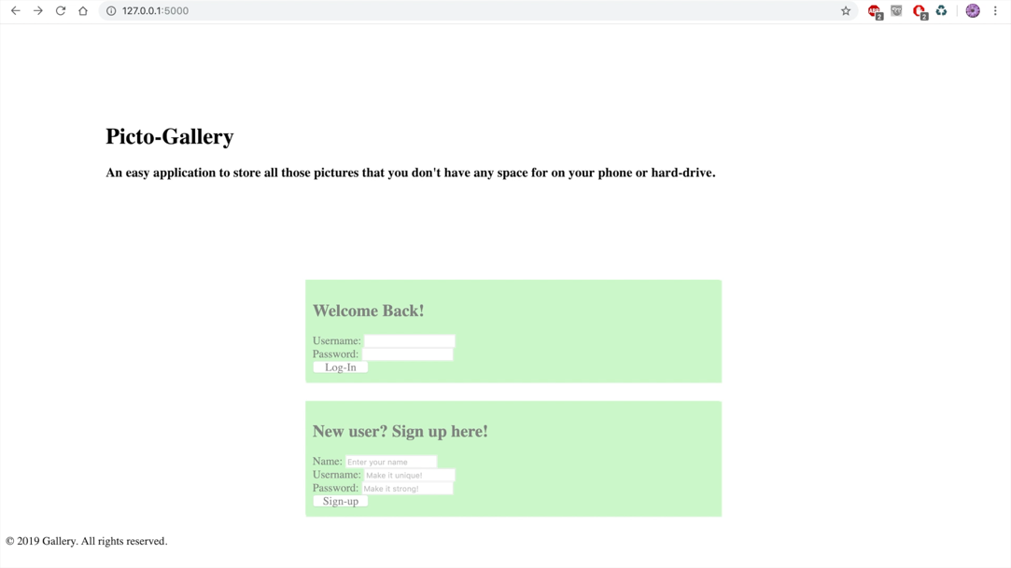](https://youtu.be/mT4vg_nLLus)**[**Watch the Video**](https://youtu.be/mT4vg_nLLus)

**Steps and Features**

1. **Create your account OR log in**

To get started, you must create an account in order to use the website. If you hover the mouse over one of the sign-up forms it will appear clearly and you can start writing in you username and password. If you have an existing account, then you can just log in with you username and password otherwise create your new account.

1. **Manage your gallery**

Once you have created the account you are taken to the home directory where you can manage your gallery. For first time user there won’t be any pictures but returning user will see their collection once they open the home directory. There are three options; Create, View, and Log out. For this step we will be focussing on the first two. By Clicking on View or Create it will take you to the image page where you can upload your images. Once you upload the image, you can also delete it as well.

1. **Contact Support**

At the home directory right below all the option is the support textbox. This textbox Is for the user’s assistance if they want to ask any question regarding the application. They can write in their message; with the name and email address it is for and send their question or concerns to a support representative. The email will be responded to as soon as possible or within two business days.

1. **Logging out**

After browsing through the gallery or adding new pictures to the user’s content, user can go to their home directory to log out of the application. The log-out button is right beside the “Create” and “View” button as mentioned earlier.

Languages used

* HTML5
* CSS
* JavaScript
* Flask

Website deployed onto Heroku

Video Link

YouTube link: <https://youtu.be/mT4vg_nLLus>