### Enable CORS to API GAteway

1. Select the API gateway for which CORS to be enabled.

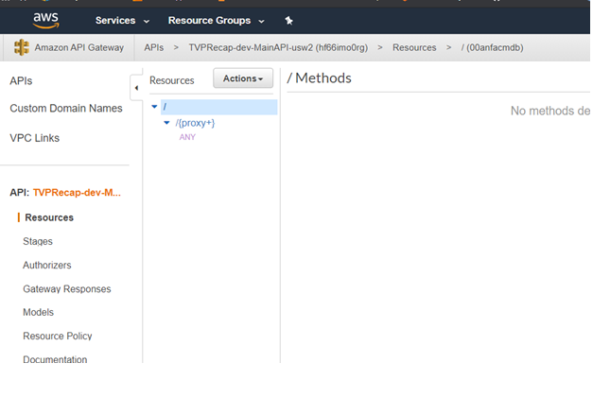

1. Click on **ANY 🡺Actions 🡺Enable CORS**

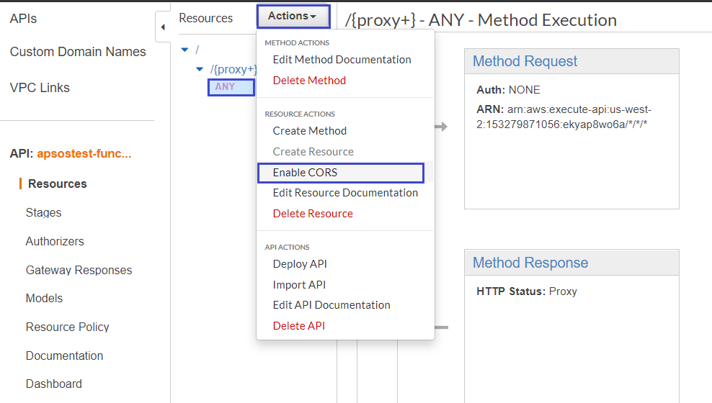

1. In the **Enable CORS**  pane, Click on **Enable CORS and replace existing CORS headers** button.

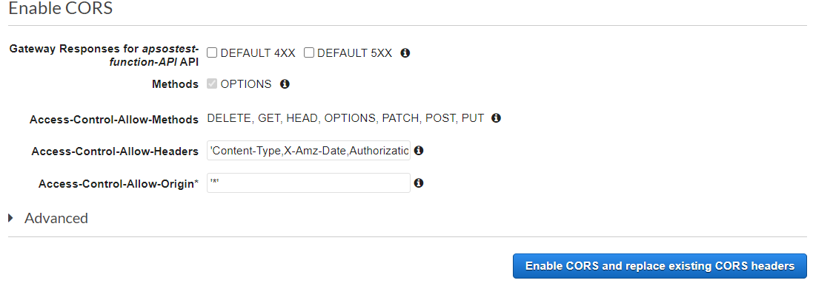

1. Click on **Yes, replace existing values** button on the **Confirm method changes** popup

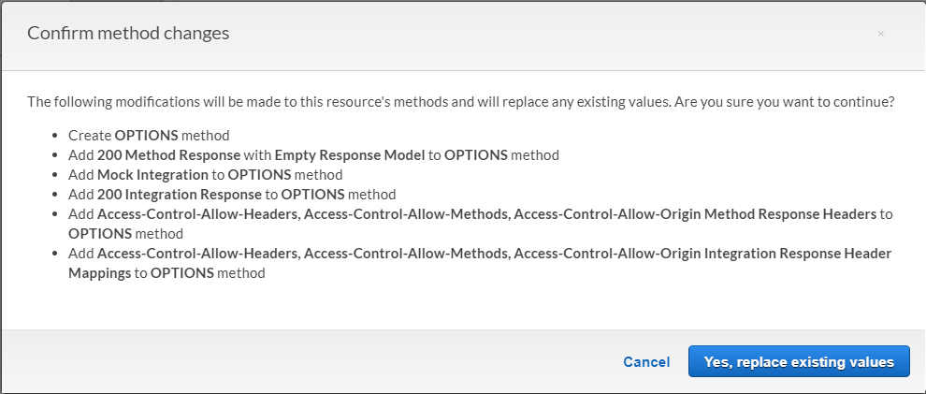

1. If, in the **Enable CORS** confirmation pane, there is any bulleted item with red cross for the Options method and is related to **200 Method Response**  follow the step #6

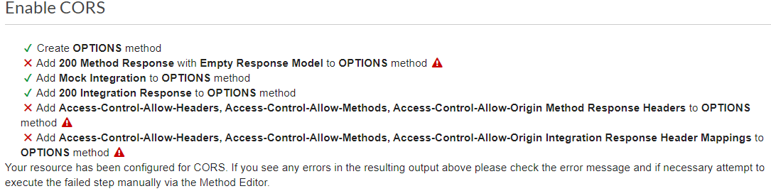

1. Manually Add **200** method response to **Options** method.
   1. Click on **Options 🡺Method Response**

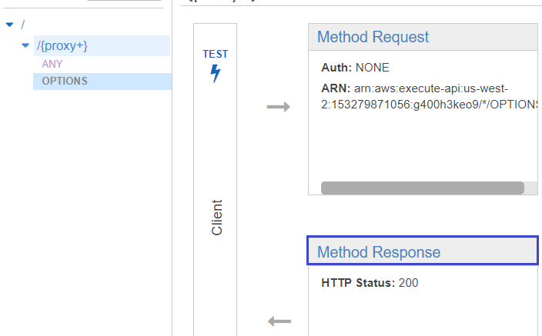

* 1. Click on **Add Response.**
  2. Enter **200**  and click on tick icon.

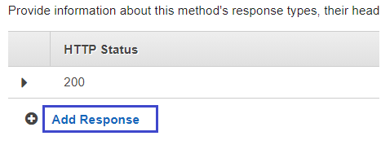

1. Allow **openIdToken** and **userSso** Custom Headers to be accepted: **[OPTIONAL]**
   1. Click on **Options🡺Method Request** method.
   2. Select **HTTP Request Headers**
   3. Add **openIdToken** and **userSso** request headers.

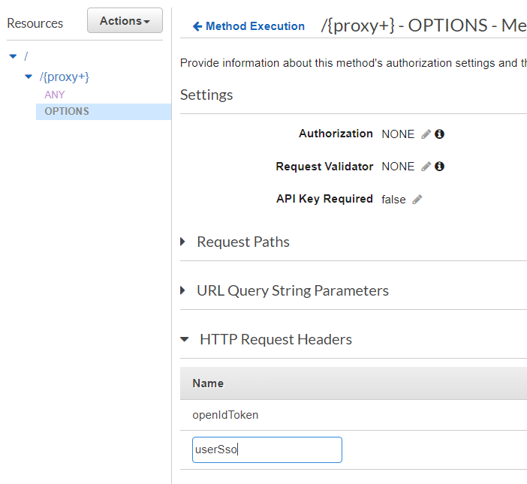

1. Enable CORS again

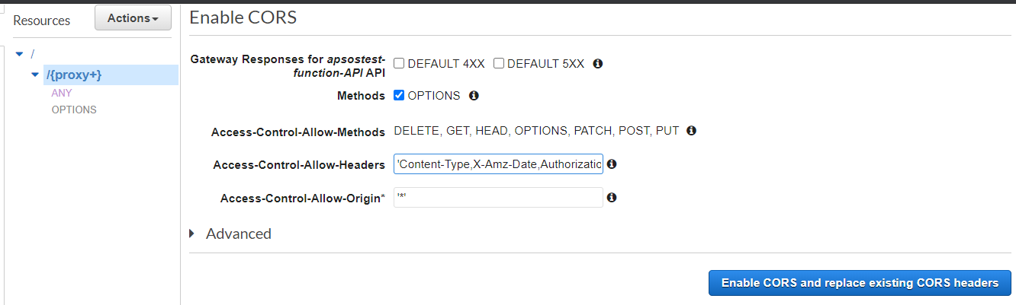

* 1. Append **openIdToken,userSso**  in **Access-Control-Allow-Headers**  and click on **Enable CORS and replace existing CORS headers**  button
  2. **Confirm to Yes in confirmation dialog.**

1. **Finally , Deploy the API.**