TASK 2: METHODOLOGY PASSPORT CARD
Research Methods
Yerkindik Ailen, Aitkali Dariga
1. Project Information
Research title: The Impact of Generative AI Assistance on Programming Learning Effectiveness Among Undergraduate Students
GitHub repository: https://github.com/aitkalidariga/AI-Programming-Research-Team
Research aim: To examine how generative AI affects programming learning among undergraduate students and identify which type of AI support helps students learn without reducing their ability to solve problems independently.
2. Research Type and Study Design
Research type: Quantitative research
We plan to compare students in three conditions: no AI assistance, AI hints and explanations, and direct AI-generated solutions. We will use the same programming language, similar tasks, time limits, and scoring rules for all groups. Prior programming experience will be recorded so that we can consider differences between students.
During practice, students will work under their assigned condition. After that, all students will complete a separate programming task without AI. This will help us compare both performance during practice and independent performance afterward. A later concept test will be used to assess retention if the study is carried out.
3. Research Questions and Hypotheses
Research Question 1
How does access to generative AI during programming exercises affect students’ task performance and completion time compared with learning without AI?
H0: There is no statistically significant difference in programming task scores or completion time between students using generative AI and students working without AI.
H1: Students using generative AI achieve higher programming task scores and complete tasks faster than students working without AI.
Research Question 2
How does the use of generative AI during programming practice affect students’ understanding and retention when AI assistance is later removed?
H0: There is no statistically significant difference in understanding and retention between students who practiced with AI and students who practiced without AI.
H1: Students who practiced with AI show a statistically significant difference in understanding and retention when completing later tasks without AI.
Research Question 3
Which type of AI support, explanations and hints or direct solution generation, leads to better independent programming performance?
H0: There is no statistically significant difference in independent programming performance between students receiving AI-generated hints and students receiving complete AI-generated solutions.
H1: Students receiving AI-generated hints and explanations achieve higher independent programming performance than students receiving complete AI-generated solutions.
4. Variables Matrix
Variable type | Variables | How we will use them
Independent | AI access;  Type of AI support | Three groups: no AI, AI hints, direct AI solutions
Dependent | Task score (%);  Completion time (minutes);  Independent task score (%); Programming errors (count);  Concept test score (%) | Scores and time recorded for each student
Controlled | Programming language;  Task difficulty;  Time limit;  Learning materials;  Evaluation criteria | Kept as similar as possible for all groups
Background factor | Prior programming experience | Measured before the experiment and considered in analysis
5. Metrics and Baseline
1. Primary Metric
Independent Programming Task Score (%): The percentage of test cases passed on a task completed without AI assistance.
Formula: Independent Task Score (%) = (Passed Test Cases / Total Test Cases) × 100
We selected this as the main metric because the research focuses on whether students can solve programming problems on their own.
2. Secondary and Guardrail Metrics
Metric | Definition / unit | Purpose
Completion time | Minutes needed to finish the task | Compare task speed
Concept test score | Correct answers / total answers × 100 (%) | Check understanding
Programming errors | Number of recorded errors | Compare mistakes
Execution error rate (guardrail) | Programs that fail to execute / submitted programs × 100 (%) | Monitor code execution problems
Valid results rate (guardrail) | Valid records / all records × 100 (%) | Monitor data quality
Pipeline reliability (guardrail) | Benchmark finishes without a critical error | Confirm the script can run
The current demonstration script calculates practice task scores, completion time, concept scores, and programming errors from synthetic sample records. It does not yet measure the primary independent-task score after AI assistance is removed. Independent performance, retention, and the remaining guardrail metrics are planned for the actual study.
3. Baseline
Group A - No AI: Students complete programming exercises without generative AI. This is our baseline.
Group B - AI hints: Students can use AI-generated explanations and hints, but not complete solutions.
Group C - AI solutions: Students can use direct AI-generated solutions during practice.
After the practice phase, all groups will complete an independent task without AI. We will compare their results with the baseline and with each other.
6. Reproducibility and Current Project Status
We created a public team GitHub repository with an academic README, configuration files, nine-row synthetic CSV dataset, Python benchmark, requirements.txt, Dockerfile, and an automated GitHub Actions workflow.
The sample dataset contains nine synthetic records (three per group). These are made-up examples used only to check whether the program works. They are not real student results and cannot be used to accept or reject our hypotheses.
The benchmark was successfully executed locally using Docker with the nine-row synthetic CSV dataset. The Docker Benchmark Check workflow also completed successfully on GitHub Actions after the project files were uploaded.
Group (synthetic data) | Mean task score | Mean time | Mean concept score | Mean errors
No AI | 70.00% | 35.67 min | 70.00% | 2.00
AI hints | 86.67% | 25.67 min | 86.67% | 0.67
AI solutions | 76.67% | 20.33 min | 66.67% | 1.33
These numbers are demonstration outputs only. Real data collection, hypothesis testing, and conclusions will come later.
7. Files and Reproduction
Main files: README.md; src/benchmark.py; configs/config.json and configs/config.yaml; data/sample/sample_results.csv; requirements.txt; Dockerfile; .github/workflows/main.yml; .gitignore; LICENSE. The Methodology Passport Card is prepared for upload to docs/Methodology_Passport_Card.pdf.
To run the project with Docker from the repository root:
docker build -t ai-programming-research .
docker run --rm -v "%cd%:/app" ai-programming-research (Windows Command Prompt; run from the repository root)
The script reads the synthetic CSV file, calculates average metrics for the three groups, and prints the results. The same check is run automatically through GitHub Actions.

8.
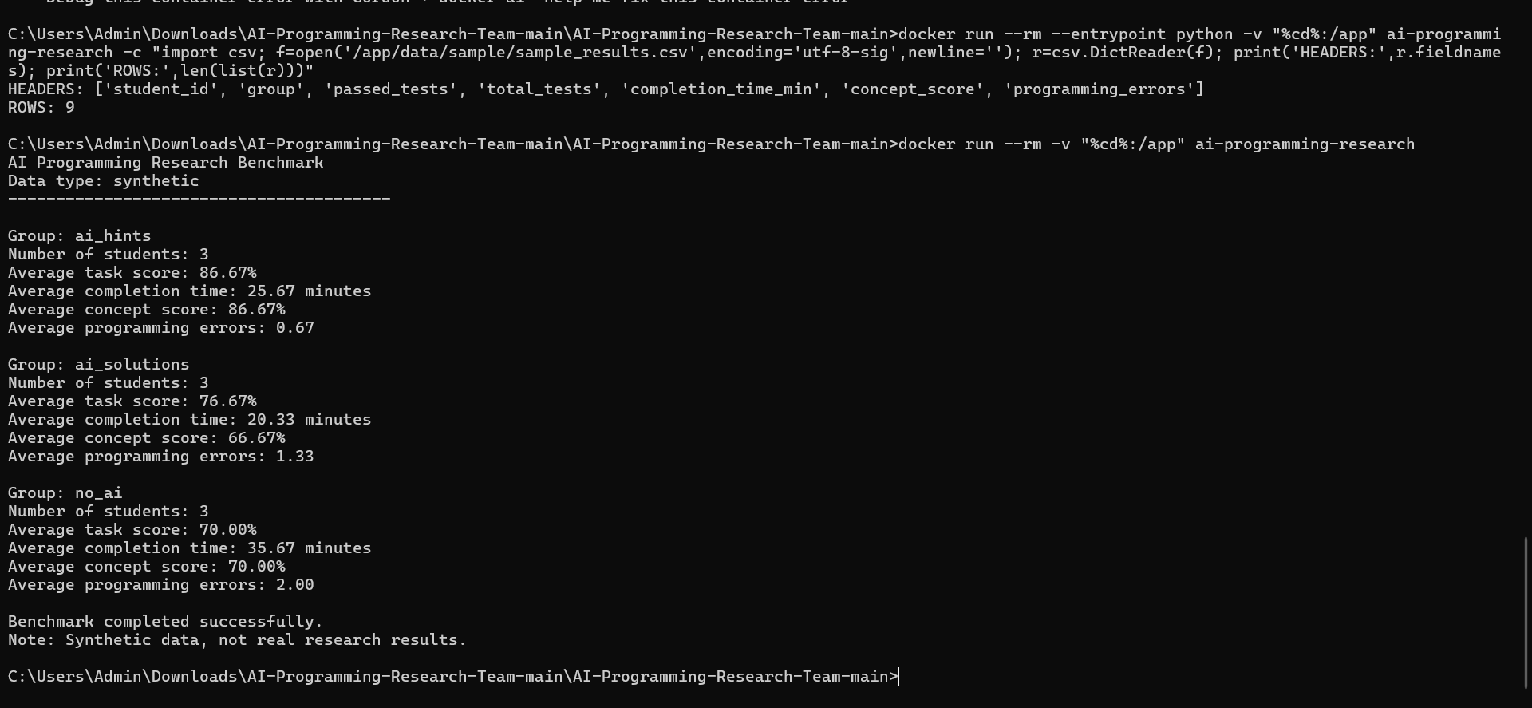
The screenshot shows the successful execution of the Python benchmark in Docker. The program processed nine synthetic records across three groups (No AI, AI Hints, and AI Solutions) and calculated average task scores, completion times, concept scores, and programming errors.

