ANGADIINSTITUTEOFTECHNOLOGY&MANAGEMENT

DEPARTMENTOFCOMPUTERSCIENCEANDENGINEERING



LABORATORYMANUAL

“Analysis & Design of Algorithms Lab”

Semester: IV

PreparedBy
Prof. Manjunath Patil
AssistantProfessor,Dept.ofCSE,
AITM,Belagavi.

VISION OF THE DEPARTMENT
To impart quality education in computer science and engineering with emphasis on professional skills to meet the global challenges in IT paradigm.

MISSION OFTHEDEPARTMENT
M1: Impart knowledge in current and emerging computing technologies by adopting various pedagogical approaches.
M2: Developaconduciveenvironment toinculcateandnurtureanalyticaland communication skills along with societal and ethical responsibility in all professional endeavors.
M3: Enablestudentstobesuccessfulgloballybybeingeffectiveproblemsolversand lifelong learners.

INDEX
S.NO | EXPERIMENTS | PAGE  NO
1. | DesignandimplementC/C++ProgramtofindMinimumCostSpanningTreeofagiven connected undirected graph using Kruskal's algorithm.
2. | DesignandimplementC/C++ProgramtofindMinimumCostSpanningTreeofagiven  connectedundirectedgraphusingPrim'salgorithm.
3. | a.DesignandimplementC/C++ProgramtosolveAll-PairsShortestPathsproblemusing  Floyd'salgorithm.b.DesignandimplementC/C++Programtofindthetransitiveclosure using Warshal's algorithm.
4. | DesignandimplementC/C++Programtofindshortestpathsfromagivenvertexina  weightedconnectedgraphtootherverticesusingDijkstra's algorithm.
5. | DesignandimplementC/C++ProgramtoobtaintheTopologicalorderingofverticesin  agivendigraph
6. | DesignandimplementC/C++Programtosolve0/1KnapsackproblemusingDynamic  Programmingmethod.
7. | DesignandimplementC/C++ProgramtosolvediscreteKnapsackandcontinuous  Knapsackproblemsusinggreedyapproximationmethod.
8. | DesignandimplementC/C++ProgramtofindasubsetofagivensetS={sl,s2,. ,sn}  ofnpositiveintegerswhosesumisequaltoagivenpositiveintegerd.
9. | Design and implement C/C++ Program to sort a given set of n integer elements using Selection Sort method and compute its time complexity. Run the program for varied values of n> 5000 and record the time taken to sort. Plot a graph of the time taken versusn.Theelementscanbereadfromafileorcanbegeneratedusingtherandom  numbergenerator.
10 | Design and implement C/C++ Program to sort a given set of n integer elements using Quick Sort method and compute its time complexity. Run the program for varied values of n> 5000 and record the time taken to sort. Plot a graph of the time taken versus n. Theelementscanbereadfromafileorcanbegeneratedusingtherandomnumber  generator.
11. | Design and implement C/C++ Program to sort a given set of n integer elements using Merge Sort method and compute its time complexity. Run the program for variedvalues of n> 5000, and record the time taken to sort. Plot a graph of the time taken versusn.Theelementscanbereadfromafileorcanbegeneratedusingtherandom  numbergenerator.
12 | DesignandimplementC/C++ProgramforNQueen'sproblemusingBacktracking.
II | SAMPLEVIVAQUESTIONSANDANSWERS

Design and Analysis of Algorithms (ADA) Lab Manual

Objective
This lab manual contains simplified programs and explanations for common Design and Analysis of Algorithms experiments. Each experiment includes aim, theory, algorithm steps, program, sample input/output, and complexity.

Experiment 1: Design and implement C/C++ Program to find Minimum Cost Spanning Tree of a given connected undirected graph using Kruskal's algorithm.
Aim:To find the Minimum Cost Spanning Tree using Kruskal’s algorithm.
Theory:
Kruskal’s algorithm is a greedy algorithm used to find the Minimum Spanning Tree (MST) of a connected weighted graph.
It works by repeatedly selecting the edge with the smallest weight and adding it to the spanning tree, provided it does not form a cycle.
Cycle detection is performed using the Union-Find (disjoint set) technique.
The algorithm continues until (n − 1) edges are included in the spanning tree, where n is the number of vertices.
Program:
#include<stdio.h>
#define MAX 20
#define INF 999
int parent[MAX];
int find(int x)
{
while(parent[x])
x = parent[x];
return x;
}
int main()
{
int n,cost[MAX][MAX],i,j,a,b,u,v,min,edges=0,total=0;
printf("Enter vertices: ");
scanf("%d",&n);
printf("Enter cost matrix:\n");
for(i=1;i<=n;i++)
for(j=1;j<=n;j++)
scanf("%d",&cost[i][j]);
while(edges < n-1)
{
min = INF;
for(i=1;i<=n;i++)
for(j=1;j<=n;j++)
if(cost[i][j] < min)
{
min = cost[i][j];
a=i; b=j;
}
u = find(a);
v = find(b);
if(u != v)
{
parent[v] = u;
printf("Edge %d: %d -> %d\n", ++edges, a, b);
total += min;
}
cost[a][b] = cost[b][a] = INF;
}
printf("Minimum cost = %d", total);
}
Time and Space Complexity:
Time: O(n³)
As the minimum edge is searched using full matrix every time
Space: O(n²)
Due to cost matrix storage
Input/Output
Enter vertices: 5
Enter cost matrix:
0 10 15 9 999
10 0 999 17 15
15 999 0 20 999
9 17 20 0 18
999 15 999 18 0

Edge 1: 1 -> 4
Edge 2: 1 -> 2
Edge 3: 1 -> 3
Edge 4: 2 -> 5
Minimum cost = 49

Result:
The program to find the Minimum Cost Spanning Tree using Kruskal’s algorithm was successfully executed.
The edges of the Minimum Spanning Tree were obtained and the minimum cost of the spanning tree was computed correctly.

Experiment 2: Design and implement C/C++ Program to find Minimum Cost Spanning Tree of a given connected undirected graph using Prim's algorithm.
Aim:To construct a Minimum Cost Spanning Tree for a given weighted graph using Prim’s algorithm.
Theory:
Prim’s algorithm is a greedy technique used to determine the Minimum Spanning Tree of a connected weighted graph.
It starts from a selected source vertex and grows the spanning tree by repeatedly adding the minimum weight edge that connects a visited vertex to an unvisited vertex.
At each step, the algorithm ensures that no cycles are formed by only choosing edges that expand the tree to new vertices. The process continues until all vertices are included, resulting in a tree with minimum total cost.
Program:
#include<stdio.h>
#define MAX 10
#define INF 999
int main()
{
int cost[MAX][MAX], visited[MAX]={0};
int n,i,j,edges=0,min,u,v,total=0,s;
printf("Enter number of vertices: ");
scanf("%d",&n);
printf("Enter cost matrix:\n");
for(i=1;i<=n;i++)
for(j=1;j<=n;j++)
scanf("%d",&cost[i][j]);
printf("Enter the source node: ");
scanf("%d",&s);
visited[s] = 1;
while(edges < n-1)
{
min = INF;
for(i=1;i<=n;i++)
{
if(visited[i])
{
for(j=1;j<=n;j++)
{
if(!visited[j] && cost[i][j] < min)
{
min = cost[i][j];
u = i;
v = j;
}
}
}
}
printf("Edge %d: %d -> %d cost=%d\n", edges+1, u, v, min);
visited[v] = 1;
total += min;
edges++;
}
printf("Minimum cost = %d\n", total);
return 0;
}
Time and Space Complexity:
Time: O(n²)
Two nested loops to find minimum edge
Space: O(n²)
Cost matrix + visited array
Input/Output
Enter number of vertices: 3
Enter cost matrix:
0 10 1
10 0 6
1 6 0

Enter the source node: 1
Edge 1: 1 -> 3 cost=1
Edge 2: 3 -> 2 cost=6
Minimum cost = 7

Results: The program to find the Minimum Cost Spanning Tree using Prim’s algorithm was executed successfully. The selected edges and the total minimum cost of the spanning tree were obtained correctly.

Experiment 3: 3A.Design and implement C/C++ Program to solve All-Pairs Shortest Paths problem using Floyd's algorithm

Aim: To find the shortest distance between all pairs of vertices using Floyd’s algorithm.

Theory: Floyd’s algorithm is used to calculate shortest paths between all vertices in a graph.
It works by checking whether a path between two vertices can be made shorter by passing through another vertex.

The algorithm updates the distance matrix step by step by considering each vertex as an intermediate node.

Program
#include<stdio.h>
#define INF 999
int main()
{
int n,i,j,k;
int a[10][10];
printf("Enter number of vertices: ");
scanf("%d",&n);
printf("Enter cost matrix:\n");
for(i=0;i<n;i++)
for(j=0;j<n;j++)
scanf("%d",&a[i][j]);
for(k=0;k<n;k++)
for(i=0;i<n;i++)
for(j=0;j<n;j++)
if(a[i][j] > a[i][k] + a[k][j])
a[i][j] = a[i][k] + a[k][j];
printf("Shortest path matrix:\n");
for(i=0;i<n;i++)
{
for(j=0;j<n;j++)
printf("%d ",a[i][j]);
printf("\n");
}
return 0;
}

Time and Space Complexity:
Time: O(n³)
Three nested loops (k, i, j)
Space: O(n²)
Distance matrix
Input/Output
Enter number of vertices: 4
Enter cost matrix:
0 999 3 999
2 0 999 999
999 7 0 1
6 999 999 0

Shortest path matrix:
0 10 3 4
2 0 5 6
7 7 0 1
6 16 9 0

Result: The program to find the shortest paths between all pairs of vertices using Floyd’s algorithm was executed successfully. The shortest path matrix was obtained correctly.

3B Design and implement C/C++ Program to find the transitive closure using Warshal's algorithm.

Aim: To determine the reachability of vertices in a graph using transitive closure.

Theory: Transitive closure is used to find whether a path exists between any two vertices in a graph.
Instead of finding the shortest path, it simply tellswhether we can reach one vertex from another.
This method works on a boolean concept:
- 1 means path exists
- 0 means no path
The algorithm checks if a path from vertex i to j can be formed through another vertex k. If yes, it updates the matrix accordingly.
Program
#include<stdio.h>
int main()
{
int n,i,j,k;
int a[10][10];
printf("Enter number of vertices: ");
scanf("%d",&n);
printf("Enter adjacency matrix:\n");
for(i=0;i<n;i++)
for(j=0;j<n;j++)
scanf("%d",&a[i][j]);
for(k=0;k<n;k++)
for(i=0;i<n;i++)
for(j=0;j<n;j++)
if(a[i][j] == 0)
a[i][j] = a[i][k] && a[k][j];
printf("Transitive closure matrix:\n");
for(i=0;i<n;i++)
{
for(j=0;j<n;j++)
printf("%d ",a[i][j]);
printf("\n");
}
return 0;
}

Time and Space Complexity:
Time: O(n³)
Same triple nested loop structure
Space: O(n²)
Reachability matrix

Input/output
Enter number of vertices: 4
Enter adjacency matrix:
0 1 0 0
0 0 0 1
0 0 0 0
1 0 1 0
Transitive closure matrix:
1 1 1 1
1 1 1 1
0 0 0 0
1 1 1 1

Result: The program to find the transitive closure of a graph using Warshall’s algorithm was executed successfully. The reachability matrix representing paths between all pairs of vertices was obtained correctly.

Experiment 4: Design and implement C/C++ Program to find shortest paths from a given vertex in a weighted connected graph to other vertices using Dijkstra's algorithm.

Aim:To compute the shortest distance from a given source vertex to all other vertices using Dijkstra’s method.

Theory: Dijkstra’s algorithm is used to find the minimum distance from one vertex to all other vertices in a weighted graph.It works by always selecting the vertex with the smallest temporary distance and then updating its neighboring vertices.

This process continues until all vertices are visited and the shortest distances are finalized.
Note: This method works only when all edge weights are non-negative.
Program
#include<stdio.h>
#define INF 999
int main()
{
int c[10][10], d[10], v[10]={0};
int i,j,n,s,u,min;
printf("Enter number of vertices: ");
scanf("%d",&n);
printf("Enter cost matrix:\n");
for(i=1;i<=n;i++)
for(j=1;j<=n;j++)
scanf("%d",&c[i][j]);
printf("Enter source vertex: ");
scanf("%d",&s);
for(i=1;i<=n;i++)
d[i]=c[s][i];
v[s]=1;
for(i=1;i<=n;i++)
{
min=INF;
for(j=1;j<=n;j++)
if(!v[j] && d[j]<min)
{
min=d[j];
u=j;
}
v[u]=1;
for(j=1;j<=n;j++)
if(!v[j] && d[u]+c[u][j] < d[j])
d[j]=d[u]+c[u][j];
}
for(i=1;i<=n;i++)
printf("Shortest distance from %d to %d = %d\n",s,i,d[i]);
return 0;
}

Time and Space Complexity:
Time: O(n²)
Finding minimum + updating distances
Space: O(n²)
Cost matrix + distance array
Input/Output
Enter number of vertices: 4
Enter cost matrix:
444 767 987 12
999 87 56 45
1 0 999 678
444 678 235 0
Enter source vertex: 1
Shortest distance from 1 to 1 = 444
Shortest distance from 1 to 2 = 247
Shortest distance from 1 to 3 = 247
Shortest distance from 1 to 4 = 12

Result: The program was executed to find the shortest path from the given source vertex to all other vertices using Dijkstra’s algorithm. The shortest distances were computed and displayed correctly.

Experiment 5: Design and implement C/C++ Program to obtain the Topological ordering of vertices in a given digraph

Aim: To write a C program that determines a valid ordering of vertices in a directed graph such that for every directed edge u→vu \rightarrow vu→v, vertex uuu appears before vvv. This is achieved using the concept of topological sorting based on indegree.

Theory: Topological sorting is applicable only for Directed Acyclic Graphs (DAGs). It provides a linear arrangement of vertices where dependencies are maintained.
In this method, we make use of the concept of indegree, which represents the number of incoming edges to a vertex.
Steps involved in the concept:
- First, calculate the indegree of all vertices.
- A vertex with indegree 0 means it has no dependencies and can be placed first.
- Once a vertex is selected, it is removed from the graph, and the indegree of its adjacent vertices is reduced.
- This process is repeated until all vertices are processed.
If at any stage no vertex with indegree 0 is found and some vertices are still unprocessed, the graph contains a cycle, and topological ordering is not possible.
Program
#include <stdio.h>
int main()
{
int a[10][10], indeg[10] = {0}, topo[10];
int n, i, j, k = 0, count = 0;
printf("Enter number of vertices: ");
scanf("%d", &n);
printf("Enter adjacency matrix:\n");
for(i = 0; i < n; i++)
for(j = 0; j < n; j++)
{
scanf("%d", &a[i][j]);
if(a[i][j] == 1)
indeg[j]++;
}
while(count < n)
{
for(i = 0; i < n; i++)
{
if(indeg[i] == 0)
{
topo[k++] = i + 1;
indeg[i] = -1;
for(j = 0; j < n; j++)
if(a[i][j] == 1)
indeg[j]--;
count++;
break;
}
}
if(i == n) break; // cycle case
}
if(count != n)
printf("Topological ordering not possible");
else
{
printf("Topological order: ");
for(i = 0; i < n; i++)
printf("%d ", topo[i]);
}
return 0;
}

Time and Space Complexity:
Time: O(n²)
Repeated scanning of adjacency matrix
Space: O(n²)
Adjacency matrix + indegree array

Input/ output 1
Enter number of vertices: 6
Enter adjacency matrix:

0 0 1 1 0 0
0 0 0 1 1 0
0 0 0 1 0 1
0 0 0 0 0 1
0 0 0 0 0 1
0 0 0 0 0 0

Topological Order: 1 2 3 4 5 6

Input/ output 2

Enter number of vertices: 4
Enter adjacency matrix:
1 4 3 2
5 4 2 1
5 3 4 2
4 1 2 3
Topological Order: 3
Topological ordering not possible

Result: The program was executed to determine the topological ordering of the given directed graph.The ordering of vertices was obtained successfully when the graph was acyclic. In case of a cycle, the program correctly indicated that topological ordering is not possible.

Experiment 6: Design and implement C/C++ Program to solve 0/1 Knapsack problem using Dynamic Programming method.

Aim: To determine the maximum profit that can be obtained by selecting a subset of given items such that the total weight does not exceed the knapsack capacity, using a recursive approach.

Theory: The 0/1 Knapsack problem is a classical problem in optimization where each item is associated with a weight and a profit. The objective is to select items in such a way that the total profit is maximized without exceeding the given capacity of the knapsack.
In this method, each item has only two choices:
- Either include the item in the knapsack
- Or exclude the item
Since the decision is binary (0 or 1), the problem is called 0/1 Knapsack.The recursive solution explores all possible combinations of items. For every item, the function calls itself twice:
- Considering the item (if weight permits)
- Not considering the item
The maximum of these two choices is taken as the optimal solution.
This approach follows the principle of optimal substructure, where the solution to the main problem depends on solutions to smaller subproblems.
Program
#include<stdio.h>
int n, w[10], p[10];
int max(int a, int b)
{
if(a > b) return a;
else return b;
}
int knap(int i, int m)
{
if(i > n) return 0;
if(w[i] > m)
return knap(i+1, m);
return max(knap(i+1, m), p[i] + knap(i+1, m - w[i]));
}
int main()
{
int m, i;
printf("Enter number of items: ");
scanf("%d", &n);
printf("Enter capacity: ");
scanf("%d", &m);
printf("Enter profit and weight:\n");
for(i = 1; i <= n; i++)
scanf("%d %d", &p[i], &w[i]);
printf("Maximum profit = %d", knap(1, m));
return 0;
}
Input/Output
Enter number of items: 4
Enter capacity: 5
Enter profit and weight:
12 3
43 5
45 2
55 3
Maximum profit = 100

Time Complexity
The time complexity of this recursive approach is O(2ⁿ). This is because for every item, two recursive calls are made (include or exclude), forming a binary recursion tree. As the number of items increases, the number of function calls grows exponentially.

Space Complexity
The space complexity is O(n) due to recursion stack usage.

Result
The program successfully computes the maximum profit for the given set of items and knapsack capacity using recursion.

Experiment 7: Design and implement C/C++ Program to solve discrete Knapsack and continuous Knapsack problems using greedy approximation method.

Aim
To implement a greedy strategy to select objects based on their profit-to-weight ratio and obtain the maximum possible profit without exceeding the given knapsack capacity.

Theory
The Knapsack problem is a well-known optimization problem where a set of items is given, each having a weight and a profit. The objective is to choose a subset of items such that the total weight does not exceed the capacity of the knapsack while maximizing the total profit.
In the greedy approach, items are not selected arbitrarily. Instead, a decision is made based on a specific criterion, which in this case is the profit-to-weight ratio. Items with higher ratio contribute more profit per unit weight and are therefore preferred.
Initially, the ratio for each item is calculated. The items are then arranged in descending order of this ratio. Starting from the item with the highest ratio, items are added to the knapsack as long as the total weight remains within the allowed capacity.
In this implementation, only complete items are selected, and once an item cannot be fully accommodated, the process is stopped. This makes the solution simple and suitable for demonstrating greedy selection, although it does not consider fractional inclusion.

Program
#include <stdio.h>
int main() {
int n, m, i, j, w[50], p[50], x[50] = {0};
float ratio[50], profit = 0;
printf("Enter the number of objects: ");
scanf("%d", &n);
printf("Enter the objects' weights: ");
for(i = 0; i < n; i++)
scanf("%d", &w[i]);
printf("Enter the objects' profits: ");
for(i = 0; i < n; i++) {
scanf("%d", &p[i]);
ratio[i] = (float)p[i] / w[i];
}
printf("Enter the maximum capacity: ");
scanf("%d", &m);
// Sort items by profit/weight ratio (descending)
for(i = 0; i < n-1; i++)
for(j = i+1; j < n; j++)
if(ratio[i] < ratio[j]) {
float r = ratio[i]; ratio[i] = ratio[j]; ratio[j] = r;
int t = w[i]; w[i] = w[j]; w[j] = t;
t = p[i]; p[i] = p[j]; p[j] = t;
}
int curW = 0;
// Greedy selection (only full items)
for(i = 0; i < n; i++) {
if(curW + w[i] > m) break;
x[i] = 1;
curW += w[i];
profit += p[i];
}
printf("Optimal solution for greedy method: %.1f\n", profit);
printf("Solution vector for greedy method: ");
for(i = 0; i < n; i++)
printf("%d\t", x[i]);
return 0;
}

Input/Output
Enter the number of objects: 4
Enter the objects' weights: 56 78 98 78
Enter the objects' profits: 23 45 76 78
Enter the maximum capacity: 100
Optimal solution for greedy method: 78.0
Solution vector for greedy method: 1 0 0 0

Time Complexity
- The sorting step takes O(n²) time (since simple nested loops are used)
- The selection process takes O(n) time
Overall time complexity: O(n²)

Space Complexity
The program uses arrays to store weights, profits, ratios, and solution vector.
Space complexity: O(n)

Result
The program successfully selects items based on profit-to-weight ratio using a greedy method and computes the maximum obtainable profit within the given capacity.

Experiment 8: Design and implement C/C++ Program to find a subset of a given set S = {sl , s2,.....,sn} of n positive integers whose sum is equal to a given positive integer d.

Aim
To find all possible subsets of a given set whose sum is equal to a specified target value using backtracking technique.
Theory
The Sum of Subsets problem is a classic example of a backtracking technique, where all possible combinations of a given set are explored to find those subsets whose sum matches a specified target value.
In this approach, each element of the set is considered one by one. For every element, there are two possible decisions: either include it in the current subset or exclude it. Based on these choices, different subset combinations are formed.
The solution is built incrementally using recursion. At each stage, the current sum is updated depending on whether the element is included or not. If the sum becomes equal to the target value, the corresponding subset is printed. If the sum exceeds the target or all elements have been considered, that path is terminated.
This method systematically explores all possible subsets, making it exhaustive in nature. Although it may not be the most efficient for large inputs, it is simple to understand and effectively demonstrates the concept of recursive problem solving.
The approach follows the principle of backtracking, where the algorithm proceeds step-by-step and abandons a path as soon as it determines that it cannot lead to a valid solution. This avoids unnecessary computations to some extent.
Thus, the Sum of Subsets problem illustrates how recursion and backtracking can be used to generate and test all possible combinations to obtain the desired result.
Program
#include <stdio.h>
int s[10], x[10], n, d;
void subset(int k, int sum) {
if(sum == d) {
for(int i = 0; i < k; i++)
if(x[i]) printf("%d ", s[i]);
printf("\n");
return;
}
if(k == n || sum > d) return;
x[k] = 1;
subset(k + 1, sum + s[k]);
x[k] = 0;
subset(k + 1, sum);
}
int main() {
int i;
printf("Enter n: ");
scanf("%d", &n);
printf("Enter elements (in increasing order): ");
for(i = 0; i < n; i++)
scanf("%d", &s[i]);
printf("Enter target sum: ");
scanf("%d", &d);
subset(0, 0);
getchar(); // fix for CodeBlocks
getchar(); // waits before closing
return 0;
}

Input/Output

Enter n: 9
Enter elements (in increasing order): 1 2 3 4 5 6 7 8 9
Enter target sum: 9
1 2 6
1 3 5
1 8
2 3 4
2 7
3 6
4 5
9

Time Complexity
- Each element has 2 choices
Total combinations = 2ⁿ
So, time complexity = O(2ⁿ)

Space Complexity
- Recursion depth = n
Space = O(n)

Conclusion
The program successfully generates all subsets whose sum equals the given target using backtracking. It clearly demonstrates recursive problem-solving by exploring all possible combinations.

Experiment 9: Design and implement C/C++ Program to sort a given set of n integer elements using Selection Sort method and compute its time complexity. Run the program for varied values of n> 5000 and record the time taken to sort. Plot a graph of the time taken versus n. The elements can be read from a file or can be generated using the random number generator.

Aim: To sort a list of numbers using Selection Sort and find the time taken for execution.

Theory: Selection Sort works by repeatedly selecting the smallest element from the unsorted part and placing it at the beginning.
In each pass, the minimum element is found and swapped with the current position.

Time complexity: Time complexity is O(n2)O(n^2)O(n2), so it is not efficient for large inputs but easy to understand and implement.

Program
#include <stdio.h>
#include <stdlib.h>
#include <time.h>
void selectionSort(int a[], int n)
{
for(int i = 0; i < n-1; i++)
{
int min = i;
for(int j = i+1; j < n; j++)
if(a[j] < a[min]) min = j;
int t = a[i];
a[i] = a[min];
a[min] = t;
}
}
int main()
{
int n;
printf("Enter number (>5000): ");
scanf("%d", &n);
if(n <= 5000) return printf("Enter value > 5000\n"), 0;
int *a = malloc(n * sizeof(int));
if(!a) return printf("Memory error\n"), 0;
for(int i = 0; i < n; i++) a[i] = rand() % 10000;
clock_t s = clock();
selectionSort(a, n);
clock_t e = clock();
printf("Time: %f seconds\n", (double)(e - s)/CLOCKS_PER_SEC);
free(a);
}

Input/Output

Enter number (>5000): 6000
Time: 0.015000 seconds

Enter number (>5000): 7000
Time: 0.021000 seconds

Enter number (>5000): 8000
Time: 0.027000 seconds

Enter number (>5000): 9000
Time: 0.033000 seconds

Enter number (>5000): 10000
Time: 0.041000 seconds

Graph
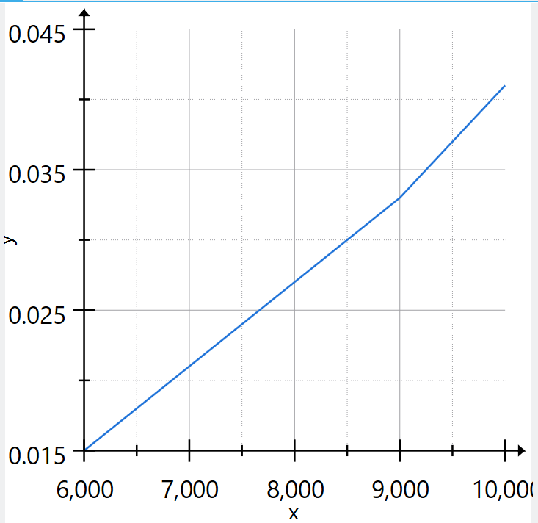

Result
The program successfully sorts the given set of random numbers using Selection Sort.
The time taken for sorting is displayed in seconds.
Experiment 10: Design and implement C/C++ Program to sort a given set of n integer elements using Quick Sort method and compute its time complexity. Run the program for varied values of n> 5000 and record the time taken to sort. Plot a graph of the time taken versus n. The elements can be read from a file or can be generated using the random number generator.

Aim:
To sort a list of elements using Quick Sort technique and measure the time taken for execution.

Theory:
Quick Sort is a divide and conquer algorithm. It selects a pivot element and partitions the array into two parts such that elements smaller than the pivot are on the left and greater elements are on the right.
The same process is repeated recursively for the subarrays until the entire array is sorted.
It is faster than simple sorting methods for large inputs.
Time complexity: O(n log n) and worst case is O(n2).
Program
#include <stdio.h>
#include <stdlib.h>
#include <time.h>
void swap(int *a,int *b){int t=*a;*a=*b;*b=t;}
int partition(int a[],int l,int h){
int p=a[h],i=l-1;
for(int j=l;j<h;j++)
if(a[j]<p) swap(&a[++i],&a[j]);
swap(&a[i+1],&a[h]);
return i+1;
}
void quickSort(int a[],int l,int h){
if(l<h){
int pi=partition(a,l,h);
quickSort(a,l,pi-1);
quickSort(a,pi+1,h);
}
}
int main(){
int n;
printf("Enter n (>5000): ");
scanf("%d",&n);
if(n<=5000) return printf("Enter >5000\n"),0;
int *a=malloc(n*sizeof(int));
if(!a) return printf("Memory error\n"),0;
srand(time(0));
for(int i=0;i<n;i++) a[i]=rand()%100000;
clock_t s=clock();
quickSort(a,0,n-1);
clock_t e=clock();
printf("Time: %f sec\n",(double)(e-s)/CLOCKS_PER_SEC);
free(a);
}

Input/Output
1.
Enter n (>5000): 10000
Time: 0.002000 sec

2.
Enter n (>5000): 20000
Time: 0.003000 sec

3.
Enter n (>5000): 30000
Time: 0.004000 sec

4.
Enter n (>5000): 40000
Time: 0.005000 sec

5.
Enter n (>5000): 50000
Time: 0.007000 sec

Graph
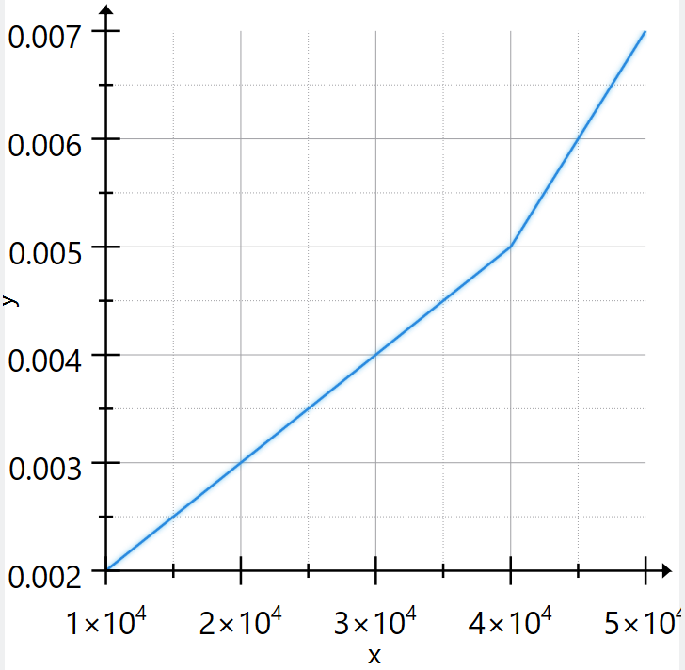

Experiment 11: Design and implement C/C++ Program to sort a given set of n integer elements using Merge Sort method and compute its time complexity. Run the program for varied values of n> 5000, and record the time taken to sort. Plot a graph of the time taken versus n. The elements can be read from a file or can be generated using the random number generator.

AIM
To implement the Merge Sort algorithm using recursion and measure its average execution time by repeatedly sorting a large array of randomly generated numbers.

THEORY
Merge Sort is a divide-and-conquer algorithm that works by recursively breaking down an array into smaller subarrays, sorting them, and then merging them back together in sorted order.
The process involves three main steps:
- Divide
The array is divided into two halves repeatedly until each subarray contains only one element.
- Conquer
Each subarray is considered sorted since it contains a single element.
- Merge
The sorted subarrays are merged in a way that results in a fully sorted array.
In this program:
- Dynamic memory allocation is used to create temporary arrays during merging.
- Random numbers are generated using rand() to simulate real input.
- The sorting process is repeated 1000 times to compute an average execution time.
- The clock() function is used to measure CPU time.
Merge Sort is a stable sorting algorithm and performs consistently well regardless of input order.

TIME COMPLEXITY
Case | Time Complexity
Best Case | O(n log n)
Average Case | O(n log n)
Worst Case | O(n log n)
- The array is divided into log n levels.
- At each level, merging takes O(n) time.
- Hence total complexity = O(n log n).
Space Complexity: O(n) (due to temporary arrays used in merging)
Program
#include <stdio.h>
#include <stdlib.h>
#include <time.h>
void merge(int a[],int l,int m,int r){
int i=l,j=m+1,k=0,*t=malloc((r-l+1)*sizeof(int));
while(i<=m && j<=r) t[k++]=a[i]<=a[j]?a[i++]:a[j++];
while(i<=m) t[k++]=a[i++];
while(j<=r) t[k++]=a[j++];
for(i=l,k=0;i<=r;i++) a[i]=t[k++];
free(t);
}
void mergeSort(int a[],int l,int r){
if(l<r){
int m=(l+r)/2;
mergeSort(a,l,m);
mergeSort(a,m+1,r);
merge(a,l,m,r);
}
}
int main(){
int n;
printf("Enter n (>5000): "); scanf("%d",&n);
if(n<=5000) return printf("Enter >5000\n"),0;
int *a=malloc(n*sizeof(int));
if(!a) return printf("Memory error\n"),0;
srand(time(0));
for(int i=0;i<n;i++) a[i]=rand()%100000;
clock_t s=clock();
for(int i=0;i<1000;i++) mergeSort(a,0,n-1);
clock_t e=clock();
printf("Time: %f sec\n",(double)(e-s)/CLOCKS_PER_SEC/1000);
free(a);
}

Input/Output
1.
Enter n (>5000): 6000
Time: 0.000407 sec

2.
Enter n (>5000): 7000
Time: 0.000434 sec

3.
Enter n (>5000): 8000
Time: 0.000490 sec

4.
Enter n (>5000): 9000
Time: 0.000567 sec

5.
Enter n (>5000): 10000
Time: 0.000633 sec

6.
Enter n (>5000): 11000
Time: 0.000703 sec

RESULT
The Merge Sort program was successfully executed for an array size greater than 5000.
Random elements were generated and sorted repeatedly. The average execution time was calculated using the system clock.
The output displays the time taken per execution, confirming that Merge Sort performs efficiently with large datasets and maintains consistent time complexity.
Graph

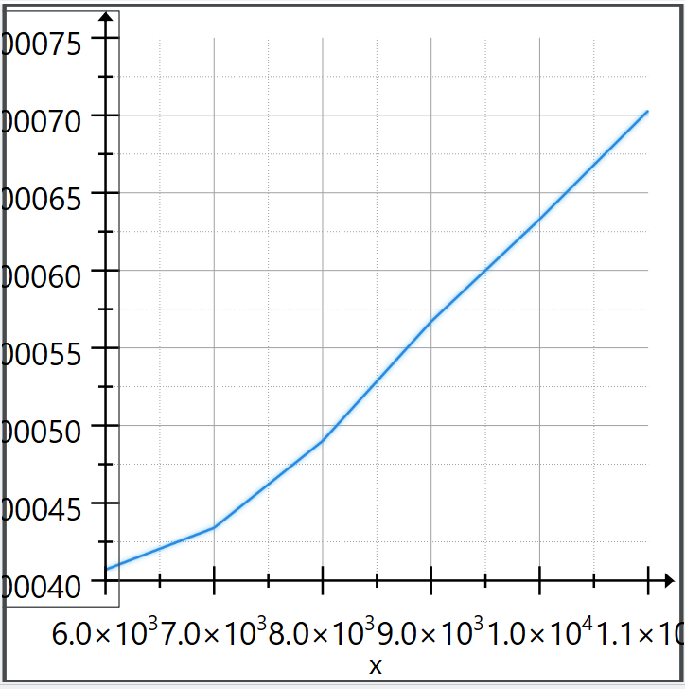

Experiment 12: Design and implement C/C++ Program for N Queen's problem using Backtracking.

Aim
To develop a C program that places N queens on an N×N chessboard such that no two queens attack each other, using the backtracking technique.

Theory
The N-Queens problem is a classical problem in computer science that demonstrates the concept of backtracking. The goal is to place N queens on a chessboard in such a way that no queen can attack another queen.
A queen can attack:
- Horizontally (same row)
- Vertically (same column)
- Diagonally (both directions)
In this program, queens are placed column by column. For each column, all possible rows are checked. Before placing a queen, the program verifies whether the position is safe by checking:
- The left side of the current row
- The upper-left diagonal
- The lower-left diagonal
If a safe position is found, the queen is placed. If placing a queen leads to a conflict later, the algorithm removes the queen (backtracks) and tries the next possible position.
This process continues until all queens are placed or all possibilities are exhausted.

Time Complexity
The time complexity of the N-Queens problem is approximately O(N!).
Due to backtracking, many invalid configurations are eliminated early, but in the worst case, the algorithm still explores a large number of possibilities.

Space Complexity
The space complexity is O(N²) due to the chessboard representation.
Additional space is used for:
- Recursive function calls → O(N) (call stack)
So overall space usage remains manageable for moderate values of N.
Program
#include <stdio.h>
#include <stdlib.h>
int isSafe(int **b,int n,int r,int c){
for(int i=0;i<c;i++) if(b[r][i]) return 0;
for(int i=r,j=c;i>=0&&j>=0;i--,j--) if(b[i][j]) return 0;
for(int i=r,j=c;i<n&&j>=0;i++,j--) if(b[i][j]) return 0;
return 1;
}
int solve(int **b,int n,int c){
if(c==n) return 1;
for(int r=0;r<n;r++){
if(isSafe(b,n,r,c)){
b[r][c]=1;
if(solve(b,n,c+1)) return 1;
b[r][c]=0; // backtrack
}
}
return 0;
}
int main(){
int n;
printf("Enter number of queens: ");
scanf("%d",&n);
int **b=malloc(n*sizeof(int*));
for(int i=0;i<n;i++) b[i]=calloc(n,sizeof(int));
if(!solve(b,n,0)) printf("No solution\n");
else
for(int i=0;i<n;i++){
for(int j=0;j<n;j++)
printf("%s ",b[i][j]?"Q":"#");
printf("\n");
}
for(int i=0;i<n;i++) free(b[i]);
free(b);
}

Input/Output
Enter number of queens: 8
Q # # # # # # #
# # # # # # Q #
# # # # Q # # #
# # # # # # # Q
# Q # # # # # #
# # # Q # # # #
# # # # # Q # #
# # Q # # # # #

Result
The program was successfully executed and a valid arrangement of N queens on the chessboard was obtained such that no two queens attack each other. The output displays the board configuration using:
- Q to represent a queen
- # to represent an empty space

II)SampleVivaQuestionsandAnswers

- Explainwhatisanalgorithmincomputing?
An algorithm is a well-defined computational procedure that take some value as input and generate some value as output. In simple words, it’s a sequence of computational steps that converts input into the output.
- Explain whatistimecomplexityofAlgorithm?
Time complexity of an algorithm indicates the total time needed by the program to run to completion.It is usually expressed by using the big O notation.
3. Themainmeasureforefficiencyalgorithmare-Timeandspace
4.Thetimecomplexityoffollowingcode:
int a = 0;
for (i = 0; i < N; i++) { for(j =N;j >i;j--) {
a =a +i+j;
}
}Ans O(n*n)
- Whatdoesthealgorithmicanalysiscount?

- Thenumberofarithmeticand theoperationsthatarerequired to run theprogram

- Examples of O(1) algorithms are A Multiplying two numbers.
Bassigningsomevaluetoa variable
Cdisplayingsomeintegeronconsole
- Examples of O(n2) algorithms are . A Adding of two Matrices
BInitializingall elementsofmatrixbyzero
- Thecomplexityofthreealgorithmsisgivenas:O(n),O(n2)andO(n3).Whichshould execute slowest for large value of n?
Allwill executein sametime.
- Inquicksort,thenumberofpartitionsintowhichthefileofsizenisdividedbya selected record is 2.
Thethreefactorscontributingtothesortefficiencyconsiderationsaretheefficiencyin coding, machine run time and the space requirement for running the procedure.
- Howmanypassesarerequiredtosortafileofsizenbybubblesortmethod? N-1

- How many number of comparisons are required in insertion sort to sort a file if the file is sorted in reverse order?
  - N2

- How many number of comparisons are required in insertion sort to sort a file if the file is already sorted? N-1

- Inquicksort,thenumberofpartitionsintowhichthefileofsizenisdividedbya selected record is 2

- Theworst-casetime complexityofQuickSort is .O(n2)

- Theworst-casetime complexityofBubbleSortis .O(n2)

- Theworst-casetimecomplexityof MergeSort is .O(nlogn)

- ThealgorithmlikeQuicksortdoesnotrequireextramemoryforcarryingoutthe sorting procedure. This technique is called .in-place

- Whichofthefollowingsortingproceduresistheslowest?
  - Quicksort
  - Heapsort
  - Shellsort
  - Bubblesort

- The time factor when determining the efficiency of algorithm is measured by Counting the number of key operations

- TheconceptoforderBigO isimportant because
  - Itcan beusedto decidethebestalgorithmthatsolvesa given problem

- Therunningtimeofinsertionsortis A.O(n^2)
- Asort which compares adjacent elements in a list and switches wherenecessary is .
  - insertion sort

- Thecorrectorderoftheefficiencyofthefollowingsortingalgorithmsaccordingtotheir overall running time comparison is
bubble>selection>insertion
- Thetotal numberof comparisonsmadeinquick sortforsorting a file ofsizen, is
  - O(n log n)

- Quicksortefficiencycanbeimprovedbyadopting
  - non-recursivemethod

- For the improvement of efficiency of quick sort the pivot can be . “the mean element”
- Whatisthetimecomplexityoflinearsearch?Θ(n)

- Whatisthetimecomplexityofbinarysearch?Θ(log2n)

- Whatisthemajorrequirementforbinarysearch?
Thegivenlistshouldbesorted.
- Whatareimportantproblemtypes?(or)Enumeratesomeimportanttypesofproblems.
1.Sorting 2.Searching
3.Numericalproblems 4.Geometricproblems
5.CombinatorialProblems 6.GraphProblems
7.StringprocessingProblems

- NamesomebasicEfficiencyclasses
1.Constant 2.Logarithmic
3.Linear 4.nlogn
5.Quadratic 6.Cubic
7.Exponential 8.Factorial

33)Whatarealgorithmdesigntechniques?
Algorithmdesigntechniques(orstrategiesorparadigms)aregeneralapproachestosolving problemsalgorithmically,applicabletoavarietyofproblemsfromdifferentareasof computing.Generaldesigntechniquesare:
(i)Bruteforce (ii)divideandconquer
(iii)decreaseandconquer (iv)transformandconcquer
(v)greedytechnique (vi)dynamicprogramming
(vii)backtracking (viii)branchandbound
34).Howisanalgorithm’stimeefficiencymeasured?
Timeefficiencyindicateshowfastthealgorithmruns.Analgorithm’stimeefficiencyis
measuredasafunctionofitsinputsizebycountingthenumberoftimesitsbasicoperation(runningtime)is executed.Basicoperationisthemosttimeconsumingoperationinthealgorithm’sinnermostloop.

35)Explainthegreedymethod.
Greedymethodisthemostimportantdesigntechnique,whichmakesachoicethatlooksbestatthatmoment.A given‘n’inputsarerequiredustoobtainasubsetthatsatisfiessomeconstraintsthatisthefeasiblesolution.A greedymethodsuggeststhatonecandeviceanalgorithmthatworksinstagesconsideringoneinputatatime.

- Definefeasibleandoptimalsolution.
Givenninputsandwearerequiredtoformasubsetsuchthatitsatisfiessomegivenconstraintsthensuchasubset iscalledfeasiblesolution.Afeasiblesolutioneithermaximizesorminimizesthegivenobjectivefunctioniscalled asoptimalsolution
- Whataretheconstraintsofknapsackproblem? Tomaximize∑pixi
Theconstraintis:∑wixi≥mand0≤xi≤11≤i≤n
wheremisthebagcapacity,nisthenumberofobjectsandforeachobjectiwiandpiaretheweightandprofitof objectrespectively.
38).SpecifythealgorithmsusedforconstructingMinimumcostspanningtree.
Prim’sAlgorithm
Kruskal’sAlgorithm

39).Statesinglesourceshortestpathalgorithm(Dijkstra’salgorithm).
Foragivenvertexcalledthesourceinaweigtedconnectedgraph,findshotrtestpathstoallits othervertices.Dijikstra’salgorithmappliestographwithnon-negativeweightsonly.
40).Stateefficiencyofprim’salgorithm.
O(|v|2)(WEIGHTMATRIXANDPRIORITYQUEUEASUNORDEREDARRAY) O(|E|LOG|V|)(ADJACENCYLISTANDPRIORITYQUEUEASMIN-HEAP)
- StateKruskalAlgorithm.
ThealgorithmlooksataMSTforaweightedconnectedgraphasanacyclicsubgraphwith|v|-1 edgesforwhichthesumofedgeweightsisthesmallest.
- StateefficiencyofDijkstra’salgorithm.
O(|v|2)(WEIGHTMATRIXANDPRIORITYQUEUEASUNORDEREDARRAY)

