Library system

System for print publishing house where people can publish/buy their products. Therefore, every user can operate with CRUD operations.

Every user has to sign up before logging in to website. After successful sign in they able to edit, delete, add books.

Also, other users able to subscribe to updates of publishers, in order to stay up to date.

Beans: BooksList(), PublisherList(), SubscriberList(), etc.

Entities: Publisher, Book, Subscriber, BookService, etc

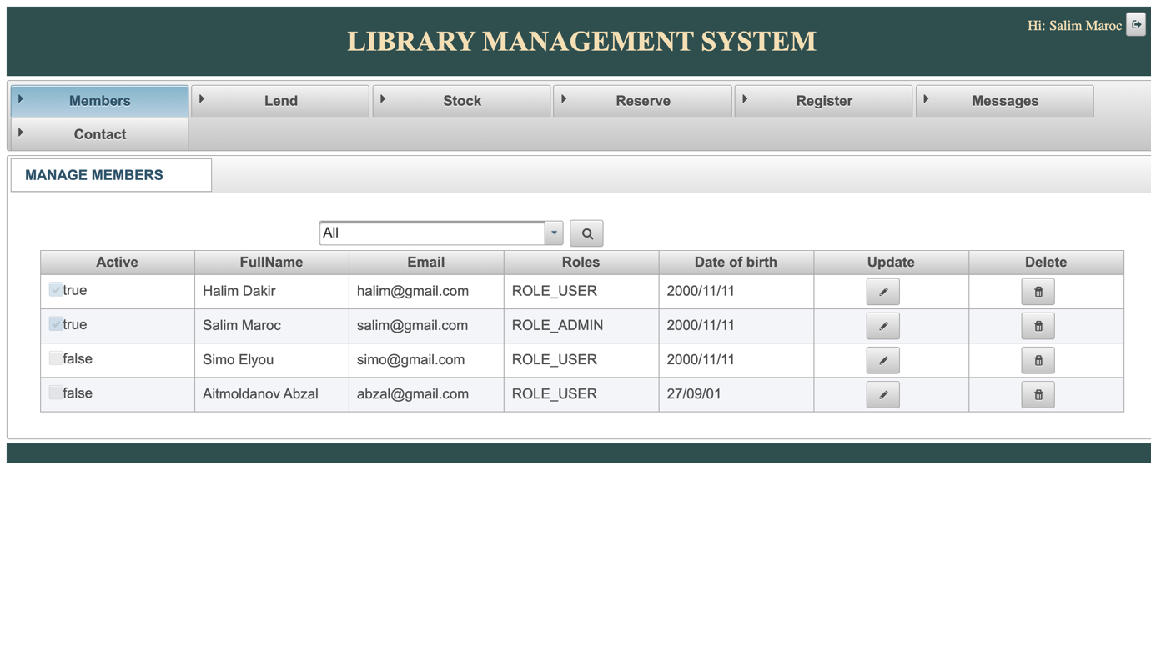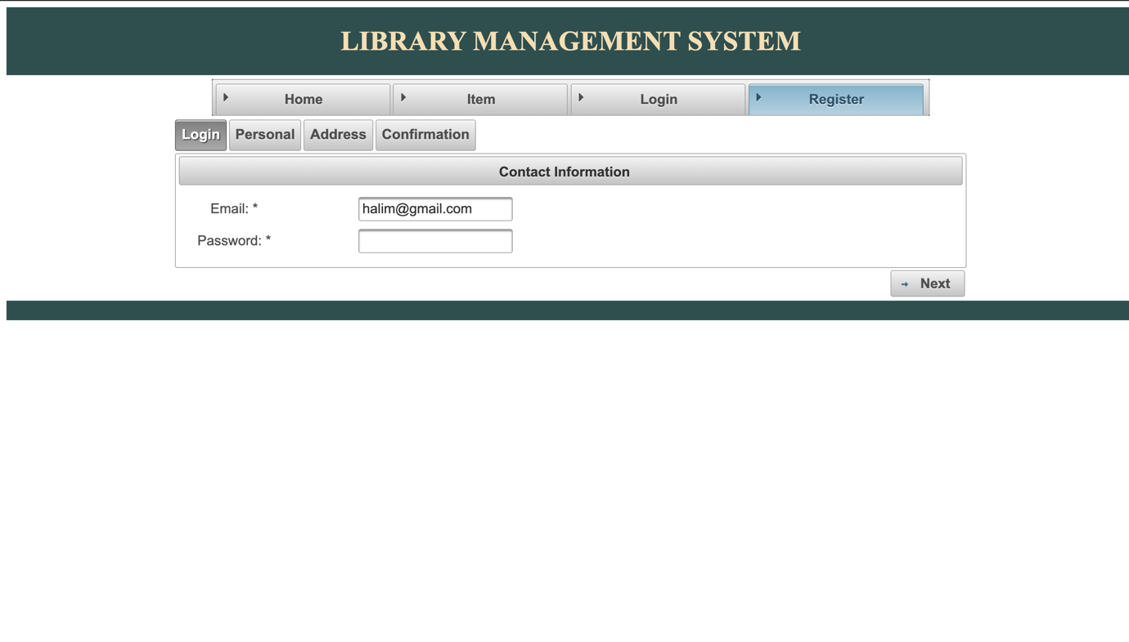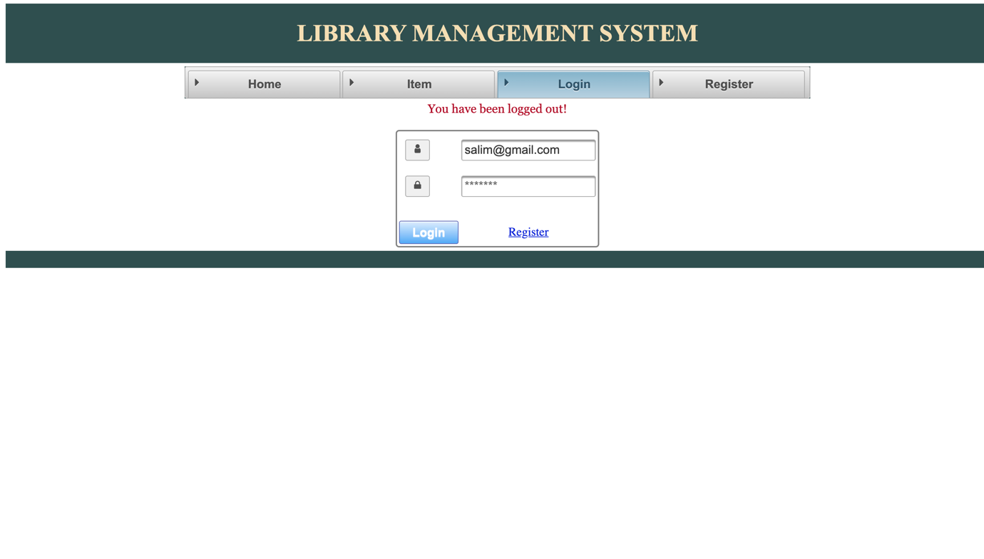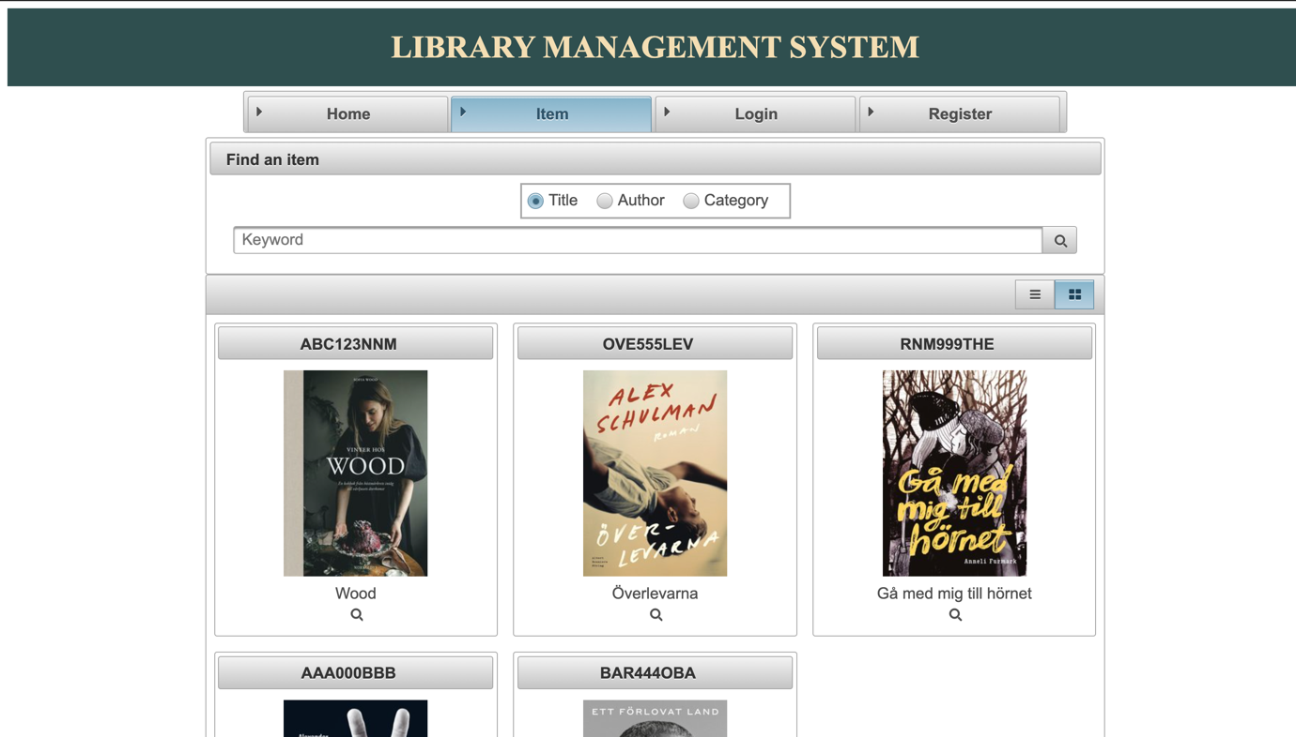

System architecture:

Í