
A security awareness tabletop role playing game

Oh no! The ironclad suitcase containing the secret recipe for the piggy bakery’s famous cake has been stolen! The trail leads to the greatest rival: The honey pot bakery. Can the players manage to steal the recipe back, before the rivals can open the suitcase?
A two-hour adventure for players interested in security and social engineering.


Idea and Production: Jessica Schumacher, Vanessa Procacci, Katja Dörlemann, Sandra Helfenstein, Frank Hauser, Oli Schacher
Illustrations: Diana Bethmann aka CHIBS

This work is licensed under a Creative Commons Attribution-ShareAlike 4.0 International License.

Introduction

Story overview
The characters are all employees of the Piggy Bakery. They learn that they might all lose their jobs, because the competing Honey Pot bakery has stolen the ironclad briefcase containing the super secret recipe of Piggy Bakery's signature cake.
They'll have to steal back the briefcase before the competitors can crack it open.
After an optional online information-gathering phase the characters drive to the honey pot bakery and use several penetration testing methods to find the hidden safe containing their briefcase.
Honey Pot is already promoting their alleged brand new cake creation. Honey Pot's employees do not know about the robbery and are just wondering why their boss, Jenny, hasn't even told them the ingredients they need to bake the new cake.
Jenny herself is currently out of office, trying to find someone to help her crack open the briefcase.

A "typical" game session could go like this:
- The characters drive to the Honey Pot bakery and try to enter the back rooms either through the front entrance or the delivery door by persuading grumpy salesman Marc or Alfred the apprentice to let them in.
- From the bakers Billy and Anna they learn, that even they haven't received the list of ingredients from their boss Jenny yet, even though they were supposed to bake the new cake by tomorrow.
- The characters sneak into the upper floors and try to persuade John the secretary to let them into Jenny's office, for example by pretending to repair her computer
- On Jenny's computer they find building plans of the honey pot bakery and determine the location of the hidden safe. The code for the safe is on the computer as well.
- They grab the briefcase and bolt (or maybe swap the real recipe with a fake one)
Of course you as a DM can adapt the story at will. Maybe in your version Jenny is present and the character pretend to be locksmiths? Or the characters enter by night and have to convince a night watch woman? Everything is possible!

Dramatis personae
More detailed descriptions are available on the character sheets
Player characters (PC):
- Max, new CEO of the Piggy Bakery. Son of Markus Piggy. Very charismatic.
- Elliot, apprentice, computer nerd.
- Kelly, baker, very athletic
- Tom, driver, very versatile
- Margrith, sales woman, most charismatic

Non player characters (NPC):
- Markus Piggy, previous CEO of the Piggy Bakery. Currently handing over the reigns to Max.
- Jenny, CEO of the honey pot bakery. Self confident, intimidating. Usually not present in the game, she is currently looking for someone to help her crack open the stolen briefcase.
- Marc, sales man. Hates his job and looking forward to retirement.
- Alfred, apprentice. Often hangs around the delivery entrance, smoking.
- Anna, baker. Eagerly awaiting the list of ingredients from Jenny's new "invention" so she can start baking
- Billy, baker, working with Anna.
- John, secretary/assistant. Works on the first floor.


Story Hook
Read the following text out loud or use your own words
Monday morning in the Piggy Bakery. Markus Piggy, the former CEO of this family owned business sits at the large kitchen table, his face in tears.
"Everything is lost! I'm afraid you'll have to look for a new job. The secret recipe for our signature cake has been stolen! And I know exactly who it was: The honey pot bakery! They have been trying for a long time to identify our secret ingredients and copy our cake. If they manage to do that, we're out of business. And it's only a matter of time before they crack open that armored briefcase. I don't know what to do! I should have protected that briefcase better!". Angry and sad he leaves the room.
Well, of course you can't just accept defeat, can you? You decide to steal the recipe back. But time is of the essence, you need to get it back before honey pot has a chance to open the armored briefase. What would you like to do?

The players may now either drive directly to the honey pot bakery or maybe gain an advantage by gathering information about the target online. (see "Information Gathering / Active Reconnaissance")

Information Gathering / Active Reconnaissance
Clever characters will try to gain information about their target before driving there, potentially even launch social engineering attacks to make their break-in easier.
On the website you can see an announcement of a brand new cake creation which should be available very soon.
On the top right, there is a login form for the intranet.
On the contacts page you see the address of the honey pot bakery with a notice "For deliveries, please drive to the back of the building". You also find phone numbers for the shop and the administrative office.
Using social engineering attacks such as phishing emails or phone calls (charisma FS 13) the characters might gain access to the intranet and also learn that nobody at honey pot knows the new recipe yet as their boss is still very secretive about it (because she wasn't able to open the briefcase yet, but the employees don't know that).
Instead of social engineering, the characters might also use technical methods such as SQL injection attacks or brute force login to gain access to the intranet (nerd FS 12).

If the characters manage to snoop around the intranet, they find information about a construction project. Apparently honey pot is planning to extend the size of several rooms. Give the players the handout with the floor plans.

Honey Pot Bakery

Outdoor Area

1 - Main Entrance
After a short drive through the city the characters reach the honey pot bakery. Let them decide where to park and how they want to approach the building.
The bakery is at the corner of the main and a side road. In front of the building there are three parking spots facing the side road. You see a small sign "delivery entrance" with an arrow pointing to the back of the building.
A large glass front provides a good view into the sales room. You smell fresh bread and a hint of sweetness.
Small stone stairs with three steps lead to the entrance. Next to the steps you see a sign saying "The cake is not a lie! Something great is coming soon(TM)!"
The entrance itself are glass sliding doors, plastered with little stickers depicting little smiling bees.
Looking into the sales room the characters notice that apparently today is a slow day. An elderly woman is paying for her bread rolls and about to leave.
If the characters already have a plan they might want to wait until either no or many customers are in the room.
The grumpy sales man Marc is always present but might be persuaded to come outside with a (charisma FS 11) or even let the characters into the back rooms if they present a plausible reason such as an urgent visit to the toilet.
(see "3 - sales room" for more information if the characters enter the sales room)

2 - Delivery Entrance
The side road turns left around the road. Above a metal door there is a small sign saying "Delivery entrance". Next to the sign there is a flickering spotlight. Next to the door attached to the wall you see a electronic keypad. In front of the door, a little to the left there is a small table and two chairs. In the ashtray on the table a cigarette is still glowing.
On the right side of the door, there are several open cardboard boxes and two waste bins, one of which is labelled "Paper", the other "Industrial waste"
From a small open window next to the waste bins you smell fresh cake.
An empty parking spot has a little metallic sign saying "Parking for management only"
Using (Athletics FS 13) the characters may climb into the waste bins and search them. They find an invoice for a safe which has been installed last week.

The keypad next to the delivery entrance can be cracked with a (Nerd FS 14). Otherwise, if the characters wait a while, the door opens and Alfred the apprentice steps out for a smoke. He can be persuaded with (charisma FS 14) to let the characters in or give out more information about the bakery.


Ground Floor

3 - Sales room
As you enter the sales room, the smell of fresh bread and cakes becomes more intensive. You see a large variety of bread, cakes, pies, rolls, muffins and croissants on display.
On the counter there is a sales terminal with touch screen, opposite a coffee machine on the back wall.
A man in his late fifties with way too much hair gel on his head is restocking a glass display with fresh sandwiches.
Above a door on the right of the counter there is a sign saying "Toilet" with an arrow pointing to the left.
To your left you see a small wooden coat rack.
In the back you see two round tables with two chairs each.
Marc the sales man tosses an unfriendly greeting towards the characters. He was hoping for some time to relax and is annoyed that he has to serve customers again.
Using (charisma FS 11) the characters can try to extract some information about the bakery or persuade Marc to let them in to the back rooms if they can come up with a good reason (such as an urgent toilet visit).
If the character look around more closely, they will also find a sign saying "Free Wifi: Password 123456"
If they connect to that wifi they may be able to access the bakery's intranet with (Nerd FS 12) and get access to the building plans. (see "Information gathering")



4 - Hallway
Through the door you enter a dark and ugly hallway. The flickering lights from the ceiling hardly manage to illuminate this area.
You see various doors with little metallic signs next to them: "Sales room", "Toilet", "Break Room", "Baking kitchen", "Storage", "Cold storage"
Spiral staircases at the end of the hallway lead towards the first floor.

5 - Storage
The storage room is quite dark. With the dim light coming from the hallway you see several shelves. The room smells of coffee beans.
In the shelves you see all kinds of ingredients such as flour, sugar and salt. There are card boards filled with sacks of coffee beans.
This room doesn't have special significance for the story. It might serve as a place for hiding or it could even contain the hidden safe under a lose floor board if you're pressed for time.

6 - Cold storage
The lights automatically go on as you enter this cold room. In the shelves you see milk,cream and cartons full of yeast.
This room doesn't have special significance for the story.

7 - Kitchen
Entering the kitchen you smell freshly baked cake. You see a large table in the center of the room and two smaller ones on the wall to your left. Several shelf trolleys contain large amounts of bread rolls. A older industrial washing machine is humming in the back of the room. Two small windows let a little light inside the otherwise dimly lit room. To your right there are two large ovens. Shelves on the wall are filled with dishes and tools.
In the Kitchen the characters meet Anna and Billy, the bakers. They are a little nervous as they are supposed to start baking the new cake but their boss, Jenny, still hasn't given them the list of ingredients yet.
Anna and Billy do not know that Jenny did not invent the new cake and instead has stolen it from the Piggy Bakery.

8 - Toilet
The toilet is a very small rectangular room with a frosted glass window. Apart from the toilet, a small washbasin a mirror and a waste bin, nothing is in the room.
This room can be used as a hiding spot. If it's necessary for your story, you could also place information in the waste bin, such as an invoice for tools Jenny tried to buy to break the ironclad briefcase open.

9 - Break Room
In this small kitchen you see a single hot plate, a micro wave, a washing basin and a cupboard. In the middle of the room are a small table and three cheap chairs.
In the wardrobe's lower section the characters just see dishes and cups. The upper shelf however contains a network switch and the Wifi-Access Point.
The character can connect to the network and gain access to the intranet using a (Nerd FS 11) and find the map of the bakery, see Information Gathering.




First Floor

10 - Hallway / Lounge
The spiral stairways lead to a wide, brightly lit hallway. You see four doors. The first one to the left is a glass door leading into what looks like a meeting room. Another glass door at the end of the hallway seems to lead outside to a little terrace. The remaining two doors to the left and right are made out of wood.
Next to the staircases there is a small sitting corner with two armchairs and an oval glass table, covered with baking magazines.
On the walls there are several pictures showing this building in the past. Some of them in black and white.

11 - Meeting room
A large oaken wood table stands in the center of this room, surrounded by black leather chairs. On the left there are several wall cupboards. A flip board stands in the corner of the room, next to the window.
With (Nerd FS 12) the characters can find LAN access cables under the table, giving them access to the intranet where they can find the building plans, if they haven't already. (See information gathering)
If they turn around the last page from the flip board they see the meeting notes of the last meeting. Apparently a new product is being launched which will hopefully put "PB" out of business. (where PB stands for "Piggy Beck" which can be found out with intelligence FS 11)

12 – Administration Office (John)
The administration office smells of flowers which are standing on a desk next to a computer. A printer stands on a double-doored cupboard on the left side of the room.
Next to the door, a small silver box is attached to the wall.
John the secretary is present and typing on the computer. To convince him to let them into Jenny's room or to leave the room so they can investigate his computer requires (charisma FS 13).
On his computer they can find Jenny's calendar (see Section 14).
The key to Jenny's office is in the small silver box on the wall, which requires a key itself. This key can be found in a drawer in John's desk or the players can crack the silver Box with a (nerd FS 13)

13 - Terrace
On the terrace you see a grill, a ping-pong table and a table with two benches. Two palms in the corners provide a bit of shadow.
This place can be used to lure John out of the administration office for example ("Let's go talk outside") while other members of the group search the office.

14 – CEO’s office (Jenny)
The left part of the room is dominated by a lounge area with a large couch and two armchairs. On the right side you see a large desk with a computer flat screen and keyboard on it. The right wall is covered by an immense bookshelf.
Next to the door you see an aquarium housing several clown fish.
Using an (intelligence FS 11) the characters can find the password for the PC below the keyboard, or they could use a (Nerd FS 13) to try to brute force Jenny’s password. (let them suggest a few passwords based on what they see around the office)
On the pec they find Jenny's calendar and a file called "passwords.xls" , in which they can find the pin to the hidden safe: 1-3-3-7

Jenny's calendar
Yesterday 21:00 to today, 02:00: "PB Ingredients"
Currently: Meeting with advertisement company.
In one hour: Meet locksmith

The safe is hidden behind the book shelf and can be opened with PIN 1-3-3-7. In the safe they'll find the armored briefcase.
The characters can now decide how they want to finish the story, for example running away or maybe swap the recipes in the briefcase. (Max knows the current code to open the briefcase from his father).

Debriefing
Once the recipe is recovered we can drive back to the Piggy Bakery , have a big party.. and maybe tomorrow's papers will show how bad Honey Pot's supposed product launch went...
Now let's review the pen testing/social engineering topics the characters used in their heist:
Potential topics
- Active reconnaissance (call honey pot in advance)
- Passive reconnaissance (check the website, facebook, twitter, ...)
- Mapping (watch entrance, perimeter
- Lock picking
- Telephotography
- Network access (open network access ports, wireless, ..)
- Dumpster Diving
- Tailgating
- Meeting Rooms : clean desk
- Social Engineering
- Phishing(mail) / Vishing (Voice) / Smishing (SMS)
- Impersonation
- USB Drops

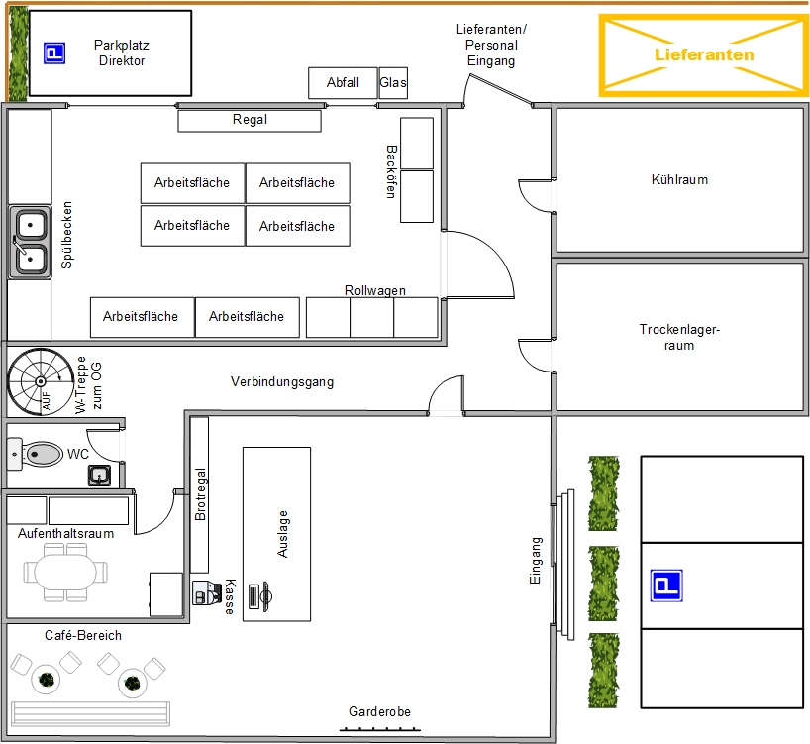
Honey Pot bakery - Ground Floor

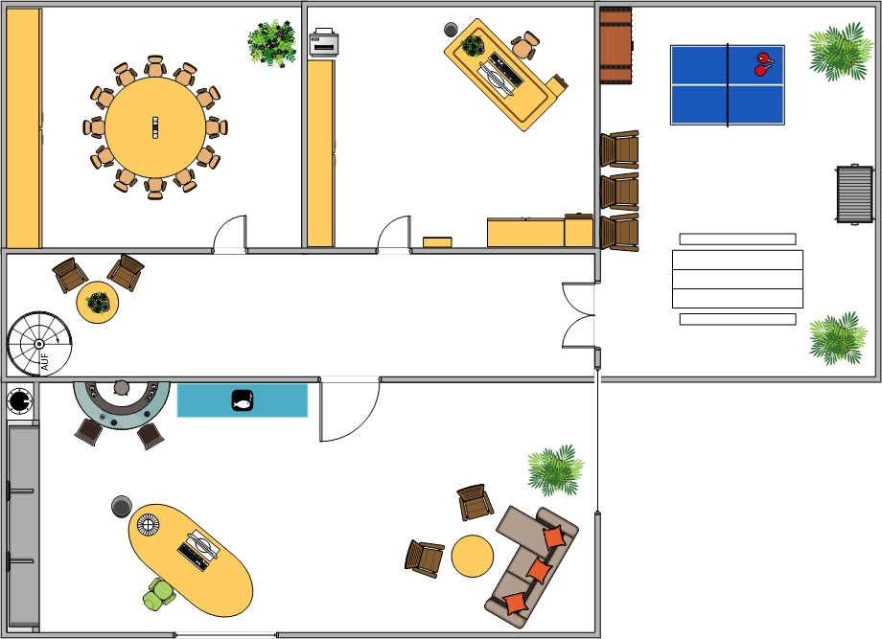
Honey Pot bakery - First Floor

