AMPS SEP Geospace Validation Campaign
Reconciled v9 - Implemented Tests, Planned Tests, Acceptance Logic, and Reference Products
26 August 2026
Scope. This revision reconciles the validation descriptions with the supplied all-test(1).tar snapshot. The archive contains 24 implemented test directories: 15 cutoff-rigidity tests (including C19) and 9 density/flux tests. Descriptions without a matching archive directory are retained as planned specifications and are labelled accordingly.
Changes in this revision. Integrated the complete C14-C19 validation descriptions into the main cutoff-rigidity campaign section so the stated C1-C19 coverage is continuous and auditable; preserved the implemented/planned distinction for C14-C19; retained the detailed C19/C19A directional-access contract; and separated the later F14-F17 density/flux additions into their own section. The v8 reconciliation corrections to the implemented-test inventory, parser/runner settings, locations, units, comparison quantities, acceptance gates, references, and seed-file mapping are retained.

1. Current archive implementation status
Archive category | Reconciled coverage
Implemented cutoff tests | C1, C2, C3, C4, C5, C6, C7, C9, C10, C11, C12, C14, C17, C18, C19
Planned cutoff descriptions | C8, C13, C15, C16, C-PARALLEL
Implemented density/flux tests | F1, F2, F3, F4, F5, F11, F12, F15, F16
Planned density/flux descriptions | F6, F7, F8, F9, F10, F13, F14, F17
Archive total | 24 test directories: 15 cutoff-rigidity and 9 density/flux
Execution evidence | Static/reference checks are documented in Appendix A; full physics execution requires the AMPS executable and source tree.

2. Common parameter conventions
The snippets below intentionally list only parameters that are essential to each validation case. All production runs should archive the complete input file, command line, code version, MPI rank count, thread count, scheduler, dynamic chunk size, random seed if any, and full diagnostic output.
# Recommended common production defaults unless a test states otherwise
MODE3D_MPI_SCHEDULER DYNAMIC
MODE3D_MPI_DYNAMIC_CHUNK 0 ! auto = 4 * workers_per_rank
GRIDLESS_MPI_SCHEDULER DYNAMIC
GRIDLESS_MPI_DYNAMIC_CHUNK 0
MODE3D_PARALLEL THREADS
MODE3D_THREADS 8
CUTOFF_SEARCH_ALGORITHM UPPER_SCAN
CUTOFF_UPPER_SCAN_N 80
DS_TRANSMISSION_MODE SCAN
DS_TRANSMISSION_SCAN_N 80
DS_TRANSMISSION_SAVE T

3. Cutoff-rigidity validation tests C1-C19 (implemented and planned)

C1. Pure dipole vertical Størmer cutoff [implemented]
Validates rigidity conversion, sign convention, vertical-arrival backtracing, and the upper-cutoff search against the analytical Størmer vertical cutoff in a centered aligned dipole.
Essential input parameters:
#NUMERICAL
MODE3D_MPI_SCHEDULER DYNAMIC
MODE3D_MPI_DYNAMIC_CHUNK 0
MODE3D_PARALLEL THREADS
MODE3D_THREADS 8
CUTOFF_SEARCH_ALGORITHM UPPER_SCAN
CUTOFF_UPPER_SCAN_N 80
#BACKGROUND_FIELD
FIELD_MODEL DIPOLE
E_FIELD OFF
#CUTOFF_RIGIDITY
CUTOFF_SAMPLING VERTICAL
CUTOFF_EMIN 1.0
CUTOFF_EMAX 20000.0
#OUTPUT_DOMAIN
OUTPUT_MODE SHELLS
SHELL_ALT_KM 500 9000
SHELL_LON_DEG 0 60 120 180 240 300
SHELL_LAT_DEG -60 -30 0 30 60
Calculation locations:
Two spherical shells at 500 km and 9000 km; longitudes 0–300° every 60°; latitudes −60°, −30°, 0°, 30°, 60°.
Expected output values / acceptance targets:
Latitude (deg) | -60 | -30 | 0 | 30 | 60
Rc, alt=500 km (GV) | 0.801 | 7.206 | 12.810 | 7.206 | 0.801
Rc, alt=9000 km (GV) | 0.160 | 1.440 | 2.560 | 1.440 | 0.160
Reference solution / comparison target:
Analytical Størmer vertical cutoff, Rc = 14.9 cos^4(lambda)/r_RE^2 GV; classical cutoff methodology in Smart & Shea and Størmer.
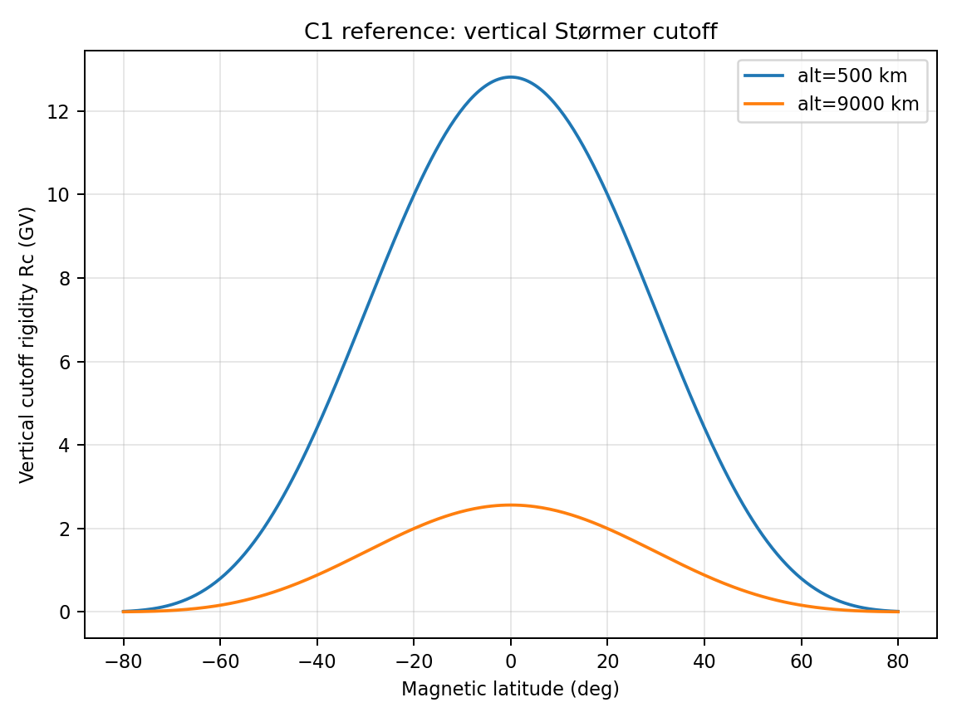
Figure C1 — Reference/target behavior for Pure dipole vertical Størmer cutoff.

C2. Dipole longitude and north/south symmetry [implemented]
Checks that the centered dipole solution is independent of longitude and symmetric about the magnetic equator when using vertical or isotropic sampling.
Essential input parameters:
#NUMERICAL
MODE3D_MPI_SCHEDULER DYNAMIC
MODE3D_MPI_DYNAMIC_CHUNK 0
MODE3D_PARALLEL THREADS
MODE3D_THREADS 8
CUTOFF_SEARCH_ALGORITHM UPPER_SCAN
CUTOFF_UPPER_SCAN_N 80
FIELD_MODEL DIPOLE
CUTOFF_SAMPLING VERTICAL
OUTPUT_MODE SHELLS
SHELL_ALT_KM 9000
SHELL_LON_DEG 0 30 60 90 120 150 180 210 240 270 300 330
SHELL_LAT_DEG -60 -30 0 30 60
Calculation locations:
One shell at 9000 km; longitude every 30°; latitudes ±60°, ±30°, and 0°.
Expected output values / acceptance targets:
Metric | Expected
max_lon(Rc)−min_lon(Rc) at fixed latitude | <1% for |latitude| <= 30 deg; <5% at |latitude| = 60 deg (runner defaults)
Rc(+lat)−Rc(−lat) | <1% at |latitude| = 30 deg; <5% at |latitude| = 60 deg (runner defaults)
Bad outcome | longitude bands or N/S asymmetry not explainable by mesh interpolation
Reference solution / comparison target:
Analytical symmetry of centered aligned dipole; use this as an internal regression before IGRF/Tsyganenko tests.
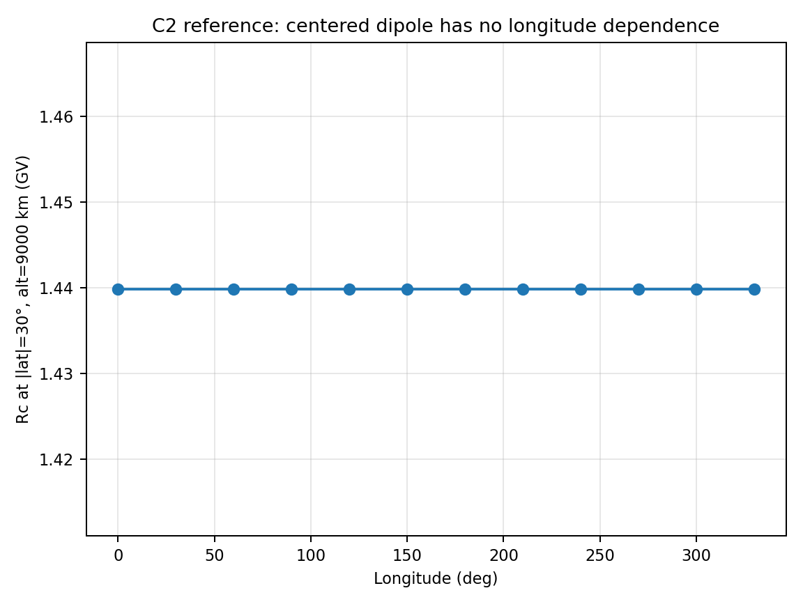
Figure C2 — Reference/target behavior for Dipole longitude and north/south symmetry.

C3. Penumbra and UPPER_SCAN regression [implemented]
Implementation status: Implemented by run_C3.py for Mode3D or GRIDLESS; BINARY is diagnostic unless --require-binary-collapse is selected.
C3 validates the penumbra-safe UPPER_SCAN search at lon 0 deg, lat -60 deg, altitude 9000 km in a centered dipole. The analytical vertical Stormer cutoff is about 0.159984 GV. CUTOFF_EMIN is 1 MeV/n, corresponding to Rmin about 0.043331 GV for a proton.
FIELD_MODEL DIPOLE
CUTOFF_SAMPLING VERTICAL
CUTOFF_SEARCH_ALGORITHM BINARY | UPPER_SCAN
CUTOFF_UPPER_SCAN_N 200
DT_TRACE 1.0 s
MAX_TRACE_TIME 600 s
MAX_TRACE_DISTANCE 300 Re
Check | Implemented default
UPPER_SCAN lower-boundary collapse | Must not return Rc < 2 Rmin.
UPPER_SCAN Stormer agreement | Absolute relative error <= 0.25 at the target high-latitude points.
BINARY behavior | Diagnostic by default; require the legacy collapse only with --require-binary-collapse.
Rc_effective | Not a C3 pass/fail quantity; effective-cutoff integration is exercised by C6/C7 PENUMBRA_SCAN.
Outputs: C3_summary.csv, C3_result.json, optional comparison plot, and per-algorithm generated inputs/logs.

C4. Mode3D trajectory-exit classifier and invariant diagnostic [implemented]
Implementation status: Implemented as a Mode3D many-trajectory debug-exit diagnostic, not a global cutoff-map test.
One AMPS run traces all requested cases from CUTOFF_DEBUG_EXIT_LIST_FILE. Defaults are latitudes -60,-30,0,30,60 deg, lon 0 deg, altitude 9000 km, and rigidities 0.5 and 2.0 times the local analytical cutoff. A mover or DT_TRACE sweep launches one run per global configuration.
FIELD_MODEL DIPOLE
E_FIELD OFF
CUTOFF_DEBUG_EXIT_TRACE T
CUTOFF_DEBUG_EXIT_LIST_FILE c4_debug_trajectories.dat
DT_TRACE 0.25 s
MOVER BORIS (default)
Check | Implemented gate
High-rigidity trajectory | Must terminate OUTER_BOX and report allowed=1.
Low-rigidity trajectory | Must not be counted as allowed; any non-OUTER_BOX reason is forbidden/diagnostic.
Rigidity conservation | |rel_dR| <= 1e-6 (hard default).
Canonical axis momentum | Recorded by default; hard only with --fail-on-paxis, tolerance 1e-5.
Outputs: C4_summary.csv, C4_case_metrics.csv, C4_result.json, and the combined cutoff_3d_debug_exit_trace.dat per mover/timestep case.

C5. Dipole mesh-interpolation convergence [implemented]
Implementation status: Implemented by run_C5.py for the Mode3D MESH field path, with an optional ANALYTIC baseline.
C5 stores the aligned dipole on the Mode3D AMR mesh and tests whether mesh-backed vertical cutoffs on the 9000 km shell approach the analytical Stormer solution under refinement. Resolution is controlled by Mode3D CLI options; there is no MESH_REFINEMENT_LEVELS input keyword and convergence is not required to be monotonic at every individual point.
Default MESH profiles (dR_Earth, dR_boundary, coarsening):
(0.20 Re, 1.00 Re, LOG)
(0.10 Re, 0.75 Re, LOG)
(0.05 Re, 0.50 Re, LOG)
CLI: -mode3d-mesh-res-earth-re, -mode3d-mesh-res-boundary-re,
-mode3d-mesh-coarsening, -mode3d-mesh-exponent, -mode3d-mesh-r-boundary-re
Gate | Default acceptance
ANALYTIC baseline | Mean relative error <=2% for |lat|<=30 deg and <=15% at |lat|>=60 deg.
Finest MESH, mid latitude | RMS and maximum mean relative error <=5%.
Finest MESH, high latitude | RMS and maximum mean relative error <=25%.
Longitude spread | Maximum spread/reference <=10%.
Coarse-to-fine convergence | Mid-latitude RMS improves by at least 5%; may be disabled explicitly with --no-convergence-gate.
Outputs: C5_latitude_summary.csv, C5_aggregate_summary.csv, C5_result.json, optional convergence plot, and one run directory per field profile.

C6. Global IGRF effective vertical-cutoff validation [implemented]
Implementation status: Implemented by run_C6.py with INITIAL, COMPLETE, and MODERN reference subtests and GRIDLESS, GRIDDED, or BOTH solver selections.
C6 compares AMPS PENUMBRA_SCAN Rc_effective_GV with published global vertical-cutoff tables. The calculation uses IGRF only at 20 km WGS-84 geodetic altitude. GRIDLESS evaluates IGRF directly; GRIDDED materializes the same epoch on the Mode3D mesh and interpolates it. No T96/T05 event driver is used.
FIELD_MODEL IGRF
SHELL_GEOMETRY GEODETIC
SHELL_ALTS_KM 20
CUTOFF_SEARCH_ALGORITHM PENUMBRA_SCAN
CUTOFF_SCAN_SPACING LINEAR
CUTOFF range 0.01-20 GV, 2000 vertices (0.01 GV spacing)
CUTOFF_BACKTRACE_CHARGE REVERSED
CUTOFF_MAX_TRAJ_TIME 600 s
Subtest | Bundled reference and coverage
INITIAL | Smart and Shea epoch 2000 table, 444 points on a 5 deg latitude x 30 deg longitude grid.
COMPLETE | CARI-7, six epochs and complete 1 deg tables (386,640 points); a coarser subset is the default calculation.
MODERN | Author-supplied Gerontidou 2015 5 deg x 15 deg grid; loaders accept authoritative 2010/2020 tables, which are not synthesized.
Metric | Default gate
Reference rows matched and valid | >=98%.
Per-point tolerance | |error| <= max(0.50 GV, 0.15*max(reference,0.25 GV)).
Point pass fraction | >=85% of valid rows.
RMSE | <=0.60 GV for each expanded epoch case.
GRIDDED convergence | Repeat at a finer near-Earth mesh and document convergence; the checked-in 0.02 Re setting is only an initial numerical profile.
Outputs: Pointwise Rc_lower/Rc_effective/Rc_upper, access-band topology, solver/mesh provenance, residual tables, command/input, and JSON summaries.

C7. IZMIRAN T96 vertical-cutoff benchmark [implemented]
Implementation status: Implemented. The standard bundled case is the 28-point IZMIRAN Cutoff2050 IGRF+T96 benchmark; GeoMagSphere files are templates/optional strict imports, not bundled authoritative results.
The default reference uses 2012-03-08T00:00:00 at 500 km geodetic altitude, latitudes -60,-45,-30,0,30,45,60 deg and east longitudes 0,90,180,270 deg. Drivers are SWDP 2 nPa, Dst -50 nT, IMF By 0 nT, and IMF Bz -5 nT. The calculator used 0.01-20 GV with 0.1 GV step and a 20 s maximum flight time.
Standard runner: run_C7_izmiran.py
FIELD_MODEL T96
MOVER RK4
CUTOFF_BACKTRACE_CHARGE REVERSED
CUTOFF_TRACE_LIMIT_POLICY FORBIDDEN
CUTOFF_UPPER_SCAN_N 400
MAX_TRACE_TIME 20 s
SOLVER GRIDLESS (default), GRIDDED, or BOTH
Comparison | Implemented rule
Lower cutoff | AMPS lower cutoff vs IZMIRAN lower cutoff.
Upper cutoff | AMPS upper cutoff vs IZMIRAN upper cutoff.
Effective cutoff | AMPS penumbra-integral Rc_effective vs IZMIRAN value labelled PENUMBRA_INTEGRAL.
Point tolerance | max(0.20 GV, 1.5*reference scan step, 10% of reference).
Group gates | Matched >=95%, valid >=95%, pass fraction >=85%, maximum judged RMSE <=0.50 GV.
Interpretation: This is an external numerical/model benchmark. Differences can also reflect IGRF versions, transforms, boundary treatment, and termination conventions.

C8. AMS-style directional access and charge reversal [planned - not in archive]
Implementation status: Planned. No C8 directory or runner is present in all-test(1).tar. The following material is a proposed validation specification, not an executed archive test.
Validates asymptotic directions, charge-sign convention, East–West effect, and directional access solid angle.
Essential input parameters:
#NUMERICAL
MODE3D_MPI_SCHEDULER DYNAMIC
MODE3D_MPI_DYNAMIC_CHUNK 0
MODE3D_PARALLEL THREADS
MODE3D_THREADS 8
CUTOFF_SEARCH_ALGORITHM UPPER_SCAN
CUTOFF_UPPER_SCAN_N 80
FIELD_MODEL T05
CUTOFF_SAMPLING DIRECTIONAL_MAP
DIRMAP_ZENITH_DEG 0 15 30 45 60
DIRMAP_AZIMUTH_DEG 0 30 60 90 120 150 180 210 240 270 300 330
CUTOFF_RIGIDITY_LIST_GV 1 2 5 10 20 50 100
SPECIES PROTON
RUN_CHARGE_REVERSAL T
Calculation locations:
ISS-like points near 400 km, inclination ±51.6°, using representative AMS-02 orbital samples.
Expected output values / acceptance targets:
Metric | Expected
R > 50 GV T96/T05 asymptotic direction difference | mrad-level
Intermediate rigidities | larger T96/T05 differences expected
East–West effect | correct sign for protons; reverses with charge sign
Access solid angle | smooth except in penumbra regions
Reference solution / comparison target:
Boschini et al. (2013), AMS-02 T96/T05 backtracing; high-rigidity asymptotic directions nearly converge and East–West effect is reproduced.
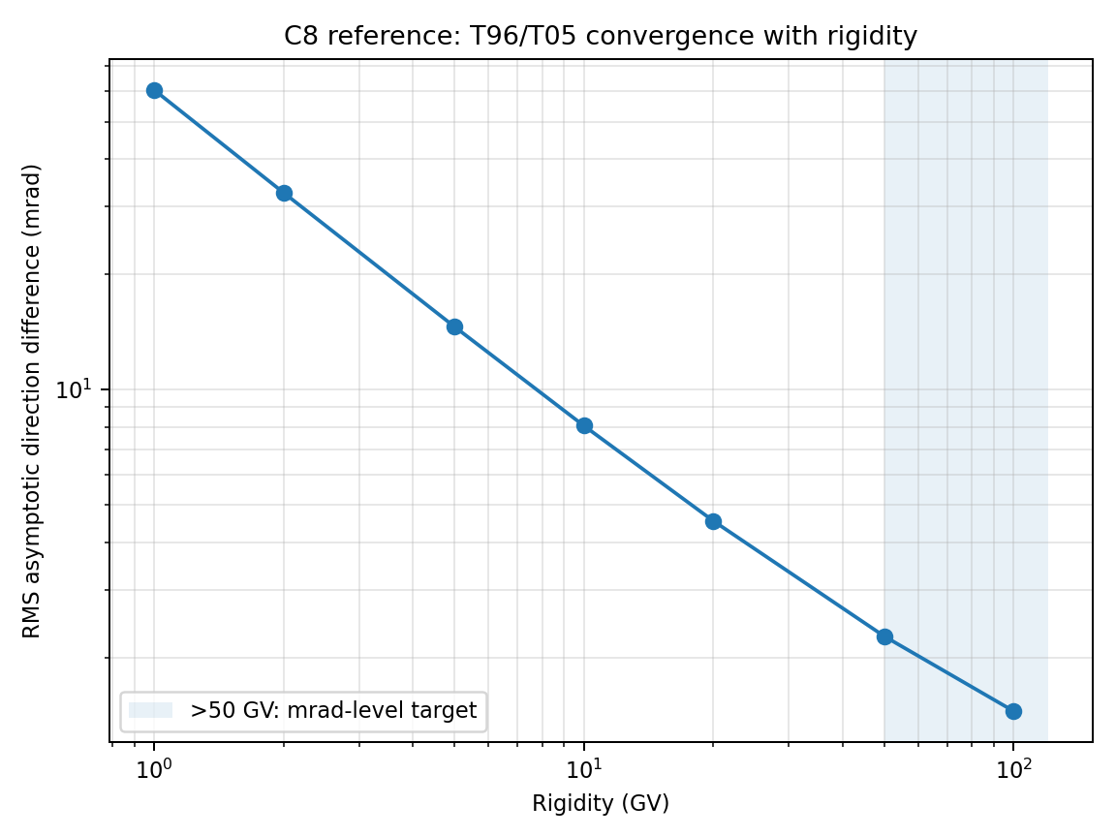
Figure C8 — Reference/target behavior for AMS-style directional access and charge reversal.

C9. PAMELA public-data global-shell cutoff-latitude validation [implemented]
C9 is the routinely executable public-data form of the December 2006 PAMELA storm test. It validates the time-dependent AMPS IGRF+T05/TS05 vertical-access boundary against the numerical AACGM cutoff latitudes in Adriani et al. (2016) Supporting Information Table S1. C9 provides two numerical products, FULL_SCAN and DIRECT_ACCESS, but both now use the same primary scientific observable: PAMELA_T50, the longitude-averaged vertical transmission T=0.5 latitude calculated separately in the north and south AACGM hemispheres. FULL_SCAN preserves the complete PENUMBRA_SCAN calculation and supports GRIDLESS direct empirical-field evaluation, GRIDDED standalone Mode3D AMR-mesh/interpolation, or both. It also saves exact access states at the seven PAMELA rigidity centers. DIRECT_ACCESS is an efficient GRIDDED-only product that traces only those seven rigidities in a selected latitude band. C9 deliberately avoids dependence on nonpublic Resurs-DK1 attitude, the PAMELA mounting matrix, and event-level track directions.
Scientific question:
Does the AMPS global vertical cutoff boundary at PAMELA altitude reproduce the rigidity dependence, equatorward storm displacement, time of minimum cutoff latitude, and recovery reported by PAMELA?
Reference data and fixed defaults:
Item | Implemented C9 definition
Observational source | Adriani et al. (2016), Space Weather, doi:10.1002/2016SW001364, Supporting Information Table S1.
Reference quantity | Magnitude of geomagnetic cutoff AACGM latitude, with asymmetric statistical uncertainties.
Reference inventory | 37 interval midpoints x 7 rigidity bins = 259 table cells; 258 numerical values and one retained missing datum.
Observation interval | Each printed UTC is the midpoint of a 94-minute PAMELA interval; start/end metadata are midpoint +/-47 minutes.
Altitude and direction | 475-km geodetic shell; vertically incident protons.
Rigidity representation | Geometric center of each published bin: 0.4236, 0.4984, 0.5879, 0.6928, 0.8170, 0.9621, and 1.1310 GV.
Magnetic field | IGRF plus T05/TS05, sampled from the bundled five-minute event driver containing Pdyn, Sym-H, IMF By/Bz, tilt, and W1-W6.
Default shell grid | 30 deg geographic longitude x 2 deg geographic latitude; both AACGM hemispheres are retained.
Products and solver branches | FULL_SCAN: complete-shell PENUMBRA_SCAN plus exact seven-rigidity access states, with GRIDLESS, GRIDDED, or BOTH. DIRECT_ACCESS: exact seven-rigidity access states within a selected latitude band, GRIDDED only. Both use PAMELA_T50 for pass/fail.
Mode3D default mesh | 0.02 Re near Earth, 2.0 Re at the boundary, LINEAR coarsening, exponent 1.0.
DIRECT_ACCESS latitude band | Default 35 <= |geodetic latitude| <= 75 deg, retaining both hemispheres and all longitudes. At 30 deg x 2 deg spacing this selects 480 of 1092 shell nodes. The band must bracket T=0.5 in both hemispheres.
Nominal work per snapshot | FULL_SCAN: 1092 x (160 regular scan values + 7 exact PAMELA values) = up to 182,364 nominal classifications before penumbra refinement. DIRECT_ACCESS: 480 x 7 = 3,360 trajectories, approximately a factor of 54 reduction.
Implemented AMPS inputs, cutoff products, and solver branches:
Common physics and shell controls:
#CALCULATION_MODE
CALC_TARGET CUTOFF_RIGIDITY
#CUTOFF_RIGIDITY
CUTOFF_SAMPLING VERTICAL
CUTOFF_BACKTRACE_CHARGE REVERSED
CUTOFF_TRACE_LIMIT_POLICY FORBIDDEN
CUTOFF_MAX_TRAJ_TIME 20.0
CUTOFF_RIGIDITY_LIST_GV <seven exact centers derived from reference CSV>
#BACKGROUND_FIELD
FIELD_MODEL T05
EPOCH <Table-S1 interval sample UTC>
DRIVER_FILE <bundled C9 five-minute TS05 driver>
#OUTPUT_DOMAIN
OUTPUT_MODE SHELLS
SHELL_ALTS_KM 475.0
SHELL_LON_RES_DEG 30.0
SHELL_LAT_RES_DEG 2.0
SHELL_GEOMETRY GEODETIC
FULL_SCAN product (backward-compatible default):
CUTOFF_SEARCH_ALGORITHM PENUMBRA_SCAN
CUTOFF_UPPER_SCAN_N 160
CUTOFF_SCAN_SPACING LINEAR
GRIDLESS raw outputs: cutoff_gridless_shells_penumbra.dat and cutoff_gridless_shells_pamela_access.dat
GRIDDED raw outputs: cutoff_3d_shells_penumbra.dat and cutoff_3d_shells_pamela_access.dat
DIRECT_ACCESS product (GRIDDED only):
CUTOFF_SEARCH_ALGORITHM RIGIDITY_LIST
CUTOFF_ACCESS_ABS_LAT_MIN 35.0
CUTOFF_ACCESS_ABS_LAT_MAX 75.0
raw output: cutoff_3d_shells_access.dat
state codes: 0=PHYSICAL_FORBIDDEN, 1=ALLOWED, 2=UNRESOLVED
Primary comparison observable:
--comparison-observable PAMELA_T50
--t50-grid-step-deg 0.25
--t50-min-resolved-longitude-fraction 0.80
GRIDLESS branch:
FIELD_EVAL_METHOD GRIDLESS
launch: -mode gridless
GRIDDED branch:
FIELD_EVAL_METHOD GRID_3D
launch: -mode 3d -mode3d-field-eval MESH -mode3d-parallel THREADS
MODE3D_MESH_RES_EARTH_RE 0.02
MODE3D_MESH_RES_BOUNDARY_RE 2.0
MODE3D_MESH_COARSENING LINEAR
MODE3D_MESH_EXPONENT 1.0
The complete numerical templates are srcEarth/test/C9/AMPS_PARAM_C9_gridless.in and srcEarth/test/C9/AMPS_PARAM_C9_mode3d.in. The runner exposes --cutoff-evaluation FULL_SCAN|DIRECT_ACCESS and --comparison-observable PAMELA_T50|RC_LOWER|RC_EFFECTIVE|RC_UPPER|ALL. PAMELA_T50 is the default and the only primary observable shared by both numerical products. During FULL_SCAN, a nonempty CUTOFF_RIGIDITY_LIST_GV requests exact companion access states without changing the regular 160-node penumbra scan or its Rc_lower/Rc_effective/Rc_upper diagnostics. DIRECT_ACCESS traces only the explicit reference rigidities and is rejected with GRIDLESS or BOTH. The seven rigidities are derived from the checked reference CSV rather than duplicated as independent constants. Every sample receives both an explicit --epoch command-line override and the same EPOCH in its generated input. The runner archives every generated input and command and prints the total number of AMPS launches before execution.
Public TS05 driver and provenance controls:
The bundled event driver is the routine C9 input. For an alternate official Tsyganenko yearly product, tools/prepare_official_ts05_driver.py copies the five-minute values without smoothing and writes the source URL, archive SHA-256, member name, and source-kind tag. The runner validates column count, monotonic UTC sequence, five-minute median cadence, maximum gap, requested-time coverage, and bundled-checksum or official provenance before execution.
C9 bundles the supplied five-minute event driver as srcEarth/test/C9/data/ts05_driving.txt. The runner uses it by default and verifies its fixed SHA-256 digest (cb3f3f1959763660beb1e26e5a49489b132708944fb91c4e1ee37cfc3a6c4317), timestamp plus 19 numerical fields, strictly increasing UTC sequence, five-minute median cadence, maximum gap, and coverage of every requested snapshot before execution.
GEO-to-AACGM postprocessing and boundary algorithm:
Step | Detailed implementation
1. Product selection | Select --cutoff-evaluation FULL_SCAN (default) or DIRECT_ACCESS and --comparison-observable PAMELA_T50 (default). FULL_SCAN supports GRIDLESS, GRIDDED, or BOTH; DIRECT_ACCESS requires GRIDDED.
2. Field snapshots | For each selected Table-S1 interval, run one midpoint snapshot by default. --interval-samples N uses N samples per selected interval and solver branch; the runner prints the total launch arithmetic before execution. The exact epoch appears in both the command and generated input.
3. AMPS raw result | FULL_SCAN writes its normal penumbra file and a companion *_pamela_access.dat file containing exact 0/1/2 states at the seven PAMELA rigidities. DIRECT_ACCESS writes cutoff_3d_shells_access.dat with the same long-form schema. Redundant allowed/unresolved flags are cross-checked.
4. AACGM conversion | Convert every retained geographic shell point at the exact snapshot UTC and 475-km altitude with the aacgmv2 G2A transformation.
5. Longitude/hemisphere profiles | For each rigidity, group rows by geographic longitude, separate north/south AACGM hemispheres, and interpolate each resolved 0/1 profile onto a common absolute-AACGM latitude grid. UNRESOLVED terminates interpolation across that segment.
6. FULL_SCAN boundary | Primary FULL_SCAN pass/fail uses the same fixed-rigidity PAMELA_T50 algorithm as DIRECT_ACCESS. Rc_lower, Rc_effective, and Rc_upper contours remain selectable diagnostics and are written together when --comparison-observable ALL is used.
7. DIRECT_ACCESS boundary | At each common AACGM latitude, compute raw transmission as the mean resolved access state across longitudes. Exclude points below the minimum resolved-longitude fraction. Fit a weighted nondecreasing transmission with the pool-adjacent-violators algorithm and interpolate T=0.5.
8. Spatial aggregation | Fit north and south independently. Require both hemispheres to bracket T=0.5, then use their median as the snapshot cutoff. Retain raw T50, isotonic adjustment RMS, coverage, unresolved fraction, north-south difference, and longitude profiles with multiple resolved state changes.
9. Temporal aggregation | For N > 1 snapshots, average the N snapshot T50 boundaries so every requested field epoch has equal weight in the 94-minute interval.
10. PAMELA comparison | Join by Table-S1 midpoint and rigidity bin; compute residuals, uncertainty-normalized residuals, RMSE, bias, correlation, storm suppression, and minimum-time error.
11. Solver/product diagnostics | Judge each selected branch independently against PAMELA. BOTH writes GRIDDED-minus-GRIDLESS. Separate FULL_SCAN and DIRECT_ACCESS PAMELA_T50 runs test method consistency; differences no longer reflect different scientific boundary definitions.
Routine, smoke, and full profiles:
Profile | Intervals and intended use
SMOKE | 14 Dec 14:31 UT and 15 Dec 03:03 UT. Fast end-to-end software and geometry check.
ROUTINE (default) | Seven representative midpoints: 14 Dec 09:49, 14:31, 16:05, 23:55; 15 Dec 03:03, 09:19; and 16 Dec 04:08 UT. Covers pre-shock, shock, early response, main phase, minimum, recovery, and late recovery. DIRECT_ACCESS is the recommended frequent GRIDDED product; FULL_SCAN remains the penumbra-reference product.
FULL | All 37 Table-S1 midpoints. Intended for publication-quality reproduction and convergence/sensitivity studies. Use multiple interval samples when computationally feasible.
Expected behavior and default acceptance:
Metric | Default C9 requirement / diagnostic
Physical sign | Cutoff latitude moves equatorward during the main phase and subsequently recovers.
Rigidity ordering | Lower-rigidity bins remain at higher cutoff latitude and exhibit larger storm displacement.
Valid comparison fraction | >= 0.85 of selected nonmissing Table-S1 observations.
Overall latitude RMSE | <= 3.0 deg.
Absolute mean bias | <= 2.0 deg.
PAMELA-AMPS correlation | >= 0.80.
Lowest-bin storm suppression | 4-9 deg; observed Table-S1 change is approximately 6.3 deg from 14 Dec 09:49 to 15 Dec 03:03 UT.
Time of lowest-bin minimum | Within 100 minutes (approximately one PAMELA orbit) of the observed 15 Dec 03:03 UT minimum.
Uncertainty diagnostics | Report weighted normalized residual and fractions inside 1-sigma and 2-sigma; do not use statistical uncertainty alone as the pass criterion.
Cross-solver diagnostic | For FULL_SCAN/BOTH, report mean, RMSE, and maximum |GRIDDED-GRIDLESS| PAMELA_T50 differences. Diagnostic only; both branches are independently compared with PAMELA.
Common-observable method diagnostic | Compare GRIDDED DIRECT_ACCESS PAMELA_T50 with GRIDDED FULL_SCAN PAMELA_T50. Differences diagnose latitude sampling and execution-path consistency; Rc contours are reported separately as scientific diagnostics.
The tolerances are wider than the PAMELA statistical errors because C9 is a global-shell public-data approximation. They include practical allowance for longitude aggregation, midpoint-only temporal sampling, one rigidity per finite bin, lack of exact spacecraft acceptance, and magnetic-field/model discretization. They no longer compensate for a FULL_SCAN-versus-DIRECT_ACCESS observable mismatch: both products use the same PAMELA_T50 algorithm. A T50 boundary is invalid when either hemisphere does not bracket T=0.5 or when resolved-longitude coverage falls below the configured threshold. Rc_lower, Rc_effective, and Rc_upper remain diagnostic products rather than substitutes for PAMELA_T50.
Commands:
# Reference and driver integrity
python3 srcEarth/test/C9/run_C9.py --validate-references --validate-driver
# Efficient GRIDDED routine regression: one midpoint per selected interval
python3 srcEarth/test/C9/run_C9.py --solver GRIDDED --cutoff-evaluation DIRECT_ACCESS --comparison-observable PAMELA_T50 --profile ROUTINE --interval-samples 1 --access-abs-lat-min-deg 35 --access-abs-lat-max-deg 75 --t50-grid-step-deg 0.25 --t50-min-resolved-longitude-fraction 0.8 --output-root test_output/C9_direct --amps /home/vtenishe/T11/AMPS/amps --shell-lon-res-deg 30 --shell-lat-res-deg 2 --dynamic-chunk 64 -np 4 -nt 16
# Complete GRIDDED penumbra scan reduced through the same PAMELA_T50 observable
python3 srcEarth/test/C9/run_C9.py --solver GRIDDED --cutoff-evaluation FULL_SCAN --comparison-observable PAMELA_T50 --profile ROUTINE --interval-samples 1 --output-root test_output/C9_full --amps /home/vtenishe/T11/AMPS/amps --cutoff-scan-n 160 --shell-lon-res-deg 30 --shell-lat-res-deg 2 --t50-grid-step-deg 0.25 --t50-min-resolved-longitude-fraction 0.8 --dynamic-chunk 64 -np 4 -nt 16
# Full scan plus Rc_lower/Rc_effective/Rc_upper diagnostic boundary files
python3 srcEarth/test/C9/run_C9.py --solver GRIDDED --cutoff-evaluation FULL_SCAN --comparison-observable ALL --profile ROUTINE --interval-samples 1 --output-root test_output/C9_all_observables --amps /home/vtenishe/T11/AMPS/amps --cutoff-scan-n 160 --dynamic-chunk 64 -np 4 -nt 16
# Five-sample diagnostic of only the observed minimum interval (five launches total)
python3 srcEarth/test/C9/run_C9.py --solver GRIDDED --cutoff-evaluation DIRECT_ACCESS --comparison-observable PAMELA_T50 --timestamps 2006-12-15T03:03:00Z --interval-samples 5 --output-root test_output/C9_0303_5samples --amps /home/vtenishe/T11/AMPS/amps --dynamic-chunk 64 -np 4 -nt 16
# Preview exact sample epochs, launch count, commands, and generated inputs
python3 srcEarth/test/C9/run_C9.py --solver GRIDDED --cutoff-evaluation DIRECT_ACCESS --comparison-observable PAMELA_T50 --profile SMOKE --interval-samples 5 --dry-run --output-root test_output/C9_direct_dry -np 4 -nt 16
Archived products:
Product | Contents
C9_reference_used.csv | Exact selected Table-S1 values, uncertainties, intervals, and rigidity centers.
C9_driver_info.json | Driver path, SHA-256, provenance, cadence, coverage, and bundled/official verification status.
C9_commands.json | Combined command inventory plus a branch-local command inventory under gridless/ and gridded/.
Per-snapshot directories | Generated input, log, explicit epoch, primary C9_snapshot_boundaries.csv, C9_snapshot_t50_profiles.csv, product-specific exact access-state file, and FULL_SCAN penumbra/diagnostic boundary files.
gridless/C9_model.csv and gridded/C9_model.csv | Branch/product-specific PAMELA_T50 latitude plus temporal scatter, north-south difference, resolved-longitude coverage, unresolved fraction, isotonic adjustment, and nonmonotonic-profile diagnostics.
Branch-local C9_comparison.csv / .png | Independent PAMELA comparison and residual plot. PAMELA and AMPS use the same color for the same rigidity; line style and marker distinguish the data source, and PAMELA uncertainties are plotted as error bars.
C9_result.json | Top-level branch summary plus selected evaluation and observable, T50 grid and coverage controls, exact rigidity list, acceptance metrics, pass/fail, driver provenance, and limitations.
Cross-solver CSV/JSON | Written only for --solver BOTH with FULL_SCAN; GRIDDED-minus-GRIDLESS point differences and summary diagnostics.
Exact access-state files | cutoff_3d_shells_access.dat for DIRECT_ACCESS; cutoff_3d_shells_pamela_access.dat and cutoff_gridless_shells_pamela_access.dat for FULL_SCAN. Every file uses one row per node/rigidity with state 0/1/2 and redundant flags.
Boundary/profile diagnostics | C9_snapshot_boundaries_pamela_t50.csv and, for FULL_SCAN/ALL, C9_snapshot_boundaries_rc_lower.csv, rc_effective.csv, and rc_upper.csv; C9_snapshot_t50_profiles.csv contains raw and isotonic transmission versus AACGM latitude.
Limitations and test hierarchy:
C9 validates the published PAMELA product without exact spacecraft geometry and must be described as a global-shell public-data comparison. FULL_SCAN and DIRECT_ACCESS now differ only in how the same seven fixed-rigidity access states are obtained; both are reduced through the identical longitude-averaged, hemisphere-resolved PAMELA_T50 postprocessor. FULL_SCAN additionally provides Rc_lower/Rc_effective/Rc_upper and penumbra-topology diagnostics. DIRECT_ACCESS retains all configured longitudes and both hemispheres but omits nodes outside its selected geodetic latitude band; the band must be widened when either hemisphere fails to bracket T=0.5. Weighted isotonic regression prevents a first low-latitude allowed island from being selected as the cutoff, while preserving raw-profile and nonmonotonic diagnostics. GRIDLESS and GRIDDED are independently judged for FULL_SCAN, and their difference diagnoses Mode3D mesh/interpolation effects. A future C9B may compare published global cutoff maps, while C9C remains the exact orbit/attitude/acceptance reproduction requiring collaboration ephemeris and pointing. Publication use should include latitude, longitude, temporal-sampling, mesh, and FULL_SCAN-versus-DIRECT_ACCESS consistency checks.
Reference solution / comparison target:
Adriani et al. (2016), main paper and Supporting Information Table S1; Tsyganenko and Sitnov (2005) for the TS05 field model; AACGM-v2 for epoch-dependent geographic-to-AACGM coordinate conversion.

Figure C9 - Target behavior: PAMELA and AMPS AACGM cutoff latitude versus time for all seven rigidity bins, with an equatorward minimum near 15 December 03:03 UT and decreasing displacement with increasing rigidity. PAMELA and AMPS use the same color for the same rigidity; dashed circles with error bars identify PAMELA and solid x-marked curves identify AMPS. The plot title records the selected observable. FULL_SCAN GRIDLESS/GRIDDED residuals diagnose mesh effects, while a DIRECT_ACCESS-versus-FULL_SCAN comparison made with PAMELA_T50 tests numerical-method consistency rather than different boundary definitions.

C10. POES/MetOp measured proton-access boundary [implemented]
Boundary feature | Expected
Primary boundary product | MLT-sector, hemisphere-resolved ACCESS_T50 from exact P6/P7 access states for the primary background-normalized code-validation gate; P8/P9 and first-harmonic morphology are diagnostic
Storm response | equatorward main-phase expansion, MLT asymmetry, north/south differences, and recovery
Comparison metrics | per-cell latitude residuals, coverage, bias/RMSE/correlation, low-rigidity expansion and timing; optional FULL_SCAN/DIRECT_ACCESS raw-state consistency
C10 is the real-measurement, constellation-scale companion to C9. It validates the storm-time low-Earth-orbit proton-access boundary against NOAA POES/MetOp SEM-2 MEPED observations during the December 2006 solar-particle event and geomagnetic storm. The test resolves the boundary by rigidity, hemisphere, UTC, and magnetic local time (MLT), and evaluates equatorward displacement, recovery, north/south behavior, and first-order MLT asymmetry.

Observed reference quantity
For each MEPED omnidirectional integral-proton channel, the production reference uses a background-normalized transmission on each inbound and outbound pass leg: Tobs=(F-Fbackground)/(Fpolar-Fbackground). Fpolar is the median valid flux above 75 deg absolute AACGM latitude, while Fbackground is estimated independently from the equatorward samples on that leg. Samples are ordered from equator to pole and fitted with a nondecreasing pool-adjacent-violators isotonic regression. The builder requires explicitly bracketed T25, T50, and T75 crossings, retains the T25-T75 transition width and isotonic RMS, and rejects insufficient-background, low-contrast, edge-clipped, excessively broad, or strongly nonmonotonic transitions. Time, position, altitude, AACGM latitude, and MLT are interpolated at fitted T50. The former direct 0.5*Fpolar threshold remains available only as the diagnostic HALF_POLAR_PLATEAU mode and cannot produce acceptance-eligible cells.
The four channels remain P6 (>16 MeV), P7 (>36 MeV), P8 (>70 MeV), and P9 (>=140 MeV), represented by nominal-threshold proton rigidities 0.174013525, 0.262395866, 0.369131538, and 0.531334344 GV. P6 and P7 are PRIMARY code-validation channels. P8 and P9 remain DIAGNOSTIC and never control PASS/FAIL until their broad integral response is forward-folded through an SEP spectrum. A robust P8/P9 diagnostic cell now requires at least two quality-eligible crossings, two pass legs, and two spacecraft. Sparse or cross-channel-outlier cells remain in the reference and detailed comparison output but are excluded from connected diagnostic means and robust diagnostic metrics.

Reference data acquisition and construction
The numerical reference cannot be reconstructed completely from journal figures or published ellipse coefficients. The publications define the method and instrument response, but the pass-level December 2006 boundaries must be extracted from the official NOAA/NCEI historical Level-2 16-second archive. Use the ASCII v01r00 products for NOAA-15, NOAA-16, NOAA-17, NOAA-18, and MetOp-02/MetOp-A. Download 5-16 December 2006 to retain pre-storm and event context; the default C10 reference window is 14 December 00:00 UT through 16 December 12:00 UT.
No-root tcsh environment setup:
cd ~/T11/AMPS/srcEarth/test/C10 && python3 -m pip install --user virtualenv && setenv PATH "${HOME}/.local/bin:${PATH}" && python3 -m virtualenv .venv && source .venv/bin/activate.csh && python -m pip install "pip<25.1" "numpy<1.25" "matplotlib<3.8" aacgmv2
Download and checksum the source files:
python download_poes_sem2.py --start 2006-12-05 --end 2006-12-16 --satellites n15,n16,n17,n18,m02 --format txt --output-dir data/reference_source
The downloader writes data/reference_source/download_manifest.json with the original URL, local path, byte count, and SHA-256 for every file. Before building the reference, list zero-byte files with "find data/reference_source -type f -size 0 -print" and remove or redownload them. The current downloader rejects zero-byte and obvious HTML/error responses; the builder skips documented empty satellite-day files but continues to fail on malformed nonempty scientific files.
Build the archive-derived reference:
python build_poes_reference.py --input-dir data/reference_source --event-start 2006-12-14T00:00:00Z --event-end 2006-12-16T12:00:00Z --crossing-method BACKGROUND_NORMALIZED_ISOTONIC --minimum-background-samples 3 --minimum-crossings-per-cell 2 --minimum-diagnostic-crossings-per-cell 2 --minimum-distinct-pass-legs-per-cell 2 --minimum-diagnostic-distinct-pass-legs-per-cell 2 --minimum-diagnostic-distinct-satellites-per-cell 2 --minimum-primary-transition-samples 2 --minimum-diagnostic-transition-samples 3 --minimum-diagnostic-contrast-to-noise 3 --p8-p9-outlier-sigma 4 --p8-p9-minimum-pairs 6 --p8-p9-fallback-max-separation-deg 6 --acceptance-window-stride-hours 2 --crossings-output C10_poes_boundary_crossings.csv --reference-output reference_C10_poes_meped_boundary.csv.gz --manifest-output C10_reference_manifest.json --summary-output C10_reference_summary.json
The required products are: (1) C10_poes_boundary_crossings.csv, one row per fitted pass-leg T50 with background, plateau, T25/T50/T75, transition width, isotonic residual, transition-support count, contrast/noise estimate, P8-minus-P9 separation, cross-channel-outlier flag, and aggregation eligibility; (2) reference_C10_poes_meped_boundary.csv.gz, schema C10_POES_T50_V3, containing acceptance_eligible, diagnostic_eligible, quality_status, independent-pass and spacecraft counts, eligible-crossing count, outlier count, and support/noise summaries; (3) C10_reference_manifest.json, containing source checksums, processing settings, and cross-channel quality statistics; and (4) C10_reference_summary.json, containing observation, crossing, robust-diagnostic, sparse-diagnostic, acceptance, coverage, and skipped-file counts. An older reference must be rebuilt. Validate with "python run_C10.py --validate-references --reference reference_C10_poes_meped_boundary.csv.gz".

AMPS cutoff-evaluation products
C10 now uses the same FULL_SCAN/DIRECT_ACCESS design as C9. FULL_SCAN performs PENUMBRA_SCAN on the complete global shell and retains Rc_lower, Rc_effective, and Rc_upper. A nonempty P6-P9 rigidity list also requests companion exact-state output. FULL_SCAN supports GRIDLESS and GRIDDED. DIRECT_ACCESS is GRIDDED-only; it selects RIGIDITY_LIST, traces only the four P6-P9 rigidities, and restricts trajectory work to the configured 45-85 deg absolute-geodetic-latitude band.
For the default 15 deg longitude by 2 deg latitude shell, DIRECT_ACCESS removes the 120-rigidity penumbra scan and most low-latitude shell nodes. The nominal trajectory count is approximately 60-70 times smaller than FULL_SCAN, although Mode3D mesh construction, field initialization, MPI startup, and multiple temporal samples remain fixed costs. For routine development, run DIRECT_ACCESS with one snapshot per two-hour observational interval first; increase --interval-samples to 5 only after the fast product is stable and time averaging is required.

Common model observable
The primary observable for both products is ACCESS_T50. Exact access states (0=forbidden, 1=allowed, 2=unresolved) are filtered to the common geodetic latitude band, converted to AACGM latitude and MLT, grouped into longitude profiles within each MLT sector and hemisphere, and sampled on a common AACGM latitude grid. The resolved allowed-state fraction is the modeled transmission. Weighted nondecreasing isotonic regression removes finite-longitude reversals; a boundary is accepted only when T=0.5 is explicitly bracketed and at least 1 deg from the retained latitude edge. This common reduction prevents FULL_SCAN and DIRECT_ACCESS from being compared through different boundary definitions. Rc_lower, Rc_effective, and Rc_upper remain FULL_SCAN-only diagnostics.

Recommended execution sequence
Fast GRIDDED routine calculation:
python run_C10.py --solver GRIDDED --cutoff-evaluation DIRECT_ACCESS --comparison-observable ACCESS_T50 --profile ROUTINE --interval-samples 1 --reference reference_C10_poes_meped_boundary.csv.gz --output-root test_output/C10_direct --amps /home/vtenishe/T11/AMPS/amps --shell-lon-res-deg 15 --shell-lat-res-deg 2 --access-abs-lat-min-deg 45 --access-abs-lat-max-deg 85 --t50-grid-step-deg 0.25 --t50-min-resolved-profile-fraction 0.66 --t50-min-edge-margin-deg 1.0 --dynamic-chunk 32 -np 8 -nt 16
Complete GRIDDED calculation and method-consistency check:
python run_C10.py --solver GRIDDED --cutoff-evaluation FULL_SCAN --comparison-observable ACCESS_T50 --profile ROUTINE --interval-samples 1 --reference reference_C10_poes_meped_boundary.csv.gz --output-root test_output/C10_full --access-consistency-root test_output/C10_direct --amps /home/vtenishe/T11/AMPS/amps --cutoff-scan-n 120 --shell-lon-res-deg 15 --shell-lat-res-deg 2 --access-abs-lat-min-deg 45 --access-abs-lat-max-deg 85 --t50-grid-step-deg 0.25 --t50-min-resolved-profile-fraction 0.66 --t50-min-edge-margin-deg 1.0 --min-access-state-agreement 0.999 --max-access-unresolved-fraction 0.01 --dynamic-chunk 32 -np 8 -nt 16
The consistency gate compares matching raw exact-rigidity classifications before AACGM conversion. A final FULL_SCAN pass requires at least 0.999 resolved-state agreement, no missing shell/rigidity keys, and an unresolved fraction no larger than 0.01. Scheduler chunk size is a work-distribution choice and is not a scientific difference. Use separate output roots because each mode has different raw filenames and computational cost.

Outputs and acceptance
Each solver branch writes C10_comparison.csv, C10_diagnostic_flags.csv, a time-series/residual figure, an observed-versus-modeled scatter plot, MLT morphology, and C10_result.json. Every plotted mean now uses exactly the same paired observation/model hemisphere-MLT rows. P8/P9 connected curves require at least two robust paired cells; sparse or cross-channel-outlier estimates are shown as open markers annotated with the paired count and are listed in C10_diagnostic_flags.csv. PASS/FAIL metrics remain restricted to background-corrected P6/P7 cells with at least two distinct pass legs on the nonoverlapping two-hour acceptance stride. C10_result.json reports robust and unfiltered per-channel metrics separately, so quality filtering cannot hide a diagnostic disagreement. The default primary gates remain valid fraction >=0.85, RMSE <=3 deg, absolute bias <=2 deg, correlation >=0.80, expansion 4-12 deg, and expansion-time error <=180 min. The runner interpolates SYM-H from column 9 of the verified C9 TS05 driver at each midpoint.
P8/P9 quality decisions are observational and independent of AMPS. For each pass leg containing both channels, the builder computes delta=|latitude_P8|-|latitude_P9| and flags an anomalously large positive separation using the larger of a median-plus-four-robust-sigma limit and a conservative 6 deg fallback when too few pairs exist. A flagged P9 crossing remains in the pass-level product but aggregate_eligible is false. The builder also records the number of samples supporting the central T20-T80 transition and a robust plateau-minus-background contrast/noise ratio. Remaining physical limitations include nominal-threshold rigidity labels rather than detector response convolution, vertical-trajectory modeling of an omnidirectional channel, detector aging, and rapidly evolving storm structure. The P6/P7 observational gate and FULL_SCAN/DIRECT_ACCESS exact-state gate preserve C10 as a useful code-validation test while P8/P9 remain transparent diagnostics.
Primary references: NOAA/NCEI POES/MetOp SEM-2 Level-2 16-second archive and format documentation; Dmitriev, Jayachandran, and Tsai, JGR Space Physics (2010), for the December 2006 half-polar-cap-flux boundary method and morphology; Yando et al. (2011) for MEPED response functions; and the C10 REFERENCES.md file for the complete ten-source dataset and processing bibliography.
Offline regression coverage: 16 tests exercise ASCII parsing, headerless input, zero-byte handling, deterministic gzip I/O, background-normalized T50 extraction, T25-T75 diagnostics, transition-support and contrast metadata, P8/P9 same-pass outlier retention, robust multi-pass/multi-satellite diagnostic eligibility, exact paired-cell averaging, sparse diagnostic flag output, driver SYM-H interpolation, primary/diagnostic metric separation, FULL_SCAN/DIRECT_ACCESS command and raw-state consistency, all plot products, and an archive-independent end-to-end --self-test.
Figure C10 - Target behavior: paired background-normalized POES/MetOp and AMPS ACCESS_T50 cutoff latitude versus UTC. P6/P7 are the primary code-validation curves. Robust P8/P9 means are connected only where at least two quality-eligible paired cells exist; sparse or cross-channel-outlier values are open markers with n annotations. The residual panel uses AMPS minus POES for the same paired rows. FULL_SCAN versus DIRECT_ACCESS tests numerical-method consistency through matching exact-state classifications, while FULL_SCAN Rc contours and GRIDLESS/GRIDDED differences remain sensitivity diagnostics.

C11. Penumbra-pocket regression (BINARY Rmin-collapse defect) [implemented]
Implementation status: Implemented as a Mode3D-only debug-rigidity-scan regression.
At lon 0 deg, lat -60 deg, altitude 9000 km, C11 compares legacy BINARY and UPPER_SCAN in a centered dipole. The key unit correction is that CUTOFF_EMIN=0.05 is MeV/n, not GV. For a proton it gives Rmin about 0.0096866 GV, while the analytical vertical cutoff is about 0.159972 GV.
CUTOFF_EMIN 0.05 MeV/n
Rmin ~ 9.6866e-3 GV
CUTOFF_DEBUG_RIGIDITY_SCAN T
CUTOFF_DEBUG_SCAN_N 200
Algorithms: BINARY and UPPER_SCAN
Gate | Implemented expectation
BINARY primary point | Reproduces the legacy Rmin-collapse signature.
UPPER_SCAN | Does not collapse and agrees with Stormer within --upper-rel-tol.
Independent debug scan | Reports the same endpoint-BINARY and UPPER_SCAN behavior.
Repeat points | +60 deg and 500/9000 km are diagnostics unless --require-binary-collapse-all is used.

C12. Particle-mover cross-validation against Stormer [implemented]
Implementation status: Implemented as a GRIDLESS mover-versus-Stormer test.
Full-orbit movers BORIS, RK2, RK4, and RK6 are checked at 9000 km and 25000 km. Guiding-center movers GC2, GC4, and GC6 are hard-checked only on the 25000 km shell by default; their 9000 km results may be retained as diagnostics. The sampled latitudes are -60,-30,0,30,60 deg.
FIELD_MODEL DIPOLE
CUTOFF_SAMPLING VERTICAL
CUTOFF_EMIN 0.1 MeV/n
FULL_ORBIT shells: 9000 km and 25000 km
GUIDING_CENTER hard gate: 25000 km
MOVER BORIS | RK2 | RK4 | RK6 | GC2 | GC4 | GC6
Mover | Default relative-error tolerance vs Stormer
BORIS | 1e-3
RK2 | 5e-3
RK4 | 1e-3
RK6 | 5e-4
GC2 / GC4 / GC6 | 5e-3 at the 25000 km high shell
Cross-mover agreement | Diagnostic by default; hard only with --enforce-cross-mover.

C13. Gridless inter-rank scheduler load-balance and agreement [planned - not in archive]
Implementation status: Planned. No C13 directory or runner is present in all-test(1).tar. The following material is a proposed validation specification, not an executed archive test.
C-PARALLEL (Section 4) exercises only MODE3D_MPI_SCHEDULER on -mode 3d; it never sets GRIDLESS_MPI_SCHEDULER or runs -mode gridless, even though gridless cutoff and density/flux were rewritten in this code revision to use the identical DynamicMpiLocationScheduler RMA mechanism (srcEarth/3d/Mode3DParallel.h, reused directly by CutoffRigidityGridless.cpp and DensityGridless.cpp). This test is the gridless-mode companion to C-PARALLEL: same three-scheduler matrix, same numerical-agreement requirement, plus the load-balance measurement that motivated the rewrite in the first place (rank 0 now performs real trajectory work in gridless, where it previously only dispatched tasks).
Essential input parameters:
#NUMERICAL
GRIDLESS_MPI_SCHEDULER DYNAMIC | BLOCK_CYCLIC | STATIC
GRIDLESS_MPI_DYNAMIC_CHUNK 0 | 32 | 128
CUTOFF_SEARCH_ALGORITHM UPPER_SCAN
CUTOFF_UPPER_SCAN_N 80
FIELD_MODEL T05
TS05_DST -50.0
CUTOFF_SAMPLING ISOTROPIC
CUTOFF_MAX_PARTICLES 200
OUTPUT_MODE SHELLS
SHELL_ALT_KM 500
SHELL_LON_RES 10.0
SHELL_LAT_RES 10.0
# Run -mode gridless with nRanks = 1, 4, 8, 16 for each scheduler value above
Calculation locations:
Global 10°×10° shell at 500 km under an active T05 field, the same uneven-cost workload class (cost concentrated near the equatorial cutoff and the penumbra latitudes) used for the Mode3D load-balance figure in C-PARALLEL.
Expected output values / acceptance targets:
Diagnostic | Expected
Rc array, all three GRIDLESS_MPI_SCHEDULER values, fixed nRanks | bit-identical for DIPOLE control runs; relative difference <1e−7 for T05 (roundoff only, per the MPI_MIN/MPI_MAX reduction design in CutoffRigidityGridless.cpp)
Rc array vs nRanks (1, 4, 8, 16), DYNAMIC fixed | identical within the same 1e−7 tolerance — scheduler/rank-count choice must not change physics output
sum(all-rank tasks) reported by the post-run diagnostic | exactly equals totalTasks for every run; any mismatch is an immediate fail
Load imbalance max(rank time)/mean(rank time), GRIDLESS_MPI_SCHEDULER=DYNAMIC, 8 ranks | <1.3, matching the Mode3D C-PARALLEL target
Load imbalance, GRIDLESS_MPI_SCHEDULER=STATIC, 8 ranks | documented only; expected to be markedly worse than DYNAMIC because STATIC assigns one contiguous task block per rank
Chunk-size sensitivity (32 vs 128 vs auto) | must not change the Rc array; may change wall-clock load balance only
Reference solution / comparison target:
MPI Forum (2021) one-sided communication standard (same RMA mechanism as Mode3D); internal consistency target derived directly from the DynamicMpiLocationScheduler / MPI_MIN reduction design documented in CutoffRigidityGridless.cpp §“MPI WORK SCHEDULING” and READ.md's gridless/Mode3D scheduler section.
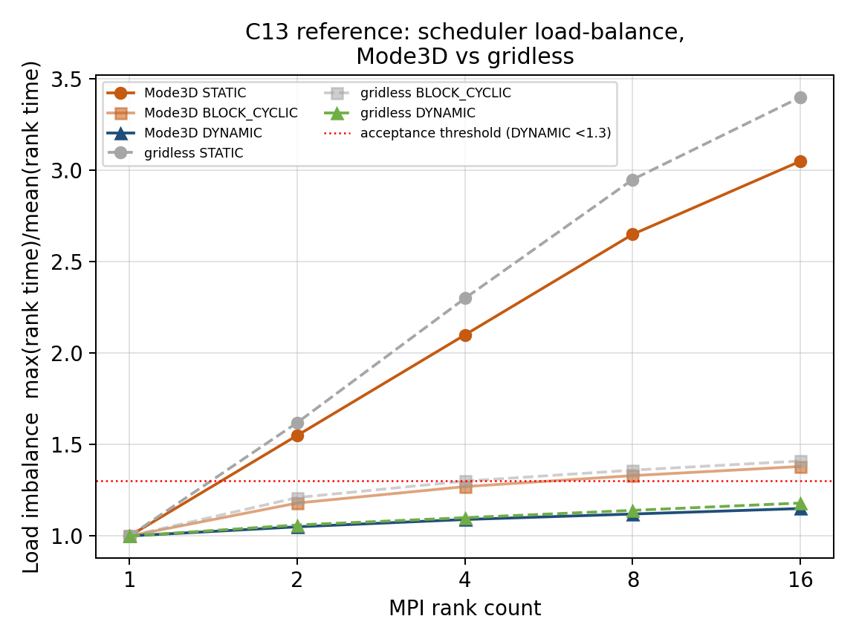
Figure C13 — Schematic load-imbalance scaling with MPI rank count for STATIC, BLOCK_CYCLIC, and DYNAMIC, shown for both Mode3D (solid) and gridless (dashed) to make explicit that the two solvers now share the same scheduler mechanism and should show the same qualitative behavior.
Tests C14-C19 extend the cutoff-rigidity campaign from the earlier analytic, observational, mover, and scheduler checks to cross-solver equivalence, time-dependent field reproducibility, termination-state closure, charge/velocity symmetry, deterministic threaded field initialization, and direct observational validation of the directional access function. C14, C17, C18, and C19 are implemented in the supplied archive; C15 and C16 remain planned specifications and must not be reported as executed tests.

C14. Mode3D versus gridless cross-solver consistency [implemented]
Implementation status: Implemented for the centered dipole only, with CROSS_SOLVER and STRICT_STORMER profiles.
C14 runs the same vertical-cutoff problem through standalone Mode3D and GRIDLESS using identical mover, search, limits, box, points, and CUTOFF_TRACE_POLICY=ACCURATE. It does not implement the previously described T05 repeat. The finite Cartesian escape box preserves 90 deg rotational groups, not arbitrary continuous longitude symmetry.
Profiles: CROSS_SOLVER (default) | STRICT_STORMER
FIELD_MODEL DIPOLE
CUTOFF_TRACE_POLICY ACCURATE
CROSS_SOLVER: half-box 35 Re, scan N=100
STRICT_STORMER: half-box 100 Re, scan N=200
Hard check | Default tolerance/role
Mode3D vs GRIDLESS | 1% mid-latitude; 5% high-latitude with ANALYTIC field, 15% with MESH.
90 deg finite-box symmetry | 3%; MESH high-latitude tolerance 15%.
North/south symmetry | 3%; MESH high-latitude tolerance 10%.
Stormer residual | Diagnostic in CROSS_SOLVER; hard only in STRICT_STORMER (5% mid, 25% high latitude).
Full-longitude invariance | Diagnostic in both profiles because a finite cube is not continuously rotationally invariant.

C15. Time-dependent T05 driver interpolation and epoch reproducibility [planned - not in archive]
Implementation status: Planned. No C15 directory or runner is present in all-test(1).tar. The following material is a proposed validation specification, not an executed archive test.
Validates time-dependent field handling separately from trajectory physics. The same epoch must produce the same cutoff map regardless of scheduler, while adjacent epochs should vary smoothly according to the driver file and FIELD_UPDATE_DT.
Essential input parameters:
#NUMERICAL
MODE3D_MPI_SCHEDULER DYNAMIC
MODE3D_MPI_DYNAMIC_CHUNK 0
MODE3D_PARALLEL THREADS
MODE3D_THREADS 8
CUTOFF_SEARCH_ALGORITHM UPPER_SCAN
CUTOFF_UPPER_SCAN_N 80
FIELD_MODEL T05
TEMPORAL_MODE TIME_SERIES
EVENT_START 2017-09-10T12:00
EVENT_END 2017-09-10T18:00
FIELD_UPDATE_DT 5
TS_INPUT_MODE FILE
TS_INPUT_FILE omni_sep2017_t05.dat
OUTPUT_MODE POINTS
POINTS_FILE c15_fixed_points.dat
CUTOFF_SAMPLING VERTICAL
Calculation locations:
Fixed points at 500 km and 9000 km: latitudes -60, -45, -30, 0, 30, 45, 60 degrees and longitudes 0, 90, 180, 270 degrees. Repeat one epoch three times to test deterministic epoch reuse.
Expected output values / acceptance targets:
Quantity / diagnostic | Expected output or acceptance target
Repeated identical epoch | Bitwise-identical results for DIPOLE and IGRF; relative difference <1e-7 for T05.
Time continuity | Rc(t) changes smoothly between adjacent 5-min driver epochs; discontinuities must correspond to actual discontinuities in the driver file.
Thread safety proxy | Changing MODE3D_PARALLEL between SERIAL and THREADS does not change results for a fixed epoch.
Archive requirement | Store the selected driver row, interpolated/held TS05 parameters, epoch, and scheduler in diagnostic output.
Reference solution / comparison target:
Tsyganenko and Sitnov [R6] define the storm-time T05 parameter dependence; Bobik et al. [R4] and Boschini et al. [R5] provide trajectory-code context for T96/T05 comparisons.
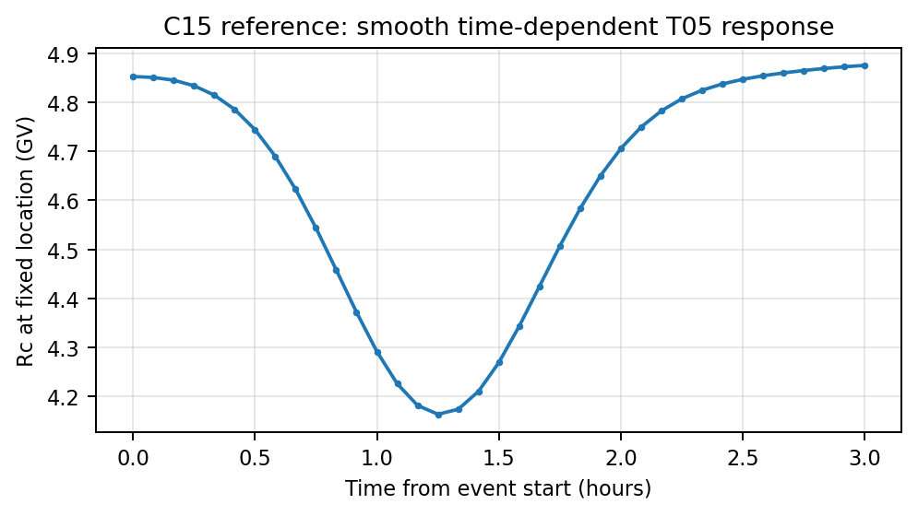
Figure C15 — Target behavior for time-dependent T05 response. Cutoff values should vary smoothly with driver time and exactly repeat for identical epochs.

C16. Exit-reason closure and boundary-classification audit [planned - not in archive]
Implementation status: Planned. No C16 directory or runner is present in all-test(1).tar. The following material is a proposed validation specification, not an executed archive test.
Ensures that the cutoff classifier does not count time-limit, step-limit, inner-boundary, invalid-cell, or numerical-failure outcomes as allowed. This is a direct guard against false access in high-latitude penumbra cases.
Essential input parameters:
#NUMERICAL
MODE3D_MPI_SCHEDULER DYNAMIC
MODE3D_MPI_DYNAMIC_CHUNK 0
CUTOFF_SEARCH_ALGORITHM UPPER_SCAN
CUTOFF_UPPER_SCAN_N 100
FIELD_MODEL DIPOLE
E_FIELD OFF
CUTOFF_DEBUG_EXIT_TRACE T
CUTOFF_DEBUG_EXIT_LON 0.0
CUTOFF_DEBUG_EXIT_LAT -60.0
CUTOFF_DEBUG_EXIT_ALT 9000.0
CUTOFF_DEBUG_EXIT_R_GV 0.16
CUTOFF_DEBUG_EXIT_N 100
CUTOFF_DEBUG_EXIT_FILE c16_exit_closure.dat
CUTOFF_MAX_TRAJ_TIME 60 300 600
Calculation locations:
Diagnostic points at latitudes -60, -30, 0, 30, 60 degrees and rigidities just below, near, and above Rc_upper. Repeat for DIPOLE and T05.
Expected output values / acceptance targets:
Quantity / diagnostic | Expected output or acceptance target
Allowed rows | 100% of allowed rows must have OUTER_BOUNDARY or the configured external escape boundary as the terminal reason.
Forbidden rows | INNER_BOUNDARY, TIME_LIMIT, STEP_LIMIT, invalid-field, or trapped classifications must remain forbidden.
Sensitivity to max trajectory time | Increasing CUTOFF_MAX_TRAJ_TIME may move ambiguous trapped/timeout samples, but must not turn non-escape reasons into allowed outcomes.
Diagnostic ratios | Report counts and percentages for every exit reason; no unclassified rows allowed.
Reference solution / comparison target:
This is a code-level trajectory-classifier closure test. It is supported by the same cutoff/penumbra concepts in Smart & Shea [R2,R3] and by trajectory-tracing practice in GeoMag/HelMod [R4].
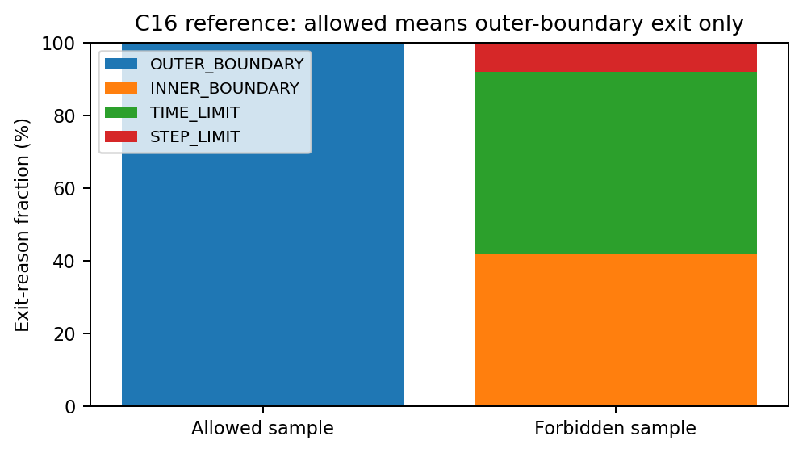
Figure C16 — Target exit-reason closure. Allowed samples should terminate only at the configured escape boundary; all other terminal reasons must remain forbidden.

C17. Dipole charge-sign and velocity-reversal symmetry [implemented]
Implementation status: Implemented as a GRIDLESS POINTS directional-map symmetry test.
The two runs use a proton and a negative proton with the same proton mass, isolating charge sign from mass/energy conversion. At five 9000 km points, the runner compares directional cutoff cells under (lon,lat) -> (lon+180 deg,-lat) and derives a step-transmission proxy at 0.1,0.2,0.5,1,2,5,10 GV. It does not consume a full saved T(R,Omega) cube.
FIELD_MODEL DIPOLE
OUTPUT_MODE POINTS
DIRECTIONAL_MAP T
DIRMAP_LON_RES 30 deg
DIRMAP_LAT_RES 30 deg
SPECIES PROTON vs NEGATIVE_PROTON (same mass)
Gate | Implemented tolerance
Directional cutoff symmetry | Absolute difference <=1e-8 GV or relative difference <=1e-6.
Derived transmission proxy | Must match at every selected rigidity.
Directional poles | Skipped by default because longitude is degenerate; optional with --include-poles.

C18. POSIX-thread deterministic background-field initialization [implemented]
Validates that temporary POSIX workers used to initialize the standalone Mode3D cell-centered background-field mesh do not change either the stored background-field values or the resulting exact-rigidity cutoff-access map. The default cutoff backend is SERIAL, so a difference is attributable to field initialization, mesh materialization, field assembly, or stale magnetic-model state rather than to the cutoff worker queue.
Implementation status: Implemented. The executable runner is srcEarth/test/C18/run_C18.py and the input template is srcEarth/test/C18/AMPS_PARAM_C18.in. The supported standalone field models are DIPOLE, IGRF, T96, and T05.
Reference strategy: No checked-in numerical reference solution is required. For each magnetic model, the runner first creates a serial field-initialization and serial-cutoff baseline with the same executable, MPI rank count, mesh, epoch, and physical input. Every POSIX-thread case is compared directly with that runtime baseline. C6, C7, C9, and C10 remain the physical validation tests for IGRF and Tsyganenko fields.
Essential input parameters:
#CALCULATION_MODE
CALC_TARGET CUTOFF_RIGIDITY
FIELD_EVAL_METHOD GRID_3D
#CUTOFF_RIGIDITY
CUTOFF_SAMPLING VERTICAL
CUTOFF_SEARCH_ALGORITHM RIGIDITY_LIST
CUTOFF_RIGIDITY_LIST_GV 0.20,0.50,1.00,2.00
CUTOFF_ACCESS_ABS_LAT_MIN 50.0
CUTOFF_ACCESS_ABS_LAT_MAX 80.0
CUTOFF_TRACE_POLICY ACCURATE
CUTOFF_BACKTRACE_CHARGE REVERSED
#BACKGROUND_FIELD
FIELD_MODEL DIPOLE | IGRF | T96 | T05
EPOCH 2006-12-15T03:05:00
DST -177.0
PDYN 2.89
IMF_BX/BY/BZ 5.31 / 11.76 / -10.50
T05_W1 ... T05_W6 fixed disturbed-state values
#MODE3D_MESH / OUTPUT
MODE3D_MESH_RES_EARTH_RE 0.50
MODE3D_MESH_RES_BOUNDARY_RE 1.50
MODE3D_MESH_COARSENING LINEAR
OUTPUT_MODE SHELLS
SHELL_ALTS_KM 850.0
SHELL_LON_RES_DEG 90.0
SHELL_LAT_RES_DEG 10.0
Execution:
# Routine regression from the AMPS repository root
python3 srcEarth/test/C18/run_C18.py --profile ROUTINE \
--amps ./amps -np 4
# Short initial check
python3 srcEarth/test/C18/run_C18.py --profile SMOKE \
--amps ./amps -np 2
# The runner launches AMPS with mpirun by default. Example parallel case:
mpirun -np 4 ./amps -mode 3d -i AMPS_PARAM_C18.in \
-mode3d-field-eval MESH -mode3d-parallel SERIAL \
-mode3d-threads N -mode3d-mpi-scheduler STATIC \
-mode3d-output-initialized -mode3d-parallel-field-init
The -mode3d-threads value is the number of temporary POSIX workers used by field initialization. The calling MPI-rank thread also performs one equal share; therefore, N workers correspond to N+1 field-initialization participants per MPI rank.
Routine calculation matrix:
DIPOLE, IGRF, T96, and T05; temporary-worker counts 1, 2, 4, 8, and 16; two independent repeats of each parallel case; four MPI ranks by default. The exact-rigidity access product is evaluated at 0.20, 0.50, 1.00, and 2.00 GV on an 850-km geodetic shell. The default serial cutoff backend isolates the field-initialization stage. --cutoff-backend THREADS is available as an optional end-to-end stress mode.
Comparison method:
The runner parses all numeric records in amps_3d_initialized*.data.dat* and cutoff_3d_shells_access*.dat*. Every finite decimal value is converted to a canonical binary64 hexadecimal representation before a SHA-256 fingerprint is calculated. Numerically identical records with different text formatting therefore match, while any represented numerical difference changes the fingerprint. The AMPS log banner is also checked to confirm the requested worker count and the additional caller participant.
Expected output values / acceptance targets:
Quantity / diagnostic | Expected output or acceptance target
AMPS execution and worker banner | Every run exits with code 0. Each parallel log reports exactly N temporary workers plus the caller, for N+1 equal shares per MPI rank.
Initialized-field fingerprint | Exact equality with the serial runtime baseline for every selected model, worker count, and repeat.
Exact-rigidity cutoff-map fingerprint | Exact equality with the serial runtime baseline; no access-state, coordinate, or represented floating-point difference is allowed.
Repeatability | Independent repeats at the same model and worker count produce identical field and cutoff fingerprints.
Reference requirement | No stored reference solution. The serial result generated during the same runner invocation is the comparison baseline.
Failure interpretation | A DIPOLE mismatch indicates a general partition/write or mesh-assembly defect; a model-specific mismatch indicates remaining shared or stale Geopack/Tsyganenko state.
Archived products:
C18_configuration.json, C18_commands.json, C18_comparison.csv, C18_result.json, C18_summary.txt, per-run AMPS_PARAM_C18.in, C18_command.json, C18_amps.log, initialized-field dumps, and exact-rigidity access maps.
Reference solution / comparison target:
Internal serial-versus-parallel equivalence. C18 is an all-or-nothing determinism test: a nonzero mismatch fraction is not accepted. Physical model accuracy is established independently by C6, C7, C9, and C10.
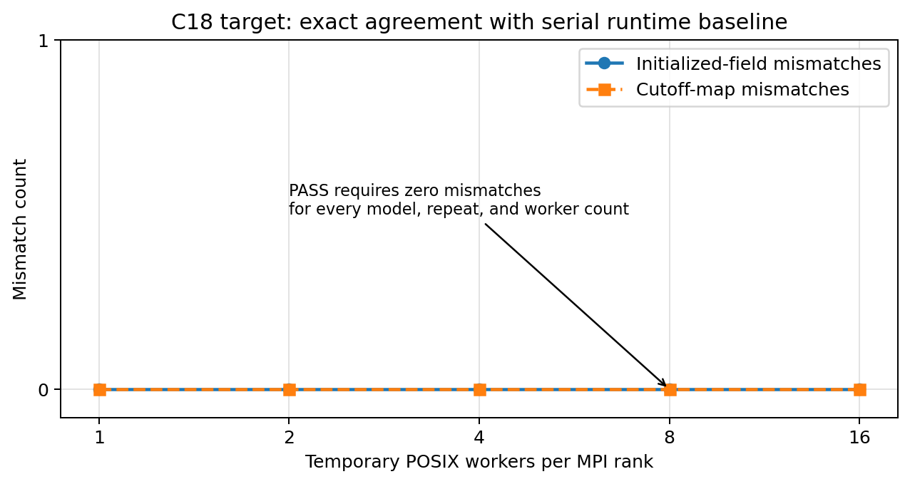
Figure C18 - Target deterministic parallel behavior. Initialized-field and cutoff-map mismatch counts must remain exactly zero for every requested POSIX-worker count.

C19 (C19A). GOES EPEAD East-West directional-access validation [implemented]
Implementation status: Implemented in srcEarth/test/C19. This is the first observational validation of the directional access function rather than only an internal symmetry or scalar-cutoff benchmark.
C19 compares the calculated detector-folded log10 physical EAST/WEST proton-flux ratio with simultaneous GOES-13 and GOES-15 EPEAD observations during the 17 May 2012 SEP/GLE71 decay. The default interval is 2012-05-17 06:00 UTC through 2012-05-18 06:00 UTC; the prompt onset is excluded because interplanetary anisotropy can mask the geomagnetic East-West effect.

C19.1 Observational and instrument definition
Item | Implemented default
Spacecraft/channels | GOES-13 and GOES-15; EPEAD P4 (15-40 MeV) and P5 (38-82 MeV).
Observation | Background-subtracted physical EAST/WEST flux ratio from public NOAA/NCEI five-minute p17ew files.
Telemetry-head mapping | May 2012 yaw mapping is explicit: GOES-13 W->physical EAST and E->physical WEST; GOES-15 W->physical WEST and E->physical EAST.
Ephemeris | Reference builder requires real one-minute NOAA orbit data by default; --require-real-ephemeris rejects nominal-slot rows in science runs.
Apertures | Nominal elliptical P4 half-angles 25 deg equatorial/45 deg north-south; P5 30 deg/60 deg.
Detector response | Piecewise energy response from epead_response_C19_uncorrected_extended.csv by default, including documented secondary high-energy components.
Source spectrum | Epoch-dependent power law fitted to physical-WEST P4/P5 by default; FILE and FIXED modes are supported.
The NOAA correction state is explicit. The reference builder does not silently fall back among UNCOR_FLUX, FLUX, and COR_FLUX, and each selected row records the exact east/west variables and correction-state labels. Detector attitude may use the historical SM proxy or exact per-head time-tagged vectors from a file. The AMPS arrival direction is converted to telescope look direction with the required minus sign; C19_direction_sense_diagnostic.csv preserves the production and legacy conventions.

C19.2 Magnetic-access calculation
GRIDDED Mode3D and GRIDLESS compute the same explicit three-state access function A(E,Omega): 0=physical forbidden, 1=allowed outer escape, 2=unresolved. GRIDDED interpolates a materialized field mesh; GRIDLESS evaluates the configured field directly. The default field list is IGRF+T96 and IGRF+T05/TS05, driven by the committed five-minute May 2012 file.
--solver GRIDDED | GRIDLESS | BOTH
--models T96,T05
--cutoff-search DIRECT_ACCESS (default) | PENUMBRA_SCAN
--dir-lon-res-deg 2.5 --dir-lat-res-deg 2.5
--direction-coverage INSTRUMENT_APERTURES
--adaptive-access-seed-points 12
--adaptive-access-guard-depth 1
--adaptive-access-max-depth 6
--dt-trace 0.25 --max-steps 500000 --max-trace-time 300
--unresolved-extension-passes 2 --unresolved-extension-factor 2
DIRECT_ACCESS traces only response-supported energies and instrument-aperture directions; per-direction midpoint guards and recursive refinement resolve state changes. --no-adaptive-access --access-energy-points 48 supplies the dense independent reference. PENUMBRA_SCAN is an explicit, more expensive diagnostic that additionally writes full lower/effective/upper cutoff topology; it does not replace the direct detector observable.

C19.3 Detector fold, uncertainty, and trajectory guardrails
The runner folds A(E,Omega) with the event spectrum, file-defined detector energy response, angular aperture, and optional bounded upstream dipole anisotropy. Resolved state changes between rigidity nodes contribute an explicit finite-grid uncertainty interval rather than a fictitious 0.5 transmission. UNRESOLVED samples remain a separate uncertainty source and are never relabelled forbidden.
Validity control | Implemented default/meaning
Aperture solid-angle coverage | >=0.95 for each detector head.
Unresolved aperture fraction | <=0.05 separately for EAST and WEST.
Discrete transition response fraction | <=0.05; exceeding it rejects a quantitative central value as under-resolved in rigidity.
Unresolved-only extensions | Two passes by default: 300 -> 600 -> 1200 s; only TIME_LIMIT/STEP_LIMIT samples are retraced.
Direct ratio bounds | Rigorous lower/upper E/W bounds are always retained; maximum accepted width is disabled by default unless explicitly configured.
Frozen-field sensitivity | Long-trace dominance is an advisory warning; long-and-still-unresolved response <=0.05 is a hard per-head guard by default.
Convergence label | Ordinary runs report NOT_TESTED; a separate convergence campaign may report PASS or FAIL.

C19.4 Staged acceptance and exit policy
C19 keeps calculated, accepted, and convergence-validated values distinct. direct_calculated_* is the finite central fold before final gates; direct_bound_midpoint_* is plotting-only when only a finite rigorous interval exists; modeled_* is the accepted science scalar. Calculated-but-unaccepted and bounds-only values remain visible diagnostics but never enter observational metrics.
Stage | PASS requirement
Execution complete | AMPS launch/output/postprocessing complete; operational failures use shell exit 2.
Trajectory resolution | Required access rows exist, per-head coverage passes, and unresolved/termination guardrails pass.
Instrument fold | Finite detector signals/bounds are produced with valid spectrum, response, aperture, orientation, and finite-grid uncertainty.
Observational validation | After earlier gates: finite modeled fraction >=0.85; correct sign >=0.90; correlation >=0.60; MAE <=0.20 log10; RMSE <=0.30 log10.
Overall | All scientific stages pass. --enforce-acceptance changes only the shell exit policy: scientific FAIL becomes exit 1.

C19.5 Reproducible commands and products
python3 srcEarth/test/C19/run_C19.py --self-test
python3 srcEarth/test/C19/run_C19.py --profile SMOKE --solver GRIDDED --models T05 --cutoff-search DIRECT_ACCESS --amps ./amps -np 4 -nt 16
python3 srcEarth/test/C19/run_C19.py --profile ROUTINE --solver BOTH --models T96,T05 --require-real-ephemeris --amps ./amps
python3 srcEarth/test/C19/run_C19.py --profile SMOKE --solver GRIDDED --cutoff-search DIRECT_ACCESS --no-adaptive-access --access-energy-points 48 --amps ./amps
Product | Contents
C19_reference_used.csv / C19_spectrum_used.csv | Selected GOES rows, detector IDs/variables/correction state, ephemeris, and epoch spectrum provenance.
C19_access_energy_grid.csv / direct access cubes | Common seed or dense energy grid and solver-native three-state A(E,Omega) values.
C19_model.csv / C19_comparison.csv | Calculated, accepted, bounds-only, and cutoff-diagnostic results with all validity flags.
C19_aperture_availability.csv / termination budget | Coverage, unresolved fractions, extension accounting, physical/numerical termination categories, and bound widths per head.
C19_access_classification_by_rigidity.csv | Stage-A allowed/forbidden/unresolved fractions and response weights on mandatory common seed rigidities.
C19_metrics.csv | Per-spacecraft and aggregate finite fraction, sign agreement, bias, MAE, RMSE, correlation, and provisional gate.
C19_result.json / C19_summary.txt / C19_commands.json | Staged status, thresholds, limitations, hashes/provenance, exact commands, failures, and plot consistency.
Plots (PNG and EPS) | Comparison, scatter/parity/residual, transmission, aperture/classification, cutoff topology, trace extension, and boundary spectrum.

C19.6 Interpretation and limitations
A passing science run supports agreement of the measured and detector-folded directional East-West ratio for this event under the documented spectrum, field, position, attitude, response, and convergence assumptions. It is not an exact count-rate validation. The default response remains factorized in energy and angle, secondary response geometry is approximate, detector-head intercalibration may remain, OBSERVED_WEST is not an independent upstream spectrum, the default upstream distribution is isotropic, and the provisional thresholds require extension to more events/yaw states.
Publication-quality use should enable real ephemeris and orientation, use an independent spectrum and calibrated energy-angle response when available, repeat adaptive-versus-dense/angular/mesh convergence on difficult epochs, and archive C19_result.json with all provenance. The extracted test-only archive does not include srcEarth/util/amps_param_parser.cpp required by the runner self-test; execute C19 inside the full AMPS source tree.

4. Additional cutoff scheduler gate: C-PARALLEL [planned - not in archive]
Implementation status: Planned. No C-PARALLEL directory or runner is present in all-test(1).tar. Treat this section as a proposed scheduler gate.
C-PARALLEL is a required gate before any event-level cutoff validation. It verifies that scheduler choice does not change the final numerical output.
# Run the identical input three times:
MODE3D_MPI_SCHEDULER DYNAMIC
MODE3D_MPI_SCHEDULER BLOCK_CYCLIC
MODE3D_MPI_SCHEDULER STATIC
# Repeat with nRanks = 1, 4, 8 and with MODE3D_PARALLEL = SERIAL, THREADS.
Diagnostic | Expected
Rc and Emin arrays | bit-identical for DIPOLE; relative difference <1e−7 for IGRF/T05
Unfilled global slots after reduction | 0
Duplicate compute-count slots | 0 if computeCount diagnostic is enabled
Load imbalance max/mean rank time | DYNAMIC target <1.3 for uneven shell maps
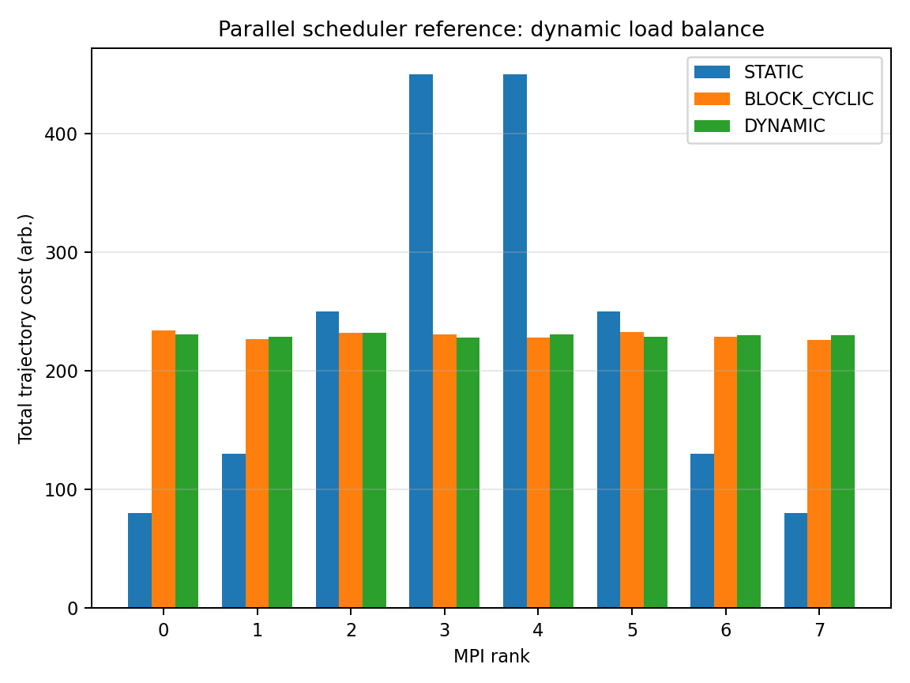
Figure C-PARALLEL — Dynamic scheduling should reduce rank-time imbalance without changing final arrays.

5. Density/flux validation tests F1-F13 (implemented and planned)

F1. Zero-field density/flux normalization [implemented]
Checks that flux and density normalization, unit conversion, angular weights, and energy weights are correct when transport is trivial.
Essential input parameters:
#BACKGROUND_FIELD
FIELD_MODEL NONE
E_FIELD OFF
#DENSITY_SPECTRUM
DS_TRANSMISSION_MODE DIRECT
SPECTRUM_TYPE POWER_LAW
SPEC_J0 1.0
SPEC_E0 10.0
SPEC_GAMMA 3.5
SPEC_EMIN 1.0
SPEC_EMAX 1000.0
DENSITY_OUTPUT_DENSITY T
DENSITY_OUTPUT_FLUX T
#NUMERICAL
MODE3D_MPI_SCHEDULER DYNAMIC
MODE3D_PARALLEL THREADS
MODE3D_THREADS 8
Calculation locations:
Ten arbitrary Cartesian or spherical points inside the domain; no boundaries should block straight-line access.
Expected output values / acceptance targets:
Quantity | Expected
J_local(E)/J_boundary(E) | 1 at all points and energies
Omnidirectional flux | 4π times directional flux for isotropic input
Density | 4π ∫ J(E)/v(E) dE
Spatial variation | zero within numerical quadrature tolerance
Reference solution / comparison target:
Analytical straight-line/no-field solution; validates normalization before magnetic access tests.
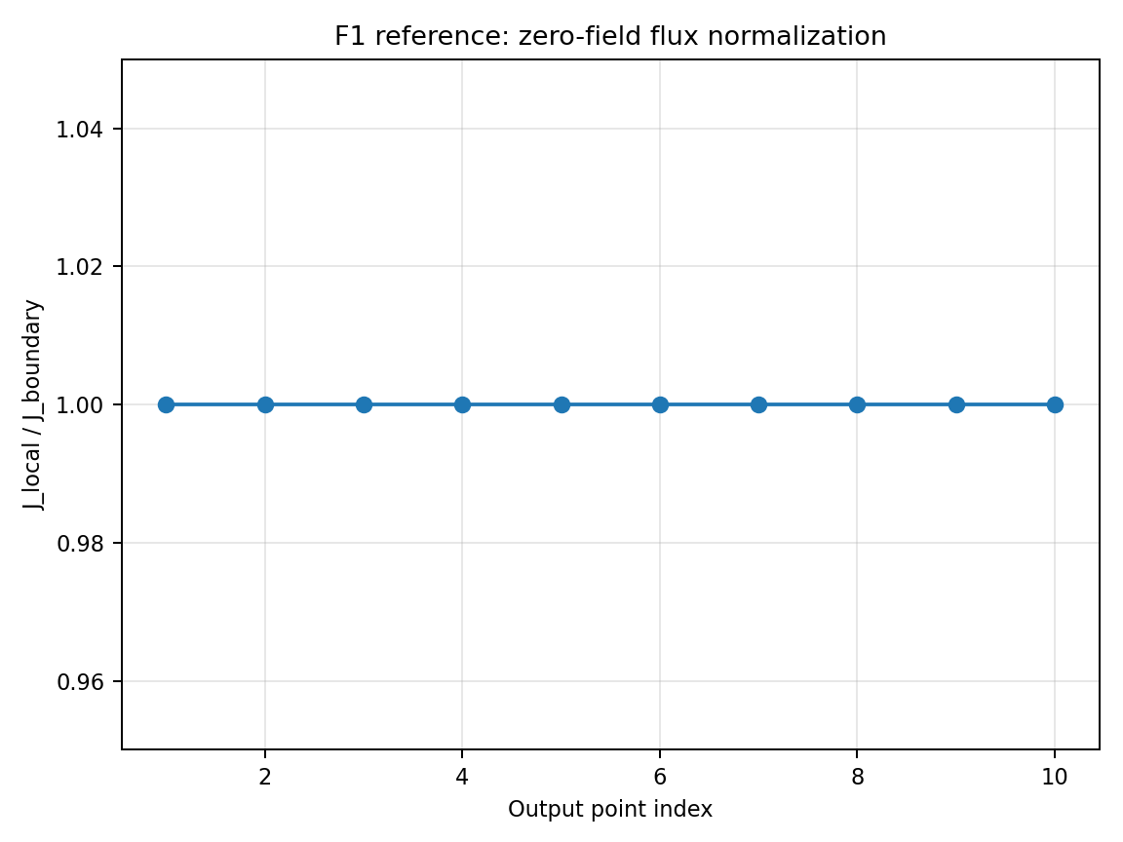
Figure F1 — Reference/target behavior for Zero-field density/flux normalization.

F2. Power-law energy integration [implemented]
Verifies the energy quadrature used for differential flux, integral flux, and density for a known analytical spectrum.
Essential input parameters:
FIELD_MODEL NONE
SPECTRUM_TYPE POWER_LAW
SPEC_J0 1.0
SPEC_E0 10.0
SPEC_GAMMA 3.5
SPEC_EMIN 1.0
SPEC_EMAX 1000.0
ENERGY_BINS 1 3 10 30 100 300 1000
DS_TRANSMISSION_MODE DIRECT
Calculation locations:
Any single point; zero-field or all-open transmission.
Expected output values / acceptance targets:
Expression | Expected
Differential spectrum | J(E)=J0(E/E0)^−γ
Integral flux above E_th | J0 E0^γ [E_th^(1−γ)−Emax^(1−γ)]/(γ−1)
Numerical error | decreases with energy-grid refinement; target <1% for production grid
Reference solution / comparison target:
Analytical power-law integration; supports later GOES/PAMELA spectral folding.
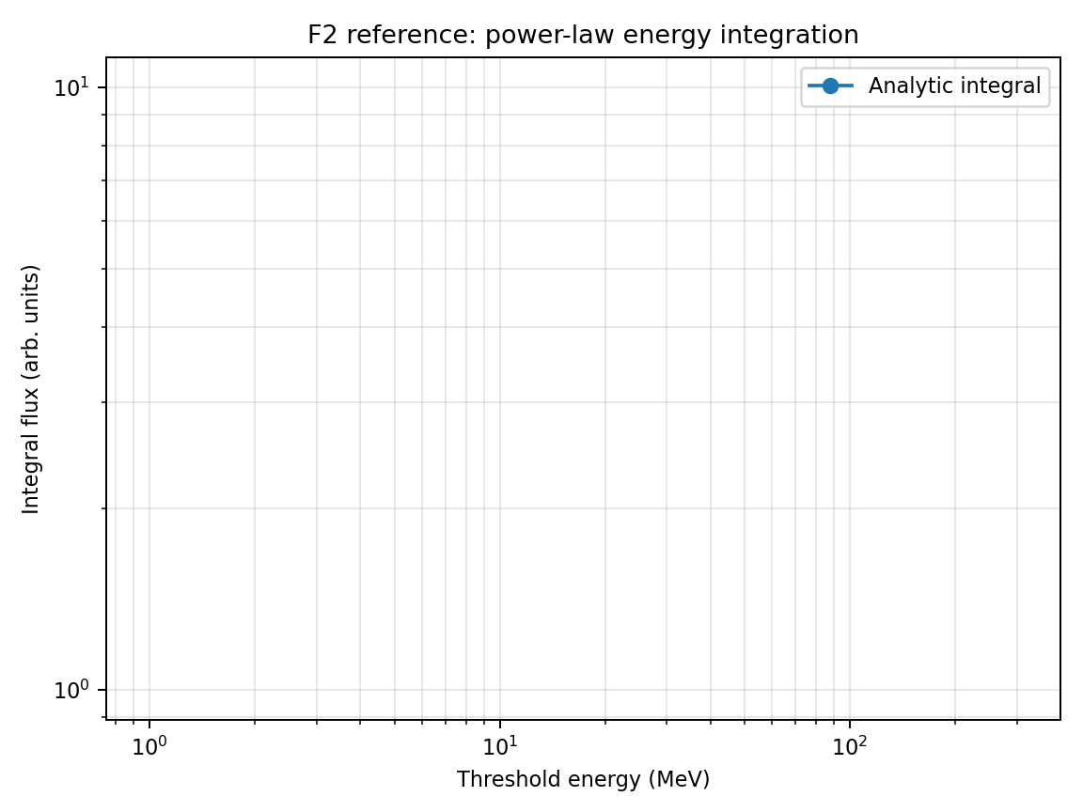
Figure F2 — Reference/target behavior for Power-law energy integration.

F3. Dipole cutoff-filtered flux [implemented]
Implementation status: Implemented by run_F3.py in GRIDLESS POINTS mode with a full directional transmission calculation.
Default points are altitude 9000 km; longitudes 0 and 90 deg; latitudes -70,-60,-45,-30,0,30,45,60,70 deg. The full profile uses 100 energy/rigidity samples and 1152 directions per energy. The --fast profile uses 12 samples, 288 directions, and five latitudes while retaining the equator, symmetry pairs, and high-latitude trend.
FIELD_MODEL DIPOLE
DS_TRANSMISSION_MODE SCAN
SPECTRUM_TYPE POWER_LAW, gamma=3.5, 1-1000 MeV
OUTPUT_MODE POINTS
Structured termination: ALLOWED, PHYSICAL_FORBIDDEN, or UNRESOLVED
Check | Implemented rule
Analytical external reference | Hard-cutoff Stormer flux with straight-line open-sky fraction; approximate, configurable tolerances.
Spectrum closure | J_local(E)=T(E)J_boundary(E); density and flux reconstruct from saved spectrum.
Symmetry/trend | Longitude and north/south symmetry; transmitted flux increases with |latitude|.
Unresolved handling | Time/step/distance/numerical limits remain unresolved, not forbidden; default unresolved fraction <=0.01.
Parallel path | MPI-only trajectory work; -nt values other than 1 are ignored explicitly.

F4. Transmission reconstruction consistency [implemented]
Implementation status: Implemented as a bounded GRIDLESS closure test, not a high-resolution production transmission calculation.
Five POINTS at longitude 0 deg, altitude 9000 km, and latitudes -60,-30,0,30,60 deg are evaluated. The routine workload is deliberately capped at 32 SCAN energies and 512 particles per point, yielding 16 directions per energy and 2,560 trajectories total.
DS_TRANSMISSION_SCAN_N 32
DS_NINTERVALS 31
DS_MAX_PARTICLES 512 per point
DS_MAX_TRAJ_TIME 120 s
MAX_TRACE_DISTANCE 300 Re
MAX_STEPS 100000
TRAP_DETECTION T
DS_RETRY_UNRESOLVED F
Closure identity | Implemented check
Boundary spectrum | Saved J_boundary matches the configured power law.
Local spectrum | J_local(E)=T(E)J_boundary(E), with T in [0,1].
Density | AMPS density equals 4*pi integral J_local(E)/v(E) dE reconstructed from the saved spectrum.
Flux | Total and named channel fluxes equal AMPS quadrature; channel edges interpolate T and evaluate J_boundary at the exact edge.
Termination | Structured unresolved outcomes are excluded from the physical denominator; no legacy Boolean relabeling.

F5. Directional anisotropy / PAD mapping [implemented]
Implementation status: Implemented for ISOTROPIC, COSALPHA_N n=2, and SINALPHA_N n=2 using parser-supported BA_PAD_MODEL/BA_PAD_EXPONENT controls.
The primary reference is the exact complementary identity sin^2(alpha)+cos^2(alpha)=1. For identical trajectories this requires T_sin+T_cos=T_iso, J_local,sin+J_local,cos=J_local,iso, and the same sum identity for density and flux. This is not a charge-reversal test.
DS_BOUNDARY_MODE ANISOTROPIC
BA_PAD_MODEL ISOTROPIC | COSALPHA_N | SINALPHA_N
BA_PAD_EXPONENT 2
Default energy range 5-50 GeV
Points: 8 Re equator, 8 Re pole, 6 Re equator
Reference | Acceptance role
Complement identity | Exact primary gate; configurable default tolerance in the runner.
High-energy straight-line ratios | Secondary semi-analytic check with looser tolerance because magnetic bending and finite-box geometry remain.
Broader PAD matrix | Covered by F11, not F5.

F6. Energy and angular quadrature convergence [planned - not in archive]
Implementation status: Planned. No F6 directory or runner is present in all-test(1).tar. The following material is a proposed validation specification, not an executed archive test.
Quantifies convergence of flux and density as energy-grid and angular-grid resolution are increased.
Essential input parameters:
FIELD_MODEL DIPOLE
DS_TRANSMISSION_MODE SCAN
ENERGY_GRID_TEST 16 32 64 128 256
ANGULAR_GRID_TEST 24 48 96 192 384
OUTPUT_MODE POINTS
POINTS lon=0 lat=-60 alt=9000
SPECTRUM_TYPE POWER_LAW
SPEC_GAMMA 3.5
Calculation locations:
Penumbra-sensitive point and a low-latitude shielded point.
Expected output values / acceptance targets:
Metric | Expected
Differential flux | converges with energy-grid refinement
Integral flux | usually smoother than differential flux
Density | most sensitive to low-energy resolution through 1/v(E)
Acceptance | successive refinements change flux/density by <2–5% for production settings
Reference solution / comparison target:
Numerical quadrature convergence test; no external observational reference required.
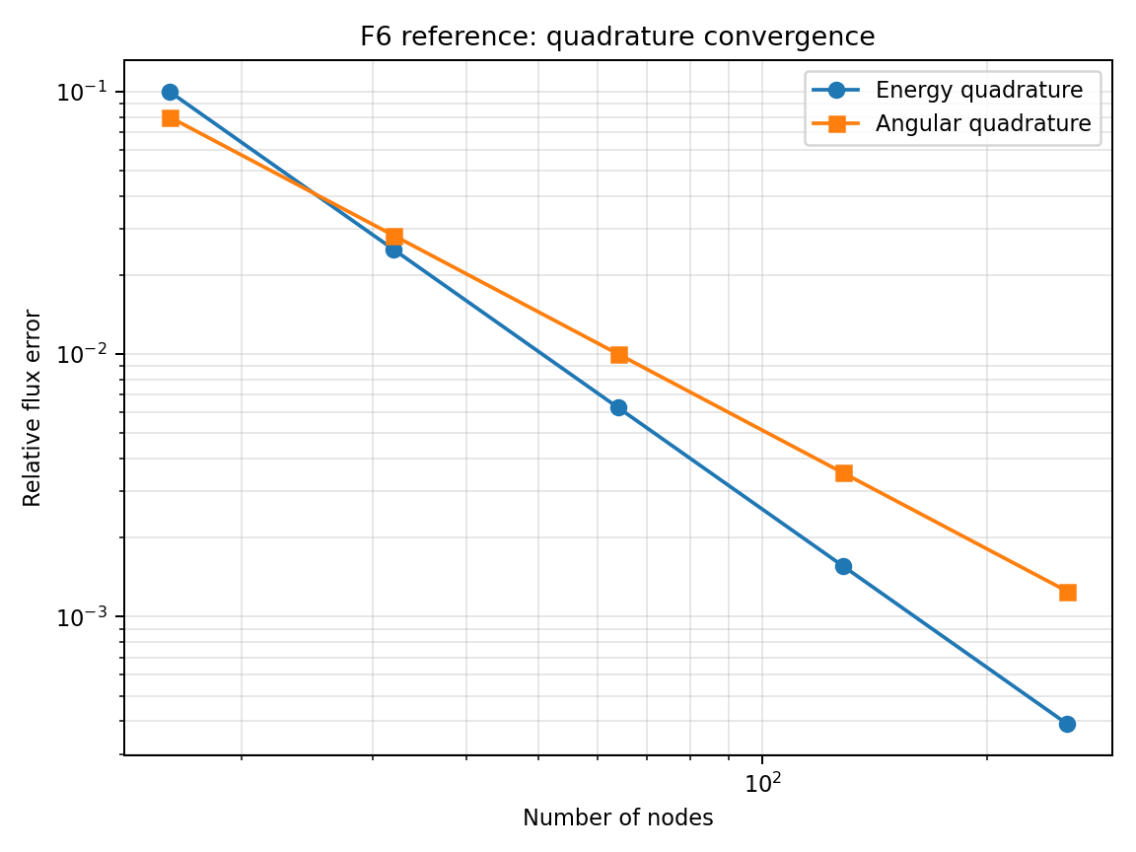
Figure F6 — Reference/target behavior for Energy and angular quadrature convergence.

F7. Parallel reproducibility and scheduler independence [planned - not in archive]
Implementation status: Planned. No F7 directory or runner is present in all-test(1).tar. The following material is a proposed validation specification, not an executed archive test.
Verifies that SERIAL, OPENMP, THREADS, MPI STATIC, MPI BLOCK_CYCLIC, and MPI DYNAMIC produce the same density/flux and transmission outputs.
Essential input parameters:
FIELD_MODEL DIPOLE
DS_TRANSMISSION_MODE SCAN
DS_TRANSMISSION_SCAN_N 80
# Run matrix:
MODE3D_PARALLEL SERIAL | OPENMP | THREADS
MODE3D_MPI_SCHEDULER STATIC | BLOCK_CYCLIC | DYNAMIC
MODE3D_MPI_DYNAMIC_CHUNK 1 | 0 | 64
GRIDLESS_MPI_SCHEDULER STATIC | BLOCK_CYCLIC | DYNAMIC
Calculation locations:
Small global shell or 100-point trajectory list with deterministic quadrature.
Expected output values / acceptance targets:
Comparison | Expected
THREADS/OPENMP vs SERIAL | max relative difference <1e−7
MPI scheduler variants | same final arrays; scheduling affects only rank ownership/time
Chunk-size scan | chunk size must not affect physics results
Load-balance metric | DYNAMIC imbalance max_rank_time/mean_rank_time <1.3 for uneven workloads
Reference solution / comparison target:
MPI Forum one-sided communication standard for RMA scheduler; internal numerical reproducibility test.
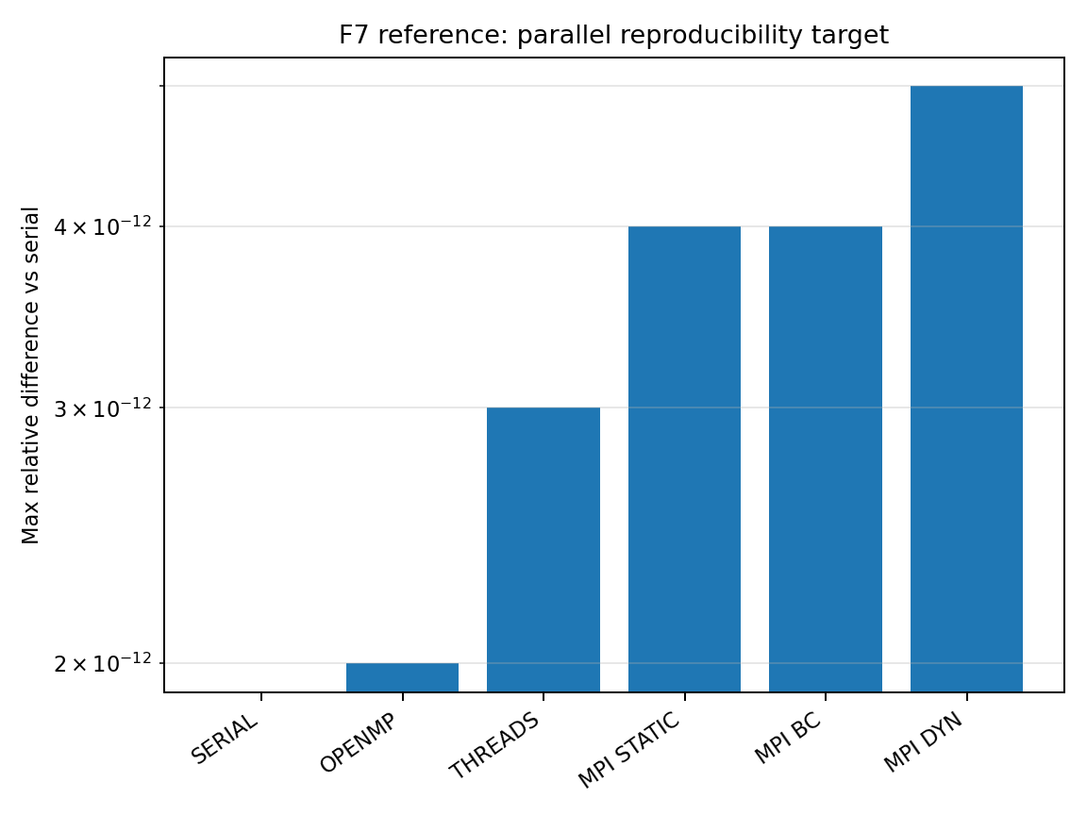
Figure F7 — Reference/target behavior for Parallel reproducibility and scheduler independence.

F8. GOES SEP flux time-series at GEO [planned - not in archive]
Implementation status: Planned. No F8 directory or runner is present in all-test(1).tar. The following material is a proposed validation specification, not an executed archive test.
Validates upstream/GEO SEP spectrum and high-altitude access using GOES proton flux channels.
Essential input parameters:
FIELD_MODEL T05
TEMPORAL_MODE TIME_SERIES
EVENT_START 2017-09-10T00:00
EVENT_END 2017-09-11T00:00
FIELD_UPDATE_DT 5
OUTPUT_MODE TRAJECTORY
TRAJ_FILE goes16_geo_track.dat
SPECTRUM_DRIVER GOES
ENERGY_BINS 10 30 50 100 300 500
DS_TRANSMISSION_MODE DIRECT
Calculation locations:
GOES-16 or GOES-13/15 geostationary track; compare channel time series.
Expected output values / acceptance targets:
Metric | Expected
Onset time | within one field/spectrum update cadence if boundary driver is correct
Peak flux | within factor ~2 for calibrated channels
Fluence | within factor ~2; use calibrated GOES/PAMELA spectra where possible
Caution | GOES high-energy proton channels require calibration corrections
Reference solution / comparison target:
Bruno (2017), GOES-13/15 EPEAD/HEPAD calibration using PAMELA; GOES/SEISS documentation for channels.
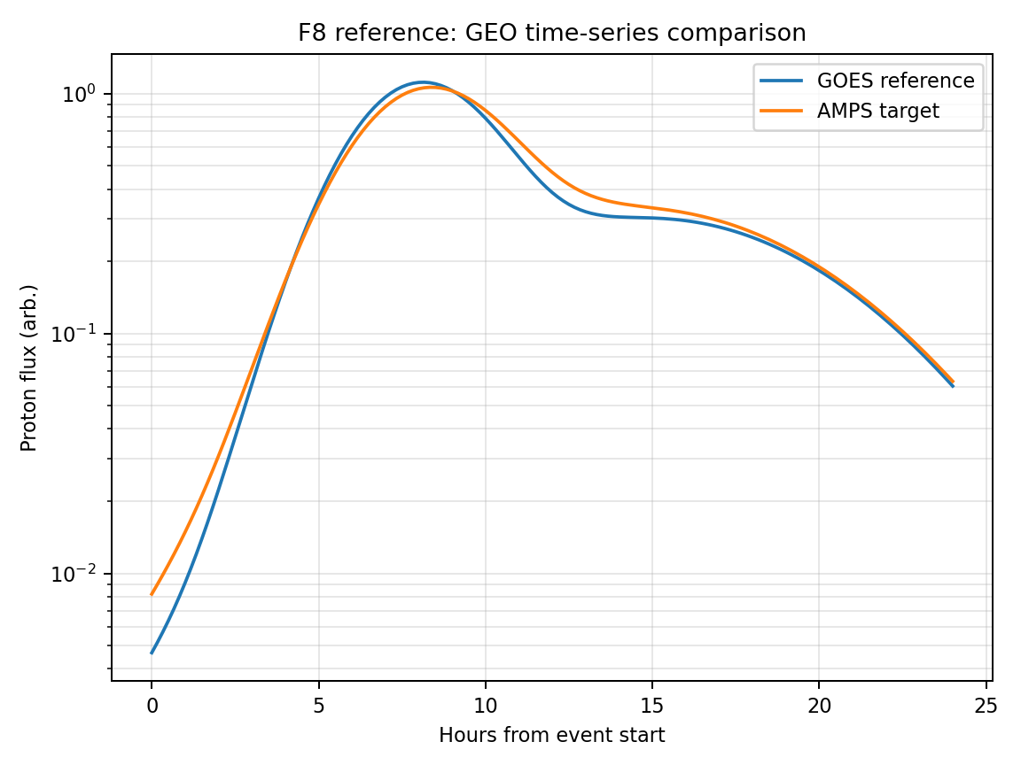
Figure F8 — Reference/target behavior for GOES SEP flux time-series at GEO.

F9. LEO flux-transition: PAMELA / AMS-02 [planned - not in archive]
Implementation status: Planned. No F9 directory or runner is present in all-test(1).tar. The following material is a proposed validation specification, not an executed archive test.
Validates the flux turn-on/turn-off across geomagnetic cutoff boundaries along LEO tracks.
Essential input parameters:
FIELD_MODEL T05
TEMPORAL_MODE TIME_SERIES
EVENT_START 2006-12-13T00:00
EVENT_END 2006-12-15T00:00
TRAJ_FILE pamela_or_ams_track.dat
ENERGY_BINS 80 100 300 1000
DS_TRANSMISSION_MODE SCAN
DS_TRANSMISSION_SCAN_N 100
OUTPUT_COORDS GEO MLT CGM
Calculation locations:
PAMELA Dec 2006 trajectory or AMS-02 ISS-like trajectory; compare flux versus latitude and orbit time.
Expected output values / acceptance targets:
Observable | Expected
Flux transition latitude | moves equatorward during storm main phase
PAMELA low-rigidity suppression | order 6–7° for ~80 MeV protons
Transition width | controlled by penumbra and angular acceptance
High rigidity | less storm-time displacement
Reference solution / comparison target:
Bruno et al. (2015) and Adriani et al. (2016), PAMELA cutoff variations; AMS-02 proton flux precision in low-rigidity range.
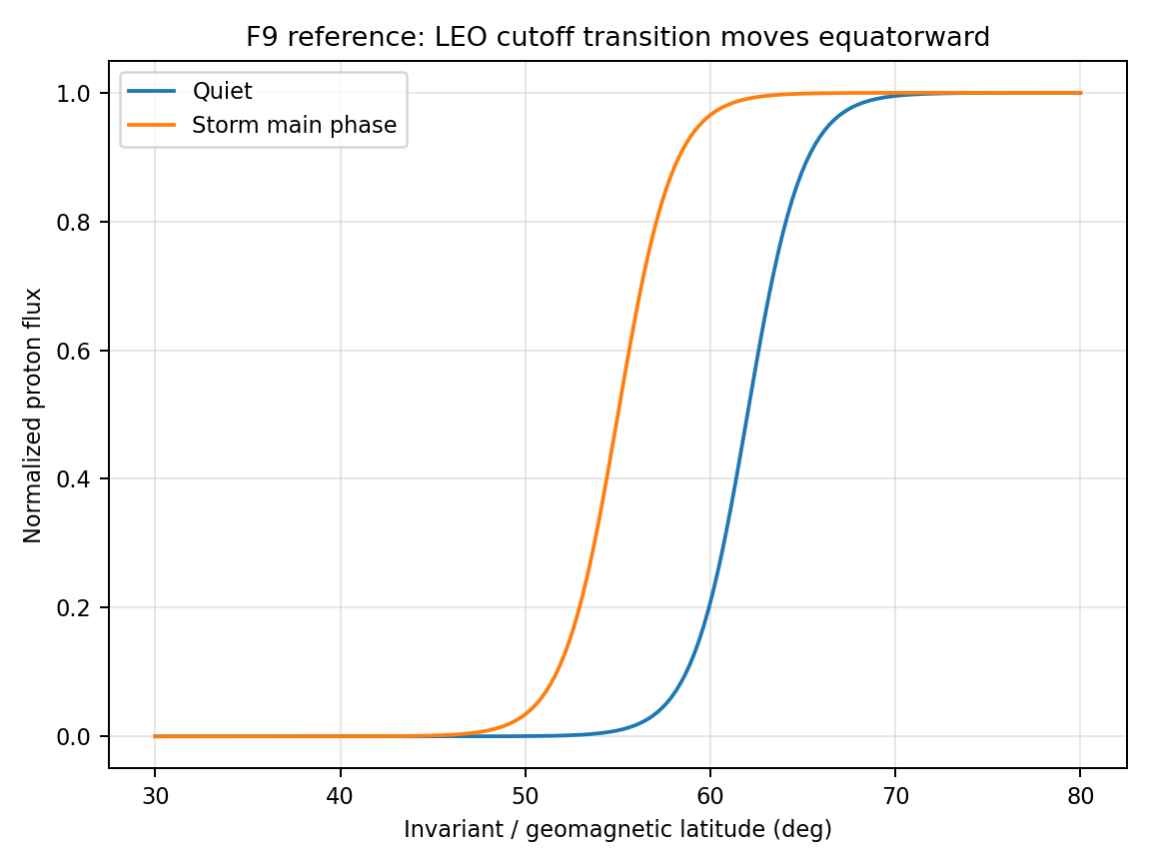
Figure F9 — Reference/target behavior for LEO flux-transition: PAMELA / AMS-02.

F10. POES/SAMPEX high-latitude flux boundary [planned - not in archive]
Implementation status: Planned. No F10 directory or runner is present in all-test(1).tar. The following material is a proposed validation specification, not an executed archive test.
Validates global SEP flux boundary morphology and energy dependence at high latitudes.
Essential input parameters:
FIELD_MODEL T05
TEMPORAL_MODE TIME_SERIES
EVENT_START 2006-12-05T00:00
EVENT_END 2006-12-15T00:00
OUTPUT_MODE SHELLS
SHELL_ALT_KM 850
ENERGY_BINS 1 10 30 100 140
DS_TRANSMISSION_MODE SCAN
DS_TRANSMISSION_SAVE T
COORDS_OUTPUT MLT_CGM
Calculation locations:
POES-like shell and/or SAMPEX orbit; postprocess flux boundary latitude versus MLT.
Expected output values / acceptance targets:
Boundary property | Expected
MLT dependence | ellipse-like boundary with local-time asymmetry
Energy dependence | lower rigidity/energy reaches lower latitudes
Storm response | boundary expands equatorward during disturbed intervals
Comparison | fit ellipse parameters and residuals vs POES empirical model
Reference solution / comparison target:
Dmitriev et al. (2013), POES SEP cutoff-boundary ellipses; SAMPEX/PET mission data for high-energy proton flux validation.
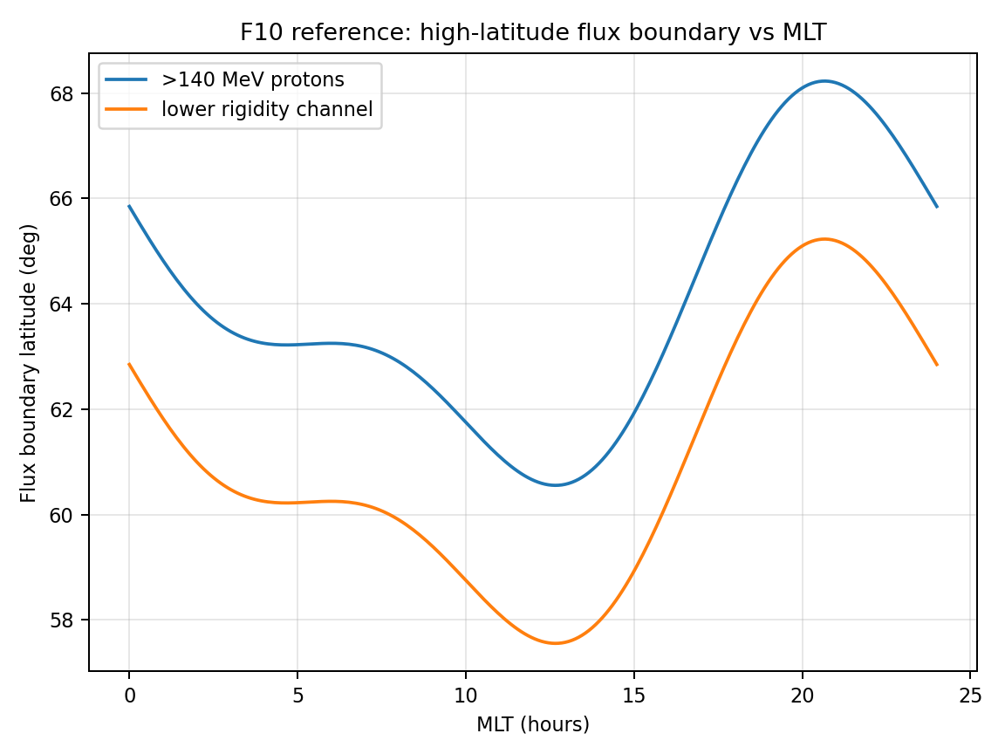
Figure F10 — Reference/target behavior for POES/SAMPEX high-latitude flux boundary.

F11. Anisotropic PAD model sum-check (ISOTROPIC / SINALPHA_N / COSALPHA_N / BIDIRECTIONAL) [implemented]
Implementation status: Implemented as exact pairwise identity checks over saved density, flux, spectrum, and transmission outputs.
F11 tests two identities only: every implemented PAD model reduces to isotropic at exponent n=0; and COSALPHA_N equals BIDIRECTIONAL for the same exponent because both use |cos(alpha)|^n. Claims about monotonic density trends or SINALPHA_N being larger at a selected point are not F11 acceptance gates.
Models: ISOTROPIC, SINALPHA_N, COSALPHA_N, BIDIRECTIONAL
Exponents: 0,1,2,4,8 (ISOTROPIC only needs n=0)
Default identity tolerance: 1e-8
Identity | Expected
Any model at n=0 vs ISOTROPIC | Zero difference in total density, total/channel flux, T(E), J_boundary(E), and J_local(E) within 1e-8.
COSALPHA_N vs BIDIRECTIONAL | Zero difference at equal exponent within 1e-8.

F12. Day/night spatial boundary-anisotropy identities [implemented]
Implementation status: Implemented as an exact zero-field GRIDLESS spatial-factor identity test.
The geometry uses FIELD_MODEL NONE, EFIELD_MODEL NONE, R_INNER=0, and diagnostic points with GSM X=0. Every direction is allowed and the deterministic direction grid pairs under x -> -x, so exactly half of trajectories exit dayside and half nightside.
DS_BOUNDARY_MODE ANISOTROPIC
BA_PAD_MODEL ISOTROPIC
BA_SPATIAL_MODEL DAYSIDE_NIGHTSIDE
FIELD_MODEL NONE
EFIELD_MODEL NONE
R_INNER 0
Case | Exact ratio to UNIFORM
DAYSIDE_NIGHTSIDE(1,1) | 1.0
DAY_ONLY(1,0) | 0.5
NIGHT_ONLY(0,1) | 0.5
DAY_ONLY + NIGHT_ONLY | 1.0
DAYSIDE_NIGHTSIDE(2,0.5) | 1.25
Scope: The runner checks these identities for density, total and channel flux, T(E), J_boundary(E), and J_local(E); no approximate dipole day/night split is used.

F13. Density/flux OpenMP × MPI-scheduler reproducibility matrix [planned - not in archive]
Implementation status: Planned. No F13 directory or runner is present in all-test(1).tar. The following material is a proposed validation specification, not an executed archive test.
DensityGridless.cpp retains three #pragma omp parallel for regions (direction loop in ComputeT_atEnergy and the energy loops in both the POINTS and SHELLS drivers) even after the MPI layer was rewritten to the collective DYNAMIC/BLOCK_CYCLIC/STATIC scheduler. Gridless cutoff has no threading at all. F7 checks MODE3D_PARALLEL and the MPI scheduler as separate axes; this test is the explicit cross-product for gridless density/flux specifically — OpenMP on/off combined with each MPI scheduler — since that combination is unique to the density/flux solver and is exactly where a nested-parallelism or reduction-order bug would surface.
Essential input parameters:
#DENSITY_SPECTRUM
DS_TRANSMISSION_MODE SCAN
DS_TRANSMISSION_SCAN_N 80
FIELD_MODEL DIPOLE
OUTPUT_MODE POINTS
POINTS lon=0 lat=-60 alt=9000
# Run matrix (OMP_NUM_THREADS x GRIDLESS_MPI_SCHEDULER x nRanks):
# OMP_NUM_THREADS 1 | 4
# GRIDLESS_MPI_SCHEDULER STATIC | BLOCK_CYCLIC | DYNAMIC
# nRanks 1 | 4
Calculation locations:
Same single diagnostic point as F4/F11 so results are directly comparable across this whole family of consistency tests; repeat on the 9000 km shell from F3 to confirm the matrix holds at production problem size, not only for one point.
Expected output values / acceptance targets:
Comparison | Expected
OMP_NUM_THREADS=4 vs 1, single rank, GRIDLESS_MPI_SCHEDULER fixed | max relative difference in n(x0) and J(>E) <1e−7, matching F7's OPENMP-vs-SERIAL target
GRIDLESS_MPI_SCHEDULER variants, OMP_NUM_THREADS fixed | max relative difference <1e−7 — partialWeight/dirsDone MPI_SUM reductions in DensityGridless.cpp are designed to be order-independent
Full 2x3x2 matrix vs single-thread/single-rank/STATIC reference | all twelve configurations agree with the reference to <1e−7
nDirBlocks task-batching boundary (kTrajBatch=32 in source) | results independent of whether nDirs is an exact multiple of 32 — verify with a direction count deliberately not divisible by 32
Reference solution / comparison target:
Internal reduction-order consistency target; same MPI Forum RMA standard underlying the scheduler, combined with the OpenMP reduction(+:weightSum) construct documented in ComputeT_atEnergy's source comments.
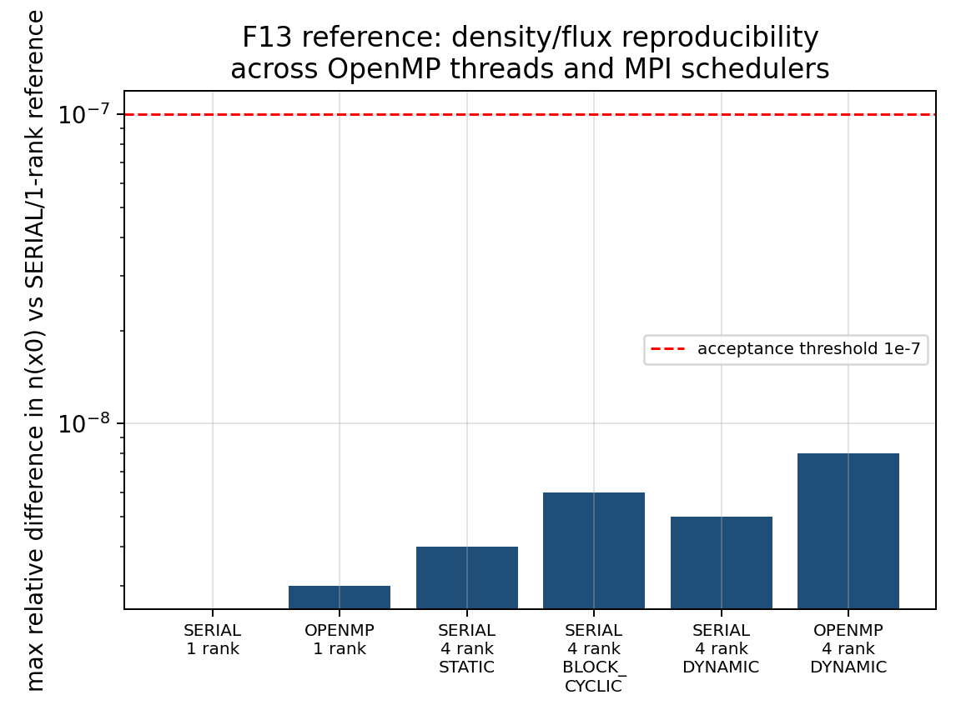
Figure F13 — Maximum relative difference in n(x0) across representative OpenMP-thread / MPI-scheduler combinations, all sitting roughly two orders of magnitude below the 1e−7 acceptance line.

6. Required archive products for every validation run
Category | Required archive item
Input and execution | Complete input file, command line, code commit, compiler, MPI implementation, rank/thread count, scheduler, chunk size.
Cutoff products | Rc_upper, Rc_effective, Rc_lower, Emin, penumbra width, T(R) if saved, exit-reason statistics.
Density/flux products | J_diff(E), J_integral(>E), density n, T(E), T(E,Ω) where available, quadrature weights, spectrum parameters.
Parallel diagnostics | Per-rank wall time, unfilled global slot count, duplicate slot count, progress-bar completion, max/mean load imbalance.
Comparison scripts | Postprocessing script that regenerates the expected-value plot and computes the acceptance metric.

7. References used for comparison targets
[R1] Størmer, C. (1930). Periodische Elektronenbahnen im Felde eines Elementarmagneten und ihre Anwendung auf Brüches Modellversuche und auf Eschenhagens Elementarwellen des Erdmagnetismus. Astrophysica Norvegica.
[R2] Smart, D. F., and Shea, M. A. (2001). Geomagnetic Cutoff Rigidity Computer Program. NASA STI.
[R3] Smart, D. F., and Shea, M. A. (2009). Fifty years of progress in geomagnetic cutoff rigidity determinations. Advances in Space Research.
[R4] Bobik, P., et al. (2013). GeoMag and HelMod webmodels version for magnetosphere and heliosphere transport of cosmic rays. arXiv:1307.5196.
[R5] Boschini, M. J., et al. (2013). Geomagnetic Backtracing: A comparison of Tsyganenko 1996 and 2005 External Field models with AMS-02 data. arXiv:1307.5192.
[R6] Tsyganenko, N. A., and Sitnov, M. I. (2005). Modeling the dynamics of the inner magnetosphere during strong geomagnetic storms. Journal of Geophysical Research.
[R7] Shue, J.-H., et al. (1998). Magnetopause location under extreme solar wind conditions. Journal of Geophysical Research.
[R8] Bruno, A., et al. / PAMELA Collaboration (2015). PAMELA measurements of geomagnetic cutoff variations during solar energetic particle events. arXiv:1511.00530.
[R9] Adriani, O., et al. / PAMELA Collaboration (2016). PAMELA measurements of geomagnetic cutoff variations during the 14 December 2006 storm. Space Weather, 14, 210-220, doi:10.1002/2016SW001364. Supporting Information Table S1 provides the numerical AACGM cutoff-latitude reference used by C9.
[R10] Dmitriev, A. V., Jayachandran, P. T., and Tsai, L.-C. (2013). Elliptical model of cutoff boundaries for solar energetic particles measured by POES satellites in December 2006. arXiv:1305.6710.
[R11] Bruno, A. (2017). Calibration of the GOES-13/15 high energy proton detectors based on PAMELA solar energetic particle observations. arXiv:1708.05641.
[R12] Consolandi, C. / AMS-02 Collaboration (2014). Primary cosmic ray proton flux measured by AMS-02. arXiv:1402.0467.
[R13] MPI Forum (2021). MPI: A Message-Passing Interface Standard, Version 4.0. MPI one-sided communication, MPI_Win, and MPI_Fetch_and_op.
[R14] Birdsall, C. K., and Langdon, A. B. (1991). Plasma Physics via Computer Simulation. McGraw-Hill.
[R15] Cary, J. R., and Brizard, A. J. (2009). Hamiltonian theory of guiding-center motion. Reviews of Modern Physics, 81, 693–738. Range of validity for guiding-center (GC2/GC4/GC6) integration referenced by C12.

8. Additional density/flux validation tests F14-F17
The additions below retain the planned density/flux validation cases that are not implemented in the supplied archive. They focus on transmission-mode consistency and related density/flux closure checks. The C14-C19 cutoff-rigidity descriptions have been moved into Section 3 so the C-series campaign is presented in numerical order.

F14. Density/flux transmission-mode consistency: DIRECT versus SCAN versus ADAPTIVE [planned - not in archive]
Implementation status: Planned. No F14 directory or runner is present in all-test(1).tar. The following material is a proposed validation specification, not an executed archive test.
Validates that the new density/flux transmission scan does not change answers in regimes where DIRECT sampling is already sufficient, while revealing penumbra structure when the DIRECT energy grid is too sparse. ADAPTIVE currently acts as a fixed-grid scan alias and should match SCAN exactly.
Essential input parameters:
#NUMERICAL
GRIDLESS_MPI_SCHEDULER DYNAMIC
GRIDLESS_MPI_DYNAMIC_CHUNK 0
MODE3D_MPI_SCHEDULER DYNAMIC
DS_TRANSMISSION_SAVE T
DS_TRANSMISSION_SCAN_N 80
DS_TRANSMISSION_REFINE_N 0
DS_TRANSMISSION_MAX_N 80
FIELD_MODEL DIPOLE
DENSITY_SPECTRUM POWER_LAW
SPEC_J0 1.0e4
SPEC_GAMMA 3.5
SPEC_E0 10.0
SPEC_EMIN 1.0
SPEC_EMAX 1000.0
# Run A: DS_TRANSMISSION_MODE DIRECT
# Run B: DS_TRANSMISSION_MODE SCAN
# Run C: DS_TRANSMISSION_MODE ADAPTIVE
Calculation locations:
Mode3D and gridless runs at latitudes -60, -30, 0, 30, 60 degrees; altitudes 500 km and 9000 km; one isotropic and one directional-map case.
Expected output values / acceptance targets:
Quantity / diagnostic | Expected output or acceptance target
DIRECT vs SCAN at scan-node energies | T(E) values identical when DIRECT energies coincide with SCAN rigidity nodes.
SCAN vs ADAPTIVE | Identical output in the current implementation because ADAPTIVE is documented as a SCAN alias.
Integrated density/flux | Differences decrease with increasing DS_TRANSMISSION_SCAN_N; penumbra cases may require more nodes.
Diagnostic output | Rc_lower, Rc_effective, Rc_upper, penumbra width, and T_high archived for every location.
Reference solution / comparison target:
Smart & Shea [R2,R3] and Cooke et al. [R16] motivate explicit cutoff/penumbra terminology; Kudela and Usoskin [R18] provide transmissivity context. This is an internal consistency test of AMPS density/flux integration.
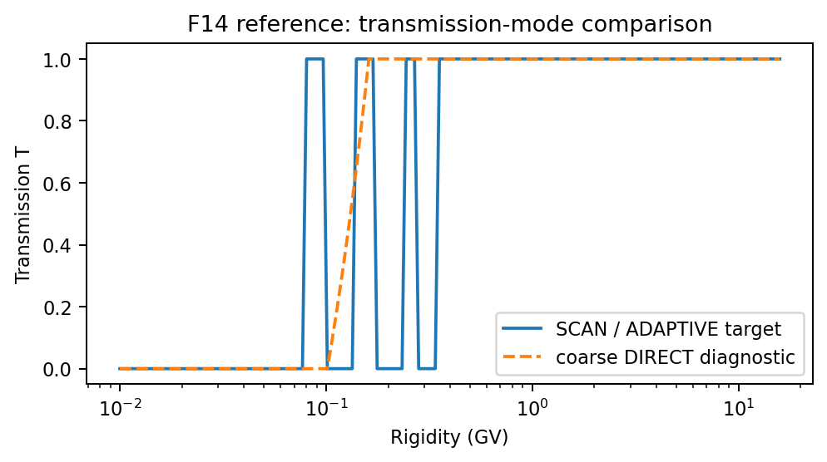
Figure F14 — Target comparison of density/flux transmission modes. SCAN/ADAPTIVE retain penumbra structure; coarse DIRECT sampling can miss narrow forbidden or allowed intervals.

F15. Density normalization from differential flux and relativistic speed factor [implemented]
Implementation status: Implemented as an exact zero-field relativistic normalization test using four narrow top-hat TABLE spectra.
The cases are centered at 1,10,100,1000 MeV with default full width 0.02 E0. FIELD_MODEL NONE, EFIELD_MODEL NONE, R_INNER=0, and DIRECT transmission make T(E)=1 at both the center and near-boundary points.
F = 4*pi*J0*(E2-E1)
n = (4*pi*J0/c) * [sqrt(E2*(E2+2m)) - sqrt(E1*(E1+2m))]
v(E)/c = sqrt(E*(E+2m))/(E+m)
Check | Implemented expectation
Total flux and density | Match the finite top-hat closed forms.
Effective speed F/n | Matches the analytical finite-width value and monoenergetic correction.
Saved spectrum | T=1, J_local/J_boundary=1, and reconstruction agrees with integrated files.
Spatial invariance | Center and near-boundary points agree in the zero-field box.
Endpoint protection | TABLE/SPEC endpoints tolerate only roundoff-sized conversion excursions.

F16. Blocked-access zero-flux regression [implemented]
Implementation status: Implemented as an exact GRIDLESS blocked-access regression.
Every diagnostic point is inside the absorbing inner sphere. The classifier therefore rejects every direction before the first push even though the incident power-law spectrum is nonzero. This is not an equatorial dipole-shell scan.
FIELD_MODEL NONE
OUTPUT_MODE POINTS
all points satisfy r < R_INNER
nonzero boundary power-law spectrum
expected T(E)=J_local(E)=density=total flux=channel flux=0
Gate | Expected
Transmission and local spectrum | Exactly zero at every sampled energy.
Density and all flux products | Zero within the configured zero tolerance.
Boundary spectrum | Verified nonzero so the case cannot pass as a zero-input test.

F17. Event-level closure across GEO boundary, LEO flux transition, and cutoff boundary [planned - not in archive]
Implementation status: Planned. No F17 directory or runner is present in all-test(1).tar. The following material is a proposed validation specification, not an executed archive test.
Connects the separate event-level tests into one closure workflow. The same imposed SEP boundary spectrum, field model, and driver file should explain the GEO time series, the LEO flux-transition latitude, and the high-latitude cutoff/flux boundary consistently.
Essential input parameters:
#NUMERICAL
FIELD_MODEL T05
TEMPORAL_MODE TIME_SERIES
FIELD_UPDATE_DT 5
TS_INPUT_MODE FILE
TS_INPUT_FILE event_driver.dat
GRIDLESS_MPI_SCHEDULER DYNAMIC
MODE3D_MPI_SCHEDULER DYNAMIC
DS_TRANSMISSION_MODE SCAN
DS_TRANSMISSION_SCAN_N 80
DS_TRANSMISSION_SAVE T
DENSITY_OUTPUT_DIFFERENTIAL_FLUX T
DENSITY_OUTPUT_INTEGRAL_FLUX T
# Use the same boundary SEP spectrum in F8, F9, and F10 runs.
# Archive GOES/GEO normalization, PAMELA/AMS-like LEO samples, and POES-like boundary maps.
Calculation locations:
A single event interval, preferably the Dec 2006 PAMELA/POES event used by C9/C10 or a modern GOES/SEISS event with well-calibrated channels. Locations include GEO points, LEO orbit samples, and a global 850-km shell.
Expected output values / acceptance targets:
Quantity / diagnostic | Expected output or acceptance target
GEO flux | GOES/SEISS channel timing, peak, and fluence matched within documented calibration uncertainty.
LEO transition | Flux turn-on/off latitude follows the observed or reference cutoff latitude versus rigidity.
POES-like boundary | MLT-dependent boundary shift has the correct storm-time sign and order-of-magnitude amplitude.
Closure criterion | No separate retuning of boundary spectrum between GEO, LEO, and high-latitude boundary products.
Reference solution / comparison target:
Bruno/PAMELA [R8,R9], Dmitriev et al. [R10], GOES calibration [R11], and AMS-02 proton flux context [R12] motivate the multi-instrument closure comparison.
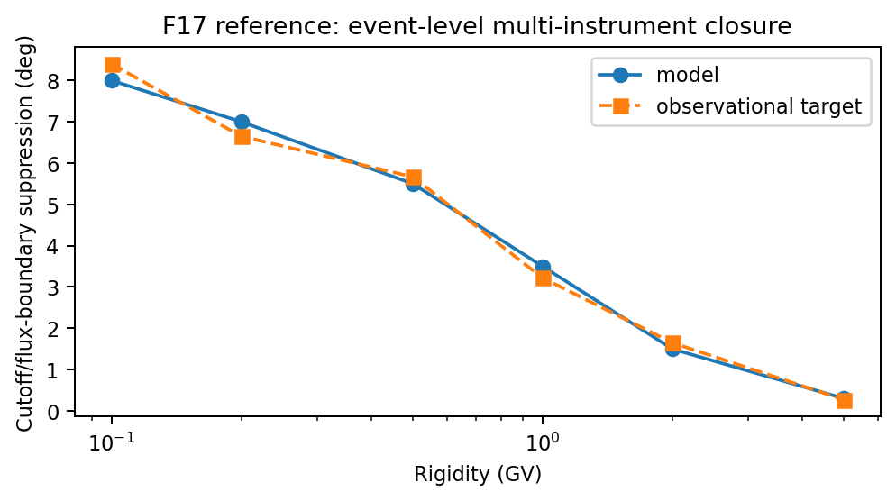
Figure F17 — Target multi-instrument closure behavior. The same event model should reproduce the rigidity trend of storm-time boundary/flux suppression across GEO and LEO diagnostics.

9. Additional references retained and organized in v9
The v6 reference list above is retained unchanged. The following references support the supplemental C14-C19 cutoff-rigidity tests now integrated into Section 3 and the F14-F17 density/flux specifications retained in Section 8.
- [R16] Cooke, D. J., Humble, J. E., Shea, M. A., Smart, D. F., Lund, N., Rasmussen, I. L., Byrnak, B., Goret, P., and Petrou, N. (1991). On cosmic-ray cutoff terminology. Il Nuovo Cimento C. Recommended for precise lower/upper/effective cutoff and penumbra terminology.
- [R17] Desorgher, L., Flückiger, E. O., Gurtner, M., Moser, M. R., and Bütikofer, R. (2005). Magnetocosmics / PLANETOCOSMICS trajectory tracing and geomagnetic cutoff calculations. Useful as an independent trajectory-code comparison family.
- [R18] Kudela, K., and Usoskin, I. G. (2004/2005). Magnetospheric transmissivity and cosmic-ray cutoff-rigidity studies. Useful context for transmission-function based validation rather than a single scalar cutoff.
- [R19] Forman, M. A. (1970). The Compton-Getting effect for cosmic-ray particles and photons and the Lorentz invariance of the distribution function. Planetary and Space Science. Supports the use of phase-space/differential-intensity invariance in flux-density normalization tests.
- [R20] Northrop, T. G. (1963). The Adiabatic Motion of Charged Particles. Interscience. Useful background for guiding-center invariants and mover validation near the limits of GC applicability.
- [R21] Roelof, E. C. (1969). Propagation of solar cosmic rays in the interplanetary magnetic field. Lectures in High-Energy Astrophysics. Useful context for SEP pitch-angle distributions and directional flux mapping.

- [R22] Smart, D. F., and Shea, M. A. (2008). World Grid of Calculated Cosmic Ray Vertical Cutoff Rigidities for Epoch 2000.0. Proceedings of the 30th International Cosmic Ray Conference, Vol. 1, 737-740.
- [R23] Copeland, K. (2019). CARI-7 Documentation: Geomagnetic Cutoff Rigidity Calculations and Tables for 1965-2010. Federal Aviation Administration report DOT/FAA/AM-19/4.
- [R24] Gerontidou, M., Katzourakis, N., Mavromichalaki, H., Yanke, V., and Eroshenko, E. (2021). World grid of cosmic ray vertical cut-off rigidity for the last decade. Advances in Space Research, 67, 2231-2240. DOI: 10.1016/j.asr.2021.01.011.
- [R25] Belov, A. V., Zobnin, A. V., and Yanke, V. G. (2021). Program for Calculating the Geomagnetic Cutoff Rigidity of Cosmic Rays and the Trajectories of Their Motion. Bulletin of the Russian Academy of Sciences: Physics. DOI: 10.3103/S106287382111006X. IZMIRAN Cutoff2050 methodology and secondary-code context for C7.
- [R26] NOAA National Centers for Environmental Information. NOAA GOES 1-15 SEM L1B/L2 operational five-minute EPEAD p17ew products used by C19A.
- [R27] Rodriguez, J. V., Onsager, T. G., and Mazur, J. E. (2010). The east-west effect in solar proton flux measurements in geostationary orbit: A new GOES capability. Geophysical Research Letters, 37, L07109.
- [R28] Rodriguez, J. V., Krosschell, J. C., and Green, J. C. (2014). Intercalibration of GOES 8-15 solar proton detectors. Space Weather, 12, 92-109.
- [R29] Kress, B. T., Rodriguez, J. V., Mazur, J. E., and Engel, M. (2013). Modeling solar proton access to geostationary spacecraft with geomagnetic cutoffs. Advances in Space Research, 52, 1939-1948.
- [R30] Rodriguez, J. V. et al. (2017). On the use of NOAA GOES energetic particle detector integral fluxes. Space Weather, 15, 290-309.
- [R31] Tsyganenko, N. A., and Sitnov, M. I. (2005). Modeling the dynamics of the inner magnetosphere during strong geomagnetic storms. Journal of Geophysical Research, 110, A03208.

Appendix A. all-test(1).tar implementation inventory
This appendix is the authoritative mapping for the supplied all-test(1).tar snapshot and replaces the former seed-file mapping. A test is called implemented only when its directory and runner/configuration files are present in this archive.

A.1 Implemented cutoff-rigidity tests
Test | Archive status | Implemented scope
C1 | Implemented | Analytical dipole vertical cutoff
C2 | Implemented | Dipole longitude and north/south symmetry
C3 | Implemented | UPPER_SCAN penumbra regression
C4 | Implemented | Mode3D trajectory exit/invariant diagnostic
C5 | Implemented | Mode3D mesh-interpolation convergence
C6 | Implemented | Global IGRF effective vertical cutoff
C7 | Implemented | IZMIRAN T96 external benchmark
C9 | Implemented | PAMELA cutoff-latitude validation
C10 | Implemented | POES/MetOp proton-access boundary
C11 | Implemented | BINARY Rmin-collapse regression
C12 | Implemented | Gridless mover cross-validation
C14 | Implemented | Mode3D/gridless cross-solver comparison
C17 | Implemented | Charge-sign/velocity-reversal symmetry
C18 | Implemented | Threaded field-initialization determinism
C19 | Implemented | GOES EPEAD East-West directional access

A.2 Implemented density/flux tests
Test | Archive status | Implemented scope
F1 | Implemented | Zero-field normalization
F2 | Implemented | Power-law energy integration
F3 | Implemented | Dipole cutoff-filtered flux
F4 | Implemented | Transmission reconstruction closure
F5 | Implemented | Exact complementary PAD mapping
F11 | Implemented | PAD identity matrix
F12 | Implemented | Exact day/night spatial-factor identities
F15 | Implemented | Differential-flux-to-density normalization
F16 | Implemented | Blocked-access zero-flux regression

A.3 Planned descriptions not present in the archive
Class | Descriptions retained as validation plans
Cutoff | C8, C13, C15, C16, and C-PARALLEL
Density/flux | F6, F7, F8, F9, F10, F13, F14, and F17
These sections remain useful specifications, but they must not be reported as executed or packaged tests until a directory, parser-valid input, runner, reference data (when required), and result contract are added.

A.4 Verification and packaging notes
- The supplied archive contains 24 test directories: 15 C-series directories and 9 F-series directories.
- All included Python files compile successfully with Python 3.12 in this workspace.
- The C10 offline unit suite contains 16 tests, not 24; all 16 passed during this reconciliation.
- C6, C7, C9, and C10 bundled reference/driver validation paths passed, and the C18 self-test passed.
- C19's standalone self-test imports the full repository source file srcEarth/util/amps_param_parser.cpp. That file is absent from the test-only tar, so the extracted snapshot alone is not a self-contained C19 self-test package. Run C19 inside the full AMPS source tree.
- Physics calculations were not executed during document reconciliation because the archive does not include a built AMPS executable. A validation result must distinguish packaging/static checks from actual trajectory execution.

A.5 Required products for an executed test
- Exact input file and generated input, complete command line, executable/source revision, MPI/thread/scheduler settings, and runtime log.
- Machine-readable summary/result files and the reference data actually used, including hashes or provenance when the runner provides them.
- Numerical convergence evidence when the test definition makes convergence a gate; otherwise label convergence NOT_TESTED rather than implying it passed.
- Plots generated from the same accepted data population as the metrics, with diagnostic-only values visibly separated from accepted science values.

