LAB 3
Aitzaz ul hassan
04072313026
SETUP:
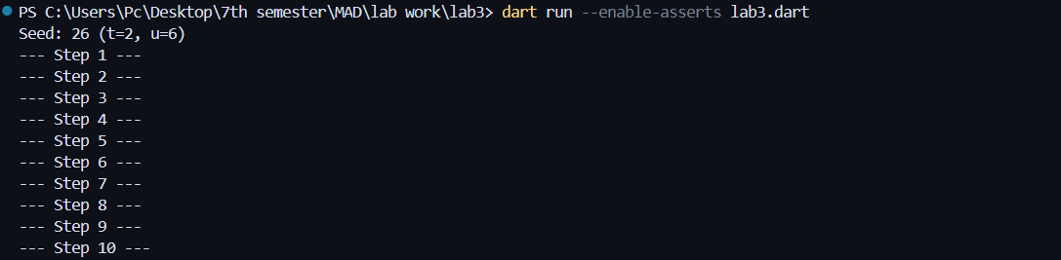
TASK1:
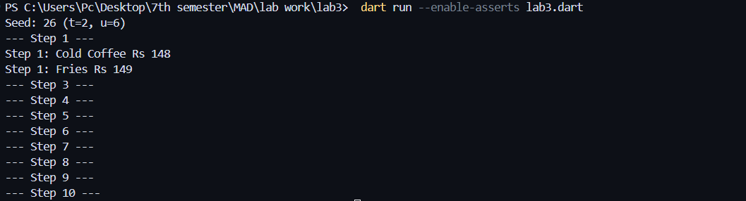
TASK2: give error at that constructor..this version will not compile in null-safe Dart
can run this by putting (late)with the variable
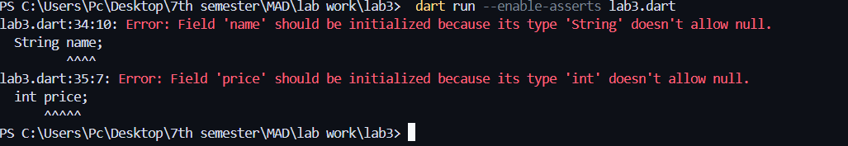
this is the result when I put (MenuItem(this.name, this.price)
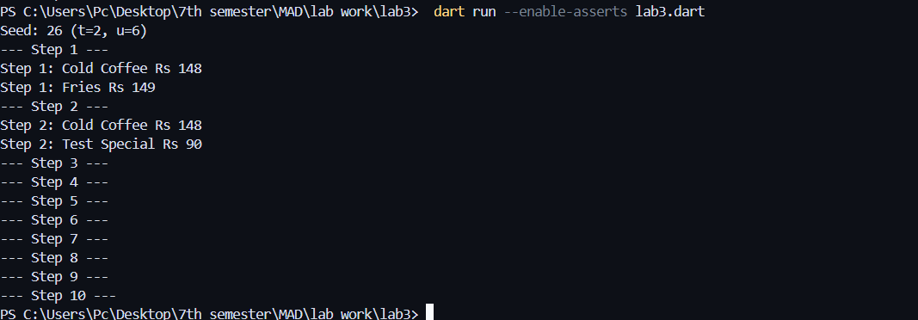
TASK3:
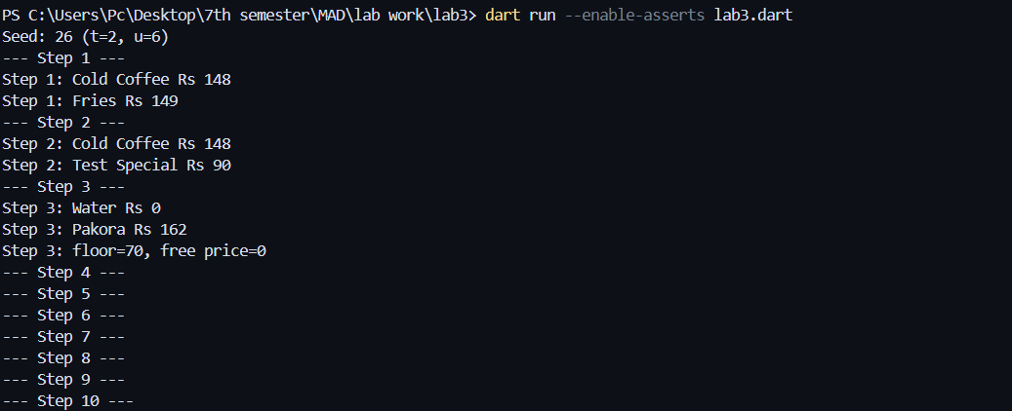
TASK4:
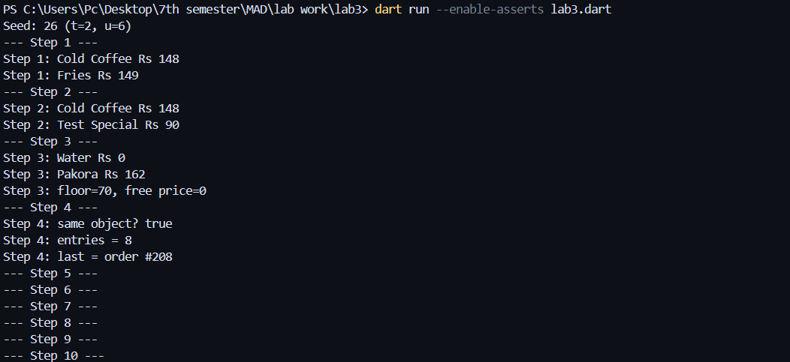
TASK5:
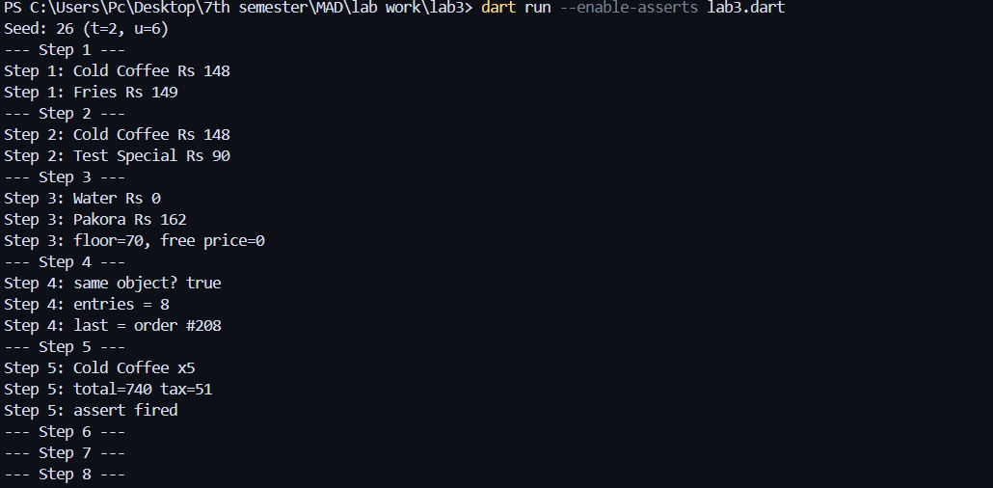
TASK6:
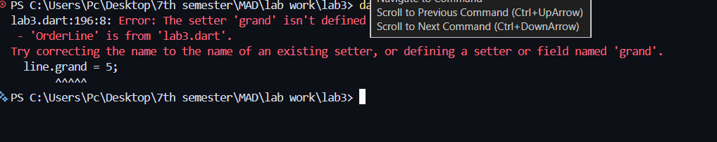
After error
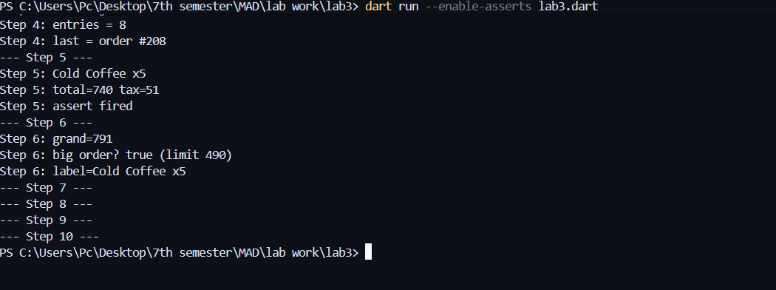

Task7:
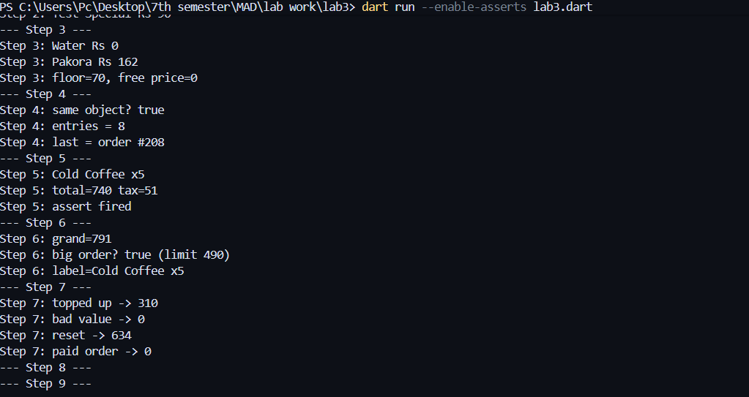
TASK8:
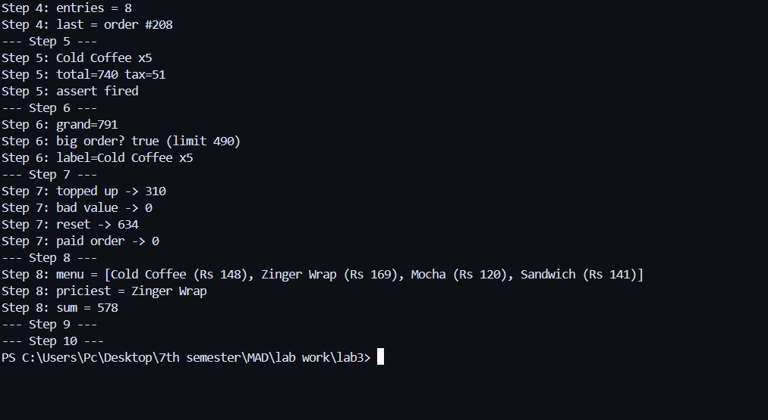

TASK9:
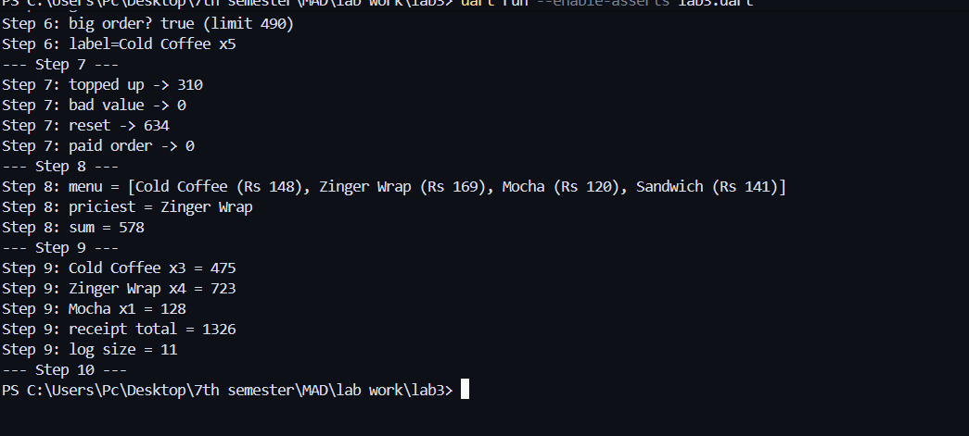
TASK10:
