

Department of Education

Region X – Northern MindanaHMEo

**DIVISION OF MALAYBALAY CITY**

presented this

Certificate of Participation

To

**{participant}**

***Position, School Name***

during the **____________________________** of the Division of Malaybalay City

held at the **______________________________**, _____________, Malaybalay City, Bukidnon.

on **_______________________**.

*Given this ____ day of ________*, 2023 at _____________________________,

Fortich Street, Malaybalay City, Bukidnon.

**CHERRY MAE L. LIMBACO-REYES**

Schools Division Superintendent

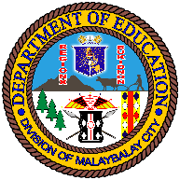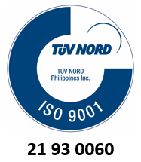

QR Code