Homework 1

Data mining and network analysis ITI8370
Aivo Olev
18.10.2018

Exercise 1: Distance functions
I implemented the following distance functions: euclidean, Manhattan, Chebyshev, Canberra, cosine similarity, Mahalanobis and Minkowski distance. I exposed most of those from one function mydistancefun() which accepts function name as a parameter. Though I left Mahalanobis and Minkowski distance functions as separate, because they require another parameter. All the functions accept any finite number of dimensions.
Compared to library functions mine don’t try to validate inputs but expect those to be valid, because that didn’t seem to be necessary here.
My Minkowski distance function has 3 special cases when p parameter value is 1, 2 or Inf. Then it returns manhattan, euclidean or Chebyshev distance, otherwise it uses it’s defining formula to calculate the distance.

Exercise 2: Clustering
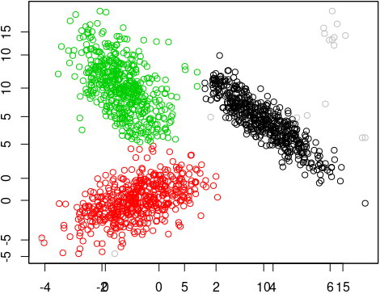
I implemented a k-medoids clustering algoritm. It accepts a finite number of k and finds that many clusters. Although with bigger k values the performance will suffer as with any k-medoids algoritm. It starts by randomly selecting centroids from the input data set. And it also accepts a threshold value to stop clustering when centroids have not changed more than that value in a step.
As a bonus I also implemented outlier detection for each cluster using Mahalanobis distance and for testing set the threshold at 5 standard deviations from cluster average. So this detection work quite nicely even with the ellipsoidic data set with normal distribution. But since I relied on standard deviation, it might not work when data is not at all standardly distributed. Outliers are visible here as grey dots:
K-medoids is very sensitive to outliers. And my solution is far from perfect from protecting the clustering from outliers. It currently cleans the cluster after the classification. As I read, it’s possible also to try to handle outliers during the classification, although there are no perfect mathematical solutions to do so.
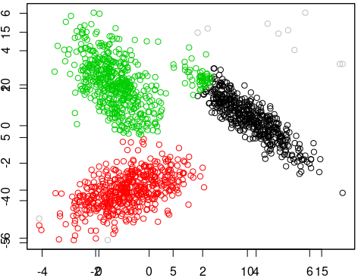
K-medoids worked well with the tested dataset, but will not be good when data is not distributed around centroids. K-medoids and k-means also prefer clusters of approximately similar size as they assign point to their nearest centroid.
I also implemented Dunn index and silhouette coefficient calculations and compared results with two different data sets and different distance functions (euclidean, Manhattan, Chebyshev, Canberra, cosine similarity). As expected, euclidean and Manhattan performed the best, others were not appropriate for at least those continuous and standardly distributed data sets that I tested with. Manhattan even had the best Dunn index, but it it was visually worse at finding ellipsoid clusters than euclidean distance. And it’s well, known that these indexes don’t imply nor compare validity, these just indicate that one algoritm (distance function) might be more appropriate.

Exercise 3: Classification
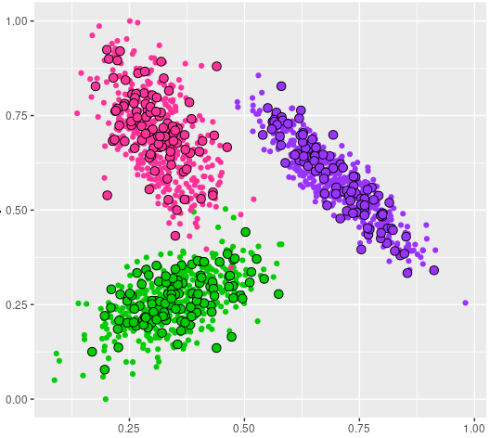
I implemented a k-NN algoritm. It accepts any number of dimensions to classify by. To use it I split the input data into training and test sets randomly. As the algoritm will look through all training data to classify the test data. As an extra step, I made sure to standardize the dimensions so as to avoid one dimension to affect classification more than others just because it’s values are on a different scale.
The k-NN classifier I worked very well with low number of input dimensions, as visible in this screenshot. It was able to classify almost perfectly all test data point. But it is subject to the curse of dimensionality so when the number of dimensions increases, it will need considerable more training data while euclidean distance will become less helpful.
During my testing the data had mostly data with standard distribution and each dimension was equally important. And I had plenty of data point. So with even 9 dimensions I got accuracy of 98% with cosine similarity and 99.0 – 100% with others (manhattan, euclidean, Chebushev, Canberra). So it works well with different distance functions.
Weaknesses of this algoritm are that all computation is deferred until classification and so it can’t be pre-trained. So it requires a lot of memory and computation resources to run.
My implementation is currenlty still subject to skewed results when there would be dominantly represented classes, which would dominate the classification prediction. To overcome this it would need to for example weight the classification taking into account the distance from the test point to each of its k nearest neighbors.
The k-NN algoritm will also start to degrade if there is noisy or irrelevant features. Or if some feature scales are not consisent with their importance. Thus it requires features to be well selected and well evenly scaled.

Exercise 5: Rotating surfaces

