INSTITUTE OF PUBLIC ADMINISTRATION AND MANAGEMENT (IPAM)
UNIVERSITY OF SIERRA LEONE (USL)

FINAL YEAR PROJECT REPORT
TOPIC:
MULTILINGUAL VOICE-FIRST AI BUSINESS ASSISTANT FOR LOW-RESOURCE SMEs
GROUP 10
S/N | Names | ID
1 | SUALEH LANSANA GOBBA | 16060
2 | ALLIA SAIDU DUMBUYA | 13788
3 | MOHAMED ALIE KAMARA | 16546
4 | MARVELOUS THEOPHILOUS CAULKER | 16138
5 | SAMUEL MASSAQUI | 13707

SUPERVISOR: Mr. Oluwatosin B. Ayorinde
COURSE: Diploma in Information Technology
DATE: OCTOBER 2026
DECLARATION
We, the undersigned members of Group 10, hereby declare that this project report titled "Multilingual Voice-First AI Business Assistant for Low-Resource SMEs" is our own original work. The system described in this report was designed, developed, tested and documented by the members of the group. All sources of information, tools, libraries and ideas that belong to other authors have been duly acknowledged in the text and in the list of references.
We further declare that this work has not been submitted, in whole or in part, to any other institution or for any other award, and that it is submitted in partial fulfilment of the requirements for the Diploma in Information Technology at the Institute of Public Administration and Management (IPAM), University of Sierra Leone.
Name | ID | Signature | Date
SUALEH LANSANA GOBBA | 16060
ALLIA SAIDU DUMBUYA | 13788
MOHAMED ALIE KAMARA | 16546
MARVELOUS THEOPHILOUS CAULKER | 16138
SAMUEL MASSAQUI | 13707

CERTIFICATION
This is to certify that the project report titled "Multilingual Voice-First AI Business Assistant for Low-Resource SMEs" was carried out by Group 10, whose members are listed on the title page, under my supervision. The work meets the standard required for the award of the Diploma in Information Technology at the Institute of Public Administration and Management (IPAM), University of Sierra Leone.

Supervisor: Mr. Oluwatosin B. Ayorinde
Signature: ...................................................... Date: ..............................
Head of Department: ......................................................
Signature: ...................................................... Date: ..............................
External Supervisor: ......................................................
Signature: ...................................................... Date: ..............................
DEDICATION

This project is dedicated to Almighty God, who gave us the strength, wisdom and good health to complete it;
to our parents, guardians and families for their love, prayers and sacrifices;
and to every small business owner in Sierra Leone whose hard work builds our nation.
ACKNOWLEDGEMENTS
First and foremost, we give thanks to Almighty God for His grace, protection and guidance throughout this project and throughout our studies at IPAM.
We sincerely thank our supervisor, Mr. Oluwatosin B. Ayorinde, for his patient guidance, constructive corrections and clear submission guidelines. His supervision shaped the direction, structure and quality of this work.
We are grateful to the lecturers and staff of the Institute of Public Administration and Management (IPAM), University of Sierra Leone, for the knowledge and discipline they have shared with us during the Diploma in Information Technology programme.
We thank the small and medium business owners and employees in Freetown who shared their experiences of keeping records and serving customers, and who gave their time to review the system. Their views kept this project focused on real needs.
We also acknowledge the creators and communities of the open-source tools used in this project, including Python, Flask, SQLite, OpenAI Whisper, Coqui TTS, Android Studio and Visual Studio Code.
Finally, we thank our families and friends for their encouragement, and each member of Group 10 for the teamwork, commitment and sacrifice that made this project possible.
ABSTRACT
Small and Medium Enterprises (SMEs) are important to the economy of Sierra Leone, yet many still keep sales, stock and customer records in notebooks. Existing digital business tools usually assume that users can read and type English, own capable devices and have stable internet access. This project designed, developed and tested a Multilingual Voice-First AI Business Assistant that allows a shop owner to run everyday business tasks by speaking or typing short commands.
The system was built with an Agile, iterative approach. The back end is written in Python using the Flask framework and stores data in an SQLite database; a matching MySQL schema is provided for larger deployments. Speech is converted to text with OpenAI Whisper or the browser microphone, and replies are spoken with Coqui TTS or the browser voice. A rule-based Natural Language Processing engine detects the language (English, Krio, with starter files for Mende and Temne), the intent of the command and the details in it, such as product, quantity, price, customer, date and time. The assistant can record sales, add and check stock, check prices, register customers, book appointments, answer customer-support questions and produce daily and monthly reports. The web interface is built with HTML, CSS and JavaScript, and an Android application written in Java opens the same assistant on a phone.
The system was tested with 29 automated test functions, including 22 sentence-level language-understanding cases, and all of them passed. A user acceptance testing procedure was prepared for SME owners. The project shows that a low-cost, voice-first business assistant that supports a local language can be built with open-source tools. Its main limitations are the small vocabulary available for Mende and Temne, the dependence of speech accuracy on the audio quality, and the prototype scope.
Keywords: voice-first, multilingual, Krio, speech recognition, Natural Language Processing, SME, Sierra Leone.
TABLE OF CONTENTS
CHAPTER ONE: PROJECT OVERVIEW 1
1.1 Background of the Project 1
1.2 Problem Statement 1
1.3 Project Gap 2
1.4 Aim of the Project 2
1.5 Project Objectives 3
1.6 Project Questions 3
1.7 Significance and Contribution of the Project 4
1.8 Scope of the Project 4
1.9 Limitations 5
CHAPTER TWO: DEVELOPMENT METHODOLOGY 6
2.1 Development Approach 6
2.2 Requirement Analysis 6
2.3 Data Collection Methods 7
2.4 System Requirements 8
2.5 System Design 9
2.6 Technologies and Tools 15
2.7 System Development 16
2.8 Testing Methodology 19
2.9 Challenges Encountered and Solutions 20
CHAPTER THREE: PRODUCT EVALUATION AND OUTCOMES 21
3.1 Developed System 21
3.2 System Features 21
3.3 System Interface 22
3.4 Testing Results 24
3.5 User Evaluation 28
3.6 Summary of Outcomes 29
CHAPTER FOUR: DISCUSSION AND REFLECTIVE ANALYSIS 30
4.1 Interpretation of Findings 30
4.2 Achievement of Project Objectives 30
4.3 Evaluation Against the Problem 30
4.4 Strengths of the Developed System 31
4.5 Limitations of the System 31
4.6 Lessons Learned 32
4.7 Reflection on the Development Process 32
CHAPTER FIVE: CONCLUSION AND RECOMMENDATIONS 33
5.1 Conclusion 33
5.2 Recommendations 33
5.3 Future Development 33
REFERENCES 35
APPENDICES 37
Appendix A: Questionnaire 37
Appendix B: Interview Questions 37
Appendix C: System Screenshots 38
Appendix D: Test Cases 42
Appendix E: Database Schema 44
Appendix F: Selected Source Code 45
Appendix G: User Acceptance Testing Forms 47
LIST OF TABLES
Table 1.1: Project objectives and how each is measured 3
Table 2.1: Development iterations 6
Table 2.2: Problems identified and the needs derived from them 7
Table 2.3: Functional requirements 8
Table 2.4: Non-functional requirements 9
Table 2.5: Technologies and tools used 15
Table 2.6: Project files and their purpose 16
Table 2.7: Voice command intents and examples 17
Table 2.8: Levels of testing 19
Table 2.9: Challenges encountered and solutions 20
Table 3.1: Features of the developed system 21
Table 3.2: Summary of automated test results 25
Table 3.3: NLP sentence test results 25
Table 3.4: Business scenario test results 26
Table 3.5: Speech recognition test results 27
Table 3.6: Task completion results 28
Table 3.7: Average user ratings (scale 1 to 5) 28
Table 4.1: Achievement of the project objectives 30
Table 4.2: Evaluation of the system against the identified problem 30
Table D.1: List of automated test functions 42
Table G.1: Task sheet 47
Table G.2: Participant rating (circle 1 to 5) 47
LIST OF FIGURES
Figure 2.1: Use case diagram 10
Figure 2.2: Activity diagram of a voice command 11
Figure 2.3: Class diagram 12
Figure 2.4: Entity relationship diagram 13
Figure 2.5: System architecture 14
Figure 2.6: Data flow diagram, level 0 (context diagram) 14
Figure 2.7: Data flow diagram, level 1 14
Figure 2.8: Interface design of the assistant screen 15
Figure 3.1: Login interface 22
Figure 3.2: User dashboard (assistant home screen) 23
Figure 3.3: Administration dashboard (system users, available to the owner only) 23
Figure 3.4: AI module: conversation with the assistant in English and Krio 24
Figure 3.5: Reporting interface (owner only) 24
Figure 3.6: Terminal output of the automated test run (29 tests, all passed) 25
Figure C.1: Account registration page 38
Figure C.2: Inventory page 39
Figure C.3: Sales records page 39
Figure C.4: Customers page 40
Figure C.5: Appointments page 40
Figure C.6: Voice command logs page 41
Figure C.7: Terminal output when the system is started with "python app.py" 41
Figure C.8: Project folder structure 42
LIST OF ABBREVIATIONS
Abbreviation | Meaning
AI | Artificial Intelligence
API | Application Programming Interface
ASR | Automatic Speech Recognition
CSS | Cascading Style Sheets
DFD | Data Flow Diagram
ER | Entity Relationship
FAQ | Frequently Asked Questions
HTML | HyperText Markup Language
HTTP | HyperText Transfer Protocol
IPAM | Institute of Public Administration and Management
JSON | JavaScript Object Notation
NLP | Natural Language Processing
SME | Small and Medium Enterprise
SQL | Structured Query Language
TTS | Text-to-Speech
UAT | User Acceptance Testing
UI | User Interface
USL | University of Sierra Leone

CHAPTER ONE: PROJECT OVERVIEW

1.1 Background of the Project
Small and Medium Enterprises (SMEs) play an important role in the economic and social development of developing countries. They contribute to employment creation, income generation, innovation and poverty reduction (OECD, 2021). In Sierra Leone, SMEs operate in retail, food services, transport, tailoring, agriculture and many other small-scale activities. Despite their importance, many SMEs struggle to adopt modern digital technologies, and studies of emerging economies show that limited skills, cost and infrastructure are recurring barriers (Hussain Shahadat et al., 2023; Yusuf et al., 2024).
Artificial Intelligence (AI) now allows computers to understand speech and language, and AI chatbots have been shown to improve customer interaction and service efficiency in SMEs (Kedi et al., 2024; Panigrahi et al., 2023). However, most AI business tools are designed for users who have reliable internet, modern devices, good digital skills and a high level of English. Many SME owners in Sierra Leone are more comfortable speaking Krio, Mende, Temne or other local languages than typing English, and many conventional business applications require users to navigate menus, forms and dashboards.
Voice technology offers an alternative. A voice-first system lets a user speak naturally instead of typing. Speech recognition converts speech to text, and Natural Language Processing (NLP) interprets the request (Jurafsky & Martin, 2024). Modern speech models such as OpenAI Whisper, trained on 680,000 hours of multilingual data, perform well across many languages and recording conditions (Radford et al., 2022), and neural speech synthesis can produce natural spoken replies (Tan et al., 2021).
Developing such a system for local languages is difficult because most African languages are low-resource languages: they have little annotated text and speech data (Adebara et al., 2024; Imam et al., 2025). Internet connectivity is also expensive or unreliable in many places. This project therefore designs and builds a practical prototype that combines voice interaction, support for English and Krio (with a structure ready for Mende and Temne), business functions such as sales, stock, customers and appointments, and a design that works on a single low-cost computer without a paid subscription.

1.2 Problem Statement
Many SMEs still rely on handwritten record books to manage sales, inventory, customer information and appointments. These manual methods are slow, easy to lose and prone to calculation errors, and they make it difficult for owners to know their profits or what is running out of stock.
Digital alternatives are not designed for these owners. Most business software expects users to read and type fluently in English and to understand menus and dashboards. Commercial AI assistants and voice assistants such as Siri, Google Assistant and Alexa are general-purpose, do not understand local business contexts, and give little support to languages such as Krio, Mende and Temne. Subscription costs, powerful hardware needs and constant internet access place many of these tools out of reach.
The problem addressed by this project is therefore the limited accessibility, linguistic inclusiveness and contextual suitability of existing digital and AI business tools for low-resource SMEs in Sierra Leone.

1.3 Project Gap
The literature shows that AI, speech recognition and chatbots improve business operations (Kedi et al., 2024; Ramki et al., 2024; Kanthed, 2023). It also shows that African languages remain under-served by language technology (Adebara et al., 2024; Imam et al., 2025; Mbaye et al., 2026). The following gaps remain:
- Language gap: general assistants give little or no support for Krio, Mende and Temne.
- Business gap: general assistants answer questions but do not record sales, update stock, register customers or produce shop reports.
- Accessibility gap: conventional business applications depend on typing, reading and menu navigation, which excludes users with limited digital literacy.
- Cost and connectivity gap: many solutions need paid subscriptions, strong hardware and continuous internet access.
- Integration gap: few solutions combine multilingual speech input, language understanding, business functions and affordable deployment in one system for SMEs in developing countries.
This project fills these gaps by developing one integrated voice-first assistant, built with free and open-source tools, that performs real business tasks in English and Krio and can be extended to other local languages.

1.4 Aim of the Project
The aim of this project is to design, develop and evaluate a multilingual voice-first AI business assistant that improves access to digital business management for low-resource Small and Medium Enterprises through spoken interaction.

1.5 Project Objectives
The objectives of the project are:
- To analyse the requirements of a multilingual voice-first business assistant for low-resource SMEs.
- To design a system architecture that combines speech recognition, language understanding, business logic, speech synthesis and a database.
- To develop and implement the system, including modules for sales recording, inventory management, customer registration, appointment scheduling and customer support.
- To test the developed system for correctness, reliability and usability using unit, integration, system and user acceptance testing.
- To assess the effectiveness of the system in addressing the problem identified in Section 1.2.
Table 1.1: Project objectives and how each is measured
Objective | Measure of achievement | Where reported
1. Analyse requirements | Functional and non-functional requirements documented and numbered | Section 2.4
2. Design architecture | Use case, activity, class, ER, architecture and data flow diagrams produced | Section 2.5
3. Develop and implement | Working prototype with 12 voice-command intents, FAQ support and web and Android interfaces | Sections 2.7, 3.1, 3.2
4. Test the system | Automated test cases pass; user acceptance tasks completed | Sections 3.4, 3.5
5. Assess effectiveness | Results compared with the problem and objectives | Chapter 4

1.6 Project Questions
The project seeks to answer the following questions:
- What are the requirements of a multilingual voice-first business assistant for low-resource SMEs?
- How can the system be designed to combine speech, language understanding and business functions in one architecture?
- How can the system be implemented using affordable and open-source tools?
- How correct and reliable is the developed system when tested?
- How effectively does the developed system address the problem of inaccessible digital business tools for low-resource SMEs?

1.7 Significance and Contribution of the Project
The project is significant to several groups:

1.7.1 SME Owners and Employees
Owners can record a sale, check stock or hear a daily summary by speaking, instead of searching through record books or typing in menus. This saves time and reduces recording errors.

1.7.2 Users with Limited Digital Literacy
Voice interaction reduces dependence on keyboards and complex screens, giving people who are less comfortable with computers and smartphones a simpler way to use business technology.

1.7.3 Local Language Technology
The project contributes a small, extensible Krio vocabulary and a structure for adding Mende and Temne. It demonstrates one practical approach for low-resource languages when large speech datasets are not available.

1.7.4 Software Developers, Students and Researchers
The complete source code, database design, test cases and documentation can be reused as a foundation for future projects in speech technology, NLP and business information systems.

1.7.5 Policymakers and Development Organisations
The project provides a working example of low-cost digital inclusion for SMEs that organisations interested in digital transformation can study and extend.

1.7.6 Contribution of the Project
The contribution of the project is a working, tested prototype that integrates multilingual voice input, NLP-based command understanding, business operations, reporting and spoken replies in one low-cost system, together with documentation of the design and development process.

1.8 Scope of the Project

1.8.1 Included in the Scope
- Voice and typed interaction through a web interface and an Android application.
- Speech-to-text using OpenAI Whisper or the browser microphone, and text-to-speech using Coqui TTS or the browser voice.
- Language detection and command understanding for English and Krio, with starter lexicon files for Mende and Temne.
- Sales recording, inventory management, customer registration, appointment scheduling and customer-support (FAQ) answers.
- Daily summaries, monthly reports and a reporting dashboard.
- User registration, login, owner and staff roles, and voice command logs.
- Local data storage with SQLite and a MySQL schema for larger deployments.

1.8.2 Excluded from the Scope
- Online payment or mobile-money integration.
- Training a new speech-recognition model for Krio, Mende or Temne.
- Accounting, tax and payroll functions, and multi-branch management.
- Voice-based speaker identification (biometrics).
- An iOS application.

1.9 Limitations
- Limited language resources: Krio, Mende and Temne have very few public speech and text datasets. The Krio vocabulary is small, and the Mende and Temne files are starter files that native speakers must complete.
- Speech recognition accuracy: Whisper does not list Krio, Mende or Temne among its main supported languages, so recognition of these languages is approximate. Noise, accents and speaking speed also reduce accuracy.
- Rule-based understanding: The NLP engine understands the command patterns defined in its lexicons. Unusual sentence structures may not be understood.
- Connectivity: The browser microphone option depends on an internet connection. Whisper and Coqui TTS run on the local machine but need a capable computer.
- Prototype scope: The system serves a single shop and supports selected business functions only.
- Security: The prototype uses password hashing, sessions and role-based access, but does not include HTTPS or request-forgery tokens that a commercial system would require.
- Time and resources: The project was developed within the time and budget of a diploma programme, and the user evaluation involved a small number of participants.

CHAPTER TWO: DEVELOPMENT METHODOLOGY
This chapter explains how the Multilingual Voice-First AI Business Assistant was planned, designed, built and tested. It describes the development approach, the requirement analysis, the data collection methods, the system requirements, the system design, the technologies used, the way the system was actually built, the testing methodology, and the challenges that were met and solved.

2.1 Development Approach
The project used an Agile, iterative development approach combined with prototyping, within the framework of Design Science Research. Design Science Research suits this project because the main output is a new software artefact that solves a real business problem and is then evaluated. Agile development supports short iterations, continuous feedback and adaptive planning (Nazir et al., 2024). Each iteration produced a working part of the system that could be tested, and frequent automated testing helped to find defects early (Soares et al., 2022).
Work was divided into iterations. After each iteration the group reviewed the result, corrected problems and planned the next iteration (Table 2.1).
Table 2.1: Development iterations
Iteration | Focus | Output
1 | Analysis and planning | Requirements, tool selection, project structure and Git repository
2 | Database and security | SQLite database design, user registration, login and roles
3 | Language understanding | NLP engine: language detection, intent detection and entity extraction with English and Krio lexicons
4 | Business modules | Sales, stock, customers, appointments, FAQ answers, daily and monthly reports
5 | Web interface | HTML, CSS and JavaScript pages, chat-style assistant screen and dashboard
6 | Speech integration | Whisper speech-to-text, Coqui text-to-speech and browser microphone and voice fallbacks
7 | Mobile application | Android application (Java) that opens the assistant on a phone
8 | Testing and documentation | Automated tests, user acceptance procedure and this report

2.2 Requirement Analysis
Requirement analysis identified who will use the system, what they need and under what conditions. The analysis used document analysis (the approved proposal and related literature), observation of how small shops record sales and stock, and the questionnaire and interviews described in Section 2.3.

2.2.1 Stakeholders
- Shop owner: manages products, prices, staff accounts and reports.
- Shop staff: serves customers, records sales and checks stock.
- Customers: indirectly benefit from faster service, appointment booking and answers to common questions.
- Developers and supervisors: maintain, extend and evaluate the system.

2.2.2 Problems and Derived Needs
Table 2.2: Problems identified and the needs derived from them
Problem | Need derived
Records kept in notebooks are slow to search and easily lost | A database that stores sales, stock, customers and appointments
Owners prefer to speak Krio or another local language | Voice input and language detection for English and Krio, with a structure for other languages
Limited digital literacy | Voice commands, a simple screen and short spoken replies
Software is expensive and needs strong internet | Free and open-source tools, a local database and offline-capable components
Owners need quick business information | Daily summaries, monthly reports and low-stock alerts

2.3 Data Collection Methods
Four data collection methods were planned to gather requirements and evaluate the system:
- Questionnaire: a short questionnaire (Appendix A), prepared with Google Forms or KoboToolbox, collects information about how SMEs record business data, the languages they use and their experience with digital tools.
- Interview: a short structured interview (Appendix B) with SME owners gives deeper information about daily problems and expectations.
- Observation: observing how sales, stock and customers are recorded in shops shows the tasks that the system must support.
- Document analysis: the approved proposal, the literature and the documentation of the tools (Flask, Whisper, Coqui TTS) were reviewed to guide the design.
Participants were selected by purposive sampling from SMEs in Freetown, including retail shops, pharmacies, restaurants and salons, because these businesses handle frequent sales and customer contact. Participation was voluntary, no names were published without permission, and participants could stop at any time. [Insert the number of SME owners/employees who completed the questionnaire and interviews, for example: 10 respondents].

2.4 System Requirements

2.4.1 Functional Requirements
Functional requirements describe what the system must do (Table 2.3).
Table 2.3: Functional requirements
ID | Requirement
FR1 | The system shall allow users to register and log in with a username and password.
FR2 | The system shall give the shop owner more rights than staff (for example reports and user list).
FR3 | The system shall accept spoken commands through the microphone and typed commands.
FR4 | The system shall convert speech to text.
FR5 | The system shall detect whether a command is in English, Krio, Mende or Temne.
FR6 | The system shall identify the intent of the command and extract product, quantity, price, customer, phone, date and time.
FR7 | The system shall record sales and reduce the stock of the product sold.
FR8 | The system shall add stock, create new products and check stock quantity and price.
FR9 | The system shall warn when stock is low.
FR10 | The system shall register customers.
FR11 | The system shall schedule appointments and list upcoming appointments.
FR12 | The system shall answer common customer-support questions.
FR13 | The system shall produce daily summaries and monthly reports.
FR14 | The system shall reply in writing and by speech, in the language of the command where available.
FR15 | The system shall store every command, its result and the reply in a voice log.
FR16 | The system shall store all business records in a database.

2.4.2 Non-Functional Requirements
Table 2.4: Non-functional requirements
ID | Quality | Requirement
NFR1 | Accuracy | Supported commands shall be understood correctly; sales shall never make stock negative.
NFR2 | Performance | A typed command shall receive a reply in a fraction of a second on a normal laptop.
NFR3 | Security | Passwords shall be stored as hashes; protected pages and the API shall require login; owner-only pages shall be restricted.
NFR4 | Reliability | The system shall continue to work if Whisper or Coqui TTS is not installed, by using typed input and browser speech.
NFR5 | Usability | Common tasks shall be possible with one short sentence; the screen shall be simple and clear.
NFR6 | Portability | The system shall run on Windows, and the Android application shall run on Android 10 or higher.
NFR7 | Maintainability | Vocabulary shall be stored in editable JSON files so that new words and languages can be added without changing the program.
NFR8 | Cost | The system shall use free and open-source software only.

2.5 System Design
The design was prepared before coding and refined during the iterations. The diagrams below describe the final design of the implemented system.

2.5.1 Use Case Diagram
The use case diagram (Figure 2.1) shows the two actors, the shop owner and shop staff, and the functions of the system that each can use. The owner has additional rights for the monthly report, the dashboard and user management.
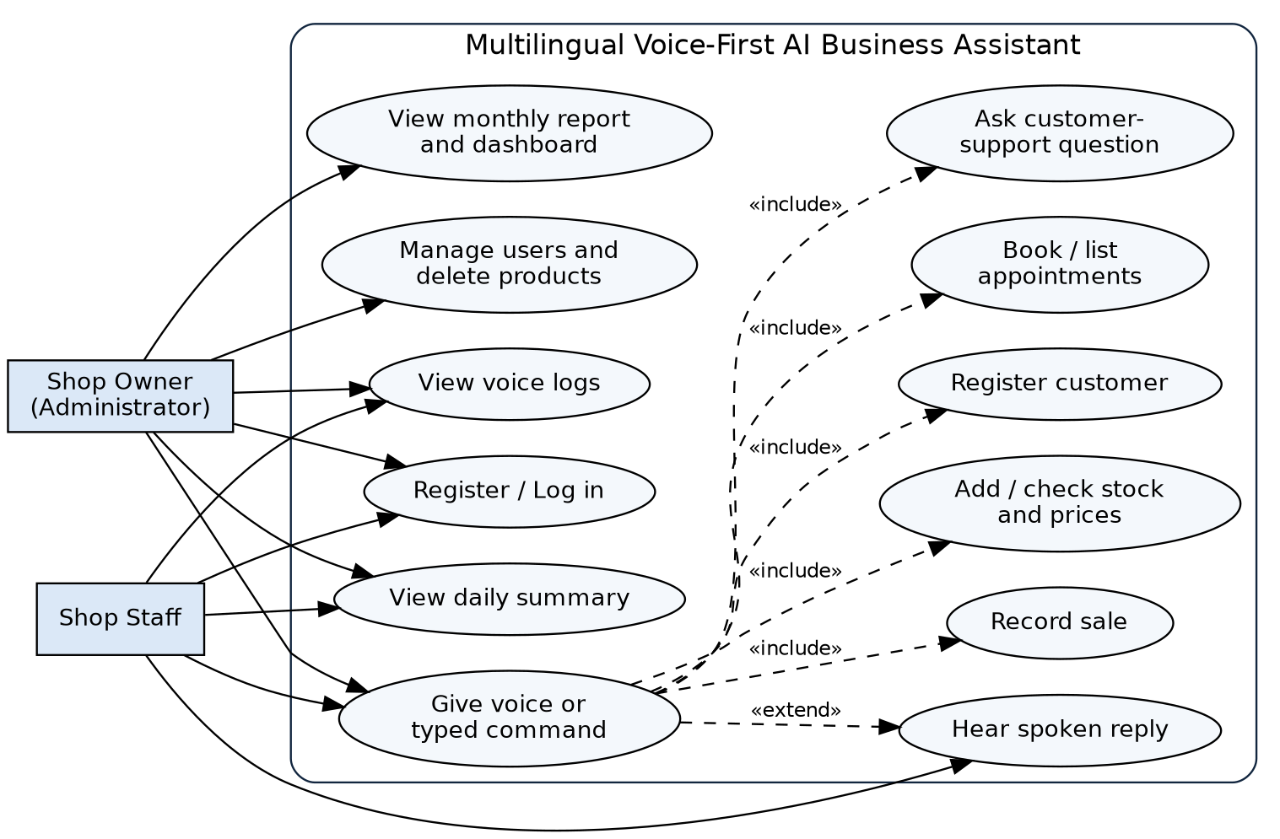
Figure 2.1: Use case diagram

2.5.2 Activity Diagram
Figure 2.2 shows the activities from the moment a user gives a command until the assistant replies. The system validates each command before changing the database, and it always produces a reply, even when the command cannot be understood.
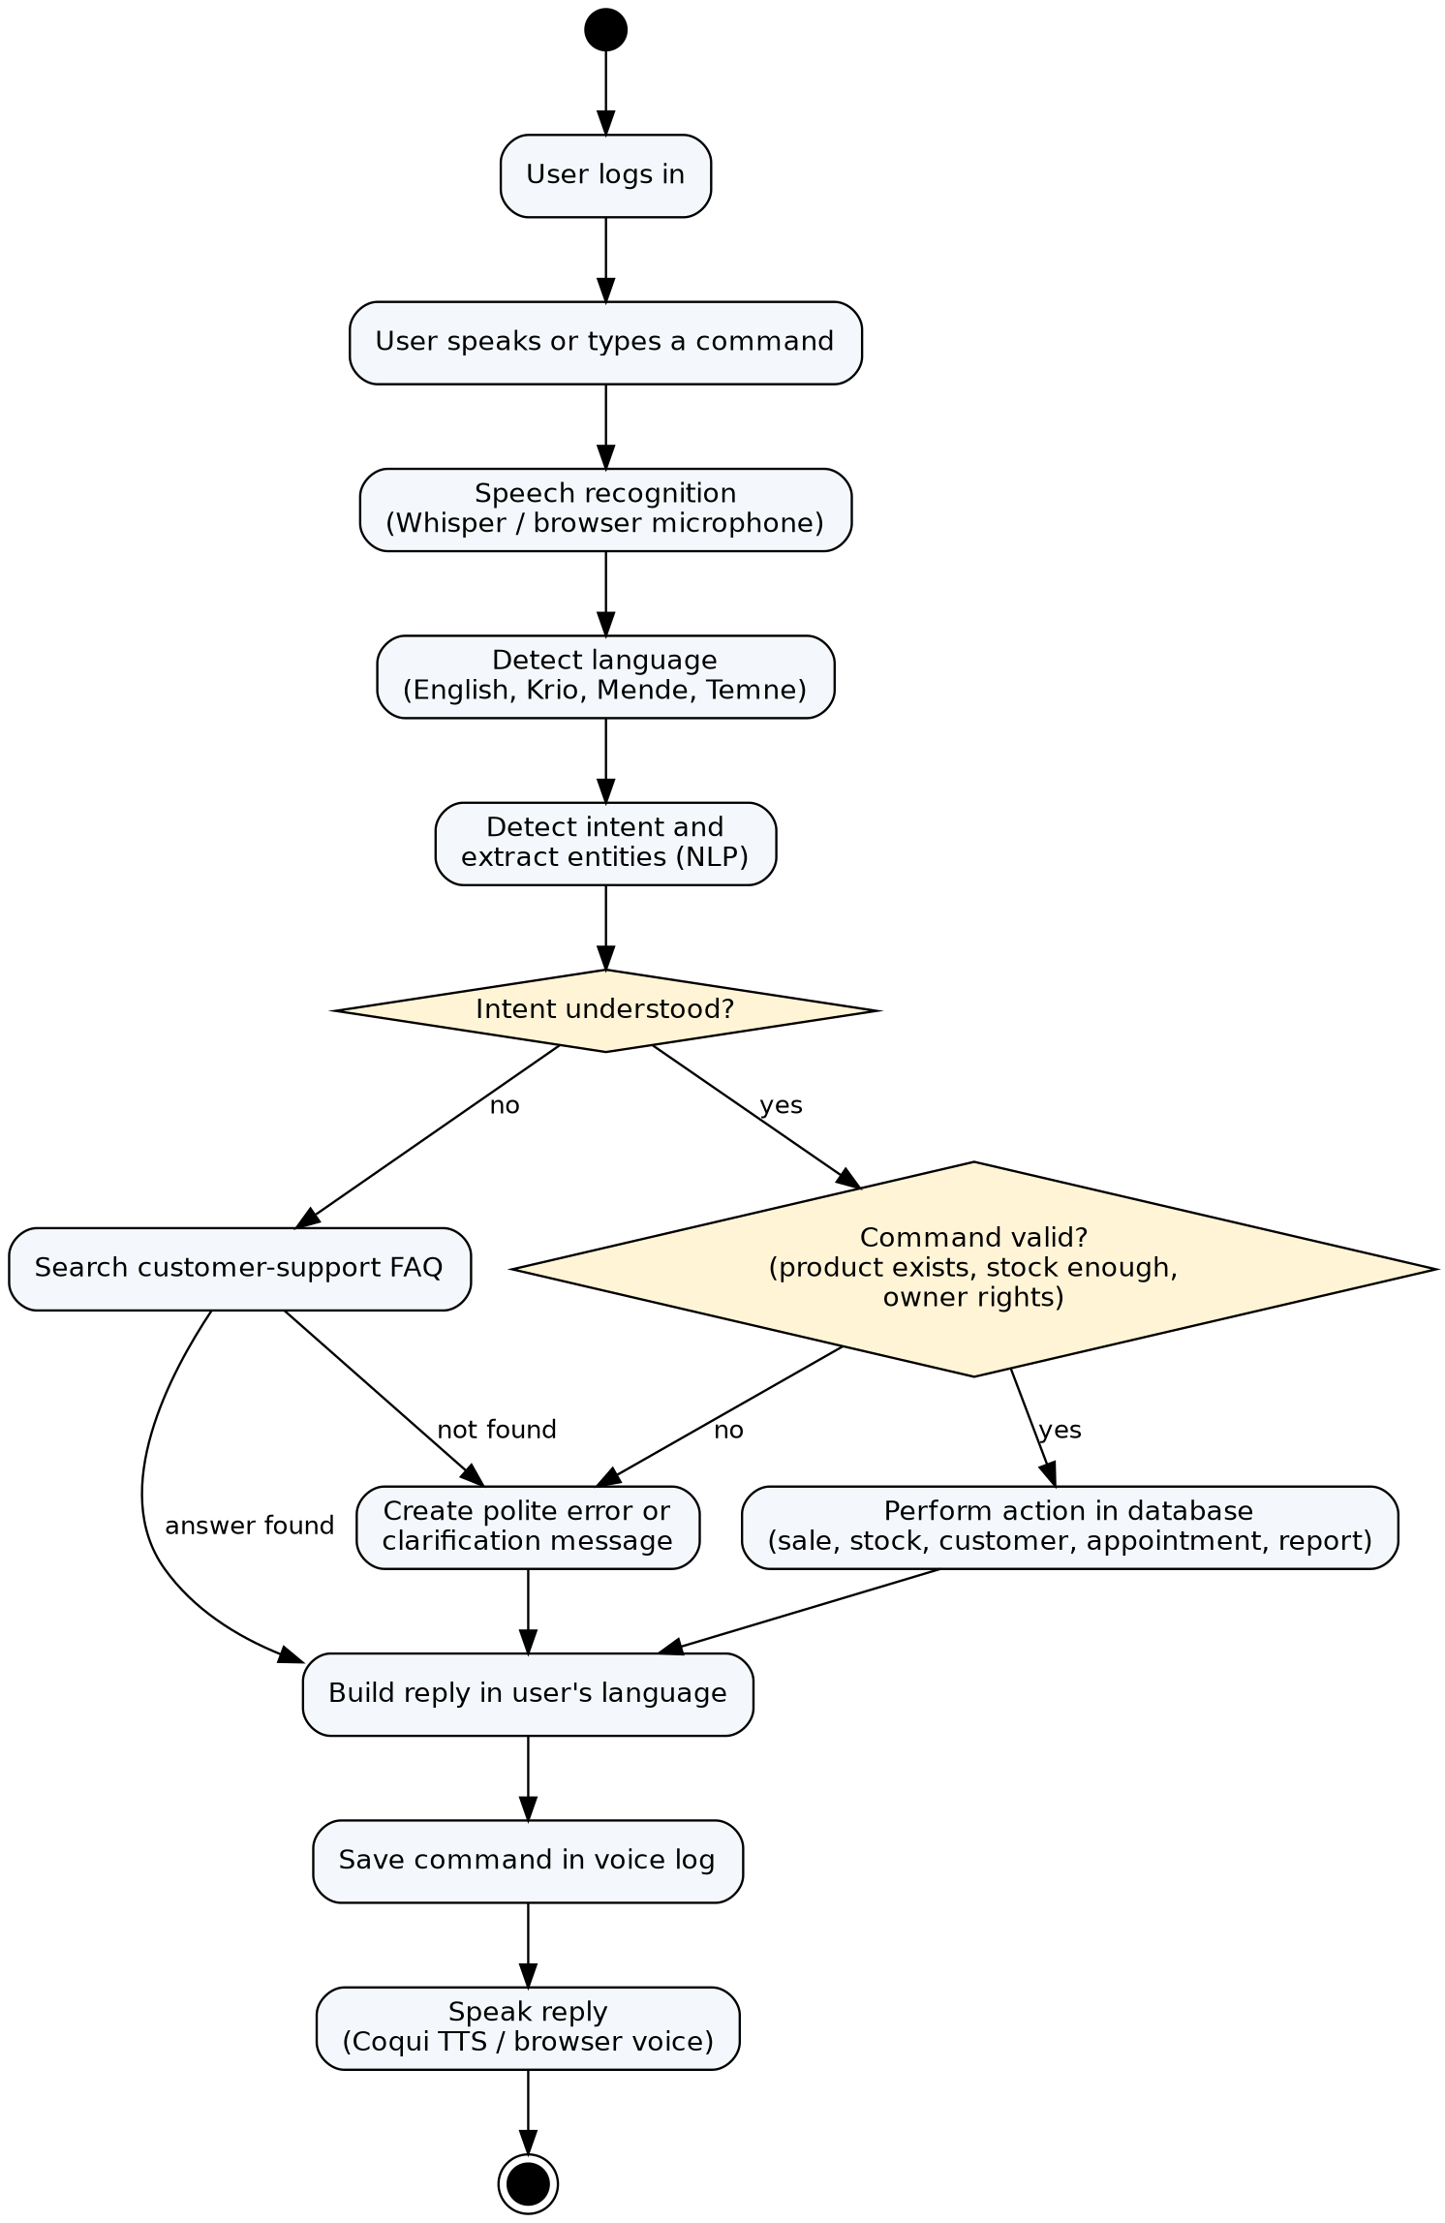
Figure 2.2: Activity diagram of a voice command

2.5.3 Class Diagram
The class diagram (Figure 2.3) shows the main data classes and the service classes of the system. The services correspond to the Python modules: the NLP parser, the business service, the speech service and the text-to-speech service.
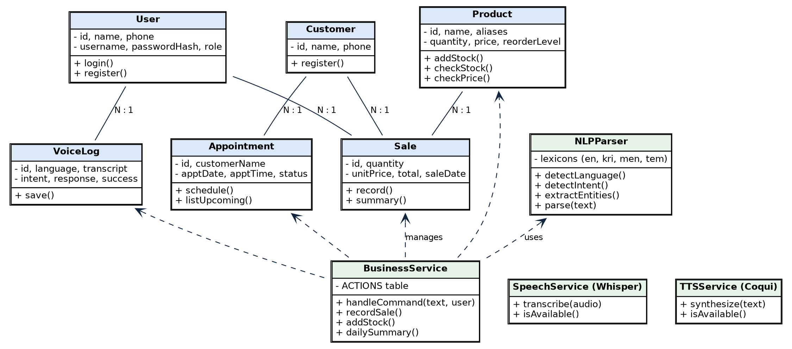
Figure 2.3: Class diagram

2.5.4 Entity Relationship Diagram
The database has seven tables (Figure 2.4). Sales link a product, a customer and the user who recorded the sale. Appointments link a customer and a user. Voice logs link to the user who spoke. The table of FAQs stores customer-support answers and is searched by keywords.
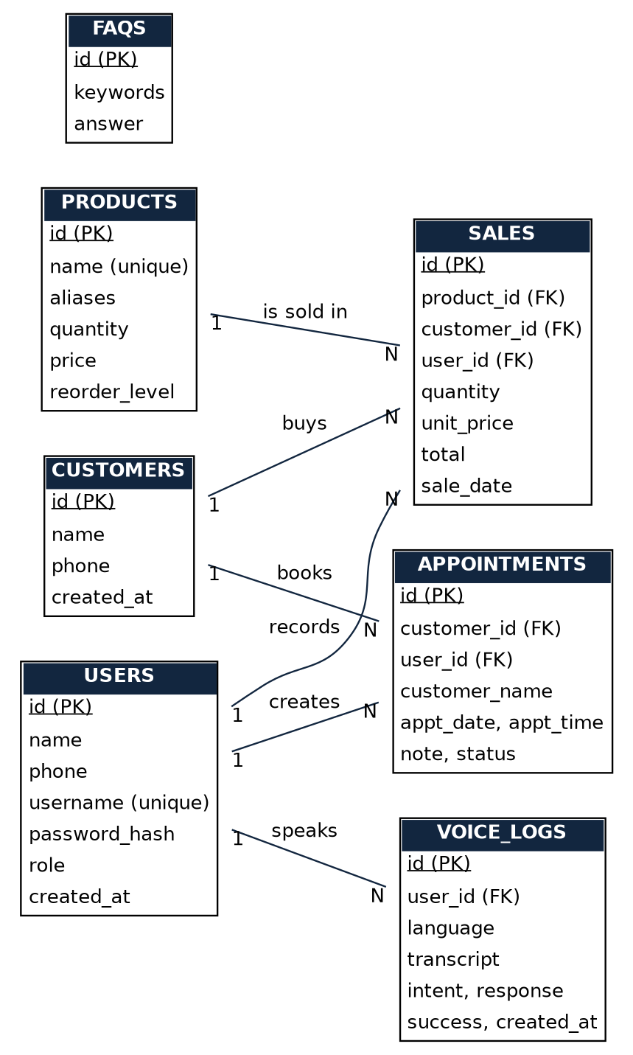
Figure 2.4: Entity relationship diagram

2.5.5 System Architecture
The system uses a three-layer architecture (Figure 2.5). The presentation layer is the web page or the Android application. The application layer is a Flask server written in Python that contains authentication, speech recognition, the NLP engine, the business logic layer and the text-to-speech engine. The data layer is an SQLite database for local, offline use, with a MySQL schema for larger deployments.
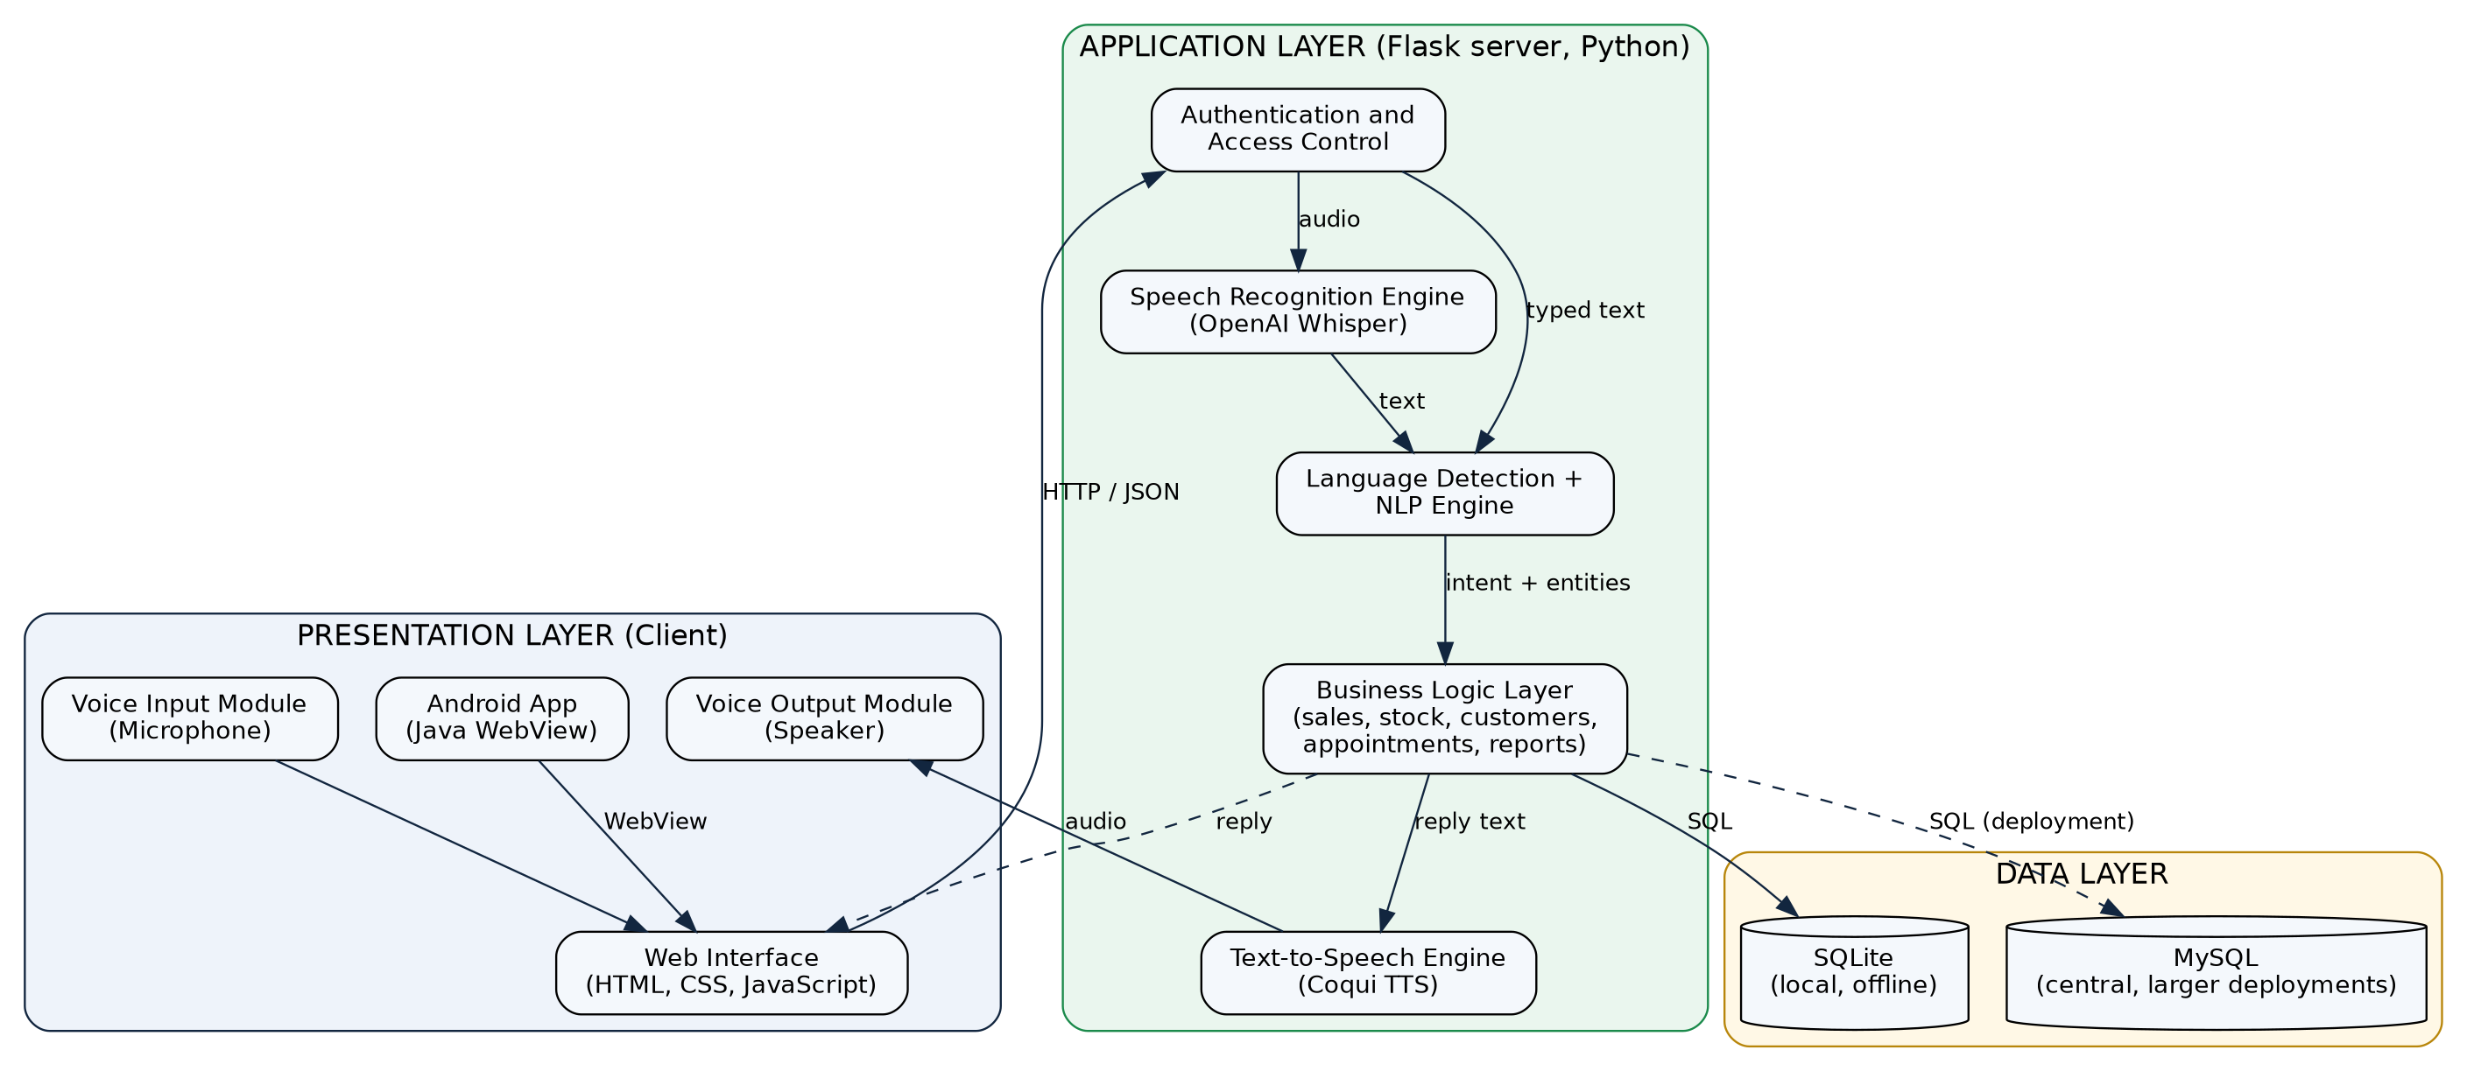
Figure 2.5: System architecture

2.5.6 Data Flow Diagrams
The context diagram (Figure 2.6) shows the system as one process that exchanges commands, replies and reports with its users. The level-1 diagram (Figure 2.7) breaks the system into five processes and four data stores.
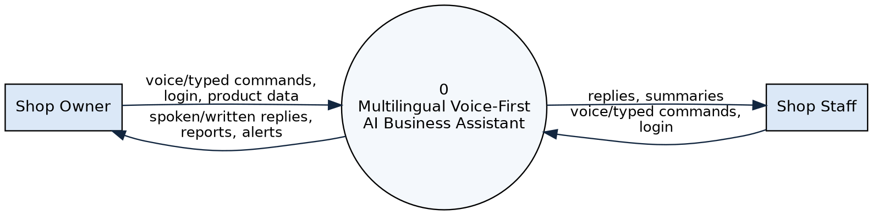
Figure 2.6: Data flow diagram, level 0 (context diagram)
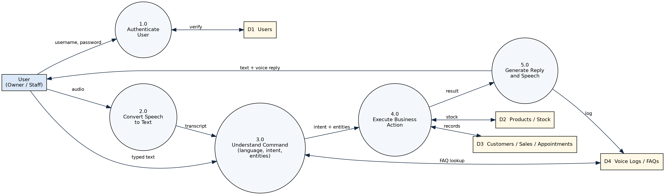
Figure 2.7: Data flow diagram, level 1

2.5.7 User Interface Design
The interface follows Human-Computer Interaction principles of simplicity, feedback and consistency. The main screen is a chat-style page. A large green microphone button is placed next to a text box, so the user can speak or type. Replies appear as speech bubbles that also show the detected language and intent, and the same replies are spoken aloud. A side panel lists example sentences that can be clicked, which helps first-time users to learn what to say. A navigation bar gives access to Inventory, Sales, Customers, Appointments, Reports (owner only) and Voice Logs. Figure 2.8 shows the designed layout of the main screen.
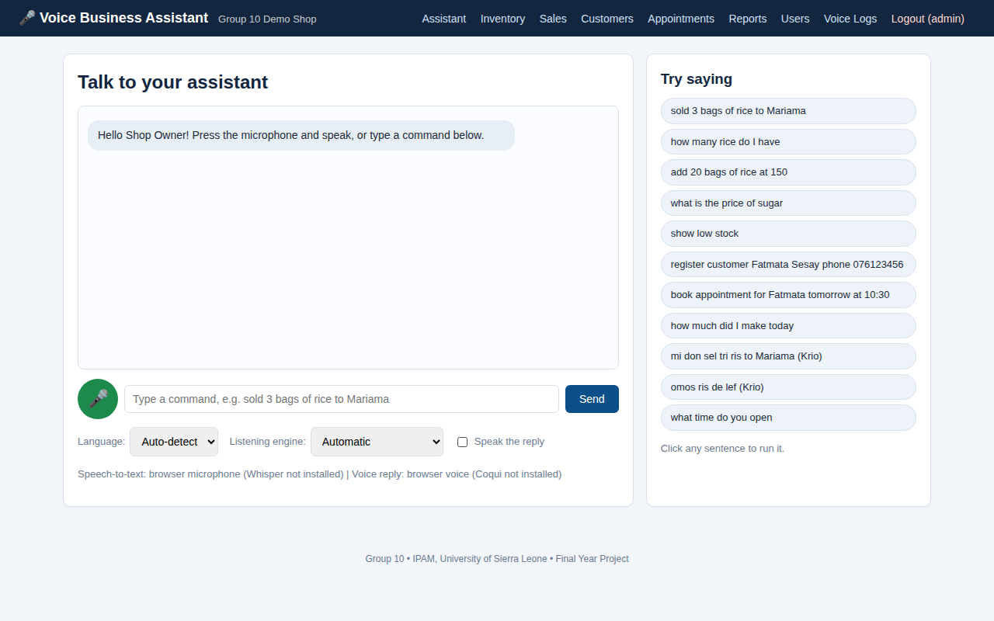
Figure 2.8: Interface design of the assistant screen

2.6 Technologies and Tools
The tools were chosen because they are free, widely documented and suitable for a low-resource environment. Table 2.5 lists each approved technology and how it was used.
Table 2.5: Technologies and tools used
Technology | Purpose in the project
Python 3 | Main programming language of the back end, NLP engine and tests
Flask | Web framework that provides the pages and the API
Java and Android Studio | Android application that displays the assistant on a phone and allows microphone use
OpenAI Whisper | Speech-to-text engine for recorded voice (Radford et al., 2022); installed as an optional component
Coqui TTS | Text-to-speech engine for spoken replies; installed as an optional component
Python NLP libraries | The rule-based NLP engine uses the Python standard libraries (re, unicodedata, json, datetime), so it needs no internet and no paid language-model service
SQLite | Local database used by the running prototype
MySQL and MySQL Workbench | Central database design (schema_mysql.sql) imported and viewed in MySQL Workbench for larger deployments
HTML, CSS and JavaScript | User interface pages, styling, microphone recording and speech playback
Git and GitHub | Version control and sharing of the source code with the supervisor
Visual Studio Code | Code editor and terminal used for development
Postman | Sending test requests to the API (for example /api/command) to check replies
Pytest and Android Emulator | Automated back-end tests; the Android application is tested on the Android Studio emulator
Graphviz and Draw.io | Drawing the system diagrams
Google Forms / KoboToolbox | Creating and collecting the questionnaire

2.7 System Development
This section explains how the system was actually built.

2.7.1 Project Structure
The source code is organised in folders so that each part of the system has one clear job (Table 2.6).
Table 2.6: Project files and their purpose
File or folder | Purpose
app.py | Starts the Flask server; defines the pages, login and API routes
config.py | Settings such as business name, secret key and Whisper model
database.py and schema.sql | Database connection, table creation and first owner account
nlp/parser.py | Language detection, intent detection and entity extraction
nlp/lexicons/*.json | Editable vocabulary for English, Krio, Mende and Temne
services/business.py | Business actions: sales, stock, customers, appointments, reports, FAQs
services/messages.py | Reply sentences in English and Krio
services/speech_service.py | Whisper speech-to-text
services/tts_service.py | Coqui text-to-speech
templates/ and static/ | HTML pages, CSS style and JavaScript
tests/ | Automated test cases
android_app/ | Android Studio project written in Java
database/schema_mysql.sql | MySQL version of the database design

2.7.2 Database Implementation
The database was implemented in SQLite using the schema in Appendix E. Foreign keys connect sales, appointments and logs to their related records, and check constraints prevent negative quantities and prices. All database queries use parameters instead of joining user text into SQL, which protects against SQL injection. On the first run the program creates the tables, one owner account and a few customer-support answers.

2.7.3 Natural Language Processing Engine
The NLP engine (nlp/parser.py) is rule-based. A rule-based design was chosen because no large Krio, Mende or Temne training datasets are available (Imam et al., 2025), it runs quickly on an ordinary computer and its behaviour is easy to test and explain. It processes each sentence in five steps:
- Normalisation: the text is converted to lower case and special letters such as the Krio ɔ and ɛ are folded to o and e, so that different spellings match the same word.
- Language detection: the sentence is scored against each language lexicon using its phrases and words. English wins ties, and the language with the highest score is chosen.
- Intent detection: all phrases in all lexicons are matched in the sentence. Longer phrases score higher, and a priority list resolves ties. Because every lexicon is searched, a sentence that mixes English and Krio is still understood.
- Entity extraction: number words ("twenty five", "tri") are converted to digits; the product is matched against the product names, aliases and built-in local product names (for example "ris" for rice); a price follows a price marker such as "at"; a customer follows a marker such as "to" or "for"; phone numbers, dates (for example 2026-10-05, tomorrow, Monday) and times (for example 3 pm, 10:30) are extracted with patterns.
- Dispatch: the intent is passed to the matching business function, which performs the action and produces the reply.
Table 2.7 lists the twelve intents that the engine understands, with examples.
Table 2.7: Voice command intents and examples
Intent | English example | Krio example
Record sale | Sold 3 bags of rice to Mariama | Mi don sel tri ris to Fatmata
Add stock | Add 20 bags of rice at 150 | Mi don bay 20 ris
Check stock | How many rice do I have | Omos ris de lef
Check price | What is the price of sugar | Pris fɔ sugah
Low stock | Show low stock | Stok lɔw
Register customer | Register customer Fatmata Sesay phone 076123456 | Rɛjista kɔstoma Fatmata
Schedule appointment | Book appointment for Mariama tomorrow at 10:30 | Buk apɔyntmɛnt fɔ Mariama tumara
List appointments | Show my appointments | Sho apɔyntmɛnt dɛm
Daily summary | How much did I make today | Aw mɔch mi mek tide
Monthly report | Give me the monthly report | Dis mɔnt rapɔt
Greeting | Good morning | Aw di bodi
Help | Help | Ɛp

Questions that match no intent, such as "What time do you open?", are checked against the keywords of the FAQ table to give customer-support answers. If nothing matches, the assistant politely says that it did not understand and suggests saying "help".

2.7.4 Business Logic Layer
The business logic layer (services/business.py) contains one function for each intent. Each function checks the command before changing data. For example, a sale is rejected if the product does not exist, if the quantity is missing, or if the stock is not enough. A successful sale creates a sale record, reduces the stock, registers a new customer if the name is new and warns the user when the product falls to its low-stock level. The monthly report is available only to the owner role. Every command, whether it succeeds or fails, is saved in the voice log table.

2.7.5 Speech Modules
Speech-to-text is provided by OpenAI Whisper. The browser records the voice with the MediaRecorder interface and sends the audio to the server, where Whisper converts it to text. Text-to-speech is provided by Coqui TTS, which creates an audio file from the reply. Because Whisper and Coqui TTS are large packages, the system checks whether they are installed. If they are not, the browser microphone (Web Speech API) and the browser voice (speech synthesis) are used instead, and typing is always available. Krio sentences are passed to Whisper with the English decoder because Krio is an English-based creole and Whisper does not list it as a supported language.

2.7.6 Web Interface
The web interface uses HTML templates rendered by Flask, a single CSS file and one JavaScript file. The pages are the login and registration pages, the assistant, inventory, sales, customers, appointments, reports, voice logs and users. The reports page shows today's and this month's sales, a seven-day bar chart, the top five products and the products that need restocking, all drawn with plain HTML and CSS so that no internet connection is needed.

2.7.7 Android Application
The Android application (Java, Android Studio) contains one activity with a WebView that opens the assistant page from the server. The application requests the RECORD_AUDIO permission and allows the web page to use the microphone. In this way the same business logic serves both the computer and the phone, and a change to the server is immediately available on the phone.

2.7.8 Security Measures
- Passwords are stored as salted hashes and never as plain text.
- Pages and API routes require login; unauthenticated API calls return an error.
- Owner-only pages (reports, users, deleting products) are protected by role checks.
- Session cookies are marked HttpOnly and SameSite.
- Parameterised SQL queries protect against SQL injection.

2.8 Testing Methodology
Testing was planned at four levels (Table 2.8), following the practice described by Pressman and Maxim (2020).
Table 2.8: Levels of testing
Level | What is tested | Method
Unit testing | Individual functions of the NLP engine: normalisation, number words, dates and the 22 sentence cases | Pytest automated tests
Integration testing | NLP engine, business logic and database working together through the command API | Pytest with the Flask test client and a temporary database
System testing | Login, access control, all pages, and complete business scenarios from command to database change | Pytest and manual testing in the browser; API requests with Postman
User acceptance testing | Whether real users can complete business tasks with the system | Task sheet and questionnaire completed by SME users (Appendix G)

Each automated test creates a fresh temporary database, so tests do not affect each other or the real data. A test passes when the actual result equals the expected result. The system is accepted when all automated tests pass and the user acceptance tasks can be completed.

2.9 Challenges Encountered and Solutions
Several problems were met during development. Table 2.9 records them and the solutions that were adopted.
Table 2.9: Challenges encountered and solutions
Challenge | Solution
Almost no training data for Krio, Mende and Temne | A rule-based NLP engine with editable lexicon files was used instead of training a model. Krio was implemented; Mende and Temne files were prepared for native speakers to complete.
Special Krio letters (ɔ, ɛ) and spelling variations broke word matching | All text and vocabulary are folded to plain letters before matching.
The word "fɔ" means both "for" and "four" in Krio | "fɔ" was left out of the number words; numbers from speech are normally written as digits by Whisper.
The word "for" can introduce a price ("for 500") or a customer ("for Mariama") | The word after the marker is examined: a number is a price, a name is a customer.
Two intents matched one sentence ("What did I sell today" matched sale and summary) | Longer phrases score higher, and a priority list resolves ties by placing the summary intents before the sale intent.
A Krio product name such as "ris" was not recognised as rice | Built-in local product names were added to the Krio lexicon and are matched with the product table. An automated test found this problem.
Whisper and Coqui TTS are large and difficult to install on some computers | They were made optional. The system detects them and otherwise uses the browser microphone and browser voice.
Poor or expensive internet connection | The server, database and NLP run locally; Whisper and Coqui TTS work offline once installed.
Plural and singular product names ("bags of rice" and "rices") | A simple singularisation step and a list of unit words that are ignored were added.

CHAPTER THREE: PRODUCT EVALUATION AND OUTCOMES
This chapter presents the developed system and the results of testing and evaluation. The results are stated as they were obtained. Their meaning is discussed in Chapter Four.

3.1 Developed System
The result of the project is a working prototype of the Multilingual Voice-First AI Business Assistant. It runs on a Windows computer as a Flask web application that is opened in a browser, and the Android application opens the same assistant on a phone. A shop owner can speak or type commands in English or Krio, and the assistant records sales, manages stock, registers customers, books appointments, answers customer-support questions and produces reports. The source code, database schema, tests and documentation are stored in a GitHub repository: [Insert the GitHub repository link here].
The system is started with the command "python app.py" and opened at http://127.0.0.1:5000. The first owner account is created automatically, and sample shop data can be loaded with the command "python seed_demo.py" for demonstration and testing.

3.2 System Features
Table 3.1: Features of the developed system
Feature | Description
User registration and login | Staff accounts can be created; passwords are hashed; sessions protect all pages
Roles and access control | The owner can see reports, users and delete products; staff cannot
Voice and text commands | Microphone button using Whisper or the browser microphone; text box; clickable example sentences
Language detection | English and Krio detected automatically; Mende and Temne lexicon files ready for completion
AI module (NLP engine) | Detects 12 intents and extracts product, quantity, price, customer, phone, date and time
Sales recording | Records a sale, reduces stock, registers new customers, warns of low stock
Inventory management | Adds stock, creates products, checks quantity and price, shows low-stock products
Customer management | Registers customers by voice or form
Appointment scheduling | Books appointments with date and time, lists upcoming appointments, marks them done
Customer support | Answers frequently asked questions such as opening hours and payment methods
Reporting | Daily summary by voice; owner dashboard with today, month, seven-day chart, top products and restock list
Spoken replies | Coqui TTS or the browser voice, which can be switched off
Voice logs | Every command, language, intent, reply and success status is stored
Android application | Java WebView application with microphone permission
Database | SQLite database in use; MySQL schema provided

3.3 System Interface
Figures 3.1 to 3.5 show the main interfaces of the developed system. The remaining screens are shown in Appendix C.
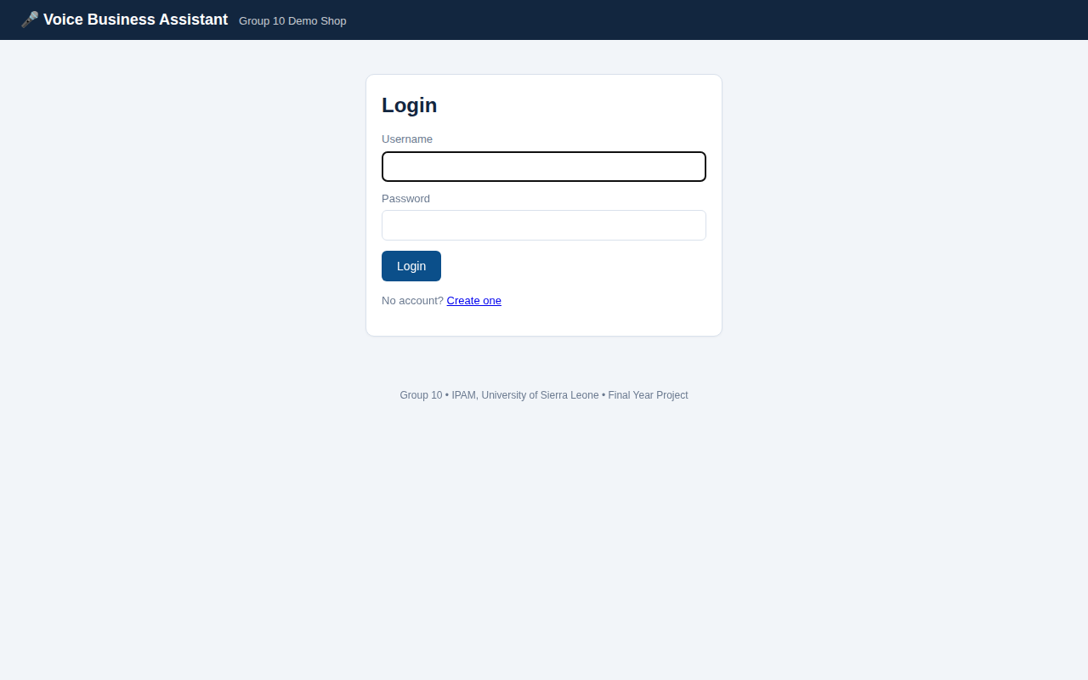
Figure 3.1: Login interface
Figure 3.2: User dashboard (assistant home screen)
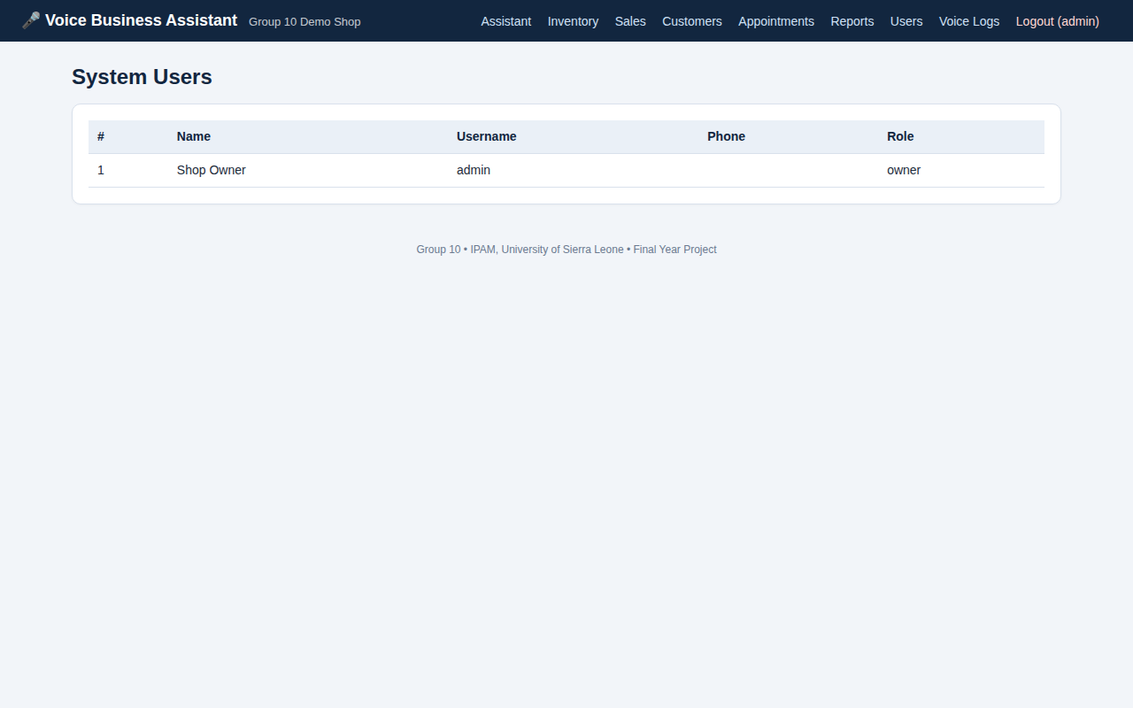
Figure 3.3: Administration dashboard (system users, available to the owner only)
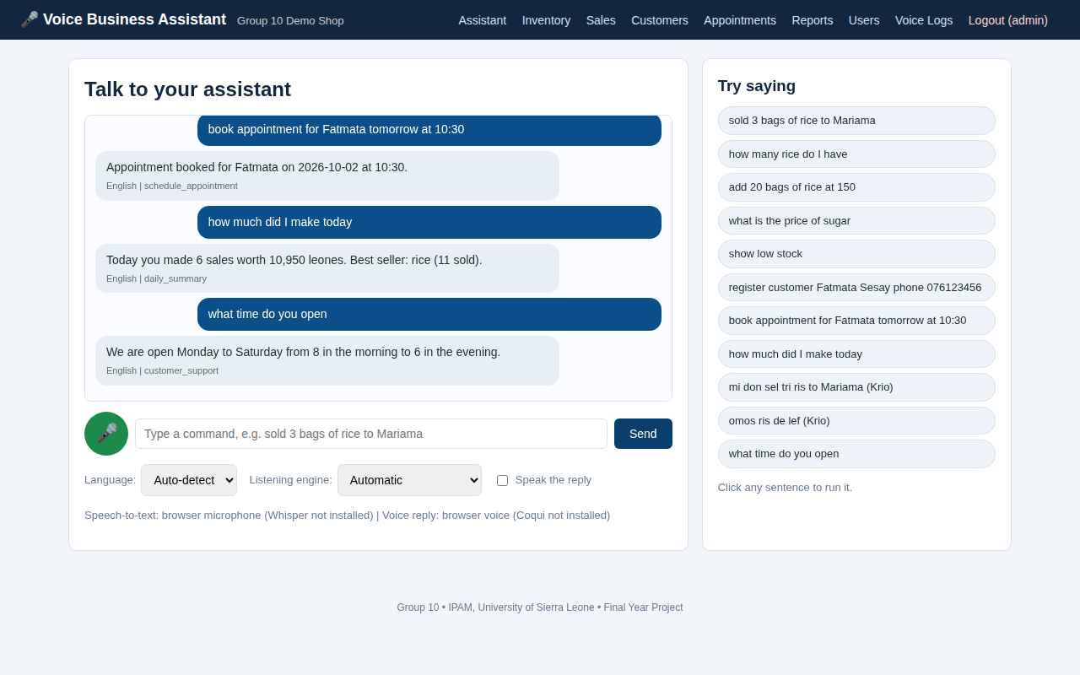
Figure 3.4: AI module: conversation with the assistant in English and Krio
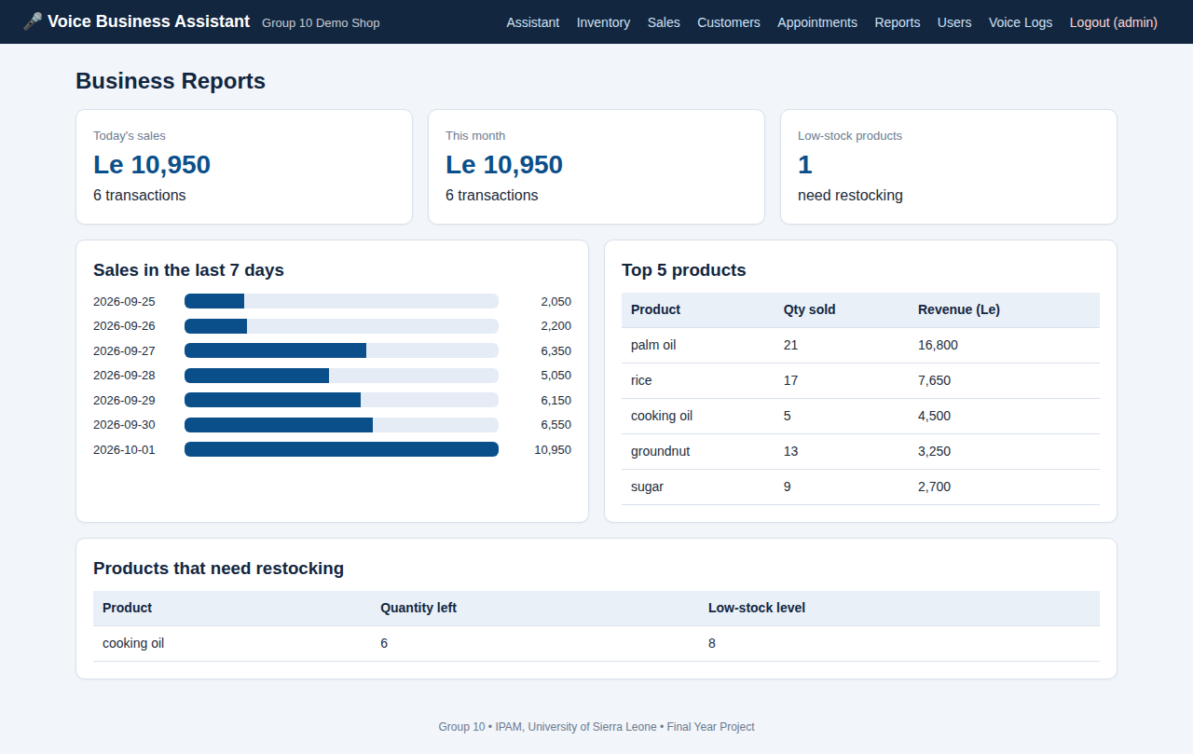
Figure 3.5: Reporting interface (owner only)

3.4 Testing Results

3.4.1 Summary of Automated Test Results
The automated tests were run with the command "python -m unittest discover -v -s tests -t ." on the final version of the code (the same test files can also be run with Pytest). A total of 29 test functions were executed, and all of them passed. Figure 3.6 shows the output of the test run, and the full list of tests is in Appendix D. Table 3.2 summarises the results by group.
Table 3.2: Summary of automated test results
Test group | Level | Test functions | Passed | Failed
NLP engine (nlp/parser.py) | Unit | 6 | 6 | 0
Login, roles and security | System | 7 | 7 | 0
Voice command scenarios | Integration / system | 14 | 14 | 0
Pages and speech endpoint | System | 2 | 2 | 0
Total |  | 29 | 29 | 0

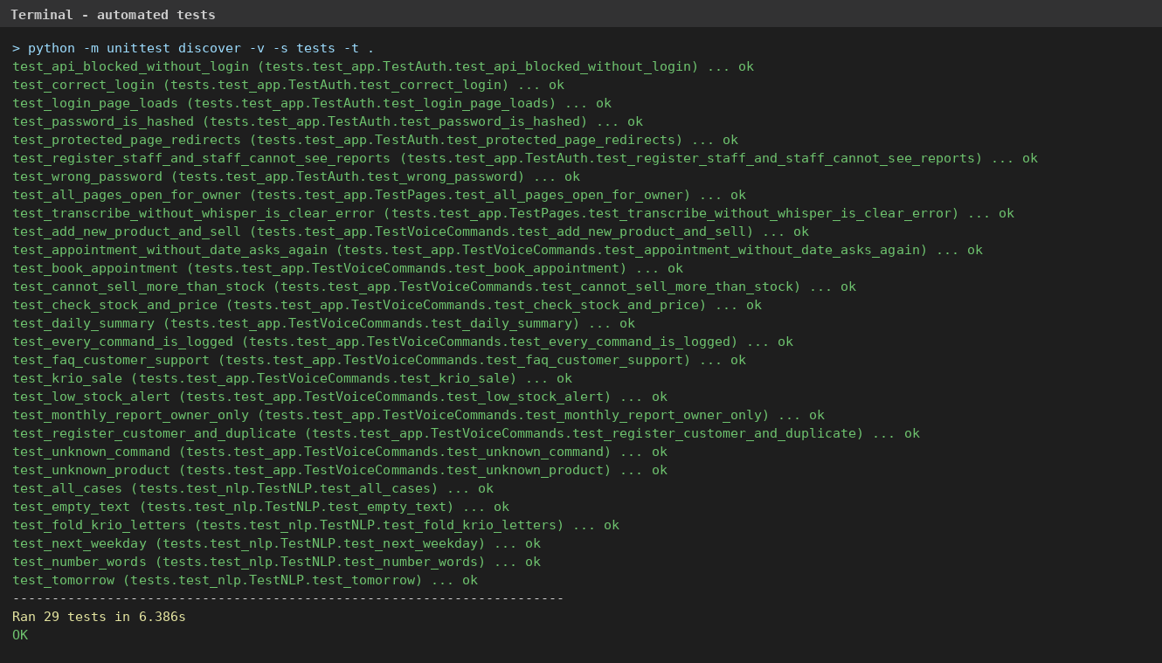
Figure 3.6: Terminal output of the automated test run (29 tests, all passed)

3.4.2 NLP Sentence Test Results
The NLP engine was tested with 22 sentences in English and Krio. For each sentence, the detected language and intent were compared with the expected values, and the extracted details (product, quantity, price, customer, phone, date, time) were also checked. Table 3.3 shows the results.
Table 3.3: NLP sentence test results
ID | Input sentence | Expected language | Expected intent | Result
TC01 | Sold 3 bags of rice to Mariama | English | record_sale | Pass
TC02 | sell two palm oil for 500 | English | record_sale | Pass
TC03 | I sold twenty five rice | English | record_sale | Pass
TC04 | add 20 bags of rice at 150 | English | add_stock | Pass
TC05 | restock sugar 30 | English | add_stock | Pass
TC06 | how many rice do I have | English | check_stock | Pass
TC07 | what is the price of sugar | English | check_price | Pass
TC08 | show low stock | English | low_stock | Pass
TC09 | register customer Fatmata Sesay phone 076 123 456 | English | register_customer | Pass
TC10 | book appointment for Mariama on 2026-10-05 at 3 pm | English | schedule_appointment | Pass
TC11 | schedule appointment with Abu at 10:30 am | English | schedule_appointment | Pass
TC12 | how much did I make today | English | daily_summary | Pass
TC13 | what did I sell today | English | daily_summary | Pass
TC14 | give me the monthly report | English | monthly_report | Pass
TC15 | good morning | English | greeting | Pass
TC16 | help | English | help | Pass
TC17 | mi don sel tri ris to Fatmata | Krio | record_sale | Pass
TC18 | omos ris de lef | Krio | check_stock | Pass
TC19 | aw di bodi | Krio | greeting | Pass
TC20 | pris fɔ sugah | Krio | check_price | Pass
TC21 | mi don sel 2 ris | Krio | record_sale | Pass
TC22 | banana bicycle moon | English | none (unknown) | Pass

All 22 sentences (100%) were understood as expected: 17 English sentences and 5 Krio sentences. One sentence with no business meaning (TC22) was correctly rejected.

3.4.3 Business Scenario Test Results
Table 3.4: Business scenario test results
Scenario tested | Expected result | Result
Add a new product by voice, then sell 3 units to a customer | Stock falls from 20 to 17; reply gives total of 450 leones | Pass
Sell more than the available stock | Sale refused; stock unchanged | Pass
Check stock and price by voice | Reply states the correct quantity and price | Pass
Ask about a product that does not exist | Polite failure message | Pass
Register a customer, then register the same name again | Second attempt reports that the customer already exists | Pass
Book an appointment with date and time, then list appointments | Appointment stored and listed | Pass
Book an appointment without a date | Assistant asks for the date; nothing is stored | Pass
Show low stock after adding a small quantity | Product appears in the low-stock reply | Pass
Ask for today's summary after a sale | Reply contains the correct total | Pass
Ask a customer-support question | FAQ answer returned | Pass
Record a sale with a Krio sentence | Language is Krio; stock reduced correctly | Pass
Say a sentence with no meaning | Failure message; command still logged | Pass
Staff user asks for the monthly report | Refused; owner-only | Pass
Staff user opens the reports and users pages | Access denied (403) | Pass

3.4.4 Speech Module Test Results
The speech modules were tested by speaking the commands in Table 3.5 into the microphone on the group's laptop and recording whether the text produced was correct. [Complete this table after installing Whisper and testing. Write the number of correct recognitions out of the number of attempts, and the microphone and room conditions used.]
Table 3.5: Speech recognition test results
Spoken command | Language | Attempts | Correctly recognised | Notes
Sold three bags of rice to Mariama | English | [ ] | [ ] | [ ]
How many rice do I have | English | [ ] | [ ] | [ ]
Add twenty bags of rice at 150 | English | [ ] | [ ] | [ ]
Omos ris de lef | Krio | [ ] | [ ] | [ ]
Mi don sel tri ris | Krio | [ ] | [ ] | [ ]

3.5 User Evaluation

3.5.1 Procedure
User acceptance testing was carried out with SME owners and employees. Each participant was shown the system for about five minutes and was then asked to complete the tasks in the task sheet (Appendix G). The evaluator recorded whether each task was completed and how long it took. Afterwards, each participant rated five statements on a scale from 1 (strongly disagree) to 5 (strongly agree). The statements are based on perceived usefulness and ease of use from the Technology Acceptance Model (Davis, 1989). [Insert the number of participants and the date and place of testing.]

3.5.2 Task Completion Results
Table 3.6: Task completion results
Task | Participants who completed the task | Average time (seconds)
T1 Log in | [ ] of [ ] | [ ]
T2 Add a product and stock by voice or text | [ ] of [ ] | [ ]
T3 Record a sale in English | [ ] of [ ] | [ ]
T4 Record a sale in Krio | [ ] of [ ] | [ ]
T5 Check stock and price | [ ] of [ ] | [ ]
T6 Register a customer | [ ] of [ ] | [ ]
T7 Book an appointment | [ ] of [ ] | [ ]
T8 Ask for today's summary | [ ] of [ ] | [ ]

3.5.3 User Rating Results
Table 3.7: Average user ratings (scale 1 to 5)
Statement | Average rating
The assistant is easy to use. | [ ]
Speaking a command is easier than writing in a record book. | [ ]
The assistant understood what I said. | [ ]
The replies were clear and useful. | [ ]
I would use this assistant in my business. | [ ]

3.6 Summary of Outcomes
- A working web application and an Android application were developed and run.
- The assistant supports 12 voice-command intents and FAQ answers in English and Krio; Mende and Temne lexicon files are present but not yet filled with vocabulary.
- Sales, stock, customers, appointments, summaries and reports were performed and stored in the database.
- All 29 automated test functions passed, including 22 of 22 NLP sentence cases.
- Staff users were refused access to owner-only pages and reports in testing.
- Speech recognition and user evaluation results are presented in Tables 3.5 to 3.7.

CHAPTER FOUR: DISCUSSION AND REFLECTIVE ANALYSIS

4.1 Interpretation of Findings
The automated tests show that the NLP engine, business logic and database work together as designed for the commands in the test set. The 22 sentence cases show that the rule-based approach can reliably detect the language, intent and details of supported English and Krio commands, including number words, dates and times. The business scenario tests show that the system protects the data: it refuses sales that would make stock negative, asks for missing information instead of guessing, and restricts owner-only functions.
These results must be read with care. The test sentences were written by the developers, so they show that the system follows its designed patterns, not that it understands every way in which a real shopkeeper might speak. The speech and user evaluation results in Section 3.5 give the more realistic view of performance with real voices and real users.

4.2 Achievement of Project Objectives
Table 4.1: Achievement of the project objectives
Objective | Status | Evidence
1. Analyse requirements | Achieved | 16 functional and 8 non-functional requirements (Section 2.4)
2. Design architecture | Achieved | Seven design diagrams and a three-layer architecture (Section 2.5)
3. Develop and implement | Achieved for English and Krio | Working web and Android applications with 12 intents (Chapter 3); Mende and Temne need vocabulary
4. Test the system | Achieved | 29 of 29 automated tests passed; user acceptance procedure prepared and applied (Section 3.5)
5. Assess effectiveness | Achieved through testing and evaluation | Section 3.4 and Section 3.5; discussed in Section 4.3

4.3 Evaluation Against the Problem
Chapter One identified five parts of the problem. The table below compares each with what the system delivers.
Table 4.2: Evaluation of the system against the identified problem
Part of the problem | How the system responds
Manual and error-prone record keeping | Sales, stock, customers and appointments are stored in a database and reports are generated automatically.
Language barrier | Commands can be given in English or Krio and the reply is returned in the same language; other languages can be added through lexicon files.
Limited digital literacy | One spoken or typed sentence performs a task, and clickable examples teach users what to say.
Cost of software | All components are free and open source; there is no subscription.
Unreliable internet | The server, database and NLP engine run locally; Whisper and Coqui TTS run offline once installed. The browser microphone option still needs internet.

The system therefore addresses each part of the problem for the supported languages and functions. It does not yet solve the shortage of speech data for Mende and Temne, which requires community-based data collection.

4.4 Strengths of the Developed System
- It combines voice input, language understanding, real business functions and reports in one low-cost system.
- It works even when the heavy speech packages are not installed, by using the browser microphone, the browser voice or typing.
- Vocabulary is stored in simple JSON files, so new words and languages can be added without programming.
- The behaviour is predictable and explainable, which makes the system easy to test and defend.
- Security basics are in place: hashed passwords, sessions, role checks and parameterised queries.
- The same server serves a computer and an Android phone.

4.5 Limitations of the System
- The Krio vocabulary is small, and the Mende and Temne files are starter files only.
- Speech recognition for local languages is approximate because Whisper does not list them as supported languages.
- The rule-based engine understands defined patterns and may fail with very different sentence structures.
- Spoken replies in Krio use an English voice, so pronunciation is not natural.
- The prototype serves one shop, has no payment integration and does not use HTTPS.
- The user evaluation involved a small number of participants and cannot be generalised to all SMEs.

4.6 Lessons Learned
- Writing automated tests early found real mistakes, such as the missing local name for rice, before users saw them.
- A simple, well-tested rule-based design can be more suitable than a complex model when data is scarce.
- Making heavy components optional greatly reduced installation problems on ordinary computers.
- Language is cultural as well as technical: correct local vocabulary must come from native speakers.
- Clear folder structure, Git version control and regular group meetings made teamwork easier.

4.7 Reflection on the Development Process
What worked well: the iterative approach allowed the group to deliver a working part of the system at the end of each cycle. Splitting the code into the NLP engine, business logic and interface made it possible for members to work on different parts. Testing with the Flask test client made it easy to repeat tests after every change.
What did not work well: the first plan to depend on Whisper and Coqui TTS alone was unrealistic for low-power computers and difficult installations. Early lexicons also missed common spoken variations, which had to be added after testing.
What was learned: the group learned Python, Flask, SQL, version control, software testing and the basics of NLP and speech technology, and also learned to plan work, document decisions and solve problems together.
What would be changed: with more time, the group would begin the collection of Krio, Mende and Temne voice samples earlier, involve users in design from the first iteration, and add HTTPS and request-forgery protection from the start.

CHAPTER FIVE: CONCLUSION AND RECOMMENDATIONS

5.1 Conclusion
This project set out to design, develop and evaluate a multilingual voice-first AI business assistant for low-resource SMEs. The group analysed the requirements, designed a three-layer architecture, and built a working system that lets a shop owner record sales, manage stock, register customers, book appointments, ask customer-support questions and read reports by speaking or typing in English or Krio. The system was implemented in Python and Flask with an SQLite database, OpenAI Whisper and Coqui TTS as optional speech components, a web interface and a Java Android application. It passed all 29 automated tests, and a user evaluation procedure was prepared and applied.
The project shows that a useful, low-cost voice-first business tool for a local-language environment can be built with open-source software and without large training datasets. The work also shows what remains to be done: building speech and text resources for Mende, Temne and other languages of Sierra Leone.

5.2 Recommendations
- SME owners should begin to move records from notebooks to a digital system, starting with sales and stock.
- Institutions such as IPAM, the University of Sierra Leone and development organisations should support community collection of Krio, Mende and Temne speech and text data.
- Future developers should ask native speakers to complete and verify the Mende and Temne lexicon files before deployment.
- Before real use in a business, HTTPS, request-forgery protection, regular backups and a stronger password policy should be added.
- Training sessions should be organised for SME owners so that they are comfortable with voice-based interaction.

5.3 Future Development
- Fine-tune a speech recognition model for Krio and other local languages using collected recordings.
- Add more languages and a larger vocabulary, and support free-form sentences with a machine-learning language model.
- Add mobile-money payment, receipts and printing.
- Synchronise the local SQLite database with a central MySQL database for shops with several branches.
- Build a native Android interface with offline voice recognition.
- Add reminders for appointments and low-stock alerts by SMS.
- Add charts for profit and expense tracking.

REFERENCES
Adebara, I., Elmadany, A., & Abdul-Mageed, M. (2024). Cheetah: Natural language generation for 517 African languages. arXiv. https://doi.org/10.48550/arXiv.2401.01053
Android Developers. (n.d.). WebView. Google. https://developer.android.com/reference/android/webkit/WebView
Coqui. (n.d.). Coqui TTS: A deep learning toolkit for text-to-speech [Software]. GitHub. https://github.com/coqui-ai/TTS
Davis, F. D. (1989). Perceived usefulness, perceived ease of use, and user acceptance of information technology. MIS Quarterly, 13(3), 319–340. https://doi.org/10.2307/249008
Hussain Shahadat, M. M., Nekmahmud, M., Ebrahimi, P., & Fekete-Farkas, M. (2023). Digital technology adoption in SMEs: What technological, environmental and organizational factors influence SMEs' ICT adoption in emerging countries? Global Business Review. https://doi.org/10.1177/09721509221137199
Imam, S. H., Sani, B., Gete, D. K., Ahmed, B. Y., Ahmad, I. S., Abdulmumin, I., Yimam, S. M., Bello, M. Y., & Muhammad, S. H. (2025). Automatic speech recognition for African low-resource languages: Challenges and future directions. In Proceedings of the Sixth Workshop on African Natural Language Processing (pp. 89–95). Association for Computational Linguistics.
Jurafsky, D., & Martin, J. H. (2024). Speech and language processing (3rd ed., draft). Pearson.
Kanthed, S. (2023). The role of chatbots in reducing customer support response time in e-commerce. International Journal of Scientific Research in Engineering and Management, 7(3), 1–7.
Kedi, W. E., Kamukama, R., & Mugisha, J. M. (2024). AI chatbot integration in SME marketing platforms: Improving customer interaction and service efficiency. International Journal of Management & Entrepreneurship Research, 6(7), 2332–2341. https://doi.org/10.51594/ijmer.v6i7.1327
Mbaye, D., Mbengue, T. D. P., Seye, M. R., Diallo, M., Ndiaye, M. L., Adjanohoun, D. S., Wade, C. S., Sow, D., Munyaka, J.-C. B., & Chenal, J. (2026). Opportunities and challenges of natural language processing for low-resource Senegalese languages in social science research. arXiv. https://doi.org/10.48550/arXiv.2601.09716
Mozilla Developer Network. (n.d.). Web Speech API. MDN Web Docs. https://developer.mozilla.org/en-US/docs/Web/API/Web_Speech_API
Nazir, S., Collignon, S. E., & Surendra, N. C. (2024). Understanding collective ownership in agile development: Turbo charging the process. Information & Management, 61(6), Article 104004. https://doi.org/10.1016/j.im.2024.104004
OECD. (2021). The digital transformation of SMEs. OECD Publishing. https://doi.org/10.1787/bdb9256a-en
OpenAI. (n.d.). Whisper: Robust speech recognition via large-scale weak supervision [Software]. GitHub. https://github.com/openai/whisper
Pallets Projects. (n.d.). Flask documentation. https://flask.palletsprojects.com/
Panigrahi, R., Shrivastava, A., Qureshi, K., Mewada, B., Alghamdi, S., Almakayeel, N., Almuflih, A., & Qureshi, M. R. (2023). AI chatbot adoption in SMEs for sustainable manufacturing supply chain performance: Mediational research in an emerging country. Sustainability, 15(18), Article 13743. https://doi.org/10.3390/su151813743
Pressman, R. S., & Maxim, B. R. (2020). Software engineering: A practitioner's approach (9th ed.). McGraw-Hill.
pytest-dev. (n.d.). pytest documentation. https://docs.pytest.org/
Python Software Foundation. (n.d.). Python documentation. https://docs.python.org/3/
Radford, A., Kim, J. W., Xu, T., Brockman, G., McLeavey, C., & Sutskever, I. (2022). Robust speech recognition via large-scale weak supervision. arXiv. https://doi.org/10.48550/arXiv.2212.04356
Ramki, G., Markan, R., Natarajan, S., & Rajalakshmi, M. (2024). AI-powered chatbots in customer service: Impact on brand loyalty and conversion rates. Economic Sciences, 20, 190–203.
Soares, E., Sizilio, G., Santos, J., Da Costa, D. A., & Kulesza, U. (2022). The effects of continuous integration on software development: A systematic literature review. Empirical Software Engineering, 27(3), Article 78. https://doi.org/10.1007/s10664-022-10119-6
SQLite Consortium. (n.d.). SQLite documentation. https://www.sqlite.org/docs.html
Tan, X., Qin, T., Soong, F., & Liu, T.-Y. (2021). A survey on neural speech synthesis. arXiv. https://doi.org/10.48550/arXiv.2106.15561
Yusuf, S., Durodola, R., Ocran, G., Abubakar, J., Amarachi, Z., Echere, A., & Paul-Adeleye, A. (2024). Challenges and opportunities in AI and digital transformation for SMEs: A cross-continental perspective. World Journal of Advanced Research and Reviews, 23(2), 668–678.

APPENDICES

Appendix A: Questionnaire
Title: Multilingual Voice-First AI Business Assistant for Low-Resource SMEs. Dear respondent, we are students of IPAM, University of Sierra Leone. Your answers are voluntary and confidential and will be used only for this academic project.

Section A: Business Profile
- Type of business: Retail / Wholesale / Pharmacy / Restaurant / Salon / Other: ________
- Years in business: Less than 1 / 1–3 / 4–10 / More than 10
- Number of employees: 1 / 2–5 / 6–10 / More than 10
- Which language do you use most with customers? English / Krio / Mende / Temne / Limba / Other: ________

Section B: Current Record Keeping
- How do you record sales? Notebook / Phone / Computer / I do not record
- How do you know when stock is running out? Counting / Notebook / Computer / I do not know
- What is your biggest problem in keeping records? ____________________________

Section C: Technology Use
- Do you own a smartphone? Yes / No
- How often do you have internet access in your shop? Always / Sometimes / Rarely / Never
- Have you used a voice assistant (for example Google Assistant)? Yes / No
- How comfortable are you typing in English? Very comfortable / Comfortable / Not comfortable

Section D: Expectations (1 = Strongly Disagree, 5 = Strongly Agree)
- I would prefer to speak to a business system instead of typing. 1 2 3 4 5
- A system that understands Krio would be easier for me to use. 1 2 3 4 5
- I would use a voice assistant to record sales and check stock. 1 2 3 4 5
- Comments or suggestions: ________________________________________

Appendix B: Interview Questions
- Please tell us about your business and how long you have operated it.
- How do you record sales, stock and customers each day?
- What problems do you meet with these methods?
- Which languages do you and your customers speak in the shop?
- Have you tried any computer or phone application for your business? What was your experience?
- What tasks would you like a voice assistant to do for you?
- What would make you trust or not trust such a system?
- Do you have any other suggestions?

Appendix C: System Screenshots
This appendix shows the system screens that are not included in Section 3.3.
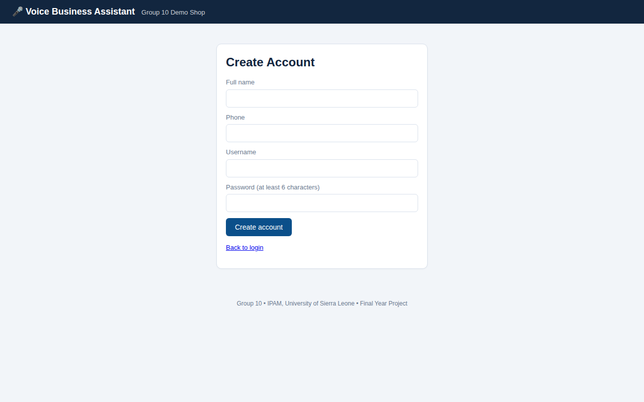
Figure C.1: Account registration page
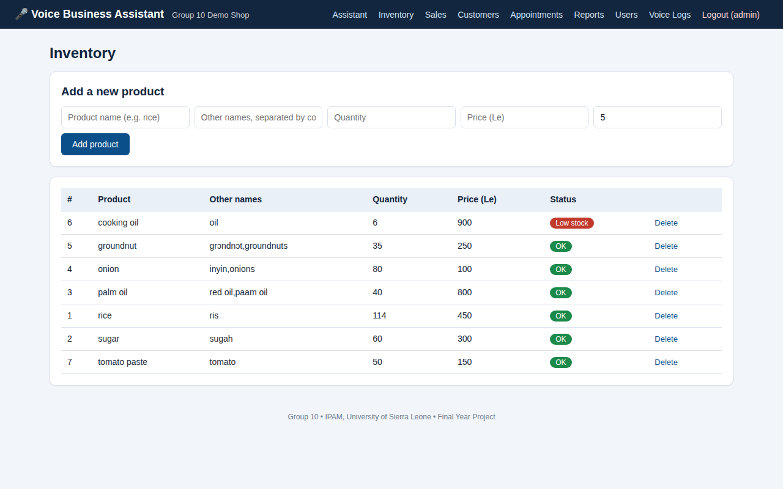
Figure C.2: Inventory page
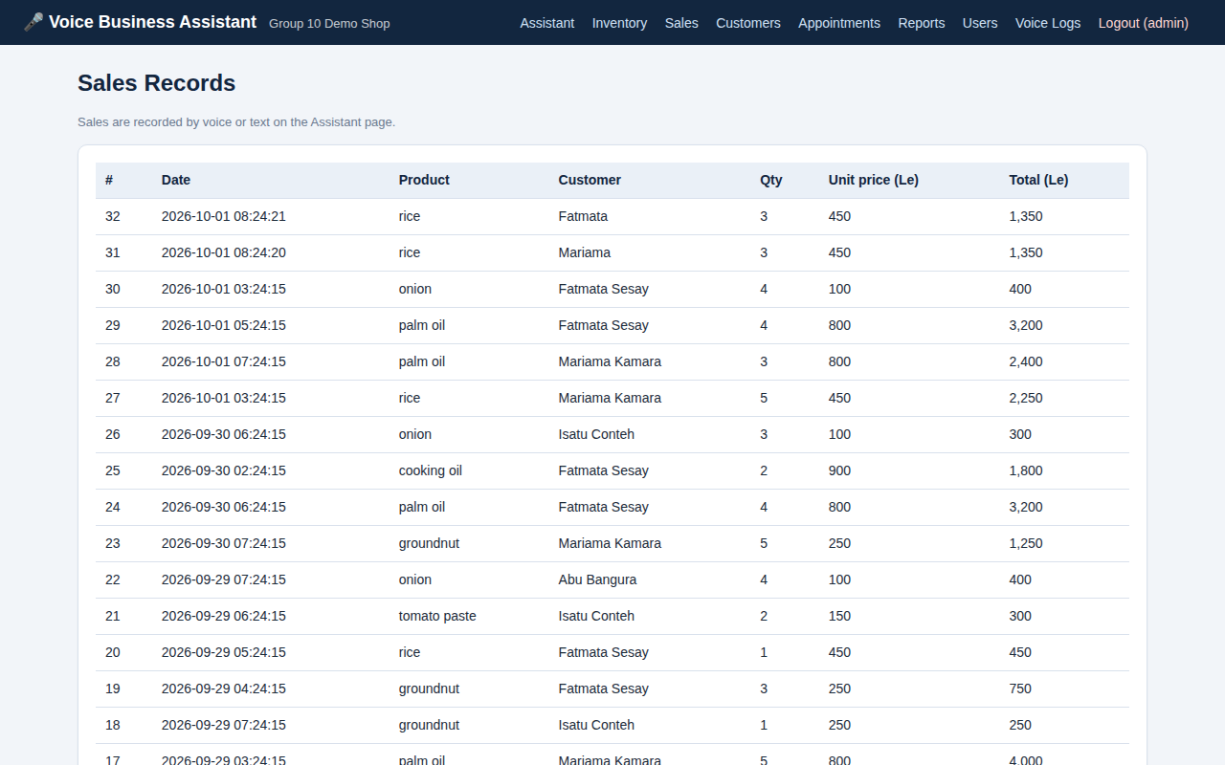
Figure C.3: Sales records page
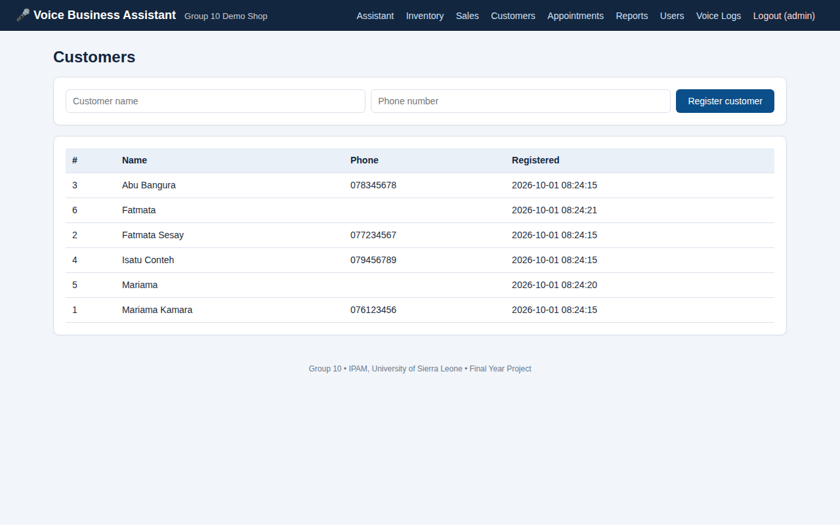
Figure C.4: Customers page
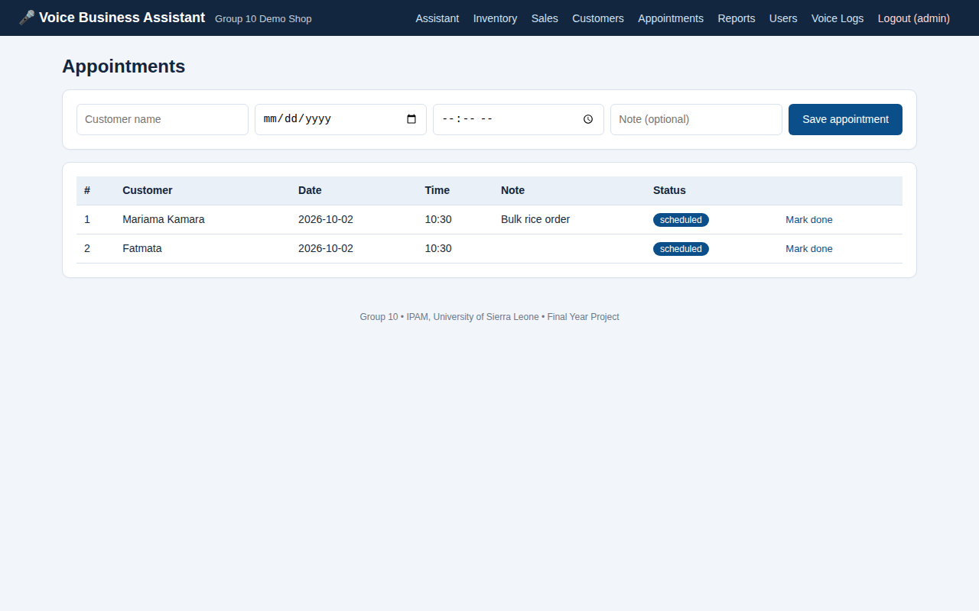
Figure C.5: Appointments page
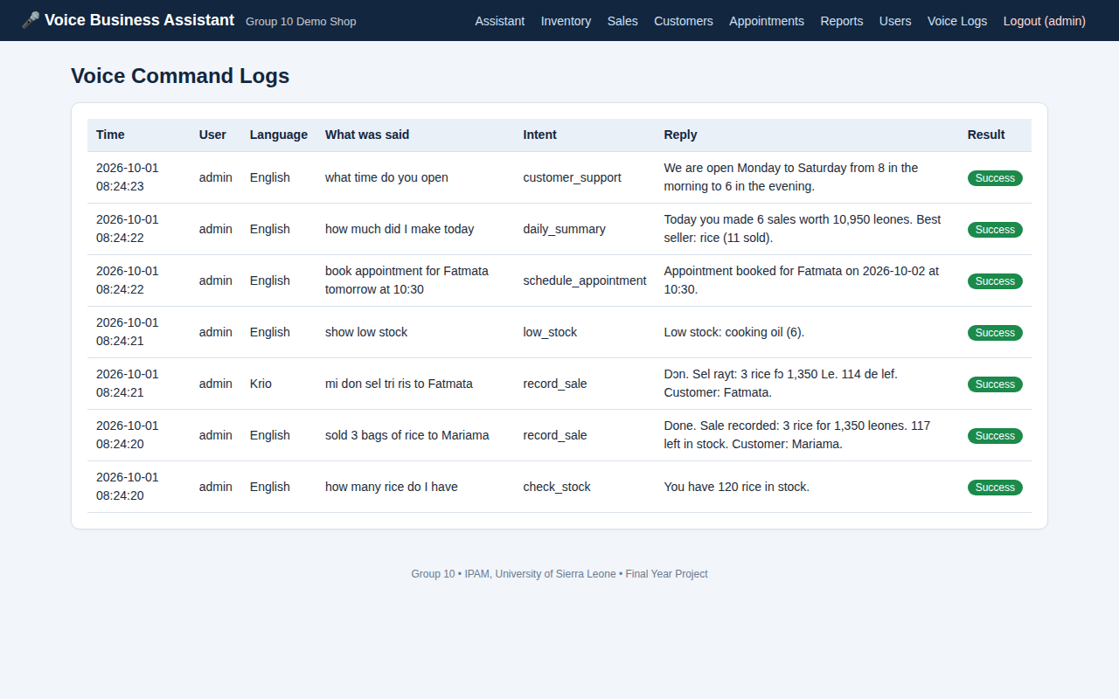
Figure C.6: Voice command logs page
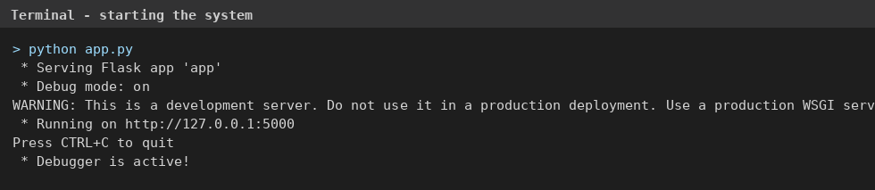
Figure C.7: Terminal output when the system is started with "python app.py"
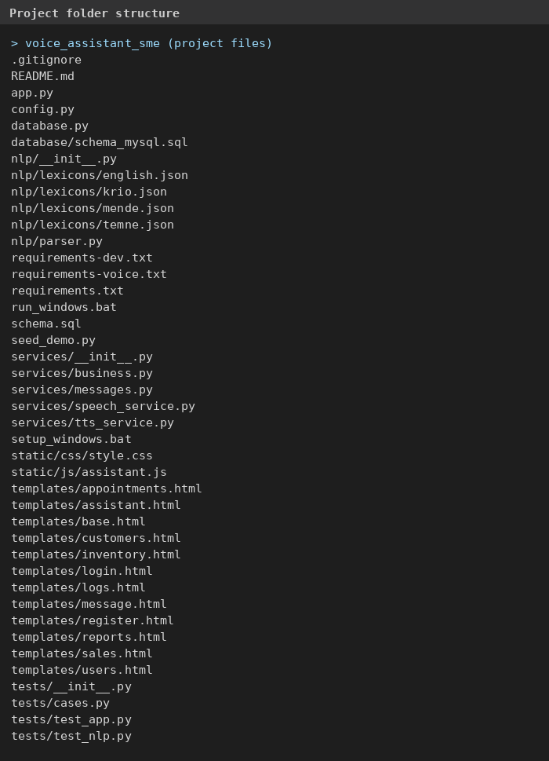
Figure C.8: Project folder structure
[Screenshot of the GitHub repository page to be added after the repository is created.]

Appendix D: Test Cases
The 22 NLP sentence cases are listed in Table 3.3. Table D.1 lists all 29 automated test functions.
Table D.1: List of automated test functions
ID | Test function | Purpose | Result
T01 | test_all_cases (22 sentences) | English and Krio sentences give the expected language, intent and details | Pass
T02 | test_fold_krio_letters | Special Krio letters are folded to plain letters | Pass
T03 | test_number_words | Number words become digits (twenty five = 25) | Pass
T04 | test_tomorrow | The word "tomorrow" gives the next date | Pass
T05 | test_next_weekday | A weekday name gives the next such date | Pass
T06 | test_empty_text | Empty text gives no intent | Pass
T07 | test_login_page_loads | Login page opens | Pass
T08 | test_wrong_password | Wrong password is refused | Pass
T09 | test_correct_login | Correct login opens the assistant | Pass
T10 | test_protected_page_redirects | Protected page redirects to login | Pass
T11 | test_api_blocked_without_login | API refuses users who are not logged in | Pass
T12 | test_register_staff_and_staff_cannot_see_reports | Staff cannot open reports and users pages | Pass
T13 | test_password_is_hashed | Password is not stored in plain text | Pass
T14 | test_add_new_product_and_sell | Product created, sale recorded, stock reduced | Pass
T15 | test_cannot_sell_more_than_stock | Sale refused when stock is not enough | Pass
T16 | test_check_stock_and_price | Stock and price replies are correct | Pass
T17 | test_unknown_product | Unknown product gives failure message | Pass
T18 | test_register_customer_and_duplicate | Customer registered; duplicate detected | Pass
T19 | test_book_appointment | Appointment booked and listed | Pass
T20 | test_appointment_without_date_asks_again | Missing date is requested | Pass
T21 | test_low_stock_alert | Low-stock product reported | Pass
T22 | test_daily_summary | Daily total is correct | Pass
T23 | test_faq_customer_support | FAQ question answered | Pass
T24 | test_krio_sale | Krio sale recorded | Pass
T25 | test_unknown_command | Meaningless sentence rejected | Pass
T26 | test_every_command_is_logged | Every command saved in voice log | Pass
T27 | test_monthly_report_owner_only | Staff refused monthly report | Pass
T28 | test_all_pages_open_for_owner | All eight pages open for the owner | Pass
T29 | test_transcribe_without_whisper_is_clear_error | Speech endpoint gives a clear message when Whisper is missing | Pass

Appendix E: Database Schema
-- schema.sql : SQLite database design for the Multilingual Voice-First AI Business Assistant
-- Tables: users, products, customers, sales, appointments, voice_logs, faqs

CREATE TABLE IF NOT EXISTS users (
id INTEGER PRIMARY KEY AUTOINCREMENT,
name TEXT NOT NULL,
phone TEXT,
username TEXT NOT NULL UNIQUE,
password_hash TEXT NOT NULL,
role TEXT NOT NULL DEFAULT 'staff' CHECK (role IN ('owner','staff')),
created_at TEXT NOT NULL DEFAULT (datetime('now'))
);

CREATE TABLE IF NOT EXISTS products (
id INTEGER PRIMARY KEY AUTOINCREMENT,
name TEXT NOT NULL UNIQUE COLLATE NOCASE,
aliases TEXT NOT NULL DEFAULT '', -- other names (Krio, Mende, Temne ...) separated by commas
quantity INTEGER NOT NULL DEFAULT 0 CHECK (quantity >= 0),
price REAL NOT NULL DEFAULT 0 CHECK (price >= 0),
reorder_level INTEGER NOT NULL DEFAULT 5,
created_at TEXT NOT NULL DEFAULT (datetime('now'))
);

CREATE TABLE IF NOT EXISTS customers (
id INTEGER PRIMARY KEY AUTOINCREMENT,
name TEXT NOT NULL,
phone TEXT,
created_at TEXT NOT NULL DEFAULT (datetime('now'))
);

CREATE TABLE IF NOT EXISTS sales (
id INTEGER PRIMARY KEY AUTOINCREMENT,
product_id INTEGER NOT NULL REFERENCES products(id),
customer_id INTEGER REFERENCES customers(id),
user_id INTEGER REFERENCES users(id),
quantity INTEGER NOT NULL CHECK (quantity > 0),
unit_price REAL NOT NULL,
total REAL NOT NULL,
sale_date TEXT NOT NULL DEFAULT (datetime('now'))
);

CREATE TABLE IF NOT EXISTS appointments (
id INTEGER PRIMARY KEY AUTOINCREMENT,
customer_id INTEGER REFERENCES customers(id),
customer_name TEXT NOT NULL,
appt_date TEXT NOT NULL, -- YYYY-MM-DD
appt_time TEXT, -- HH:MM
note TEXT,
status TEXT NOT NULL DEFAULT 'scheduled',
user_id INTEGER REFERENCES users(id),
created_at TEXT NOT NULL DEFAULT (datetime('now'))
);

CREATE TABLE IF NOT EXISTS voice_logs (
id INTEGER PRIMARY KEY AUTOINCREMENT,
user_id INTEGER REFERENCES users(id),
language TEXT,
transcript TEXT NOT NULL,
intent TEXT,
response TEXT,
success INTEGER NOT NULL DEFAULT 0,
created_at TEXT NOT NULL DEFAULT (datetime('now'))
);

CREATE TABLE IF NOT EXISTS faqs (
id INTEGER PRIMARY KEY AUTOINCREMENT,
keywords TEXT NOT NULL, -- words separated by commas, e.g. "open,hours,time"
answer TEXT NOT NULL
);

Appendix F: Selected Source Code
F.1 Intent detection (nlp/parser.py)
def detect_intent(folded):
"""Return (intent, matched_phrases, scores)."""
lex = lexicons()
scores, matched = {}, {}
for code, l in lex.data.items():
for intent, phrases in l["intents"].items():
for p in phrases:
if p and _phrase_regex(p).search(folded):
scores[intent] = max(scores.get(intent, 0), len(p.split()) + len(p) / 100.0)
matched.setdefault(intent, []).append(p)
if not scores:
return None, [], scores
best = sorted(scores, key=lambda i: (-scores[i], PRIORITY.index(i) if i in PRIORITY else 99))[0]
return best, matched.get(best, []), scores

F.2 Number-word conversion (nlp/parser.py)
def words_to_numbers(tokens):
"""['twenty','five','rice'] -> ['25','rice']"""
nums = lexicons().numbers
out, seq = [], []

def flush():
if not seq:
return
total, current = 0, 0
for w in seq:
v = nums[w]
if v == 1000:
total += (current or 1) * 1000
current = 0
elif v == 100:
current = (current or 1) * 100
else:
current += v
out.append(str(total + current))
seq.clear()

for t in tokens:
if t.isdigit():
flush()
out.append(t)
elif t in nums:
if seq:
last = nums[seq[-1]]
v = nums[t]
can_join = (v in (100, 1000)) or (last >= 100) or (20 <= last < 100 and last % 10 == 0 and v < 10)
if not can_join:
flush()
seq.append(t)
else:
flush()
out.append(t)
flush()
return out

F.3 Recording a sale (services/business.py)
def record_sale(ent, lang, user):
prod = _get_product(ent.get("product"))
if not ent.get("product"):
return False, say("product_missing", lang)
if prod is None:
return False, say("product_not_found", lang, product=ent["product"])
qty = ent.get("quantity")
if not qty or qty <= 0:
return False, say("quantity_missing", lang)
if prod["quantity"] < qty:
return False, say("not_enough_stock", lang, have=prod["quantity"], product=prod["name"])
unit = ent.get("price") if ent.get("price") else prod["price"]
total = unit * qty
customer_id, extra = None, ""
if ent.get("customer_name"):
cust = _find_customer(ent["customer_name"])
if cust is None:
customer_id = db.execute("INSERT INTO customers (name) VALUES (?)", (ent["customer_name"],))
else:
customer_id = cust["id"]
extra = " Customer: %s." % ent["customer_name"]
db.execute("INSERT INTO sales (product_id, customer_id, user_id, quantity, unit_price, total) VALUES (?,?,?,?,?,?)",
(prod["id"], customer_id, user["id"], qty, unit, total))
db.execute("UPDATE products SET quantity = quantity - ? WHERE id=?", (qty, prod["id"]))
left = prod["quantity"] - qty
msg = say("sale_ok", lang, qty=qty, product=prod["name"], total=_fmt(total), left=left, extra=extra)
if left <= prod["reorder_level"]:
msg += " Warning: %s is running low." % prod["name"]
return True, msg

Appendix G: User Acceptance Testing Forms
Participant number: ______ Business type: ______________ Date: ____________
Table G.1: Task sheet
Task | Instruction | Completed (Yes/No) | Time (sec) | Comment
T1 | Log in with the username and password given
T2 | Say or type: add 20 bags of rice at 150
T3 | Say or type: sold 3 bags of rice to Mariama
T4 | Say or type: mi don sel tri ris to Fatmata
T5 | Ask: how many rice do I have; then ask the price of rice
T6 | Say or type: register customer (a name and a phone number)
T7 | Book an appointment for a customer for tomorrow at 10:30
T8 | Ask: how much did I make today

Table G.2: Participant rating (circle 1 to 5)
Statement | 1 | 2 | 3 | 4 | 5
The assistant is easy to use.
Speaking a command is easier than writing in a record book.
The assistant understood what I said.
The replies were clear and useful.
I would use this assistant in my business.

Comments and suggestions: ____________________________________________________________

