TASK 2

Image Encryption and Transformation Tool

Report

**1. Introduction**

In the current digital age, image security is crucial in various domains including medical imaging, military applications, confidential documentation, and private communications. This project presents a Python-based tool that allows users to perform image **encryption and decryption** using three different techniques:

1. **Pixel-level encryption** using XOR and flip operations.
2. **Fourier Transform-based encryption**, where the image is transformed into the frequency domain and can be reconstructed.
3. **Laplacian transform**, a one-way filtering technique useful for edge detection.

Each method serves a different purpose—ranging from basic image scrambling to frequency-domain analysis and feature enhancement.

**2. Theory and Background**

**2.1. Pixel-Level Encryption**

Pixel-level encryption uses simple reversible operations:

* **XOR operation** (^): A bitwise logical operation that is commonly used in symmetric key cryptography.
* **Vertical flip** (np.flipud): Inverts the order of pixel rows.

These operations are chosen for their simplicity and reversibility, making encryption and decryption symmetric.

**Algorithm:**

Let I be the original image and K be the key (an integer between 0–255).

* **Encryption**:  
  E=flipud(I)⊕KE = \text{flipud}(I) \oplus K
* **Decryption**:  
  D=flipud(E⊕K)D = \text{flipud}(E \oplus K)

Where ⊕\oplus denotes the XOR operation.

**2.2. Fourier Transform Encryption**

The **Discrete Fourier Transform (DFT)** converts an image from the **spatial domain** to the **frequency domain**, which reveals the image’s frequency characteristics. It is typically used for compression and filtering, but can also be used for obfuscation by storing the transformed data securely.

The **2D DFT** of an image f(x, y) of size M×N is defined as:

F(u,v)=∑x=0M−1∑y=0N−1f(x,y)⋅e−j2π(uxM+vyN)F(u, v) = \sum_{x=0}^{M-1} \sum_{y=0}^{N-1} f(x, y) \cdot e^{-j2\pi \left( \frac{ux}{M} + \frac{vy}{N} \right)}

Its **Inverse DFT** reconstructs the original image:

f(x,y)=1MN∑u=0M−1∑v=0N−1F(u,v)⋅ej2π(uxM+vyN)f(x, y) = \frac{1}{MN} \sum_{u=0}^{M-1} \sum_{v=0}^{N-1} F(u, v) \cdot e^{j2\pi \left( \frac{ux}{M} + \frac{vy}{N} \right)}

**Workflow:**

* **Encrypt**: Apply FFT2, save result to .npy, visualize magnitude using:

Magnitude=20⋅log⁡10(∣F(u,v)∣+1)\text{Magnitude} = 20 \cdot \log_{10}(|F(u, v)| + 1)

* **Decrypt**: Load .npy and apply IFFT2 to reconstruct.

This method is *lossless* if the original complex spectrum is stored.

**2.3. Laplacian Filtering**

The **Laplacian operator** is a second-order derivative that highlights regions of rapid intensity change and is often used for **edge detection**.

In discrete form, the Laplacian kernel is:

[0−10−14−10−10]\begin{bmatrix} 0 & -1 & 0 \\ -1 & 4 & -1 \\ 0 & -1 & 0 \end{bmatrix}

The Laplacian is computed by convolving this kernel with the grayscale image:

L(x,y)=∂2f∂x2+∂2f∂y2L(x, y) = \frac{\partial^2 f}{\partial x^2} + \frac{\partial^2 f}{\partial y^2}

This transform is **one-way** and cannot be reversed, thus not suitable for encryption but useful for feature extraction.

**3. Methodology and Implementation**

**3.1. Technologies Used**

* **Python 3**
* **NumPy**: For mathematical operations and array handling.
* **Pillow (PIL)**: For reading and saving images.
* **OpenCV**: For image filtering and processing.
* **Matplotlib (optional)**: For plotting during debugging or visualization.

**3.2. Modular Design**

**Functions:**

* load_image(path, as_gray=False): Reads image as array.
* save_image(array, mode, path): Saves image in proper format.
* encrypt_pixels, decrypt_pixels: Uses XOR and vertical flipping.
* encrypt_fourier, decrypt_fourier: Transforms to frequency domain.
* apply_laplacian: Computes edge map.

**3.3. User Interface (CLI)**

The program offers a **command-line interface** where users can select:

1. Encryption method
2. Encrypt/Decrypt
3. File paths and parameters (e.g., keys)

The tool checks for input validity and guides the user with appropriate prompts.

**4. Algorithm Flow**

**🔄 Pixel Encryption Algorithm**

1. Input image and key.
2. Convert image to NumPy array.
3. Flip image vertically.
4. Apply XOR with the key.
5. Save result.

**🔄 Fourier Encryption Algorithm**

1. Input grayscale image.
2. Apply 2D FFT: np.fft.fft2(img)
3. Save spectrum (.npy).
4. Display magnitude for visualization (optional).
5. For decryption, load .npy and apply ifft2.

**🧠 Laplacian Algorithm**

1. Input grayscale image.
2. Apply Laplacian filter via cv2.Laplacian.
3. Normalize and save result.

**5. Security Analysis**

**Pros:**

* XOR encryption is lightweight and fast.
* Fourier spectrum encryption can obfuscate content at a higher level.
* Modular design allows future integration of advanced cryptographic methods.

**Cons:**

* XOR alone is vulnerable to brute force if the key space is small.
* Fourier method requires storing large .npy files for decryption.
* Laplacian is not reversible, so not a true encryption.

**6. Use Cases**

* Educational tool for understanding basic image encryption
* Pre-processing for advanced watermarking or steganography
* Lightweight encryption for non-critical image data
* Frequency-domain analysis and visualization

CODE

import numpy as np

from PIL import Image

import cv2

import os

def load_image(path, as_gray=False):

    """Load an image from the given path."""

    try:

        if as_gray:

            img = cv2.imread(path, cv2.IMREAD_GRAYSCALE)

            return img, "L"

        else:

            img = Image.open(path)

            return np.array(img), img.mode

    except Exception as e:

        print(f"❌ Error loading image: {e}")

        return None, None

def save_image(array, mode, path):

    """Save an image array to disk."""

    try:

        if mode == "L":

            cv2.imwrite(path, array)

        else:

            img = Image.fromarray(array.astype('uint8'), mode)

            img.save(path)

        print(f"✅ Image saved as: {path}")

    except Exception as e:

        print(f"❌ Error saving image: {e}")

# ------------------------------

# Pixel-Level Encryption

# ------------------------------

def encrypt_pixels(img_array, key):

    """Encrypt image using XOR and flip."""

    return np.flipud(img_array) ^ key

def decrypt_pixels(img_array, key):

    """Decrypt image by reversing encryption steps."""

    return np.flipud(img_array ^ key)

# ------------------------------

# Fourier Transform Encryption

# ------------------------------

def encrypt_fourier(img_array, spectrum_file):

    """Encrypt by applying FFT and saving the spectrum."""

    f = np.fft.fft2(img_array)

    np.save(spectrum_file, f)  # Save complex data

    magnitude = 20 * np.log(np.abs(np.fft.fftshift(f)) + 1)

    return magnitude.astype(np.uint8)

def decrypt_fourier(spectrum_file):

    """Decrypt by applying inverse FFT from saved spectrum."""

    try:

        f = np.load(spectrum_file)

        img_back = np.fft.ifft2(f)

        img_back = np.abs(img_back)

        return np.uint8(img_back)

    except Exception as e:

        print(f"❌ Error decrypting Fourier data: {e}")

        return None

# ------------------------------

# Laplacian (One-Way Filter)

# ------------------------------

def apply_laplacian(img_array):

    """Apply Laplacian edge detection."""

    lap = cv2.Laplacian(img_array, cv2.CV_64F)

    abs_lap = np.absolute(lap)

    return np.uint8(abs_lap)

# ------------------------------

# Input Validation

# ------------------------------

def get_int_input(prompt, min_val=0, max_val=255):

    """Prompt the user for a valid integer in range."""

    while True:

        try:

            val = int(input(prompt))

            if min_val <= val <= max_val:

                return val

            else:

                print(f"Please enter a number between {min_val} and {max_val}.")

        except ValueError:

            print("Invalid input. Enter a valid integer.")

# ------------------------------

# Main Interface

# ------------------------------

def main():

    print("\n=== 🔐 Image Encryption Tool ===")

    print("1. Pixel-based Encryption/Decryption")

    print("2. Fourier Transform Encryption/Decryption")

    print("3. Laplacian Transform (edge detection only)")

    choice = input("Choose method (1/2/3): ").strip()

    if choice == "1":

        operation = input("Encrypt (e) or Decrypt (d)? ").strip().lower()

        path = input("Enter image path: ").strip()

        key = get_int_input("Enter encryption key (0-255): ")

        output = input("Output image filename: ").strip()

        img_array, mode = load_image(path)

        if img_array is None: return

        result = encrypt_pixels(img_array, key) if operation == 'e' else decrypt_pixels(img_array, key)

        save_image(result, mode, output)

    elif choice == "2":

        operation = input("Encrypt (e) or Decrypt (d)? ").strip().lower()

        if operation == 'e':

            path = input("Enter grayscale image path: ").strip()

            spectrum_file = input("Enter path to save spectrum data (e.g., spectrum.npy): ").strip()

            output = input("Output (magnitude image) filename: ").strip()

            img_array, mode = load_image(path, as_gray=True)

            if img_array is None: return

            result = encrypt_fourier(img_array, spectrum_file)

            save_image(result, "L", output)

        elif operation == 'd':

            spectrum_file = input("Enter .npy spectrum file path: ").strip()

            output = input("Output decrypted image filename: ").strip()

            result = decrypt_fourier(spectrum_file)

            if result is not None:

                save_image(result, "L", output)

        else:

            print("❌ Invalid operation. Use 'e' or 'd'.")

    elif choice == "3":

        path = input("Enter image path: ").strip()

        output = input("Output image filename: ").strip()

        img_array, mode = load_image(path, as_gray=True)

        if img_array is None: return

        lap = apply_laplacian(img_array)

        save_image(lap, "L", output)

    else:

        print("❌ Invalid choice. Please enter 1, 2, or 3.")

# ------------------------------

if __name__ == "__main__":

    main()

OUTPUT



Sample image

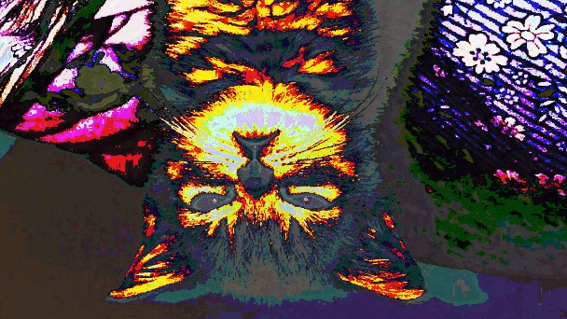

Pixel manipulation

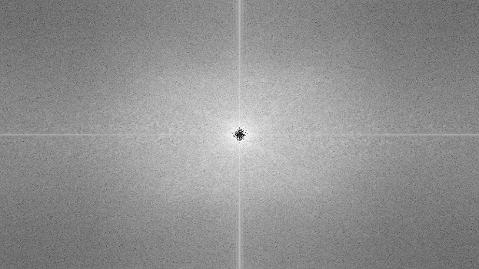

Fourier transform

Code outputs

1)

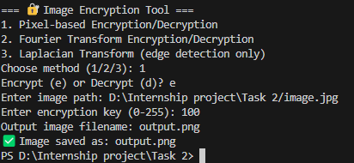

2)

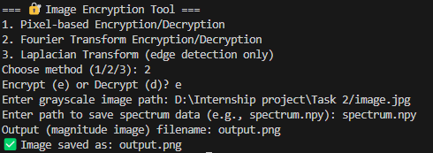

**7. Conclusion**

This project successfully implements a flexible and beginner-friendly **Image Encryption and Processing Tool** that supports both **basic and intermediate-level image transformation techniques**. The integration of spatial-domain (XOR-based), frequency-domain (Fourier Transform), and feature-domain (Laplacian) approaches makes it a versatile learning platform for cybersecurity and image processing enthusiasts.

**🔧 Future Improvements:**

* GUI using tkinter or PyQt
* Password-derived keys using hashlib
* AES integration using pycryptodome
* Watermarking and steganography support
* Network-based transmission module