BPM-GenAI Assignment Report (MHYP 521)
Oct 19, 2026 · @nana
Cyprus University of Technology — Department of Electrical Engineering, Computer Engineering and Informatics
MHYP 521 (463) – Advanced Topics in Software Engineering, Academic Year 2026–2027, Fall Semester
Team members: [Name Surname – Student ID], [Name Surname – Student ID]
Submission date: 30/11/2026
Link to the system (Questions 3, 4, 5): [https://…streamlit.app — to be added after deployment]
The system runs online; no installation or API key is needed to test it.

1. Introduction and dataset
This report applies process mining and generative AI to a synthetic insurance-claims event log. The log contains 100 cases and 500 events (5 events per case), recorded between 2026-09-01 and 2026-12-09, in both CSV and XES format. Each event has a case id, an activity, a timestamp, a resource (User_A to User_E) and an operational cost ($50–$500).
The expected process, followed by 93 of the 100 cases in file order, is:
Register Claim → Verify Documents → Evaluate Claim → Approve Claim → Close Claim
Tools. Python 3 with pandas (data processing) and PM4PY (process discovery and conformance checking) for Questions 1–2. For Questions 3–5, a web application built with Streamlit that calls large language models through the Groq API (OpenAI-compatible). All code is included in the submission.
Part | Files
Question 1 | q1_timestamp_errors.py
Question 2 | q2_petri_nets.py
Questions 3–5 (web system) | app.py, assistant.py, data.py, llm.py

2. Question 1 — Timestamp errors
The log contains four types of timestamp errors in 22 of the 100 cases (29 events). All detection was done with code (pandas + PM4PY); no LLM was used. The CSV and the XES give identical results.

2.1 Method
The script q1_timestamp_errors.py reads the log keeping each timestamp as raw text, so that broken values stay visible. It then runs these checks on the events in their original file order (sorting by time first would hide reversed timestamps):
- Missing: the timestamp field is empty.
- Malformed: a value exists but does not match YYYY-MM-DDTHH:MM:SS.
- Negative duration: an event is earlier than the last valid timestamp before it in the same case.
- Out-of-order: the sequence of activities differs from the most frequent variant (93 cases), which is used as the expected process.
- Generic checks (C1–C4): duplicate timestamps in a case, extreme durations per transition (IQR × 3 rule), cases spanning more than one day, and dates outside the log period.

2.2 Results
Error | Events | Cases | Explanation
E1 Missing timestamp | 5 | Case_28, 34, 70, 77, 84 | The event cannot be placed in time. PM4PY must drop it, so the trace loses an activity. In Case_77 the missing event is Register Claim, so the case has no start time.
E2 Malformed timestamp | 5 | Case_13, 16, 20, 75, 93 | Minutes and seconds are cut (e.g. 2026-09-13T16). A strict parser rejects the value; pm4py.read_xes silently reads it as 16:00:00, so the true minute is lost. In all five cases the hour still fits between the neighbouring events.
E3 Negative duration | 5 | Case_5, 6, 31, 60, 81 | Approve Claim is recorded exactly 15 minutes before Evaluate Claim, although the rows are in the correct order.
E4 Out-of-order | 14 (7 pairs) | Case_4, 15, 29, 32, 36, 82, 95 | The timestamps increase, but place Approve Claim 61–115 minutes before Evaluate Claim. A claim cannot be approved before it is evaluated.
C1–C4 generic checks | — | — | No duplicates, no multi-day cases, no out-of-range dates. One duration outlier (Case_5, Approve → Close = 250 min) is a side effect of its E3 error.
Which timestamp is wrong in E3. In this log every normal step takes 30–120 minutes. In the five E3 cases the step into Evaluate Claim is normal (38–98 min), but Approve → Close takes 160–250 min. The Approve timestamp was therefore moved back; the Evaluate timestamp is correct. In E4 all gaps stay inside the normal 30–120 min range, which indicates that the two timestamps (or labels) were swapped.
What PM4PY sees. After the invalid events are dropped and each case is sorted by time, the E3 and E4 cases become the same variant (Approve before Evaluate, 12 cases), and every E1/E2 case loses one activity. This is the input that the miners of Question 2 receive.

2.3 Possible causes
Following the event-log imperfection patterns of Suriadi et al. (2017):
- E1 — events captured outside the logging system or lost during integration (unanchored / missing values).
- E2 — truncation during export or a different time format in one source system (unanchored event).
- E3 and E4 — both affect only the Evaluate/Approve pair, with a fixed 15-minute shift in E3. This points to a systematic recording problem, e.g. timestamps entered manually or pre-filled by a form, rather than random noise (form-based event capture, inadvertent time travel).

2.4 Ground truth
The 29 affected events are saved in q1_error_events.csv. This list is the ground truth against which the timestamp corrections of Questions 5–6 are evaluated.
📷 Figure 1 (to insert): screenshot of the terminal output of q1_timestamp_errors.py — the SUMMARY table and the E3 section.

3. Question 2 — Process discovery with Petri nets
On the clean cases all three miners discover the same correct sequential process. On the raw log the timestamp errors turn into false parallelism (Evaluate ∥ Approve) and false optional activities, and the Alpha Miner even produces an unsound net.

3.1 Setup
The script q2_petri_nets.py uses PM4PY with Alpha Miner, Heuristic Miner (dependency threshold 0.5) and Inductive Miner (IM, noise 0), plus Inductive Miner infrequent (IMf, noise 0.2) for comparison. Two logs were mined:
- Dirty log: the XES exactly as pm4py.read_xes loads it. The 5 events with no timestamp are dropped (they cannot be ordered); the 5 malformed values are read as HH:00. Result: 100 cases, 495 events, 5 variants.
- Clean reference: the 78 cases with no error from Question 1 (1 variant).
Each model was evaluated on fitness (token-based replay), precision (ETC), generalization, simplicity and soundness.

3.2 Variants of the dirty log
Cases | Variant (sorted by time) | Caused by
83 | Register → Verify → Evaluate → Approve → Close | normal (78 clean + 5 malformed read as HH:00)
12 | Register → Verify → Approve → Evaluate → Close | E3 (5) + E4 (7)
3 | Register → Verify → Approve → Close | E1: Evaluate missing (Case_34, 70, 84)
1 | Register → Evaluate → Approve → Close | E1: Verify missing (Case_28)
1 | Verify → Evaluate → Approve → Close | E1: Register missing (Case_77)

3.3 Results
Log | Miner | Fitness | Fitting traces | Precision | Generalization | Simplicity | Sound | Places / transitions (silent)
dirty | Alpha | 0.937 | 0% | 1.000 | 0.899 | 0.765 | No | 8 / 5 (0)
dirty | Heuristic | 0.977 | 84% | 1.000 | 0.750 | 0.778 | Yes | 8 / 6 (1)
dirty | Inductive (IM) | 1.000 | 100% | 0.729 | 0.647 | 0.739 | Yes | 8 / 9 (4)
dirty | Inductive (IMf 0.2) | 0.992 | 95% | 1.000 | 0.899 | 1.000 | Yes | 7 / 5 (0)
clean (78) | all four | 1.000 | 100% | 1.000 | 0.887 | 1.000 | Yes | 6 / 5 (0)
Figure 2. Clean log (78 cases): all miners produce the same sequential model.
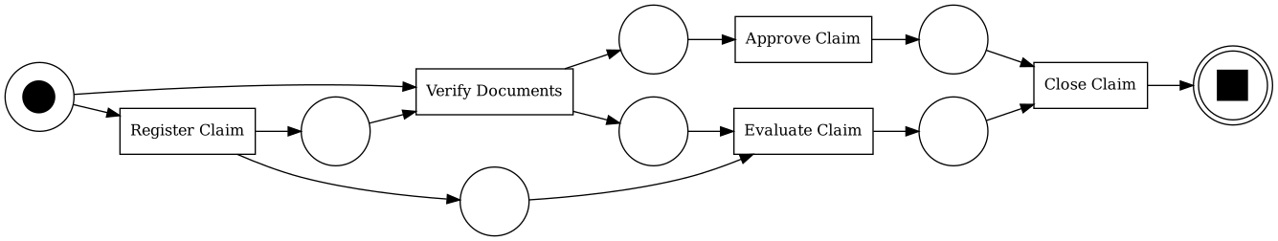
Figure 3. Alpha Miner, dirty log: Evaluate and Approve become parallel; Verify needs a token from both the start place and Register, so the net is not sound.
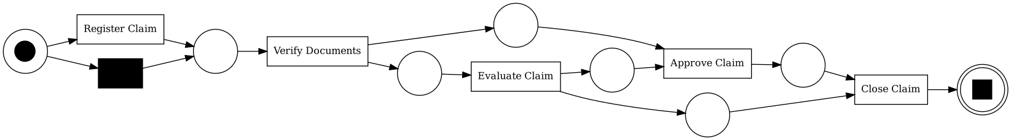
Figure 4. Heuristic Miner, dirty log: the main order is kept; a silent transition lets Register be skipped.
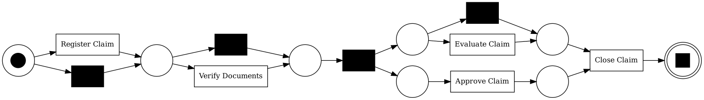
Figure 5. Inductive Miner (IM), dirty log: Register, Verify and Evaluate become optional, and Evaluate ∥ Approve.
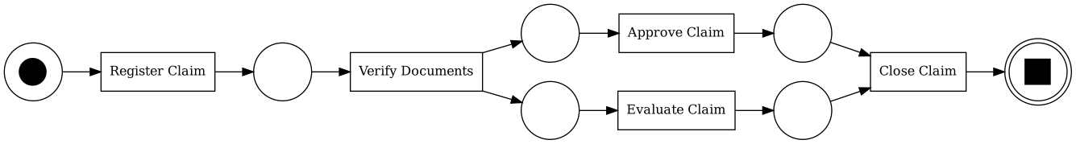
Figure 6. Inductive Miner infrequent (IMf 0.2), dirty log: the skips are filtered, but Evaluate ∥ Approve remains.

3.4 Comments per model
Alpha Miner is the most affected. Because both Approve→Evaluate (12 cases) and Evaluate→Approve (83 cases) occur, it declares the two activities parallel. The traces with a missing Register or Verify add extra places, and the result is an unsound net in which no trace replays perfectly, although average token fitness looks high (0.937). Alpha ignores frequencies, so a single wrong event changes the structure.
Heuristic Miner uses frequencies and is more robust. The 12 reversed cases fall below the dependency threshold, so the order Evaluate → Approve is kept. The missing Register of Case_77 adds a skip, and the traces without Evaluate add arcs Verify → Approve and Evaluate → Close. The net is sound, but 16% of the traces do not fit.
Inductive Miner (IM) guarantees a sound model and perfect fitness, so it must explain every trace, including the wrong ones. It adds 4 silent transitions: Register, Verify and Evaluate become optional, and Evaluate ∥ Approve. Precision drops to 0.729: the model over-generalizes and allows behaviour that never happens, such as closing a claim that was never evaluated.
Inductive Miner infrequent (IMf) removes the skips caused by the 5 missing timestamps, but the reversed pair occurs in 12% of the cases, which is frequent enough to survive filtering. Errors in 12% of the cases no longer look like noise; they look like real behaviour.

3.5 Conclusions
- The timestamp errors do not create loops. They create false parallelism and false optional activities.
- Robustness on this log: IMf > Heuristic > IM > Alpha.
- The malformed timestamps (E2) had no visible effect only because PM4PY reads them as HH:00 and the hour still fits in these cases. With a strict parser they would be dropped and would add 5 more skip variants.
- Filtering is not enough (IMf keeps the parallelism). The timestamps must be corrected, which is the subject of Question 5.

4. Question 3 — LLM assistant for questions about the log
The assistant answers natural-language questions with a table, a chart and a short explanation. The LLM never computes numbers itself: it writes pandas code, the code runs on the real data, and the result is shown. After three rounds of prompt improvements, all six test questions return correct numbers and correct explanations.

4.1 Design (text-to-pandas)
LLM: GPT-OSS 120B (open-weights model by OpenAI), called through the Groq API with temperature 0 and JSON output mode. GUI: Streamlit.
- The question and a description of two tables are sent to the LLM: events (one row per event) and cases (one row per claim). The LLM never receives the data itself, only the schema.
- The LLM returns JSON with three fields: pandas code that sets a variable result, a chart specification (type, x, y, title) and a one-sentence note on its assumptions.
- The code is checked before it runs (see 4.3) and executed on copies of the tables.
- If the code fails, the error is sent back to the LLM, which corrects it (up to 2 retries: a self-correction loop).
- A second LLM call turns the result table into 2–4 sentences, using only the numbers in the table.
- The GUI shows the answer, the table, a Plotly chart, the generated code, and the time and tokens of each call.

4.2 Data preparation
The tables are enriched in Python before any question is asked, so the LLM's code stays simple. Each event has a duration_min (time since the previous event of the case), a data_issue flag with the error type from Question 1, and two reliability flags: ts_reliable (the timestamp itself is correct) and duration_reliable (the duration can be trusted). Each claim has its total_cost, users, sequence, start/end and cycle_time_min. The schema description given to the LLM also states the domain rules, e.g. “claims handled by a user” = claims where that user appears in at least one event.

4.3 Safety of the generated code
The code is parsed into a syntax tree (Python ast) and rejected if it imports modules, uses names such as open, exec, eval, os, or calls methods that read or write files (read_*, to_csv, …). It then runs with a whitelist of basic built-in functions and only pd, np, events and cases in scope. In testing, the first attempt of several questions contained import pandas; it was blocked and the LLM corrected it automatically (Figure 7).
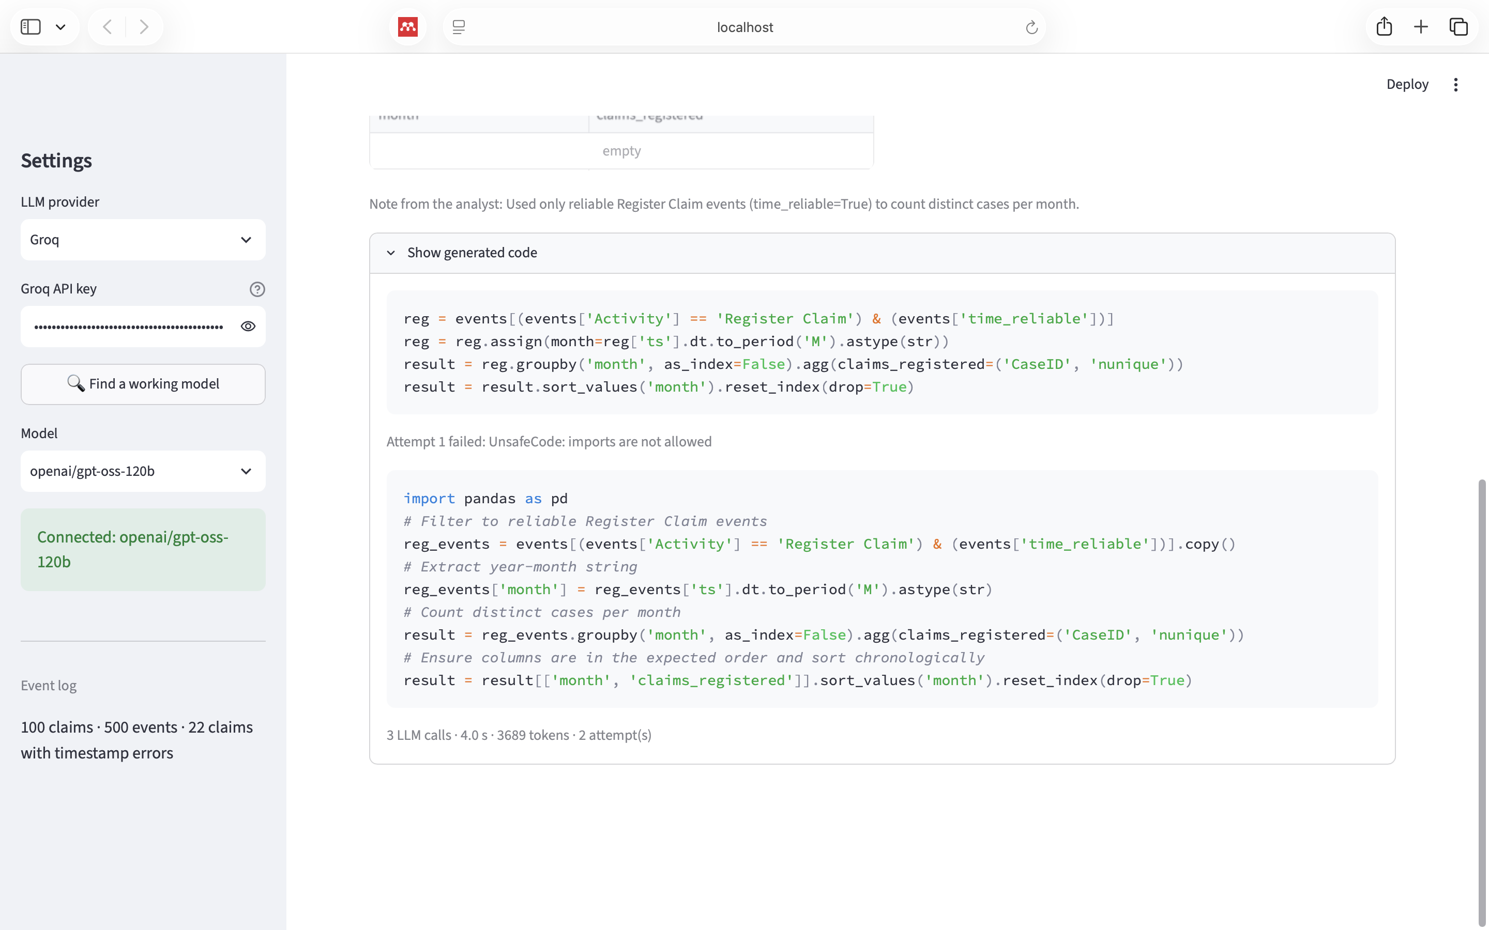
Figure 7. Attempt 1 was rejected (“imports are not allowed”); attempt 2 ran successfully.

4.4 Results
Each answer was checked against values computed independently with pandas.
Question | Result | Correct?
Show me all claims handled by User_42 that exceeded $500 | Empty table; the note explains that User_42 does not exist (users are A–E) | Yes
Show me all claims handled by User_C that exceeded $1500 | 26 claims, $1,503–$1,954 | Yes
Which activities have the longest waiting times and what is their percentage over the total? | Evaluate 79.2 min (26.7%), Verify 75.0 (25.3%), Close 71.6 (24.2%), Approve 70.6 (23.8%) | Yes
What is the total cost per user? | A $25,070, B $27,307, C $32,838, D $30,408, E $25,767 | Yes
How many claims were registered each month? | Sep 30, Oct 31, Nov 30, Dec 9 (total 100) | Yes
Which user is involved in the most expensive claims on average? | User_E, $1,443 per claim | Yes
Note on the example questions of the assignment. The first example cannot be answered as written, and the system says so instead of inventing data. User_42 does not exist in the log. The “$500” threshold also does not separate anything: no single event costs more than $500 (the maximum is exactly $500), while every claim costs more than $500 in total (the cheapest claim is $754). We therefore also tested the same question with a real user and a meaningful threshold (User_C, $1,500).
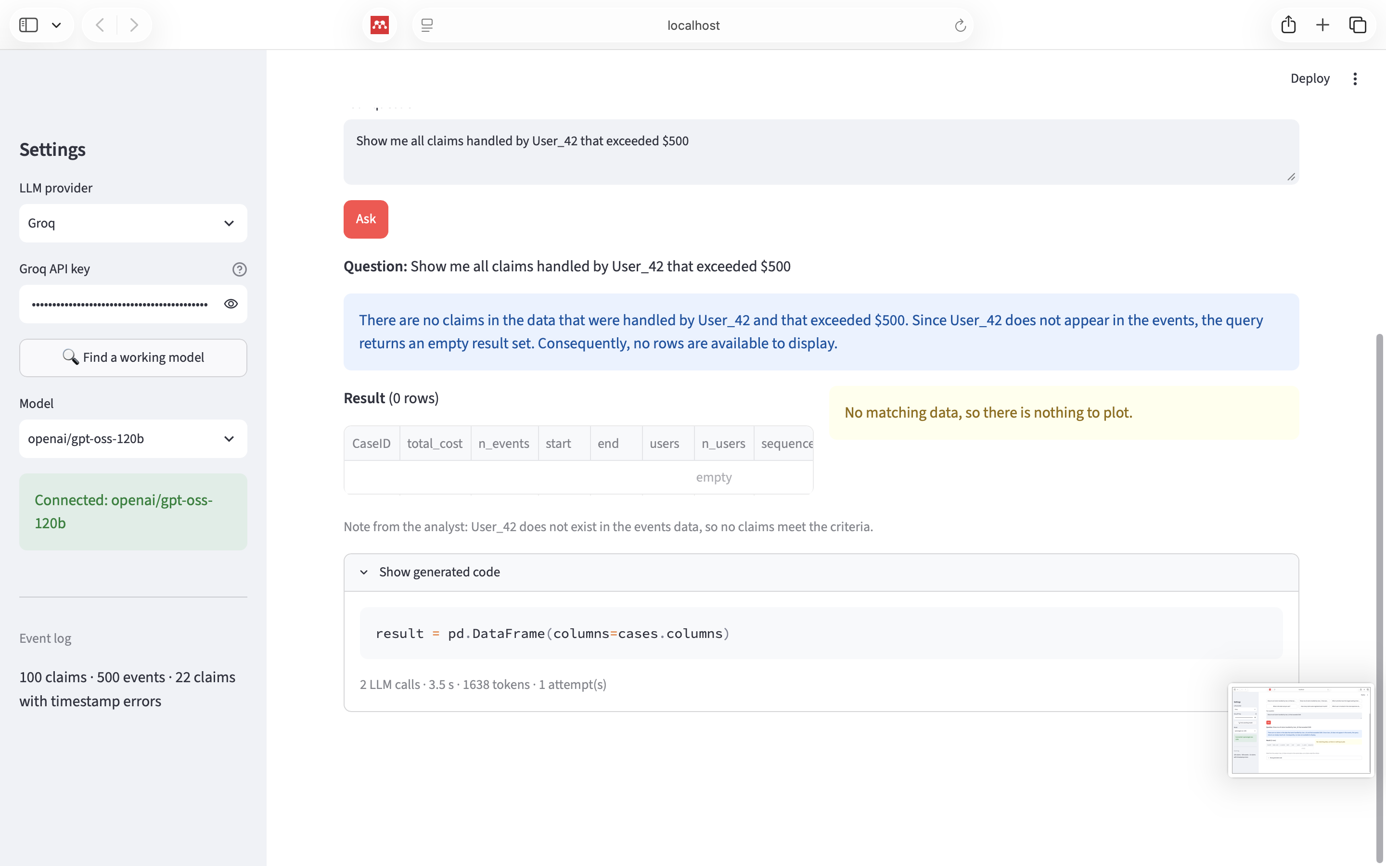
Figure 8. The question from the assignment with a user that does not exist: no data is invented.
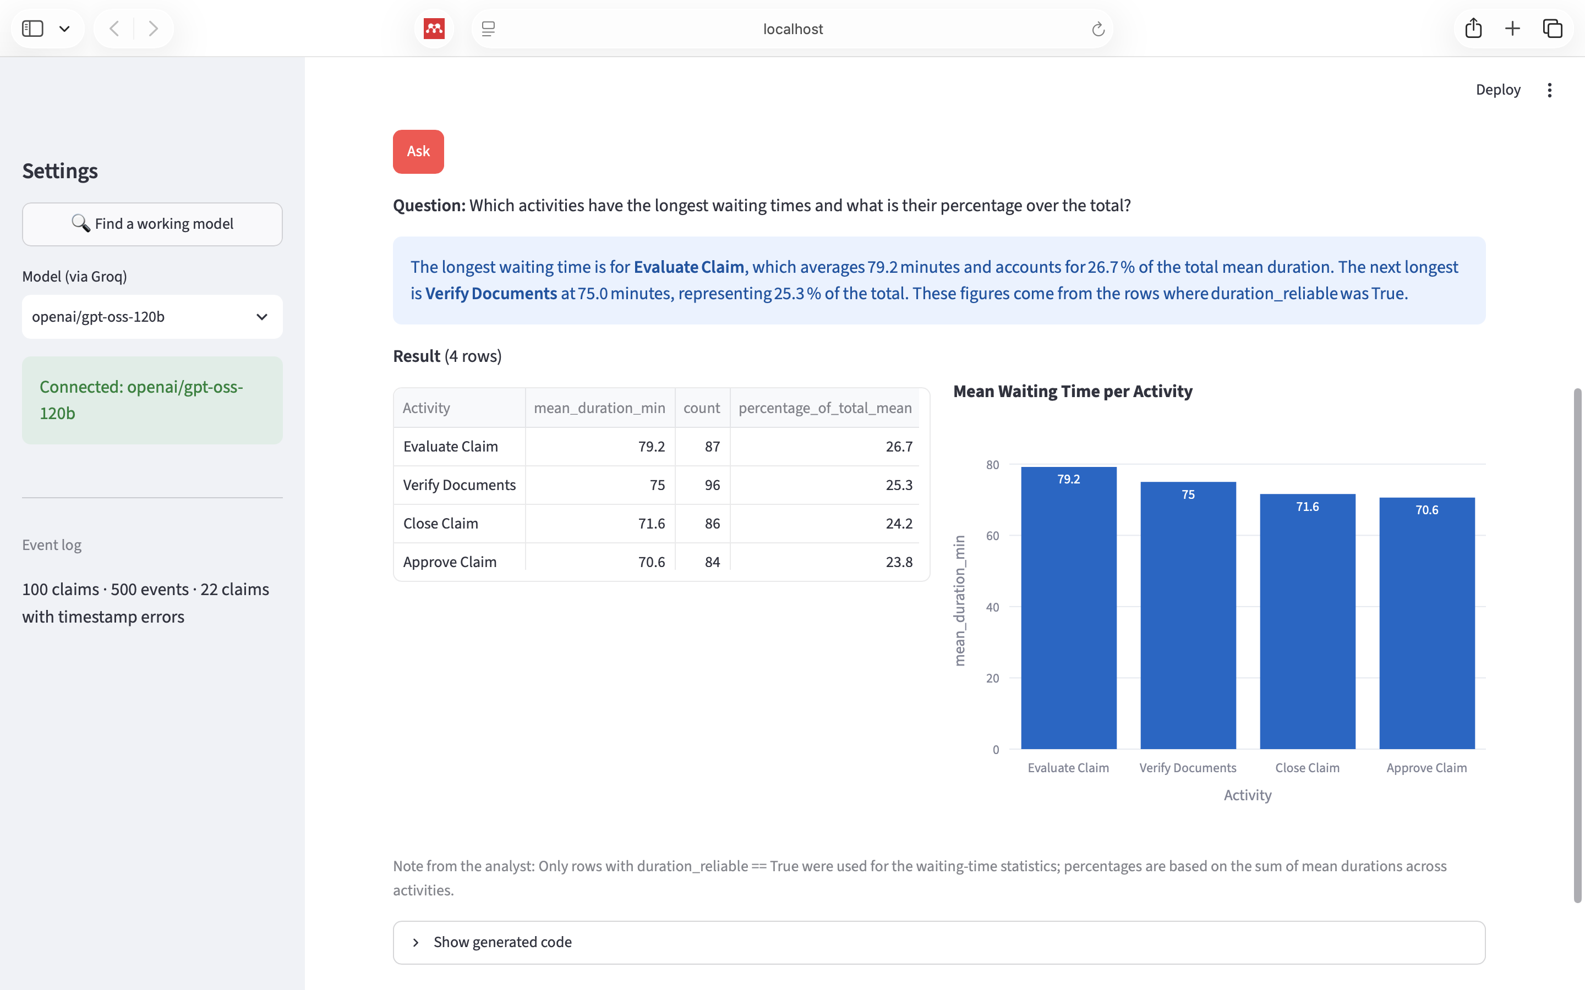
Figure 9. Waiting times per activity (mean of reliable durations).
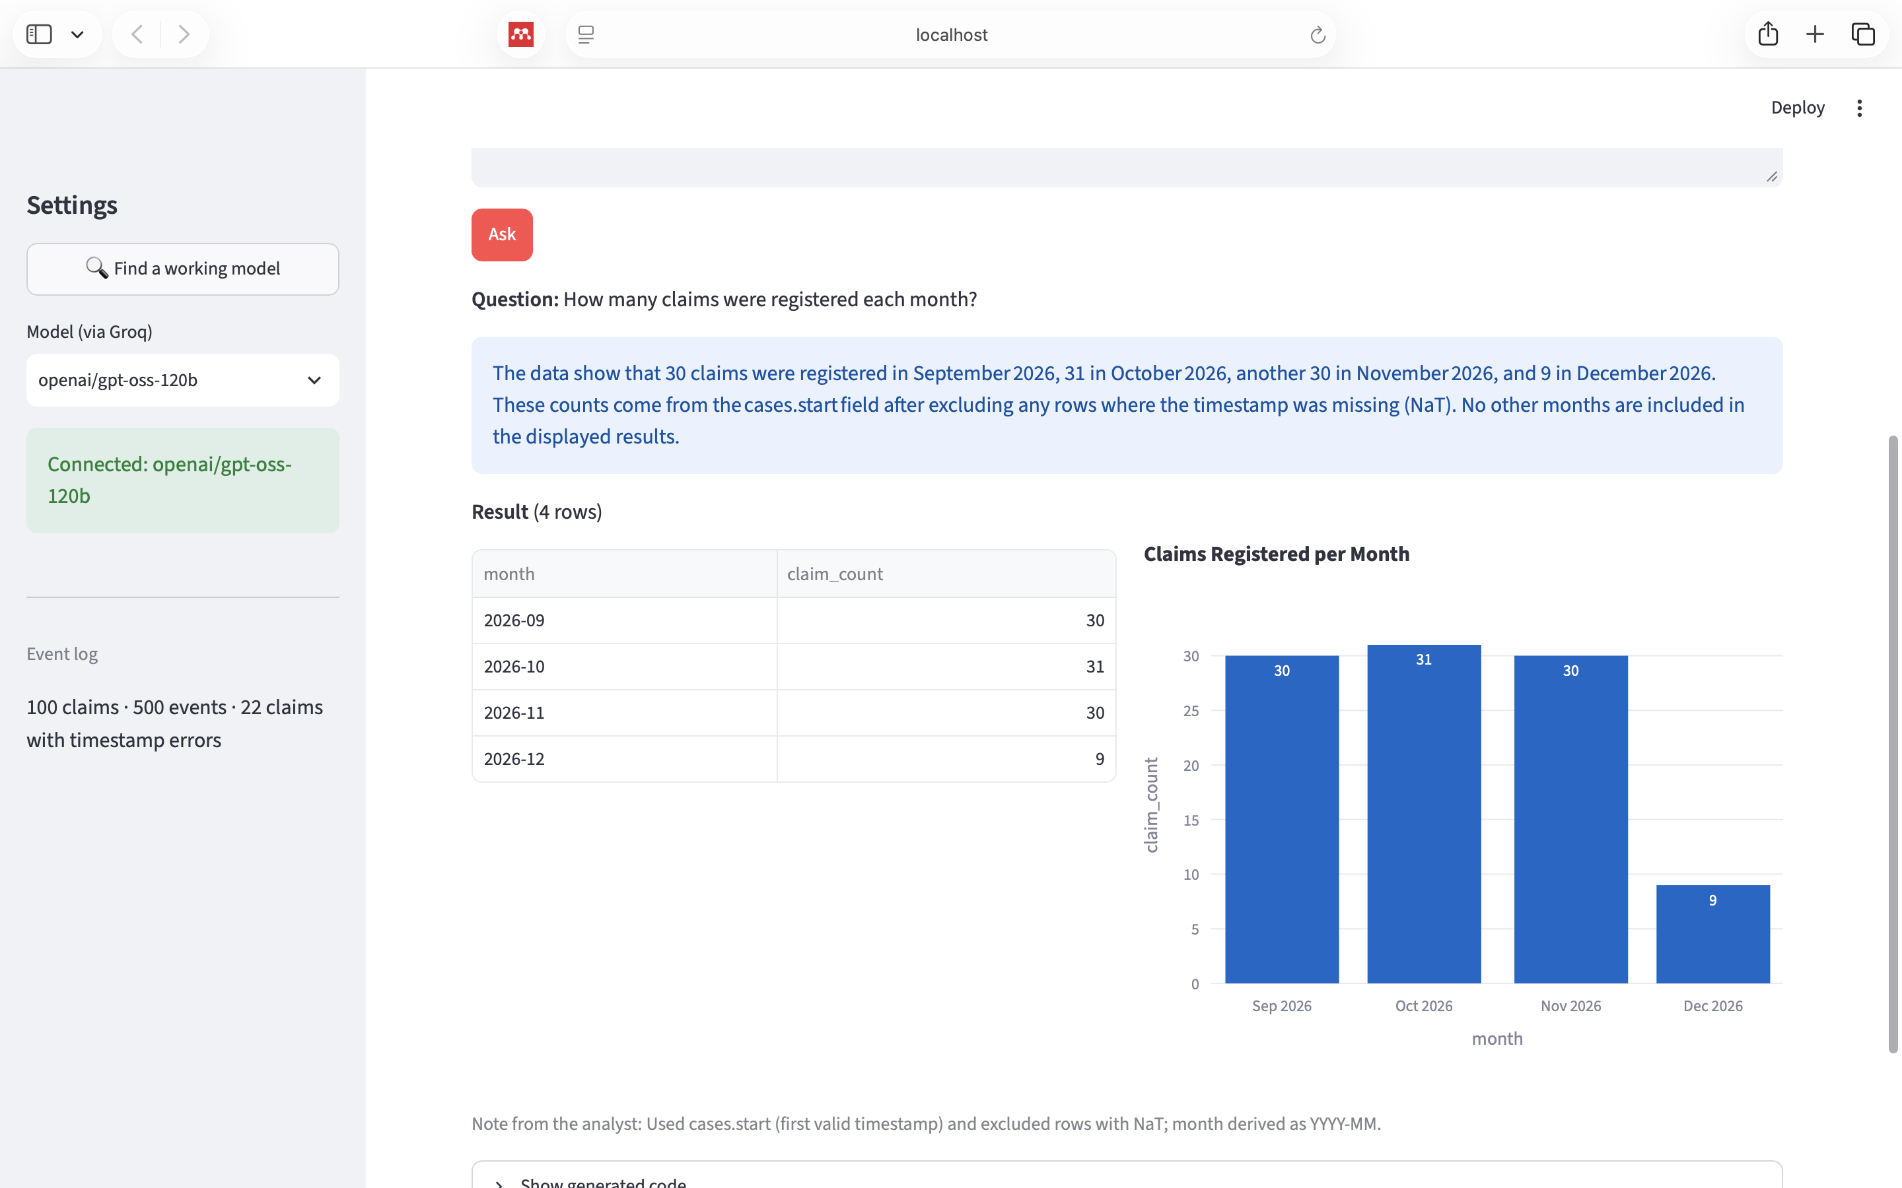
Figure 10. Claims registered per month; all 100 claims are counted.

4.5 Errors found and prompt improvements
The first version produced correct numbers but three wrong interpretations and one hallucination. Each was fixed by changing the prompt or the data description, not the code that computes the numbers.
Problem in the first version | Cause | Fix
User_C answer said “all of these claims followed the same five-step sequence”; Case_82 and Case_95 did not (hallucination) | The answer prompt allowed generalizing from a preview of the table | Rule: never generalize about all rows unless every row shows it; tell the LLM when it sees only a preview
Waiting times ranked Verify first by total minutes | Activities have different numbers of reliable rows (Verify 96, Approve 84), so totals are not comparable | Rule: compare activities by the mean; report mean, count and share
Claims per month summed to 98 | Case_20 and Case_77 have a broken Register timestamp | Rule: group claims by cases.start (first valid timestamp)
Claims per month returned 0 rows after the first fix | The column time_reliable was always False for step 1 and was misread as “timestamp is correct” | Split into ts_reliable and duration_reliable with clear descriptions
User_42 code was result = pd.DataFrame(...) without looking at the data | The LLM used the schema description instead of querying | Rule: always compute from the data, never hard-code a result
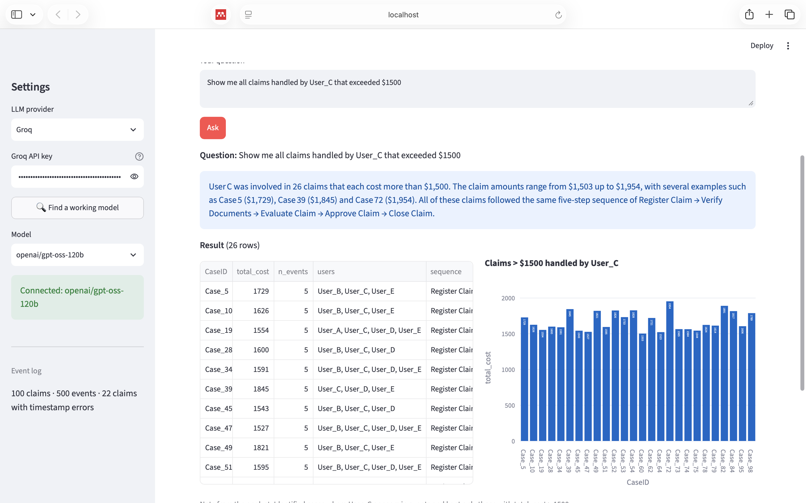
Figure 11. Before: the last sentence of the answer is a hallucination.
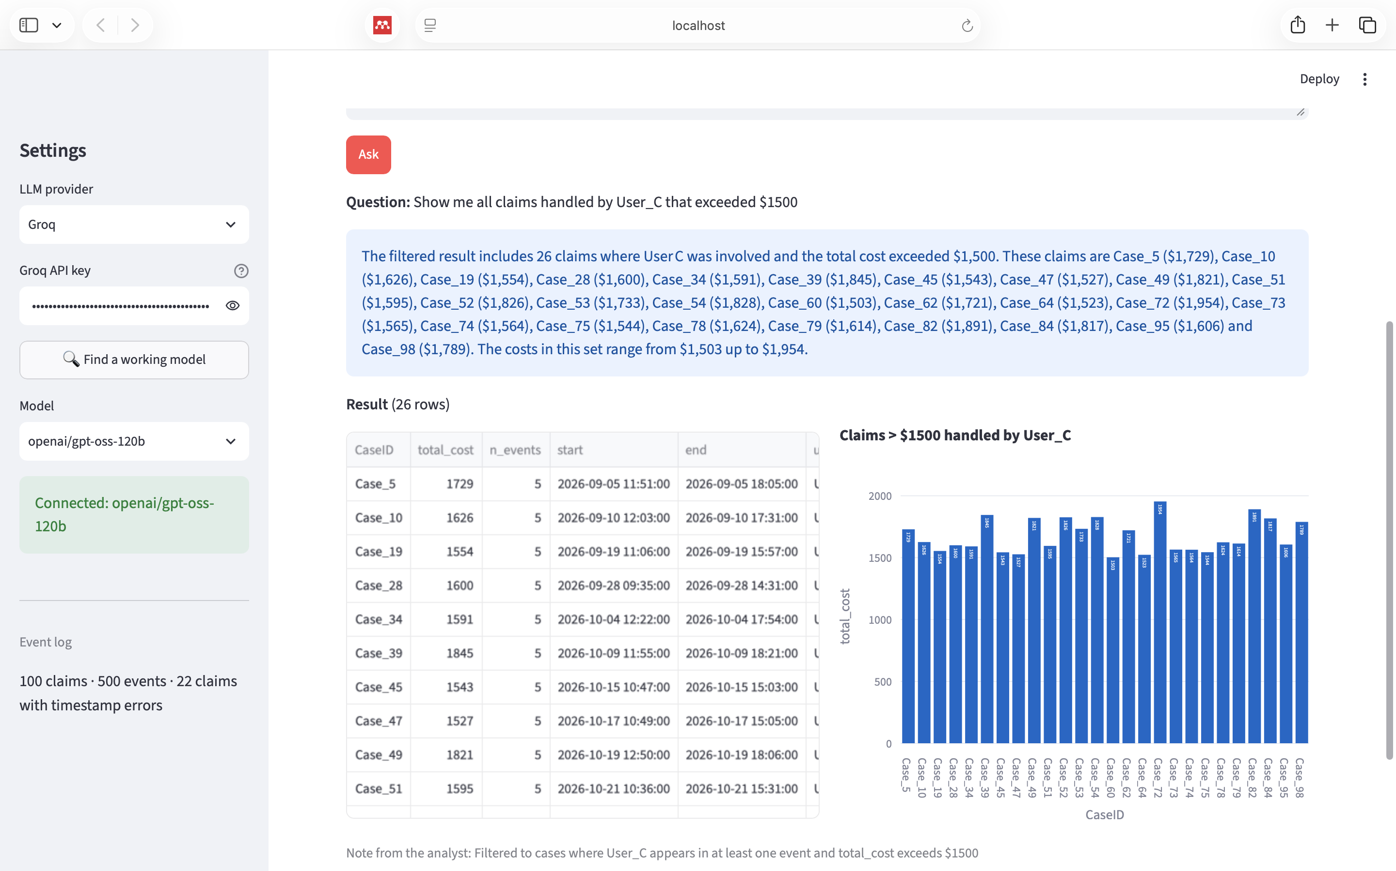
Figure 12. After: the answer lists the claims and makes no unsupported claim.
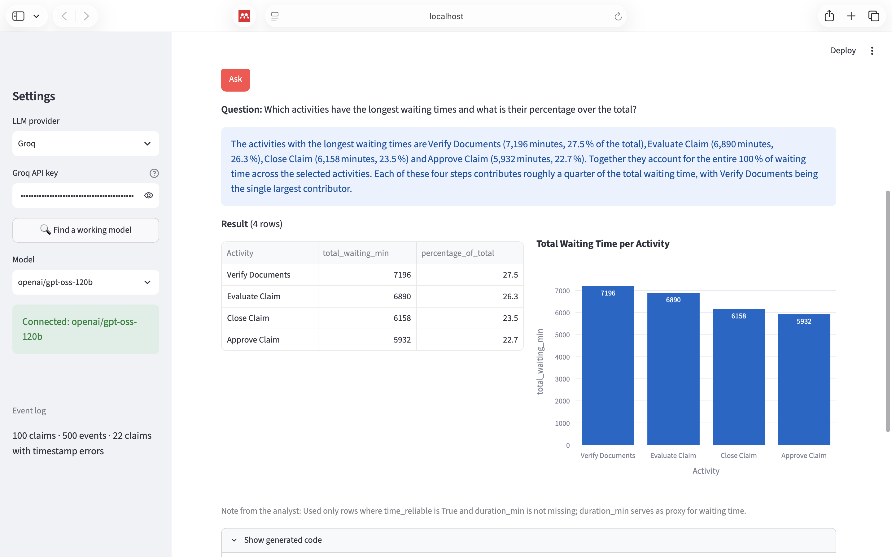
Figure 13. Before: ranking by total minutes put Verify Documents first.

5. Question 4 — Trace summary with enhancement
Given a case id, the system returns a narrative summary of the claim enriched with performance information (who, how long, how much, where the bottleneck was). As in Question 3, all numbers are computed in Python; the LLM only writes the text.

5.1 Method
- For the chosen case, the code collects every step: activity, user, completion time, duration since the previous step, cost and any data issue from Question 1.
- Each duration is compared with the typical duration of that activity (median over all reliable events of the log). The ratio (e.g. 1.61×) shows how unusual the step was.
- The bottleneck is the step with the highest ratio to its typical duration; the longest step is the one with the most minutes. The total cost is compared with the average claim cost ($1,414).
- Durations that depend on a broken timestamp are set to null, and the cycle time is marked as unreliable.
- These facts are sent to the LLM as JSON with a one-shot prompt, using the example sentence from the assignment as the target style. The prompt forbids invented numbers, users, dates or time zones, and asks the LLM to state any data-quality problem.
The GUI also shows the step table, three key figures (total cost, cycle time, bottleneck) and a timeline of the steps.

5.2 Examples
Case_3 (no errors). Total cost $1,644 (+$230 vs average), cycle time 6 h 17 min. Evaluation by User_A was the longest step (2 h, 1.5× typical); approval by User_B was the bottleneck (1 h 54 min, 1.61× typical). All numbers in the generated text match the computed facts.
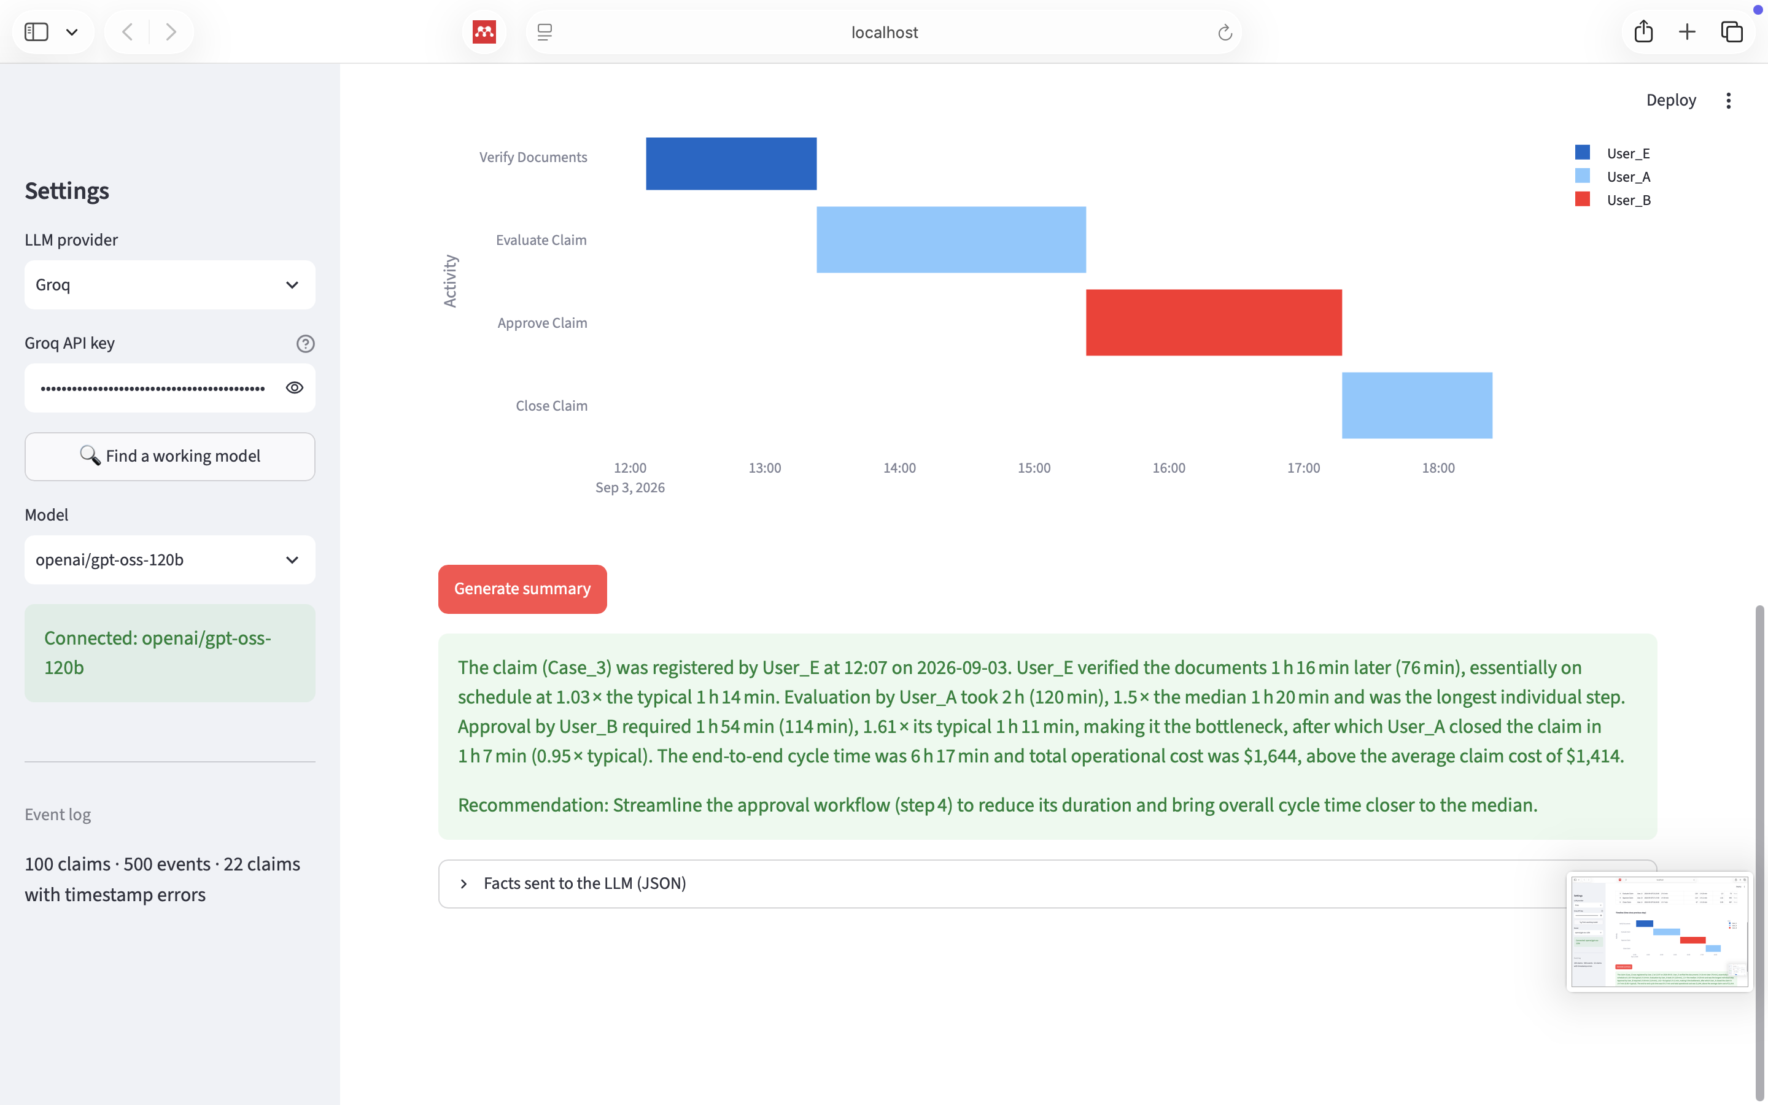
Figure 14. Summary of Case_3.
Case_77 (missing Register timestamp, E1). The summary says that the registration timestamp is missing, so the duration of verification and the cycle time cannot be measured, and identifies Evaluate Claim as the bottleneck (1 h 51 min, 1.39× typical). Total cost $1,330.
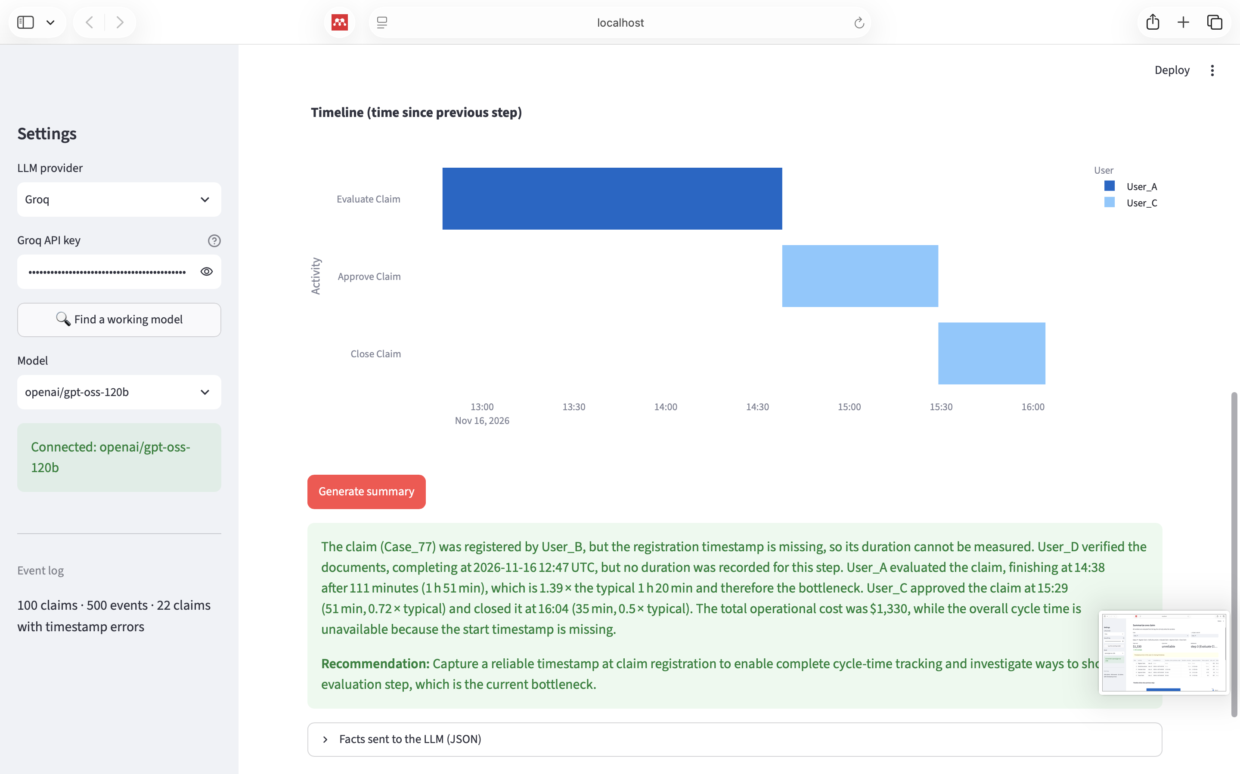
Figure 15. Summary of Case_77: the data-quality issue is reported instead of hidden.
In an early test the Case_77 summary wrote “12:47 UTC”, although the log has no time zone. A rule forbidding invented time zones was added to the prompt.

6. Question 5 — Timestamp correction with two LLMs
To be written after implementation: the two LLMs, the statistical and the machine-learning method, a short literature review justifying each, and screenshots of the Q5 tab.

7. Question 6 — Evaluation
To be written: one 2×2 table per metric (columns: model A, model B; rows: statistical, machine learning) for Accuracy, Precision, Recall and hallucination rate, evaluated against the 29-event ground truth of Question 1.

8. Question 7 — Time and cost
To be written: seconds and tokens per LLM and method, from the Usage & cost tab of the system.

References
- Suriadi, S., Andrews, R., ter Hofstede, A. H. M., & Wynn, M. T. (2017). Event log imperfection patterns for process mining: Towards a systematic approach to cleaning event logs. Information Systems, 64, 132–150.
- van der Aalst, W. M. P. (2016). Process Mining: Data Science in Action (2nd ed.). Springer.
- van der Aalst, W., Weijters, T., & Maruster, L. (2004). Workflow mining: Discovering process models from event logs. IEEE Transactions on Knowledge and Data Engineering, 16(9), 1128–1142.
- Weijters, A. J. M. M., van der Aalst, W. M. P., & Alves de Medeiros, A. K. (2006). Process mining with the HeuristicsMiner algorithm. BETA Working Paper 166, Eindhoven University of Technology.
- Leemans, S. J. J., Fahland, D., & van der Aalst, W. M. P. (2013). Discovering block-structured process models from event logs – a constructive approach. In Petri Nets 2013, LNCS 7927, 311–329. Springer.
- Muñoz-Gama, J., & Carmona, J. (2010). A fresh look at precision in process conformance. In BPM 2010, LNCS 6336, 211–226. Springer.
- Berti, A., van Zelst, S. J., & van der Aalst, W. M. P. (2019). Process Mining for Python (PM4Py): Bridging the gap between process- and data science. ICPM Demo Track, CEUR-WS 2374, 13–16.

