

UDACITY MACHINE LEARNING NANODEGREE 2020

CAPSTONE PROJECT

Classifying Urban sounds using Deep Learning

Qasim Hassan

April 17, 2020

# Definition

## Project Overview

The goal of this capstone project, is to apply Deep Learning techniques to the classification of environmental sounds, specifically focusing on the identification of particular urban sounds.

There is a plethora of real-world applications for this research, such as:

* + - Content-based multimedia indexing and retrieval
    - Assisting deaf individuals in their daily activities
    - Smart home use cases such as 360-degree safety and security capabilities
    - Automotive where recognizing sounds both inside and outside of the car can improve safety
    - Industrial uses such as predictive maintenance

## Problem Statement

The objective of this project will be to use Deep Learning techniques to classify urban sounds.

When given an audio sample in a computer readable format (such as a .wav file) of a few seconds duration, we want to be able to determine if it contains one of the target urban sounds with a corresponding likelihood score. Conversely, if none of the target sounds were detected, we will be presented with an unknown score.

To achieve this, we plan on using different neural network architectures such as Multi-Layer Per- ceptrons (MLPs) and Convolutional Neural Networks (CNNs).

## Metrics

The evaluation metric for this problem will be the ‘Classification Accuracy’ which is defined as the percentage of correct predictions.

### Accuracy = correct classifications / number of classifications

Classification Accuracy was deemed to be the optimal choice metric as it is presumed that the dataset will be relatively symmetrical (as we will explore in the next section) with this being a multi-class classifier whereby the target data classes will be generally uniform in size.

Other metrics such as Precision, Recall (or combined as the F1 score) were ruled out as they are more applicable to classification challenges that contain a relatively tiny target class in an unbalanced data set.

# 2.Analysis

## Data Exploration and Visualization

### Urban Sound dataset

For this project we will use a dataset called Urbansound8K. The dataset contains 8732 sound ex- cerpts (<=4s) of urban sounds from 10 classes, which are:

* + - * Air Conditioner
      * Car Horn
      * Children Playing
      * Dog bark
      * Drilling
      * Engine Idling
      * Gun Shot
      * Jackhammer
      * Siren
      * Street Music

The accompanying metadata contains a unique ID for each sound excerpt along with it’s given class name. A sample of this dataset is included with the accompanying git repo and the full dataset can be downloaded from [here](https://urbansounddataset.weebly.com/urbansound8k.html).

### Audio sample file data overview

These sound excerpts are digital audio files in .wav format.

Sound waves are digitized by sampling them at discrete intervals known as the sampling rate (typically 44.1kHz for CD quality audio meaning samples are taken 44,100 times per second).

Each sample is the amplitude of the wave at a particular time interval, where the bit depth determines how detailed the sample will be also known as the dynamic range of the signal (typically 16bit which means a sample can range from 65,536 amplitude values).

This can be represented with the following image:

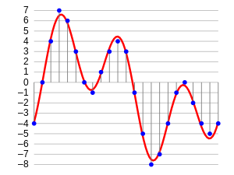

Therefore, the data we will be analyzing for each sound excerpts is essentially a one-dimensional array or

vector of amplitude values.

### Analyzing audio data

For audio analysis, we will be using the following libraries:

1. **IPython.display.Audio:** This allows us to play audio directly in the Jupyter Notebook.
2. **Librosa:** librosa is a Python package for music and audio processing by Brian McFee and will allow us to load audio in our notebook as a numpy array for analysis and manipulation.

You may need to install librosa using pip as follows:

### Auditory inspection

We will use IPython.display.Audio to play the audio files so we can inspect aurally.

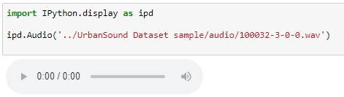

### Visual inspection

We will load a sample from each class and visually inspect the data for any patterns. We will use librosa to load the audio file into an array then librosa. display and matplotlib to display the waveform.

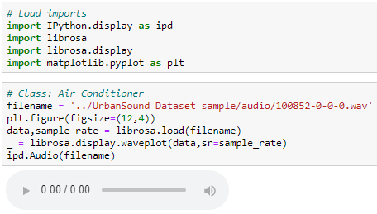

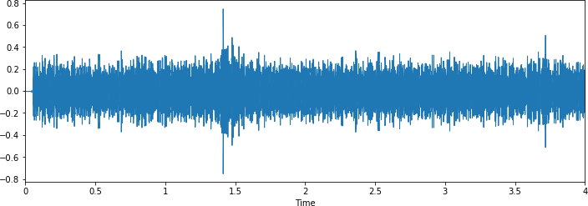

Similarly Load sounds files of all classes i:e Car Horn, Children playing, Dog Bark ,Drilling Etc. present in the data set.

**Observation:** From a visual inspection we can see that it is tricky to visualize the difference between some of the classes. Particularly, the waveforms for repetitive sounds for air conditioner, drilling, engine idling and jackhammer are similar in shape.

Likewise, the peak in the dog barking sample is similar in shape to the gun shot sample (albeit the samples differ in that there are two peaks for two gunshots compared to the one peak for one dog bark). Also, the car horn is similar too. There are also similarities between the children playing and street music.

The human ear can naturally detect the difference between the harmonics, it will be interesting to see how well a deep learning model will be able to extract the necessary features to distinguish between these classes. However, it is easy to differentiate from the waveform shape, the difference between certain classes such as dog barking and jackhammer.

### Dataset Metadata

Here we will load the Urban Sound metadata .csv file into a Panda data frame.

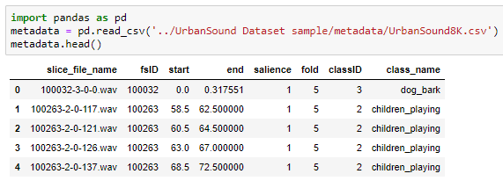

### Class distributions

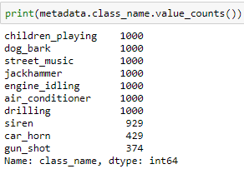

### 

**Observation:**  Here we can see the Class labels are unbalanced. Although 7 out of the 10 classes all have exactly 1000 samples, and siren is not far off with 929, the remaining two (car_horn, gun_shot) have significantly less samples at 43% and 37% respectively.

This will be a concern and something we may need to address later on.

### Audio sample file properties:

Next, we will iterate through each of the audio sample files and extract, number of audio channels, sample rate and bit-depth.

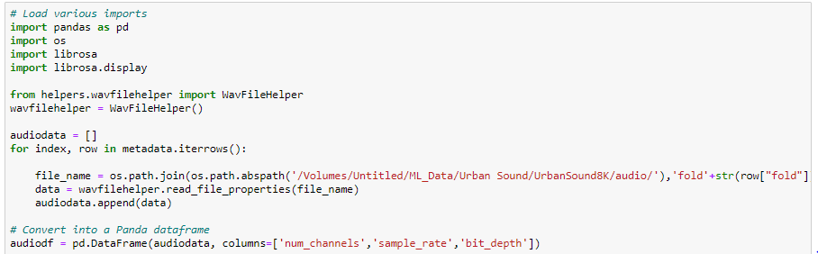

### Audio channels

Most of the samples have two audio channels (meaning stereo) with a few with just the one channel (mono).

The easiest option here to make them uniform will be to merge the two channels in the stereo samples into one by averaging the values of the two channels.

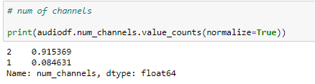

### Sample rate

There is a wide range of Sample rates that have been used across all the samples which is a concern (ranging from 96k to 8k).

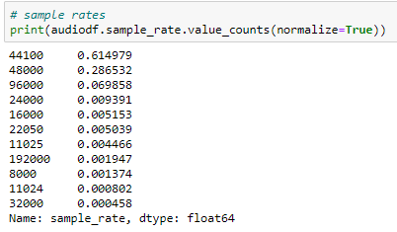This likely means that we will have to apply a sample-rate conversion technique (either up- conversion or down-conversion) so we can see an agnostic representation of their waveform which will allow us to do a fair comparison.

### Bit-depth

There is also a wide range of bit-depths. It’s likely that we may need to normalize them by taking the maximum and minimum amplitude values for a given bit-depth.

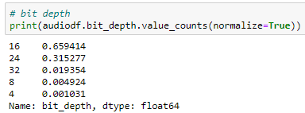

### Other audio properties to consider

We may also need to consider normalizing the volume levels (wave amplitude value) if this is seen to vary greatly, by either looking at the peak volume or the RMS volume.

## Algorithms and Techniques

The proposed solution to this problem is to apply Deep Learning techniques that have proved to be highly successful in the field of image classification.

First, we will extract Mel-Frequency Cepstral Coefficients (MFCC) [2] from the audio samples on a per-frame basis with a window size of a few milliseconds. The MFCC summarizes the frequency distribution across the window size, so it is possible to analyses both the frequency and time characteristics of the sound. These audio representations will allow us to identify features for classification.

The next step will be to train a Deep Neural Network with these data sets and make predictions. We will begin by using a simple neural network architecture, such as Multi-Layer Perceptron before experimenting with more complex architectures such as Convolutional Neural Networks.

Multi-layer perceptron’s (MLP) are classed as a type of Deep Neural Network as they are composed of more than one layer of perceptron’s and use non-linear activation which distinguish them from linear perceptron’s. Their architecture consists of an input layer, an output layer that ultimately make a prediction about the input, and in-between the two layers there is an arbitrary number of hidden layers.

These hidden layers have no direct connection with the outside world and perform the model computations. The network is fed a labelled dataset (this being a form of supervised learning) of input-output pairs and is then trained to learn a correlation between those inputs and outputs. The training process involves adjusting the weights and biases within the perceptron’s in the hidden layers in order to minimize the error.

The algorithm for training an MLP is known as Backpropagation. Starting with all weights in the network being randomly assigned, the inputs do a forward pass through the network and the decision of the output layer is measured against the ground truth of the labels you want to predict. Then the weights and biases are backpropagated back though the network where an optimization method, typically Stochastic Gradient descent is used to adjust the weights so they will move one step closer to the error minimum on the next pass. The training phase will keep on performing this cycle on the network until it the error can go no lower which is known as convergence.

Convolutional Neural Networks (CNNs) build upon the architecture of MLPs but with a number of important changes. Firstly, the layers are organized into three dimensions, width, height and depth. Secondly, the nodes in one layer do not necessarily connect to all nodes in the subsequent layer, but often just a sub region of it.

This allows the CNN to perform two important stages. The first being the feature extraction phase. Here a filter window slides over the input and extracts a sum of the convolution at each location which is then stored in the feature map. A pooling process is often included between CNN layers where typically the max value in each window is taken which decreases the feature map size but retains the significant data. This is important as it reduces the dimensionality of the network meaning it reduces both the training time and likelihood of overfitting. Then lastly, we have the classification phase. This is where the 3D data within the network is flattened into a 1D vector to be output.

For the reasons discussed, both MLPs and CNN’s typically make good classifiers, where CNN’s in particular perform very well with image classification tasks due to their feature extraction and classification parts. I believe that this will be very effective at finding patterns within the MFCC’s much like they are effective at finding patterns within images.

We will use the evaluation metrics described in earlier sections to compare the performance of these solutions against the benchmark models in the next section.

## Benchmark Model

For the benchmark model, we will use the algorithms outlined in the paper "A Dataset and Taxon- omy for Urban Sound Research" (Salamon, 2014) [3]. The paper describes five different algorithms with the following accuracies for a audio slice maximum duration of 4 seconds using the same Ur- banSound dataset.

|  |  |
| --- | --- |
| **Algorithm** | **Classification Accuracy** |
| SVM_rbf | 68% |
| RandomForest500 | 66% |
| IBk5 | 55% |
| J48 | 48% |
| ZeroR | 10% |

# 3.Methodology

## Data Preprocessing and Data Splitting

### Audio properties that will require normalizing

Following on from the previous section, we identified the following audio properties that need preprocessing to ensure consistency across the whole dataset:

* + - * Audio Channels
      * Sample rate
      * Bit-depth

We will continue to use Librosa which will be useful for the pre-processing and feature extraction.

### Preprocessing stage

For much of the preprocessing we will be able to use [Librosa’s load() function.](https://librosa.github.io/librosa/generated/librosa.core.load.html)

We will compare the outputs from Librosa against the default outputs of [scipy’s wavfile library](https://docs.scipy.org/doc/scipy-0.14.0/reference/generated/scipy.io.wavfile.read.html) using a chosen file from the dataset.

**Sample rate conversion:** By default, Librosa’s load function converts the sampling rate to 22.05 KHz which we can use as our comparison level.

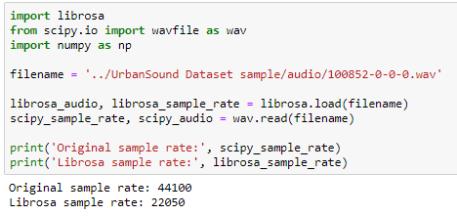

**Bit-depth:** Librosa’s load function will also normalize the data so it’s values range between -1 and 1. This removes the complication of the dataset having a wide range of bit-depths.

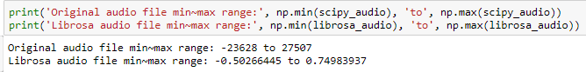

**Merge audio channels:** Librosa will also convert the signal to mono, meaning the number of channels will always be 1.

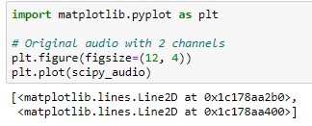

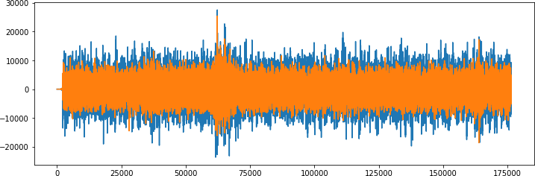

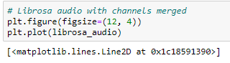

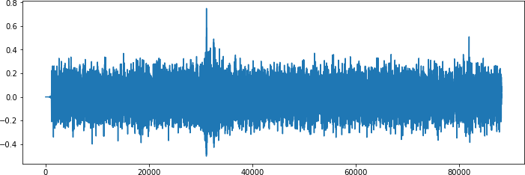

**Other audio properties to consider:** At this stage it is not yet clear whether other factors may also need to be taken into account, such as sample duration length and volume levels.

We will proceed as is for the meantime and come back to address these later if it’s perceived to be affecting the validity of our target metrics.

### Extract Features

As outlined in the proposal, we will extract [Mel-Frequency Cepstral Coefficients (MFCC)](https://en.wikipedia.org/wiki/Mel-frequency_cepstrum) from the audio samples.

The MFCC summarizes the frequency distribution across the window size, so it is possible to analyze both the frequency and time characteristics of the sound. These audio representations will allow us to identify features for classification.

**Extracting a MFCC** For this we will use [Librosa’s mfcc() function](https://librosa.github.io/librosa/generated/librosa.feature.mfcc.html) which generates an MFCC from time series audio data.

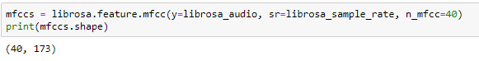

This shows librosa calculated a series of 40 MFCCs over 173 frames.

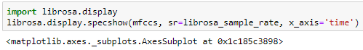

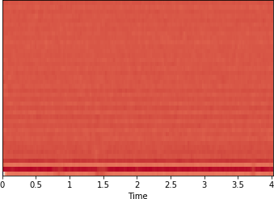

**Extracting MFCC’s for every file:** We will now extract an MFCC for each audio file in the dataset and store it in a Panda Data frame along with its classification label.

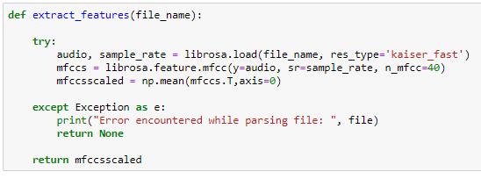

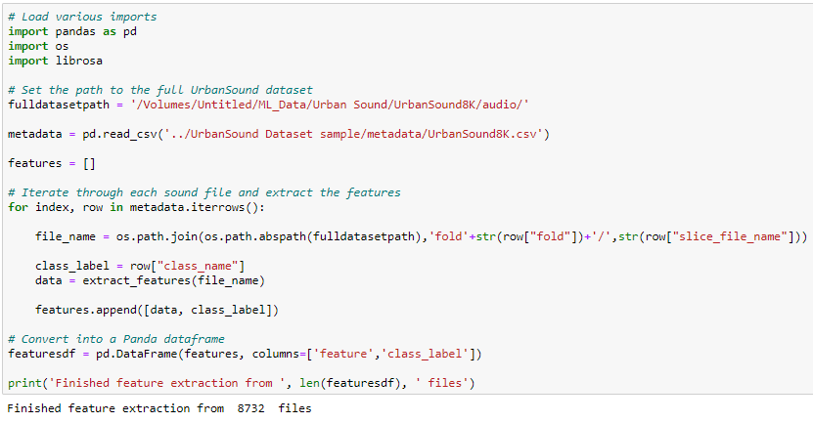

### Convert the data and labels

We will use sklearn.preprocessing.LabelEncoder to encode the categorical text data into model-understandable numerical data.

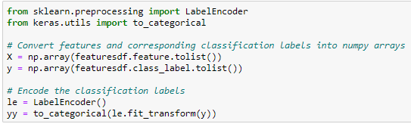

### Split the dataset

Here we will use sklearn.model_selection.train_test_split to split the dataset into training and testing sets. The testing set size will be 20% and we will set a random state.

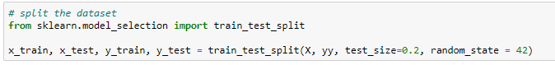

## Implementation

### Initial model architecture - MLP

We will start with constructing a Multilayer Perceptron (MLP) Neural Network using Keras and a Tensorflow backend.

Starting with a sequential model so we can build the model layer by layer.

We will begin with a simple model architecture, consisting of three layers, an input layer, a hidden layer and an output layer. All three layers will be of the dense layer type which is a standard layer type that is used in many cases for neural networks.

The first layer will receive the input shape. As each sample contains 40 MFCCs (or columns) we have a shape of (1x40) this means we will start with an input shape of 40.

The first two layers will have 256 nodes. The activation function we will be using for our first 2 layers is the ReLU, or Rectified Linear Activation. This activation function has been proven to work well in neural networks.

We will also apply a Dropout value of 50% on our first two layers. This will randomly exclude nodes from each update cycle which in turn results in a network that is capable of better generali- sation and is less likely to overfit the training data.

Our output layer will have 10 nodes (num_labels) which matches the number of possible classifi- cations. The activation is for our output layer is softmax. Softmax makes the output sum up to 1 so the output can be interpreted as probabilities. The model will then make its prediction based on which option has the highest probability.

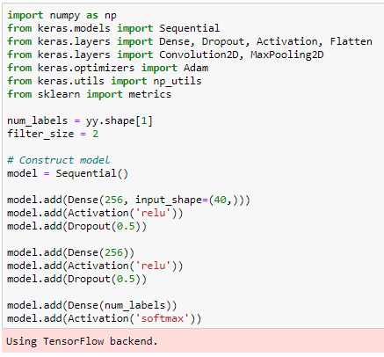

### Compiling the model

For compiling our model, we will use the following three parameters:

* + - * Loss function - we will use categorical_crossentropy. This is the most common choice for classification. A lower score indicates that the model is performing better.
      * Metrics - we will use the accuracy metric which will allow us to view the accuracy score on the validation data when we train the model.
      * Optimizer - here we will use adam which is a generally good optimizer for many use cases.

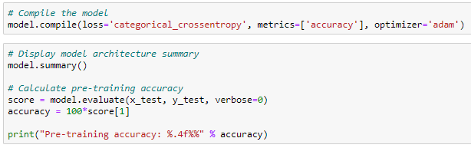

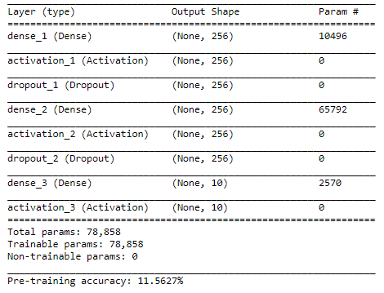

### Training

Here we will train the model.

We will start with 100 epochs which is the number of times the model will cycle through the data. The model will improve on each cycle until it reaches a certain point.

We will also start with a low batch size, as having a large batch size can reduce the generalization ability of the model.

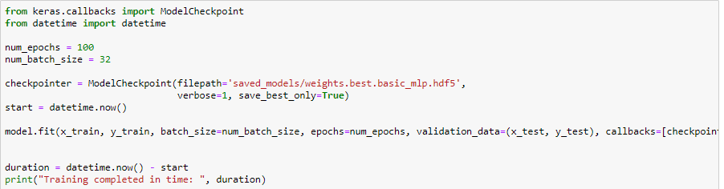

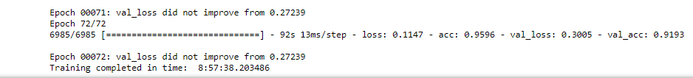

### Test the model

Here we will review the accuracy of the model on both the training and test data sets.

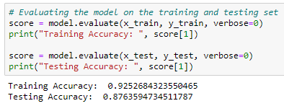

The initial Training and Testing accuracy scores are quite high. As there is not a great difference

between the Training and Test scores (~5%) this suggests that the model has not suffered from overfitting.

### Predictions

Here we will build a method which will allow us to test the model’s predictions on a specified audio .wav file.

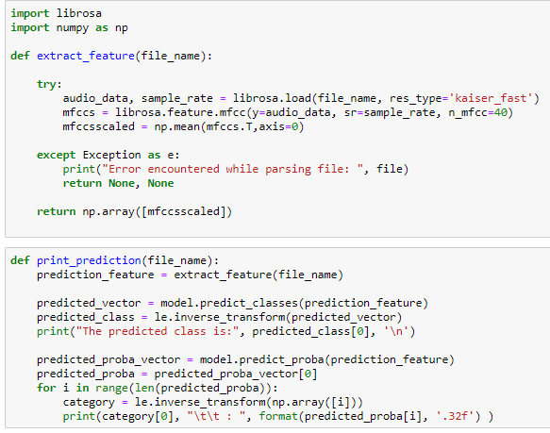



### Validation

**Test with sample data** Initial sanity check to verify the predictions using a subsection of the sample audio files we explored in the first notebook. We expect the bulk of these to be classified correctly.

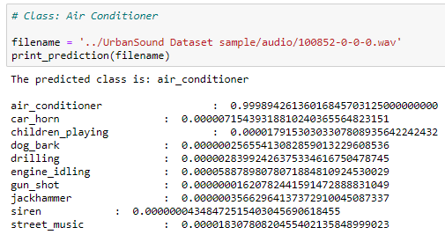

The above screen shot is the prediction of class air conditioner similarly I had predict on all classes i:e Car Horn, Street music, Drilling etc.

**Observations:** From this brief sanity check the model seems to predict well. One error was observed whereby a car horn was incorrectly classified as a dog bark.

We can see from the per class confidence that this was quite a low score (43%). This allows follows our early observation that a dog bark and car horn are similar in spectral shape.

### Other audio

Here we will use a sample of various copyright free sounds that we not part of either our test or training data to further validate our model.

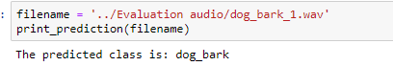

**Observations:** The performance of our initial model is satisfactory and has generalized well, seeming to predict well when tested against new audio data.

## Refinement

In our initial attempt, we were able to achieve a Classification Accuracy score of:

* + - Training data Accuracy: 92.3%
    - Testing data Accuracy: 87%

We will now see if we can improve upon that score using a Convolutional Neural Network (CNN).

**Feature Extraction refinement:** In the previous feature extraction stage, the MFCC vectors would vary in size for the different audio files (depending on the samples duration).

However, CNNs require a fixed size for all inputs which means we will have to revisit the feature extraction code that we previously wrote. To overcome this, we will zero pad the output vectors to make them all the same size.

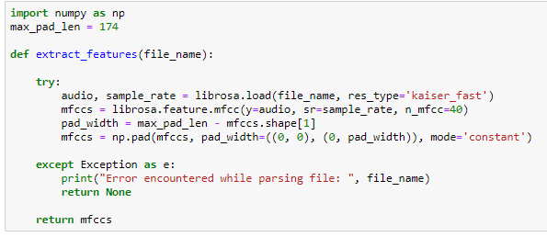

After that we use CNN which have four layers (set of Con2D, Maxpooling, dropout as shown in figure below)



Then we again train and test this time our training accuracy was very good but over testing accuracy was quite good which shows that we had kept our model save from overfitting as shown below

Then we predict on our audio files and observation was given below:

**Observations:** The performance of our final model is very good and has generalized well, seeming to predict well when tested against new audio data.

# Results

## Model Evaluation and Validation

During the model development phase, the validation data was used to evaluate the model. The final model architecture and hyperparameters were chosen because they performed the best among the tried combinations. This architecture is described in detail in section 3.

As we can see from the validation work in the previous section, to verify the robustness of the final model, a test was conducted using copyright free sounds from sourced from the internet. The following observations are based on the results of the test:

* + - The classifier performs well with new data.
    - Misclassification does occur but seems to be between classes that are relatively similar such as Drilling and Jackhammer.

## Justification

The final model achieved a classification accuracy of 92% on the testing data which exceeded my expectations given the benchmark was 68%.

|  |  |
| --- | --- |
| **Model** | **Classification Accuracy** |
| CNN | 92% |
| MLP | 88% |
| Benchmark SVM_rbf | 68% |

The final solution performs well when presented with a .wav file with a duration of a few seconds and returns a reliable classification.

However, we do not know how the model would perform on Real-time audio. We do not know whether it would be able to perform the classification in a timely manner so audio frames are not skipped or the classification would be heavily affected by latency.

Also, we do not know how the classifier would perform in a real-world setting. Our study makes no attempt to determine the effect of factors such as noise, echo’s, volume and salience level of the sample.

# 3.Conclusion

## Free-Form Visualization

It was previously noted in our data exploration, that it is difficult to visualise the difference be- tween some of the classes. In particular, the following sub-groups are similar in shape:

* + - Repetitive sounds for air conditioner, drilling, engine idling and jackhammer.
    - Sharp peaks for dog barking and gun shot.
    - Similar pattern for children playing and street music.

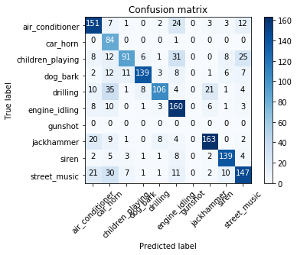Using a confusion matrix we will examine if the final model also struggled to differentiate between these classes.

The Confusion Matrix tells a different story. Here we can see that our model struggles the most with the following sub-groups:

* + - air conditioner, jackhammer and street music.
    - car horn, drilling, and street music.
    - air conditioner, children playing and engine idling.
    - jackhammer and drilling.
    - air conditioner, car horn, children playing and street music.

This shows us that the problem is more nuanced than our initial assessment and gives some in- sights into the features that the CNN is extracting to make it’s classifications. For example, street music is one of the commonly classified classes and could be to a wide variety of different samples within the class.

## Reflection

The process used for this project can be summarised with the following steps:

1. The initial problem was defined and relevant public dataset was located.
2. The data was explored and analysed.
3. Data was preprocessed and features were extracted.
4. An initial model was trained and evaluated. A further model was trained and refined.
5. The final model was evaluated.

From the initial exploration of the data in step 2, I envisaged that the preprocessing work in step 3 would be incredibly time consuming. However, this was actually relatively easy thanks to the Python tool Librosa. I also thought that the feature extraction would be a lot trickier but again Librosa shortened the effort required immensely.

MFCC’s we extracted in step 3 perform much better than I had expected. However, we had to revisit the extraction process when we transitioned to using a CNN as our model. I did consider revisiting our MLP model to see how it performed with the updated feature extraction technique, but unfortunately there was not enough time for this.

Overall, the model performed better than planned. One observation we made during step 2 is that the dataset is slightly unbalanced with 2 out of the 10 classes having roughly a 40% sample size of the other 8. However, it is unclear whether this is significant enough to have caused any issues.

## Improvement

If we were to continue with this project there are a number of additional areas that could be explored:

* + - As previously mentioned, test the model’s performance with Real-time audio.
    - Train the model for real world data. This would likely involve augmenting the training data in various ways such as:
      * Adding a variety of different background sounds.
      * Adjusting the volume levels of the target sound or adding echoes.
      * Changing the starting position of the recording sample, e.g. the shape of a dog bark.
    - Experiment to see if per-class accuracy is affected by using training data of different dura- tions.
    - Experiment with other techniques for feature extraction such as different forms of Spectro- grams.

# References

1. Justin Salamon, Christopher Jacoby and Juan Pablo Bello. *Urban Sound Datasets*. [https:](https://urbansounddataset.weebly.com/urbansound8k.html)

[//urbansounddataset.weebly.com/urbansound8k.html](https://urbansounddataset.weebly.com/urbansound8k.html)

1. *Mel-frequency cepstrum Wikipedia page* [https://en.wikipedia.org/wiki/Mel-frequency_ cepstrum](https://en.wikipedia.org/wiki/Mel-frequency_cepstrum)
2. J. Salamon, C. Jacoby, and J. P. Bello. *A dataset and taxonomy for urban sound research*. [http:](http://www.justinsalamon.com/uploads/4/3/9/4/4394963/salamon_urbansound_acmmm14.pdf)

[//www.justinsalamon.com/uploads/4/3/9/4/4394963/salamon_urbansound_acmmm14.pdf](http://www.justinsalamon.com/uploads/4/3/9/4/4394963/salamon_urbansound_acmmm14.pdf)

1. Manik Soni *AI which classifies Sounds:Code:Python*. [https://hackernoon.com/ ai-which-classifies-sounds-code-python-6a07a2043810](https://hackernoon.com/ai-which-classifies-sounds-code-python-6a07a2043810)
2. Manash Kumar Mandal *Building a Dead Simple Speech Recog- nition Engine using ConvNet in Keras*. [https://blog.manash.me/ building-a-dead-simple-word-recognition-engine-using-convnet-in-keras-25e72c19c12b](https://blog.manash.me/building-a-dead-simple-word-recognition-engine-using-convnet-in-keras-25e72c19c12b)
3. Eijaz Allibhai *Building a Convolutional Neural Network (CNN) in Keras*. [https:// towardsdatascience.com/building-a-convolutional-neural-network-cnn-in-keras-329fbbadc5f5](https://towardsdatascience.com/building-a-convolutional-neural-network-cnn-in-keras-329fbbadc5f5)
4. Daphne Cornelisse *An intuitive guide to Convolutional Neural Networks*. [https://medium. freecodecamp.org/an-intuitive-guide-to-convolutional-neural-networks-260c2de0a050](https://medium.freecodecamp.org/an-intuitive-guide-to-convolutional-neural-networks-260c2de0a050)
5. *Urban Sound Classification - Part 2: sample rate conversion, Librosa*. [https:// towardsdatascience.com/urban-sound-classification-part-2-sample-rate-conversion-librosa-ba7b](https://towardsdatascience.com/urban-sound-classification-part-2-sample-rate-conversion-librosa-ba7bc88f209a)
6. *wavsource.com THE Source for Free Sound Files and Reviews*. <http://www.wavsource.com/>
7. *soundbible.com*. <http://soundbible.com//>