CHOOSE THE RIGHT HARDWARE

PROPOSAL TEMPLATE  
By: QASIM HASSAN

# **SCENARIO 1: MANUFACTURING**

Client Requirements and Potential Hardware Solution

Look through the scenario and find any relevant client requirements. Then, suggest a potential hardware type and explain how this hardware would satisfy each of the requirements.

|  |
| --- |
| **Which hardware might be most appropriate for this scenario?**  **(CPU / IGPU / VPU / FPGA)** |
| **FPGA** is the most appropriate scenario in this case. |

|  |  |
| --- | --- |
| **Requirement Observed**  **(Include at least two.)** | **How does the chosen hardware meet this requirement?** |
| The manufacturing plant has a dream camera introduced at each belt. Every camera records video at 30-35 FPS (Frames Per Second). The customer would like the picture handling assignment to be finished five times each second. | This angle shows that inertness is a significant worry for this situation. When an FPGA is modified with the bitstream required for this application can run the model with extremely elite and give low idleness. As an FPGA can run numerous areas of the chip in equal and the capacity of FPGA to not go off-chip for performing induction from the model would especially be extremely valuable for this sort of situation. An FPGA additionally doesn't send the yield back to the CPU utilizing the PCIe transport making the deduction significantly quicker. |
| The second issue the customer has experienced is that a huge level of the semiconductor chips being bundled for transportation have blemishes. These are not identified until the chips are utilized by customers. On the off chance that these imperfections could be distinguished before bundling, this would set aside cash and improve the organization's notoriety. | To tackle this issue the edge framework would require having the option to convey elite. FPGAs would be an ideal fit for doing as such as they give an elite. Another part of FPGA which may help in this situation would be its capacity to be reconstructed on the field, which can help improve derivations. |
| To have the option to distinguish chip imperfections without slowing down the bundling procedure, the framework would have the option to run derivation on the video stream rapidly. | FPGAs can likewise be utilized as equipment quickening agents accelerating the surmising. The equal handling and no compelling reason to go off-chip further give an additional bit of leeway in playing out the deduction quicker. |
| Moreover, on the grounds that there are numerous chip structures and new plans are made regularly the framework would likewise be adaptable so that it tends to be reinvented and improved to rapidly recognize imperfections in various chip structures. | This need of the customer makes FPGA line up with the necessary equipment. FPGAs are profoundly adaptable; they are field programmable and can be reconstructed varying. |

## Queue Monitoring Requirements

|  |  |
| --- | --- |
| **Maximum number of people in the queue** | 02 |
| **Model precision chosen (FP32, FP16, or Int8)** | FP16 |

## 

## Test Results

After you've tested your application on all four hardware types (CPU, IGPU, VPU, and FPGA), copy the matplotlib output showing the comparison into the spaces below. You should have three graphs (for model load time, inference time, and FPS).

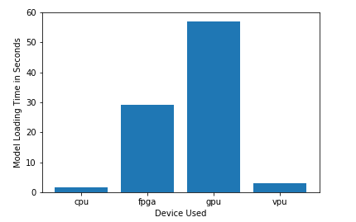

**Model Load Time**

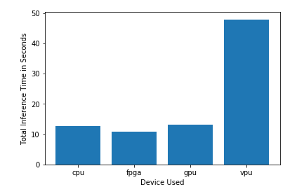

**Inference Time**

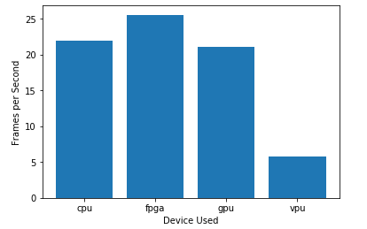

**FPS**

## Final Hardware Recommendation

Now synthesize your points from above and provide a brief write-up describing why the chosen hardware is the best choice for this scenario. Be sure to discuss the client's requirements, the test results, and how these relate to one another (e.g., perhaps one of the devices performed better than the rest, but does not meet one of the client's requirements).

|  |
| --- |
| **Write-up: Final Hardware Recommendation** |
| As appeared in the deduction time chart FPGAs set aside minimal measure of effort to perform inductions. The customer needs deduction to be performed quickly so this FPGA can make an admirable showing. We can see that FPGA additionally gives the most noteworthy FPS. The customer requires 25 - 30 FPS which can be tended to by an FPGA.  Further, they are likewise fielded programmable and have a high life which is mentioned by the customer. Thus, **FPGA would be a decent choice​ for this utilization case.** |

# 

# 

# **SCENARIO 2: RETAIL**

Client Requirements and Potential Hardware Solution

Look through the scenario and find any relevant client requirements. Then, suggest a potential hardware type and explain how this hardware would satisfy each of the requirements.

|  |
| --- |
| **Which hardware might be most appropriate for this scenario?**  **(CPU / IGPU / VPU / FPGA)** |
| **CPU** is the appropriate choice in this case. |

|  |  |
| --- | --- |
| **Requirement Observed**  **(Include at least two.)** | **How does the chosen hardware meet this requirement?** |
| The greater part of the store's checkout counters as of now have a cutting-edge PC, every one of which has an Intel i7 center processor. Presently, these processors are just used to complete some insignificant undertakings that are not computationally costly. | Since the customer as of now has a lot of CPUs that can't convey some computationally costly assignments. These CPUs with some new ones for the costly undertakings could be utilized. |
| The customer does not have much money to capitalize in supplementary computer hardware. | Current CPUs with few new CPUs can be used by the customer can be made use of to diminish the budget. |
| The customer would like to save as much as possible on his rechargeable bill. | CPUs could meet the computer hardware requirements and also support to save the customer’s rechargeable bill. |

## Queue Monitoring Requirements

|  |  |
| --- | --- |
| **Maximum number of people in the queue** | 2 to 5 |
| **Model precision chosen (FP32, FP16, or Int8)** | FP32 |

## 

## Test Results

After you've tested your application on all four hardware types (CPU, IGPU, VPU, and FPGA), copy the matplotlib output showing the comparison into the spaces below. You should have three graphs (for model load time, inference time, and FPS).

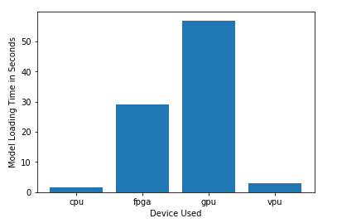

**Model Load Time**

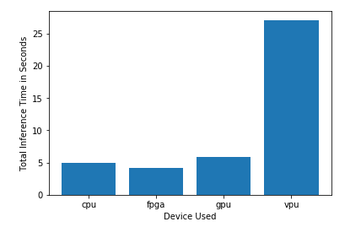

**Inference Time**

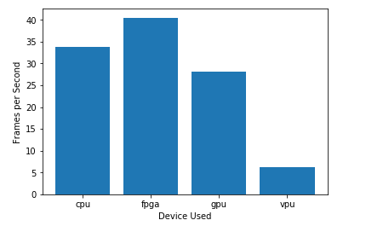

**FPS**

## Final Hardware Recommendation

Now synthesize your points from above and provide a brief write-up describing why the chosen hardware is the best choice for this scenario. Be sure to discuss the client's requirements, the test results, and how these relate to one another (e.g., perhaps one of the devices performed better than the rest, but does not meet one of the client's requirements).

|  |
| --- |
| **Write-up: Final Hardware Recommendation** |
| CPU has a nearly lower derivation time than a GPU and VPU which is significant for this application. A CPU can likewise make deductions on an adequate FPS for a retail location. It would likewise help spare expenses and power bills as mentioned by the customer. Along these lines, **​the CPU would be a decent choice​ for this utilization case.** |

# 

# **SCENARIO 3: TRANSPORTATION**

Client Requirements and Potential Hardware Solution

Look through the scenario and find any relevant client requirements. Then, suggest a potential hardware type and explain how this hardware would satisfy each of the requirements.

|  |
| --- |
| **Which hardware might be most appropriate for this scenario?**  **(CPU / IGPU / VPU / FPGA)** |
| **VPU** is the appropriate choice in this case. |

|  |  |
| --- | --- |
| **Requirement Observed**  **(Include at least two.)** | **How does the chosen hardware meet this requirement?** |
| The CPUs in these machines are right now being utilized to process and view CCTV film for security purposes and no critical extra handling power is accessible to run derivation. | A VPU or NCS 2 can be connected to a USB port and has an advantageous fitting and play sort of execution. This especially is ideal as not any more extra preparing power is accessible to run induction. |
| The customer's inexpensive allows for a thoroughgoing of $300 per machine. | A VPU or NCS 2 stick budgets almost $100 opposed to the relatively higher budgets of FPGA, CPU or GPU. |
| The customer would like to save as much as possible both on computer hardware and upcoming power necessities. | A VPU or NCS 2 stick is considered to run on very low power. The NCS 2 can run on just 1 W of power observing to the customer’s needs. |

## Queue Monitoring Requirements

|  |  |
| --- | --- |
| **Maximum number of people in the queue** | 7 to 15 |
| **Model precision chosen (FP32, FP16, or Int8)** | FP16 |

## 

## Test Results

After you've tested your application on all four hardware types (CPU, IGPU, VPU, and FPGA), copy the matplotlib output showing the comparison into the spaces below. You should have three graphs (for model load time, inference time, and FPS).

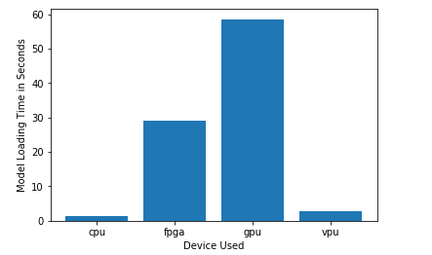

**Model Load Time**

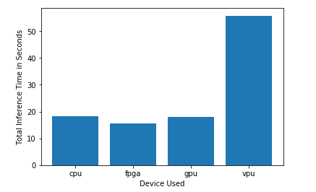

**Inference Time**

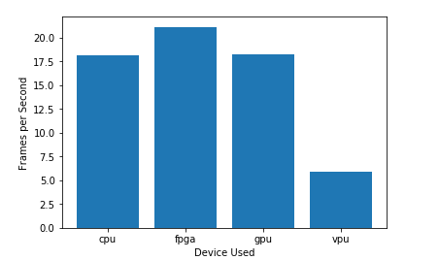

**FPS**

## Final Hardware Recommendation

Now synthesize your points from above and provide a brief write-up describing why the chosen hardware is the best choice for this scenario. Be sure to discuss the client's requirements, the test results, and how these relate to one another (e.g., perhaps one of the devices performed better than the rest, but does not meet one of the client's requirements).

|  |
| --- |
| **Write-up: Final Hardware Recommendation** |
| VPU gives a high surmising time and induction on low FPS. A CPU or GPU would in a perfect world be useful for this if the financial plan and force situation would be overlooked. Since the customer requires these aspects VPU would be a decent choice​ for this situation. |

# 