Bahria University,

Karachi Campus



COURSE: CEL-409 Artificial Intelligence & Machine Learning lab

TERM: FALL 2023, CLASS: BCE- 7A

Submitted By:

_____ _khizar_____________________ __02-132202-010___

(Name) (Reg. No.)

Submitted To:

Engr. Sidra Mudassar/Engr. QASIM HASSAN

Signed Remarks: Score:

Bahria University,

Karachi Campus



LAB EXPERIMENT NO.

___2____

LIST OF TASKS

|  |  |
| --- | --- |
| TASK NO | OBJECTIVE |
| TASK NO 1 | Given 3 int values, a b c, return their sum. However, if any of the values is a teen -- in the range 13..19 inclusive -- then that value counts as 0.  Sample Run:  Input: a=3, b=1, c=4 ; a=21, b=1, c=2 ; a=13, b=1, c=19  Output: Sum= 8, ; Sum=24 ; Sum = 1 |
| TASK NO 2 | Given a string input Count all lower case, upper case, digits, and special symbols.  Sample Run:  String: ABC123@gmail.com  Output: lowercase = 8, uppercase = 3 , special symbols = 2 , digits = 3 |
| TASK NO 3 | Given a string, return the sum and average of the digits that appear in the string, ignoring all other characters.  Sample Run:  String: Q-301 is at 4 th floor of quaid block.  Output: Sum = 8 and Average is 2 |
| TASK NO 4 | Given an array length 1 or more of ints, return the difference between the largest and smallest values in the array. Note: the built-in min(v1, v2) and max(v1, v2) functions return the smaller or larger of two values.  Sample Run: 1,2,3,4,5,8,9,10,15,40,3  Input: min = 1, max= 40 difference = 39 |
| TASK NO 5 | Return the number of times that the string "ant" appears anywhere in the given string, except we'll accept any letter for the 'n', so "art" and "abt" and other counts.  Sample Run:  String: Antandart  **Output: count = 2** |

Submitted On:

______10/10/2023______

(Date: DD/MM/YY)

**Task No. 1:** Given 3 int values, a b c, return their sum. However, if any of the values is a teen -- in the range 13..19 inclusive -- then that value counts as 0.

**Sample Run:**

**Input:** a=3, b=1, c=4 ; a=21, b=1, c=2 ; a=13, b=1, c=19

**Output: Sum= 8, ; Sum=24 ; Sum = 1**

**Code:**

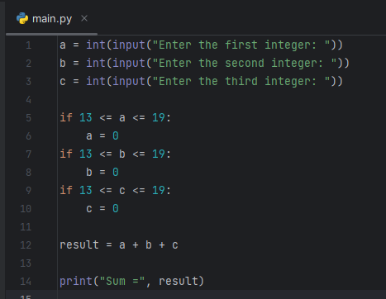

**Output:**

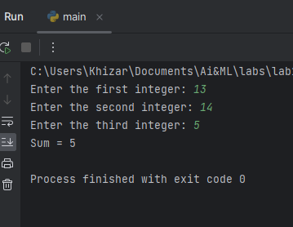

**Task No. 2:** Given a string input Count all lower case, upper case, digits, and special symbols.

**Sample Run:**

**String:** ABC123@gmail.com

**Output: lowercase = 8, uppercase = 3 , special symbols = 2 , digits = 3**

**Code:**

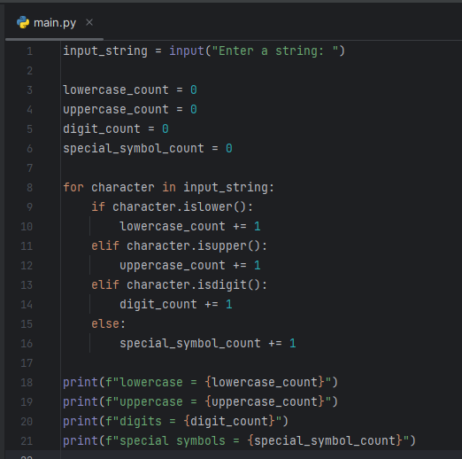

**Output:**

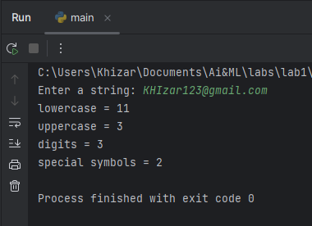

**Task No. 3:** Given a string, return the sum and average of the digits that appear in the string, ignoring all other characters.

**Sample Run:**

**String:** Q-301 is at 4 th floor of quaid block.

**Output: Sum = 8 and Average is 2**

**Code:**

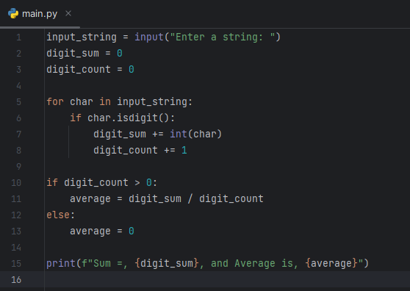

**Output:**

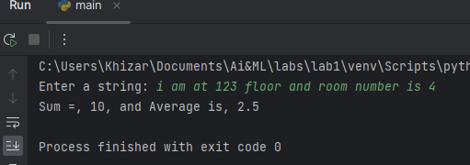

**Task No. 4:** Given an array length 1 or more of ints, return the difference between the largest and smallest values in the array. Note: the built-in min(v1, v2) and max(v1, v2) functions return the smaller or larger of two values.

Sample Run: 1,2,3,4,5,8,9,10,15,40,3

Input: min = 1, max= 40 difference = 39

**Code:**

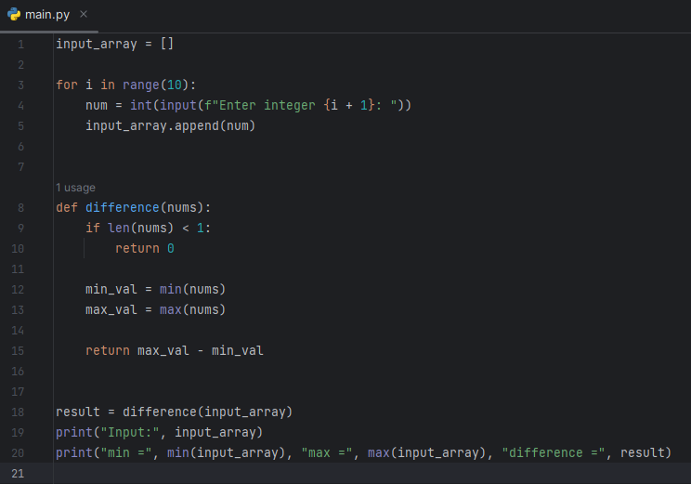

**Output:**

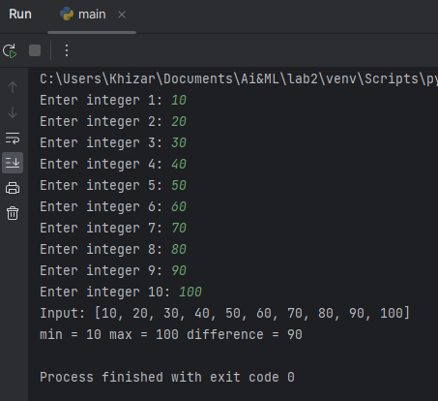

**Task No. 5:** Return the number of times that the string "ant" appears anywhere in the given string, except we'll accept any letter for the 'n', so "art" and "abt" and other counts.

Sample Run:

String: Antandart

Output: count = 2

**Code:**

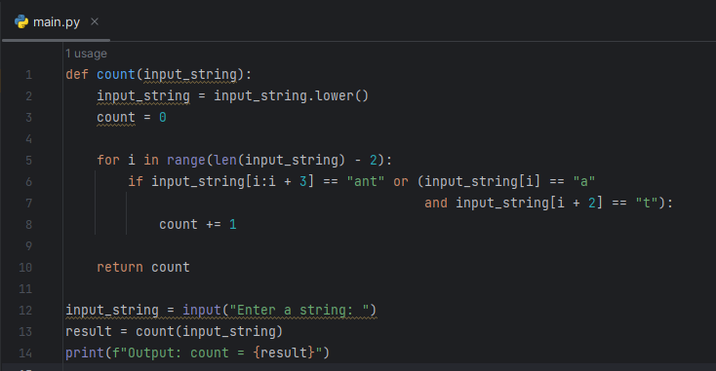

**Output:**

