Bahria University,

Karachi Campus



COURSE: CEL-409 Artificial Intelligence & Machine Learning lab

TERM: FALL 2023, CLASS: BCE- 7A

Submitted By:

_____ _khizar_____________________ __02-132202-010___

(Name) (Reg. No.)

Submitted To:

Engr. Sidra Mudassar/Engr. QASIM HASSAN

Signed Remarks: Score:

Bahria University,

Karachi Campus



LAB EXPERIMENT NO.

___3____

LIST OF TASKS

|  |  |
| --- | --- |
| TASK NO | OBJECTIVE |
| TASK NO 1 | Write a Python program to construct the following pattern, using a nested for loop.  *  * *  * * *  * * * *  * * * * *  * * * *  * * *  * *  * |
| TASK NO 2 | Write a Python program that accepts a sequence of comma separated 4 digit binary numbers as its input. The program will print the numbers that are divisible by 5 in a comma separated sequence. Sample Data : 0100,0011,1010,1001,1100,1001 Expected Output : 1010 |
| TASK NO 3 | Write a Python program to convert a month name to a number of days. Expected Output:  List of months: January, February, March, April, May, June, July, August  , September, October, November, December  Input the name of Month: February  No. of days: 28/29 days |
| TASK NO 4 | Write a Python program to convert a month name to a number of days. Expected Output:  List of months: January, February, March, April, May, June, July, August  , September, October, November, December  Input the name of Month: February  No. of days: 28/29 days |
| TASK NO 5 | Write a Python program to convert a month name to a number of days. Expected Output:  List of months: January, February, March, April, May, June, July, August  , September, October, November, December  Input the name of Month: February  No. of days: 28/29 days |
| TASK NO 6 | Completed the Hacktoberfest Challenge as described in the class. Reference material is given below: (NOTE: If you skipped this task, you’ll marked zero) |
|  |  |
|  |  |
|  |  |
|  |  |
|  |  |

Submitted On:

_____12/10/2023_______

(Date: DD/MM/YY)

**Task No. 1:** Write a Python program to construct the following pattern, using a nested for loop.

*   
* *   
* * *   
* * * *   
* * * * *   
* * * *   
* * *   
* *   
*

**Code:**

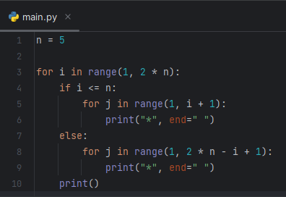

**Output:**

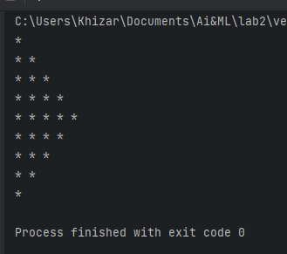

**Task No. 2:** Write a Python program that accepts a sequence of comma separated 4 digit binary numbers as its input. The program will print the numbers that are divisible by 5 in a comma separated sequence.  
Sample Data : 0100,0011,1010,1001,1100,1001  
Expected Output : 1010

**Code:**

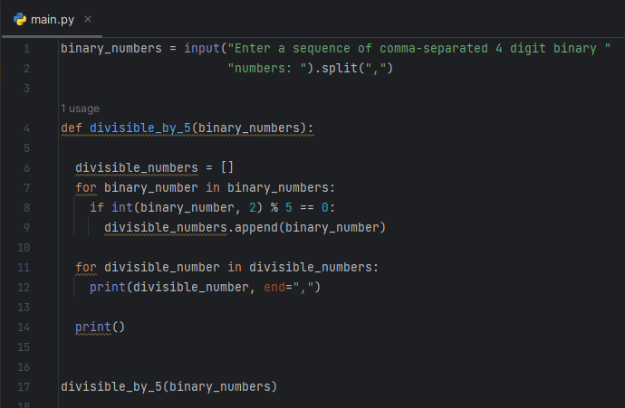

**Output:**

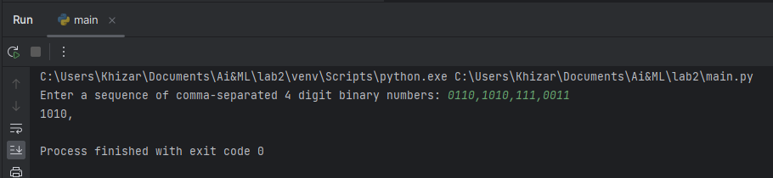

**Task No. 3:** Write a Python program to convert a month name to a number of days.  
Expected Output:

List of months: January, February, March, April, May, June, July, August

, September, October, November, December

Input the name of Month: February

No. of days: 28/29 days

**Code:**

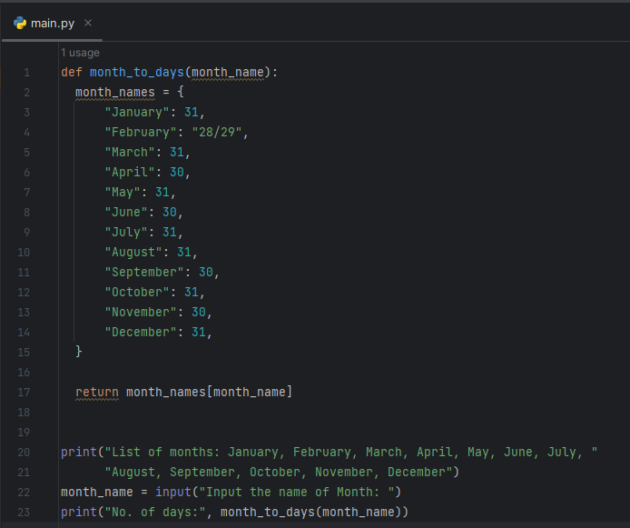

**Output:**

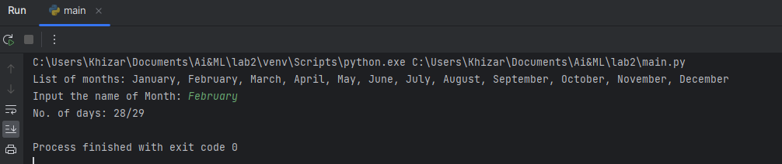

**Task No. 6:** Completed the Hacktoberfest Challenge as described in the class. Reference material is given below: (NOTE: If you skipped this task, you’ll marked zero)

**Output:**

