Bahria University,

Karachi Campus



COURSE: CEL-409 Artificial Intelligence & Machine Learning lab

TERM: FALL 2023, CLASS: BCE- 7A

Submitted By:

_____ _khizar_____________________ __02-132202-010___

(Name) (Reg. No.)

Submitted To:

Engr. Sidra Mudassar/Engr. QASIM HASSAN

Signed Remarks: Score:

Bahria University,

Karachi Campus



LAB EXPERIMENT NO.

___4____

LIST OF TASKS

|  |  |
| --- | --- |
| TASK NO | OBJECTIVE |
| TASK NO 1 | 1. Write a Python program to sort Counter by value. Sample data: {'Math':81, 'Physics':83, 'Chemistry':87} Expected data: [('Chemistry', 87), ('Physics', 83), ('Math', 81)] |
| TASK NO 2 | 1. Write a Python program to store dictionary data in a JSON file. Original dictionary: {'students': [{'firstName': 'Nikki', 'lastName': 'Roysden'}, {'firstName': 'Mervin', 'lastName': 'Friedland'}, {'firstName': 'Aron ', 'lastName': 'Wilkins'}], 'teachers': [{'firstName': 'Amberly', 'lastName': 'Calico'}, {'firstName': 'Regine', 'lastName': 'Agtarap'}]} <class 'dict'> Json file to dictionary: {'students': [{'firstName': 'Nikki', 'lastName': 'Roysden'}, {'firstName': 'Mervin', 'lastName': 'Friedland'}, {'firstName': 'Aron ', 'lastName': 'Wilkins'}], 'teachers': [{'firstName': 'Amberly', 'lastName': 'Calico'}, {'firstName': 'Regine', 'lastName': 'Agtarap'}] |
| TASK NO 3 | 1. Write a Python program to remove a specified dictionary from a given list. Original list of dictionary: [{'id': '#FF0000', 'color': 'Red'}, {'id': '#800000', 'color': 'Maroon'}, {'id': '#FFFF00', 'color': 'Yellow'}, {'id': '#808000', 'color': 'Olive'}] Remove id #FF0000 from the said list of dictionary: [{'id': '#800000', 'color': 'Maroon'}, {'id': '#FFFF00', 'color': 'Yellow'}, {'id': '#808000', 'color': 'Olive'}] |
| TASK NO 4 | 1. Write a program (using functions!) that asks the user for a long string containing multiple words. Print back to the user the same string, except with the words in backwards order. For example, Input: I live in Pakistan. Output: Pakistan in live I. |
| TASK NO 5 | 1. Write a recursive function to compute Ntn Fibonacci number. Test and trace for N = 6 is 8. We remember that a Fibonacci number can be recursively defined as: $F\left(n\right)=F\left(n-1\right)+F\left(n-2\right)\text{for}n≥2$  , where $F\left(0\right)=0, F\left(1\right)=1$. |
| TASK NO 6 | Implement BFS & DFS in python as describes in the class |
|  |  |
|  |  |
|  |  |
|  |  |
|  |  |

Submitted On:

_____16/10/2023_______

(Date: DD/MM/YY)

**Task No. 1:** Write a Python program to sort Counter by value.  
Sample data: {'Math':81, 'Physics':83, 'Chemistry':87}  
Expected data: [('Chemistry', 87), ('Physics', 83), ('Math', 81)]

**Code:**

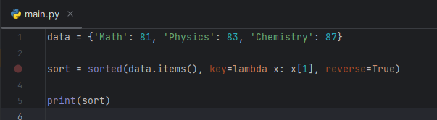

**Output:**

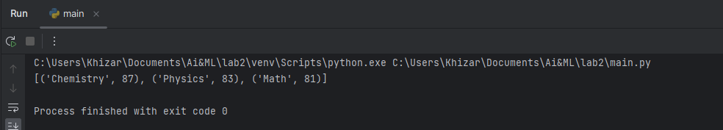

**Task No. 2:** Write a Python program to store dictionary data in a JSON file.  
Original dictionary:  
{'students': [{'firstName': 'Nikki', 'lastName': 'Roysden'}, {'firstName': 'Mervin', 'lastName': 'Friedland'}, {'firstName': 'Aron ', 'lastName': 'Wilkins'}], 'teachers': [{'firstName': 'Amberly', 'lastName': 'Calico'}, {'firstName': 'Regine', 'lastName': 'Agtarap'}]}  
<class 'dict'>  
Json file to dictionary:  
{'students': [{'firstName': 'Nikki', 'lastName': 'Roysden'}, {'firstName': 'Mervin', 'lastName': 'Friedland'}, {'firstName': 'Aron ', 'lastName': 'Wilkins'}], 'teachers': [{'firstName': 'Amberly', 'lastName': 'Calico'}, {'firstName': 'Regine', 'lastName': 'Agtarap'}]}

**Code:**

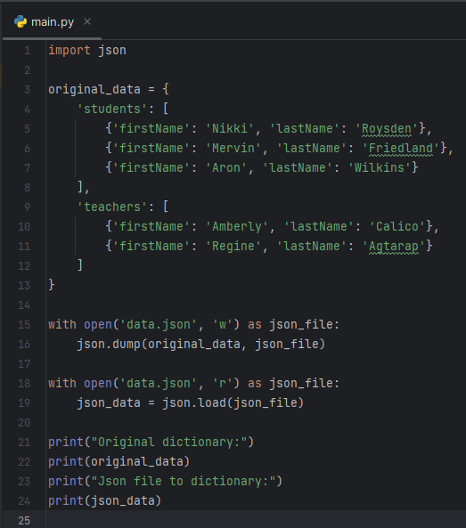

**Output:**

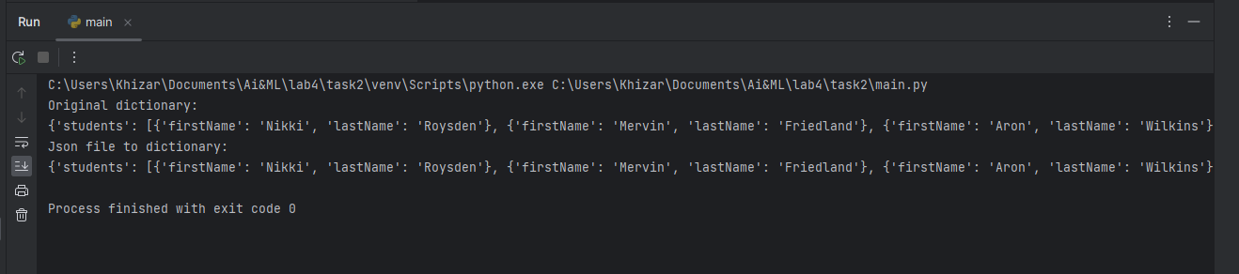

**Task No. 3: .** Write a Python program to remove a specified dictionary from a given list.  
Original list of dictionary:  
[{'id': '#FF0000', 'color': 'Red'}, {'id': '#800000', 'color': 'Maroon'}, {'id': '#FFFF00', 'color': 'Yellow'}, {'id': '#808000', 'color': 'Olive'}]  
Remove id #FF0000 from the said list of dictionary:  
[{'id': '#800000', 'color': 'Maroon'}, {'id': '#FFFF00', 'color': 'Yellow'}, {'id': '#808000', 'color': 'Olive'}]

**Code:**

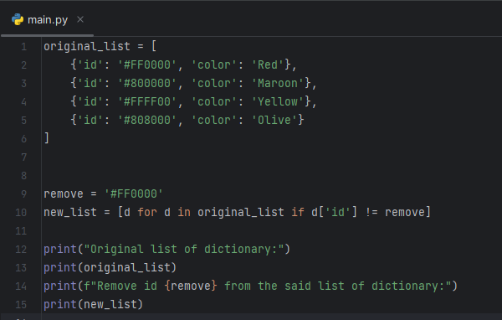

**Output:**

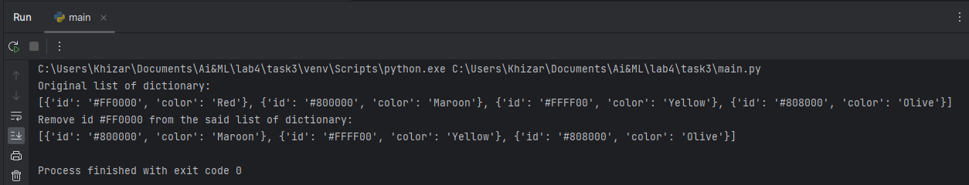

**Task No. 4:** Write a program (using functions!) that asks the user for a long string containing multiple words. Print back to the user the same string, except with the words in backwards order. For example, Input: I live in Pakistan. Output: Pakistan in live I.

**Code:**

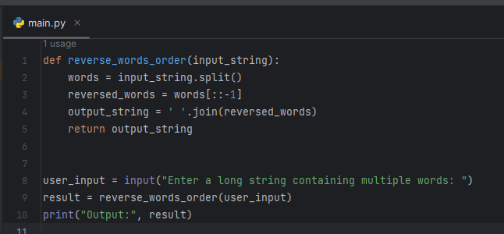

**Output:**

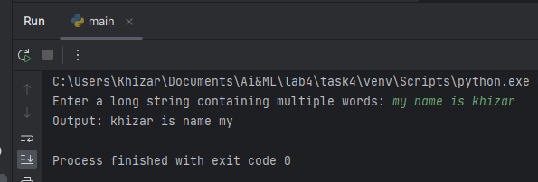

**Task No. 5:** Write a recursive function to compute Ntn Fibonacci number. Test and trace for N = 6 is 8. We remember that a Fibonacci number can be recursively defined as:

$F\left(n\right)=F\left(n-1\right)+F\left(n-2\right)\text{for}n≥2$, where $F\left(0\right)=0, F\left(1\right)=1$.

**Code:**

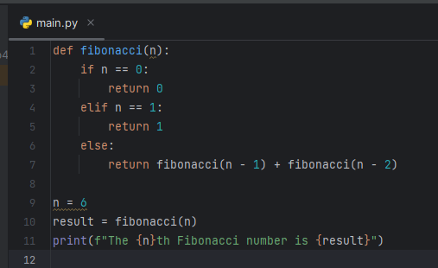

**Output:**

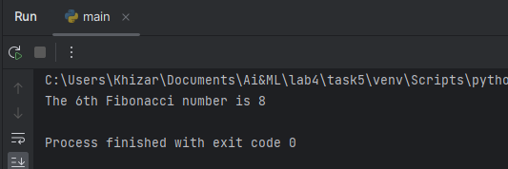

**Task No. 6:**  Implement BFS & DFS in python as describes in the class

**BFS**

**Code:**

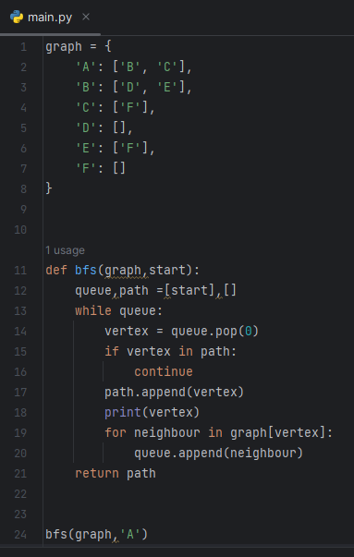

**Output:**

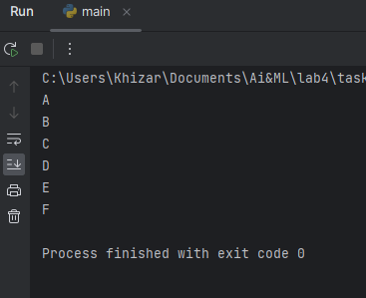

**DFS**

**Code:**

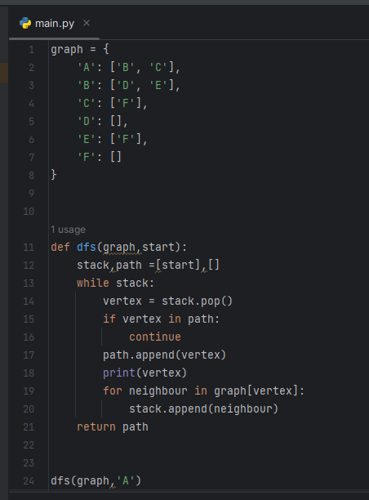

**Output:**

