Bahria University,

Karachi Campus



COURSE: CEN-409 ARTIFICIAL INTELLIGENCE &

MACHINE LEARNING

TERM: FALL 2023, CLASS: BCE- 7A

Submitted By:

**Sheikh Muhammad Salman Farid 02-132202-006**

(Name) (Reg. No.)

Submitted To:

Engr. Qasim Hassan

Signed Remarks: Score:

Bahria University,

Karachi Campus



ASSIGNMENT NO.

**_4_**

LIST OF TASKS

|  |  |
| --- | --- |
| TASK NO | OBJECTIVE |
| 1 | Write a Python program to sort Counter by value. |
| 2 | Write a Python program to store dictionary data in a JSON file. |
| 3 | Write a Python program to remove a specified dictionary from a given list. |
| 4 | Write a program (using functions!) that asks the user for a long string containing multiple words. Print back to the user the same string, except with the words in backwards order. |
| 5 | Write a recursive function to compute Ntn Fibonacci number. Test and trace for N = 6 is 8. We remember that a Fibonacci number can be recursively defined as: $F\left(n\right)=F\left(n-1\right)+F\left(n-2\right)\text{for}n≥2$ , where $F\left(0\right)=0, F\left(1\right)=1$. |
| 6 | Implement BFS & DFS in python as describes in the class. |

Submitted On:

**___15 - 10 - 2023___**

(Date: DD/MM/YY)

**Task 1:**

Write a Python program to sort Counter by value.

**Solution:**

**Task 2:**

Write a Python program to store dictionary data in a JSON file.

**Solution:**

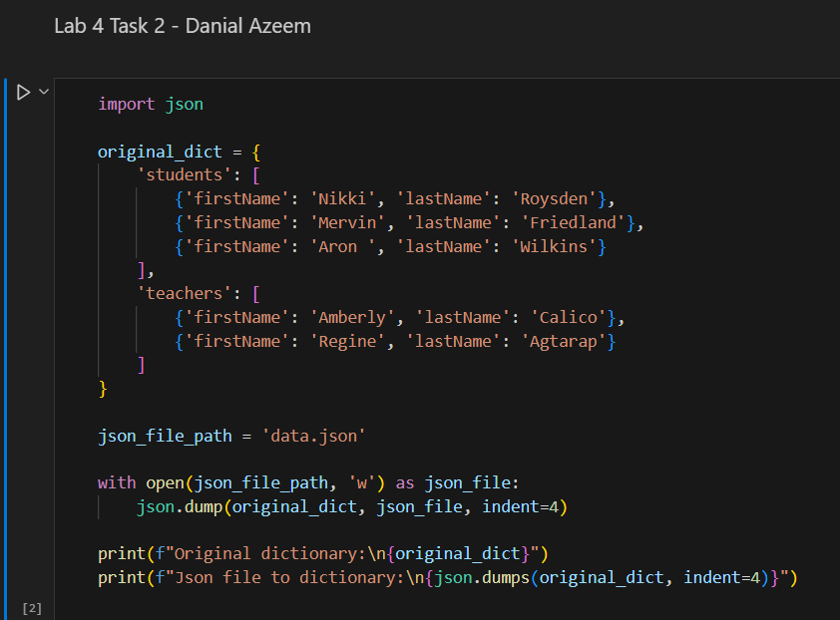

**Task 3:**

Write a Python program to remove a specified dictionary from a given list.

**Solution:**

**Task 4:**

Write a program (using functions!) that asks the user for a long string containing multiple words. Print back to the user the same string, except with the words in backwards order.

**Solution:**

**Task 5:**

Write a recursive function to compute Ntn Fibonacci number. Test and trace for N = 6 is 8. We remember that a Fibonacci number can be recursively defined as:

$F\left(n\right)=F\left(n-1\right)+F\left(n-2\right)\text{for}n≥2$, where $F\left(0\right)=0, F\left(1\right)=1$.

**Solution:**

**Task 6:**

**Implement BFS & DFS in python as describes in the class.**

**Solution:**

