Cargill’s Corner
Based on King’s Corner
Navigate to https://aiyazmostofa.github.io/cargills-corner

Rules
- Rule #1: Draw a card from the deck (automatically done).
- Rule #2: You can place your card onto any pile if your card is the opposite color of the top card and the rank of the card is exactly one below the top card’s.
- Rule #3: If you have a king, you can place your card in one of the corner’s (if not already occupied) to start a new pile.
- Rule #4: You can move one pile (a) to the top of another pile (b) if the bottom card of (a) and the top card of (b) follows rule #1.
- Rule #5: You can place any card in a vacant spot if it isn’t a corner spot.
- Rule #6: Play as many moves as you can (or like), then go to the next player.

Gameplay
You can click on any card in your deck. You can also click on any card in one of the piles (this will select a pile).
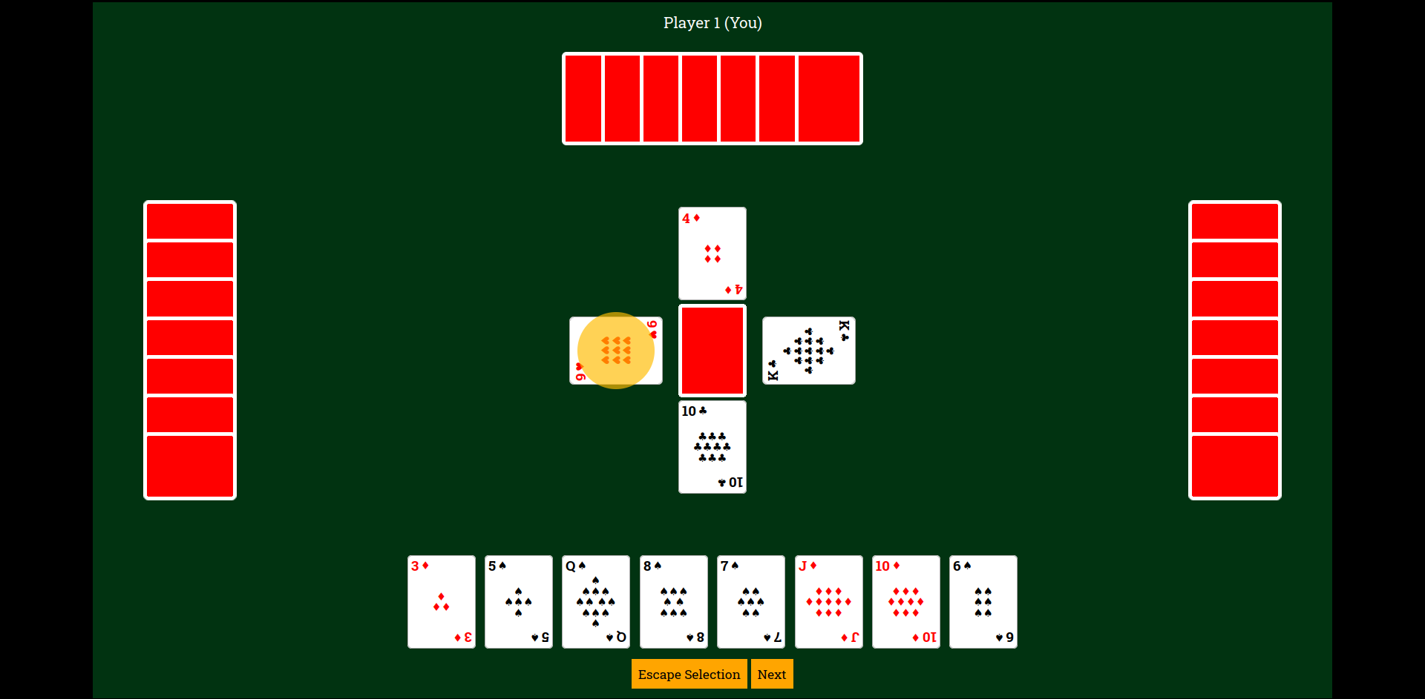
Then, you will see a screen like one shown above. You can move that card (or pile) to any of the piles highlighted yellow. You can escape this selection by clicking the “Escape Selection” button. After you are done with all of your moves, click the next button.
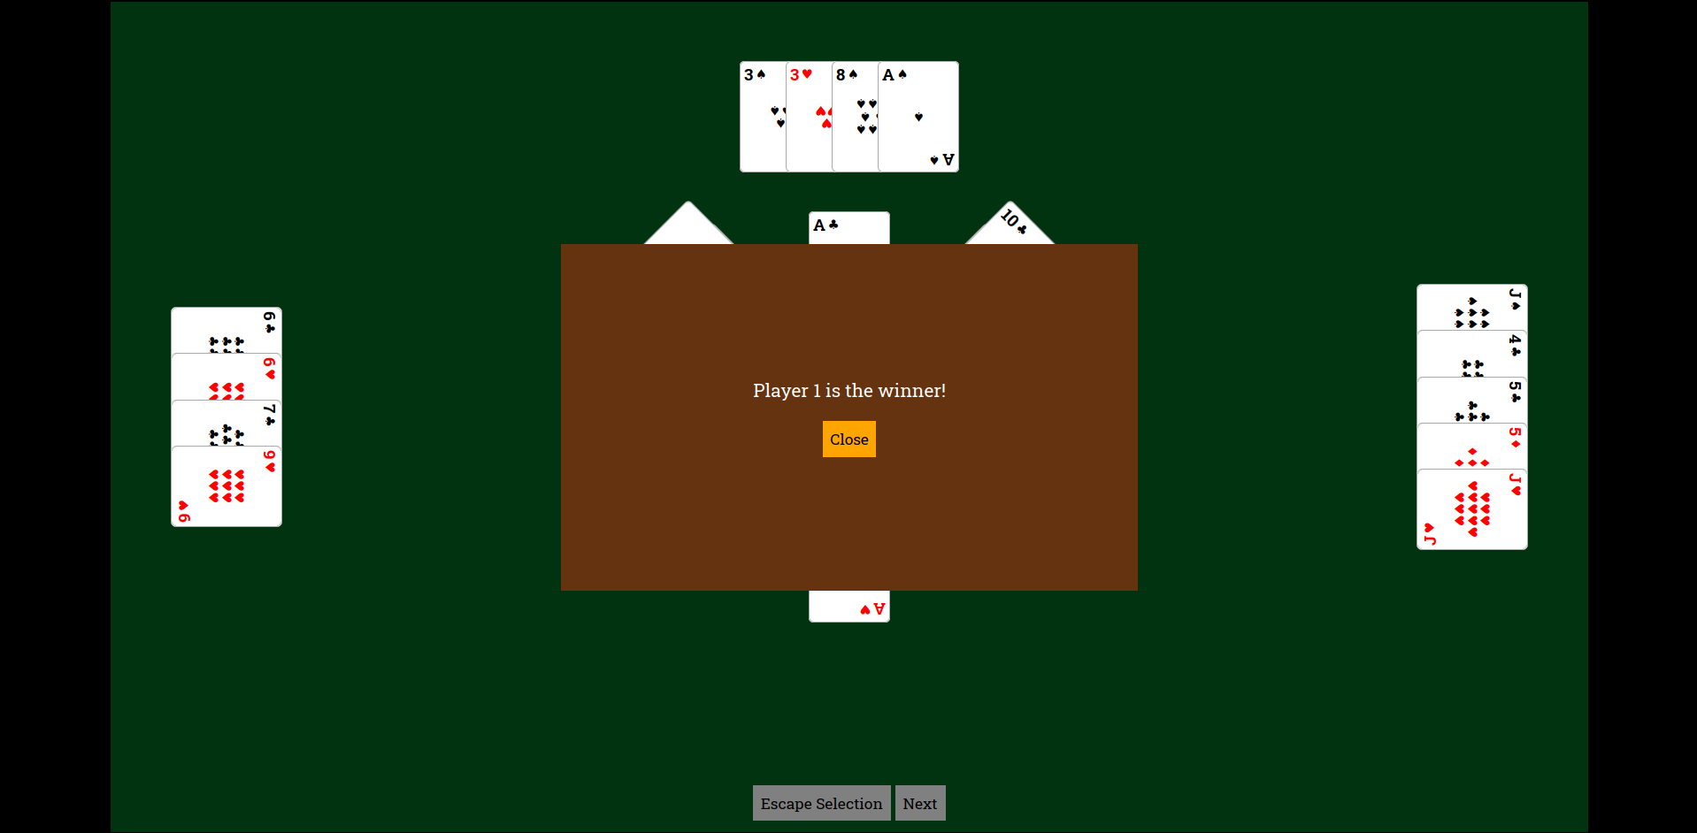
After you are done, you will see a screen like one below. Either click close to analyze the game. Or refresh the page to start another game.

