EXERCISE 1: RECORDING AND STIMULATION OF VENTRAL NERVE CORD

Objective:

- Visualizing the ventral nerve cord
- Testing cercal response
- Test how neuromodulating agents affect neuronal spiking patterns.

Introduction:

Cercal response:
Cerci are complex sensory organs found on the 'tail end' of many insects. Sensory information from the cerci is integrated in the terminal ganglion and passed to other areas of the nervous system by interneurons. The cockroach's nervous system runs along its ventral side and is known as the ventral nerve cord. The ventral nerve cord is composed of connectives that contain a multitude of nerve axons, and ganglia which contain cell bodies, dendrites, terminals and axons.

If you look at the cerci through the dissecting microscope you will notice that each cercus (which is the singular of cerci) is covered with fine hairs. Close inspection of these hairs will reveal many specializations in size, shape and spatial distribution. If you compare the size and morphology of the cercal hairs to the mechanosensory spines on the leg (that you have been working with during the pervious labs) you'll see that the cercal hairs are a lot finer. Blow a puff of air through your lips as you look at the cerci through the microscope. You should see some of the hairs bend as the pulse of air passes over them. The bending hairs stimulate receptors and send information towards the head along the ventral nerve cord

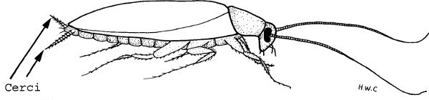
Effect of pharmacological agents:
Nicotine: Nicotine comes from the tobacco plant. Tobacco evolved nicotine to prevent insects from eating its leaves. Nicotine is a powerful acetylcholine (ACh) receptor agonist. An agonist is a chemical that activates the receptor by binding to it. Nicotine binds to acetylcholine (ACh) receptors in synapses, causing a neuron to fire more (due to increased sodium ion influx).

Alcohol: Ethanol (alcohol) is a drug that is positive modulator to GABA. Unlike ACh receptors, stimulation of GABA receptors often leads to inhibition of action potentials. In other words, binding of ethanol to GABA channels will slow down the firing of a neuron.

Methods:

Preparation of Neuroactive Solutions

- Cockroach saline solution has the following composition:
Cockroach saline solution: (grams for 100 ml) 210 mM NaCl (1.227 g) 2.9 mM KCl (0.0216 g) 1.8 mM CaCl₂ (0.0265 g) 0.2 mM NaH₂PO₄•2H₂O (0.0032 g) 1.8 mM Na₂HPO₄•7H₂O (0.0483 g) (pH 7.2. Adjust pH with 1 M NaOH or 1 M HCl).
- Nicotine
To create a nicotine solution, take a cigarette or small cigar, remove all the shredded tobacco leaves, and place them in a small container (a clear pill bottle, for example). Fill the container with saline solution, put the cap on, shake up the mixture, and allow it to sit for a couple days to extract the nicotine. Over time the solution should turn yellowish-brown.
- Ethyl Alcohol
Make a 2% EtOh solution.

Dissection

- Select a male cockroach from the holding tank that has robust cerci . The last segments of the male are narrow compared to the female; and containing no ovaries and egg mass, males are easier to dissect. The males of P. americana have a pair of short styli between the cerci. These styli are not observed in the females.

- Cut off the wings, legs and head and pin the body, ventral side down, to a dish lined with material that is easy to pin (eg: styrofoam).

- With forceps pick up the dorsal plates and cut them off with fine scissors, starting at the posterior end and working anteriorly. Always keep the internal organs moist with saline while trying to keep the cerci dry. One can use wax or pieces of rubber to position the abdomen upwards to prevent the saline from wetting the cerci. If they do get wet, dry them with a piece of tissue paper. Push to the side the internal organs and the white matter (fat body). The VNC is in the center of the field, runs the length of the abdomen and should be visible between the shiny tracheae. The nerve cord is translucent and may initially be difficult to see until the lighting is adjusted properly. DO NOT handle the VNC with forceps or insect pins; instead manipulate it using glass probes.

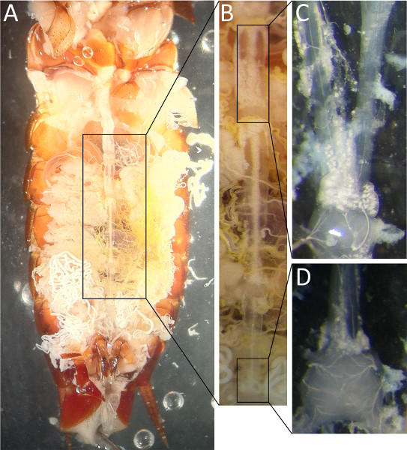

- Clear away the animal's tracheae system as best as possible from the nerve cord with forceps and with a pair of fine glass needles. Be extra careful in the last abdominal segment not to damage the cercal nerves that project into the ganglion.

Recording from VNC

- Carefully insert the hooked recording electrodes under the ventral nerve cord and lift it slightly. (Hooked electrodes can be made from using one of the strands of a multistrand copper wire)

- Using the twisted end of a Kimwipe, draw up any excess CPS so that the fluid will not short out the recording electrode.

- Make sure that the cerci are completely free of liquid and not touching anything (dish, pins, etc.).

- Switch on the spikerbox and record the spontaneous activity of VNC.

- Cercal stimulation: Stimuli can be applied in a number of ways. The simplest method is to use a plastic transfer pipette. Directing it at the cerci and squeezing the bulb provides a stimulus strong enough to trigger the cercal response. If the responses to individual puffs of the same intensity are being compared, it is important to keep the stimuli constant by compressing the pipette bulb with consistent pressure and from a consistent distance from the cerci.

As one function of the cercal system is to differentiate directionality of a wind stimulus, you should be able to see differences in response to the blowing from one side versus the other. Students should record the time and duration of stimulus (blowing) and the side the stimulus was delivered (right or left).

- Response of ventral nerve to application of neuroactive solutions:
- First record the spontaneous activity of VNC.
- Beginning with the nicotine solution, using a pipette students should apply a few drops of nicotine solution into the abdomen of the cockroach.
- After five minutes record and listen to the spontaneous VNC activity. Increase in firing rate should be visible and audible.
- After this apply few drops of ethanol solution into the abdomen of cockroach and wait for five minutes. Decrease in firing rate should be apparent.

ANALYSIS
- Visualize action potential
- Identifying spikes: For identifying spikes, you will have to select the datapoints that cross the threshold
- Calculate firing rate for each condition and compare them

EXERCISE 2: EFFECT OF TEMPERATURE ON NEURONS

OBJECTIVE:
- learn how changes in temperature affect neural spike firing

INTRODUCTION:
In order to understand the effect that temperature can have on neural communication, one must first understand some specifics about how that communication takes place. We discussed the basics about action potentials (APs) in Lab One; APs are generated at the cell membrane through the movements of various ions (Na+ , K+ , Cl- ) across the membrane. Let’s look closer at the mechanisms of that process to see how temperature factors in.

The cell membrane is a double layer of lipids (i.e. fats) that are hydrophobic (they don’t mix with water). This lipid bi-layer is the barrier between the inside of the cell and the outside of the cell, allowing the cell to maintain a different concentration of ions inside the cell than outside the cell. Thus, ions align on both the inner and outer surfaces of the membrane with an excess of positive charges (Na+ ions) on the outside of the membrane and an excess of negative charges (Clions) on the inside. The charge separation creates a difference in electrical potential, or voltage, across the membrane called the resting membrane potential. The potential outside the cell is defined as zero, so thus the resting membrane potential is then negative, usually in the range of -60 mV to -70 mV.

How, then, do ions flow through the membrane to produce action potentials? The ion currents are carried into and out of the cells through ion channels, proteins that span the cell membrane and can open to conduct specific ions across to the other side. In nerve cells, ion channels conduct ions at extremely high rates (up to 100 million ions per second). Ion channels can be active at rest or activated due to an external stimulus (such as voltage or chemicals). Resting channels in cell membranes can be selective for Na+ , K+ , or Cl ions, and it is in fact the resultant concentration of ions inside and outside of the cell due to these channels that are most responsible for the resting membrane potential. Ion pumps also actively move ions into and out of the cell to maintain that stable membrane potential at rest.

During an action potential, Na+ channels are activated by changes in voltage that allow the Na+ ions layered on the outer cell membrane to rapidly diffuse into the cell and thus push the inner membrane potential highly positive (depolarization). This positive membrane potential causes the Na+ channels to close and K+ channels to instantly open, allowing the K+ ions inside the cell to rapidly diffuse out of the cell and drop the membrane potential sharply in the other direction (repolarization). At this point the K+ channels close, but the K+ outflow current has brought the membrane potential below the resting state (hyperpolarization). With the voltage-gated ion channels closed, the leaky K+ and Na+ channels again dominate and return the cell membrane to its resting state.

Recent research has demonstrated ion channel activation has a dependence on temperature. Collins et al 1972 demonstrated that the conductance of Na+ channels is dependent upon temperature with an Arrhenius temperature relationship (i.e. an equation to relate the rate constant of chemical reactions to temperature) defined by this equation:
Ln (1/Τ) = ln F – Ea/(RT)

Where T is temperature, Ea is the difference in energy level between an activated ion channel and a nonactive state, and both F and R are constants. If we solve that equation for the activation energy,
Ea = RT*ln(TF)

We see that activation energy increases as T increases, and conversely that it would lower as T decreases. The take-home for our purposes is that the ion channel is more active at higher temperatures (more likely to be open), and less active at lower temperatures. Fohlmeister et al demonstrated in 2009 that sodium channels in retinal ganglion cells were consistently “sleepy” for temperatures below 8 degrees Celsius, with a loss of spiking for T < 7 C (note: different cell types have different temperature ranges, and the neurons in this experiment can spike well below 7 C).
The next question is, why? Why is there such a temperature dependence for neural cell behavior? Wouldn’t it be great if neurons worked just as well at all temperatures? The short answer is that every active cellular process, including the opening and closing of ion channels, is some type of chemical reaction that requires energy. As a general rule of thumb (though there are many exceptions) increasing temperature speeds up and increases chemical reactions, while decreasing the temperature slows them down. At extreme cold temperatures chemical reactions can stop happening altogether, which in this example could lead to ion channels not opening and thus no action potential initiation.

While increasing temperatures can speed up chemical reactions within certain ranges, we also have to consider that if temperature is increased too much this could damage the cell in other ways. The cell membrane is composed of lipids, and lipids transition from solid and ordered (called a gel) to liquid and disordered (called ‘fluid’) based upon temperature. These temperature transition thresholds are different based on the type of lipid and the environment, but once these thresholds are reached the lipid cell membrane can break apart which effectively results in the death of that cell.

EQUIPMENT:
• SpikerBox
• Computer with Audacity installed or iPhone/iPad/Android device with Backyard Brains app
• Associated Laptop Cable or iPhone/Android Cable
• Cockroach
• Ice or access to a freezer
• Digital thermometer
• Dissection scissors
• Toothpick

General Methods:
- Take a cockroach and either put it in ice water or a standard freezer to anaesthetize it. Wait 5-10 minutes, or until the cockroach stops moving. Take care to monitor how long the cockroach has been placed in the water or freezer, as extended exposure to low temperatures can be fatal.

- Once your cockroach has been anaesthetized, remove it from the water or freezer and place it on your lab bench. Using dissection scissors cut off one of the legs. Make sure you cut close to the thorax (body) so that the coxa remains attached.

- Place the leg on the cork on top of your Spiker Box. Insert the electrodes through the leg and into the cork. Insert one electrode into the coxa and the second electrode into the femur. The electrodes will measure action potentials as well as keep your leg in place. Record this baseline activity.

- Carefully take the electrodes out of the leg and place the leg again in ice for 5 mins. Record spontaneous activity again. Decrease in firing rate should be apparent.

- Keep recording from the same leg for next 10 mins. You should be able to observe the recovery of firing rate as the temperature of the leg starts approaching the room temperature.

ANALYSIS
- Visualize action potential
- Identifying spikes: For identifying spikes, you will have to select the datapoints that cross the threshold
- Calculate firing rate for each condition and compare them

