

Recruitment Agency

Logical Data Model · DB Basics HW1 · Aiym Abay
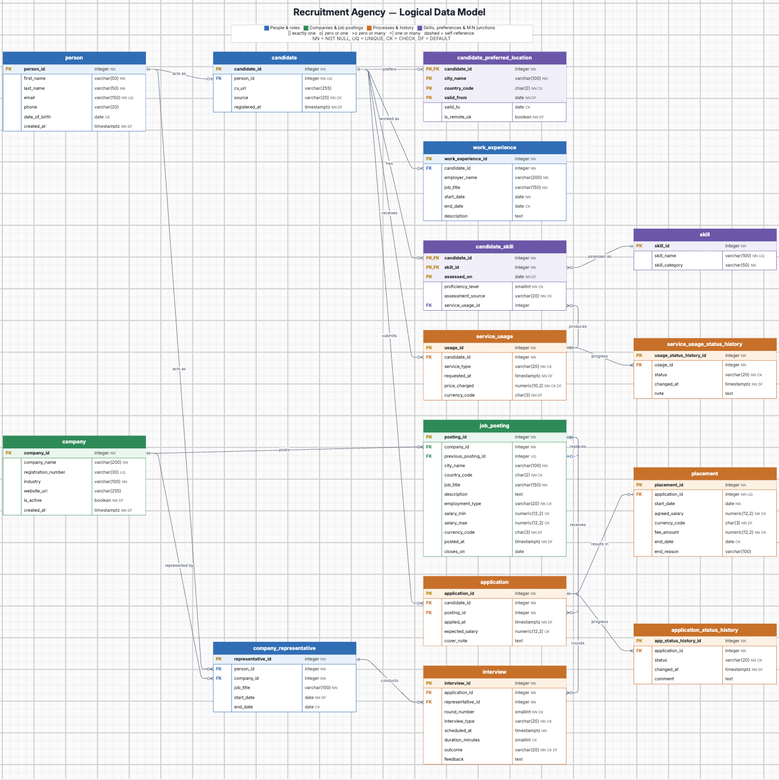

Contents
Business Description 3
1.1 the Benefits of implementing a database. Project Vision 3
2 Model description 3
2.1 Definitions & Acronyms 3
2.2 Logical Scheme 3
2.3 Objects 3

Business Description

Benefits of implementing a database. Project Vision
- How will the database solve the problems listed in the description? Each company, posting, candidate and person is stored once. Applications link candidates to postings; stages, interviews, services used and placements each have their own table, so every question in the brief has one place to look.
- How will it ensure data integrity, consistency, and traceability? Foreign keys prevent orphan rows, UNIQUE keys prevent duplicates (one application per candidate per posting, one placement per application, one candidate profile per person), and every state change carries a timestamp. A shared person table keeps one identity when the same participant is a candidate and later a company representative.
- How does your model store the history of changes? Application stages and service statuses are insert-only history tables - the current state is the latest row. Skill levels are dated rows, preferences and representative roles use start/end dates, and a changed job becomes a new posting linked to the old one. Nothing is overwritten.
- How does your structure allow the system to scale without major redesign? Growing lists are rows, not columns: new skills, preferred cities, interview rounds or stage changes are inserts. A new role for a person is one new table referencing person.
- Which constraints and checks have you added to keep data correct as volume grows? NOT NULL on required fields; UNIQUE on natural keys (email, skill_name, BIN, person_id in candidate); CHECK on stages, service types and statuses, salary range, proficiency 1-5, ISO country/currency codes and end dates >= start dates; DEFAULTs for timestamps, currency (KZT) and flags.

Model description

Definitions & Acronyms
Term | Meaning in this model
Person | A human the agency knows, independent of role.
Candidate | Role of a person looking for a job through the agency.
Company representative | Role of a person acting for a company during a period; conducts interviews.
Job posting | One job offered by a company; changed terms create a new posting linked to the old one.
Application | One candidate applying to one job posting.
Stage | Application step: submitted, under_review, interview, approved, rejected, withdrawn.
Placement | Hiring outcome: a successful application linking a candidate to a job at a company.
Service usage | One delivery of resume advice, coaching or skills testing to a candidate.
History table | Insert-only table; each row is one change, the newest row is the current state.
PK / FK | Primary key / foreign key.
NN / UQ / CK / DF | NOT NULL / UNIQUE / CHECK / DEFAULT (diagram abbreviations).
M:N | Many-to-many relationship, implemented with a junction table.

Logical Scheme
Which modeling decision was the most difficult and why?
Handling the same participant in different roles over time. Separate candidate and representative tables with their own names and emails would duplicate a person who changes role. I moved personal data to person and made candidate (UNIQUE person_id) and company_representative (person + company + period) role tables - one extra join, but one identity.
Provide examples of potential data anomalies that your design prevents.
- Update: an email lives only in person, so it is changed once even if the person has two roles.
- Insertion: a skill can exist before any candidate has it (separate skill table).
- Deletion: deleting an application does not delete the candidate; ending a role closes a period instead of deleting the person.
- Duplicates and lost history: UNIQUE (candidate_id, posting_id) and UNIQUE application_id in placement block double records; stages are new rows, so an update cannot erase the previous stage.
If you were to add new attributes or participants, would the model remain scalable and why?
Yes. Attributes have an obvious owner (e.g. linkedin_url in person), and a new participant type is a new role table referencing person, so existing tables do not change.
Which part of your model would most likely change if requirements expand?
The services part: if services get prices, durations or packages, service_type would become a separate service table and service_usage could get payment or session child tables.

Objects

person
Concept: A human the agency deals with, in any role.
Why separate: Personal data belongs to the human, not to a role; storing it once keeps one identity when roles change.
Normalization: 3NF - all attributes depend only on person_id; no role-specific columns.
Keys: Surrogate PK person_id; email UNIQUE as natural key. No FKs.
Table Name | Field name | Field Description | Data Type
person | person_id | Surrogate key. PK, IDENTITY | INTEGER
person | first_name | First name. NN | VARCHAR(50)
person | last_name | Last name. NN | VARCHAR(50)
person | email | Personal email - natural identifier of the human. NN, UQ | VARCHAR(150)
person | phone | Phone number | VARCHAR(20)
person | date_of_birth | Birth date. CHECK (< CURRENT_DATE) | DATE
person | created_at | When the person was first recorded. NN, DEFAULT now() | TIMESTAMPTZ
Example with data (3 rows)
Field | Row 1 | Row 2 | Row 3
person_id | 1 | 2 | 3
first_name | Aigerim | Nursultan | Aruzhan
last_name | Tulegen | Ermekov | Seitkali
email | aigerim.t@mail.kz | n.ermekov@gmail.com | aruzhan.s@gmail.com
phone | +77071234567 | +77077654321 | +77011112233
date_of_birth | 1999-05-12 | 1996-11-30 | 1990-02-07
created_at | 2026-03-02 | 2026-04-18 | 2026-01-10

candidate
Concept: The job-seeker role of a person.
Why separate: CV, source and registration apply only to candidates; in person they would be NULL for representatives.
Normalization: 3NF - attributes depend on candidate_id; names are not copied (that would be candidate -> person -> name).
Keys: Surrogate PK; FK person_id UNIQUE, so one person has at most one candidate profile.
Table Name | Field name | Field Description | Data Type
candidate | candidate_id | Surrogate key. PK, IDENTITY | INTEGER
candidate | person_id | The human behind the profile. FK -> person, NN, UQ | INTEGER
candidate | cv_url | Link to the latest CV file | VARCHAR(255)
candidate | source | How the candidate found the agency. NN, CHECK IN (website, referral, job_board, social_media) | VARCHAR(20)
candidate | registered_at | Registration time. NN, DEFAULT now() | TIMESTAMPTZ
Example with data (2 rows)
candidate_id | person_id | cv_url | source | registered_at
1 | 1 | cv/1.pdf | job_board | 2026-03-02
2 | 2 | cv/2.pdf | referral | 2026-04-18

company
Concept: A client company that posts jobs.
Why separate: Company data does not depend on any posting or representative.
Normalization: 3NF - all attributes depend only on company_id.
Keys: Surrogate PK; registration_number (BIN) UNIQUE. No FKs.
Table Name | Field name | Field Description | Data Type
company | company_id | Surrogate key. PK, IDENTITY | INTEGER
company | company_name | Legal/trading name. NN | VARCHAR(200)
company | registration_number | Business ID (BIN in Kazakhstan). UQ | VARCHAR(30)
company | industry | Industry sector. NN | VARCHAR(100)
company | website_url | Website | VARCHAR(255)
company | is_active | Soft-delete flag; rows are never deleted. NN, DEFAULT TRUE | BOOLEAN
company | created_at | When the client was registered. NN, DEFAULT now() | TIMESTAMPTZ
Example with data (2 rows)
Field | Row 1 | Row 2
company_id | 1 | 2
company_name | Kaspi Tech | Tengri Logistics
registration_number | 990140001234 | 050240009876
industry | FinTech | Logistics
website_url | kaspi.kz | tengri.kz
is_active | TRUE | TRUE
created_at | 2026-01-10 | 2026-02-03

company_representative
Concept: A person acting for a company during a period (M:N person - company over time).
Why separate: Title and period depend on the person-company pair, not on either side alone.
Normalization: 3NF - job_title and dates depend on the representation; names are reached through FKs.
Keys: Surrogate PK (referenced by interview); FKs person_id, company_id; UNIQUE (person_id, company_id, start_date).
Table Name | Field name | Field Description | Data Type
company_representative | representative_id | Surrogate key. PK, IDENTITY | INTEGER
company_representative | person_id | Who. FK -> person, NN | INTEGER
company_representative | company_id | For which company. FK -> company, NN | INTEGER
company_representative | job_title | Title at the company in this period. NN | VARCHAR(100)
company_representative | start_date | Start of representation. NN, DEFAULT CURRENT_DATE | DATE
company_representative | end_date | NULL while still representing. CHECK (>= start_date) | DATE
company_representative | (table constraint) | UQ (person_id, company_id, start_date)
Example with data (2 rows)
representative_id | person_id | company_id | job_title | start_date | end_date
1 | 3 | 1 | Head of Engineering | 2026-01-10 | NULL
2 | 1 | 1 | Junior HR Partner | 2027-03-01 | NULL

candidate_preferred_location
Concept: A city where a candidate wants to work, for a period.
Why separate: A candidate can prefer several cities - a list cannot be one column (1NF).
Normalization: 3NF - valid_to and is_remote_ok depend on the whole key; city does not determine country, so both are key parts.
Keys: Composite PK (candidate_id, city_name, country_code, valid_from); FK candidate_id.
Table Name | Field name | Field Description | Data Type
candidate_preferred_location | candidate_id | Candidate. PK, FK -> candidate | INTEGER
candidate_preferred_location | city_name | Preferred city. PK | VARCHAR(100)
candidate_preferred_location | country_code | Country, e.g. 'KZ'. PK, CHECK (ISO 3166-1 alpha-2) | CHAR(2)
candidate_preferred_location | valid_from | Preference recorded on. PK, DEFAULT CURRENT_DATE | DATE
candidate_preferred_location | valid_to | NULL while the preference is current. CHECK (>= valid_from) | DATE
candidate_preferred_location | is_remote_ok | Also accepts remote work. NN, DEFAULT FALSE | BOOLEAN
Example with data (3 rows)
candidate_id | city_name | country_code | valid_from | valid_to | is_remote_ok
1 | Astana | KZ | 2026-03-02 | 2026-08-31 | FALSE
1 | Almaty | KZ | 2026-09-01 | NULL | TRUE
2 | Almaty | KZ | 2026-04-18 | NULL | FALSE

skill
Concept: Catalogue of skills.
Why separate: Shared by many candidates; avoids spelling variants.
Normalization: 3NF - attributes depend only on skill_id.
Keys: Surrogate PK; skill_name UNIQUE.
Table Name | Field name | Field Description | Data Type
skill | skill_id | Surrogate key. PK, IDENTITY | INTEGER
skill | skill_name | Skill name. NN, UQ | VARCHAR(100)
skill | skill_category | technical, language, soft. NN | VARCHAR(50)
Example with data (3 rows)
skill_id | skill_name | skill_category
1 | SQL | technical
2 | Python | technical
3 | English | language

candidate_skill
Concept: A dated level of one skill for one candidate (M:N candidate - skill).
Why separate: Level and source depend on candidate + skill + date; a new assessment is a new row.
Normalization: 3NF - no partial dependency (skill_name stays in skill); every attribute needs the full key.
Keys: Composite PK (candidate_id, skill_id, assessed_on); FKs candidate_id, skill_id, service_usage_id (nullable, skills test).
Table Name | Field name | Field Description | Data Type
candidate_skill | candidate_id | Candidate. PK, FK -> candidate | INTEGER
candidate_skill | skill_id | Skill. PK, FK -> skill | INTEGER
candidate_skill | assessed_on | Date of this assessment. PK, DEFAULT CURRENT_DATE | DATE
candidate_skill | proficiency_level | 1 = beginner ... 5 = expert. NN, CHECK 1-5 | SMALLINT
candidate_skill | assessment_source | Where the level comes from. NN, CHECK IN (self_reported, skills_test) | VARCHAR(20)
candidate_skill | service_usage_id | Skills test that produced it. FK -> service_usage, NULL | INTEGER
candidate_skill | (table constraint) | CHECK ((assessment_source = 'skills_test') = (service_usage_id IS NN))
Example with data (3 rows)
candidate_id | skill_id | assessed_on | proficiency_level | assessment_source | service_usage_id
1 | 1 | 2026-03-02 | 3 | self_reported | NULL
1 | 1 | 2026-09-20 | 4 | skills_test | 2
2 | 2 | 2026-04-18 | 5 | self_reported | NULL

work_experience
Concept: One past or current job of a candidate.
Why separate: A candidate has many jobs; storing them in candidate would create repeating groups (1NF).
Normalization: 3NF - employer, title and dates depend on the row; employer is free text, not a client.
Keys: Surrogate PK; FK candidate_id.
Table Name | Field name | Field Description | Data Type
work_experience | work_experience_id | Surrogate key. PK, IDENTITY | INTEGER
work_experience | candidate_id | Candidate. FK -> candidate, NN | INTEGER
work_experience | employer_name | Employer as stated in the CV. NN | VARCHAR(200)
work_experience | job_title | Title held. NN | VARCHAR(150)
work_experience | start_date | Start. NN | DATE
work_experience | end_date | NULL = current job. CHECK (>= start_date) | DATE
work_experience | description | Responsibilities and achievements | TEXT
Example with data (2 rows)
Field | Row 1 | Row 2
work_experience_id | 1 | 2
candidate_id | 1 | 2
employer_name | Halyk Bank | Air Astana
job_title | Data Intern | BI Analyst
start_date | 2024-06-01 | 2021-02-01
end_date | 2025-08-31 | NULL
description | Reporting in SQL | Power BI dashboards

job_posting
Concept: A job a company asks the agency to fill.
Why separate: Job terms belong neither to the company nor to an application.
Normalization: 3NF - terms and location depend on posting_id; company data via company_id.
Keys: Surrogate PK; FK company_id; self-FK previous_posting_id (UNIQUE) links a changed posting to the one it replaces.
Table Name | Field name | Field Description | Data Type
job_posting | posting_id | Surrogate key. PK, IDENTITY | INTEGER
job_posting | company_id | Client that owns the job. FK -> company, NN | INTEGER
job_posting | previous_posting_id | Posting this one replaces. FK -> job_posting (self), NULL, UQ | INTEGER
job_posting | city_name | Work city. NN | VARCHAR(100)
job_posting | country_code | Work country, e.g. 'KZ'. NN, CHECK (ISO 3166-1 alpha-2) | CHAR(2)
job_posting | job_title | Position title. NN | VARCHAR(150)
job_posting | description | Job description | TEXT
job_posting | employment_type | Contract form. NN, CHECK IN (full_time, part_time, contract, internship) | VARCHAR(20)
job_posting | salary_min | Lower bound, monthly. CHECK (>= 0) | NUMERIC(12,2)
job_posting | salary_max | Upper bound, monthly. CHECK (>= salary_min) | NUMERIC(12,2)
job_posting | currency_code | ISO 4217 code. NN, DEFAULT 'KZT' | CHAR(3)
job_posting | posted_at | Publication time. NN, DEFAULT now() | TIMESTAMPTZ
job_posting | closes_on | Last day to apply | DATE
job_posting | (table constraint) | CHECK (previous_posting_id <> posting_id)
Example with data (2 rows)
Field | Row 1 | Row 2
posting_id | 1 | 2
company_id | 1 | 1
previous_posting_id | NULL | 1
city_name | Astana | Astana
country_code | KZ | KZ
job_title | Data Analyst | Data Analyst
description | ... | ...
employment_type | full_time | full_time
salary_min | 600000 | 700000
salary_max | 900000 | 1000000
currency_code | KZT | KZT
posted_at | 2026-09-01 | 2026-10-05
closes_on | 2026-10-15 | 2026-11-15

application
Concept: A candidate applying to one posting (M:N candidate - posting).
Why separate: Anchors stage history, interviews and placement.
Normalization: 3NF - applied_at, expected_salary, cover_note describe the application; no status column (history is separate).
Keys: Surrogate PK (referenced by 3 tables); FKs candidate_id, posting_id; UNIQUE (candidate_id, posting_id).
Table Name | Field name | Field Description | Data Type
application | application_id | Surrogate key. PK, IDENTITY | INTEGER
application | candidate_id | Applicant. FK -> candidate, NN | INTEGER
application | posting_id | Job applied to. FK -> job_posting, NN | INTEGER
application | applied_at | Submission time. NN, DEFAULT now() | TIMESTAMPTZ
application | expected_salary | Candidate's ask for this job. CHECK (>= 0) | NUMERIC(12,2)
application | cover_note | Motivation text | TEXT
application | (table constraint) | UQ (candidate_id, posting_id)
Example with data (3 rows)
application_id | candidate_id | posting_id | applied_at | expected_salary | cover_note
1 | 1 | 1 | 2026-09-03 | 750000
2 | 2 | 1 | 2026-09-04 | 850000
3 | 1 | 2 | 2026-10-06 | 800000 | Re-applied to updated posting

application_status_history
Concept: Every stage change of an application.
Why separate: Progress must be kept without overwriting; one row per change.
Normalization: 3NF - status, time and comment describe one change; status is a CHECK value, not a code with dependent fields.
Keys: Surrogate PK; FK application_id; UNIQUE (application_id, changed_at).
Table Name | Field name | Field Description | Data Type
application_status_history | app_status_history_id | Surrogate key. PK, IDENTITY | INTEGER
application_status_history | application_id | Application. FK -> application, NN | INTEGER
application_status_history | status | New stage (spec: submission, review, approval, rejection). NN, CHECK IN (submitted, under_review, interview, approved, rejected, withdrawn) | VARCHAR(20)
application_status_history | changed_at | When it moved. NN, DEFAULT now() | TIMESTAMPTZ
application_status_history | comment | Reason, e.g. rejection cause | TEXT
application_status_history | (table constraint) | UQ (application_id, changed_at)
Example with data (3 rows)
app_status_history_id | application_id | status | changed_at | comment
1 | 1 | submitted | 2026-09-03 11:00
2 | 1 | under_review | 2026-09-05 14:00 | Good SQL test
3 | 2 | rejected | 2026-09-06 10:00 | Below required level

interview
Concept: One interview round between a candidate and a company representative.
Why separate: An application can have several rounds with their own time, interviewer and outcome.
Normalization: 3NF - round attributes depend on interview_id; interviewer details via FK.
Keys: Surrogate PK; FKs application_id, representative_id (NOT NULL); UNIQUE (application_id, round_number).
Table Name | Field name | Field Description | Data Type
interview | interview_id | Surrogate key. PK, IDENTITY | INTEGER
interview | application_id | Application interviewed. FK -> application, NN | INTEGER
interview | representative_id | Interviewer from the company. FK -> company_representative, NN | INTEGER
interview | round_number | 1, 2, 3 .... NN, CHECK (> 0) | SMALLINT
interview | interview_type | Format. NN, CHECK IN (phone, video, onsite, technical) | VARCHAR(20)
interview | scheduled_at | Planned start. NN | TIMESTAMPTZ
interview | duration_minutes | Length. CHECK (> 0) | SMALLINT
interview | outcome | Result. NN, DEFAULT 'pending', CHECK IN (pending, passed, failed, no_show, cancelled) | VARCHAR(20)
interview | feedback | Interviewer notes | TEXT
interview | (table constraint) | UQ (application_id, round_number)
Example with data (2 rows)
Field | Row 1 | Row 2
interview_id | 1 | 2
application_id | 1 | 1
representative_id | 1 | 1
round_number | 1 | 2
interview_type | video | technical
scheduled_at | 2026-09-08 10:00 | 2026-09-12 15:00
duration_minutes | 30 | 60
outcome | passed | passed
feedback |  | Strong SQL

placement
Concept: Hiring outcome linking a candidate to a job at a company.
Why separate: Only some applications end in a hire, which has its own facts (start, salary, fee).
Normalization: 3NF - candidate, job and company are reached through application, not repeated.
Keys: Surrogate PK; FK application_id UNIQUE (1 : 0..1).
Table Name | Field name | Field Description | Data Type
placement | placement_id | Surrogate key. PK, IDENTITY | INTEGER
placement | application_id | Successful application. FK -> application, NN, UQ | INTEGER
placement | start_date | First working day. NN | DATE
placement | agreed_salary | Final monthly salary. NN, CHECK (> 0) | NUMERIC(12,2)
placement | currency_code | ISO 4217 code. NN, DEFAULT 'KZT' | CHAR(3)
placement | fee_amount | Agency fee charged to the company. NN, CHECK (>= 0) | NUMERIC(12,2)
placement | end_date | Filled once if the employment ends; NULL = active. CHECK (>= start_date) | DATE
placement | end_reason | Why it ended | VARCHAR(100)
Example with data (1 rows)
Field | Row 1
placement_id | 1
application_id | 1
start_date | 2026-10-01
agreed_salary | 800000
currency_code | KZT
fee_amount | 1600000
end_date | NULL
end_reason

service_usage
Concept: One resume advice, coaching or skills testing service received by a candidate.
Why separate: A candidate uses many services; each has its own request time and price.
Normalization: 3NF - service_type, time and price depend only on usage_id.
Keys: Surrogate PK (referenced by history and candidate_skill); FK candidate_id.
Table Name | Field name | Field Description | Data Type
service_usage | usage_id | Surrogate key. PK, IDENTITY | INTEGER
service_usage | candidate_id | Who receives it. FK -> candidate, NN | INTEGER
service_usage | service_type | Which service (spec). NN, CHECK IN (resume_advice, coaching, skills_testing) | VARCHAR(20)
service_usage | requested_at | When it was requested. NN, DEFAULT now() | TIMESTAMPTZ
service_usage | price_charged | Price paid (0 = free). NN, DEFAULT 0, CHECK (>= 0) | NUMERIC(10,2)
service_usage | currency_code | ISO 4217 code. NN, DEFAULT 'KZT' | CHAR(3)
Example with data (2 rows)
usage_id | candidate_id | service_type | requested_at | price_charged | currency_code
1 | 1 | resume_advice | 2026-03-05 | 15000 | KZT
2 | 1 | skills_testing | 2026-09-15 | 0 | KZT

service_usage_status_history
Concept: Every status change of a service usage.
Why separate: Service usage is an evolving process recorded without overwriting.
Normalization: 3NF - status, time and note describe one change.
Keys: Surrogate PK; FK usage_id; UNIQUE (usage_id, changed_at).
Table Name | Field name | Field Description | Data Type
service_usage_status_history | usage_status_history_id | Surrogate key. PK, IDENTITY | INTEGER
service_usage_status_history | usage_id | Service usage. FK -> service_usage, NN | INTEGER
service_usage_status_history | status | New status. NN, CHECK IN (requested, scheduled, in_progress, completed, cancelled) | VARCHAR(20)
service_usage_status_history | changed_at | When it changed. NN, DEFAULT now() | TIMESTAMPTZ
service_usage_status_history | note | Comment, e.g. session summary | TEXT
service_usage_status_history | (table constraint) | UQ (usage_id, changed_at)
Example with data (3 rows)
usage_status_history_id | usage_id | status | changed_at | note
1 | 2 | requested | 2026-09-15 09:00
2 | 2 | scheduled | 2026-09-16 12:00 | Test on 20 Sep
3 | 2 | completed | 2026-09-20 13:00 | Score 82%

