DACSS 604 (Spring 2026 On-Line)
Final Project
Aiyman Ackbar

Hi Aiyman- I understand you did a creative Option #2 / Option #4 approach here. However, I am going to use the Option #2 dashboard grading rubric as a baseline here, since that is most appropriate.

Option 2: Interactive Dashboard

Create an interactive dashboard Yes
Short, written description (1-2 pages) Yes

To earn a full credit, your dashboard should include Points 1-4:

- At least five total visual components, including at least one chart, table, or callout. These can be displayed across one page/display, or multiple. Yes
- Some level of interactivity so that a user can filter or view data in different ways. Yes
- Concise titles and labels used intentionally, but only where necessary. Yes
- Instructive or explanatory text on the screen so that a viewer knows what they are looking at. Yes

Used intentionally in a way that helps a viewer Yes
Exemplify design principles such as reducing clutter and focusing audience attention on what matters Yes

Written description should be clear and concise. Yes, although see comments below on tone/formality
what this dashboard is Yes
address the data source and the methodology Yes

 | 80% (B-) or lower | 85% (B) | 90% (A-) | 95% (A) or higher
Major Points  (40%) | Dashboard incomplete, missing some of Points 1-4.  . | Dashboard contains all Points 1-4 in some form, but with lack of intention or organization. | Dashboard contains all Points 1-4 with intention and organization. | Parts 1-4 are presented clearly, intentionally, and aesthetically.
Clarity  (20%) | Excessive clutter or otherwise hard to understand. | Some clutter impacting dashboard readability. | Minimal clutter, dashboard is clear and understandable. | No clutter, making the dashboard easy to understand and interact with.
Audience Consideration  (20%) | Non-technical viewer seems dismissed or forgotten. | No design principles used to focus audience attention. | Design principles used to focus audience attention. | Noticeable effort into design principles that focus audience attention on what matters most.
Write-Up (20%) | No written component. | Supplemental write-up is not concise, or does not address the dashboard, the data source, or the methodology. | Supplemental write-up addresses all required components but lacks conciseness or clarity. | Supplemental write-up addresses all required topics with conciseness, clarity, and with the dashboard user in mind.

Final grade—92

Great job with this, Aiyman! Very cool to see this creative idea come together. I have a few small critiques and recommendations for improvement.

I think that’s super cool that you integrated the Tableau visual into a dashboard. Functionally this works great. However, I have some critiques of this chart itself and how it meets best practices we discussed in class. I think the axis labels “Close” and “Day of Open Time” could be more clear and descriptive, like “Closing Price” and “Date”. You use a logarithmic y-axis (1, 10, 100, 1000) which often makes a lot of sense for stock prices, but you do not address or explain how this axis works anywhere, in your dashboard—a new user could be confused. I also think you could have started the y-axis at a higher value, like 100, all that vertical space between 1 and 100 is left unused. Most importantly, I don’t agree with the decision to make this an area chart, rather than a standard line chart. Line charts are typical for stock price visualizations because each price is really just a single point, not an accumulation of an “amount of something” (i.e. if the price of Bitcoin is $1,000, you could not pile up all 1,000 of the dollars somewhere). Therefore, all of the “filled in” orange area on your dashboard is a bit distracting, and not aesthetically consistent with your Pattern Overlay charts below, which are more typical of stock data. See screenshot below of how I would begin with this:

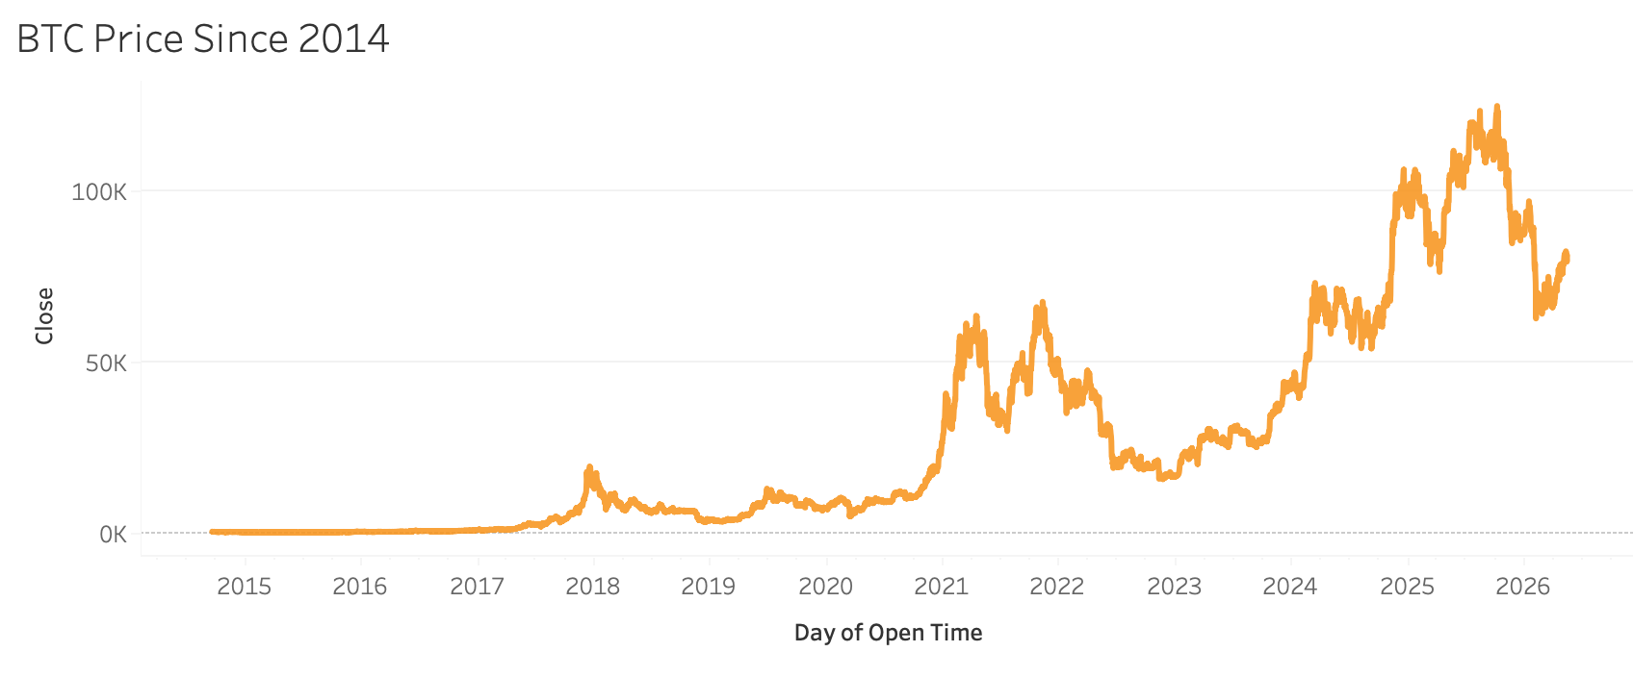

I would have also recommended that you apply the same Bitcoin-themed black background and white text to your Tableau formatting. Lastly, you could remove the chart title from Tableau; right now, it’s redundant to show the title twice, within Tableau and in its surrounding container (see screenshot below).

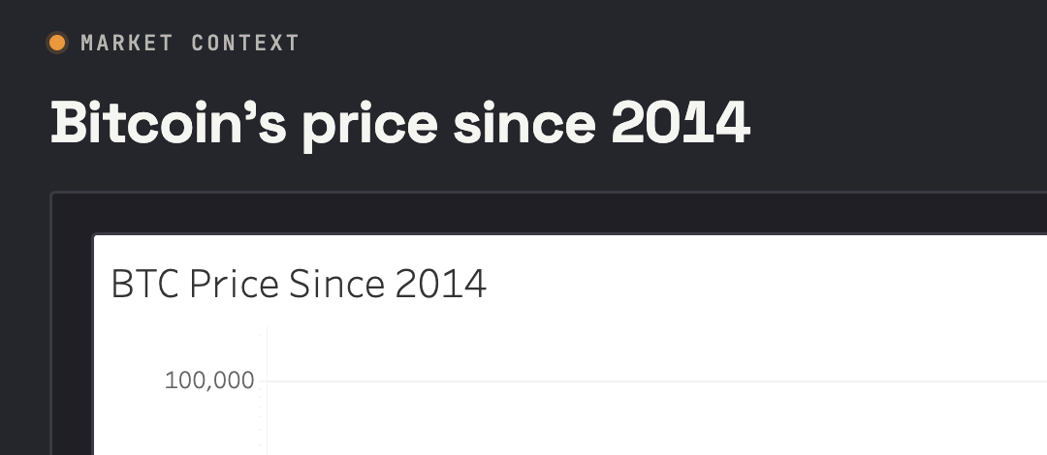

The writing in the dashboard could be made more concise, as well. For example: “seeing that full history gives you a feel for the kinds of past moments…”. The term “gives you a feel for past moments” strikes me as a little informal, vague, or unnecessary. I don’t think you need to provide this text for the reader at all—I believe the utility of an over-time view is self explanatory.

I appreciate that your supplemental write-up was written transparently and candidly, in your own voice. You definitely hit the required elements. However, you should be prepared to write more formally and with correct grammar and punctuation in future professional work (don’t say “wanna”, use periods at the ends of sentences, etc). I know the primary objective of this assignment was the dashboard, but I notice these things, and your future employer would notice it as well. It does not come across as “portfolio quality”.

No worries about using Claude to help with the coding, I am glad that you find it helpful.

