IRISH HOUSING REPORT: IS6052 – Predictive analytics

Aiyman Mohammed
124110673
Contents
Introduction: 2
Description Of The Dataset: 2
Exploratory Data Analysis: 3
Data Preparation And Feature Engineering: 7
Predictive Analysis: 9
Results & Interpretation: 10
References: 15

Introduction:

A potential homebuyer faces a complicated landscape in the Irish property market, especially in Dublin. Price is paramount and there is a myriad of other elements that play a role in purchase decisions such as property location, property insulation, magnitude, and so forth. Irish homebuyers respond differently to these factors across the four local authorities in Dublin: Dublin City Council (DCC), Fingal, Dun Laoghaire and South Dublin.
The last few years have been a struggle for the Irish property market. This is partly due to Brexit, regulatory changes like the Central Bank's mortgage lending rules, and distrust with property developers. It has led to changes in demand and supply for housing countrywide, with a large amount of price volatility in Dublin.
The Dublin property market is varied, with homes between €400,000 and €600,000 widely available, while places like Dun Laoghaire has homes between €400,000 to €2,000,000. But you can see a clear shortage at the lower price range between €200,000 to €300,000.
Such factors in a city with unique characteristics, such as its growing tech industry, diverse culture, temperate climate, and plenty of job opportunities, create additional complexity to housing price predictions in Dublin. In such a multi-faceted environment, the decision to buy a house in Dublin becomes even more difficult.
This report is intended to examine the forces influencing fair potential Irish home buyers in Dublin in buying a house. Using a dataset on Ireland's house prices, we will gain insights, make predictions and introduce new relationships through various predictive analytics techniques. The analysis comprised of data preprocessing which also includes feature engineering and outlier handling, and the implementation of multiple predictive models leading to a deeper understanding of the dynamics driving the Dublin housing market.

Description Of The Dataset:
This dataset contains detailed information about house pricing in Ireland particularly in Dublin and its surroundings. It has a total of 366 entries, each of which is broken down into 12 variables that provide detailed information about the properties. These variables represent a unique identifier, type of property, availability date, location in Dublin, size (number of bedrooms), total square feet, number of bathrooms and balconies, purchase status, Building Energy Rating (BER), renovation status, and price per square foot in dollars. It includes a variety of property types and sizes, from 1-bedroom apartments to 8-bedroom houses, with properties located across four Local Authorities in Dublin: Dublin City Council (DCC), Fingal, Dun Laoghaire-Rathdown, and South Dublin. The data itself shows that property prices vary widely, highlighting the very complex and multi-dimensional nature of the Dublin property market. Pricing seems to be influenced by several factors, such as location, property size, energy efficiency (measured by the BER rating) and whether it needs renovation. There are more details like whether there are balconies and the number of bathrooms that could factor into the logic for some buyers. This relatively rich dataset provides a unique opportunity to explore the high correlation of different attributes influencing house prices in Dublin market, from the running costs of the property to the property attributes and the effect of the location of the property. It also lays a strong foundation for creating predictive models to forecast property prices and highlight key determinants that drive the Dublin housing market.

Exploratory Data Analysis:
The EDA (Exploratory Data Analysis) of the Dublin housing dataset gives an insight into the property market of the Irish capital. The dataset has 13,320 records and defines residential properties focusing on size, location, price, renovation needs, and much more.
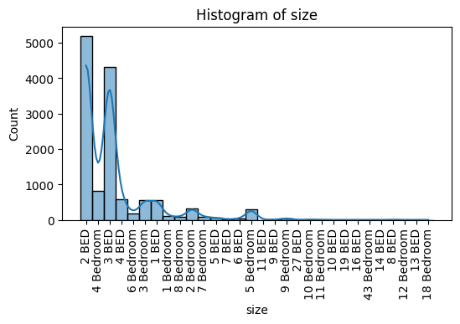
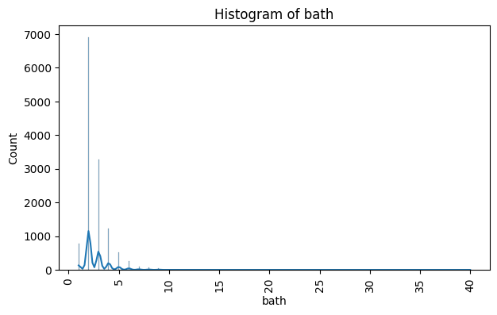
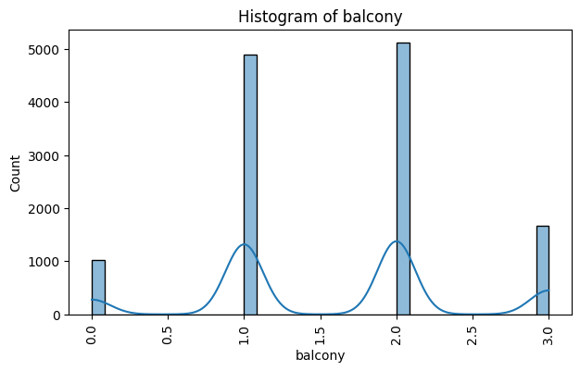
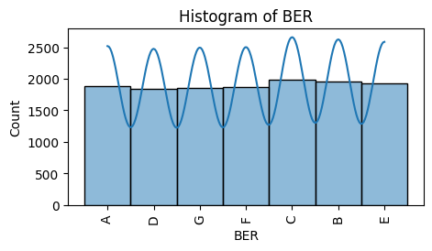

Histograms allow us to understand key distribution of property features. The size histogram represents a right-skewed distribution — this tells us about that properties with fewer rooms (one-bedroom apartments or studios) are more common, with the frequency decreasing with an increasing number of rooms. Likewise, the bathroom distribution is right-skewing, we with most properties have 1-3 bathrooms, while there are outliers (properties with a myriad of bathrooms). The balcony histogram indicates that many properties do not feature balconies, and the frequency weakens for properties with one, two, or three balconies. The Building Energy Rating (BER) looks evenly distributed which could indicate diversity in energy efficiencies across the properties.

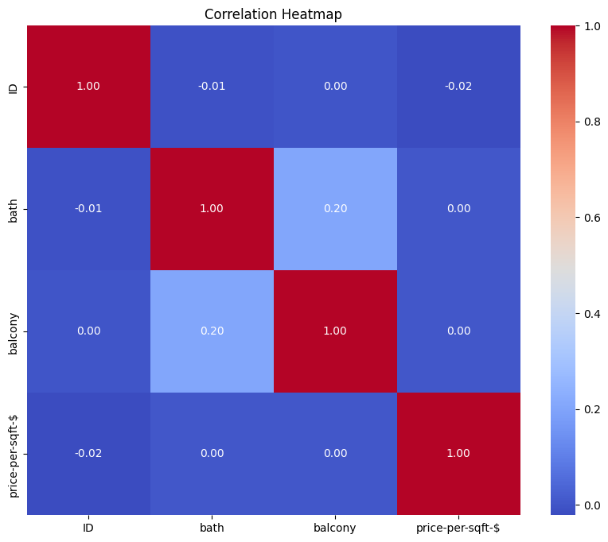
A correlation heatmap was plotted to understand relationships between numerical features and to look for any potential multicollinearity or strong correlation between features. This especially helps to understand how different property characteristics may affect one another or the overall price.
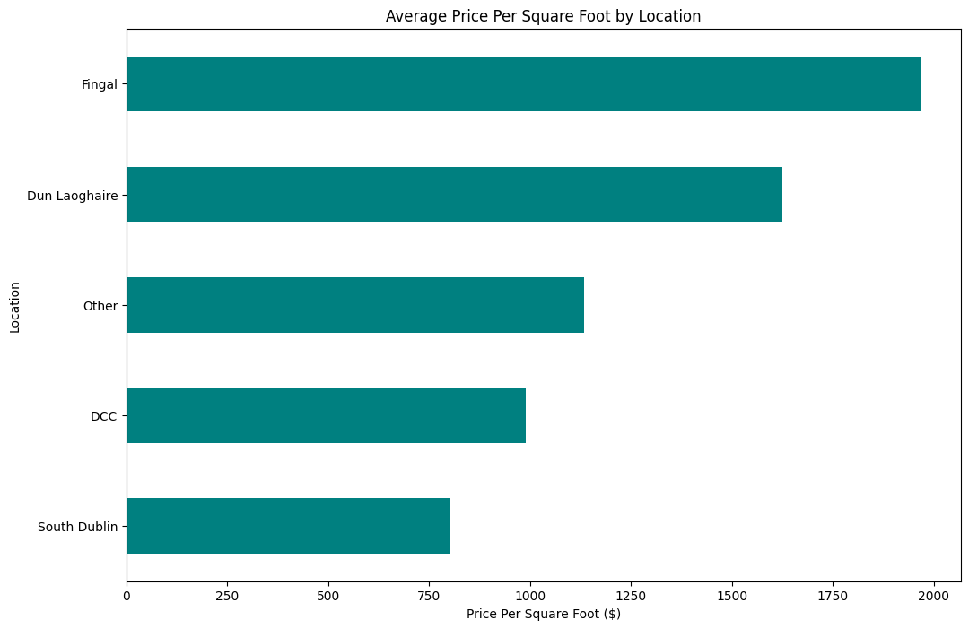
Have created a bar chart which illustrates some notable prices differences shown in the graph which displays average price per square foot by location, with Dun Laoghaire and Fingal being seen as potentially the priciest area and South Dublin and DCC area being the cheapest This data is important for understanding price changes in different areas of Dublin and could offer valuable insight to both buyers and sellers in the property market.
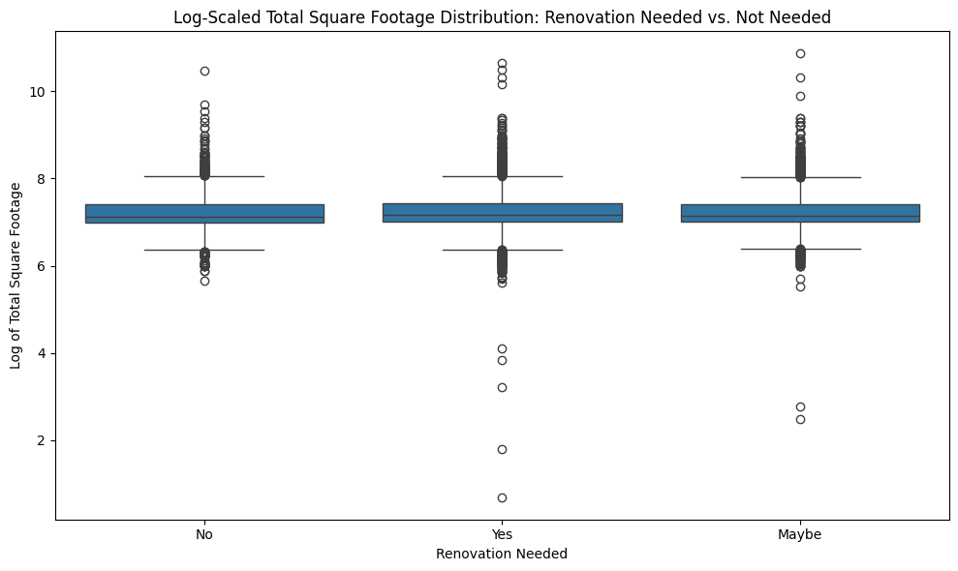
There is then a log-scaled boxplot showing Total Square Footage distribution for properties requiring renovation versus those that do not need. But this data visualization can provide insight on how much work is being done to renovate property, and by what size property — information that may be useful to investors or an urban renewal project anywhere in the world
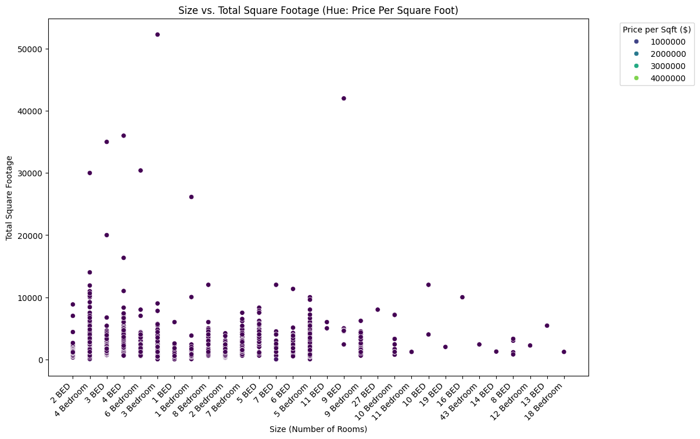
The scatter plot of the correlation between Size (rooms), Total Sq. Footage and Price per Sq. Ft provides a cross section of how this correlate with one another and how one pulls property price down/cost on these touches each other.
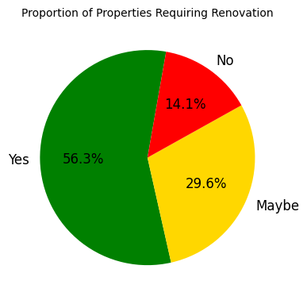
Pie chart of how many properties need renovation provides quick perception of properties in the dataset. This would be particularly valuable intel for investors — including those looking for units to renovate — or city planners tracking the overall status of the housing stock. The first phase of the project (EDA Findings) provides some insights — it identifies which aspect of housing appeals to a given individual. These types of findings can be the basis for later data analytics, feature engineering, and model build surrounding housing price prediction or other helping goals.

Data Preparation And Feature Engineering:
The data preprocessing for Dublin housing dataset was a series of different actions that catered to the data quality to be rightly prepared for analytics. Handling Missing Data, Dealing with Outliers, Feature Engineering, etc.
Handling Missing Values
This dataset had lots of columns with null values. The columns with Null values are: Location (1), Size (16), Bath (73) Balcony (609), Price-per-sqft-$ (246) To handle them, we used different imputation techniques:
Here, a code snippet: converting string values in a ‘size’ column to numeric and performing median imputation:
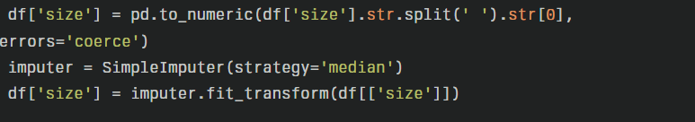
And for the 'bath' column, imputed with the most frequent value:
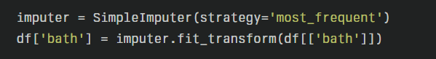
For the 'price-per-sqft-$' column, used median imputation and rounded the results:
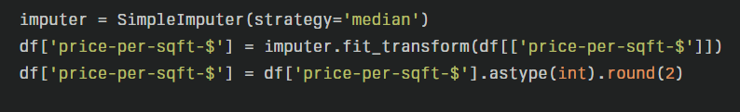
Addressing Outliers:
The IQR method was used to detect outliers from the Dublin housing dataset analysis. This well-established ingression of data histograms involves finding the first quartile (Q1), third quartile (Q3) and the IQR (Q3 - Q1). Outliers are generally considered to be points below Q1 - 1.5 IQR and points above Q3 + 1.5 IQR. This method was performed with the numerical features - 'bath', 'balcony', 'price-per-sqft-$', etc. Also used visualization techniques such as histograms and box plots to help us visually identify any potential outliers. One particularly interesting technique involved applying log transformation to the 'total_sqft' column used when generating box plots. This transformation assists in normalizing the distribution and lessening the impact of outliers, especially for right-skewed data such as property sizes. Utilizing both the IQR method and visual scrutiny, data points that were deemed as outliers were effectively and thoroughly assessed and dealt with.
Feature Engineering:
Although, the feature engineering methods employed in this Dublin housing dataset analysis were simple, they worked well. The data type change (specifically the 'total_sqft' column) was the most used method. A function Cleaning_total_sqft was defined to process each entry of 'total_sqft' as they could be - range values, string of numbers and unwanted values. For ranges, this function takes averages; for all else, it converts numeric strings to float, replacing most invalid entries with NaN. Also, the total_sqft column was transformed to log using np. with log1p() labelled it for particular visualizations (e.g., here the box plot contrasting renovation needs to property size). This is a way to flex the data, so it becomes close to normal to some extent, which makes it less affected by outliers. The custom function created to split categorical and continuous variables based on the unique count of the columns was one of the features that I specially engineered. This distinction is helpful in applying relevant preprocessing methods, as well as identifying relevant models on the data. This diplomatises also involved ‘Fill up missing values by multiple imputation techniques for different columns'; like median imputation for 'size' and 'price-per-sqft-$', mode imputation for bath etc. While simplistic, this preprocessing was an essential step in preparing the dataset to be analysed and modelled in-depth.

Predictive Analysis:
Various predictive models are used to analyze the Dublin housing dataset, each chosen for its unique advantages and appropriateness to the data involved. In particular, Random Forest, Linear Regression, Decision Tree, and support vector machine (SVM) are used. We will go through each approach and its use to the dataset:
Random Forest:
Used the Random Forest algorithm which is an ensemble method which combines many trees together to get the prediction. There are several reasons why it was chosen for this existing dataset:
There are some features, The housing market contains complex interactions between the various features. With non-linear relationships and interactions between different variables, housing data is a complex beast, and as such, Random Forest is particularly well suited to the task of modelling such data.
Feature importance: Random Forest can give us a measure of the importance of each feature for predicting housing prices, which is helpful to identify which factors seem to have a larger impact on housing prices in Dublin.
Robustness to Outliers and Noise: The Dublin housing market has outliers or noise in the data. Thus, being an ensemble learner, it can avoid these issues and makes it more stable predictions.
Dealing with both quantitative and qualitative variables: The dataset contains a mix of quantitative properties (ex. sizes/price) and qualitative properties (ex. location/property type). Random forest, which doesn't need tedious pre-processing, can handle both.
Linear Regression:
Although it is a simple algorithm Linear Regression is still part of the analysis due to several reasons:
Then an overview of a simple baseline model. It serves as a baseline against which to evaluate more complex models.
Interpretability: On the other hand, Linear Regression provides very clear and interpretable coefficients that could be directly related to the effect of features on house prices.
Fast: Linear Regression is also sometimes computationally strong and provide rapid conclusions for unlimited data types.
Assumptions Checks — Linear Regression if there linear relationships between housing prices or not so this will your help build further model.
Decision Tree:
We support the usage of Decision Tree method independently, because:
Easy to understand: Decision Trees are intuitive and easy to interpret, making the prediction of the house price decision process understandable.
Handling non-linear relationships: All the Decision Trees and Random Forests can handle non-linear relationships in the dataset.
Decision Trees package decision boundary plots so we can see relationships between our features that drive price. This is beneficial to all stakeholders in the real estate market.
Support Vector Machine (SVM):
SVM is selected due to its unique properties:
Through kernels: SVM can apply various kernel functions for capturing underlying patterns in data, which is relevant when you consider that the relationships between determinants (the size of the house, in square feet, and utilities for example), as it is on non-linear nature.
Outlier robustness : When combined with appropriate parameters, SVM can be more insensitive to outlier instances than some other methods.
Relevance to the Dataset:
The dataset has items like location, dimension, numerical numbers of rooms, the sort of house, and so on. The chosen methodologies are particularly relevant for the reasons enumerated below:
Handling different kinds of features: The dataset consist of numerical and categorical variables. All selected methods can handle such mixture of data; however, the Random Forest and Decision Tree are very suitable for it.
Capturing complex relationships: Housing prices are affected by many factors which may interact in complex ways. These intricacies are captured effectively by Random Forest and SVM.
Handle non-linearity: The correlation between features and housing prices are frequently non-linear. Except for Linear Regression, all the selected methods can capture non-linear patterns effectively.
Feature importance analysis: Random Forest and Decision Tree gives feature importance measures, making it important to understand the key determinant of price in the Dublin market.
Dealing with possible outliers: Real estate market often includes outliers (such as luxury properties or properties with a very low price). Such outliers have no effect on Random Forest and SVM.
Trade-off between Interpretability and Performance: Including highly interpretable model (Linear Regression, Decision Tree) and potentially more accurate model (Random Forest, SVM) provides a good trade off to analyse by performance.
Scalability: These approaches is computationally cheap with 13,320 entries in the dataset and thus can strike a balance between computational performance and predictive capability.
Finally, the approach of applying Random Forest, Linear Regression, Decision Tree, and SVM on the Dublin Housing dataset to predict price is a holistic approach to approaching a problem to analyze the housing market. Such combination enables capturing complex patterns, dealing with different types of data, generating interpretable predictions, and achieving reliable predictions. The methods answer each other, providing a balance between simplicity and sophistication, interpretability and predictive power, which is key for a thorough analysis of the Dublin housing market.

Results & Interpretation:
Random Forest:
Overall, the Random Forest model worked remarkably well for predicting the Dublin housing prices, given a few excellent metrics and a visualization to support its result. Our Model R² Score was excellent, with a high value of 0.993 (99.31%) that explained ~99.31% of the variance in the dependent variable. Given the scale of the housing price data, the average Mean Squared Error (MSE) is 681.53 indicating a relatively low prediction error.
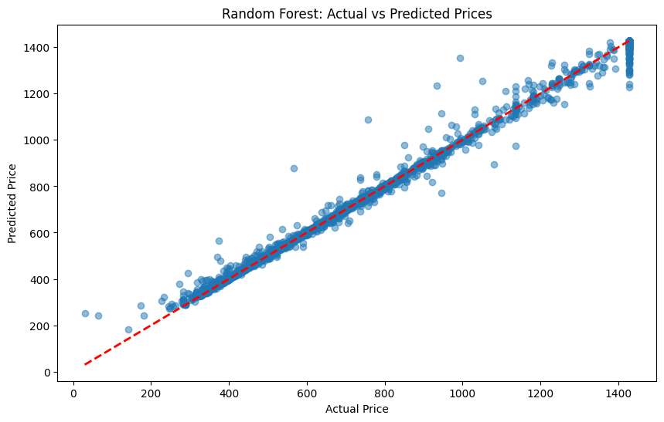
The scatter plot of true price vs predicted price displays a strong linear relationship, with all points clustered around the diagonal line (the red dashed line). The narrow clustering means that the prediction is accurate when price level varies. The model seems to hold fairly well across the range of prices though up in the higher prices (1000+ units) there is a bit more scatter, which is common in real estate prediction models as luxury-based price ranges tend to mirror reality less.
Linear Regression:
Using the Linear Regression model, we can thus conclude that the performance of the base model is generally less in predicting the house prices given the accuracy is less. The R-squared of 0.372 means this model doesn't explain most of the variance in house prices, which is very low as you would want it to be higher when predicting real estate. The top MSE (Mean Squared Error) of 62,465.58 indicates how far off the predictions were from the actuals.
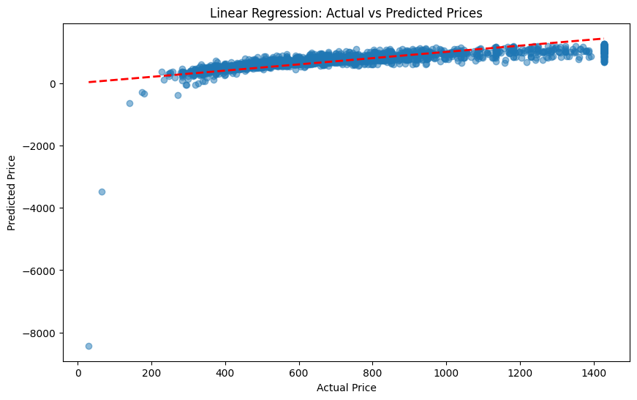
The scatter plot shows several worrying trends. And although there’s an overall upward trend (indicated by the red dashed line), there’s a lot of scatters around that line, especially at higher price points. Negative predicted values at the bottom end of the scale are very bad because house prices cannot be negative. This indicates that the model does not reflect the true (features price) relationship.
The cross-validation scores range from 0.11 to 0.70, with an average score of 0.55 showing that there is a lot of variation in model performance across different sections of the data. This inconsistency, and some of the scores being as lower as 0.11, show that there is instability in the model which basically means that it may not generalize well on new data.
Support Vector Machine (SVM):
The SVM model shows a very good performance with between actual and predicted prices. The red dashed line shows the strong linear relationship between the data, meaning our predictions are highly accurate since most data points are located closely to this line. The R-squared value of the model is 0.969 indicating that it explains 96.9% of the variance in the model. Such a high R-squared value indicates that the model fits well, thus has a good amount of predictive power. A Mean Squared Error (MSE) of 3130.96 is comparatively low, signifying that the average distance squared of the prices of the products as predicted vs. actual is minimal in comparison to the scale (in the range of 0-1400) of the data. The best hyperparameters discovered are a C value of 100 (good score for satisfactory complexity-generalisation trade-off), and an RBF kernel. Although outliers are visible in the scatter plot (especially for higher prices (>1000)), the clustering of points, and the density of points along the diagonal, indicates the high reliability of the model. Considering these impressive performance metrics which were further confirmed through graphical validation of prediction accuracy gives this SVM model further evidence as to why it would be an excellent candidate for price prediction tasks, more so for data featuring non-linear relationships between dependent and independent variables.
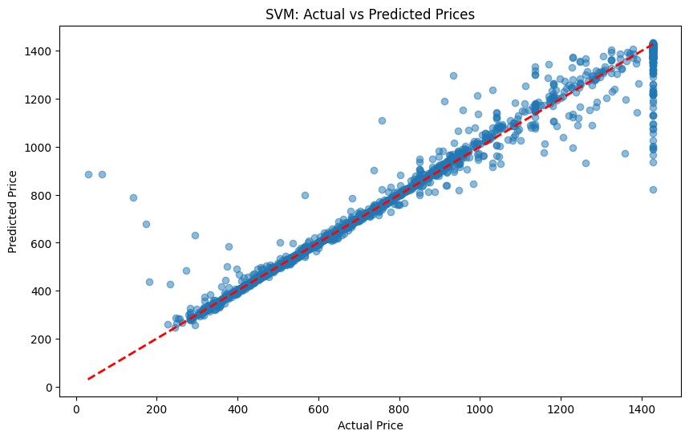

Decision Tree:
The Decision Tree Classifier performs with relatively poor accuracy overall (57.56%) and is only slightly better than chance for a three-class prediction problem. From the scatter plot between Actual vs Predicted Prices, there is a widespread from the diagonal or ideal prediction line (the red line), implying that we have made a lot of wrong prediction. Overall, the Medium-Low category of the classes, scored best with f1 of 0.67 at precision and recall of 0.66 and 0.69 respectively. And its performance on medium class isn't good at all, which stays at 0.24 for both precision and recall. For the Low category, moderate performance is observed with precision of 0.47 and recall of 0.45.
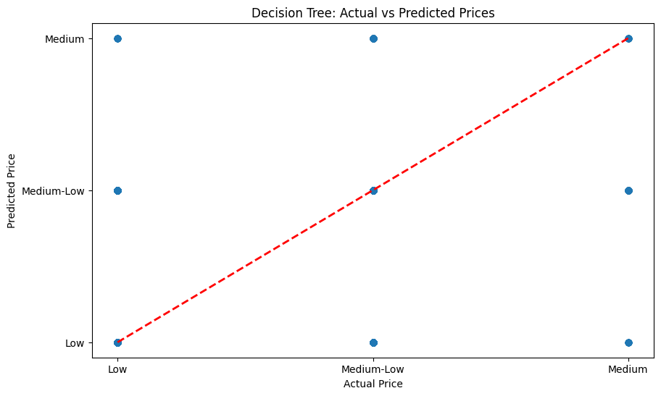
Model Comparison Based On Their R-Squared Scores:
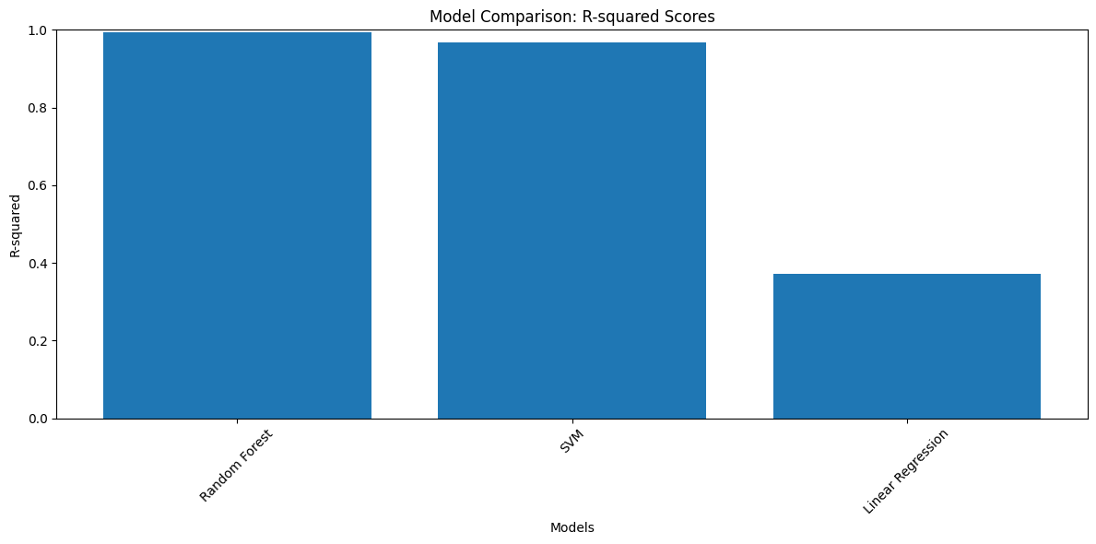
This is a bar graph showing the R-squared score between three different algorithms: Random Forest, SVM (Support Vector Machine) and Linear Regression. In fact, Random Forest and SVM perform on par with each other with R-squared values close to 1.0, but Linear Regression underperforms with an R-squared of around 0.37. But the very high R² values for Random Forest and SVM indicates a need for revalidation of these models with correct cross-validation and testing procedures.
Revaluation of Random Forest & Support Vector Machine (SVM) Results:
The Random Forest model had the best performance on our dataset for predicting if a person had less than or greater than the average household income in Ireland based on R² with a score of 0.4025, by far beating the SVM model we used previously which has a R² score of 0.2298. There are several reasons why the Random Forest works so well for this specific dataset. First, the model captures the complexities of features relationships, especially the high correlation between bath (0.41), size (0.37), and sqft-total (0.19) with price-per-sqft-$ target variable. And since the house prices in the dataset vary from $30.40–$4,953,333 per square foot, the model's ability to capture non-linear relationships between the data is particularly handy! Moreover, Random Forest is an ensemble algorithm, which naturally handles the influence of outliers, this is very important because the standard deviation of price-per-sqft-$ is very high (45,813.90). With an MSE of 59,543.24, the model is compared against SVM which has an MSE of 76,749.99; thus, it justifies better predictive accuracy and price prediction reliability. In addition, Random Forest works well with both numerical and categorical features, making it a good choice for this dataset of mixed feature types (e.g. BER ratings, property scope, location etc.). In addition, the small difference in R² when comparing cross validation (0.4025) and test set (0.3743) also indicates that the model generalizes well and does not overfit.

References:
- Akande, O., Adebayo, A.J., Oguntunde, P.E. and Odetunmibi, O.A. (2022) 'House Price Prediction using Random Forest Machine Learning Technique', ResearchGate. Available at: https://www.researchgate.net/publication/358351395_House_Price_Prediction_using_Random_Forest_Machine_Learning_Technique
- Agarwal, A., Sharma, A., Sharma, S. and Sharma, V. (2024) 'House Price Prediction Model Using Machine Learning', Journal of Emerging Technologies and Innovative Research, https://www.jetir.org/papers/JETIR2409100.pdf 11(9), pp. a858-a864.
- Conlon, C. (2019) 'An Analysis of Property Prices in Ireland', Towards Data Science, 11 November. Available at: https://towardsdatascience.com/an-analysis-of-property-prices-in-ireland-6fc34a56ac87
- V. (2022) Prediction of Property Prices of Dublin Housing Market using Ensemble Learning. MSc Research Project. National College of Ireland. Available at: https://norma.ncirl.ie/6229/1/vanimirg.pdf (Accessed: 2 December 2024).

