**At least 22 dead, more than 1,200 injured in Turkey earthquake**

By Isil Sariyuce, Hamdi Alkhshali and Amir Vera, CNN

Updated: Sat, 25 Jan 2020 15:19:20 GMT

**Istanbul (CNN)** At least 22 people died and hundreds injured in eastern Turkey after an earthquake rattled the region on Friday evening, according to authorities.

The 6.7-magnitude quake struck near the town of Sivrice, in eastern Elazig province, collapsing at least 10 buildings, Turkish Interior Minister Sulyman Soylu said.

Eighteen people were killed in Elazig province and four in Malatya, said Soylu at a news conference on Saturday.

Around 39 people were pulled from under the rubble of collapsed building overnight, he said, adding that 22 people remain trapped.

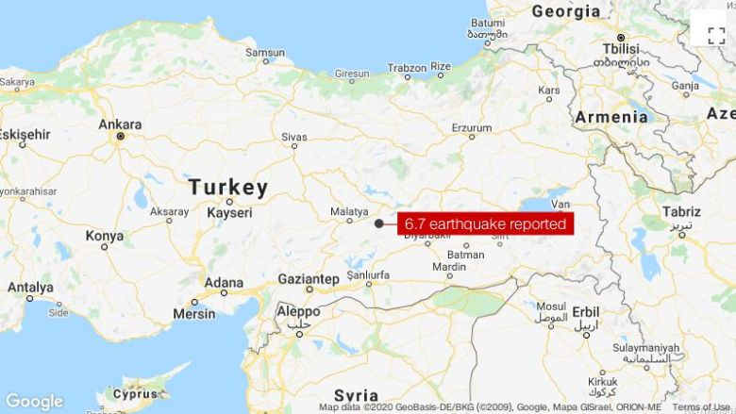

Some 1,243 people were wounded following the powerful quake, most of them in Elazig province, according to a statement published by Turkey's Disaster and Emergency Management Presidency (AFAD).