# Problem-1

Given the daily asset value of portfolio A and B (portfolio.csv), calculate the normalized annual return, annual volatility, max drawdown, sharp ratio, sortino ratio, VaR of each portfolio. Analyze the relation between two portfolios, using at least three methods.

## Answer:

The complete solution is in jupyter Question-1.ipynb. This report summarizes some key results from the notebook.

## Normalized annual return, volatility, max drawdown, sharpe, sortino, VaR of each portfolio

Trading day = 260 is applied to all calculations, since the data has 520 trading price in total.

To understand the relation between two portfolios, three analyses are done: correlation (spearman, pearson), two-sample KS test (H0: two samples are drawn from the same distribution), and linear regression.

There is a strong correlation between those two portfolios. The linear regression gives similar but more information, indicating a strong “linear” relation between the two porfolios.

The goodness-of-fit mearsure R square is ~0.7, telling us the linear model can be a good choice for explaining the relation between the two portfolio, if our goal is to start with a simple model to explain the relation. In addition, other metrics, e.g., F-statistics, T-statistics also indicate us the effectiveness of such a simple linear model.

Additionally, a p-value = 0.002 from a two sample KS test tells us the samples are not from the same distribution (the null is rejected, since p-value is less than the common 0.05 significance level).

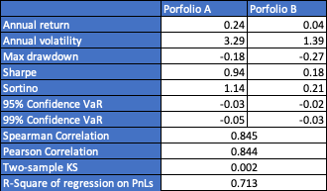

## Scatter Plot

The scatter plot and linear regression fitted straight line are shown below.

## Daily PnL Histogram

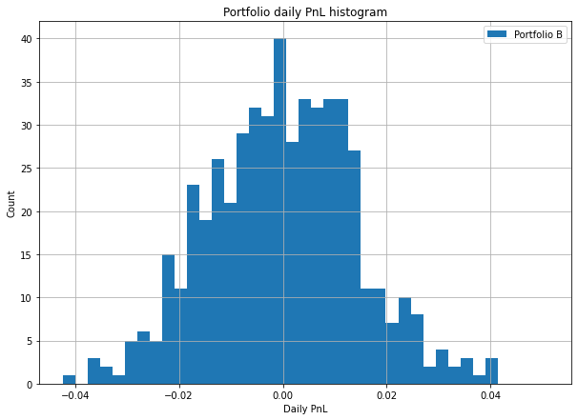

## Max drawdown

Figure 1 Max drawdown: prices, cumulative max, through value of Portfolio A

Figure 2 Max drawdown: prices, cumulative max, through value of Portfolio B

# Problem-2

Give the hdf5 file, please load the data from the file (sample.h5) and store in a pandas DataFrame.

## Answer:

The solution is in the jupyter file Question-2.ipynb and the output sample.csv.

The sample format is shown below.

The file hierarchy can printed by the Converter::_str_, shown as below:

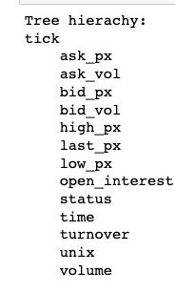

# Problem-3

Write function/class to calculate the vanilla option price and greeks (delta, gamma, rho, vega, etc.), using Black-Scholes and Trinomial-Tree models.

## Results

All the results can be generated by running ./main.py.

1. Euro_call_put.csv
2. Am_call_put.csv
3. Implied_vol.csv
4. Convergence plots:
5. S_20_T_3_r_0.05_sigma_0.3_q_0.02_K_25_payoff_call_n_200.jpg
6. S_20_T_3_r_0.05_sigma_0.3_q_0.02_K_25_payoff_put_n_200.jpg
7. S_42_T_0.75_K_40_r_0.04_q_0.08_sigma_0.35_payoff_call_n_200.jpg
8. S_100_T_3_r_0.15_sigma_0.5_q_0.04_K_65_payoff_call_n_200.jpg
9. S_127_T_1_r_0.1_sigma_0.2_q_0.03_K_130_payoff_put_n_200.jpg

## European Call and Put Option

The results for vanilla option price, greeks (delta, gamma, theta, rho and vega) are summarized in table 1, 2.

The code which generates the Black-Scholes formula results ave saved in in ./utitls/BlackScholesModel.py, the analytical formula used in the implementation can be found in *“Section2.13, The Complete Guide to Option Pricing Formulas (2nd Edition), by Espen Gaarder Haug, PhD”.*

The column names start with “Tree_” , e.g., Tree_Euro(call) in the tables are made by the trinomial model, which can be found in the class defined in ./utils/TrinomidalModel.py.

The gamma and theta have same values, as expected. As a reference, more tests, e.g., call-put parity, can be found in jupyter notebook Question-3.ipynb.

Table 1 Euro Call and Put (BS, Tree Model, R result)

## American Call and Put Option (with optimal early exercise setup)

The American option prices, and greeks are generated by the same file ./utils/TrinomidalModel.py, but with different set up, i.e., by changing payoff and exercise condition (as two parameters passed by user).

Unfortunately, it’s not easy to find reliable, open-source American option calculator to compare with the Trinomial Model results. The red number in the table indicates some R packages may have some suprising results.

Table 2 American Option vs R package result(call option only)[1]

## Implied Volatility

To obtain implied volatility, two methods (Newton’s, and bisection) are used for BS and Tree model. There are 6 tests are set up, with different parameters to include all models (call, put, Eruo, American). The meta data can be found in ./utils/WriteOut.py::save_implied_vol.

The implied volatility **all match** with the true sigma well and the convergence speed is fast.

Table 3 Implied Volatility from Tree Model and BS.

## Convergence Plots (with different steps in Trinomial Model)

In the convergence test, the Trinomial Model results with different steps, i.e., from 0 ~ 200 steps (1 step=T/dt), are used to compute initial option price and the results are compared with BS formula.

The tree model convergence results, and overall look close to BS model even with small steps and it quickly give pretty good results, after around 100~200 steps.

Note only Euro option results are compared in the convergence test.

Equation 1 S=20, T=3, r=0.05, sigma=0.3, q=0.02, K=25, Call

Equation 2 S=20, T=3, r=0.05, sigma=0.3, q=0.02, K=25, Put

Equation 3 S=42, T=0.75, r=0.04, sigma=0.35, q=0.08, K=40, Call

Equation 4 S=100, T=3, r=0.15, sigma=0.5, q=0.04, K=65, Call

Equation 5 S=127, T=1, r=0.1, sigma=0.2, q=0.03, K=130, Put

1. The table compares the TreeModel results with a R package called “AmericanCallOpt”, the theta, which defined as $Θ=-∂c/∂T$, should be negative for American option, but the results from the R package shows a relative big positive number.