

**INFO 2302 WEB TECHNOLOGIES | Section 02**

**Dr. Aidrina Binti Mohamed Sofiadin**

Group 7

**README.MD**

Prepared by Muhammad Aiman bin Razali (1916425) and Muhammad Haziq bin Samsudin (1912481)

‘SHARE4LIFE’ is a website for an online platform to help the needy by providing education resources.

|  |  |
| --- | --- |
| NAME | MATRIC NO. |
| MUHAMAD AIZAT NAZRAN BIN ROSLI | 1914785 |
| MUHAMMAD ARIF BIN ABDULLAH HALIM | 1916093 |
| MUHAMMAD AIMAN BIN RAZALI | 1916425 |
| MUHAMMAD AQIL IZDIHAR BIN SAHARUDIN | 1919801 |
| MUHAMMAD HAZIQ BIN SAMSUDIN | 1912481 |



‘SHARE4LIFE’

1. **Project Description**

On March 11, 2020, the World Health Organization (WHO) declared COVID-19 a global pandemic. The Coronavirus case has claimed more than 1.5 million human lives. The Malaysian government has taken the initiative to implement the Movement Control Order starting March 18, 2020 nationwide. All services or businesses are limited to operating to curb this pandemic. Indirectly, this has caused a huge impact on the less fortunate as a student. Therefore, we developed a website with the concept of online donation to help underprivileged students in International Islamic University Malaysia (IIUM). The website we developed is titled ‘Share4Life’. The system we developed is intended to help students who are affected by this Covid-19 case. For donors, they can channel aid such as money, food, educational devices, stationeries and some other necessities to help students.

This website building project that we developed includes the Home page as the main interface for this project. Next, on the 'Fund Donation' page we provide details to be filled by the donor such as name, email, phone number along with the amount of money to be channel and the Calculate button which serves as a calculation of the amount of money donated by the donor. On the 'Donation Form' page there are details such as first name, last name and email to be filled out by the donor. Donors also need to select the category of types of donations to be channel and there is a space that needs to be filled by the donor that is what items will be donated. Finally, on the 'Contact Us' page users can express their feedback such as suggestions, grievances or words of appreciation about our website.

1. **Project Sitemap**

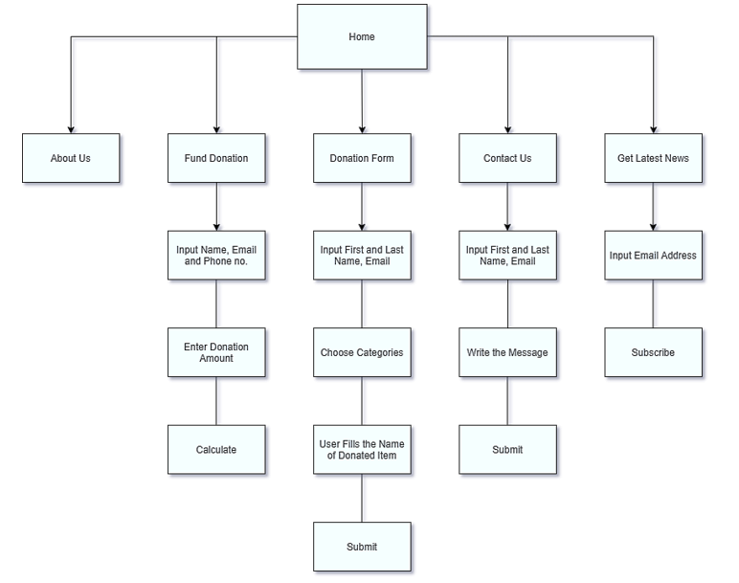

**3. Group Contributions**

|  |  |
| --- | --- |
| **Name** | **Contributions** |
| Muhamad Aizat Nazran Bin Rosli | * Page: Home page * Web elements: navigation buttons, images, video, text area, form |
| Muhammad Arif Bin Abdullah Halim | * Page: Fund Donation * Web elements: form, text area, calculation in donation amount, navigation buttons. * JavaScript event handlers for popup when calculate button clicked. |
| Muhammad Aiman Bin Razali | * Page: Donation Form * Web elements: form, text area, clickable dropdown, navigation buttons. * JavaScript event handlers for popup when submit button clicked. |
| Muhammad Aqil Izdihar Bin Saharudin | * Page: Contact Us * Web elements: required form, text area, navigation buttons. * JavaScript event handlers for popup when submit button clicked. * Base for website: Background, text, logo with suitable styling on all pages. |
| Muhammad Haziq Bin Samsudin | * Page: About Us * Web elements: images, text, navigation buttons. |

**4. Use of third-party resources**

|  |  |  |  |
| --- | --- | --- | --- |
| **Web elements** | **Name** | **Use of third-party resources and modifications (if any)** | **Modifications (if any)** |
| Background wallpaper for all pages | Black wallpaper | Used the website Wallpaper-House.com to get this image. This image is used as a background image for description on the home page. | The image is resized in the CSS. |
|  |  |  |  |
|  |  |  |  |
|  |  |  |  |
|  |  |  |  |
|  |  |  |  |
|  |  |  |  |

**5. References**

1. <https://wallpaper-house.com/data/out/9/wallpaper2you_326642.jpg>