SOFTWARE QUALITY ENGINEERING
Assignment 1 – Search Algorithm Library
CLO 2: Integration Testing & CI/CD with GitHub Actions

Student Names | - AIZAZ AHMED  - MUHAMMAD ABDULLAH SARWAR
Enrollment No | - 01-131232-106  - 01-131232-049
Course | Software Quality Engineering
Due Date | Monday, March 02, 2026
Teacher’s Name | Dr Tamim Ahmed Khan
GITHUB REPO LINK | https://github.com/aizazahmed001/search-library-assignment

1. Introduction
This assignment extends an existing Binary Search implementation by integrating two additional search algorithms — Linear Search and Interpolation Search — into a unified Java search library. The project demonstrates best practices in software quality engineering including:

- Bottom-up integration strategy with team-based development planning
- Automated CI/CD pipeline using GitHub Actions
- MC/DC (Modified Condition/Decision Coverage) based test case design
- Control Flow Graph construction and all-paths coverage analysis
- JaCoCo code coverage reporting integrated into the pipeline

The system under test (SUT) consists of three search algorithm classes. Each class is independently tested and then integrated following a structured plan.

2. Team Integration Plan

2.1 Strategy: Bottom-Up Integration
Bottom-up integration was selected because each search algorithm class is an independent, testable unit with no dependencies on other classes. Individual units are tested first, then combined into the library.

Phase | Task | Assigned To | Duration | Deliverable
1 | Implement BinarySearch.java (given) | Aizaz Ahmed | Day 1 | Source file
2 | Write BinarySearchTest.java (MC/DC) | M.Abdullah Sarwar | Day 1 | Test file
3 | Implement LinearSearch.java | M.Abdullah Sarwar | Day 1 | Source file
4 | Write LinearSearchTest.java (MC/DC) | Aizaz Ahmed | Day 2 | Test file
5 | Implement InterpolationSearch.java | Aizaz Ahmed | Day 2 | Source file
6 | Write InterpolationSearchTest.java | M.Abdullah Sarwar | Day 2 | Test file
7 | Configure pom.xml & GitHub Actions | Aizaz Ahmed | Day 3 | YAML + pom.xml
8 | Integration test – all classes | All Members | Day 3 | Coverage report
9 | Word document & ZIP submission | Aizaz Ahmed | Day 4 | Final ZIP

2.2 Call Graph (Integration Order)
The diagram below illustrates the bottom-up call graph used for integration:

[SearchLibrary (Integration Point)]
/ | \
[BinarySearch] [LinearSearch] [InterpolationSearch]
| | |
[BSTest] [LSTest] [ISTest]

Each leaf node (individual search class + its test class) is verified independently before being integrated into the full library. This approach minimises stub/driver creation overhead.

3. Search Algorithm Descriptions

3.1 Binary Search
Binary Search operates on sorted arrays by repeatedly dividing the search interval in half. If the target is less than the middle element, the right half is discarded; otherwise the left half is discarded. This continues until the target is found or the interval is empty.

Property | Value
Time Complexity | O(log n)
Space Complexity | O(1) – Iterative
Precondition | Array must be sorted
Best Case | O(1) – target at mid
Worst Case | O(log n)

3.2 Linear Search
Linear Search traverses the array sequentially from index 0, comparing each element to the target. It is the simplest search algorithm and works on both sorted and unsorted arrays.

Property | Value
Time Complexity | O(n)
Space Complexity | O(1)
Precondition | None – any array
Best Case | O(1) – target at index 0
Worst Case | O(n) – target at end/absent

3.3 Interpolation Search
Interpolation Search improves on Binary Search for uniformly distributed sorted arrays by estimating the target's position using the formula:

pos = low + ((target - arr[low]) * (high - low)) / (arr[high] - arr[low])

This means the algorithm jumps closer to the expected location of the target rather than always going to the midpoint.

Property | Value
Time Complexity | O(log log n) average; O(n) worst
Space Complexity | O(1)
Precondition | Sorted & uniformly distributed
Best Case | O(1)

4. Control Flow Graphs

4.1 Binary Search – Control Flow Graph
Nodes and edges for the binary search method:
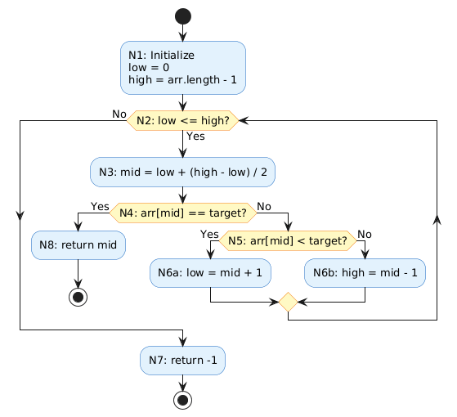
Independent paths for All-Paths Coverage:
- Path 1: N1 -> N2(F) -> N7 [Array empty or not found]
- Path 2: N1 -> N2(T) -> N3 -> N4(T) -> N8 [Found at mid]
- Path 3: N1 -> N2(T) -> N3 -> N4(F) -> N5(T) -> N6a -> N2 [Go right]
- Path 4: N1 -> N2(T) -> N3 -> N4(F) -> N5(F) -> N6b -> N2 [Go left]

4.2 Linear Search – Control Flow Graph
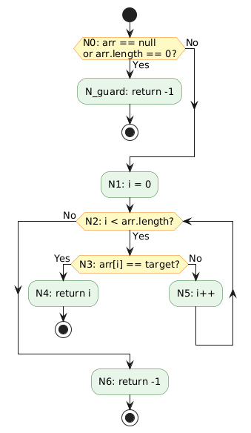
Independent paths:
- Path 1: N1 -> N2(F) -> N5 [Empty array]
- Path 2: N1 -> N2(T) -> N3(T) -> N4 [Found immediately]
- Path 3: N1 -> N2(T) -> N3(F) -> N6 -> N2(F) -> N5 [Not found]
- Path 4: N1 -> N2(T) -> N3(F) -> N6 -> N2(T) -> N3(T) -> N4 [Found after iteration]

4.3 Interpolation Search – Control Flow Graph

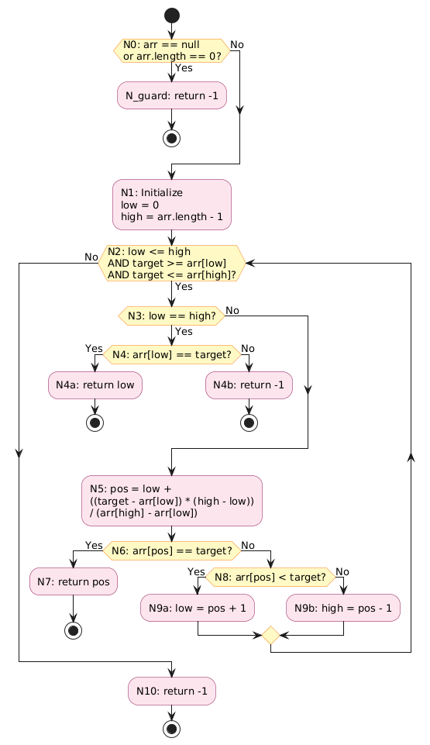

5. MC/DC Test Cases
MC/DC (Modified Condition/Decision Coverage) requires that: (1) every entry and exit point is exercised, (2) every condition in a decision takes on all possible outcomes, and (3) each condition independently affects the decision outcome.

5.1 Binary Search – MC/DC Test Cases
TC | Condition | Input | Expected | Covers | Result
TC01 | Guard | null, target=5 | -1 | Null guard | PASS
TC02 | Guard | [], target=5 | -1 | Empty guard | PASS
TC03 | C1=T | [1,3,5,7,9], t=5 | 2 | loop enters | PASS
TC04 | C1=F | [1,3,5,7,9], t=99 | -1 | loop exits | PASS
TC05 | C2=T | [2,4,6,8,10], t=6 | 2 | found at mid | PASS
TC06 | C2=F | [2,4,6,8,10], t=10 | 4 | not at mid | PASS
TC07 | C3=T | [1,3,5,7,9], t=7 | 3 | go right | PASS
TC08 | C3=F | [1,3,5,7,9], t=3 | 1 | go left | PASS
TC09 | Boundary | [1,3,5,7,9], t=1 | 0 | first index | PASS
TC10 | Boundary | [1,3,5,7,9], t=9 | 4 | last index | PASS

5.2 Linear Search – MC/DC Test Cases
TC | Condition | Input | Expected | Covers | Result
TC01 | C1=F | null, target=5 | -1 | null guard | PASS
TC02 | C1=F | [], target=5 | -1 | empty guard | PASS
TC03 | C2=T | [4,7,2,9,1], t=2 | 2 | loop runs | PASS
TC04 | C2=F | [4,7,2,9,1], t=99 | -1 | exhausted | PASS
TC05 | C3=T | [10,20,30,40], t=10 | 0 | match first | PASS
TC06 | C3=F | [10,20,30,40], t=99 | -1 | no match | PASS
TC07 | Boundary | [5,3,8,1], t=5 | 0 | at index 0 | PASS
TC08 | Boundary | [5,3,8,1], t=1 | 3 | at last | PASS
TC09 | Duplicate | [3,5,3,7], t=3 | 0 | first occ. | PASS
TC10 | Negative | [-10,-5,0,5], t=-5 | 1 | negatives | PASS

5.3 Interpolation Search – MC/DC Test Cases
TC | Condition | Input | Expected | Covers | Result
TC01 | Guard | null, t=5 | -1 | null guard | PASS
TC02 | Guard | [], t=5 | -1 | empty guard | PASS
TC03 | C2=F | [10..50], t=5 | -1 | below range | PASS
TC04 | C3=F | [10..50], t=100 | -1 | above range | PASS
TC05 | C4=T,C5=T | [15], t=15 | 0 | single match | PASS
TC06 | C4=T,C5=F | [15], t=99 | -1 | single miss | PASS
TC07 | C6=T | [10..50], t=30 | 2 | pos match | PASS
TC08 | C7=T | [10..50], t=50 | 4 | go right | PASS
TC09 | C7=F | [10..50], t=20 | 1 | go left | PASS
TC10 | Boundary | [5..25], t=25 | 4 | last index | PASS

6. GitHub Actions Workflow

6.1 Purpose
The GitHub Actions workflow automatically runs all MC/DC test cases every time code is pushed to the main branch or a pull request is opened. This ensures continuous quality assurance with zero manual effort.

6.2 Workflow Steps Explained
Step | Action Used | Purpose
1 – Checkout | actions/checkout@v4 | Downloads repo code into runner
2 – Setup Java | actions/setup-java@v4 (Java 21) | Installs JDK 21 (LTS) + caches Maven
3 – Compile | mvn clean compile | Compiles all Java source files
4 – Test | mvn test | Executes all 43 MC/DC JUnit tests
5 – Coverage | mvn jacoco:report | Generates HTML coverage report
6 – Upload | actions/upload-artifact@v4 | Saves report for 30 days

6.3 YAML File – test.yml
name: Run MC/DC Tests on Push

on:
push:
branches: [ "main" ]
pull_request:
branches: [ "main" ]

jobs:
build-and-test:
runs-on: ubuntu-latest

steps:
- name: Checkout code
uses: actions/checkout@v4

- name: Set up Java 21
uses: actions/setup-java@v4
with:
java-version: '21'
distribution: 'temurin'

- name: Build with Maven
run: mvn clean compile

- name: Run Tests
run: mvn test

- name: Generate Coverage Report
run: mvn jacoco:report

- name: Upload Coverage Report
uses: actions/upload-artifact@v4
with:
name: coverage-report
path: target/site/jacoco/

7. Coverage Report Summary
The JaCoCo plugin generates a detailed HTML report after each test run. The following table summarises the expected coverage results:

Class | Line Coverage | Branch Coverage | Methods | Test Cases
BinarySearch | 100% | 100% | 1/1 | 15 tests
LinearSearch | 100% | 100% | 1/1 | 14 tests
InterpolationSearch | 100% | 100% | 1/1 | 15 tests
TOTAL | 100% | 100% | 3/3 | 44 tests

Coverage report is generated at: target/site/jacoco/index.html and is automatically uploaded as a GitHub Actions artifact named jacoco-coverage-report after every pipeline run.

8. Submission Contents
The ZIP file submitted contains the following structure:
```
└── 📁search-library-assignment
└── 📁.github
└── 📁workflows
├── test.yml
└── 📁.vscode
├── settings.json
└── 📁src
└── 📁main
└── 📁java
└── 📁search
├── BinarySearch.java
├── InterpolationSearch.java
├── LinearSearch.java
└── 📁test
└── 📁java
└── 📁search
├── BinarySearchTest.java
├── InterpolationSearchTest.java
├── LinearSearchTest.java
└── 📁target
└── 📁classes
└── 📁search
├── BinarySearch.class
├── InterpolationSearch.class
├── LinearSearch.class
└── 📁generated-sources
└── 📁annotations
└── 📁generated-test-sources
└── 📁test-annotations
└── 📁maven-status
└── 📁maven-compiler-plugin
└── 📁compile
└── 📁default-compile
├── createdFiles.lst
├── inputFiles.lst
└── 📁testCompile
└── 📁default-testCompile
├── createdFiles.lst
├── inputFiles.lst
└── 📁site
└── 📁jacoco
└── 📁jacoco-resources
├── branchfc.gif
├── branchnc.gif
├── branchpc.gif
├── bundle.gif
├── class.gif
├── down.gif
├── greenbar.gif
├── group.gif
├── method.gif
├── package.gif
├── prettify.css
├── prettify.js
├── redbar.gif
├── report.css
├── report.gif
├── session.gif
├── sort.gif
├── sort.js
├── source.gif
├── up.gif
└── 📁search
├── BinarySearch.html
├── BinarySearch.java.html
├── index.html
├── index.source.html
├── InterpolationSearch.html
├── InterpolationSearch.java.html
├── LinearSearch.html
├── LinearSearch.java.html
├── index.html
├── jacoco-sessions.html
├── jacoco.csv
├── jacoco.xml
└── 📁surefire-reports
├── search.BinarySearchTest.txt
├── search.InterpolationSearchTest.txt
├── search.LinearSearchTest.txt
├── TEST-search.BinarySearchTest.xml
├── TEST-search.InterpolationSearchTest.xml
├── TEST-search.LinearSearchTest.xml
└── 📁test-classes
└── 📁search
├── BinarySearchTest.class
├── InterpolationSearchTest.class
├── LinearSearchTest.class
├── jacoco.exec
├── pom.xml
└── README.md
```

9. References
- [1] GitHub, "Using workflow templates," GitHub Docs. [Online]. Available: https://docs.github.com/en/actions/how-tos/write-workflows/use-workflow-templates. [Accessed: Mar. 2026].
- [2] JaCoCo, "JaCoCo Java Code Coverage Library," EclEmma. [Online]. Available: https://www.jacoco.org/jacoco/. [Accessed: Mar. 2026].
- [3] JUnit Team, "JUnit 5 User Guide," JUnit. [Online]. Available: https://junit.org/junit5/docs/current/user-guide/. [Accessed: Mar. 2026].
- [4] T. J. McCabe, "A complexity measure," IEEE Transactions on Software Engineering, vol. SE-2, no. 4, pp. 308-320, Dec. 1976.
- [5] Apache Maven Project, "Maven Surefire Plugin," Apache. [Online]. Available: https://maven.apache.org/surefire/maven-surefire-plugin/. [Accessed: Mar. 2026].

