Final
Aizat Nurtay Albek Guzmanov Akbota Aitmukasheva
Project Overview
Astra Protocol is a DeFi governance project built with Solidity, Foundry, Next.js, and The Graph. The system combines DAO governance, a governance token, timelock-based execution, treasury management, an AMM module, and an ERC-4626 vault. The protocol was deployed on Arbitrum Sepolia and tested through unit, integration, invariant, and security test suites.
Architecture
The protocol consists of several core smart contracts. GovernanceToken provides voting power through token delegation. ProtocolGovernor manages proposal creation and voting logic. ProtocolTimelock enforces delayed execution of governance decisions. Treasury stores and manages protocol-controlled funds. AMMFactory and AMMPair implement the constant-product exchange module. YieldVault provides ERC-4626 deposit and share mechanics. ChainlinkOracle is used for external price reference and staleness protection.
Deployment
The contracts were deployed to the Arbitrum Sepolia test network. After deployment, the addresses were verified and used in the frontend and subgraph configuration. In addition, a subgraph named astra-governance was deployed to The Graph Studio in order to index governance proposals, votes, delegations, and vault activity.
Testing
The testing environment is based on Foundry. The project includes unit tests for individual contracts, integration tests for protocol flow, invariant tests for system properties, and security-oriented tests. In particular, Governor.t.sol verifies proposal creation, voting power availability, proposal state, vote casting, and prevention of double voting.
Frontend
The frontend was built with Next.js and Wagmi. It supports wallet connection through MetaMask and WalletConnect. The interface reads token balance, voting power, delegated address, and vault share state from deployed contracts. It also supports state-changing actions directly from the UI, including delegation, proposal creation, and voting. The application detects incorrect networks, prompts the user to switch to Arbitrum Sepolia, and displays readable error messages instead of raw RPC errors.
Subgraph Integration
The Graph was used to index governance-related events. The deployed subgraph endpoint is used by the frontend to display indexed proposal and vote data. This satisfies the requirement that at least one section of the dApp must read from The Graph rather than directly from the blockchain.
Conclusion
As a result, Astra Protocol was implemented as a complete governance-focused DeFi application with smart contracts, testing, deployment, frontend integration, and indexed subgraph data. The project demonstrates DAO governance, secure contract design, and full-stack blockchain application development.

Deploy
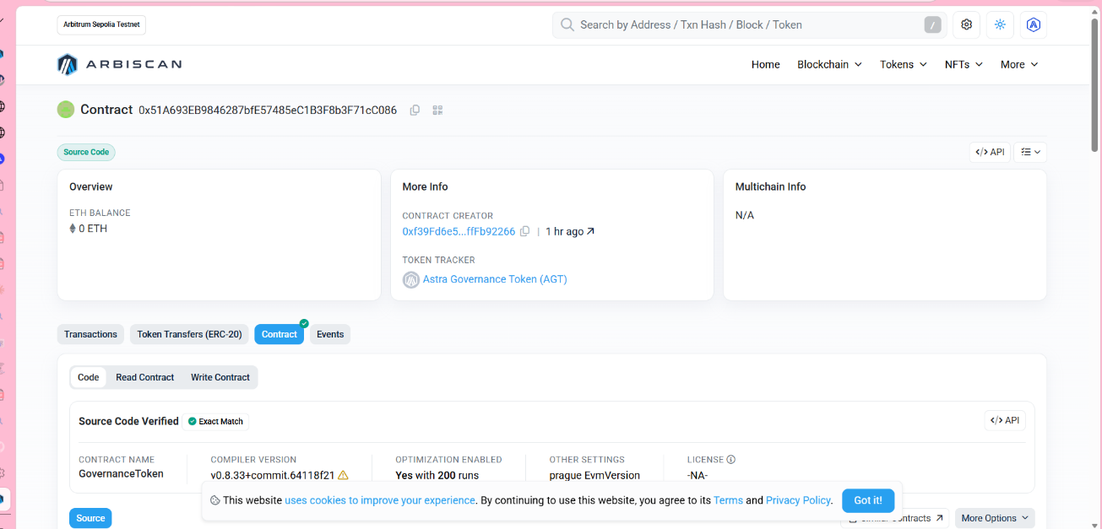
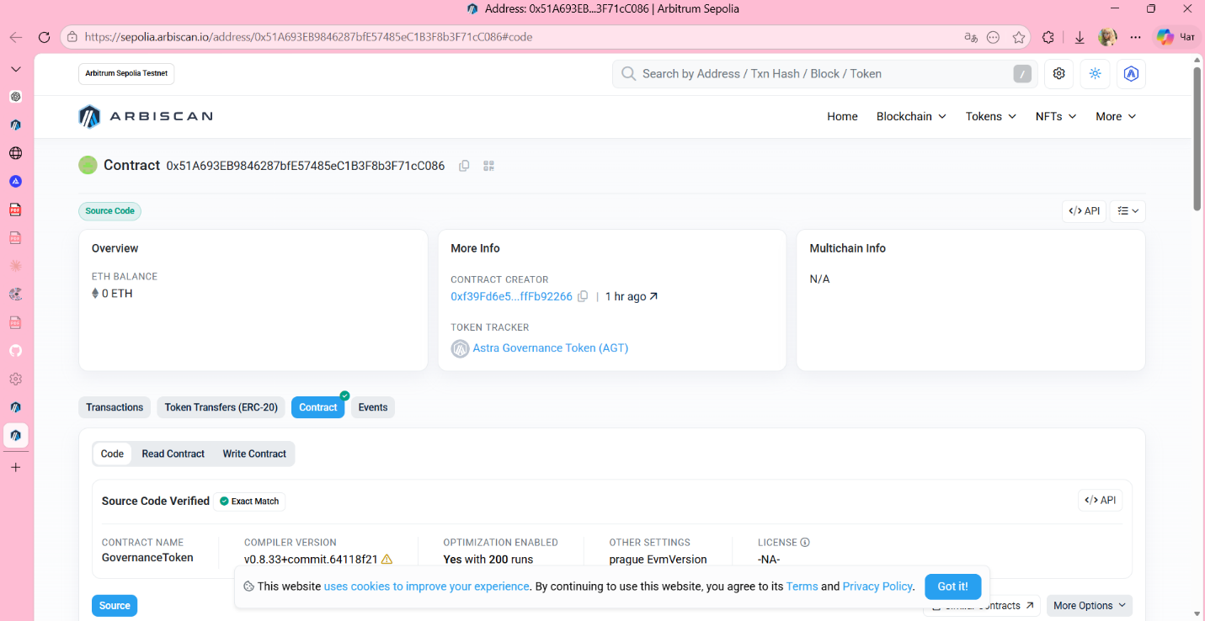
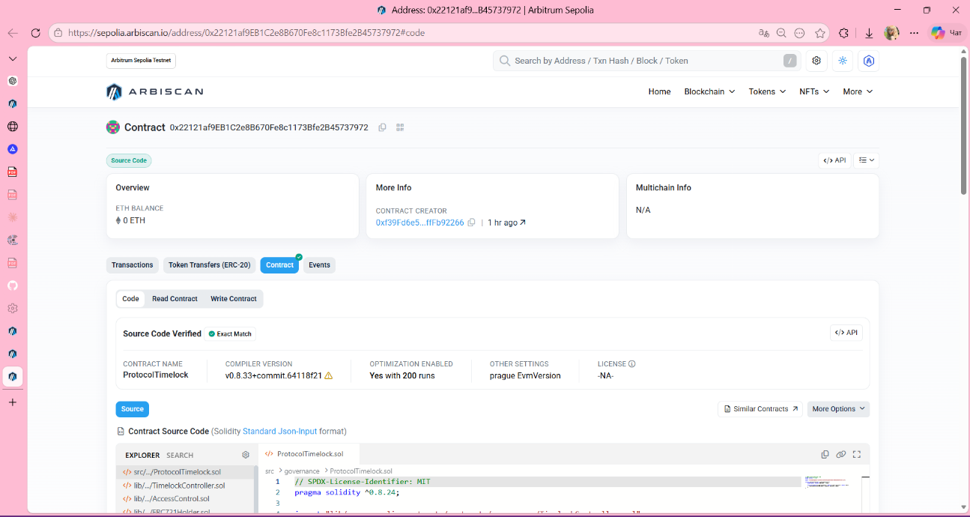

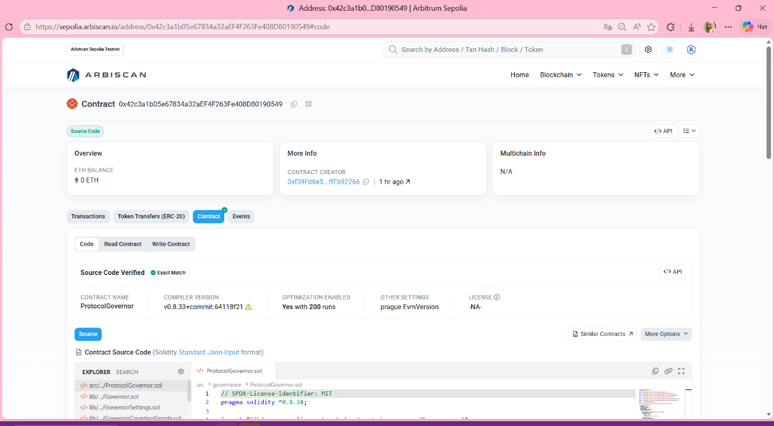
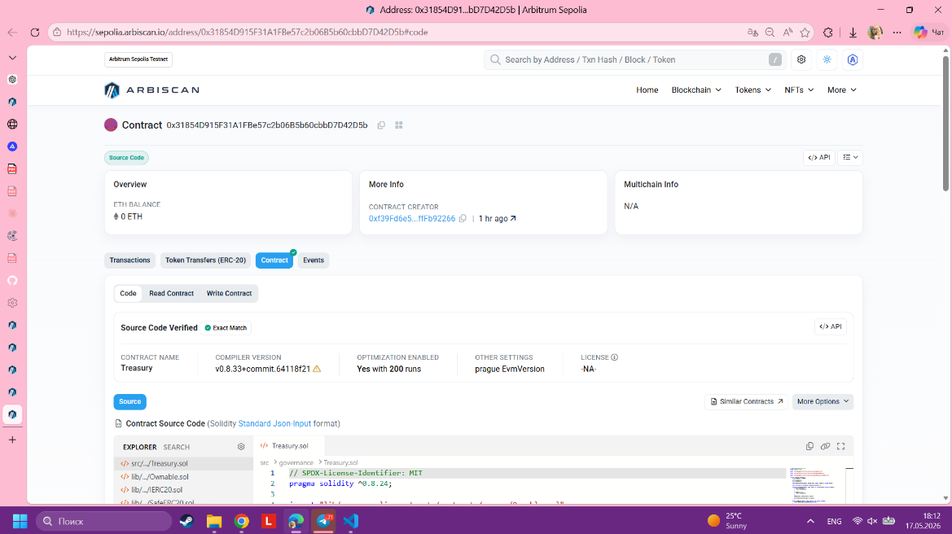
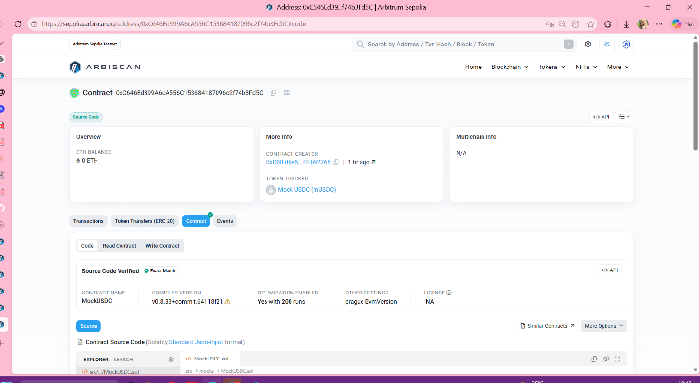
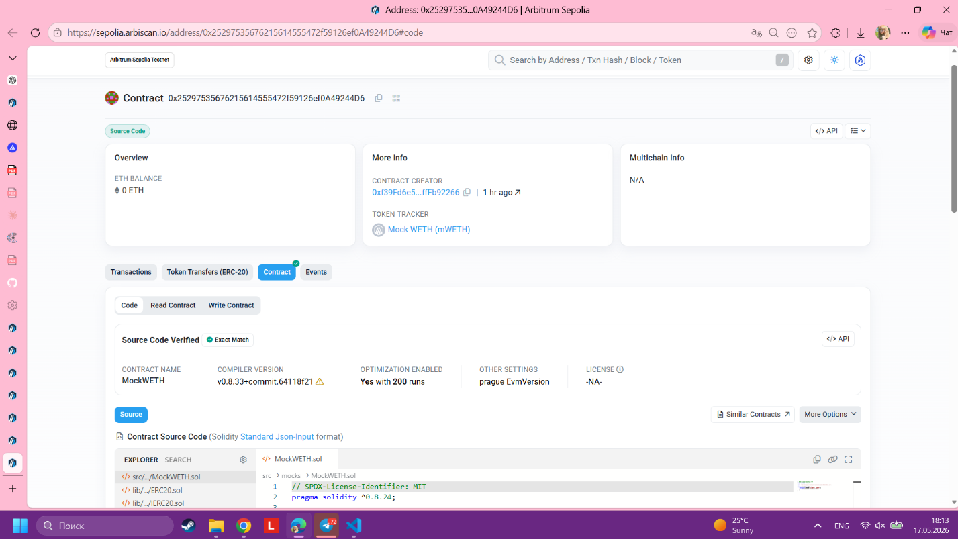
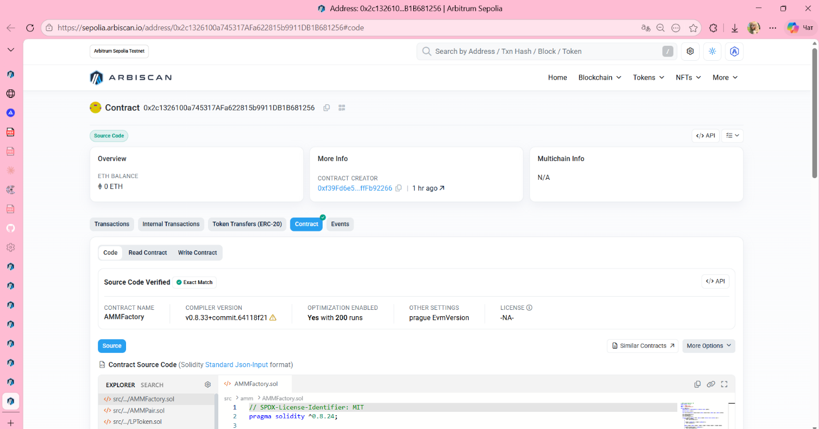
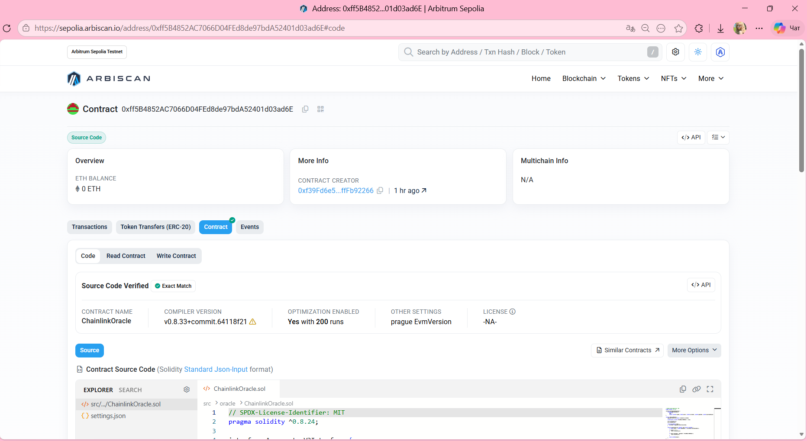
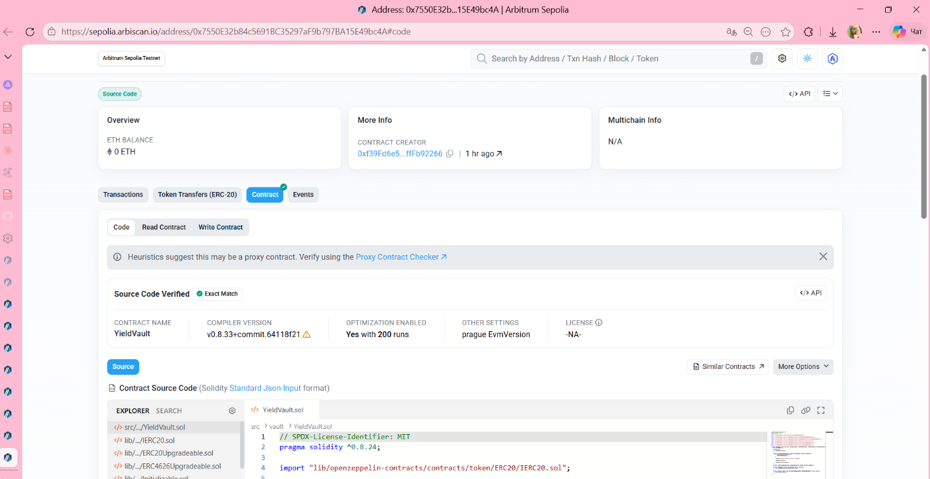

Tests
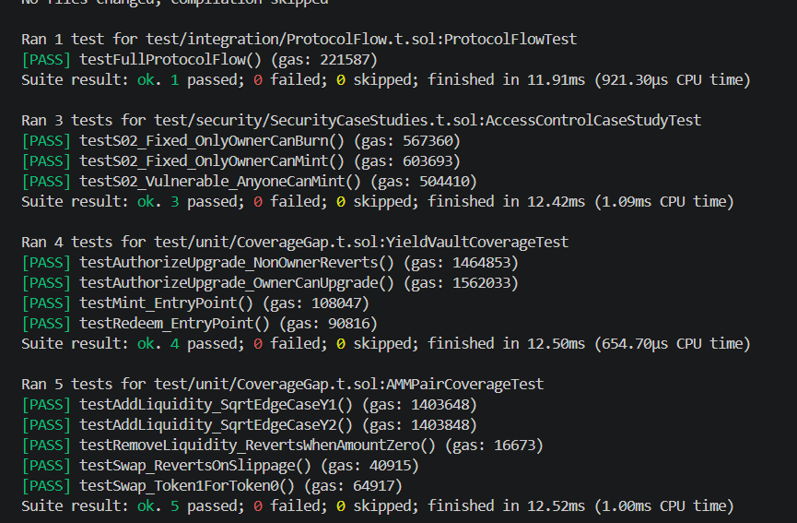
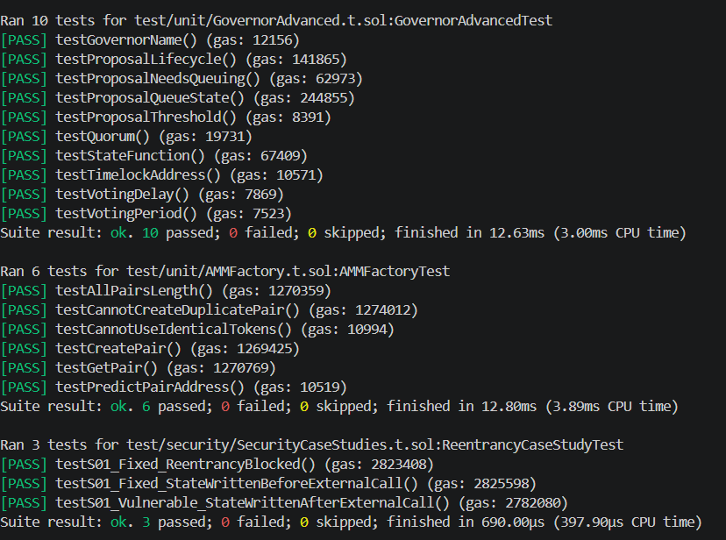
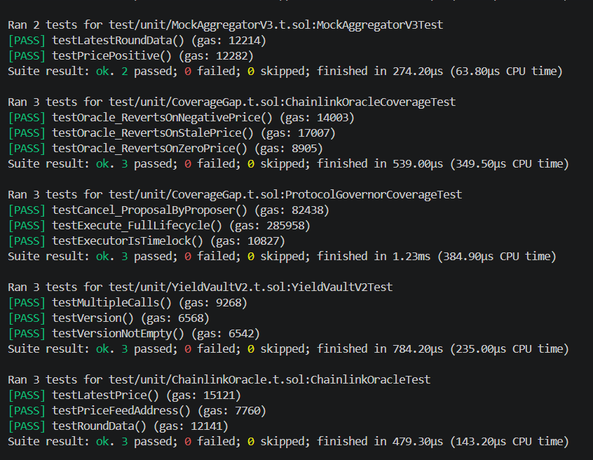
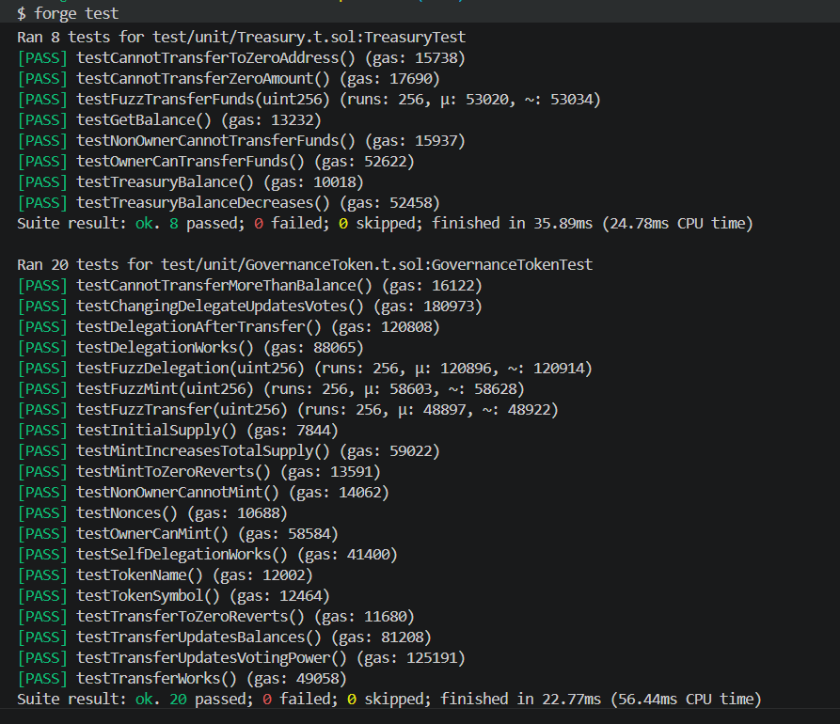
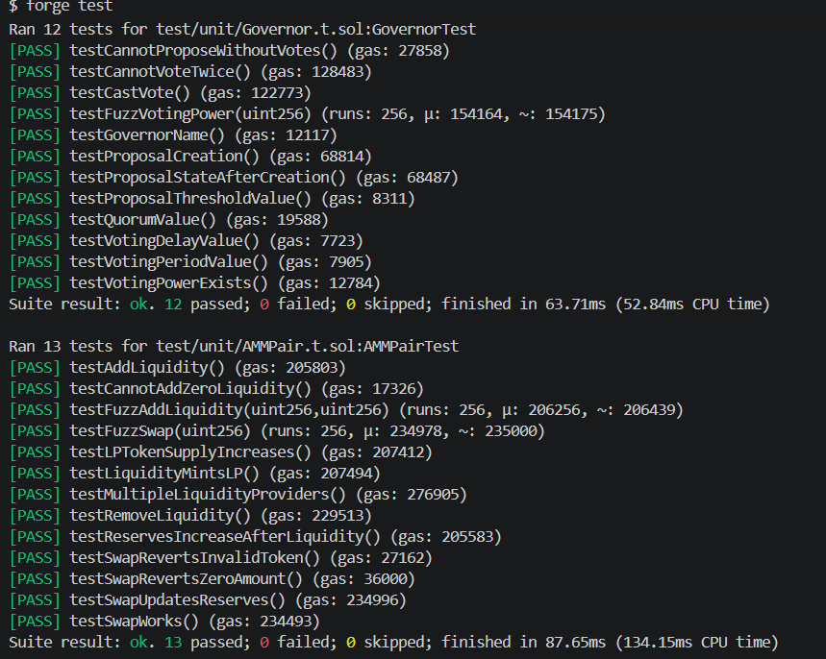
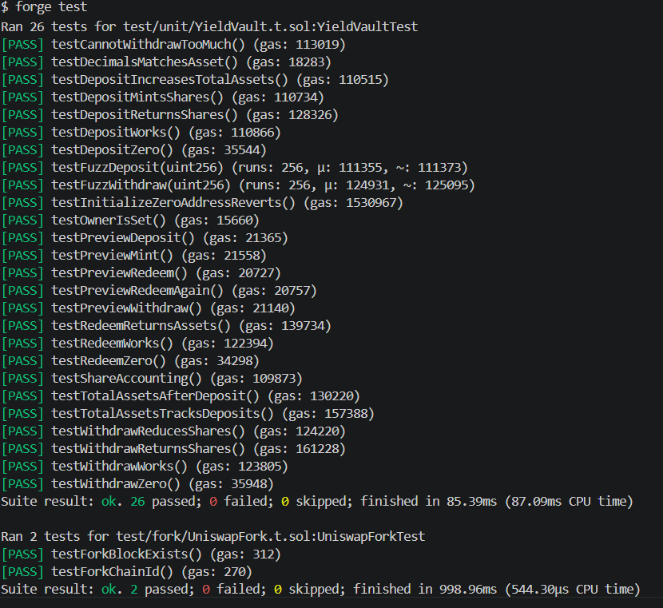
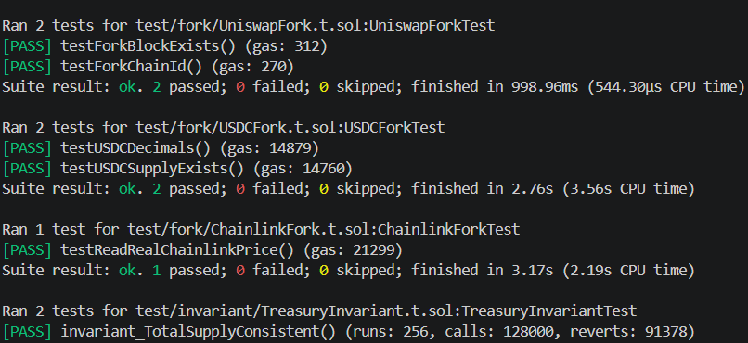
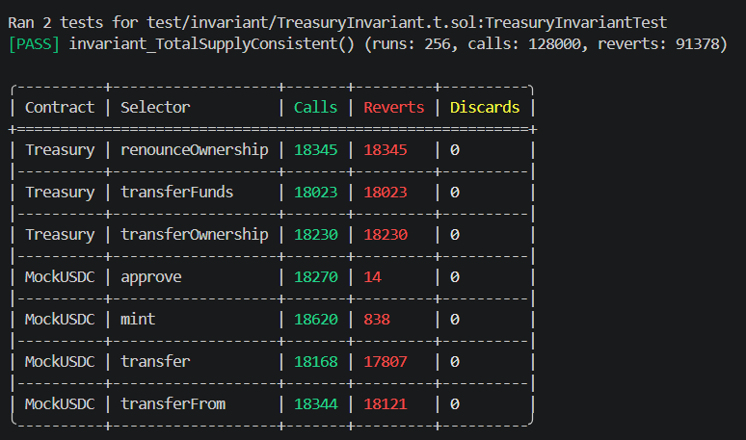
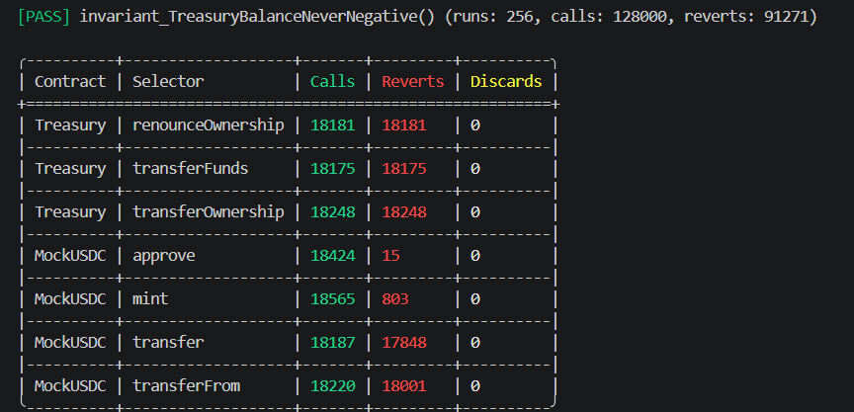
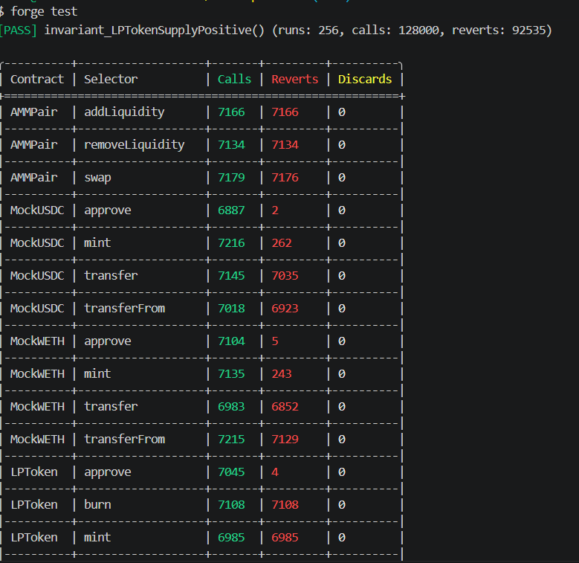
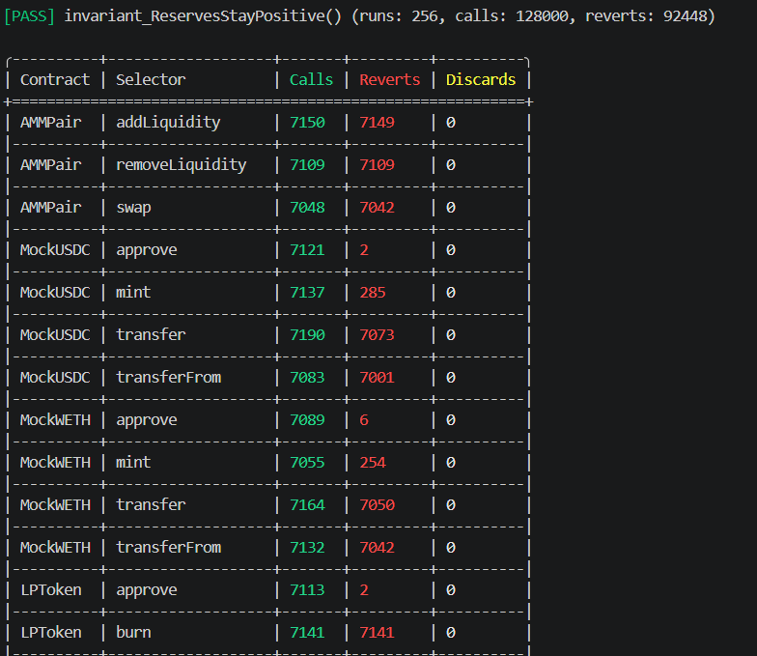

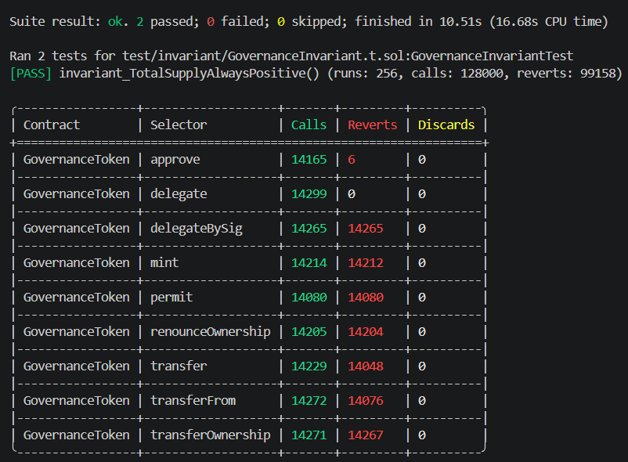
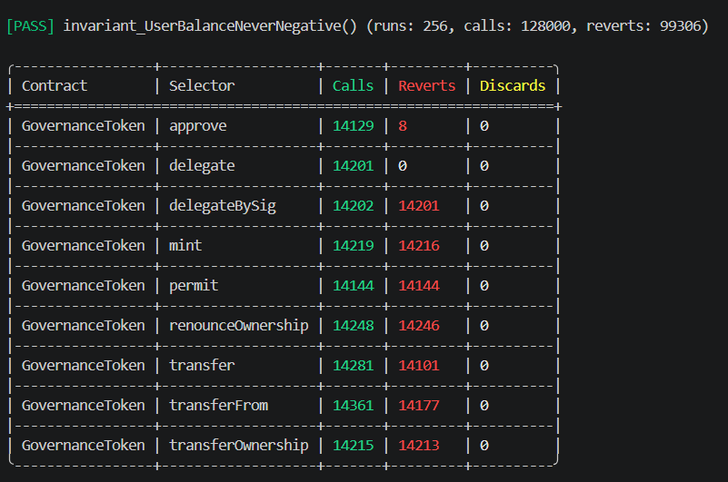
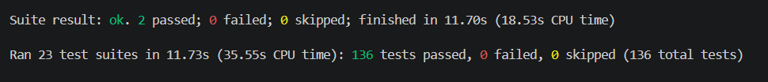

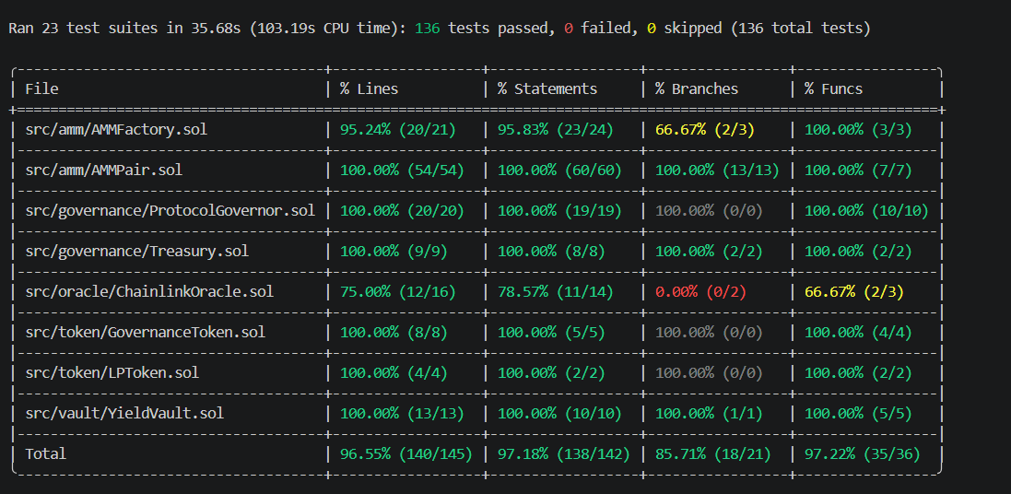

Frontend
