Samson_FA7-Probability

2023-04-19

#FA7 Number 1  
#Define function to calculate probability of scrap  
scrap_stick <- function(min_prob, max_prob, scrap_prob) {  
 if(scrap_prob >= max_prob) {  
 return(0)  
 } else if(scrap_prob <= min_prob) {  
 return(1)  
 } else {  
 return((max_prob - scrap_prob)/(max_prob - min_prob))  
 }  
}  
  
# (a) Calculate the probability that a memory stick will be scrapped.  
problem <- scrap_stick (2, 12, 10)  
cat("The probability of a memory stick that will be scrap_stick is", round(problem, 3), "\n")

## The probability of a memory stick that will be scrap_stick is 0.2

# (b) Simulate 50 memory stick lengths and obtain a histogram of the simulated values.  
set.seed(123)  
simulated_values <- runif(50, 2, 12)  
hist(simulated_values, main="Simulated Memory Stick Lengths", xlab="Length (mm)")

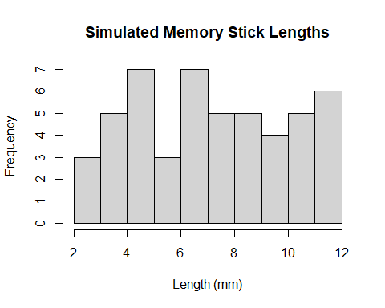

memory_mean <- mean(simulated_values)  
memory_mean

## [1] 7.20091

memory_var <- var(simulated_values)  
memory_var

## [1] 8.660557

cat("The simulated mean length of memory sticks is", round(memory_mean, 3), "mm\n")

## The simulated mean length of memory sticks is 7.201 mm

cat("The simulated variance of memory stick lengths is", round(memory_var, 3), "mm^2\n")

## The simulated variance of memory stick lengths is 8.661 mm^2

#Number 2. Students in an electronic engineering laboratory measure current in using an ammeter. Due to several random factors, the measurement X follows the pdf.  
#(a) Show that, for this to be a genuine probability density, b = 0.15.  
lower = 2  
upper = 6  
b <- 0.15  
zy <- function(x) ifelse(x > 2 & x < 6, 0.025*x + b, 0)  
problem <- integrate(zy, lower = 2, upper = 6)$val  
  
xy <- 0.1  
if (abs(problem - 1) < xy) {  
 cat("It is a genuine probability density b =", b)  
} else{  
 cat("It is not a genuine probability density.")  
}

## It is a genuine probability density b = 0.15

# (b) Find the probability that the measurement of the current exceeds 3.  
exceeds <- integrate(zy, lower = 3, upper = 6)$val  
cat("The probability that the measurement of the current exceeds is =", round(exceeds, 3))

## The probability that the measurement of the current exceeds is = 0.787

# (c) Find E (X).  
Find <- integrate(function(x) x * zy(x), lower = 2, upper = 6)$val  
cat("The value of E (X) is =", round(Find, 3))

## The value of E (X) is = 4.133

# In a radio communications system, the phase difference X between the transmitter and receiver is modeled as having a uniform density. Find the value.  
hi <- -pi  
  
pdf <- function(x) {  
 ifelse(abs(x) <= pi, 1/(2*pi), 0)  
}  
  
x <- integrate(pdf, lower = hi, upper = 0)$val  
x

## [1] 0.5

y <- integrate(pdf, lower = hi, upper = pi/2)$val  
y

## [1] 0.75