Software Requirements Specification Template
CptS 322—Software Engineering

The following annotated template shall be used to complete the Software Requirements Specification (SRS) assignment of WSU-TC CptS 322. The instructor must approve any modifications to the overall structure of this document.

Template Usage:
Text contained within angle brackets (‘<’, ‘>’) shall be replaced by your project-specific information and/or details. For example, <Project Name> will be replaced with either ‘Smart Home’ or ‘Sensor Network’.

Italicized text is included to briefly annotate the purpose of each section within this template. This text should not appear in the final version of your submitted SRS.

This cover page is not a part of the final template and should be removed before your SRS is submitted.

Acknowledgements:
Sections of this document are based upon the IEEE Guide to Software Requirements Specification (ANSI/IEEE Std. 830-1984). The SRS templates of Dr. Orest Pilskalns (WSU, Vancover) and Jack Hagemeister (WSU, Pullman) have also be used as guides in developing this template for the WSU-TC Spring 2005 CptS 322 course.

Financial Analyzer

Software Requirements Specification

1.1

07.10.2015

Roman A. Nesterov
Lead Software Engineer

Prepared for
WSU-TC CptS 322—Software Engineering Principles I
Instructor: Saleh Hadi, Ph.D.
2015

Revision History

Date | Description | Author | Comments
10.09.2015 | Version 1.0 | R. Nesterov
07.10.2015 | Version 1.1 | R. Nesterov | Additions in accordance with IEEE Std

Document Approval

The following Software Requirements Specification has been accepted and approved by the following:
Signature | Printed Name | Title | Date
 | Roman A. Nesterov | Lead Software Eng.
 | Ph.D. Hadi Saleh | Instructor, CptS 322

Table of Contents

Revision History ii
Document Approval ii
1. Introduction 1
1.1 Purpose 1
1.2 Scope 1
1.3 Definitions, Acronyms, and Abbreviations 1
1.4 References 2
1.5 Overview 2
2. General Description 2
2.1 Product Perspective 2
2.2 Product Functions 3
2.3 User Characteristics 3
2.4 General Constraints 3
2.5 Assumptions and Dependencies 4
3. Specific Requirements 4
3.1 External Interface Requirements 4
3.1.1 User Interfaces 4
3.1.2 Hardware Interfaces 4
3.1.3 Software Interfaces 4
3.1.4 Communications Interfaces 4
3.2 Functional Requirements 4
3.2.1 Populating Indicator Database 5
3.2.2 Performing comparative analysis of indicators 5
3.2.3 Financial Analyzer Sources List Configuration 6
3.2.4 Exporting Analysis Result Data 6
3.3 Use Cases 6
3.3.1 Use Case: The ordinary user logins with assigned credentials and opens the application 7
3.3.2 Use Case: The ordinary user populates the Indicator database with the freshly-downloaded data 7
3.3.3 Use Case: The ordinary user performs the comparative analysis of the economic indicators 8
3.3.4 Use Case: The database administrator changes database scheme 8
3.3.5 Use Case: The administrator assigns the user credentials 8
3.3 Non-Functional Requirements 8
3.3.1 Performance 8
3.3.2 Reliability 8
3.3.3 Availability 9
3.3.4 Security 9
3.3.5 Maintainability 9
3.3.6 Portability 9

1. Introduction
This section is to give an overall scope description and overview of aspects to be included into this document. In addition, the main document purpose description is given and a list of abbreviations and definitions is provided.

1.1 Purpose
The main purpose of this document is to give a detailed description of the requirements for the “Financial Analyzer” software. It aims to demonstrate the purpose and complete declaration for this system development. It will also cover any necessary constraints, interfaces and interactions with external applications. This document is primarily intended to be approved by a customer and to form a reference for developing the pilot version of the system for the development team members.

1.2 Scope
The “Financial Analyzer” is a web-application aiming at gathering the information on world financial indicators like oil prices, exchange rates and other similar figures. This application should also be able to conduct mathematical analysis in order to find any inter-relations and correlation between figures of different nature to discover “hidden” dependencies and trends throughout the different timespans.
The user will be able to choose the number of source to gather analytical information from provided by the system. Apart from that, the software needs the Internet connection in order to download information and to display the results of the different indicators comparative analysis. All information downloaded will be stored in the database located locally on the end user’s computer. The application will also allow displaying both summary and detailed information on the world economic indicator analysis.

1.3 Definitions, Acronyms, and Abbreviations
Term | Definition
User | The person directly interacting with the “Financial Analyzer” software system
Administrator | System administrator who is granted special permissions for managing the software
Financial Analyzer | The software allowing to gather analytical information on different economic indicators determining the global economic state
Correlation analysis | The attempt to find the dependencies between different figures and to define their nature
Stakeholder | The person interacting with the system not being the participant of the developer team
Indicator database | The database to keep information that was downloaded throughout the system operation for further analysis
Database administrator | The person who has the unrestricted access to the indicator database and who can change its structure when needed

1.4 References
[1] IEEE Software Engineering Standards Committee, “IEEE Std 830-1998, IEEE Recommended Practice for Software Requirements Specifications”, October 20, 1998.

1.5 Overview
The remainder of this document include three chapters and appendices. The second chapter is to provide the vision of the general “Financial Analyzer” functionality also introducing main types of users directly interacting with the system. Furthermore, it aims to mention notable system constraints and assumptions towards the product.
The third chapter is devoted to the detailed description of general functional and non-functional requirements alongside with the description of system interfaces requirements.
The fourth chapter deals with presenting visual analysis model including DFD diagrams, ST diagrams and sequence diagrams to describe the behavior of the “Financial Analyzer” system in detail and in the readable form.

2. General Description
This section is to give an overview of the whole system. The system will be described and explained in the context to introduce the basic functionality of it. It will also describe what type of stakeholders that will use the system and what functionality is available for each type. At last, the constraints and assumptions for the system will be presented.

2.1 Product Perspective
The system will consist of two main parts: a client web-application and a database. The client web-application will be directly used to perform the analysis of the economic indicators gathered and to view the results in a readable and a visual form, for instance, with the aid of diagrams and pivot tables.
The database will be designed to be populated with the information on economic indicators downloaded from the sources. The list of possible sources is also to be included into the main database. Apart from that, the information has to be kept in a detailed and normalized form, however allowing for a fast comparative correlation analysis conduction. In this sense, the third normal form will be enough.
The client-side application will be able to communicate with this database in accordance with the permissions granted for different roles of users. Some users are able to modify the data and some are not respectively. So far, all components including the database itself and the client-side application of this application are supposed to be stored locally on the same machine. With the evolving of the “Financial Analyzer” software the database and the web-application can be moved to the cloud (using Windows Azure techniques, for instance), so that the system will become more flexible on the whole.

2.2 Product Functions
With the client web application, the user will be able to perform the analysis of economic figures and indicators stored for now in the main database, to update the information by executing the gathering instrument, to choose the sources from the list of the available Internet resources which can be determined and changed only by the administrator of the system.
The result of the gathering and analysis of information can be viewed in the table containing the figures and their behavior over time or in the diagram giving the convenient visual representation of the indicator figures stored in the database. The user will also be able to choose the analysis type to perform, with correlation analysis being the main one showing major discovered interdependencies between the indicator chosen to juxtapose.
The client application will also provide the additional information of the general system state, its version, the number of resources it is able to analyze for now. This information is supposed to have the restricted permission for modification.

2.3 User Characteristics
There are three main types of users who may interact with the system: the ordinary user, the administrator, the database administrator. Each of these three types of users has different use of the system so each of them has their own requirements.
The ordinary user is able to use only the client-side application. This means that this person will be able to perform the comparative and juxtaposition analysis of the indicators stored and execute the population of the indicator database. The ordinary user is also able to specify the number of resources to be scanned, but not to change the list of available ones. So, this person has a restricted permission to the main database to populate table responsible for storing corresponding economic indicators tables.
The administrator is able to configure the “Financial Analyzer” system in the following ways. Firstly, this person is able to specify the list of resources that can be scanned for the information on world economic indicators by changing it adding or removing sources. Administrator also can specify the types of comparative analysis that can be executed.
The database administrator’s main responsibility is indicator database management: schema development, structure refinement, populating auxiliary tables with the sources to analyze and with the analysis types to analyze. That’s why, this person is granted full access to the indocator database.

2.4 General Constraints
The most notable constraint to bear in mind is Internet connection. The application uses different web-sites to fetch and extract information from, so the performance speed depends fully upon the bandwidth of the Internet connection. It also has to be stable throughout the system operation session in order for the data to be consistent and coherent. Otherwise, the data extracted would not represent the whole picture for an indicator, so the analysis results will not reliable to the desired extent.
Another constraint is the database capacity. Since with the evolving of this system and the possibility of access of multiple ordinary users, it has to support multiple transactioning mechanisms in order to respond and to produce the analysis result desired fast. So far, however, the system is not supposed to be distributed.

2.5 Assumptions and Dependencies
The major assumption to be made is that the computer of the end user has enough hardware resources available to establish stable Internet connection with the resources to analyze as well as to conduct computing while performing the comparative analysis of indicators.

3 Specific Requirements
This section contains all of the functional and quality requirements of the system. It gives a detailed description of the system and all its features.

3.1 External Interface Requirements
This section provides a detailed description of all inputs into and outputs from the system. It also gives a description of the hardware, software and communication interfaces and provides basic prototypes of the user interface.

3.1.1 User Interfaces

3.1.2 Hardware Interfaces
Hence the client side web application being the main “Financial Analyzer” component does not have any designated hardware, there is no need to directly specify any hardware interfaces. The connection between the client web application and the main database is provided, managed, and maintained by the means of operating system exploited.

3.1.3 Software Interfaces
The client application communicates with the world economic indicator resources to get necessary figures and to populate the main database with them, and to conduct the specified analysis type. So, the communication between the database and the application consists of operation concerning both reading and modifying the data.

3.1.4 Communications Interfaces
The communication between the different parts of the system is important since they depend on each other. However, in the way communication is achieved is not important for the system and is therefore handled by the underlying operating systems for both the client application and the main database.

3.2 Functional Requirements
This section includes the requirements that specify all the fundamental actions of the software system. Each requirement will be given a detailed description mention the inputs/outputs, general information (what will be done implementing this function) and how the occurred errors will be handled.

3.2.1 Populating Indicator Database
3.2.1.1 Introduction
This is the main function provided by “Financial Analyzer” for the ordinary user who can choose the number of sources to be scanned and the economic indicator types the data on which to be fetched.
3.2.1.2 Inputs
The major inputs for this operation include the sources list, the indicator list and the date period for which the information will be extracted.
3.2.1.3 Processing
During the processing of the indicator database population, the corresponding table will be populated with the data that were successfully fetched from sources together with the date range and the source references. The operation will be executed in full accordance with the algorithms.
3.2.1.4 Outputs
The major outputs for this operation are database tables populated and the message for the end user that the system is ready to perform the analysis or to extract information from other sources on another indicator.
3.2.1.5 Error Handling
The main error to occur here is the Internet connection loss. In case it happens, the whole operation has to be rolled back to return the indicator database to the state at which it was before trying to populate.

3.2.2 Performing comparative analysis of indicators
3.2.2.1 Introduction
This is also the main function provided by “Financial Analyzer” for the ordinary user who can choose the indicators to be juxtaposed, the type of analysis to be performed as well as the form of results representation.
3.2.2.2 Inputs
The major inputs for this operation include the indicator pair together with date period, the analysis type, the data fetched from database and the specified representation form.
3.2.2.3 Processing
During the processing of the comparative analysis, the application will request the data from the indicator database, compute any necessary auxiliary figures and show a mini-report form concluding whether any dependencies and cross-influences were found between the indicators.
3.2.2.4 Outputs
The major outputs for this operation is a report form shown in the web browser tab including all vital analysis information: the analysis type, the indicators compared, the nature of the relations discovered during the analysis conduction.
3.2.2.5 Error Handling
The main error to occur here is the database connection loss. In case it happens, the user is to be warned that at that moment in time it is not possible to perform the analysis advising to contact the administrator.

3.2.3 Financial Analyzer Sources List Configuration
3.2.3.1 Introduction
This operation is provided only for administrator users, who contact the development team, in order to configure the “Financial Analyzer” to adjust the list of financial resources that can be scanned.
3.2.3.2 Inputs
The major inputs for this operation include the indicator pair together with date period, the analysis type, the data fetched from database and the specified representation form.
3.2.3.3 Processing
Through a special administrative form of the client application administrator can modify by adding or removing sources from the list of available ones. By deleting the sources data of which are stored in the system, the all connected data on indicators is also to be deleted.
3.2.3.4 Outputs
The major outputs for this operation is changes done to the table(s) in the indicator database responsible for storing list of resources as well as indicator data.
3.2.3.5 Error Handling
The main error to occur here is the database connection loss. In case it happens, the administrator could contact the database administrator to resolve the occurred problem.

3.2.4 Exporting Analysis Result Data
3.2.4.1 Introduction
This operation allows users to export data consumed after the analysis conduction in portable document format (PDF).
3.2.4.2 Inputs
The major input for this operation is the report obtained after the comparative analysis was performed.
3.2.4.3 Processing
By pressing the special button on web report form the data presented in the table or visual form will be exported and saved in form of PDF-document containing description of the report (indicators, analysis type) and the main body including diagrams or tables needed, and the conclusion.
3.2.4.4 Outputs
The major output for this operation is PDF-document for the report.
3.2.4.5 Error Handling
The main error to occur here is the PDF-document generation malfunctions and problems (that means problems in the generation algorithms). In case it happens, the user can contact the administrator to inform the developer team on this problem.

3.3 Use Cases
This section contains the major use cases for three main type of users: ordinary user, administrator and database administrator. Use case description includes the action chain executed by the user of the defined type. The overall use case diagram (for all users) is presented in the Fig. 1.
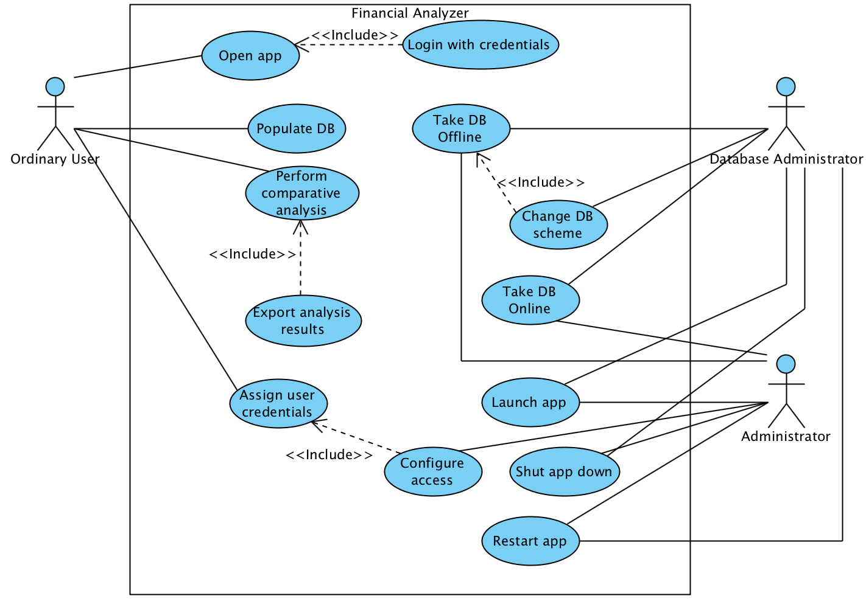
Figure 1. General Use Case Diagram

3.3.1 Use Case: The ordinary user logins with assigned credentials and opens the application
a) the user connects to the client side web-application with the credentials assigned by the administrator;
b) if the user entered the login and the password correctly, the one will be directed to the home page of application indicating the status of it;
c) if the user is mistaken entering credentials, the one will be redirected to the login page again warning for the incorrect input of login and password.

3.3.2 Use Case: The ordinary user populates the Indicator database with the freshly-downloaded data
a) the user being at the home page of the client side web-application push the button intended to update the database and download information;
b) the user specifies the number of indicators on which the information to be downloaded alongside with the date period;
c) the user performs the populating by pressing the button;
d) if there are no problems during the population, the corresponding message will be shown indicating the succeeded operation;
e) if a problem occurs during the population process, the warning message will be shown suggesting possible resolving ways (in case the problem persists, there is a need to contact the administrator);

3.3.3 Use Case: The ordinary user performs the comparative analysis of the economic indicators
a) the user being at the home page process to the page where the necessary analysis parameters can be configured;
b) the user specifies the number of indicators to be juxtaposed and the type of analysis to be performed;
c) by pressing the corresponding button, the user launches the analysis process;
d) at the end of the process, the corresponding message indicating success of the operation will be shown and the analysis results will be opened in the new browser tab;
e) if the problem occurs during the analysis conduction, the corresponding warning message will be shown suggesting possible solution ways (in case the problem persists, there is a need to contact the administrator).

3.3.4 Use Case: The database administrator changes database scheme
a) if there is a necessity to change the database scheme, database administrator will take the database offline contacting with administrator to restrict the operation of the application;
b) the database administrator will do necessary changes in the DB scheme together eith administrator in the program code when needed;
c) the all changes are to be tested by the developers team;
d) if the test is a success the DB will be returned online together with the newer (if it is needed) version application re-deployed;

3.3.5 Use Case: The administrator assigns the user credentials
a) after the users is registered to the “Financial Analyzer” system, the administrator will grants the different types of access for the different users pursuant to their credentials;
b) if access grant process is completed, the administrator will warn the users and restart the application in order for the change to take place.

3.4 Non-Functional Requirements
The section aims to give the description of the requirements to the general system functionality including its performance levels, security constraints and other related system features.

3.4.1 Performance
The main performance requirements for the “Financial Analyzer” systems concerns the response time restricting the waiting for the database population and analysis conduction. The rough estimations can be no more than 5 minutes for the database population to be completed, and no more than 3 minutes for analysis results to be shown.

3.4.2 Reliability
Reliability requirements mainly suggests the possible Internet and database connection loss rate. So, the connection could lost in no more than 2 out of 100 runs of the “Financial Analyzer” software system. With the evolving of this system, the reliability requirements are supposed to be made more rigorous.

3.4.3 Availability
The availability here concerns the database availability. So, as it can be seen from the previous paragraph, database can be unavailable only for 2 out of 100 runs. This requirement can also be hardened with new releases of the system.

3.4.4 Security
For “Financial Analyzer” security is a very important issue because it works with the database containing information both on system-specific data and on financial indicators. The different types of users must have different types of access. Therefore, the ordinary user can only read and modify tables concerning data on financial indicators figures; the administrator is able to work with “system-specific” tables such as resources list, analysis types list, users credentials; the database administrator is granted with the full access to the database and is responsible for data integrity and consistency.

3.4.5 Maintainability
The “Financial Analyzer” should be easily extended with the new analysis types, new resources specification. The structure of the source traversal and analytical functions must be straightforward and understandable in order to reuse and reproduce them. The test environments exploited should also guarantee the coverage for the most of possible fault situations as well as for the general operations.

3.4.6 Portability
So far, there is now portability requirements. The client side web application should support different browsers without the unreasonable functionality losses including following ones:
- Internet Explorer (version 9 or later);
- Safari (version 7 or later);
- Google Chrome (version 35 or later);
- Mozilla Firefox;
- Opera (version 8 or later).

3.4.7 Design Constraints
The “Financial Analyzer” is constrained by the Microsoft Windows OS limitations regarding the speed of DB reply, and the resources needed to conduct the mathematical computations during the comparative analysis process.

3.4.8 Logical Database Requirements
At this stage the “Financial Analyzer” will communicate with the Microsoft SQL Server database stored and deployed locally on the user’s machine. The maximum amount of space needed for DB storage is estimated up to 1 GB.

4. Analysis Models
This sections aims to present the major user actions through the use of UML models including Sequence Diagrams and Data Flow Diagrams.

4.1 Sequence Diagrams
The general sequence diagram in the Fig. 2 shows the main actions user does while interacting with the system. As it can be seen, there are 4 main components to the “Financial Analyzer”:
- ClientApplication – the instance of the client side web application the user interacts directly with;
- DataBase – the financial indicators database;
- DownloadModule – the component responsible for the extracting information on the economy indicators from a list of specified resources;
- ComputationModule – the component responsible for the conduction of comparative correlation analysis of the chosen indicators.

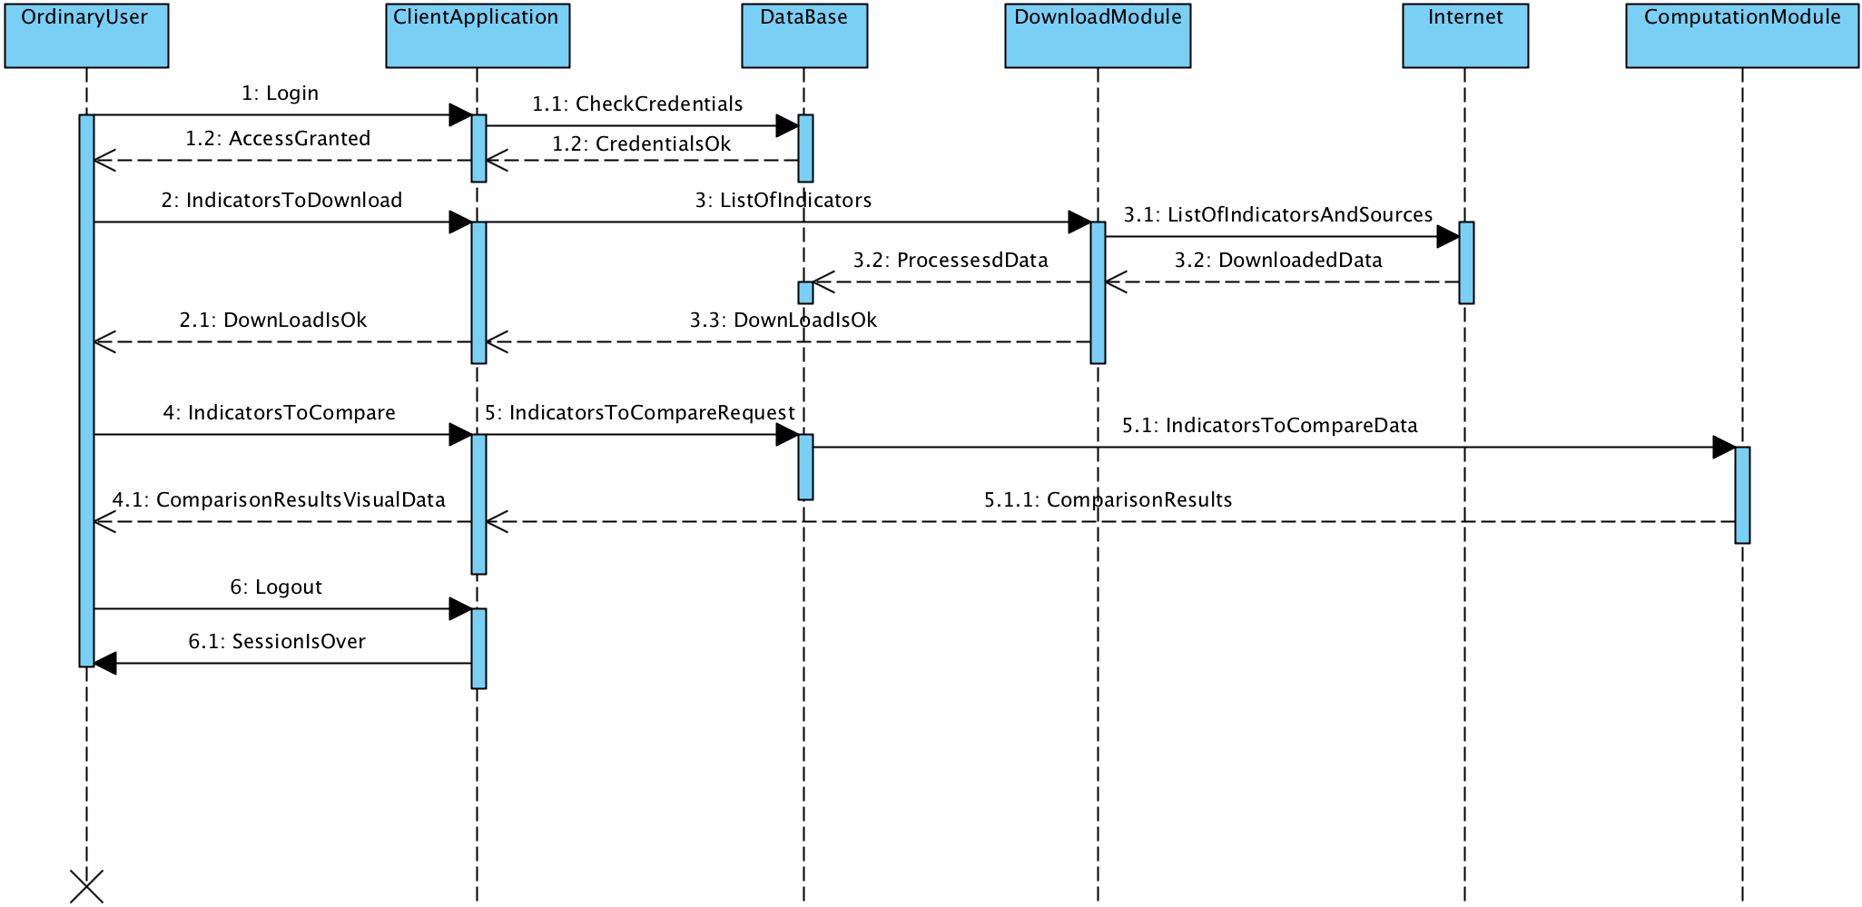
Figure 2. The general sequence diagram

The sequence diagram in the Fig. 3 shows the main actions administrator does to specify the access specification for the user, here the one of the participants is database, because it is supposed to keep the access specification in the table where user data are stored.
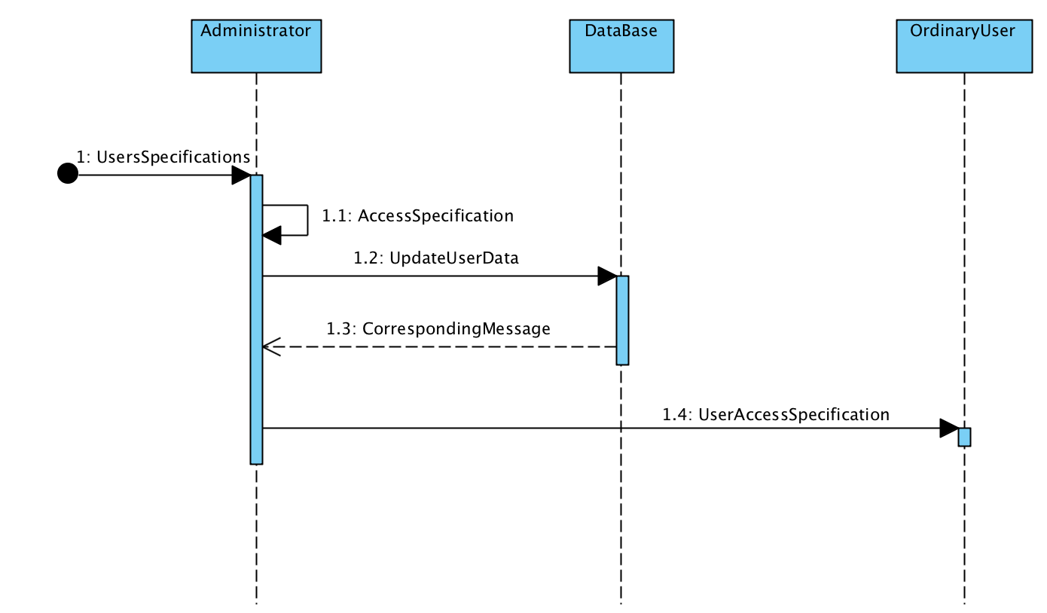
Figure 3. Access specification sequence diagram

The sequence diagram in the Fig. 4 show the main actions administrator does to change the database scheme, here the one of the participants id developer team, because the change of the DB scheme can involve some code changes as well.
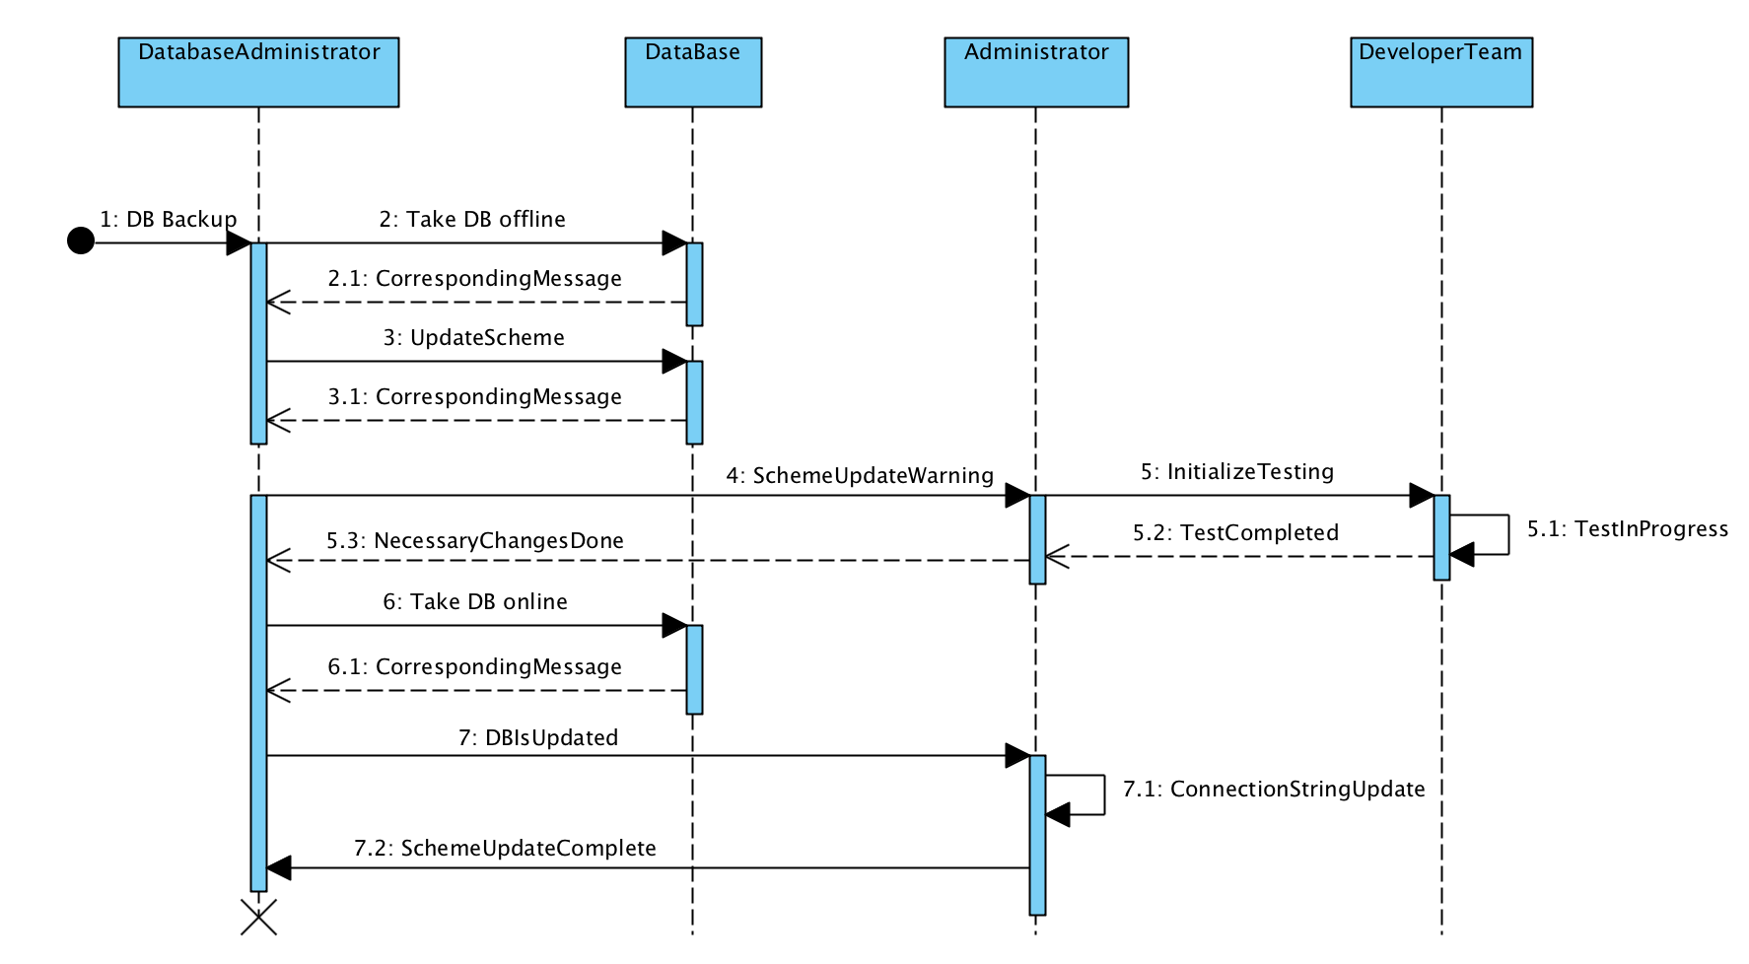
Figure 4. DB Update Sequence diagram

4.1 Data flow diagrams
The DFD diagram in the Fig. 5 shows the main data flows existing in the process of populating the database with the newly-downloaded information on the economy indicators from a pre-defined list of sources in the Internet.
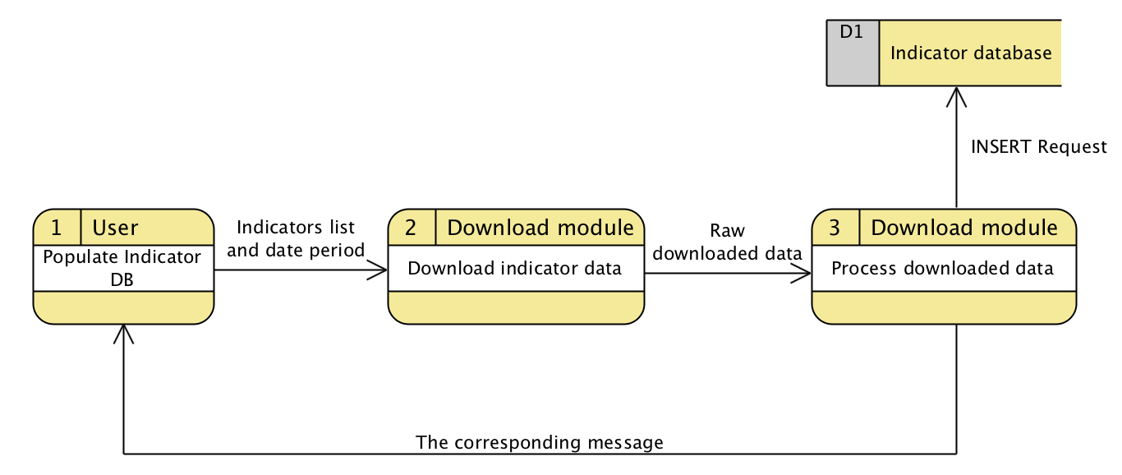
Figure 5. DFD for populating the database of indicators

The DFD diagram in the Fig. 6 indicates the main data flows existing in the process of conducting the juxtaposition correlation analysis by the user.

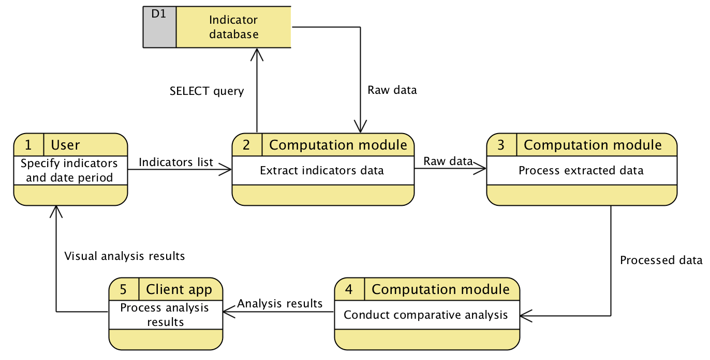
Figure 6. DFD for conducting indicators comparative analysis

