Aibar Ibragimov
life33890@gmail.com
Master's student. Research and Innovation Center “CyberTech”, Astana IT University, Astana, Kazakhstan.
ORCID: 0009-0002-7454-2382
Leila Rzayeva
l.rzayeva@astanait.edu.kz
Research and Innovation Center “CyberTech”, Astana IT University, Astana, Kazakhstan.
ORCID: 0000-0002-3382-4685
Laura Aldasheva
laura.aldasheva@astanait.edu.kz
School of Intelligent Systems, Astana IT University, Astana, Kazakhstan.
ORCID: 0000-0001-6815-1989

Verifying State Snapshot Coherence in Unidirectional Industrial Telemetry
Abstract: Industrial applications often combine received sensor fields when deciding whether a process is healthy. A complete vector can nevertheless contain values from different source captures, and repeated values can hide this mixture. This study asks what a receiver on a one-way link can establish about common capture when only values, origin identifiers or grouping evidence are available. The contribution is a provenance contract with an explicit rule for conclusive and ambiguous verdicts, and a quantitative assessment of the mixing that values alone cannot reveal. The method uses compatible explanations, exact finite-state checks and a discrete-event experiment comparing separate-field and whole-object publication. Twelve synthetic conditions vary source correlation, message loss and receiver restart. Forty replicate indices per condition produce 960 mode runs and 3.84 million scheduled reads. Under independent message loss of 5% without restart, separate-field publication mixes generations in 62.14% of reads despite complete field availability. Whole-object publication has no mixed reads under the stated capture, binding and access assumptions. With identical delivery schedules and no loss, values reveal 5.88%, 49.84% and 79.13% of mixed reads as source flip probability rises from 0.05 to 0.50 and 0.95. Bursts and restart still limit the availability of a fresh coherent state. Independent event reconstruction checks the saved logs, while a clean rerun regenerates the numerical results from the supplied code. The findings show why provenance evidence and fresh coherent availability should accompany completeness and error rates. All data and timings are synthetic; physical-device performance is not measured and requires separate field validation.
Keywords: unidirectional telemetry, snapshot coherence, provenance, partial observation, runtime verification, simulation.

Introduction
A receiving application can combine individually plausible industrial values from different source captures. Delay, loss and asynchronous updates cause this mixture even when every received record is decoded correctly. Repeated values can conceal different origins, so completeness and numerical plausibility do not establish a common capture.
In one-way telemetry, the receiver cannot request an immediate corrective exchange through the same channel. Operational-technology guidance and research on unidirectional syslog transfer describe this delivery context [1, 2]. Establishing common provenance additionally requires a capture contract, preserved origin identities and suitable receiver access.
The study asks when available evidence establishes common provenance (RQ 1), how repeated values and source correlation limit detection (RQ 2), and how publication affects coherence, completeness and freshness under loss and restart (RQ 3).

Specific contribution
The added contribution is a criterion for deciding what common source capture can be established at the receiving interface. For complete observations, it distinguishes proved coherence, proved mixing, insufficient evidence and contradiction, using only the values and provenance evidence exposed to the monitor.
For the declared repeated diagonal family, the paper derives an equality-evidence certificate and quantifies the fraction of mixing visible from values through collision and Markov-lag formulas. These results identify when repeated values prevent a conclusive decision, even if the receiver reads all fields atomically.
A paired computational study then measures hidden mixing, evidential coverage and fresh coherent availability under publication, loss and restart. Atomic snapshots, linearizability and inconclusive monitoring remain the established foundations; the contribution is the explicit provenance contract, its evidence conditions and their quantitative evaluation for one-way telemetry.

Related work and problem statement
Atomic snapshots and linearizability define indivisible access to concurrent objects [3]. Whether a returned vector represents one application capture depends on the object specification and update protocol. Distributed snapshots instead account for process and channel state, while logical clocks describe event order [4]. Here the property is common capture provenance at one receiving interface.
Monitoring over unreliable, out-of-order streams and inconclusive verdicts are established runtime-verification topics [5,6]. Assumption-based approaches retain executions compatible with incomplete observations [7,8]. We specialize these ideas to field origins, without claiming a new general temporal logic. Repeated values can make coherent and mixed provenance indistinguishable. OPC UA serialization and PubSub provide grouping mechanisms [9,10]; access attributes and Read semantics define further server-side boundaries [11,12]. An adapter must still establish its own capture and access contract.
Age-of-information research separates data freshness from delivery [13], including industrial scheduling studies [14]. We measure fresh coherent availability rather than optimize a scheduler. Our burst process is a declared two-state Markov model, not a fitted device channel. Separate random streams and documented generator behavior support controlled comparisons [15,16]. Bootstrap design and simulation-reporting guidance motivate whole-run intervals and explicit model disclosure [17,18]. Repeating computations is distinct from validating a physical installation [19].

Provenance model and monitoring method

Capture, publication and observation
A generation is one atomic source capture. Its origin is an epoch and generation pair, o=(e,i), which is never reused for another capture. Retransmissions retain that origin; a later capture receives a new origin even when its values are unchanged. The captured object is immutable. For d fields, the public catalogue Γ contains admissible vectors from one capture:
$S_{i}=(o_{i},s_{i}),o_{i}=(e,i),s_{i}∈Γ⊆𝒱_{1}×⋯×𝒱_{d}.$ (1)
The catalogue contains admissible captures, not the experimenter’s actual source history. We use Γ={(0,0),(1,1)} to expose repeated-value ambiguity and visibly inconsistent mixtures. This diagnostic family does not describe a complete industrial process. The reference records each present field’s actual value and origin; absence is distinct from every valid value.
A complete receiving vector is coherent exactly when its field origins agree:
$H(o_{1},…,o_{d})⟺o_{1}=⋯=o_{d}.$ (2)
Separate publication R0 replaces one delivered value-origin pair at a time. Whole-object publication R1 atomically replaces the vector with a validated object. Both modes use atomic consumer reads. Each value must remain atomically bound to its origin; otherwise a read can observe a false pairing. Figure 1 identifies these boundaries.
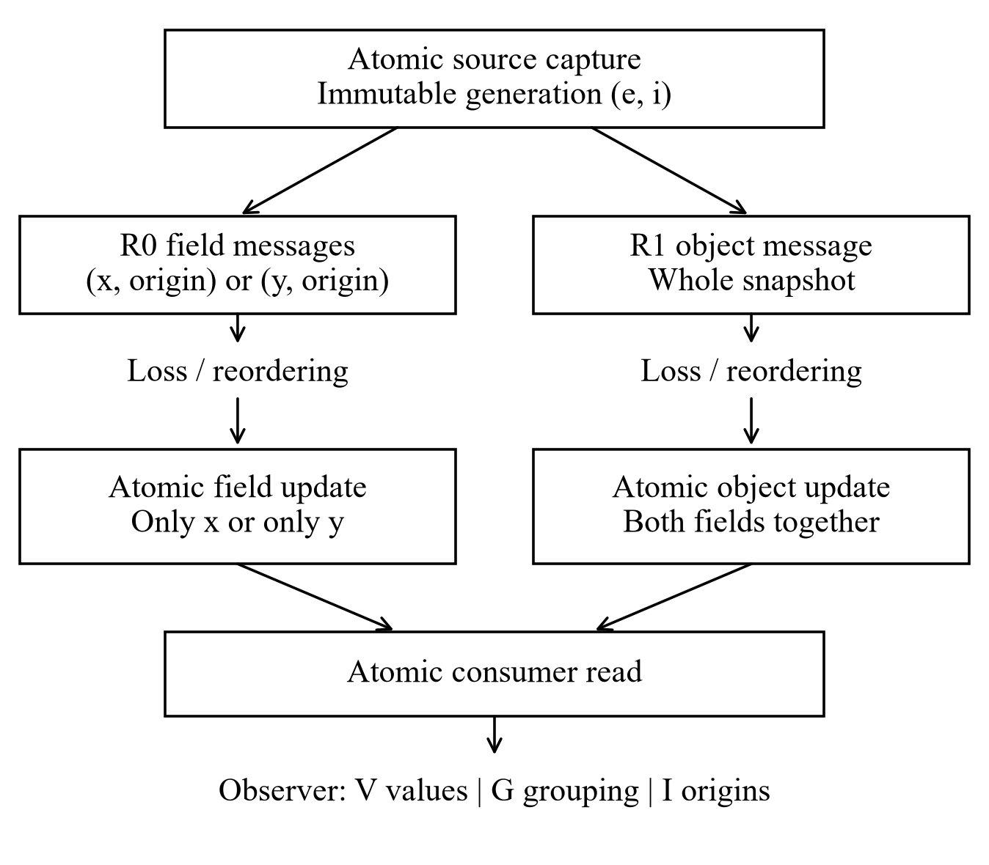
Fig. 1. Capture, publication and observation boundaries.
Coherence, freshness, completeness and authenticity are separate properties. An old object can remain coherent. Origin equality neither authenticates the sender nor establishes physical isolation. Identity comparison needs no synchronized clocks; physical age needs a justified time relation. Capture atomicity, preserved origin binding, publication and read atomicity must each hold along the adapter path.

Industrial example of pump telemetry
Consider an illustrative pump-monitoring application that exports motor-running status r and discharge pressure p to an IT-side diagnostic service through a one-way gateway. Each source capture produces an immutable object with epoch, generation, capture time, r, p and quality. Origin (epoch, generation) remains bound to every field; capture time supports a separate freshness check. For this example, the diagnostic raises a low-pressure alarm when r=1 and p<2 bar. The threshold and values below are scenario assumptions.
Capture g100 records a stopped pump (r=0, p=0.4 bar); g101 records healthy operation (r=1, p=3.2 bar). If the running flag from g101 arrives before its pressure, R0 exposes (1, 0.4), causing a false low-pressure alarm even though neither capture warrants it. At g102 a pressure fault gives (1, 0.8). Retaining pressure 3.2 from g101 while exposing running status from g102 gives (1, 3.2) and suppresses the alarm. Every field is present, and both mixed pairs are numerically plausible.
Profile I detects unequal origins in these pairs; values alone cannot prove mixing because the catalogue permits (1,0.4) and (1,3.2) as valid captures. R1 installs each captured object as a unit, avoiding this cross-generation decision error while still requiring freshness checks. It cannot guarantee immediate fault detection when a new capture is delayed or lost. Adding one identifier after separate source reads would not satisfy the capture contract. This scenario explains the application consequence; the following binary study tests the verification mechanism rather than the pump’s physical dynamics.

Compatible explanations and verdicts
An explanation ω partitions fields into origin groups and assigns each group a source vector from Γ. Different groups can have identical values. Let WE contain assignments permitted by the catalogue and provenance evidence E, and let obs(ω) return their observed values. For a complete vector z:
$Ω(z,E)=\{ω∈𝒲_{E}:obs(ω)=z\}.$ (3)
Profile V exposes values and presence. Profile I adds trustworthy origin identifiers atomically bound to fields. Profile G supplies independently justified common-origin grouping; R1 provides it under its contract, while R0 does not. Monitors cannot query the private source history, random seed or future arrivals.
Let C and M indicate whether Ω contains a coherent and a mixed witness, respectively. Their existence determines the verdict (Table 1). An offline or incomplete read is unavailable before this test; this acquisition status is separate from coherence.
Table 1. Verdicts for a complete observation
C | M | Verdict | Interpretation
true | false | coherent | All compatible explanations have common provenance
false | true | mixed | Every explanation mixes at least two origins
true | true | ambiguous | Both coherent and mixed explanations remain possible
false | false | out_of_model | No explanation satisfies the stated assumptions
For two fields, C exists when a catalogue vector matches the pair and evidence permits a common origin. M exists when each coordinate occurs in an admissible vector and evidence permits distinct origins, even if their values coincide. These witness tests require O(|Γ|) time and constant auxiliary storage. General d-field enumeration may inspect the dth Bell number of partitions.

Guarantees and information limits
Soundness requires the actual origins and source values to induce an explanation in Ω. A coherent verdict then excludes actual mixing, and a mixed verdict excludes actual coherence. Additional truthful evidence preserves a conclusive verdict when the refined set is nonempty; an empty refinement gives out_of_model. Unverified labels do not satisfy this premise.
Two distinct generations can both contain (0,0). Taking both fields from either generation and taking one from each gives identical values, forcing a sound pointwise values-only classifier to remain ambiguous. Under the diagonal catalogue, (0,1) proves mixing because no admissible capture contains it. Additional justified history can refine the problem; extra computation alone cannot separate identical permitted observations.
Under atomic capture, validation, origin binding, whole-object replacement and atomic reads, coherence is invariant: installation gives every field one origin, loss preserves the previous object, and reordering or duplication can install an older coherent object. Clearing makes state unavailable. Zero R1 mixing therefore checks the stated contract and supplies no freshness or availability bound.
In the repeated diagonal family, truthful equality evidence defines a graph over fields. On a nonempty compatible set, connectivity proves common provenance. Disconnected equal-valued components permit both shared and distinct origins unless a difference constraint excludes the former. Unequal component values or a compatible difference constraint prove mixing; contradictory constraints give out_of_model. A connected certificate needs at least d−1 logical equality links. This assumes unrestricted origin identities and is not a bound on metadata bytes or authentication cost (Table 2).
Table 2. Counterexamples that delimit the guarantee
Case | Construction | What follows
Repeated value | Two distinct captures both contain (0,0); publish x from one and y from the other | V is ambiguous although the reference is mixed
ABA | History 0,1,0; publish fields from generations three and one | Returning to the same value does not restore common provenance
False grouping | Assert one origin for an equal-valued mixed vector | A false premise can cause coherent without out_of_model
Non-atomic capture | Read changing source fields separately, then attach one new counter | The counter does not establish one capture event
Torn consumer read | Read x before an object swap and y after it | Atomic publication alone does not make the read atomic
Stale whole replay | Install a complete older object after a newer one | Coherence survives while freshness can worsen
Whole-state clear | Restart and clear all installed fields | The observation becomes unavailable, not mixed

Analytical detection limits
For r distinct origins with independent values distributed as π, values reveal mixing when the selected values are not all equal. Origin selection must be independent of values. The detected fraction conditional on those r origins is:
$d_{r}=1−\sum_{v}{π(v})^{r},r≥2.$ (4)
Two independent fair binary origins give 50% detectable mixing; three give 75% (Figure 2). These collision probabilities condition on actual mixing. Conclusive coverage over all reads additionally depends on mixing prevalence and completeness.
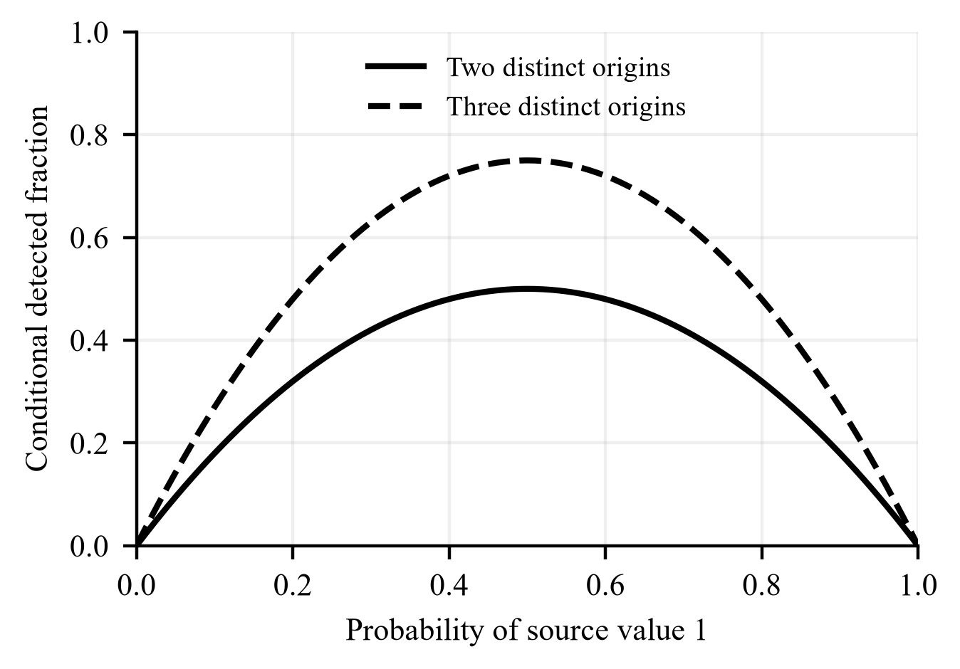
Fig. 2. Detection limits for independent binary source values.
The dynamic source is a symmetric binary Markov chain with flip probability α. Let c_{k} be the probability of unequal values for origins k generations apart. Then:
$c_{k}=\frac{1−(1−2α)^{k}}{2},k≥0.$ (5)
Let w_{k} be the fraction of actually mixed reads whose origins are k generations apart. If origin selection is independent of source values, the predicted detected fraction is:
$d_{pred}=\sum_{k≥1}{w_{k}}c_{k},\sum_{k≥1}{w_{k}}=1.$ (6)
For α=0.50, unequal values have probability one half at every positive lag. Persistent and alternating sources produce different lag effects under identical delivery schedules. Selecting origins based on unusual values would invalidate the independence premise.

Computational study design
The experiment crosses α=0.05, 0.50 and 0.95 with three channels: no loss, independent loss and shared burst loss. Three additional conditions test receiver restart at α=0.50 (Table 3). Forty independent replicate indices per condition yield 480 condition-specific pairs and 960 mode runs. Common random inputs couple conditions, so the 480 pairs are not mutually independent. Table 3 and the artifact configuration record the declared factors and analysis settings.
Table 3. Declared synthetic simulation conditions
Condition | α | Channel | Receiver restart
C01 | 0.05 | No loss | None
C02 | 0.05 | Independent loss, p=0.05 | None
C03 | 0.05 | Shared burst loss, stationary p=0.05 | None
C04 | 0.5 | No loss | None
C05 | 0.5 | Independent loss, p=0.05 | None
C06 | 0.5 | Shared burst loss, stationary p=0.05 | None
C07 | 0.95 | No loss | None
C08 | 0.95 | Independent loss, p=0.05 | None
C09 | 0.95 | Shared burst loss, stationary p=0.05 | None
C10 | 0.5 | Independent loss, p=0.05 | Clear state
C11 | 0.5 | Independent loss, p=0.05 | Preserve state
C12 | 0.5 | Shared burst loss, stationary p=0.05 | Clear state
Note: Each condition uses 40 independent paired seeds. Times are synthetic milliseconds; source, delay and read settings are common across conditions.
Each 24 s run generates 1,200 captures at 20 ms intervals. A fair initial bit evolves with flip probability α; both fields share each capture’s value. R0 emits two field records and R1 one object per generation. Each message receives an independent integer delay uniformly distributed from 0 to 40 ms. Representation and publication change together; this comparison does not equalize bytes or channel service cost.
Independent loss discards each message with probability 0.05. Shared burst loss uses a generation-indexed two-state chain with bad-to-good probability 0.1 and good-to-bad probability 0.05×0.1/0.95. Stationary bad probability is 0.05 and mean bad duration ten generations (200 ms). A bad generation drops both R0 records and the R1 object. These parameters are synthetic assumptions.
Source transitions, outages, delay, independent loss and read phase use separate SHA-256-keyed pseudo-random streams. Draws remain assigned to messages even when discarded. Ties process reset or ready first, arrivals second and reads last. Monotonic admission is outside the contract, so an older arrival can replace newer state.
After a 4 s warmup, each mode contributes 4,000 reads over 20 s at 5 ms intervals with paired phase 0–4 ms. Restart makes the receiver unavailable on [12,000,12,200) ms. Clear removes retained state; preserve keeps it. Downtime arrivals are discarded, pending arrivals retain their times, and downtime reads remain unavailable. Arrivals after 24 s are pending rather than lost.
The primary endpoint is actual mixed origins as a share of all planned reads and its paired R0−R1 contrast. Completeness, hidden mixing and conclusive coverage share the 4,000-read denominator. Fresh coherent availability additionally requires age ≤100 synthetic ms, an analysis threshold rather than an industrial limit. Age exists only for complete coherent states; mixed and unavailable states have undefined age.
Conditional detection divides detected mixed reads by actual mixed reads; conclusive coverage counts coherent or mixed verdicts over all planned reads. Conditional error uses conclusive decisions only and remains undefined when none exist. Thus V on R1 has no meaningful zero-error estimate. A naive catalogue-membership classifier provides a separate false-confirmation control.
Message-loss ratios use emissions over 24 s; state shares use the 20 s analysis window. Pointwise 95% intervals use 2,000 whole-run or paired-difference percentile-bootstrap resamples [17]. We use percentile intervals, not bias-corrected and accelerated intervals. Age p95 is calculated per run over coherent reads, then averaged over 40 runs. Lag ratios are recomputed by resampling complete runs. Displayed percentages use decimal rounding from exact counts or run-level ratios. Intervals are descriptive, without multiplicity correction; temporally dependent reads are not independent replications.

Results and verification

Finite-state and structural checks
For R0 with two fields, m source generations and q diagonal source values, the exact history-origin counts are:
$N=q^{m}(m+1)^{2},N_{complete}=q^{m}m^{2},$
$N_{H}=q^{m}m,N_{¬H}=q^{m}m(m−1).$ (7)
The four terms count all history-origin configurations (including absent fields), complete configurations, coherent configurations and mixed configurations, respectively. Repeated-value and detectable-mixing counts follow as:
$N_{hidden}=q^{m−1}m(m−1),N_{V,mixed}=q^{m−1}(q−1)m(m−1),$
$k_{complete}=\frac{m−1}{m}\frac{q−1}{q}.$ (8)
The first two terms count hidden and detected mixed configurations. The final fraction is conclusive V coverage among complete configurations, not detection conditional on mixing.
At m=3 and q=2, eight histories produce 128 R0 and 32 R1 configurations (Table 4). R0 has 24 coherent, 48 mixed and 56 incomplete configurations. V detects 24 mixed cases and leaves 48 complete cases ambiguous, including 24 mixed ones. I resolves all 72 complete cases. For R1, V leaves all 24 coherent complete cases ambiguous; truthful I or G resolves them.
Table 4. Exact verdict counts for three binary generations
Profile | N | C | M | A | U
R0 V | 128 | 0 | 24 | 48 | 56
R0 I | 128 | 24 | 48 | 0 | 56
R1 V | 32 | 0 | 0 | 24 | 8
R1 G | 32 | 24 | 0 | 0 | 8
R1 I | 32 | 24 | 0 | 0 | 8
Note: C, M, A and U denote coherent, mixed, ambiguous and unavailable. No correctly specified case is out_of_model. These are state-space counts, not operational probabilities.
R0 V coverage is 18.75% over all configurations and 33.33% over complete configurations, while detection conditional on mixing is 50%. These state-space shares are not time probabilities. A bounded schedule check covers 13,700 R0 and 65 R1 cases with loss, reordering and at most one reset; separate controls test duplication and violated assumptions.
With all four binary pairs admitted in Γ, every complete V observation becomes ambiguous on the same actual states. The origins remain mixed, but unequal values no longer contradict one capture. Conversely, omitting a truly admissible vector can create a false contradiction. Catalogue constraints therefore need independent justification.
Independent checks cover 57,520 configurations across 16 (m,q) settings, 16 collision identities, 65 exact-rational Markov recurrences and 66,064 binary evidence cases. Graph validation examines 1,098 equality graphs and 54,252 graph-partition combinations (Table 5). These are structural checks, not stochastic replications.
Table 5. Equality-evidence graph checks for equal-valued fields
Fields | Graphs | Connected | Ambiguous | Minimum links
2 | 2 | 1 | 1 | 1
3 | 8 | 4 | 4 | 2
4 | 64 | 38 | 26 | 3
5 | 1024 | 728 | 296 | 4
Note: These finite graphs validate the criterion for unrestricted origin identities. The last column counts logical pairwise equality links, not transmitted bytes or authentication cost.

Mixing and apparent completeness
At α=0.50, R0 mixing occupies 60.89% of reads without loss, 62.14% under independent loss (95% CI 61.86–62.43%) and 58.51% under bursts (Table 6). R1 has no mixed reads. The paired independent-loss contrast is 62.14 percentage points (95% CI 61.85–62.41). This measures the specified publication combination.
Table 6. Time-indexed publication outcomes for selected conditions
Condition | Mode | Mixed (%) | Complete (%) | Fresh coherent (%)
C04 | R0 | 60.89 | 100.00 | 39.11
C04 | R1 | 0.00 | 100.00 | 100.00
C05 | R0 | 62.14 | 100.00 | 37.86
C05 | R1 | 0.00 | 100.00 | 99.99
C06 | R0 | 58.51 | 100.00 | 38.10
C06 | R1 | 0.00 | 100.00 | 95.50
C10 | R0 | 61.46 | 98.89 | 37.43
C10 | R1 | 0.00 | 98.94 | 98.93
C11 | R0 | 61.56 | 99.00 | 37.43
C11 | R1 | 0.00 | 99.00 | 98.93
C12 | R0 | 57.86 | 98.86 | 37.67
C12 | R1 | 0.00 | 98.91 | 94.49
Note: Means of 40 run-level shares over 4,000 planned reads per mode run. Fresh coherent uses the 100 ms threshold. The repository supplies full intervals and paired contrasts.
All nine conditions without restart achieve 100% completeness after warmup, although retained fields may be mixed or stale. In C05, fresh coherent availability is 37.86% for R0 and 99.99% for R1. A zero-delay control eliminates R0 mixing when all simultaneous arrivals precede the read, confirming the role of asynchronous delivery.

Repeated values and diagnostic coverage
Actual R0 mixing is identical across α because origin schedules are value-independent. Under independent loss, hidden mixing falls from 58.43% to 31.25% and 13.92% of all reads as α rises (Table 7); visible mixing increases while total mixing remains 62.14%.
Table 7. Effect of source repetition on R0 observability under independent loss
Condition | α | Actual mixed (%) | V coverage (%) | Hidden mixed (%) | Detected given mixed (%)
C02 | 0.05 | 62.14 | 3.72 | 58.43 | 5.98
C05 | 0.5 | 62.14 | 30.90 | 31.25 | 49.72
C08 | 0.95 | 62.14 | 48.23 | 13.92 | 77.60
Note: Actual mixed, coverage and hidden mixed use all planned reads. The last column conditions on actual mixing. Entries are means of run-level ratios.
Figure 3 separates coherent, detected mixed and hidden mixed reads using means of 40 run-level shares.
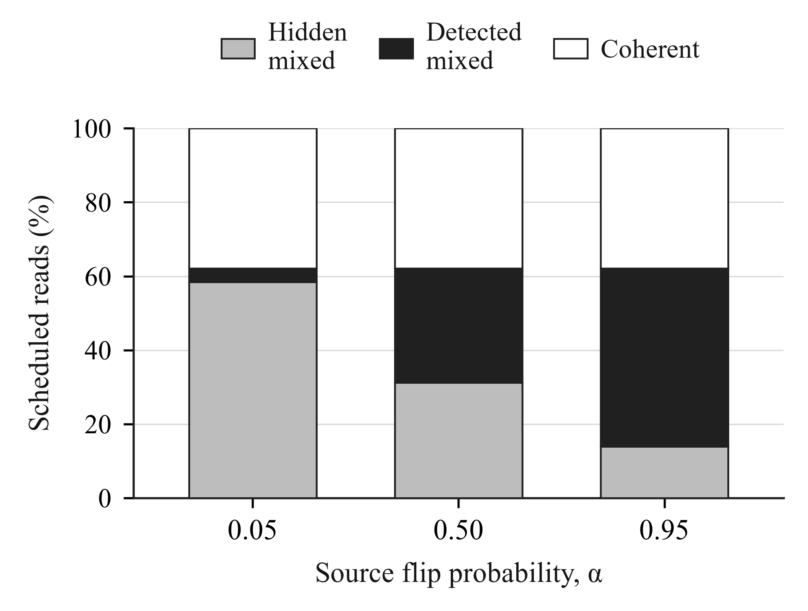
Fig. 3. R0 read outcomes under independent loss.
Without loss, V detects 5.878%, 49.839% and 79.129% of mixed reads at α=0.05, 0.50 and 0.95; lag-weighted predictions are 5.935%, 50.000% and 79.180%. Residual intervals include zero. Figure 4 shows pooled lag-specific detection ratios and whole-run bootstrap intervals for C01, C04 and C07; these ratios differ from means of run-level ratios. Sparse lags supply no extra independent replications.
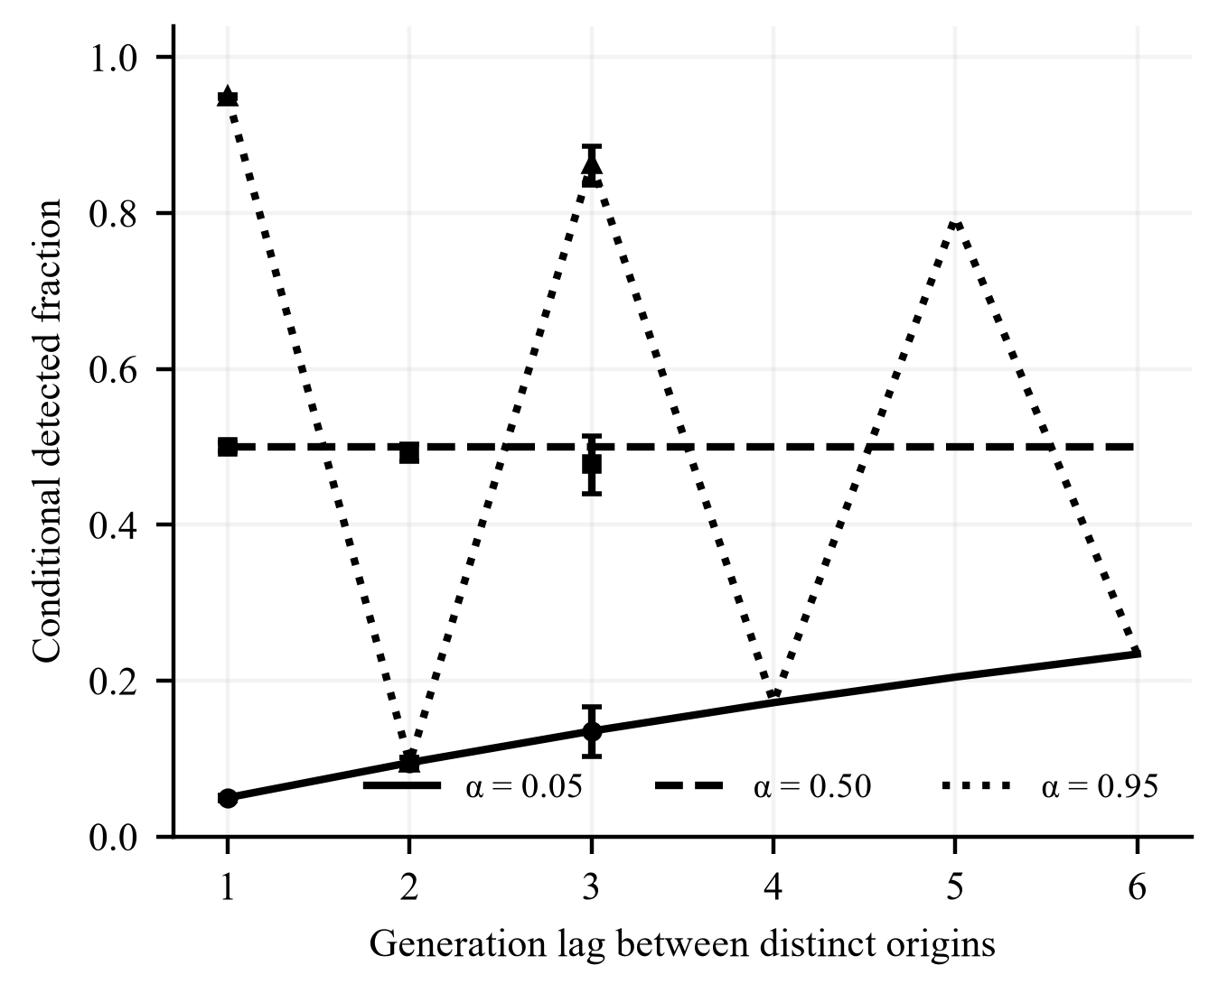
Fig. 4. Observed and predicted detection by generation lag.

Burst loss, freshness and restart
Realized channel loss averages 5.105% for R0 and 4.985% for R1 under independent loss, and 5.612% for both under shared bursts. Bursts reduce R0 mixing but prolong retained old state. R1 fresh coherent availability falls from 99.99% to 95.50% despite 100% completeness. Figure 5 reports mean run-level conditional p95 age and fresh coherent availability, with pointwise whole-run bootstrap intervals.
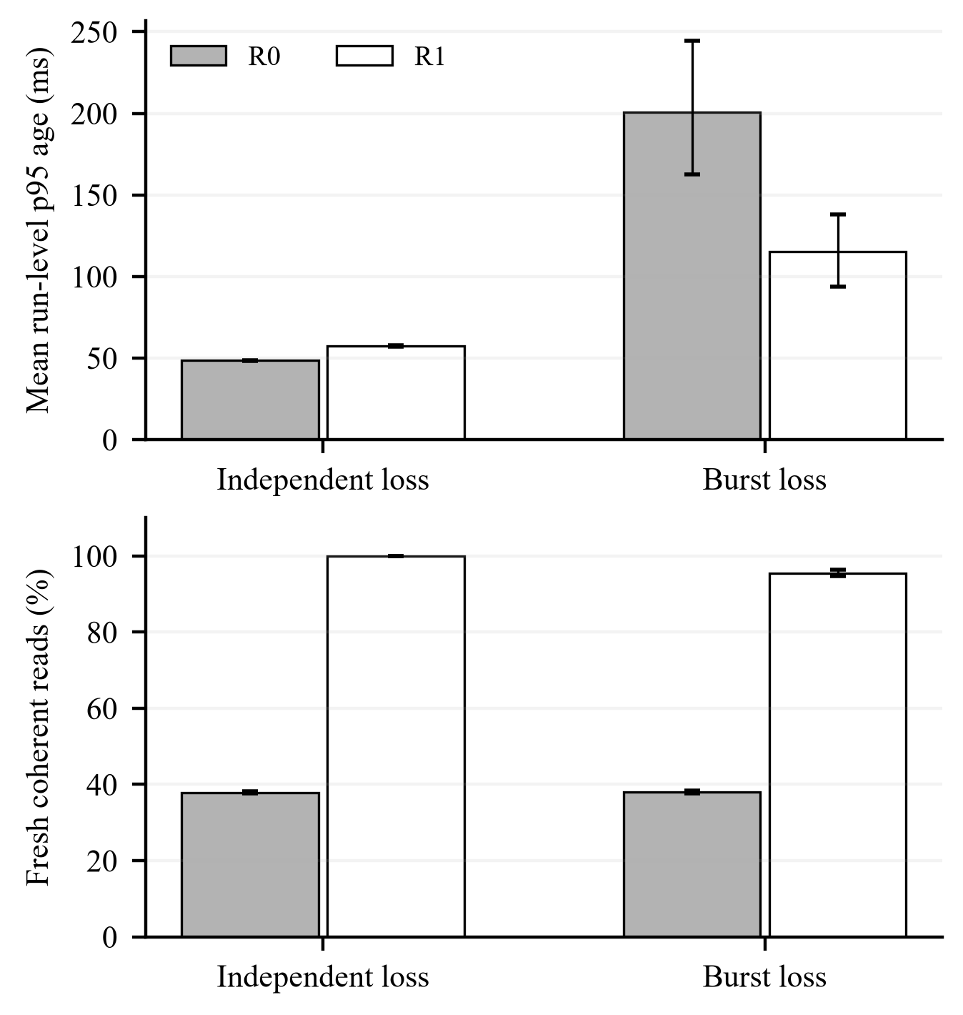
Fig. 5. Coherent-state age and fresh coherent availability at α=0.50.
The 200 ms outage covers 40 reads. Clearing R1 in C10 gives 98.94% completeness and 98.93% fresh coherent availability; preserving it in C11 gives 99.00% and 98.93%. Figure 6 shows the C10 seed-0 trace. Age gaps represent mixed or unavailable state. A slow-source control distinguishes restart policies: on recovery, clear leaves no state while preserve exposes a coherent object aged 1,200 ms.
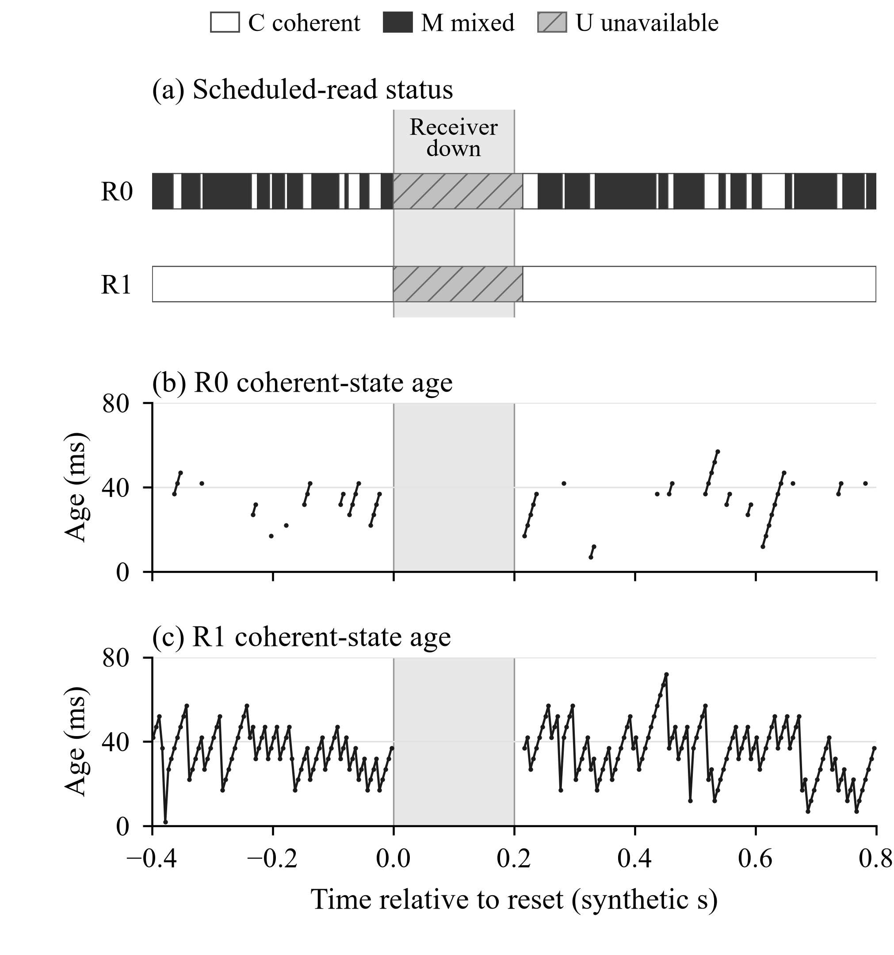
Fig. 6. Read status and coherent-state age around receiver restart (C10, seed 0).
Negative controls give unavailable for missing state and out_of_model for contradictory evidence. False grouping of an equal-valued mixed pair can instead give coherent: the false premise excludes the actual explanation without creating a contradiction. Zero conclusive I/G errors under truthful binding therefore do not measure authentication strength.

Discussion and limitations
A deployment should define generations at capture, preserve origin binding and publish and read whole objects when common capture is required. The pump example illustrates the consequence: a complete, plausible pair can trigger a false alarm or suppress a valid one. Fresh coherent availability and evidential coverage should therefore accompany reported error rates.
The model uses two binary fields, bounded delay, one burst process and at most one restart. It omits fragmentation, congestion, finite buffers, CPU contention, physical sampling and clock error. Representation and message count differ between R0 and R1, preventing a vendor-specific or byte-normalized interpretation. The pump scenario is illustrative; the diagonal catalogue is a diagnostic source family, not a plant model.
Forty replicate indices and one pseudo-random generator family limit coverage of possible realizations. Intervals describe variation within the synthetic model, excluding physical-parameter uncertainty and simultaneous coverage across results. Equipment studies must validate capture, origin binding, publication, reads, clocks and channel parameters, while distinguishing logger failure from receiver downtime.

Conclusion
Common provenance is verifiable only when the available evidence excludes mixed origins. Repeated values can make this impossible for a values-only monitor, and source correlation changes how much mixing remains visible. Whole-object publication preserves coherence under the stated contract, while freshness and availability require separate evaluation. The contribution is a precise provenance-verification criterion and its measurable observation limits, supported by reproducible synthetic results.

Reproducibility
Code and synthetic data are publicly available at https://github.com/aizexss/unidirectional, under tag article1-public-20261029 [20]. The materials include source histories, the complete reading log, metrics, models, independent validators and SHA-256 manifests (Table 8).
Python 3.10 or later and the standard library suffice. Run python reproduce.py --verify-only to check supplied evidence, or python reproduce.py --full to regenerate numerical outputs from a temporary copy with previous results removed. Numbered stages write reports/RESULTS.md and reports/verification_summary.json. Independent checks reconstruct every read tuple from event schedules and compare numerical tables and figure files with this manuscript.
Full reproduction compares newly created CSV/JSON files and decompressed readings with the reference. All six manuscript images are supplied as exact exports and checked byte for byte; the runner does not redraw the figures. The pump example is illustrative, and physical-equipment measurements are outside this computational reproduction.
Table 8. Artifact dictionary and interpretation
Artifact | Grain | Purpose
Finite-model CSV | History/state/profile | Exact counts and observation limits
run_metrics.csv | Condition/seed/mode | Counts and ratios for one 4000-read evaluation
aggregate_metrics.csv | Condition/mode/metric | Mean of 40 run metrics and pointwise CI
paired_contrasts.csv | Condition/metric | R0−R1 differences paired by seed
source_histories.csv | Source replication | Private truth sequence for independent reconstruction
readings.csv.gz | One scheduled read | Online status and installed origins
lag_validation.csv | Condition/generation lag | Pooled mixed-read detection with run resampling
Theory/graph outputs | Diagnostic configuration | Exhaustive checks of stated identities/criteria
Note: Message losses use 24 s of emissions; state shares use 20 s and 4,000 reads per mode run. Source histories provide offline reference truth and are not exposed to the tested monitors.

References
[1] Stouffer, K., Pease, M., Tang, C., Zimmerman, T., Pillitteri, V., Lightman, S., Hahn, A., Saravia, S., Sherule, A., & Thompson, M. (2023). Guide to operational technology (OT) security (NIST SP 800-82 Rev. 3). National Institute of Standards and Technology. https://doi.org/10.6028/NIST.SP.800-82r3
[2] Anton, A.-A., Csereoka, P., Capota, E. A., & Cioargă, R.-D. (2024). Enhancing syslog message security and reliability over unidirectional fiber optics. Sensors, 24(20), Article 6537. https://doi.org/10.3390/s24206537
[3] Herlihy, M., Shavit, N., Luchangco, V., & Spear, M. (2020). The art of multiprocessor programming (2nd ed.). Morgan Kaufmann. https://www.sciencedirect.com/book/9780124159501/the-art-of-multiprocessor-programming
[4] van Steen, M., & Tanenbaum, A. S. (2023). Distributed systems (4th ed.). distributed-systems.net. https://www.distributed-systems.net/index.php/books/ds4/
[5] Basin, D., Klaedtke, F., & Zălinescu, E. (2020). Runtime verification over out-of-order streams. ACM Transactions on Computational Logic, 21(1), Article 5. https://doi.org/10.1145/3355609
[6] Bartocci, E., Falcone, Y., Francalanza, A., & Reger, G. (2018). Introduction to runtime verification. In E. Bartocci & Y. Falcone (Eds.), Lectures on runtime verification (pp. 1–33). Springer. https://doi.org/10.1007/978-3-319-75632-5_1
[7] Cimatti, A., Grosen, T. M., Larsen, K. G., Tonetta, S., & Zimmermann, M. (2026). Exploiting assumptions for effective monitoring of real-time properties under partial observability. Software and Systems Modeling. Advance online publication. https://doi.org/10.1007/s10270-026-01394-6
[8] Kallwies, H., Leucker, M., & Sánchez, C. (2022). Symbolic runtime verification for monitoring under uncertainties and assumptions [Preprint]. arXiv. https://doi.org/10.48550/arXiv.2207.05678
[9] OPC Foundation. (n.d.). OPC Unified Architecture Part 25: Object Serialization (Section 4.5). Retrieved October 29, 2026, from https://reference.opcfoundation.org/specs/OPC-10000-25/4.5
[10] OPC Foundation. (n.d.). OPC Unified Architecture Part 14: PubSub (Section 5.3.3). Retrieved October 29, 2026, from https://reference.opcfoundation.org/specs/OPC-10000-14/5.3.3
[11] OPC Foundation. (n.d.). OPC Unified Architecture Part 3: Address Space Model (Section 8.58). Retrieved October 29, 2026, from https://reference.opcfoundation.org/specs/OPC-10000-3/8.58
[12] OPC Foundation. (n.d.). OPC Unified Architecture Part 4: Services (Section 5.11.2). Retrieved October 29, 2026, from https://reference.opcfoundation.org/specs/OPC-10000-4/5.11.2
[13] Yates, R. D., Sun, Y., Brown, D. R., III, Kaul, S. K., Modiano, E., & Ulukus, S. (2021). Age of information: An introduction and survey. IEEE Journal on Selected Areas in Communications, 39(5), 1183–1210. https://doi.org/10.1109/JSAC.2021.3065072
[14] Li, H., Tang, L., Chen, S., Zheng, L., & Zhong, S. (2024). AoI-aware resource scheduling for industrial IoT with deep reinforcement learning. Electronics, 13(6), Article 1104. https://doi.org/10.3390/electronics13061104
[15] L’Ecuyer, P. (2017, February). Random number generation with multiple streams for sequential and parallel computing [Lecture slides]. Université de Montréal. https://www-labs.iro.umontreal.ca/~lecuyer/myftp/slides/parallel-rng-mit17.pdf
[16] Python Software Foundation. (n.d.). random — Generate pseudo-random numbers. Python 3.12 documentation. Retrieved October 29, 2026, from https://docs.python.org/3.12/library/random.html
[17] Efron, B., & Narasimhan, B. (2020). The automatic construction of bootstrap confidence intervals. Journal of Computational and Graphical Statistics, 29(3), 608–619. https://doi.org/10.1080/10618600.2020.1714633
[18] Monks, T., Currie, C. S. M., Onggo, B. S., Robinson, S., Kunc, M., & Taylor, S. J. E. (2019). Strengthening the reporting of empirical simulation studies: Introducing the STRESS guidelines. Journal of Simulation, 13(1), 55–67. https://doi.org/10.1080/17477778.2018.1442155
[19] National Academies of Sciences, Engineering, and Medicine. (2019). Reproducibility and replicability in science. The National Academies Press. https://doi.org/10.17226/25303
[20] Ibragimov, A. (2026). Snapshot coherence in unidirectional industrial telemetry (Version article1-public-20261029) [Source code and synthetic data]. GitHub. https://github.com/aizexss/unidirectional/tree/article1-public-20261029

