EXPLAINABLE DEMAND FORECASTING FOR RETAILERS USING GRAPH NEURAL NETWORKS AND TEMPORAL FUSION TRANSFORMERS

MAKSATBEK KYZY AIZHAN

DEPARTMENT OF ARTIFICIAL INTELLIGENCE

UNIVERSITI MALAYA
Kuala lumpur

2025
EXPLAINABLE DEMAND FORECASTING FOR RETAILERS USING GRAPH NEURAL NETWORKS AND TEMPORAL FUSION TRANSFORMERS

MAKSATBEK KYZY AIZHAN

Research Report submitted in Fulfillment of the requirements for the degree of Master of Artificial Intelligence (Coursework)

DEPARTMENT OF ARTIFICIAL INTELLIGENCE
UNIVERSITI MALAYA
Kuala lumpur

2025

UNIVERSITI MALAYA
ORIGINAL LITERARY WORK DECLARATION

Name of Candidate: Maksatbek kyzy Aizhan
Passport No: PE0583904
Matric No: 23115588
Name of Degree: Master of Artificial Intelligence (Coursework)
Title of Research Report: Explainable Demand Forecasting for Retailers using Graph Neural Network and Temporal Fusion Transformers

Field of Study: Deep Learning

I do solemnly and sincerely declare that:
- I am the sole author/writer of this Work;
- This Work is original;
- Any use of any work in which copyright exists was done by way of fair dealing and for permitted purposes and any excerpt or extract from, or reference to or reproduction of any copyright work has been disclosed expressly and sufficiently and the title of the Work and its authorship have been acknowledged in this Work;
- I do not have any actual knowledge nor do I ought reasonably to know that the making of this work constitutes an infringement of any copyright work;
- I hereby assign all and every rights in the copyright to this Work to the Universiti Malaya (“UM”), who henceforth shall be owner of the copyright in this Work and that any reproduction or use in any form or by any means whatsoever is prohibited without the written consent of UM having been first had and obtained;
- I am fully aware that if in the course of making this Work I have infringed any copyright whether intentionally or otherwise, I may be subject to legal action or any other action as may be determined by UM.

Candidate’s Signature Date: 1.9.2025

Subscribed and solemnly declared before,

Witness’s Signature Date:

Name:
Designation

Abstract

Keywords: Graph Neural Networks, Temporal Fusion Transformers, Demand forecasting, Retail, Explainable AI

Acknowledgements

Table of Contents
Abstract 3
Acknowledgements 4
Table of Contents 5
List of Figures 6
List of Tables 7
List of Symbols and Abbreviations 8
List of Appendices 9
CHAPTER 1: Introduction 1
CHAPTER 2: Problem Statement 3
CHAPTER 3: Research Questions and Research Objectives 6
CHAPTER 4: Literature Review 7
CHAPTER 5: Methodology 15
5.1 Statistical Exploratory Data Analysis 16
5.2 Model Development 16
5.2.1 Baseline Model 17
5.2.2 Graph Neural Network 17
5.2.3 Temporal Fusion Transformer 19
5.2.4 GNN-TFT Hybrid 20
5.3 Explainability and Feature Importance 23
5.4 Optimizations 23
5.4.1 Optimizations for GNN 23
5.4.2 Optimizations for TFT 24
5.5 Dataset to be used 25
5.6 Evaluation Metrics 29
References 30
Appendix 31

List of Figures
Figure 5.1 Methodology Workflow
Figure 5.22. Graph NN
Figure 5.2.3.1. Temporal Fusion Transformer Architecture (Sukel, Maarten (2023))
Figure 5.2.4.1. Hybrid architecture GNN and TFT (Sukel, Maarten (2023))
Figure 5.5.1 Promotion, sales effect on daily, monthly and yearly sales
Figure 5.5.2 Sales per city
Figure 5.5.3 Heatmap of yearly sales per product

List of Tables
Table 4.1: Graph Edges
Table 6.1. Dataset features

List of Symbols and Abbreviations

TFT | : | Temporal Fusion Transformers
GNN | : | Graph Neural Networks
DNN | : | Deep Neural Networks
RNN | : | Recurrent Neural Networks
DC | : | Distribution Center
ANN | : | Artificial Neural Networks
ARIMA | : | Autoregressive Integrated Moving Average
SKU | : | Stock Keeping Unit
XAI | : | Explainable AI
MAE | : | Mean Absolute Error
LSTM | : | Long Short Term Memory
CNN | : | Convolutional Neural Network
TiDE | : | Time-Series Dense Encoder
MQRNN | : | Multi-Horizon Quantile Recurrent Forecaster
VAR | : | Vector Autoregressive
GCN | : | Graph Convolution Network

List of Appendices

Introduction
In today’s fast-paced retail sector, accurately forecasting product demand is essential for ensuring operational efficiency. Precise demand predictions enable retailers to optimize inventory management, stock replenishment, and human resources. Supply chains are becoming more complex, particularly with the involvement of third-party logistics providers, making advanced forecasting tools increasingly critical.
The combination of artificial intelligence and data analytics has opened up new ways to tackle these challenges. Models such as Graph Neural Networks, Temporal Fusion Transformers, and hybrid GNN-TFT approaches can uncover complex relationships and patterns that traditional methods may miss. This research aims to develop and compare the effectiveness of GNN, TFT, and hybrid GNN-TFT models. Alongside a focus on predictive accuracy, this project highlights the importance of making models interpretable, so that AI-generated insights are transparent and easily understood for real-world decision-making.
As ML models become increasingly sophisticated, interpreting how these algorithms arrive at their predictions presents new challenges. This has led to continued research on novel methods for improving explainability, which are typically classified as either model-specific or model-agnostic approaches. Explainable AI encompasses processes and tools designed to make the reasoning behind AI and machine learning decisions clear and accessible to humans.

In retail, explainable AI is essential for earning the trust of users and stakeholders. Transparency ensures that all parties involved in decision-making can understand how conclusions are reached, while fairness guarantees that algorithmic predictions remain unbiased across various product categories. Building trust also requires assessing the level of confidence retail managers can place in the AI system’s recommendations for real-world scenarios. Ultimately, interpretability allows stakeholders to comprehend the rationale behind model outputs, supporting actionable insights and informed choices.

Problem Statement
Precise demand forecasting plays a vital role in retail by impacting inventory management, store restocking, supply chain performance, customer satisfaction, and overall sales. However, this task is complicated by several challenges, particularly as retailers expand, operate through multiple channels (both online and physical stores), and depend on complex logistics networks. Key challenges in retail demand forecasting include:
- Overestimating demand, which can result in overproduction, high holding costs, and waste if products expire or go out of style.
- Difficulty in predicting budgets for investments, estimating returns, and determining the profitability of operations.
- Uncertainty in forecasting operating costs, stock requirements, and optimal order quantities for each season.
- The need to align orders with seasonal trends and consumer preferences to ensure in-demand products are stocked while minimizing excess inventory.
- Challenges in introducing new products without overshadowing existing ones, while still ensuring new stock will be sold.
- Greater forecasting difficulty due to expansion across regions and sales channels, given the diversity of consumer behaviors and logistics complexities.
- Delays in sales flow and the challenge of modeling complex relationships between spatial (location-based), item-similarity, and temporal (time-based) factors.
- The complexity of advanced forecasting models, which can make them difficult for decision-makers to interpret and trust.
These issues can be efficiently managed by treating them as a time-series forecasting task, aiming to predict future product demand based on past sales data, seasonal trends, and additional contextual variables. By approaching retail demand forecasting in this way and applying advanced models such as GNN, TFT, and their hybrid GNN-TFT variant, it becomes possible to tackle many of the identified challenges and substantially enhance forecasting accuracy, ultimately supporting better business decisions and outcomes.
These models are particularly well-suited for managing volatile and seasonal sales patterns, which are common in industries that experience various product life cycles and distinct seasonal trends (Spring-Summer, Fall-Winter). They are capable of capturing autocorrelations as well as linear and non-linear dynamics within intricate sales data. Additionally, the models excel at representing both spatial (across different stores or regions), item similarity and temporal (across time) dependencies, effectively addressing challenges such as delayed sales flow and the integration of spatial-temporal features and item similarity. Additionally, they are able to capture both long-term patterns and short-term changes in demand at the same time, offering thorough insights for retail forecasting.

Research Questions and Research Objectives
This study aims to explore and evaluate the performances of modern machine learning models specifically, GNN, TFT and hybrid for predicting retail demand, while also examining ways to make these models more interpretable and accurate.
Research Questions | Research Objectives
Which approach yields higher accuracy in retail demand forecasting: GNN, TFT, or a hybrid GNN-TFT model? | To evaluate and compare the forecasting accuracy of GNN, TFT, and hybrid GNN-TFT models.
Which features within the retail dataset have the greatest and least impact on the predictive accuracy of these models? | To interpret model predictions by applying both model-specific and model-agnostic explainable AI (XAI) methods.
What architectural improvements are most effective for optimizing the performances of models? | To find and implement architectural improvements, aiming to maximize predictive performance and operational value of models.

Literature Review
Demand forecasting typically involves several key processes such as
- Data collection and integration of historical sales, promotional campaigns, pricing, inventory records, product metadata, customer demographics, and external variables (such holidays, weather).
- Cleaning the data, handling missing values, extracting seasonality and trend features, and constructing additional features.
- Analyse demand patterns, trends, and anomalies across stores, products, and regions.
- Selecting and training forecasting models using historical data and engineered features.
- Evaluation of model performance using evaluation metrics.
- Translating forecasts into actionable insights for inventory replenishment, logistics planning, and promotional strategies.
While every process in demand forecasting is important, this study focuses on the modeling stage, specifically on GNN, TFT and hybrid due to their unique abilities to handle the complex, high-dimensional, and relational characteristics of contemporary retail data.
GNNs are powerful for modeling relationships and dependencies between products, stores, or customer segments, which are often represented as graphs. This is essential for environments where products influence each other.
TFTs excel at capturing temporal patterns, handling multiple exogenous variables, and providing multi-horizon forecasts, which are critical for seasonality and promotion-heavy retail environments.
Retail demand is influenced not only by a product’s own history but also by the relationships between items, stores, and customers. GNNs are uniquely suited to capture these dependencies, leveraging graph structures (e.g., co-purchase, sales similarity, or geographical proximity) (Kozodoi, N., Zinovyeva, L., and Valentin (2023)).
TFTs handle long-term dependencies, seasonality, and exogenous variables, enabling accurate forecasting far into the future (e.g., for entire seasons) (Bryan Lim and Sercan Ö. Arık (2021)).
GNNs and TFTs scale to large, high-dimensional datasets common in retail, outperforming traditional models that cannot efficiently handle such complexity (Kozodoi, N., Zinovyeva, L., and Valentin (2023)).
Although both GNNs and TFTs are powerful, their “black-box” nature makes explainability a challenge. Literature notes that standard explainability methods (e.g., LIME, SHAP) struggle with time dependencies and feature interactions in these architectures, motivating research into improved interpretability (Bryan Lim, Sercan (2021)).
An important advancement in this area comes from Lalou, P., Ponis, S.T., & Efthymiou, O.K. (2020), who examined demand forecasting across a network of 129 stores located in various countries. Their findings highlight the potential of data analytics and statistical programming to enhance decision-making processes for store restocking, inventory optimization at distribution centers and retail sites, and the organization of human and automated workforce schedules within logistics centers.
Sukel, Maarten, and Rudinac (2023) emphasize that demand prediction is essential for accurate stock replenishment and inventory management, enabling retailers to minimize waste and maintain competitiveness. They note that forecasting demand is complex due to the numerous variables that affect customer behavior over time.While conventional approaches typically use tabular data from past sales and seasonal patterns, the authors advocate for incorporating visual and textual product features, which strongly influence purchasing decisions. Additionally, they point out that geographic factors also play a significant role in shaping demand.
Sukel, Maarten, and Rudinac (2023) study combines tabular sales data with multimodal product information and the geographical context of each product. Forecasting becomes even more complex when different data sources are integrated, such as variations in delivery times, warehouses, and product types. The authors implement a Temporal Fusion Transformer (TFT) alongside Convolutional Neural Networks (CNNs) to extract image features and transformers to generate text embeddings. These multimodal features are then input into an LSTM model. Their study utilizes data from Picnic, an online grocery delivery service operating in Germany, France, and the Netherlands.
For extended forecasting horizons, Sukel, Maarten, and Rudinac (2023) observe that models such as TiDe, which utilize multilayer perceptrons, may surpass TFTs in performance while also offering faster training and inference times. Geographic information is integrated through a graph-based method. Overall, their proposed model consistently outperforms the baseline TFT across all test set delivery dates and product categories including fruits, beverages, and meat spreads.
Bryan Lim and Sercan Ö. Arık (2021) developed the Temporal Fusion Transformer (TFT), an advanced architecture utilizing attention mechanisms to address forecasting across multiple time periods. This technique enables the model to generate forecasts for several future intervals at once, which is particularly beneficial for retailers looking to manage inventory for entire seasons in advance. In practice, multi-horizon forecasting often draws on a wide range of data, such as upcoming events like holidays, records of customer visits, and fixed attributes like store locations, even if the relationships among these variables are not clearly defined. The wide variety and complexity of this information make forecasting for different time horizons especially demanding. Deep learning models like TFT have outperformed traditional time series methods. Although recurrent neural networks have long been common, attention-based models such as TFT are gaining popularity due to their effectiveness in pinpointing the most important parts of historical data for making predictions.
The findings indicate that TFT significantly outperforms all benchmark models across multiple datasets from various domains such as Electricity, Traffic, Volatility, and Retail. Of particular relevance to this research, the authors utilize the Favorita Grocery Sales Dataset (Favorita, 2018), which integrates data from various products and store locations as well as additional daily-changing external factors. The task involves predicting product sales for future 30 days using 90 days of registered history of sales. For the retail dataset, TFT achieves average improvements of 7.2% in P50 and 3.1% in P90 quantile losses compared to the next best model MQRNN.
Kozodoi, N., Zinovyeva, L., and Valentin (2023) emphasize that demand forecasting should account for relationships between individual items, which can be effectively modeled using GNNs. Their paper introduces GraphDeepAR, a model that combines a GNN encoder with the DeepAR forecasting framework. Specifically, the GNN encoder captures relationships between items, while the DeepAR decoder is responsible for demand prediction. The paper also proposes an item attribute similarity graph construction method without predefined graph structure.
While DeepAR and TFT models are trained on time series data and can learn patterns across similar series, they cannot incorporate inter-series relationships during inference. Although VAR models can capture such relationships during both training and inference, they are not scalable for high-dimensional retail environments. In contrast, GNNs offer a scalable solution for modeling complex relationships in large datasets.
The researchers construct a graph G_{t} = (N_{t}, E), with each node corresponding to a product sold at time t, and edges E capturing the pairwise associations between items based on the cosine similarity of their attributes. All edges are undirected and have static features.
The researchers utilize retail sales datasets sourced from Kaggle along with Adidas’s historical sales records. The information is structured as a time series, capturing weekly demand, product descriptions, fixed attributes, and dynamic variables that reflect seasonality, such as the week of the year, week number, and day of the month. To maintain the temporal sequence, the datasets are divided in order into training, validation (the 13 weeks following the training period), and test sets (the 26 weeks after the validation period).
The findings reveal that GraphDeepAR surpasses DeepAR by 4.36% on retail datasets and by 31.98% on e-commerce datasets, with the more substantial gains in e-commerce linked to the larger volume of data. When evaluated on the Adidas dataset, GraphDeepAR delivers a 2.05% increase in financial performance over DeepAR. However, this enhanced accuracy comes at the cost of efficiency, as GraphDeepAR takes 159% more time to train and 34% more time for inference compared to DeepAR.
Aktas, M. Y., and Ji, T. (2024) introduced the LSTMGraph model for forecasting demand across multiple products. This method combines LSTM networks, which are adept at capturing changes over time such as price fluctuations, with GCN that model overall relationships between products. Within the LSTMGraph framework, products serve as nodes, and three distinct graphs are built to capture different types of relationships: (1) Weekly Sales, (2) Customer links, and (3) Invoice connections. By merging these graphs, the model leverages diverse temporal and relational information, ultimately improving its forecasting accuracy.
To gain deeper insights into how various graph structures affect model performance, the authors performed an ablation study aimed at identifying which graph type most effectively reduces prediction error. The research assessed the model’s accuracy when each graph type was used alone, as well as in different combinations, as summarized in Table 4.1.
Graph 1 | Graph 2 | MAE
Weekly Sales Similarity |  | 11.6834
Invoice Similarity |  | 11.8377
Customer Relationship |  | 12.3293
Weekly Sales Similarity | Customer Relationship | 11.9633
Customer Relationship | Invoice Similarity | 11.9417
Weekly Sales Similarity | Invoice Similarity | 11.9802
Table 4.1: Graph Edges
The LSTMGraph model achieved a low MAE of 11.4776, highlighting its effectiveness in learning both time-based trends and relationships captured by the graph. Notably, the standalone Weekly Sales Similarity Graph outperformed all combined graph configurations, suggesting that adding information from the other graphs might have resulted in redundant data or added unneeded complexity.
Bryan Lim and Sercan (2021), the creators of TFT, highlight that one of the main difficulties is making the model interpretable when dealing with varied types of data. The TFT functions much like a ‘black box,’ and conventional methods for interpreting deep neural networks are often ineffective for time-series problems due to the model’s intricate and non-linear internal structure. Techniques like LIME and SHAP do not adequately capture the sequential characteristics of time-series inputs, leading to insufficient interpretability. Although transformer models can provide some level of explanation for applications in text and speech, they face challenges in pinpointing the significance of features at specific time points in complex, horizon-based datasets.

Methodology
The approach outlined in Figure 5.1 involves evaluating and comparing the effectiveness of three models - GNN, TFT, and a hybrid GNN-TFT - for forecasting time series data across multiple products.
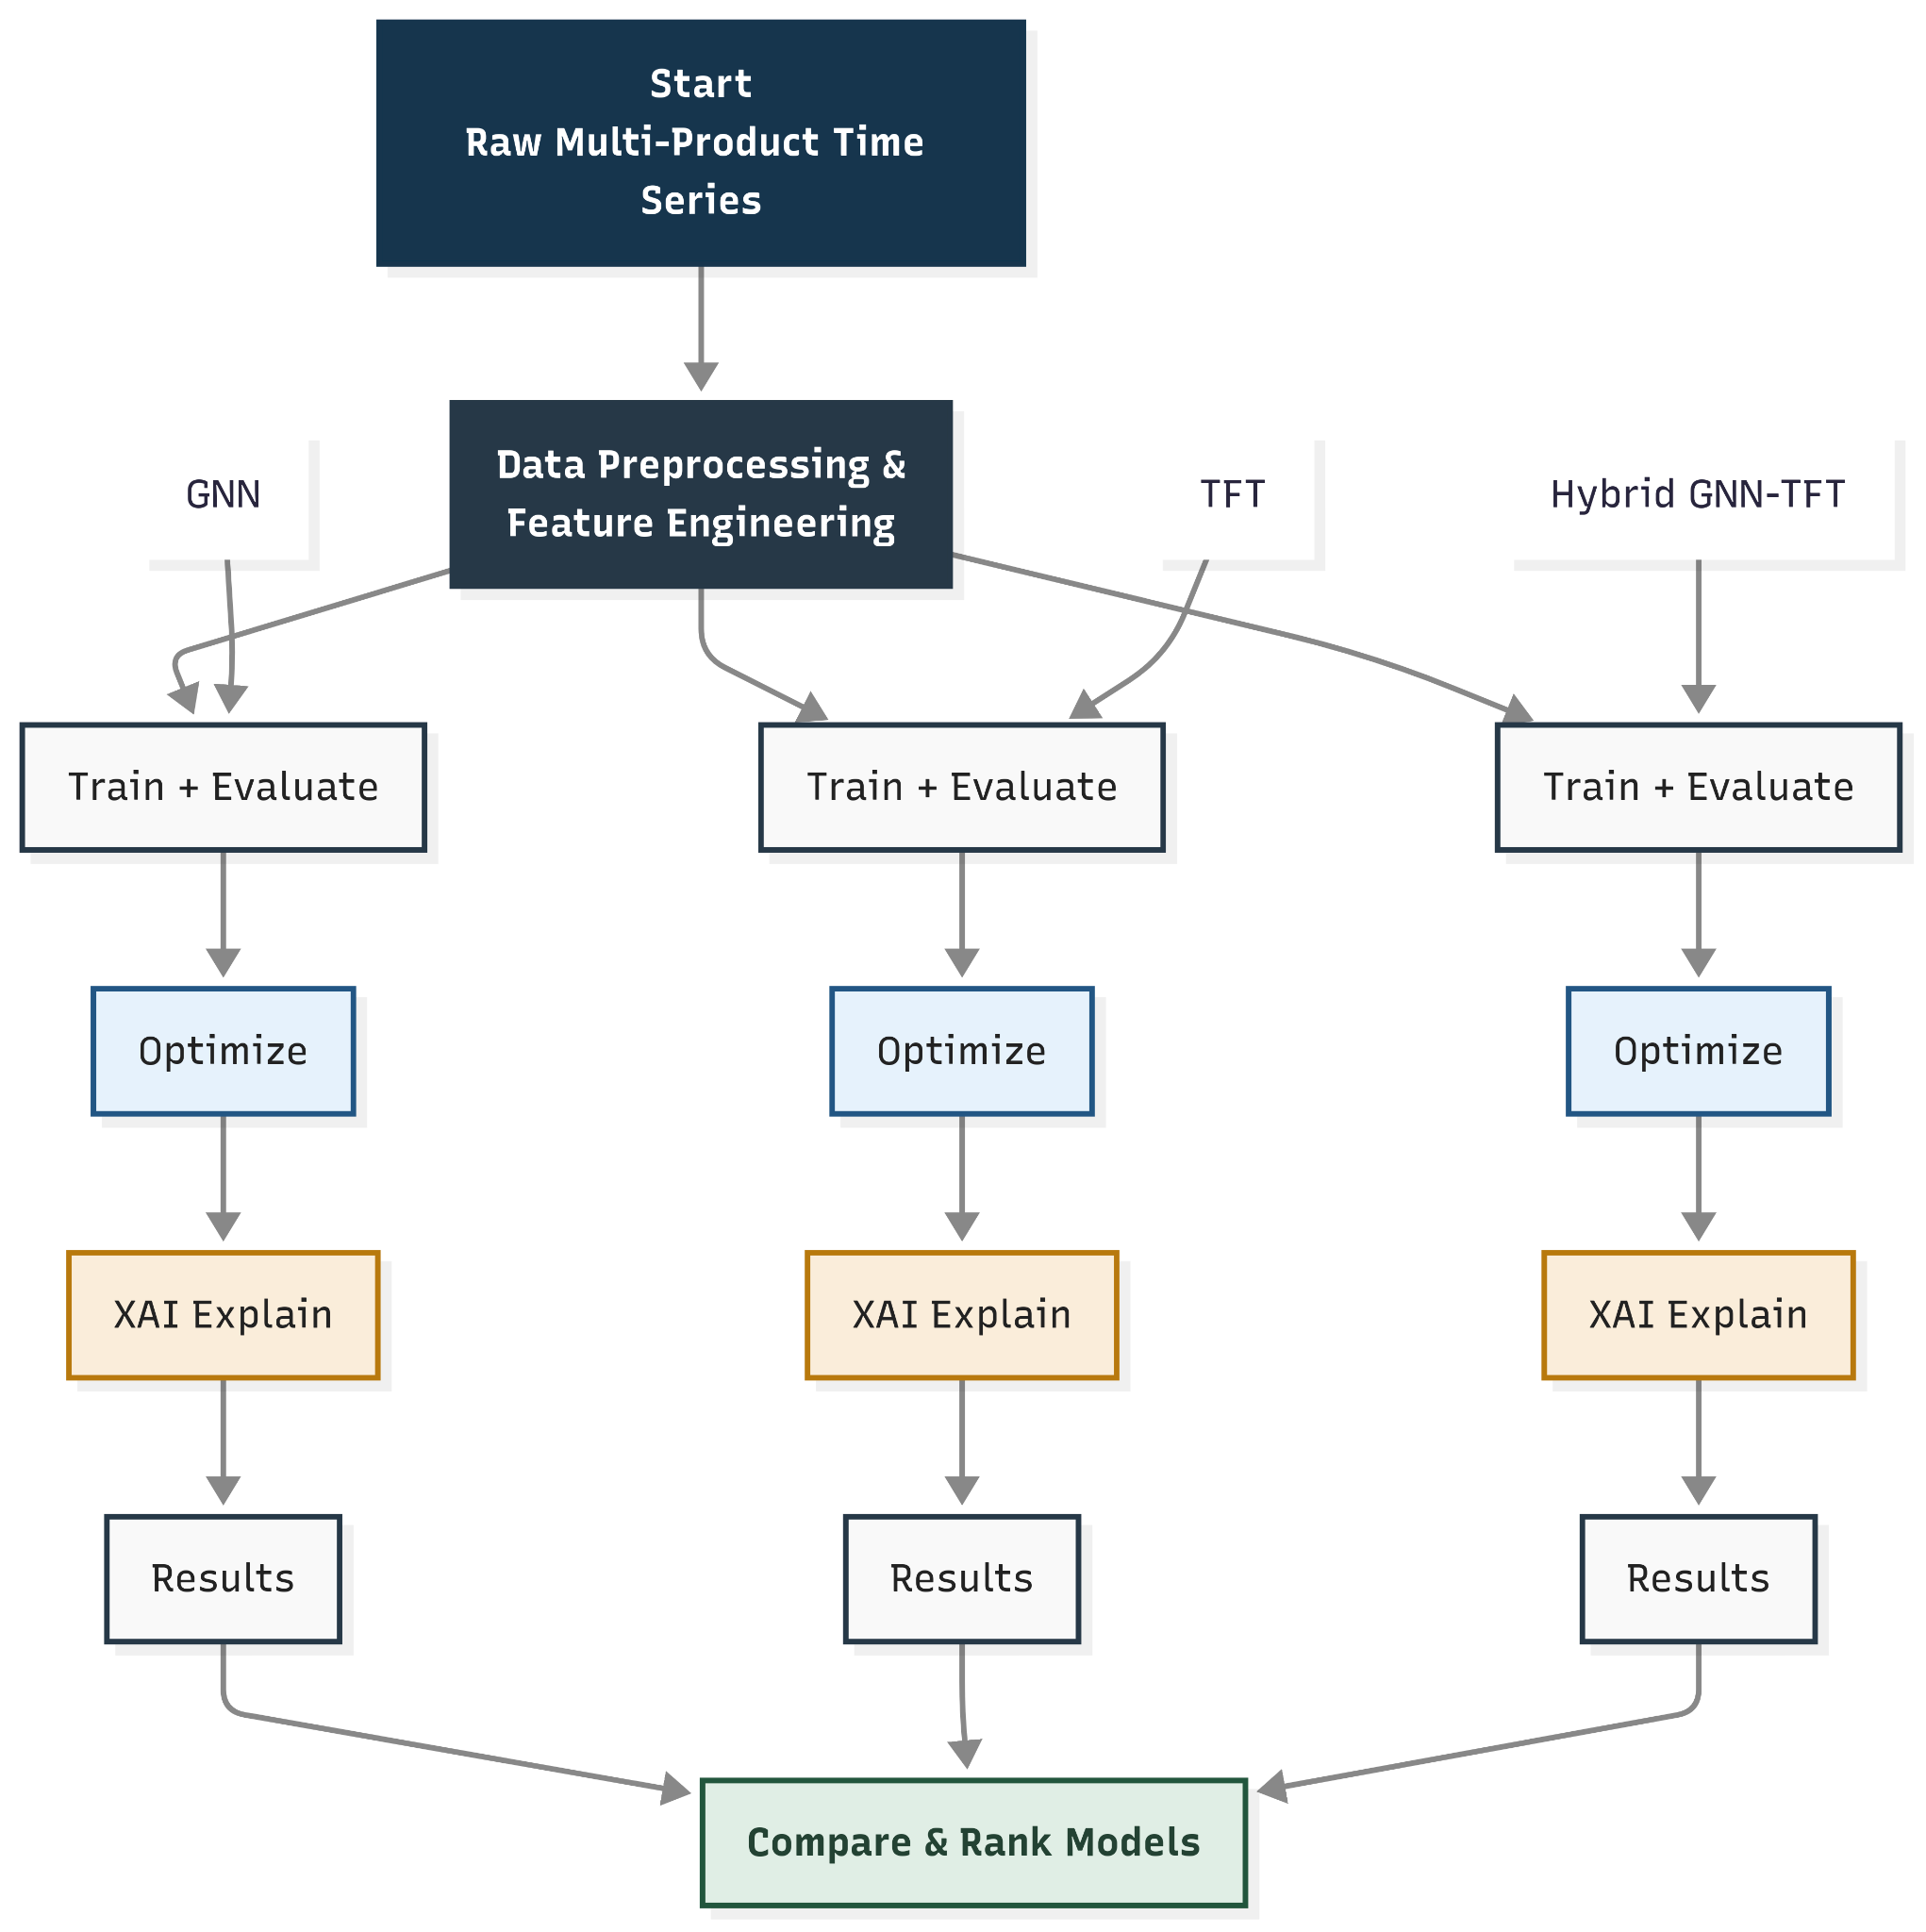
Figure 5.1 Methodology Workflow

Statistical Exploratory Data Analysis
Statistical exploratory data analysis is conducted to reveal patterns within the sales data and support modeling strategies. Time series visualizations are used to study sales trends and pinpoint seasonal effects and unusual fluctuations. Analytical methods are applied to investigate relationships between various features, such as comparing the influence of retailer locations on sales figures, and observing how demand shifts across product categories.
Analysis extends to tracking operating profit for each product throughout the observed period, monitoring how unit sales vary across regions, and evaluating seasonal behaviors to identify both peak and low-profit times for each item.
City performance is measured through unit sales over time, highlighting which cities are most profitable. Regional sales distributions are also studied to uncover patterns in retailer performance. The analysis involves detecting missing values, identifying outliers, and comparing outcomes across various stores and product categories. Findings from this process help improve attribute engineering and guide the selection of key features for the model building, including a closer look at how unit sizes for each product change over time.

Model Development
This section describes the architecture and key components of models ARIMA, GNN, TFT and hybrid GNN-TFT.

Baseline Model
The ARIMA model serves as a standard reference for unit sales forecasting over time series. The model integrates three core mechanisms. The autoregressive part captures the influence of prior observations on current values. The integrated part transforms the data by calculating differences between consecutive points to remove underlying trends and stabilize the chains. And the moving average part defines the connection among current values and past forecast errors. Collectively, these elements allow ARIMA to reveal and forecast patterns in time series by leveraging both historical values and residuals from previous predictions.

Graph Neural Network
GNN captures the relationships among products using a graph structure G = (N, E), where every node in N represents a single product, and the edges in E represent pairwise connections between products. These edges are undirected, and the weights are inferred from data, by calculating cosine similarity score between product features and sales histories.
Each product node is characterized by a time series of sales at each time step t. To enrich the node representation, the feature set for each product at time t is described as a tuple A = (X, Z, Y). X is a vector containing M static features, such as retailer, location, which remain constant over time. Z is a matrix of L time-varying features, including known-in-advance factors like month, year, seasonal events, and promotions. Y denotes the demand or sales count for the product at time t.
The main structure of the architecture (see Figure 5.22) features two graph convolutional layers. The initial layer collects information from adjacent nodes and maps the input features into a hidden space, using a ReLU activation to introduce non-linearity. The subsequent layer continues to aggregate and refine these hidden representations, generating forecast outputs for each product. For each node, the resulting output is a vector of length K, which corresponds to predicting daily demand over the next K days.
By leveraging information from both the sales history of each product and the relationships encoded in the graph, the GNN is able to forecast demand over the horizon. These multi-step predictions are especially valuable for inventory replenishment, enabling retailers to anticipate future demand and optimize stock levels for each product category.
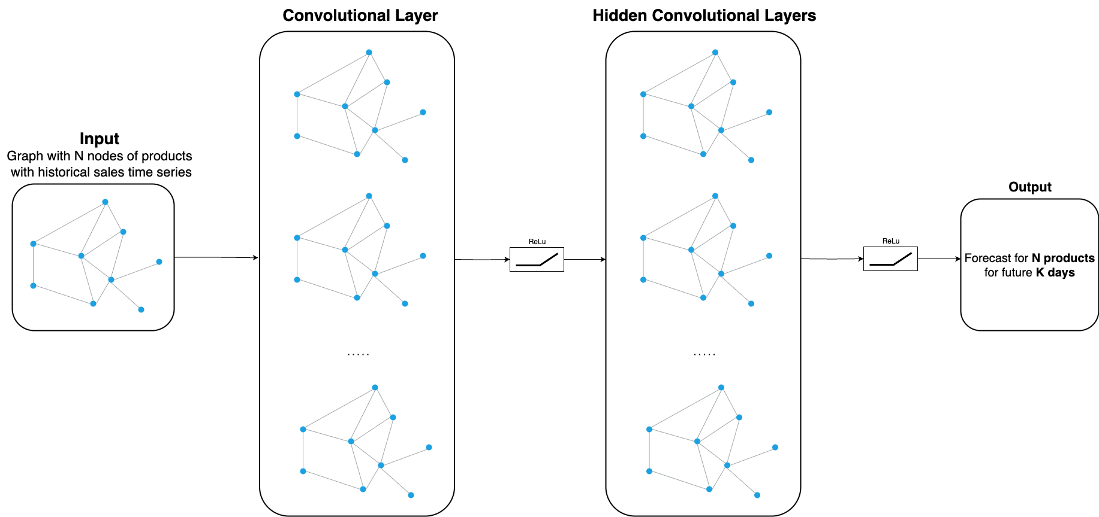
Figure 5.22. Graph NN

Temporal Fusion Transformer
The TFT (Figure 5.2.3.1) is designed to handle a variety of input features for time series forecasting. It takes in static features, which remain unchanged throughout the observation period, as well as dynamic features that can vary over time, such as calendar-related factors (month, year), seasonal effects, or special promotions. Additionally, the model utilizes the actual demand data for each product at specific time points.
The primary output generated by the TFT is a forecast for each product, predicting sales for the next K days using historical data from the previous N days.
What distinguishes TFT is its implementation of attention mechanisms that enable the model to learn complex, evolving relationships and patterns over time. Its architecture centers on Gated Residual Networks, which facilitate the handling of intricate, non-linear data interactions. The designers of TFT incorporated four essential components into the model.
Static covariate encoders transform constant features into context vectors that enrich the entire model.
Gating and variable selection ensures that only the most relevant inputs contribute to each prediction, effectively reducing noise from less important features.
The sequence-to-sequence processing layer manages both observed inputs and those known ahead of time, enabling the model to seamlessly incorporate various forms of time-dependent information.
The temporal self-attention decoder is tailored to capture and represent long-range dependencies, allowing the model to identify patterns and effects that extend throughout the entire dataset.
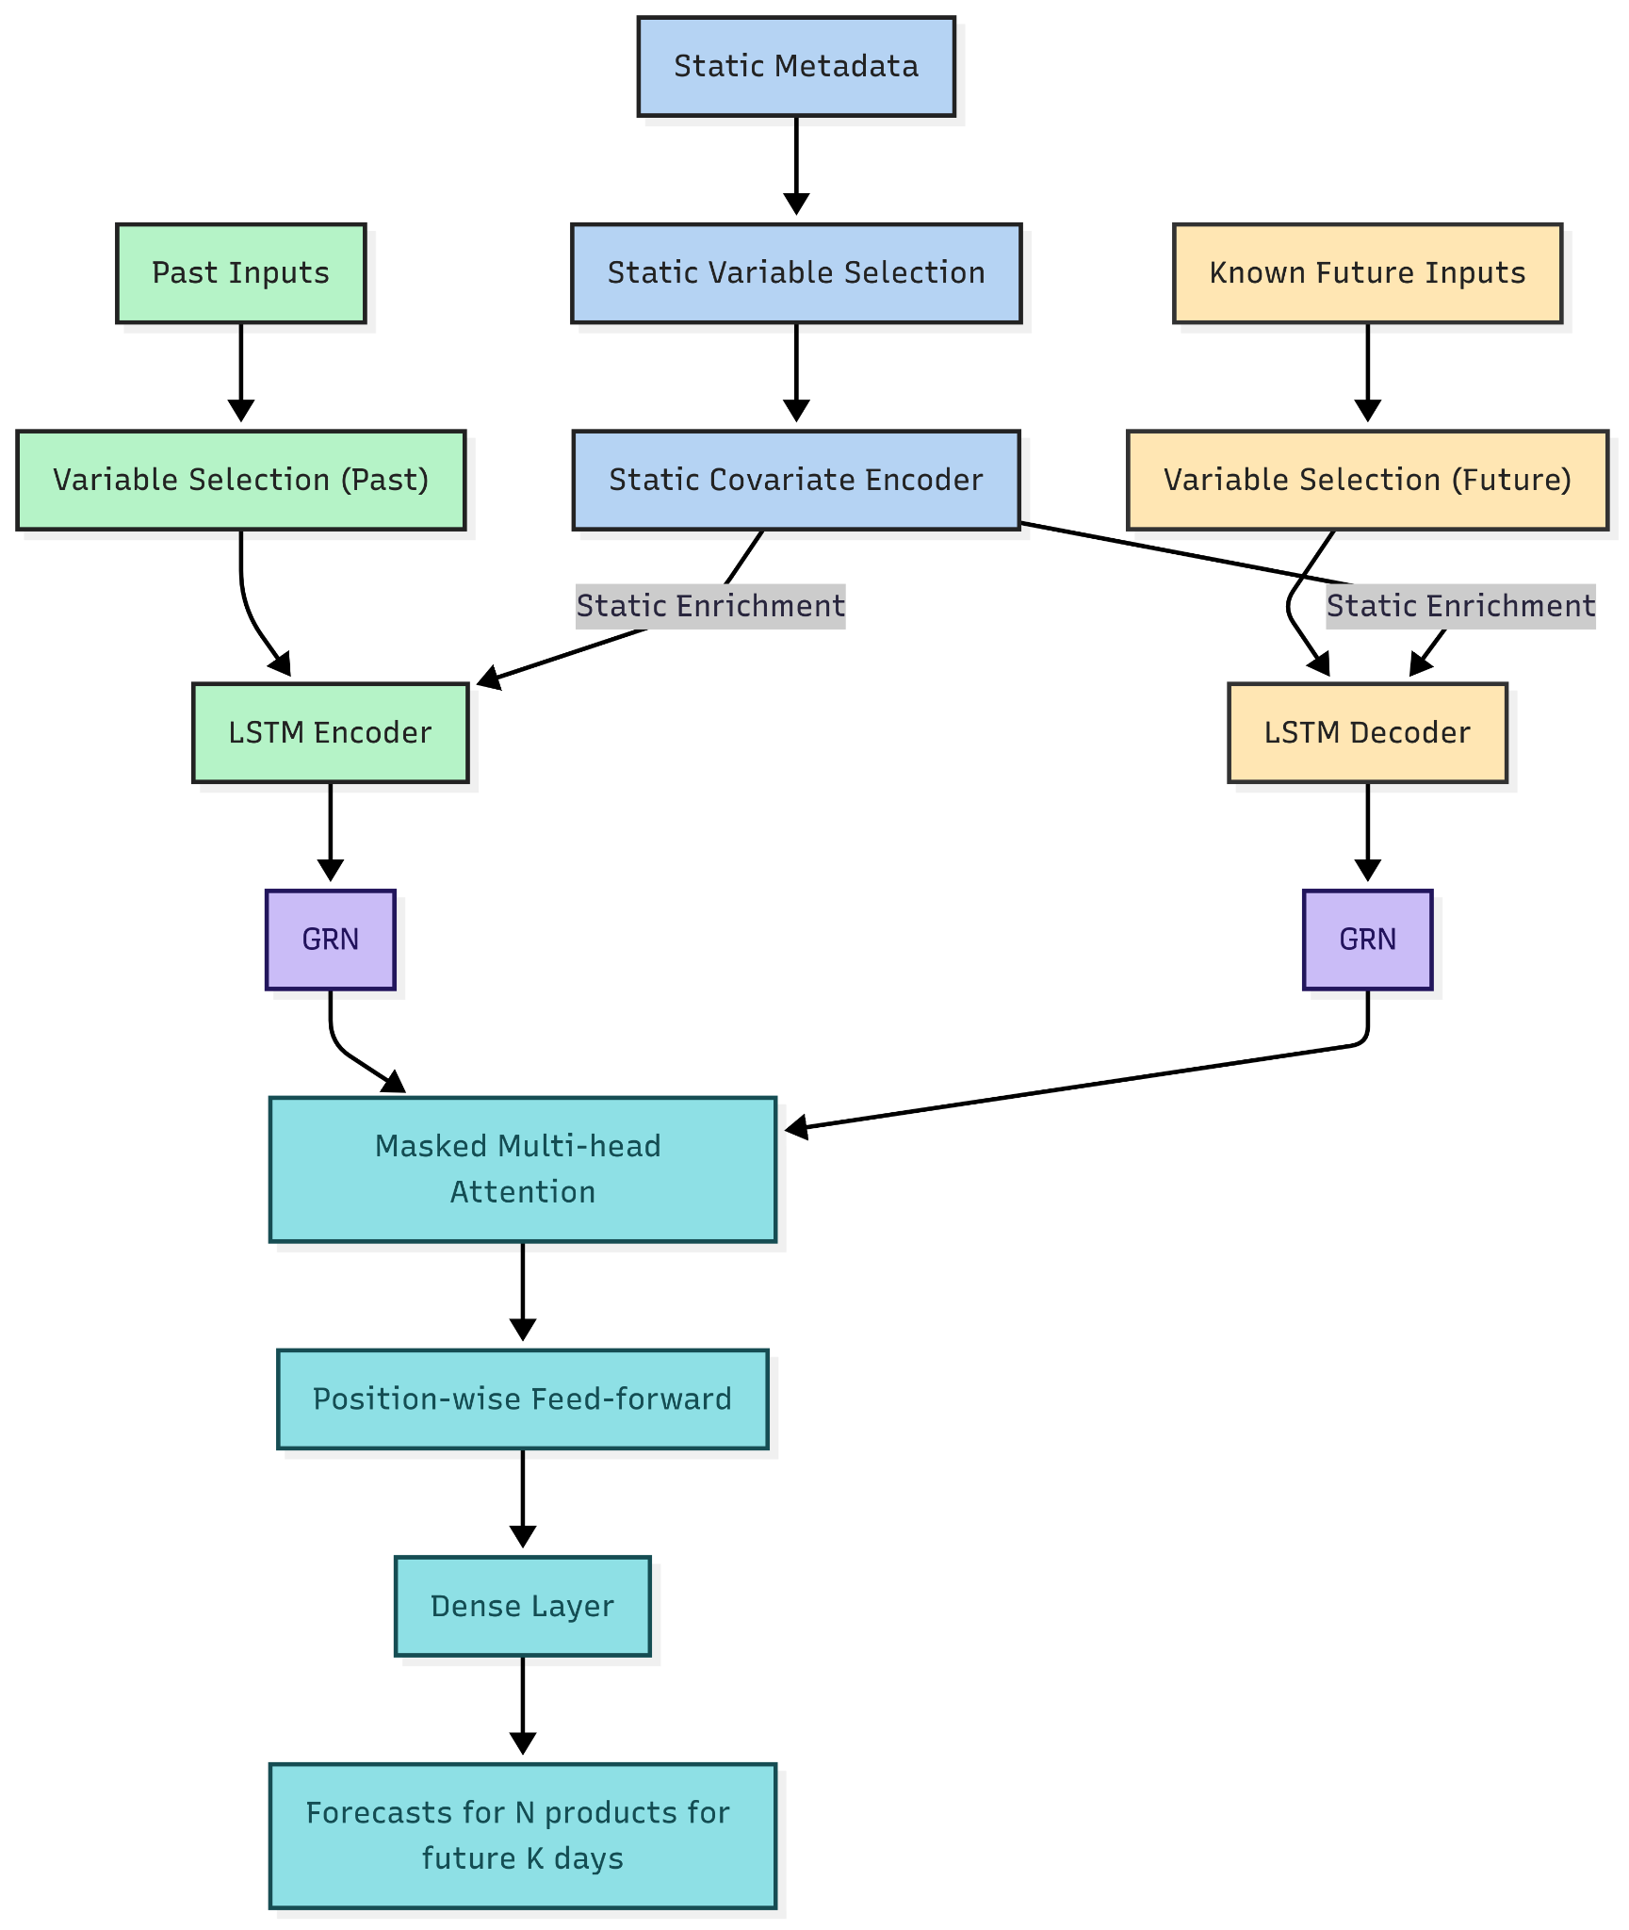
Figure 5.2.3.1. Temporal Fusion Transformer Architecture (Sukel, Maarten (2023))

GNN-TFT Hybrid
The main concept behind this approach is to leverage the GNN to derive relational features for each product, and then integrate these with static, historical, and known future features before inputting them into the TFT. This combination produces a comprehensive, context-sensitive representation for each product at every time point.
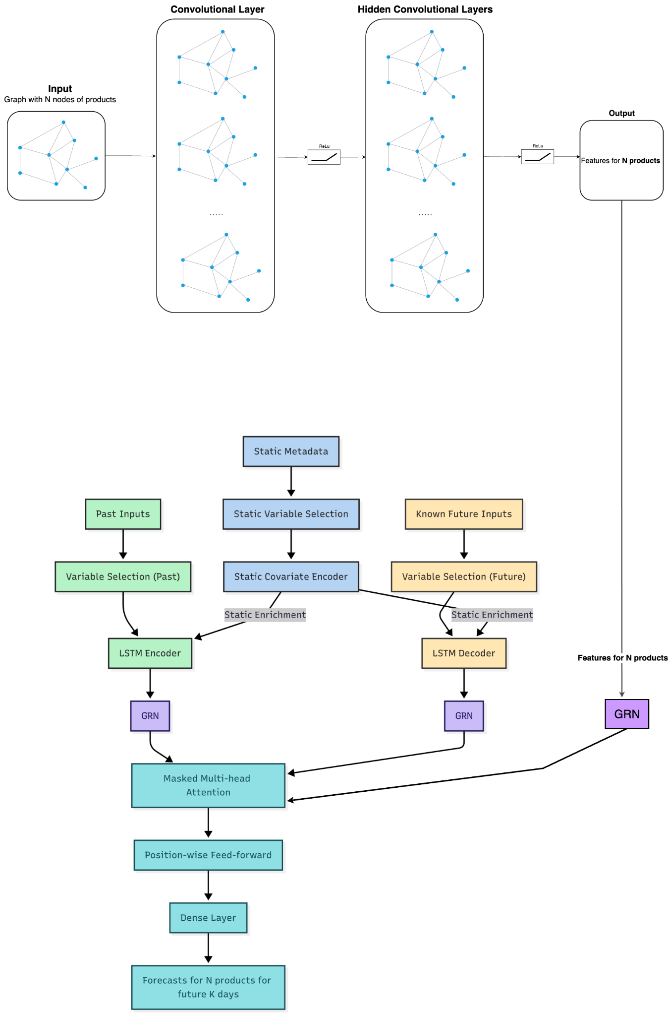
Figure 5.2.4.1. Hybrid architecture GNN and TFT (Sukel, Maarten (2023))
The integrated pipeline (Figure 5.2.4.1) works as follows:
- The product graph is processed by the GNN to generate node embeddings that encode both individual and relational information.
- These embeddings are concatenated with static and temporal covariates.
- The fused features are input into the TFT, which performs feature selection, sequential modeling, and attention-based forecasting.

Explainability and Feature Importance
The models are interpreted using both model-specific and model-agnostic techniques. The approaches help pinpoint the features that have the greatest impact on the model’s predictions.
The TFT architecture is inherently interpretable, allowing it to reveal (1) the most influential features, (2) consistent temporal patterns, and (3) key events. Additionally, the TFT model results are interpreted using model-agnostic XAI techniques such as LIME and SHAP.
For the GNN, prediction transparency is achieved with the model-specific GNNExplainer, along with the model-agnostic LIME and SHAP methods.

Optimizations
Enhancements to the model involve updating layers and refining the network architecture. Hyperparameters are carefully tuned to maximize performance, and a systematic assessment is conducted to balance model complexity, predictive accuracy, and practical utility.

Optimizations for GNN
The main GNN utilized in this study is the Convolutional Graph Network. To enhance its capacity to differentiate among neighboring nodes, an attention mechanism will be integrated. This addition allows the network to allocate varying importance to each neighbor, enabling it to focus on the most pertinent nodes when aggregating information.
To thoroughly evaluate the effectiveness of attention and model architecture choices, experiments will be conducted using several GNN variants, including Convolutional GNN, GraphSAGE, and Attention GNN. Each architecture will be tested to analyze how well it models the correlations within the data and to identify the optimal approach for the given task.

Optimizations for TFT
Following the recommendations of Bryan Lim and Sercan Ö. Arık (2021), evaluating feature importance is essential for optimizing the TFT. The model focuses on a group of input features that logically contribute to its predictive performance. Understanding persistent temporal patterns helps to reveal time-dependent relationships within the data.
Building on these insights, this research refines the forecasting model by expanding the receptive field to consider a longer historical context when attention is highest at the start of the lookback window, or by engineering features that more effectively capture seasonal trends. Leveraging attention weights from the temporal fusion decoder’s self-attention layer enables the detection of recurring patterns, particularly by analyzing how features at specific time lags impact forecasts across various horizons. This strategy involves examining variable importance, visualizing enduring temporal trends, and pinpointing distinct regimes and important events.

Dataset to be used
Daily sales data for multiple product families across Ecuadorian retail stores, designed for multi-series forecasting. Suitable for advanced temporal and relational models (TFT, GNN, hybrids) due to rich exogenous signals, hierarchical (store–family) structure, and event-driven dynamics.
The dataset contains 3,000,888 records. Each record includes the following features in the Table 6.1
Feature | Description
store | The sold product store location
family | Type of product
sales | The total purchases of a product family at a specific shop and date
on-promotion | The number of promoted product family items for a given store and date
Table 6.1. Dataset features
Key supplemental data:
- Store metadata: Includes details such as city, state, store type, and cluster (which groups together similar stores)
- Daily oil price: serves as a macroeconomic indicator relevant to Ecuador’s economy
- Holiday calendar with special semantics:
  - Transferred holidays: the original date is treated as a normal day, and the celebration occurs on the “Transfer” date
  - Bridge days: extended holidays with additional days
  - Work days: compensate for extended breaks
  - Additional days: days added a regular calendar holiday
- Daily transaction counts
Domain factors influencing demand include:
- Promotions (on-promotion)
- Holiday and event effects (with careful handling of transferred holidays)
- Bi-monthly public sector paydays (15th and end of the month) can boost sales
- The April 16, 2016 earthquake caused a temporary spike in demand
- Oil price fluctuations provide macroeconomic context
The dataset includes:
- 33 product families
- 54 unique store numbers
- 22 different states
- 5 store types
- 17 store clusters
- No missing values

A high number of stores are located in Quito among 22 cities with significant differences showing the imbalance of sales in the dataset across cities.

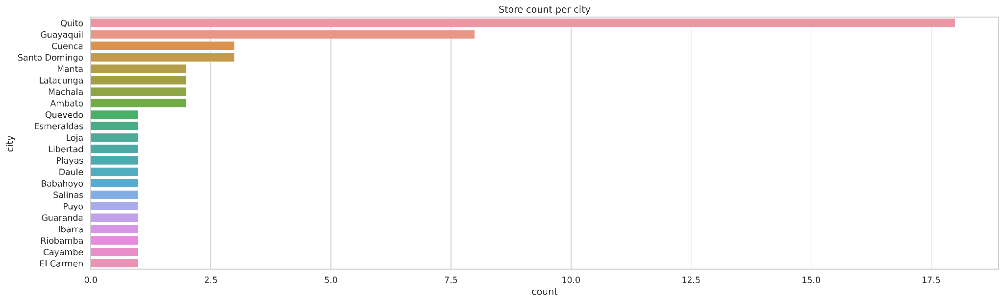
Figure 5.5.2 Stores per city
The heatmap in Figure 5.5.3 shows that core grocery and household product families have consistently high daily non-zero sales from 2013 to 2016, with a peak in 2016 and a drop in 2017. Other categories, such as HOME CARE, BABY CARE, and BOOKS, either started later or have much sparser sales.
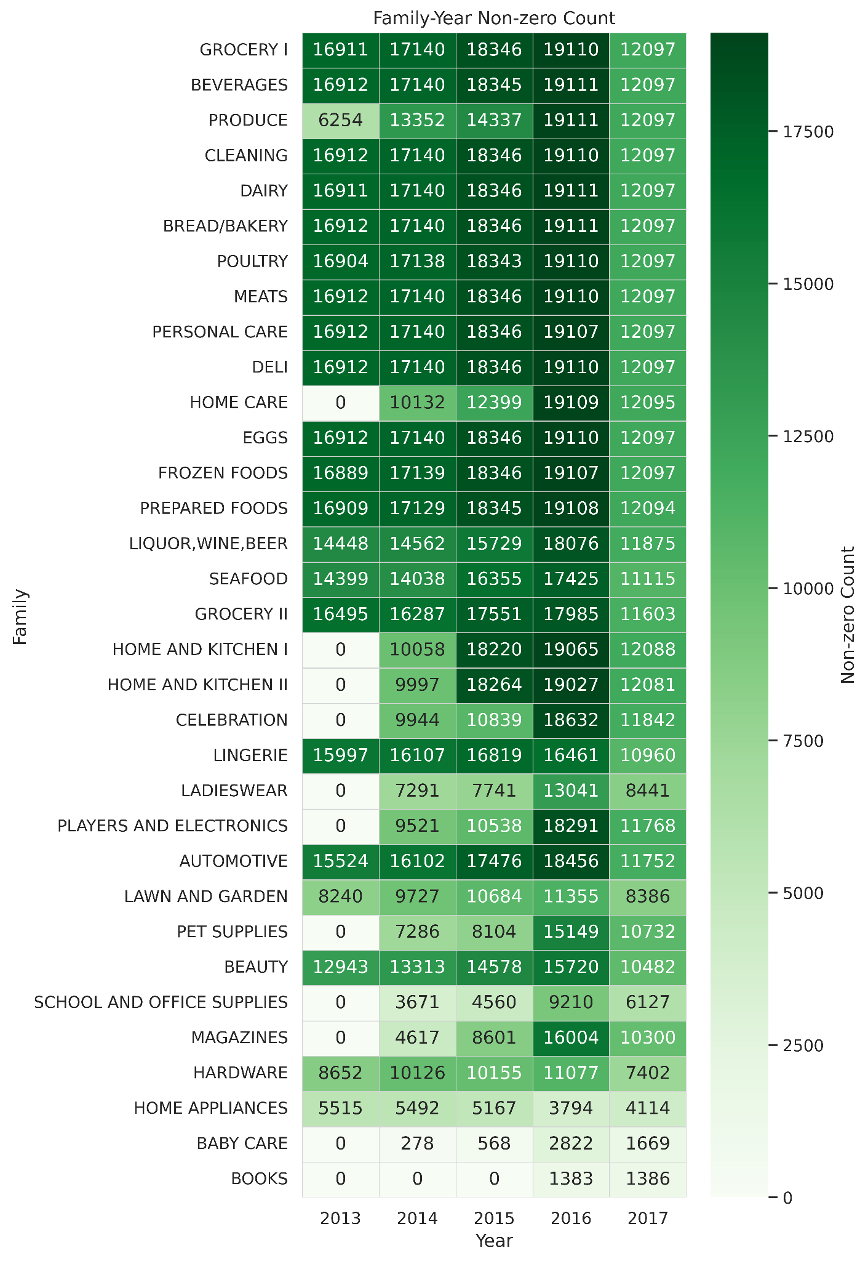
Figure 5.5.3 Heatmap of yearly sales per product

Evaluation Metrics
Forecast performance is assessed using Mean Absolute Error (MAE), a widely used and interpretable accuracy metric. The GNN, TFT, and hybrid GNN–TFT models are benchmarked against a baseline model and then comparatively evaluated to determine relative strengths.

References
Lalou, P., Ponis, S.T.. & Efthymiou, O.K.. (2020). Demand Forecasting of Retail Sales Using Data Analytics and Statistical Programming. Management & Marketing, 15(2), 2020. 186-202 https://doi.org/10.2478/mmcks-2020-0012
Sukel, Maarten & Rudinac, Stevan & Worring, Marcel. (2023). Multimodal Temporal Fusion Transformers Are Good Product Demand Forecasters. 10.48550/arXiv.2307.02578.
Bryan Lim, Sercan Ö. Arık, Nicolas Loeff, Tomas Pfister (2021). Temporal fusion transformers for interpretable multi-horizon time series forecasting. International Journal of Forecasting, 37(4), 1748–1764. https://doi.org/10.1016/j.ijforecast.2021.03.012
Kozodoi, N., Zinovyeva, L., Valentin, S., Pereira, J., & Agundez, R. (2023). Probabilistic demand forecasting with graph neural networks. Retrieved from https://www.amazon.science/publications/probabilistic-demand-forecasting-with-graph-neural-networks
Aktas, M. Y., Ji, T., & Lu, C.-T. (2024). Time series forecasting with GCN-LSTM based unified model for product demand prediction. In 2024 IEEE International Conference on Big Data (BigData) (pp. 5901–5906). https://doi.org/10.1109/BigData62323.2024.10825969
Ngeni, F., Kutela, B., Chengula, T. J., Ruseruka, C., Musau, H., Novat, N., Indah, D. A., & Kasomi, S. (2024). Prediction of bike-sharing station demand using explainable artificial intelligence. Machine Learning with Applications, 17, Article 100582. https://doi.org/10.1016/j.mlwa.2024.100582
Favorita Kaggle Dataset
https://www.kaggle.com/competitions/store-sales-time-series-forecasting/overview

Appendix

