Web Application Development Tools Laboratory Work N1

During this laboratory work you will create your own one page website with dynamical elements using Node.js with Express.js.

Task 1. Install NPM at your local environment.

NPM installation guide:
https://docs.npmjs.com/downloading-and-installing-node-js-and-npm

You can use any Node Version Manager (NVM) to set up your project.

Provide screenshot from Linux/Windows/MasOS terminal with NPM and Node.js version after installation.

To do a check after installation please run the following commands:

node -v
npm -v

Paste screenshot here:

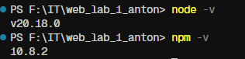

Task 2. Create New Web App Project (using Node.js with Express.js)

Create a new folder (at the place you want to keep your project).

Note: You may use ANY known method to create your own package and it’s not limited to express.js. Use any appropriate tools.

Please follow this guide, but replace project name with your own one:
https://javascript.plainenglish.io/create-a-single-page-website-using-node-js-and-express-js-a0b53e396e4f

In our example let’s call project: node-lab-website

Create two files inside node-lab-website folder:
→ package.json file.
→ server.js file.

Create a folder (name: express) and a file inside node-lab-website/express folder:
→ node-lab-website/express/index.html file.

Open up and update your node-lab-website/package.json file with below code:

{
"name": "node-lab-website",
"version": "1.0.0",
"description": "",
"scripts": {
"start": "node server.js"
},
"dependencies": {
"express": "^4.17.1"
}
}

Open up and update your node-lab-website/server.js file with below code:

const http = require('http');
const express = require('express');
const path = require('path');const app = express();
app.use(express.json());
app.use(express.static("express"));// default URL for website
app.use('/', function(req,res){
res.sendFile(path.join(__dirname+'/express/index.html'));
//__dirname : It will resolve to your project folder.
});const server = http.createServer(app);
const port = 3000;
server.listen(port);console.debug('Server listening on port ' + port);

After creating above two files, open your terminal in the "node-lab-website" folder and run this command:

npm install

This command ↑ will install the dependencies defined in "package.json" file.

After dependency installation this will create "node_modules" folder at the root of the "node-lab-website" folder.

Please create screenshot with folder node_modules and node-lab-website folder contents.\
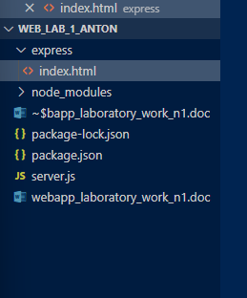

Task 3. Add design template to your Web App.

Replace your → node-lab-website/express/index.html file with code below, or you may use your own template.

You may also add all your static files inside express folder like…
→node-lab-website/express/css and node-ex-website/express/js

Code with template example is located in the Laboratory Work Task in the following file: lab1_index.html.

You can use this code, but please rename it to index.html.

Provide screenshot of index.html contents from the package structure, with project tree open in your code editor.

Paste screenshot here:
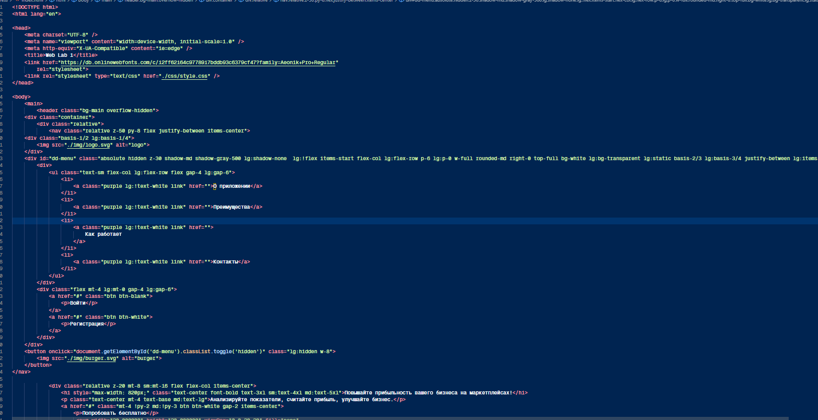

Task 4. Run Project.

To start a server run this command in terminal:
npm start
To test this API — Open your web browser and enter this URL → localhost:3000

Please make a screenshot of the result and paste it here:

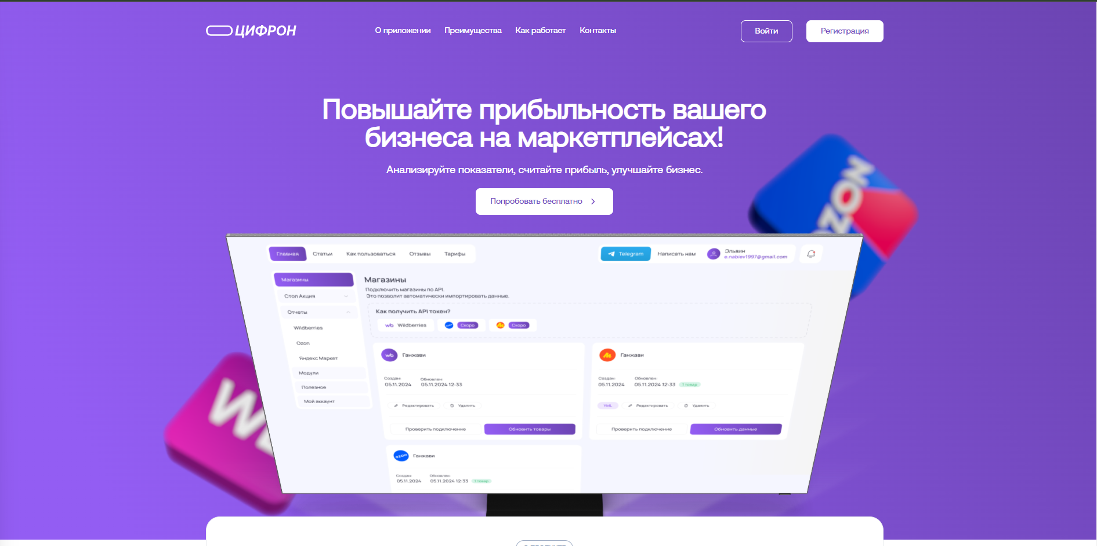

Task 5. Add your unique CSS style to the project.

TODO:
1. Add at least one paragraph style.
2. Add or change styles for two tags. Ideas for the change: div, ul, li, img

Note: you can use SASS to minimize coding effort in CSS.

Run project once again.

To run package manager:

npm start
To test this API — Open your web browser and enter this URL → localhost:3000

Please make a screenshot of the result with updated CSS and paste it here:
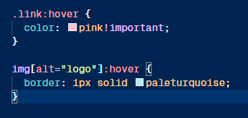

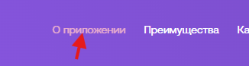

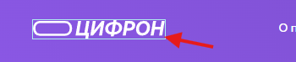

Task 6. Add Javascript effects and animation

TODO:
1. Add at 3 different JS effects to your website and use at least one event condition.
Note: You can use jQuery
2. Add at least one animation to the page.

Note: you can use SASS to minimize coding effort in CSS.

Run project once again.

That’s it! We’re close to the finish

To run package manager:

npm start
To test this API — Open your web browser and enter this URL → localhost:3000

Please make a screenshot of the result with JS effects and paste it here:

1
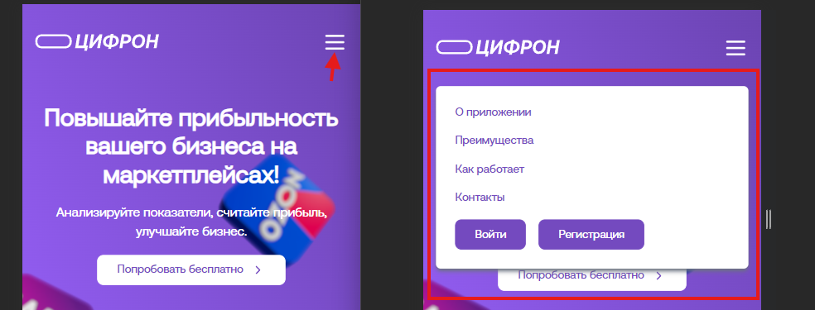

2
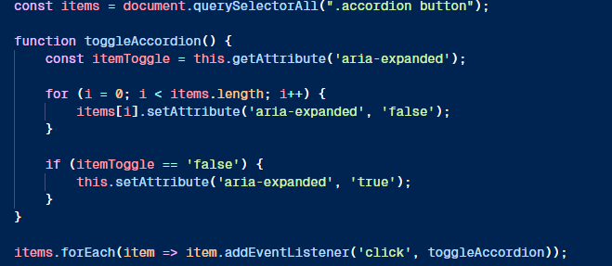
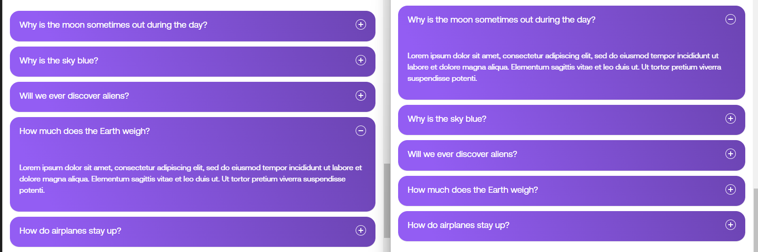

3

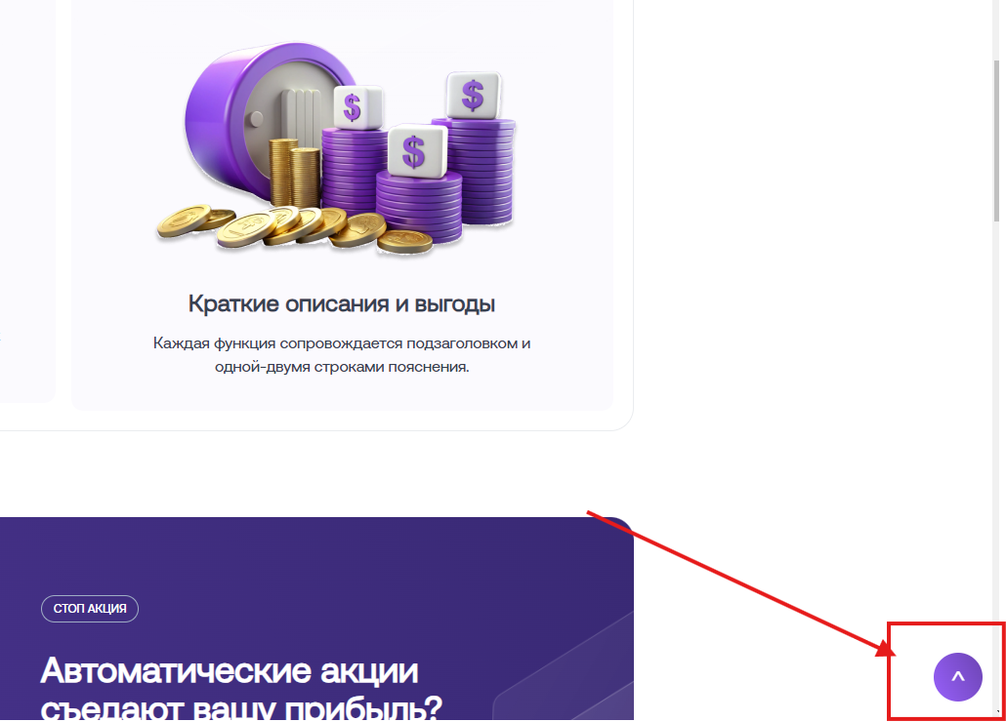

Scroll to top button

Animation: pulse animation
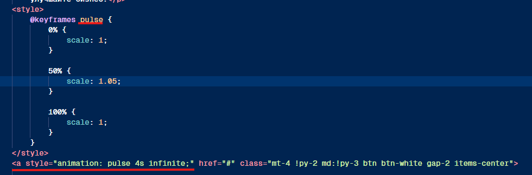
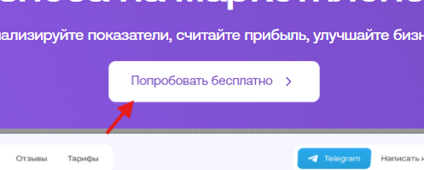

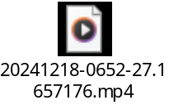

Task 7. Debug the code

During project creation you might encounter errors or problemr.

Please specify what errors/problems you encountered and solved during Laboratory Work 1.
(You may provide answer in a written form below.)

Task 8. Commit final code to your student’s GitHub account.

Provide link to your GitHub here:

