Laboratory Work N2 Task – Web Application Development Tools

Step 1.

Choose one of the following projects:

== Django ==

Lab Variant 1. Login System in Django

Implement a basic template of a login system and then you can use the template in any web app with just minimal changes to quickly build the web apps.

Apply dynamic website elements to login system and events on page load.

Lab Variant 2. Text to HTML Generator

This is an interesting project in which you can build an interface from where you can specify the text and with just a button, it will generate an HTML web page with some stylings.

Apply dynamic website elements buttons and visualize output.

Lab Variant 3. Python Calorie Counter

The calorie counter app is a great way to keep track of all the calories you are burning every day. The user can add all the food they are eating and the app will count the calories. You can further add a function for users to add their daily workout sessions, running and jogging to calculate how much calories they have burned.

Lab Variant 4. Django Chat App

Create a simple chat app where you can create chat rooms and users will chat in real-time. You don’t need to store all the previous chat records as you can display only a few recent chats and older chats will be deleted.

Apply dynamic website elements to chat. E.g. animation to the text.

Lab Variant 5. Syntax Highlighter.

Build a website where you can have an interface to write python code (or any other language). The syntax of the code should get automatically highlighted by the program. Later you can use it as a great tool which helps while coding.

Apply dynamic website elements to the highlighting and page load events.

Lab Variant 6. Sending Emails with Python

Build form to create and send email. Automate the process of sending emails. You can have a list of email addresses and their respective names. Then you can modify the message and send emails to the target audience automatically.

Apply dynamic website elements to the UI.

== React ==

Lab Variant 7. Coronavirus (COVID-19) Dashboard

Build a COVID-19 Dashboard that shows its impact on the World

You can follow the example:
https://www.freecodecamp.org/news/how-to-create-a-coronavirus-covid-19-dashboard-map-app-in-react-with-gatsby-and-leaflet/

Lab Variant 8. Piano player application

You can follow the example:
https://dev.to/ganeshmani/building-a-piano-with-react-hooks-3mih

Lab Variant 9. Blogging / Portfolio App

Build a blogging or portfolio app. It allows you to show off what you can do as a developer, while also allowing you to include posts and content that reflect what you know.

Lab Variant 10. ToDo Application

Build a todo app with react. Application should be able to add ToDo task, preview all “todo”s and remove one from the list. Please apply dynamic website elements to the Todo list.

You can follow the example:
https://towardsdatascience.com/build-a-simple-todo-app-using-react-a492adc9c8a4

NB!
1. You can use any code you find on WWW and to work with other students, but – the final mark will be split if two students have identical works.
2. You may use ANY framework for project, Django and React are a proposed framework.

Step 2. Fill in project passport

Project Passport
Student | Project Name | Brief project description | Framework | GitHub Link
 | Lab 8, Piano App | Simple piano application, 7 Notes | React, UseSound

Step 3. Create project and deploy application on local machine

Step 4. Debug code

Step 5. Provide screenshot of deployed application
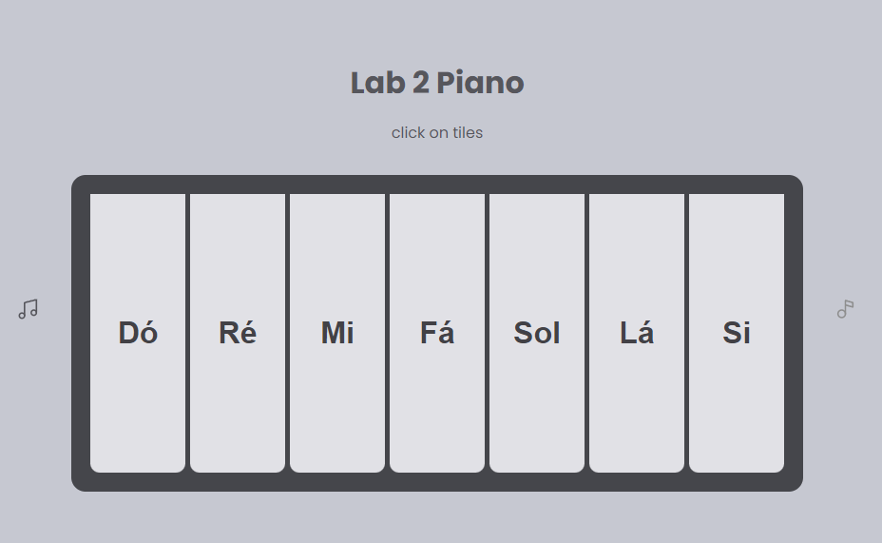

Step 6. Submit code to your GitHub Account

