Manila Water Company

FUNCTIONAL SPECIFICATION – REPORT

DID_S2P_355

Summary of Billing Progress Report

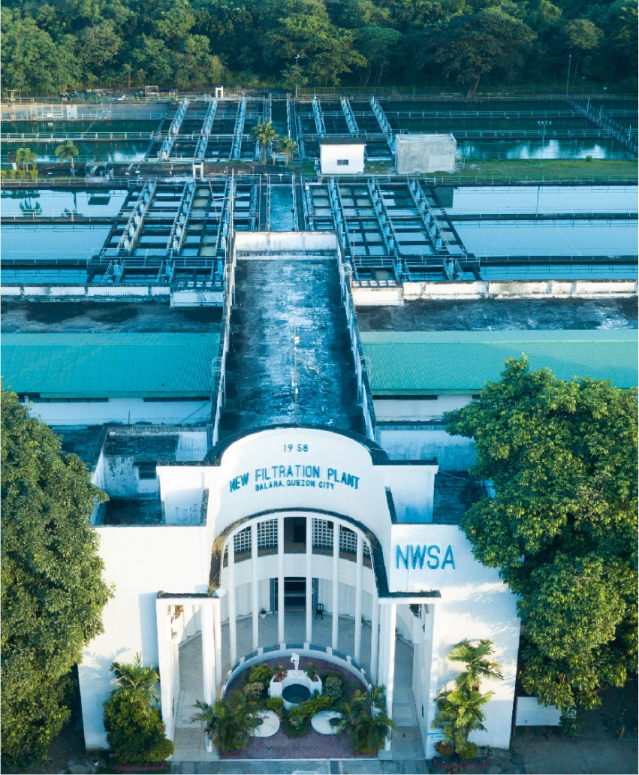

Customer NameDocument Title





[How to use the Template: This chapter gives only explanations on the template. Remove it before completing the template.
Blue text is always intended as instructions, guidelines, explanations, hints, and tips. It should always be removed from the template for the project.
Update Fields in Document: If you want to update all fields, press "CTRL+A," then "F9". You will get pop-ups sequentially, which ask you for the new values. Afterwards go to the footer area, then press "CTRL+A" and "F9" again.
Top-level chapters may not be deleted or inserted; required additions should be made as sub-chapters to existing chapters to provide a consistent representation of this document to the customer. To keep the numbering of the chapters consistent over all specifications (of the project), do NOT delete top-level chapters that are not relevant in a concrete document; only mark them as not relevant (that is, add “not relevant” or “not applicable”).]
[Document Version Status has four values: Draft, Ready for Review, Reviewed with Comments and Final. If the document send by an Author(s) without an intention of a Review should have a status as Draft. A Draft document may have some incomplete sections.
If the document send by an Author(s) with an intention of a Review should have a status as Ready for Review. All the sections in the document are expected to be completed in this case.
Reviewer(s) should set only two statuses:
- Reviewed with Comments – if documents needs to send the document to Author(s).
- Final – marks the acceptance of reviewer for the document.]
You can for example number the appropriate versions as follows:
0.1 Draft
0.2 Ready for Review
0.3 Reviewed with Comments (in case document is send back to author(s)
0.3 Ready for Review (in case of major changes)
1.0 Final

In case of fundamental changes:
1.1 Draft (new draft version that has to pass a review again)
1.2 Ready for internal review
1.3 Ready for Review
2.0 Final

Contents
1 Document Organization 5
1.1 Document Log 5
1.2 Integration, Document Reference 5
2 Justification 6
3 Functional Description 6
4 Transaction Volume 6
5 Frequency & Timing 6
6 Dependencies 6
7 Selection Criteria 6
8 Validation of Selection Criteria 7
9 Authorization Requirements 7
9.1 Definition 7
9.2 Defined Fields 7
9.3 Procedure 7
10 Variants 7
11 Functional Design 7
12 Report Output 7
12.1 Output Method 7
12.2 Main Heading 7
12.3 Sub Heading 7
12.4 Layout 8
12.5 Report Header & Footer 8
13 Assumptions in Functional Design 8
14 Open Issues in Functional Design 8
15 Business Test Conditions 8
16 Related Documentation 9

Document Organization
This section provides details about this document, previous version(s) of this document and the document(s) referred.

Document Log
Following table mentions the version changes and the processer(s):
Version | Status | Date | Version Created by (Name/E-Mail/Company) | Role | Comments
0.1 | Draft | July 15, 2025 | Surinder Reddy Surkanti | Author
 | Choose an item. | Click here to enter a date. |  | Choose an item.

Integration, Document Reference
N/A
.

Justification
There is no standard report available in SAP to fetch the data required in this report.

Functional Description
This document provides detailed functional requirements for developing a customized Billing Progress Report in SAP. The purpose of this report is to meet specific business requirements that are not fulfilled in the standard SAP. It provides information on each Service Entry Sheet created for a Project or PO along with corresponding Invoice details and other related information.
- Header Information: The header of report will have the below information: -
- PO number
- Project code
- Description
- Vendor
- Currency
- PO date
- Advance Payment
- Retention
- Balance
- Contract
- Addition
- Deletion
- Contract with changes

- Item details: The item details in table will have below information: -
- Period covered
- Date submitted
- PO
- SAP Invoice / Year
- Invoice status
- Invoice number
- Previous
- Current billing
- To date
- Balance
- Retention Withheld
- Retention released
- Advances
- The report will be generated in ALV (ABAP List Viewer) format with support for Excel export.

Transaction Volume
The expected number of records to be displayed on this report is between 100 and 2000 records of Invoice document

Frequency & Timing
This report will be run on daily basis.

Dependencies
Not applicable

Selection Criteria

Table/  Structure Name | Field Name | Format | Default Value | Table Value/  Checkbox/  Radio Button/  Radio Button Group | Select Option or Parameter | Mandatory or Optional | Field Labels
PROJ | PSPNR | CHAR | NA | Table Value | Parameter | Mandatory | Project code
EKKO | WAERS | CURR | NA | Table Value | Parameter | Optional | Currency
EKKO | EBELN | NUMC | NA | Table Value | Parameter | Mandatory | Original PO/JO
EKKO | EBELN | NUMC | NA | Table Value | Parameter | Mandatory | Purchase Order
RBKP | CPUDT | DATS | NA | Table Value | Parameter | Optional | Invoice Creation date

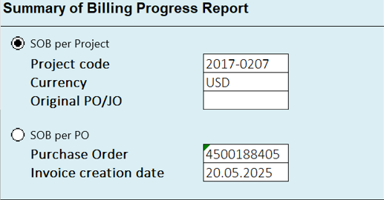

There will be 2 sets of selection parameters as shown above.
- SOB per Project
- SOB per PO
User will have the option to select either one of them using radio button.

Validation of Selection Criteria

To validate if the PO number entered in ‘Original PO/JO’ is Original PO using the below logic.

Pass EKKO-EBELN in table EKPO and fetch EKPO-KNTTP where EKPO-EBELP=10

If EKPO-KNTTP= P or Q
Then pass EKKO-EBELN in table EKKN and fetch PS_PSR_PNR.
Pass EKKN- PS_PSR_PNR into AUFK- PSPEL and fetch AUART.
If AUFK-AUART NE ‘ZMWC’ or ZNEZ’ then give error ‘ PO XXXXXXXXXX is not an original PO/JO.

If EKPO-KNTTP=N,
Then pass EKKO-EBELN in table EKKN and fetch NPLNR.
Pass EKKN- NPLNR into AUFK-AUFNR and fetch AUART.
If AUFK-AUART NE ‘ZMWC’ or ZNEZ’ then give error ‘ PO XXXXXXXXXX is not an original PO/JO
(Please create new parameter in TVARVC table to maintain AUFK-AUART values- ZMWC, ZNEZ)

To validate if the PO number entered in ‘Original PO/JO’ is created for the ‘Project code’ entered in the selection screen

Pass PO number EKKO-EBELN in table EKPO and fetch EKPO-KNTTP from the first line item where EKPO-LOEKZ NE L or S.

If EKPO-KNTTP= P or Q
Then pass EKKO-EBELN in table EKKN and fetch PS_PSR_PNR.
Pass EKKN- PS_PSR_PNR into PRPS-PSPNR and fetch project code PSPHI.
If PSPHI is Not equal to ‘Project code’ in the selection screen then give the error ‘ PO xxxxxxxxxx belongs to a different project’

If EKPO-KNTTP=N,
Then pass EKKO-EBELN in table EKKN and fetch NPLNR.
Pass EKKN- NPLNR into AUFK-AUFNR and fetch AUFK-PSPEL.
Pass AUFK-PSPEL into PRPS-PSPNR and fetch project code PSPHI.
If PSPHI is Not equal to ‘Project code’ in the selection screen then give the error ‘ PO xxxxxxxxxx belongs to a different project’

If Invoice creation date (RBKP-CPUDT) is blank, then the report should include all the invoices created for the PO entered in selection screen. However, if invoice date is entered then, only those invoices created on the entered date should be displayed in the report.

Authorization Requirements
[Please fill this section if there are special Authorization Requirements; else mention N/A. Every authorization object needs to be documented to provide the security administrator information on the purpose and use of the object. The following sections are the minimal documentation requirements]

Definition
[The definition establishes the purpose and or use for the object. Mention a standard object available to be used or custom authorization object to be created (if needed).]

Defined Fields
[The defined fields should be listed with the valid values to be used. (Like Activity 01/02/03)]

Procedure
[The procedure section helps to explain how this object is to be used. Examples with field values and explanations should be provided.]

Variants
[Selection profiles for pick list of pre-defined report options for the end user.]

Functional Design

Functional Design for SOB report ‘Per Project’
Output field | Logic to fetch data
PO No. | Original PO/JO entered in the selection screen (EKKO-EBELN)
Project Code | Project code entered in the selection screen (PROJ-PSPNR)
Description | Pass PSPNR into PROJ table and fetch POST1
Vendor | Pass EBELN (Original PO/JO number) into table EKKO and fetch vendor number LIFNR. Pass LIFNR into table LFA1 and fetch vendor name NAME1.
Currency | Currency as entered in selection screen (EKKO-WAERS)
PO Date | Pass EBELN (Original PO/JO number) into table EKKO and fetch BEDAT
Advance Payment | Pass EBELN (Original PO/JO number) into table EKKO and fetch RETPC . Suffix %
Retention | Pass EBELN (Original PO/JO number) into table EKKO and fetch DPPCT. Suffix %
Balance | 100 – Retention. Suffix %
Contract | Pass EBELN (Original PO/JO number in selection screen) into table EKPO and fetch EFFWR for each line item. Sum up all the values of EFFWR of each line item to get the contract value in the currency given in selection screen. All PO line items including those marked for deletion also need to be considered.  Pass (Original PO/JO number) EKKO-EBELN in table EKPO and fetch EKPO-KNTTP for all PO line items.  If EKPO-KNTTP= P or Q  Then pass EKKO-EBELN in table EKKN and fetch PS_PSR_PNR.  Pass EKKN- PS_PSR_PNR into AUFK- PSPEL and fetch AUART.  If AUFK-AUART = “ZMWC” or “ZNEZ” then fetch EKPO- EFFWR for each line item. Sum up all the values of EFFWR of each line item. This is Amount A  If EKPO-KNTTP=N,  Then pass EKKO-EBELN in table EKKN and fetch NPLNR.  Pass EKKN- NPLNR into AUFK-AUFNR and fetch AUART.  If AUFK-AUART = “ZMWC” or “ZNEZ” then fetch EKPO- EFFWR for each line item. Sum up all the values of EFFWR of each line item. This is Amount B  Contract = A+B  All PO line items including those marked for deletion also need to be considered.  Convert the contract amount into the currency selected on the selection screen, based on the purchase order (PO) date as the conversion date.
Addition | Pass Project code (PROJ-PSPNR) into PRPS- PSPHI and fetch the list of WBS elements from field PSPNR. Pass PSPNR in EKKN- PS_PSP_PNR and fetch all PO lines from EBELN & EBELP. Pass EBELN and EBELP into table EKPO and fetch effective value EFFWR where EBELN is NE ‘Original PO/JO’ from selection screen. Sum up effective value EFFWR for all the PO line item in the currency given in selection screen. This is amount A  Pass Project code (PROJ-PSPNR) from selection screen AFKO-PRONR and fetch the list of Network orders from field AUFNR. Pass AUFNR into EKKN- NPNLR and fetch all PO line items from EBELN & EBELP. Pass EBELN and EBELP into table EKPO and fetch effective value EFFWR where EBELN is NE ‘Original PO/JO’ from selection screen. Sum up EFFWR for all the PO line item in the currency given in selection screen. This is amount B  Addition = A + B  Extract a complete list of all the purchase orders created for Project code (PROJ-PSPNR). Pass Project code (PROJ-PSPNR) into PRPS- PSPHI and fetch the list of WBS elements from field PSPNR. Pass PSPNR into EKKN- PS_PSP_PNR and fetch all PO numbers from EBELN and line item numbers from EBELP. This is list A.  Pass Project code (PROJ-PSPNR) into AFKO-PRONR and fetch the list of Network orders from field AUFNR. Pass AUFNR into EKKN- NPNLR and fetch all PO numbers from EBELN and line item numbers from EBELP. This is list B.  Complete PO line item list (EKPO-EBELN, EKPO-EBELP) = A + B  Pass PO number EKPO-EBELN and line item EKPO-EBELP in table EKPO and fetch EKPO-KNTTP for all PO line items.  If EKPO-KNTTP= P or Q  Then pass EKKO-EBELN in table EKKN and fetch PS_PSR_PNR.  Pass EKKN- PS_PSR_PNR into AUFK- PSPEL and fetch AUART.  If AUFK-AUART = “ZVAR” or “ZNVA” then fetch EKPO- EFFWR for each line item. Sum up all the values of EFFWR of each line item. This is Amount A  If EKPO-KNTTP=N,  Then pass EKKO-EBELN in table EKKN and fetch NPLNR.  Pass EKKN- NPLNR into AUFK-AUFNR and fetch AUART.  If AUFK-AUART = “ZVAR” or “ZNVA” then fetch EKPO- EFFWR for each line item. Sum up all the values of EFFWR of each line item. This is Amount B  Addition = A+B  All PO line items including those marked for deletion also need to be considered.  Convert the contract amount into the currency selected on the selection screen, based on the purchase order (PO) date as the conversion date.
Deletion | Pass all PO numbers from above list EBELN and line items EBELP into table EKPO and fetch effective value EFFWR where EKPO-LOEKZ = L or S. Sum up effective value EFFWR for all the PO line item in the currency given in selection screen . This is deletion amount  Convert the deletion amount using the currency selected on the selection screen, based on the purchase order (PO) date as the conversion date.
Contract with Change | Contract + Addition – Deletion
 | TABLE DATA
To extract a complete list of all the purchase orders created for Project code (PROJ-PSPNR), Pass Project code (PROJ-PSPNR) into PRPS- PSPHI and fetch the list of WBS elements from field PSPNR. Pass PSPNR into EKKN- PS_PSP_PNR and fetch all PO numbers from EBELN and line item numbers from EBELP. This is list A.
Pass Project code (PROJ-PSPNR) into AFKO-PRONR and fetch the list of Network orders from field AUFNR. Pass AUFNR into EKKN- NPNLR and fetch all PO numbers from EBELN and line item numbers from EBELP. This is list B.
Complete PO list = A + B

Progress Billing | This is sequential number for data lines starting with 1
Period Covered | Period covered refers to SES performance period.  Pass PO number EBELN into MMPUR_SES_ITEM – REFERENCEPURCHASEORDER and corresponding line item numbers EBELP into MMPUR_SES_ITEM – REFERENCEPURCHASEORDERITEM and fetch PERFORMANCEDATE & PERFORMANCEENDDATE where MMPUR_SES_HEADER- APPROVALSTATUS = 30. Keep a hyphen between both the dates.
Date Submitted | Date submitted refers to Invoice creation date.  Pass EBELN into MMPUR_SES_ITEM – REFERENCEPURCHASEORDER and corresponding line item numbers EBELP into MMPUR_SES_ITEM – REFERENCEPURCHASEORDERITEM and fetch Service Entry sheet number SERVICEENTRYSHEET. Pass SERVICEENTRYSHEET into EKBE- LFBNR and fetch creation date CPUDT where BEWTP = Q
PO | This refers to the PO numbers EKKO-EBELN
SAP Invoice / Year | SAP Invoice/Year refers to SAP Supplier invoice number and Fiscal Year  Pass EBELN into MMPUR_SES_ITEM – REFERENCEPURCHASEORDER and corresponding line item numbers EBELP into MMPUR_SES_ITEM – REFERENCEPURCHASEORDERITEM and fetch Service Entry sheet number SERVICEENTRYSHEET. Pass SERVICEENTRYSHEET into EKBE- LFBNR and fetch invoice number BELNR and year GJAHR where BEWTP = Q and RBKP- STBLG=Blank  To exclude invoices that were rejected in approval workflow  Pass BELNR into SWW_WI2OBJ- SONT_KEY_PART_1 and GJAHR into SWW_WI2OBJ- SONT_KEY_PART_2 and fetch Work item ID WI_ID where WI_RH_TASK= TS00800577.  Pass WI_ID into IWORKFLOWTASK- WORKFLOWTASKINTERNALID and fetch WORKFLOWTASKRESULT. If WORKFLOWTASKRESULT = REJECTED then exclude the invoice number.
Invoice Status | Pass invoice number BELNR and year GJAHR into RBKP and fetch status RBSTAT
Invoice No. | The invoice number refers to the physical vendor's invoice number.  Pass invoice number BELNR and year GJAHR into RBKP and fetch XBLNR
Previous Billing (Doc Currency from selection) | =Previous Billing + Current Billing of previous data line. Convert the amount into the currency maintained in the selection screen based on the posting date as the conversion date.
Current Billing (Doc Currency from selection) | This refers to the total amount of current Invoice.  Pass invoice number BELNR and year GJAHR into RBKP and fetch RMWWR and VGART. Current billing = RMWWR. This value should be positive if VGART = RD and negative if VGART= RS. Convert the amount into the currency maintained in the selection screen based on the posting date as the conversion date.
To date (Doc Currency from selection) | Previous + Current billing
Balance (Doc Currency from selection) | Contract – To date
Retention Withheld | Pass invoice number BELNR and year GJAHR into RBKP-BELNR & RBKP-GJAHR and fetch supplier invoice number XBLNR and supplier LIFNR. Pass XBLNR and GJAHR into BKPF and fetch BELNR where BLART =RT. Pass BELNR, GJAHR and LIFNR into BSEG and fetch WRBTR where KTOSL= EGX. Convert the amount into the currency maintained in the selection screen based on the posting date as the conversion date.
Retention released | Pass invoice number BELNR into BKPF-XBLNR and fetch document number BELNR and year GJAHR where BLART= KZ. Pass BELNR, GJAHR and LIFNR into BSEG and fetch WRBTR where UMSKZ=H. Convert the amount into the currency maintained in the selection screen based on the posting date as the conversion date.
Advances | = Current billing * Advance Payment % / 100

Functional Design for SOB report ‘Per PO’
Output field | Logic to fetch data
PO No. | PO number entered in the selection screen (EKKO-EBELN)
Project Code | It is the Project code of the Purchase Order.  Pass PO number from selection screen EBELN into EKKN- EBELN to fetch WBS element from PS_PSP_PNR. Pass WBS element into PRPS- PSPNR and fetch project code from PSPHI.  If PS_PSP_PNR is not having values then,  Pass PO number into EKKN-EBELN to fetch Network order from NPLNR. Pass Network order NPLNR into AFKO-AUFNR and fetch project code from PRONR.
Description | Pass project code PSPNR into PROJ table and fetch POST1
Vendor | Pass PO number from selection screen into EKKO-EBELN and fetch vendor number LIFNR. Pass vendor number into table LFA1-LIFNR and fetch vendor name NAME1.
Currency | Pass PO number from selection screen into EKKO-EBELN and fetch WAERS
PO Date | Pass PO number from selection screen into EKKO-EBELN and fetch BEDAT
Advance Payment | Pass PO number from selection screen into EKKO-EBELN and fetch RETPC . Suffix %
Retention | Pass PO number from selection screen into EKKO-EBELN and fetch DPPCT. Suffix %
Balance | 100 – Retention. Suffix %
Contract | Pass PO number from selection screen into table EKPO-EBELN and fetch EFFWR for each line item. Sum up all the values of EFFWR of each line item to get the contract value in the document currency. All PO line items including those marked for deletion also need to be considered.
Addition | Not applicable. Amount will be 0
Deletion | Pass PO number from selection screen into EKPO-EBELN and fetch effective value EFFWR where EKPO-LOEKZ = L or S for all PO line items. Sum up effective value EFFWR for all the PO line item in document currency
Contract with Change | Contract + Addition - Deletion
 | TABLE DATA
Progress Billing | This is sequential number for data lines starting with 1
Period Covered | Period covered refers to SES performance period.  Pass PO number EBELN into MMPUR_SES_ITEM – REFERENCEPURCHASEORDER and corresponding line item numbers EBELP into MMPUR_SES_ITEM – REFERENCEPURCHASEORDERITEM and fetch PERFORMANCEDATE & PERFORMANCEENDDATE. Keep a hyphen between both the dates.
Date Submitted | Date submitted refers to Invoice creation date.  If Invoice creation date is not entered in the selection screen then,  Pass PO number EBELN into MMPUR_SES_ITEM – REFERENCEPURCHASEORDER and corresponding line item numbers EBELP into MMPUR_SES_ITEM – REFERENCEPURCHASEORDERITEM and fetch Service Entry sheet number SERVICEENTRYSHEET. Pass SERVICEENTRYSHEET into EKBE- LFBNR and fetch creation date CPUDT where BEWTP = Q  If Invoice creation date is entered in selection screen then,  Date Submitted = Invoice creation date
PO | PO number entered in the selection screen (EKKO-EBELN)
SAP Invoice / Year | This is the SAP Supplier invoice number and Fiscal Year  Pass EBELN into MMPUR_SES_ITEM – REFERENCEPURCHASEORDER and corresponding line item numbers EBELP into MMPUR_SES_ITEM – REFERENCEPURCHASEORDERITEM and fetch Service Entry sheet number SERVICEENTRYSHEET. Pass SERVICEENTRYSHEET into EKBE- LFBNR and fetch invoice number BELNR and year GJAHR where BEWTP = Q
Invoice Status | Pass invoice number BELNR and year GJAHR into RBKP and fetch status RBSTAT
Invoice No. | The invoice number refers to the physical vendor's invoice number.  Pass invoice number BELNR and year GJAHR into RBKP and fetch XBLNR
Previous Billing (Doc Currency from selection) | =Previous Billing + Current Billing of previous data line. Convert the amount into the currency maintained in the selection screen.
Current Billing (Doc Currency from selection) | This refers to the total amount of current Invoice.  Pass invoice number BELNR and year GJAHR into RBKP and fetch RMWWR and VGART. Current billing = RMWWR . This value should be positive if VGART = RD and negative if VGART= RS. Convert the amount into the currency maintained in the selection screen.
To date (Doc Currency from selection) | Previous + Current billing
Balance (Doc Currency from selection) | Contract – To date
Retention Withheld | Pass invoice number BELNR and year GJAHR into RBKP-BELNR & RBKP-GJAHR and fetch supplier invoice number XBLNR and supplier LIFNR. Pass XBLNR and GJAHR into BKPF and fetch BELNR where BLART =RT. Pass BELNR, GJAHR and LIFNR into BSEG and fetch WRBTR where KTOSL= EGX. Convert the amount into the currency maintained in the selection screen.
Retention released | Pass invoice number BELNR into BKPF-XBLNR and fetch document number BELNR and year GJAHR where BLART= KZ. Pass BELNR, GJAHR and LIFNR into BSEG and fetch WRBTR where UMSKZ=H. Convert the amount into the currency maintained in the selection screen.
Advances | = Current billing * Advance Payment % / 100

[What is the data to be extracted? Does the Selection Criteria include the full primary keys of the tables from which data is to be extracted?
How should the data be processed in the program – functional logic?]

Report Output
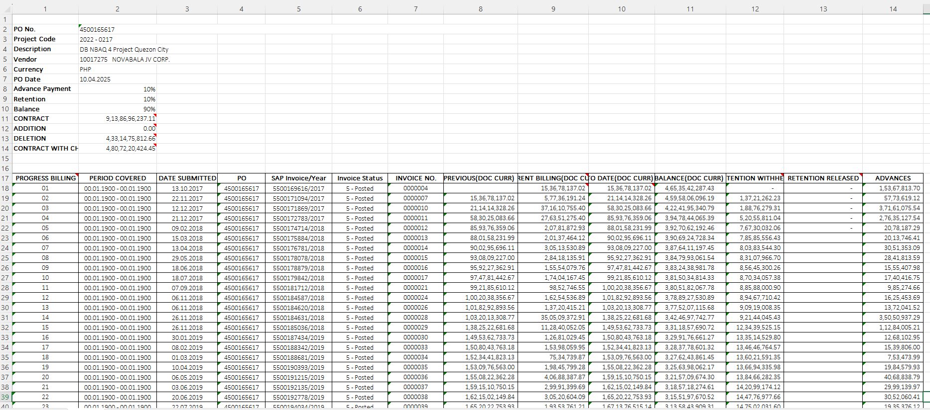

Output Method
[Please indicate the expected output method(s) for the report
Example: Saved to File / Sent to print / Send to email account / Download to excel]

Main Heading
The report heading will be ‘Summary of Billing Progress Report’

Sub Heading
Report per Project or Report per PO depending on the radio button selected in selection screen

Layout
Table/Structure Name | Field Name | Format  (i.e. decimal places) | Default Value | Column Name | Translation Rule

Report Header & Footer
[If deviation from the project defined header and footer is required mention Report Header and Report Footer]

Assumptions in Functional Design
[Describe any assumptions that have been made in the process of completing this design.]

Open Issues in Functional Design
[Please specify any open issues like missing functional information, users, details etc. which should be discussed in in subsequent phases of the project. Any open issues when cleared should be added to the relevant sections of this document in a new version.]

Business Test Conditions
[Please indicate the business level test conditions that should be used to verify successful operations of the Report]
[Document all technical scenarios associated with this development. Examples would include 1) testing an error-free run; 2) testing the exception processes; 3) testing the error handling.]
[Document all control scenarios associated with this development. Examples would include 1) Rounding of dollars and cents; 2) Audit trail processing; 3) Reconciliation reporting]
IMPORTANT: The developer will need to test repeatedly, so where appropriate provide instructions to reverse the actions performed so the test may be run again, or explain how to create new input data to the test.
Scenario # | Input Selection Criteria | Expected Result
1 | Extract the SOB report per project | The system displays the SOB report for all purchase orders related to the project
2 | Extract the SOB report per PO | The system displays the SOB report for the selected purchase order

Related Documentation
[Attach OSS notes, emails, download of existing report, etc.]

