Manila Water Company
technical specification - Enhancement

DID_M2C_016

Mass Creation of Master Data

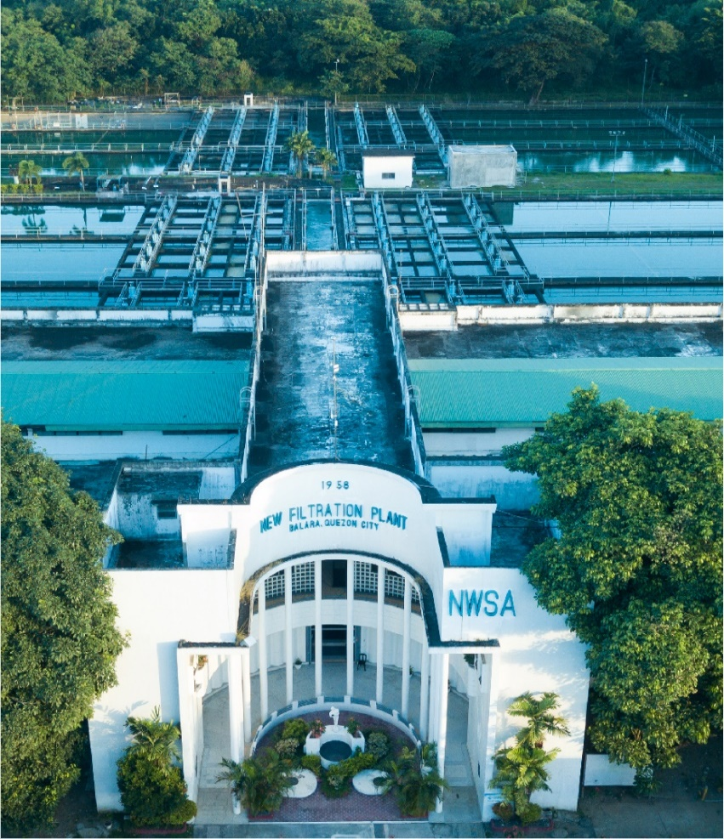



Contents
1 Document Organization 5
1.1 Document Log 5
1.2 Integration, Document Reference 5
2 Program Attributes 6
2.1 Selection Screen 6
2.2 Validation of Selection Criteria 7
2.3 CDS Views/AMDP/Table Function 7
2.3.1 Selection Condition 7
2.3.2 Join Condition 7
2.3.3 Fields 7
2.3.4 Additional Details 7
2.3.5 GIT Repository Details 7
2.4 Authorization Requirements 8
2.4.1 Definition 8
2.4.2 Defined Fields 8
2.4.3 Procedure 8
2.4.4 DCL Details 8
2.4.5 BTP Details 8
2.5 Technical Flow Diagram 8
2.6 UI Details 8
2.6.1 UI Mock Screens 8
2.6.2 Navigations 9
2.6.3 Actions 9
2.6.4 Validations 9
2.6.5 Other Details 10
2.7 Processing Logic 10
2.8 Reusable Code 10
2.9 Messages 10
2.10 Subroutines 11
3 Report Output 11
3.1 Output Method 11
3.2 Main Heading 11
3.3 Sub Heading 11
3.4 Layout / UI Design 11
3.5 Totaling 12
3.6 Sorting 12
3.7 Page Break 12
3.8 Error Handling 12
3.9 Report Header & Footer 12
4 Assumptions in Technical Design 12
5 Open Issues in Technical Design 12
6 Unit Test Results 12
7 Related Documentation 13

Document Organization
This section provides details about this document, previous version(s) of this document and the document(s) referred.

Document Log
Following table mentions the version changes and the processer(s):
Version | Status | Date | Version Created by (Name/E-Mail/Company) | Role | Comments
 | Draft | September 10, 2025 | Soumya Jaitawat | Author | Draft

Integration, Document Reference

S. No. | Referred Document Name | Referred Document Version | Referred Document URL (Optional)
N/A | N/A | N/A | N/A

Program Attributes
Program title | Mass Creation of Master Data
Program Name | ZAB_M2C_MASS_CREATION_DATA
Program Type | Executable
Package | ZS4_MWC_M2C_DM
Authorization Group | N/A

Transaction Code | ZTR_M2C_MASSCREATION
Include Programs | ZIN_M2C_MASS_CREATIONDATA_TOP.  ZIN_M2C_MASS_CREATIONDATA_SEL.  ZIN_M2C_MASS_CREATIONDATA_EVT.  ZIN_M2C_MASS_CREATIONDATA_F01.

SAP Tables Read | BUT000  FKKVK  ETYP  EVER  EANL  EVBS  EANLH  ERTFND  IFLOT  EQUI
Custom Tables Read | ZDT_M2C_DETCMPCD  ZDT_M2C_MD_TEMP
CDS Views | ZC_M2C_STREET  ZC_M2C_CITY  ZC_M2C_DISTRICT
OData Service | N/A
Business Object | N/A
Group Name | N/A
Catalog Name | N/A

Selection Screen

Validation of Selection Criteria
- File path should not exceed 127 characters.

CDS Views/AMDP/Table Function
N/A

Selection Condition
N/A

Join Condition
N/A

Fields

N/A

Additional Details
N/A

GIT Repository Details

Development Details
GIT Location | N/A
GIT URL | N/A

Authorization Requirements
N/A

Definition
N/A

Defined Fields
N/A

DCL Details
N/A

BTP Details

xs-security Configuration | N/A
IDP Setup | N/A
BTP Role Collections | N/A

Technical Flow Diagram
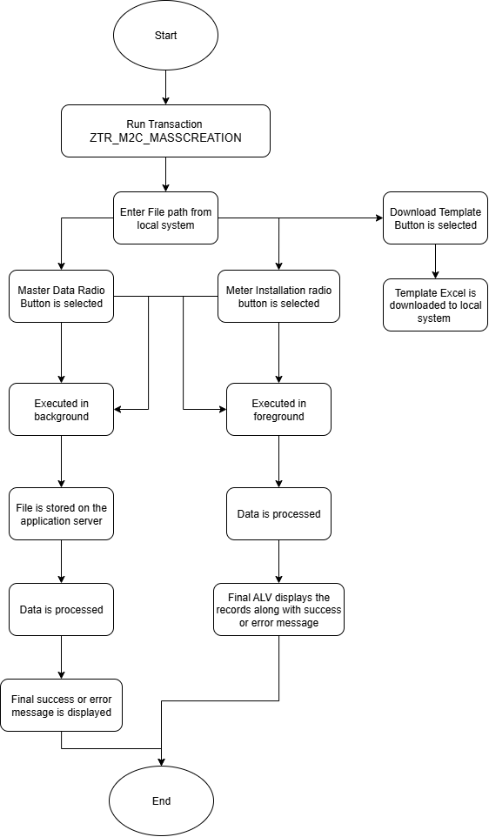

UI Details
N/A

UI Mock Screens

Application Name
Site | N/A
URL | N/A
Mockup | N/A

Navigations

Source View | Target View / URL | Pattern
N/A | N/A | N/A

Actions

Application | Screen(s) | Action | Type | Action Description
N/A | N/A | N/A | N/A | N/A

Validations
Application | Screen(s) | Field/Button | Validation Logic – Method, function details
N/A | N/A | N/A | N/A

Other Details
N/A

Processing Logic
- If user clicks download button, template is downloaded to the local system.
- Depending on chosen option ( Master Data / Meter Installation), Excel file is read using zcl_abap_utility=>read_excel_data and the data is stored in an internal table.
- If errors during upload are caught, it is displayed as an error and program exits

- If the file is executed in foreground mode -
- if Master Data radio button is selected
- Fetches reference data i.e. Street, cities, districts.
- Validates records and ensures mandatory fields are filled.
- Populates error messages into result table for missing/invalid values.

- If BP is not provided, create new BP via BAPI_BUPA_CREATE_FROM_DATA.
- If BP is already provided, validates and records as existing BP
- If Contract Account & Connection Object are not created, custom method is called to generate them.
- If already provided, logs them.
- Creates technical master data i.e. installation, device location, premise
- Adds BP identification (BAPI_IDENTIFICATION_ADD).
- Adds TIN number (BAPI_BUPA_TAX_ADD).
- Adds BP role (BAPI_BUPA_ROLE_ADD).
- Append to Final Log Table.
- Remove Information and Warning Messages.
- Final ALV is displayed.
- If radio button 2 is selected.
- Select all contract accounts (vkont) from FKKVK
- Check if vkont exists in lt_vkont, removes records which are not present in the table.
- validate mandatory fields.
- Update Equipment Master (BAPI_EQUI_CHANGE)
- Prepare Installation Data (ISU_S_WORKLIST_INSTALL_PROVIDE)
- Perform Meter Installation (ISU_S_WORKLIST_INSTALL)
- All errors and successful installations are logged with contract account, device number, and success or error message.

- If the file is executed in background mode -
- AL11 directory path is fetched from STVARV against ZTV_M2C_CM_MASTER_DATA and ZTV_M2C_CM_METER_INST.
- File name is constructed with system ID, date, and time.
- File is transferred to the application server.
- Background job is scheduled and further processing is done based on the radio button selected.
- On success, success message displayed.
- On failure, appropriate error messages raised.

Reusable Code
N/A

Messages
N/A

Subroutines
Name | Description
N/A
N/A
N/A

Report Output

Output Method

N/A

Main Heading

Sub Heading
N/A

Layout / UI Design
N/A

Totaling
N/A

Sorting
N/A

Page Break
N/A

Error Handling
N/A

Report Header & Footer
N/A

Assumptions in Technical Design

N/A

Unit Test Results

Scenario # | Input Selection Criteria | Expected Result | Actual Test Pass/Fail
01 | all records with correct values | entire data sets created successfully and result file with success records | Pass
02 | errors in few records / full records | process will fail and result file with error messages against each record | Pass
03 | all rows invalid (all missing mandatory fields) | no objects created; result file shows error messages for every row | Pass
04 | reprocessing with existing ids (bp_id, ca_id, co_id supplied) | system reuses ids: no duplicates created; result file shows all rows as success | Pass

Related Documentation

Template Version
Version | Status | Date | Version Created by (Name/E-Mail/Company) | Role | Comments
1.0 | Final | February 11, 2019 | Sweety | Author
1. | Final | March 15, 2022 | Sweety | Author | Updated to accommodate details of Fiori/UI5 Application related artifacts using ABAP programming model for SAP Fiori Elements

