Date | Version | Description | Prepared by | Approved by
18.06.2026 | V.01 | Value required in MB5B transaction code in first radio button (Storage Location) | Junaid Ali Khan

Client name | Astral Limited
Project name | UDAY
Module | MM/CO
WRICEF number | 195_BRD_FS
Version | V.01
Date | 18.06.2026
Type of development | Report
Complexity | Medium

Document revision history

Table of content
1 Overview and Scope 3
1.1 References 3
1.2 Functional Description 3
1.3 Assumptions 3
1.4 Initiating process 3
1.5 Processing Type 3
2 Detailed Functional Requirements 3
2.1 Functional Details 3
2.2 Inputs for BDC/ BAPI (data conversion program) 4
2.3 Inputs for user exit/ screen exit/ Enhancement 4
3 Testing Requirements 4
3.1 Unit Test Results 4

Overview and Scope

The business requires the value field in MB5B transaction code in first radio button (Storage Location)

References

MB5B Report

Functional Description

The business requires the value field in MB5B transaction code in first radio button (Storage Location)

Assumptions

The business requires the value field in MB5B transaction code in first radio button (Storage Location)

Initiating process

Executing MB5B report

Processing Type
Process Flow:
1. User executes the MB5B report.

Detailed Functional Requirements

Functional Details

- Program Specification:

1. User executes the MB5B report.

Logic

Copy the MB5B Report program and create a new program with below additional logic.

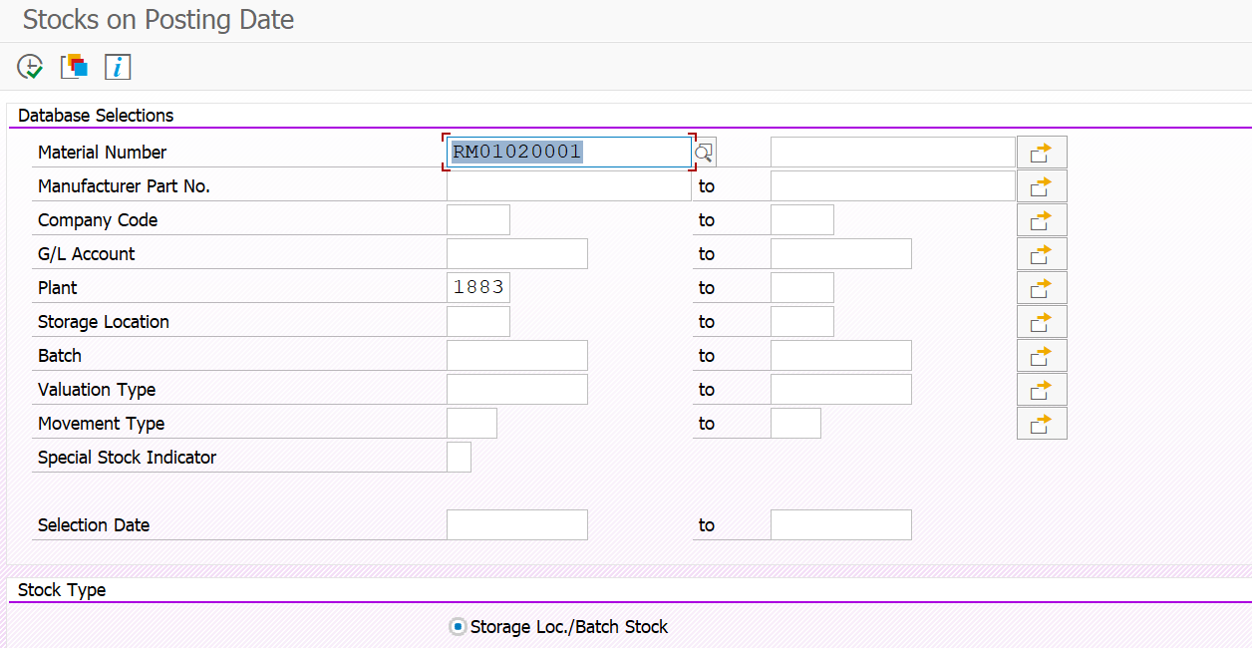

For Radio Button: Storage Loc./ Batch Stock

Please add “amount field” in the report with respect to the material document.

Pass the material document (MSEG-MBLNR) and year (MSEG-MJAHR) and pick the value (MSEG-DMBTR).

Inputs for BDC/ BAPI (data conversion program)

Inputs for user exit/ screen exit/ Enhancement

Testing Requirements

Unit Test Results

ID | Condition | Expected results | Cycle Ref.
1
2.
3.
4.
5.

