CLASSMARK: ATTENDANCE MANAGEMENT SYSTEM
Application URL: https://classmark-seven.vercel.app/Application URL: https://classmark-seven.vercel.app/
Internship Project Report\n\nSubmitted in partial fulfillment of the requirements for the degree

1. Introduction
ClassMark is a premium, institutional attendance monitoring system designed for modern colleges. It leverages Geo-fencing, Device Hardware Locking, and Time-bound OTPs to ensure 100% attendance accuracy. The system is built as a Progressive Web Application (PWA) allowing installation on mobile devices while working entirely offline during network drops.
The live deployment of ClassMark is available at: https://classmark-seven.vercel.app/

2. System Architecture
The backend leverages Node.js, Supabase Edge Functions, and PostgreSQL with strict Row Level Security (RLS). The frontend uses React 19 and Tailwind CSS.

2.1 High-Level Architecture
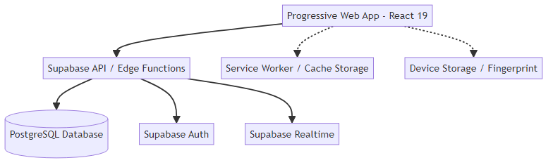

3. Database & Workflows

3.1 Entity-Relationship Diagram
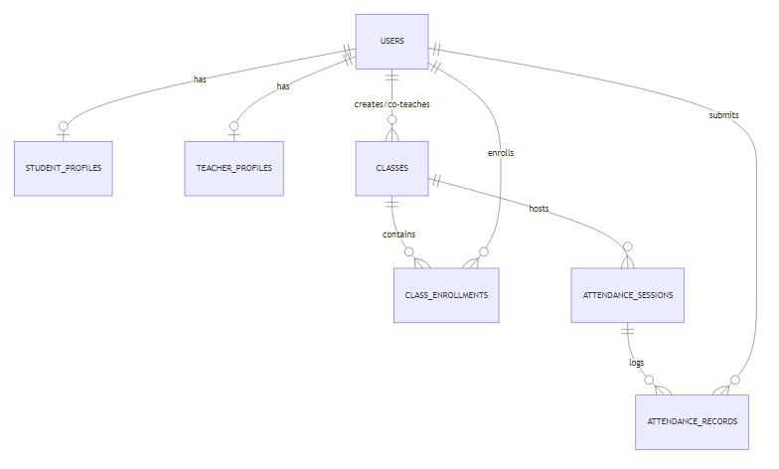

3.2 Authentication Sequence
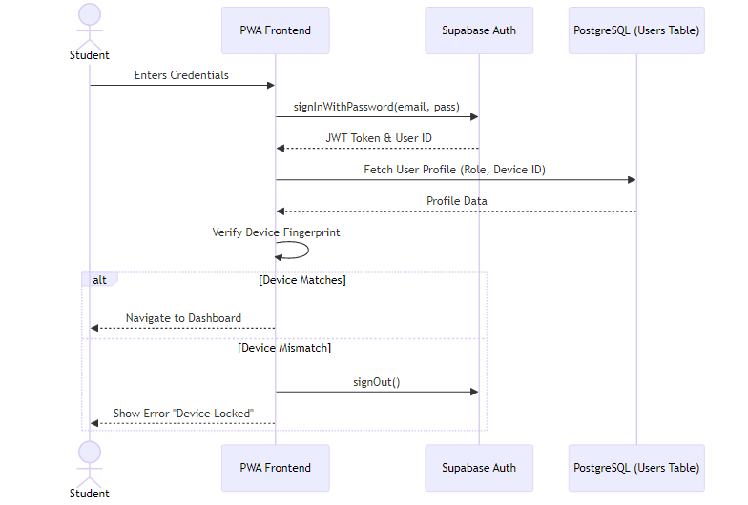

3.3 Attendance Activity Flow
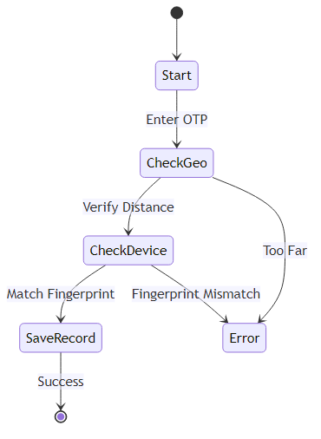

4. Application Interfaces
To cater to the primary user base (students), ClassMark is heavily optimized for mobile viewports using a mobile-first responsive design strategy. The following screenshots capture the live Progressive Web Application on a mobile viewport.

4.1 Login Interface
The secure gateway for both students and faculty members.
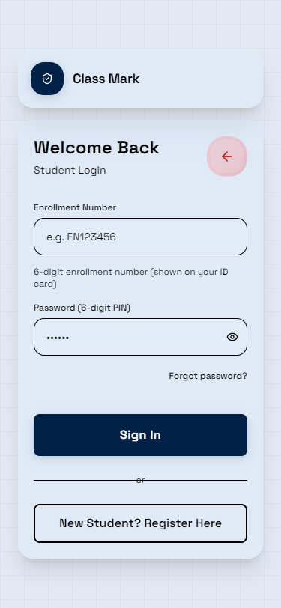

4.2 Student Dashboard
Displays student statistics, overall attendance percentage, and active classes.
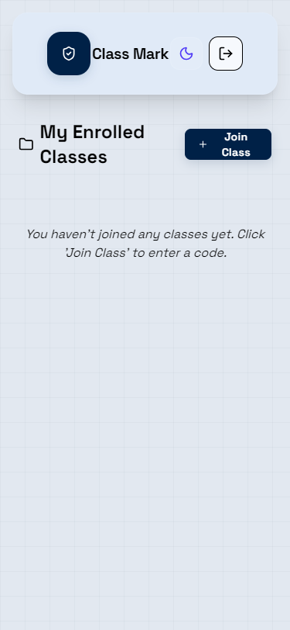

4.3 Teacher Dashboard
Allows faculty to manage classes, generate OTPs for live sessions, and export reports.
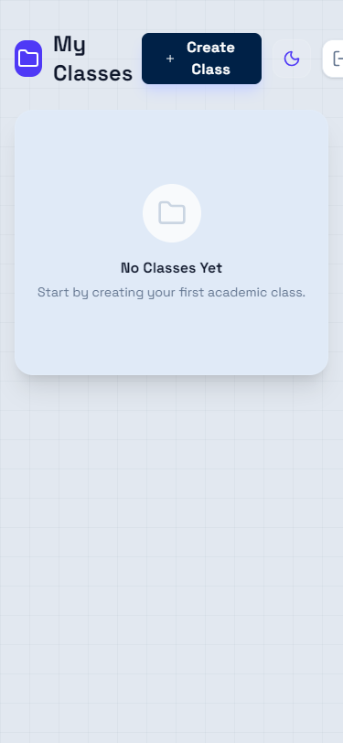

5. Conclusion
ClassMark successfully mitigates proxy attendance using a comprehensive combination of geographic restrictions and cryptographic device locking. Its highly polished PWA interface guarantees a native-like experience for all end users while maintaining strict institutional data isolation via Supabase RLS policies.

