GloveBud: A gesture control system

Akash James1, Gunjan Sethi2

1 Department of Computer Science and Engineering, REVA ITM, Bangalore, 560064, India

2 School of C&IT, REVA University, Bangalore, 560064, India

***Abstract-***

Gesture control and the concept of the Internet of Things, when implemented as a single entity, can undoubtedly revolutionize the way humans interface with various devices. From smart devices at homes to industrial robots, gestures can be used to control a number of devices that are connected together in a network.

GloveBud is a gesture-enabled glove that can be worn by the user to control various devices connected over a network preferably WiFi. The project aims at achieving home automation through the GloveBud by Wi-Fi enabling home appliances such as the lights, fans, televisions etc. GloveBud is then worn and predefined gestures allow the user to control their appliances.

***Major Components-***

* ESP8266 NodeMCU
* Accelerometer (ADXL345)
* Flex Sensors (one sensor for each finger)
* Intel Galileo 2Gen
* Fabric Glove

***Block Diagram-***

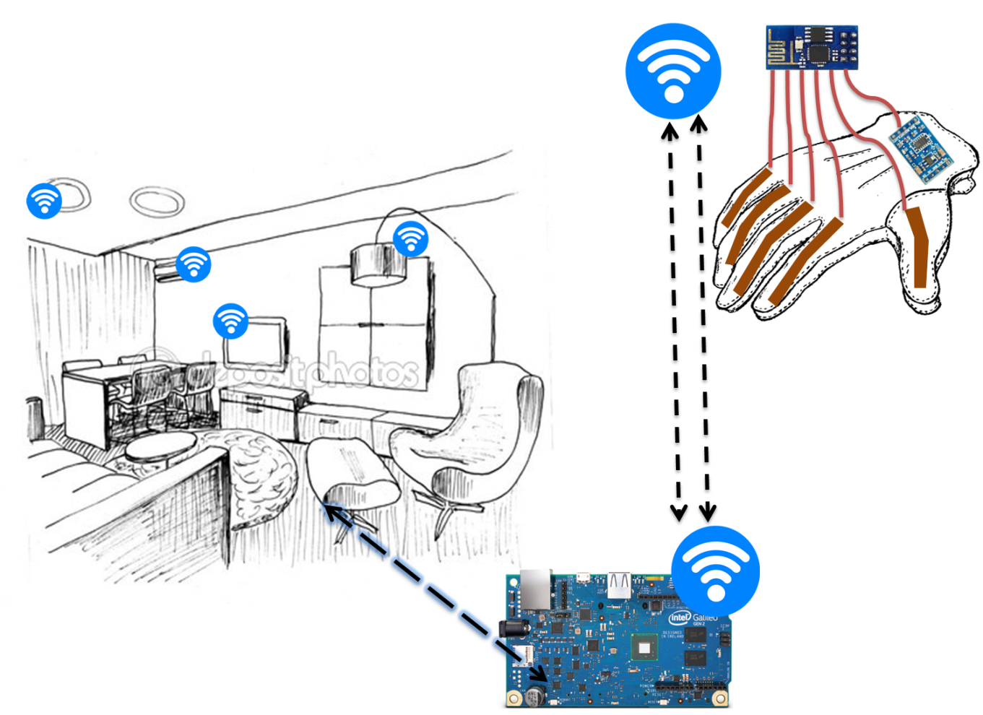

**Wi-Fi**

**Intel Galileo 2Gen**

*An Automated Living Room*

**Flex Sensors**

**Accelerometer**

*GloveBud*

**ESP8266 NodeMCU**

***Applications-***

* *Home Automation Systems*
* Gesture control (using the GloveBud) not only allows us to control our surroundings remotely, but also aids the *physically challenged* to access their surroundings more comfortably through reduced motion.
* Secure Systems: Amongst other methods on automation and control, gesture control is *extremely secure* giving a single person the soul control.
* Gesture control also gives *workers in industries* an easier work environment and a reduced pre-requisite skill-set, thereby decreasing unemployment.
* Further improvements of the project include enhancement of *human-cyborg* experiences and interfacing with *humanoids to mimic human activity.*