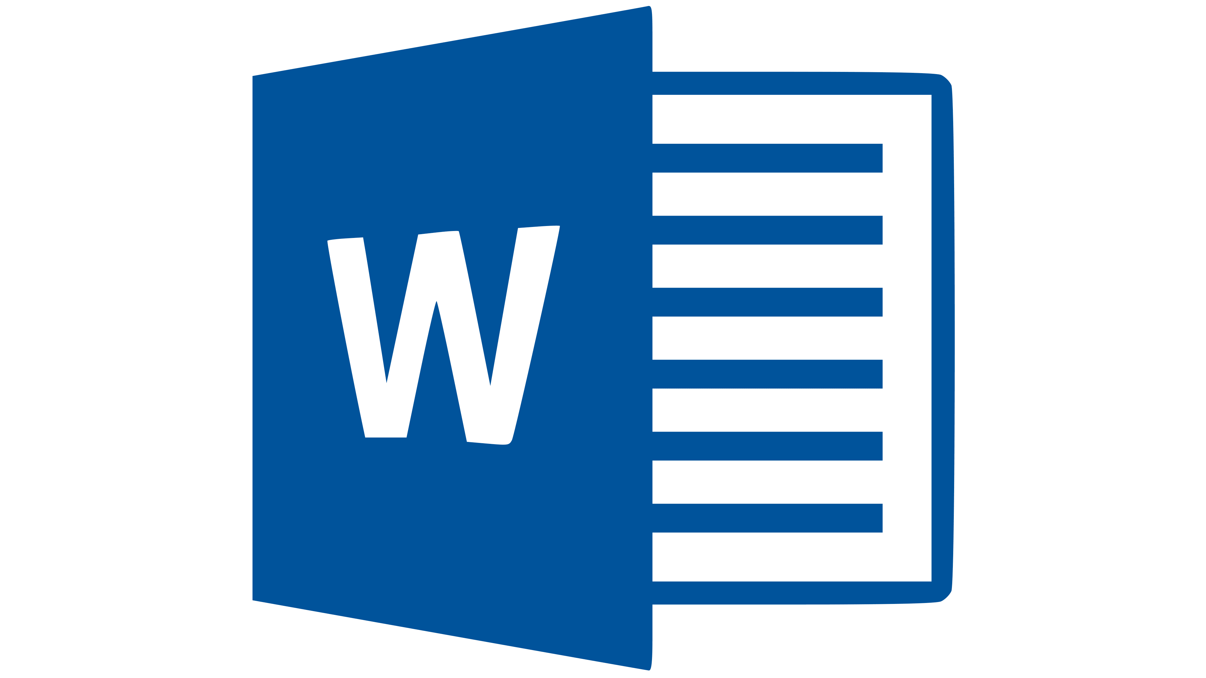Test Page

This is a Word Document File (DOCX)

Commonly associated with Microsoft Office 2007+

If you are able to read this DOCX file, software is installed on your computer capable of displaying this file type. DOCX files generally are for word processing. This format is the current version and has been available since 2007. Several software suites in addition to Microsoft’s are capable of edited these files including Google Docs.

Test Complete, you may close this File.

*Office*

*2019 / 365*