ROLL NO:727721EUCS008

DAY4:

CE2:

INPUT:

package day4pro2;

import org.openqa.selenium.By;

import org.openqa.selenium.JavascriptExecutor;

import org.openqa.selenium.WebDriver;

import org.openqa.selenium.WebElement;

import org.openqa.selenium.chrome.ChromeDriver;

import org.openqa.selenium.chrome.ChromeOptions;

import io.github.bonigarcia.wdm.WebDriverManager;

public class d4project2 {

public static void main(String[] args) throws InterruptedException {

//WebDriverManager.chromedriver().setup();

System.setProperty("webdriver.chrome.driver","C:\\chromedriver.exe");

ChromeOptions co=new ChromeOptions();

co.addArguments("--remote-allow-origins=*");

WebDriver driver=new ChromeDriver(co);

driver.get("https://demo.opencart.com/index.php?route=account/register&language=en-gb");

WebElement fname=driver.findElement(By.id("input-firstname"));

fname.sendKeys("AJAY");

WebElement lname=driver.findElement(By.id("input-lastname"));

lname.sendKeys("B");

WebElement ename=driver.findElement(By.id("input-email"));

ename.sendKeys("727721eucs008@skcet.ac.in");

WebElement pname=driver.findElement(By.id("input-password"));

pname.sendKeys("ajay");

JavascriptExecutor js=(JavascriptExecutor)driver;

js.executeScript("window.scrollBy(0,250)","");

Thread.sleep(3000);

WebElement yesbutton=driver.findElement(By.id("input-newsletter-yes"));

yesbutton.click();

}

}

OUTPUT:

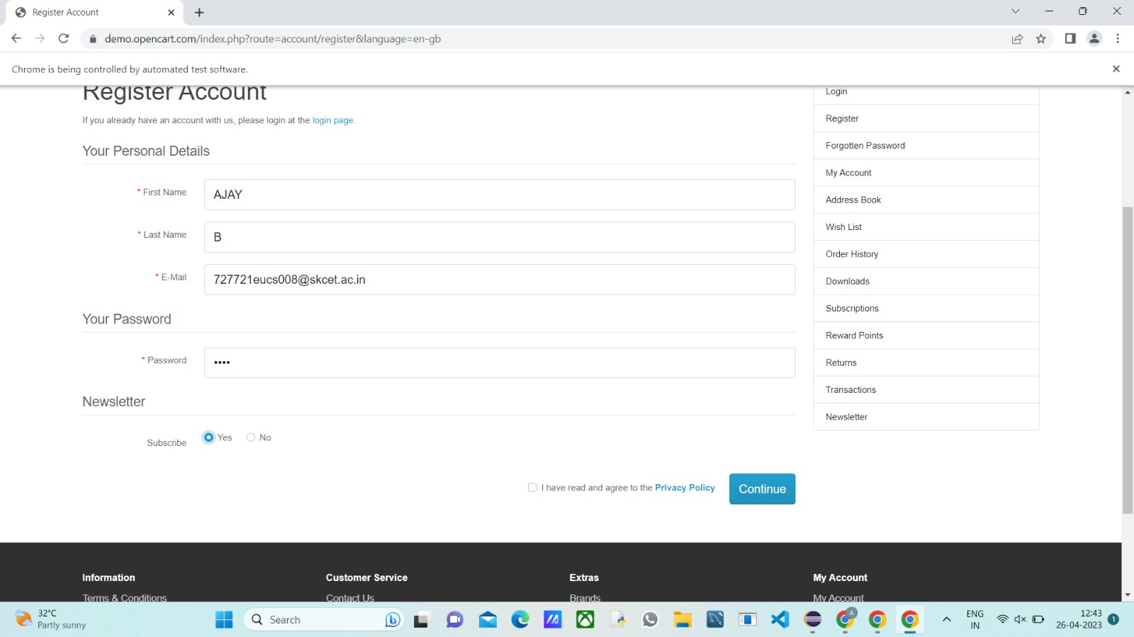

CE3:

INPUT:

package day4pro2;

import org.openqa.selenium.By;

import org.openqa.selenium.JavascriptExecutor;

import org.openqa.selenium.WebDriver;

import org.openqa.selenium.WebElement;

import org.openqa.selenium.chrome.ChromeDriver;

import org.openqa.selenium.chrome.ChromeOptions;

public class d4project3 {

public static void main(String[] args) throws InterruptedException {

//WebDriverManager.chromedriver().setup();

System.setProperty("webdriver.chrome.driver","C:\\chromedriver.exe");

ChromeOptions co=new ChromeOptions();

co.addArguments("--remote-allow-origins=*");

WebDriver driver=new ChromeDriver(co);

driver.get("https://demo.opencart.com/index.php?route=checkout/voucher&language=en-gb");

WebElement rname=driver.findElement(By.xpath("//*[@id=\"input-to-name\"]"));

rname.sendKeys("AJAY");

WebElement ename=driver.findElement(By.xpath("//*[@id=\"input-to-email\"]"));

ename.sendKeys("727721eucs008@skcet.ac.in");

WebElement fname=driver.findElement(By.xpath("//*[@id=\"input-from-name\"]"));

fname.sendKeys("AJAYB");

WebElement yname=driver.findElement(By.xpath("//*[@id=\"input-from-email\"]"));

yname.sendKeys("babuajay359@gmail.com");

WebElement yesbutton=driver.findElement(By.xpath("//*[@id=\"input-theme-7\"]"));

yesbutton.click();

JavascriptExecutor js=(JavascriptExecutor)driver;

js.executeScript("window.scrollBy(0,250)","");

WebElement mname=driver.findElement(By.xpath("//*[@id=\"input-message\"]"));

mname.sendKeys("hi guys:)");

JavascriptExecutor us=(JavascriptExecutor)driver;

us.executeScript("window.scrollBy(0,250)","");

Thread.sleep(3000);

WebElement cbutton=driver.findElement(By.xpath("//*[@id=\"form-voucher\"]/div[8]/div/div/input"));

cbutton.click();

WebElement dbutton=driver.findElement(By.xpath("//*[@id=\"form-voucher\"]/div[8]/div/button"));

dbutton.click();

}

}

OUTPUT:

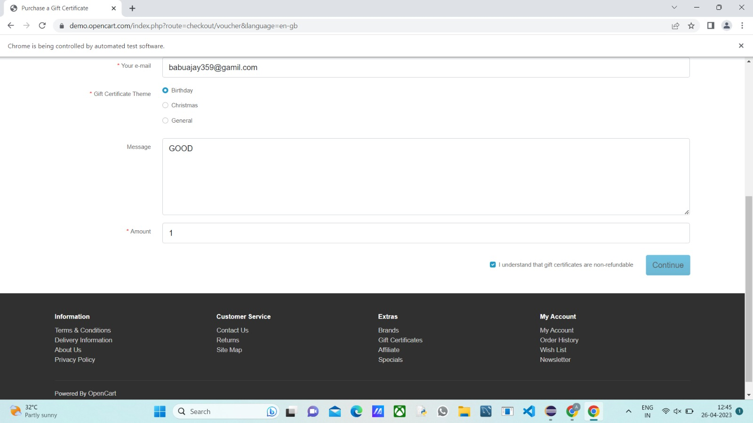

CE4:

INPUT:

package day4pro2;

import org.openqa.selenium.By;

import org.openqa.selenium.WebDriver;

import org.openqa.selenium.WebElement;

import org.openqa.selenium.chrome.ChromeDriver;

import org.openqa.selenium.chrome.ChromeOptions;

public class d4project4 {

public static void main(String[] args) {

System.setProperty("webdriver.chrome.driver","C:\\chromedriver.exe");

ChromeOptions co=new ChromeOptions();

co.addArguments("--remote-allow-origins=*");

WebDriver driver=new ChromeDriver(co);

driver.navigate().to("https://j2store.net/free/");

driver.manage().window().maximize();

WebElement clothing=driver.findElement(By.xpath("//*[@id=\"Mod112\"]/div/div/ul/li[1]/a/img"));

clothing.click();

driver.manage().window().maximize();

driver.navigate().back();

driver.navigate().forward();

driver.navigate().refresh();

driver.close();

}

}

OUTPUT:

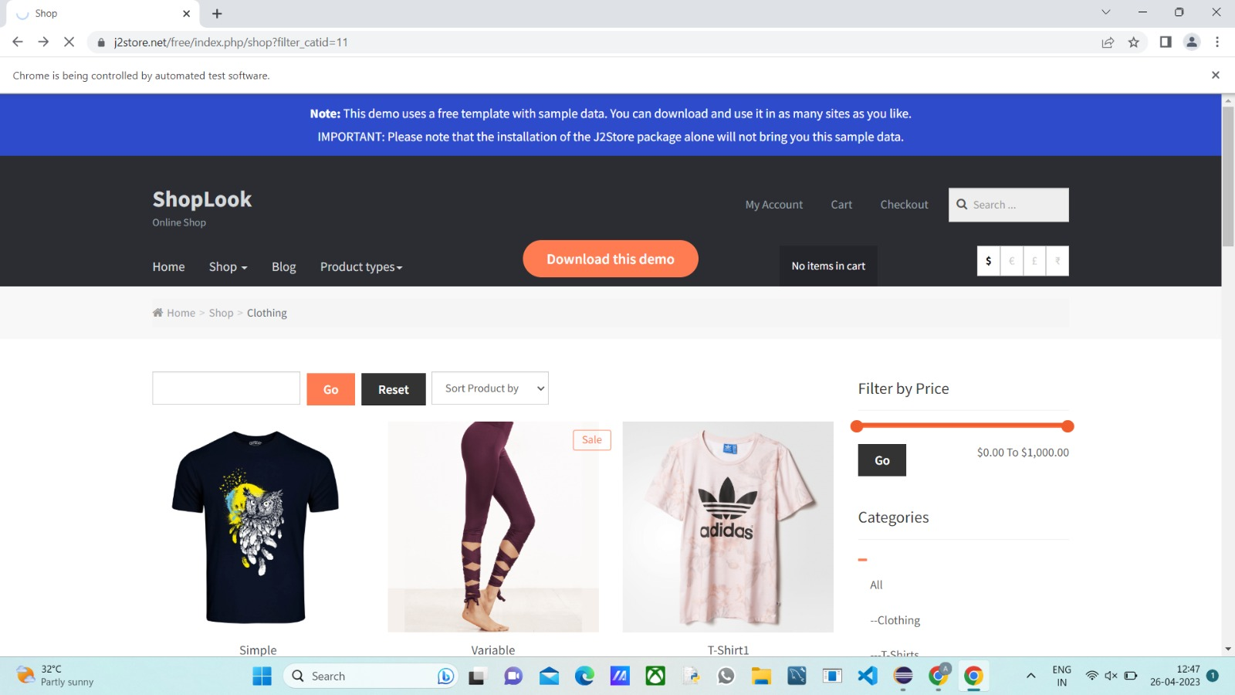

CE5.1:

INPUT:

package day4pro2;

import org.openqa.selenium.By;

import org.openqa.selenium.WebDriver;

import org.openqa.selenium.WebElement;

import org.openqa.selenium.chrome.ChromeDriver;

import org.openqa.selenium.chrome.ChromeOptions;

public class d4project5 {

public static void main(String[] args) {

System.setProperty("webdriver.chrome.driver","C:\\chromedriver.exe");

ChromeOptions co=new ChromeOptions();

co.addArguments("--remote-allow-origins=*");

WebDriver driver=new ChromeDriver(co);

driver.get("https://j2store.net/free/");

String url1=driver.getCurrentUrl();

if(url1.equals("https://j2store.net/free/"))

{

System.out.println("url validated");

}

WebElement clothing=driver.findElement(By.xpath("//*[@id=\"Mod112\"]/div/div/ul/li[1]/h4/a"));

clothing.click();

url1=driver.getCurrentUrl();

if(url1.equals("https://j2store.net/free/index.php/shop?filter_catid=11"))

{

System.out.println("url validated");

}

}

}

OUTPUT:

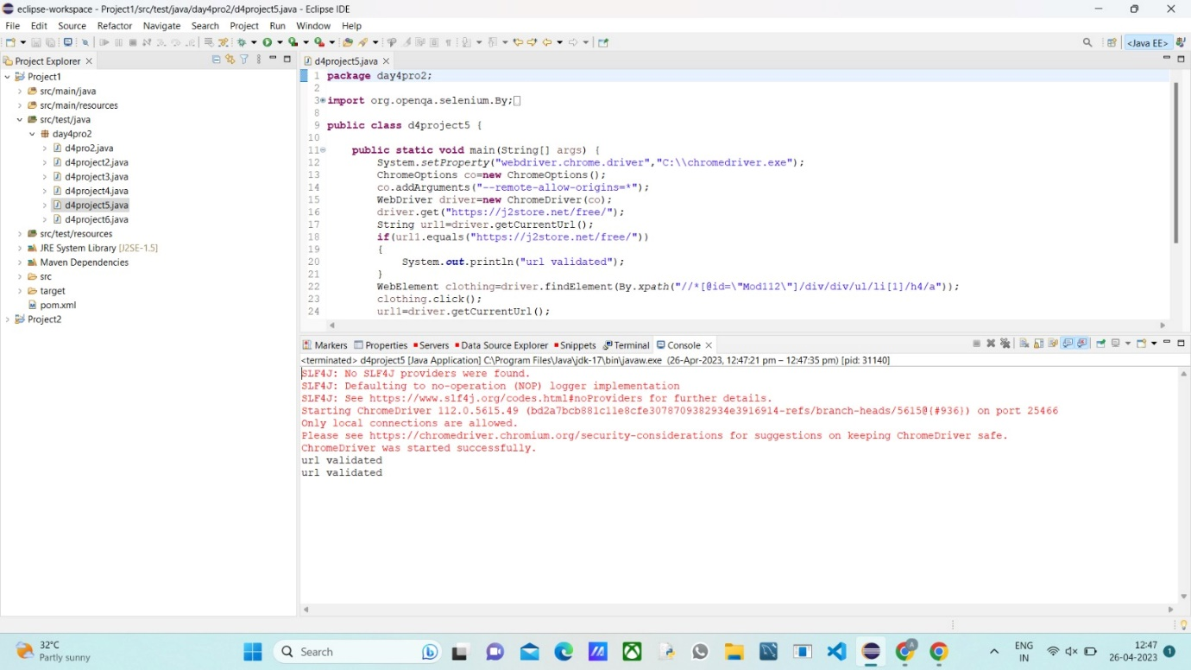

CE5.2:

INPUT:

package day4pro2;

import java.util.List;

import org.openqa.selenium.By;

import org.openqa.selenium.JavascriptExecutor;

import org.openqa.selenium.WebDriver;

import org.openqa.selenium.WebElement;

import org.openqa.selenium.chrome.ChromeDriver;

import org.openqa.selenium.chrome.ChromeOptions;

public class d4project6 {

public static void main(String[] args) throws InterruptedException {

System.setProperty("webdriver.chrome.driver","C:\\chromedriver.exe");

ChromeOptions co=new ChromeOptions();

co.addArguments("--remote-allow-origins=*");

WebDriver driver=new ChromeDriver(co);

driver.get("https://j2store.net/free/");

driver.manage().window().maximize();

JavascriptExecutor js=(JavascriptExecutor)driver;

js.executeScript("window.scrollBy(0,1000)", "");

driver.findElement(By.linkText("Clothing (5)")).click();

Thread.sleep(3000);

List<WebElement> l1=driver.findElements(By.xpath("//h2[@class='product-title']"));

for(WebElement link:l1)

{

System.out.println(link.getText());

}

}

}

OUTPUT:

