727721EUCS008

AJAY B

DAY 5:

CE1:

INPUT:

package day5;

import org.openqa.selenium.By;

import org.openqa.selenium.WebDriver;

import org.openqa.selenium.WebElement;

import org.openqa.selenium.chrome.ChromeDriver;

import org.openqa.selenium.chrome.ChromeOptions;

import org.openqa.selenium.interactions.Actions;

public class d5project1 {

public static void main(String[] args) {

System.setProperty("webdriver.chrome.driver","C:\\chromedriver.exe");

ChromeOptions co=new ChromeOptions();

co.addArguments("--remote-allow-origins=*");

WebDriver driver=new ChromeDriver(co);

driver.get("https://demoqa.com/droppable/");

Actions a=new Actions(driver);

WebElement source_ele=driver.findElement(By.id("draggable"));

WebElement dest_ele=driver.findElement(By.id("droppable"));

a.clickAndHold(source_ele).release(dest_ele).build().perform();

a.dragAndDrop(source_ele, dest_ele).build().perform();

}

}

OUTPUT:

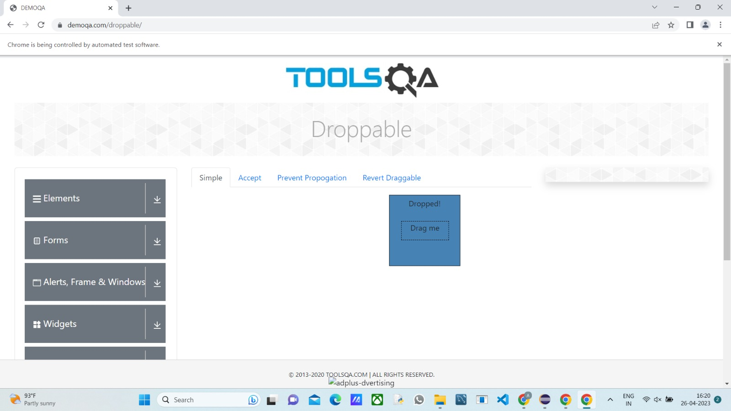

CE2:

INPUT:

package day5;

import org.openqa.selenium.By;

import org.openqa.selenium.WebDriver;

import org.openqa.selenium.WebElement;

import org.openqa.selenium.chrome.ChromeDriver;

import org.openqa.selenium.chrome.ChromeOptions;

import org.openqa.selenium.interactions.Actions;

public class d5project2 {

public static void main(String[] args) {

System.setProperty("webdriver.chrome.driver","C:\\chromedriver.exe");

ChromeOptions co=new ChromeOptions();

co.addArguments("--remote-allow-origins=*");

WebDriver driver=new ChromeDriver(co);

driver.get("https://jqueryui.com/droppable/");

driver.switchTo().frame(0);

Actions a=new Actions(driver);

WebElement source_ele=driver.findElement(By.id("draggable"));

WebElement dest_ele=driver.findElement(By.id("droppable"));

a.clickAndHold(source_ele).release(dest_ele).build().perform();

a.dragAndDrop(source_ele, dest_ele).build().perform();

}

}

OUTPUT:

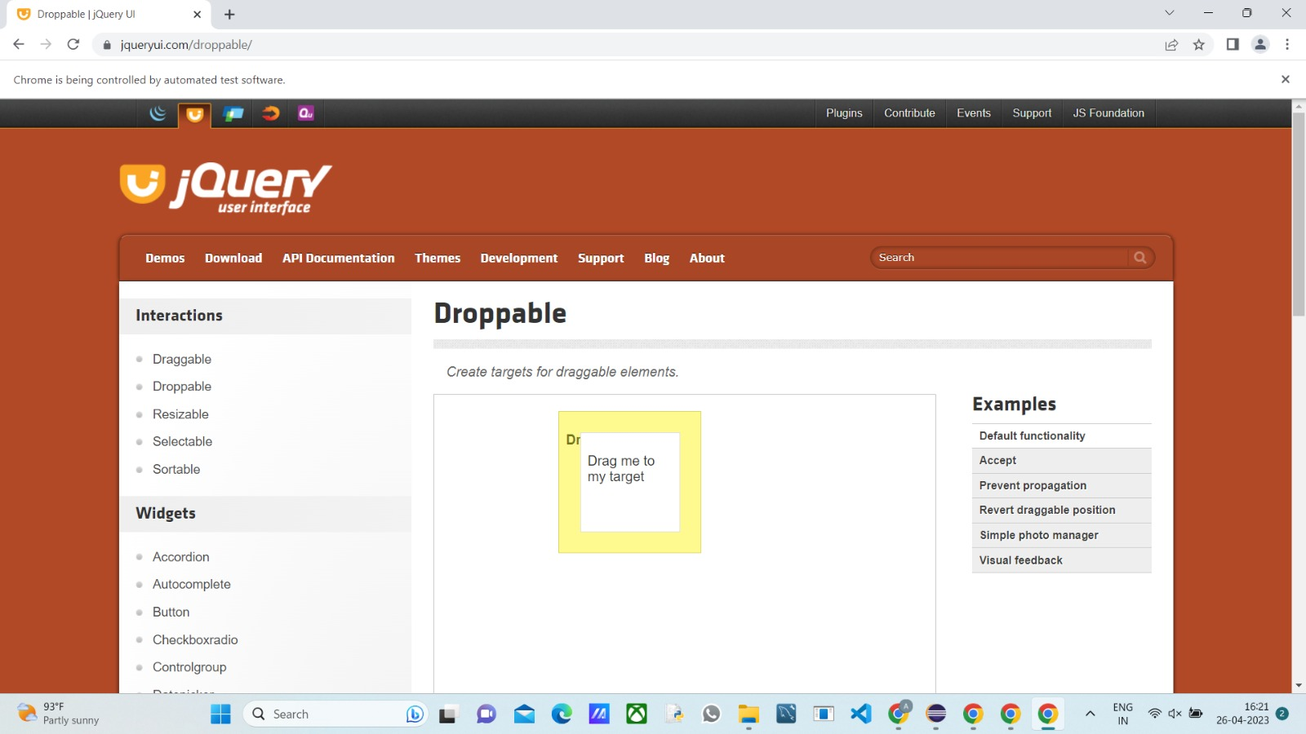

CE3:

INPUT:

package day5;

import org.openqa.selenium.Alert;

import org.openqa.selenium.By;

import org.openqa.selenium.WebDriver;

import org.openqa.selenium.WebElement;

import org.openqa.selenium.chrome.ChromeDriver;

import org.openqa.selenium.chrome.ChromeOptions;

public class d5project3 {

public static void main(String[] args) throws InterruptedException {

System.setProperty("webdriver.chrome.driver","C:\\chromedriver.exe");

ChromeOptions co=new ChromeOptions();

co.addArguments("--remote-allow-origins=*");

WebDriver driver=new ChromeDriver(co);

driver.get("https://demo.guru99.com/test/delete_customer.php");

WebElement fname=driver.findElement(By.name("cusid"));

fname.sendKeys("401");

WebElement yesbutton=driver.findElement(By.name("submit"));

yesbutton.click();

Alert alert1 =driver.switchTo().alert();

alert1.dismiss();

Thread.sleep(3000);

fname.clear();

fname.sendKeys("402");

yesbutton.click();

Alert alert2=driver.switchTo().alert();

alert2.accept();

Alert alert3=driver.switchTo().alert();

String txt=alert3.getText();

alert3.accept();

System.out.println(txt);

}

}

OUTPUT:

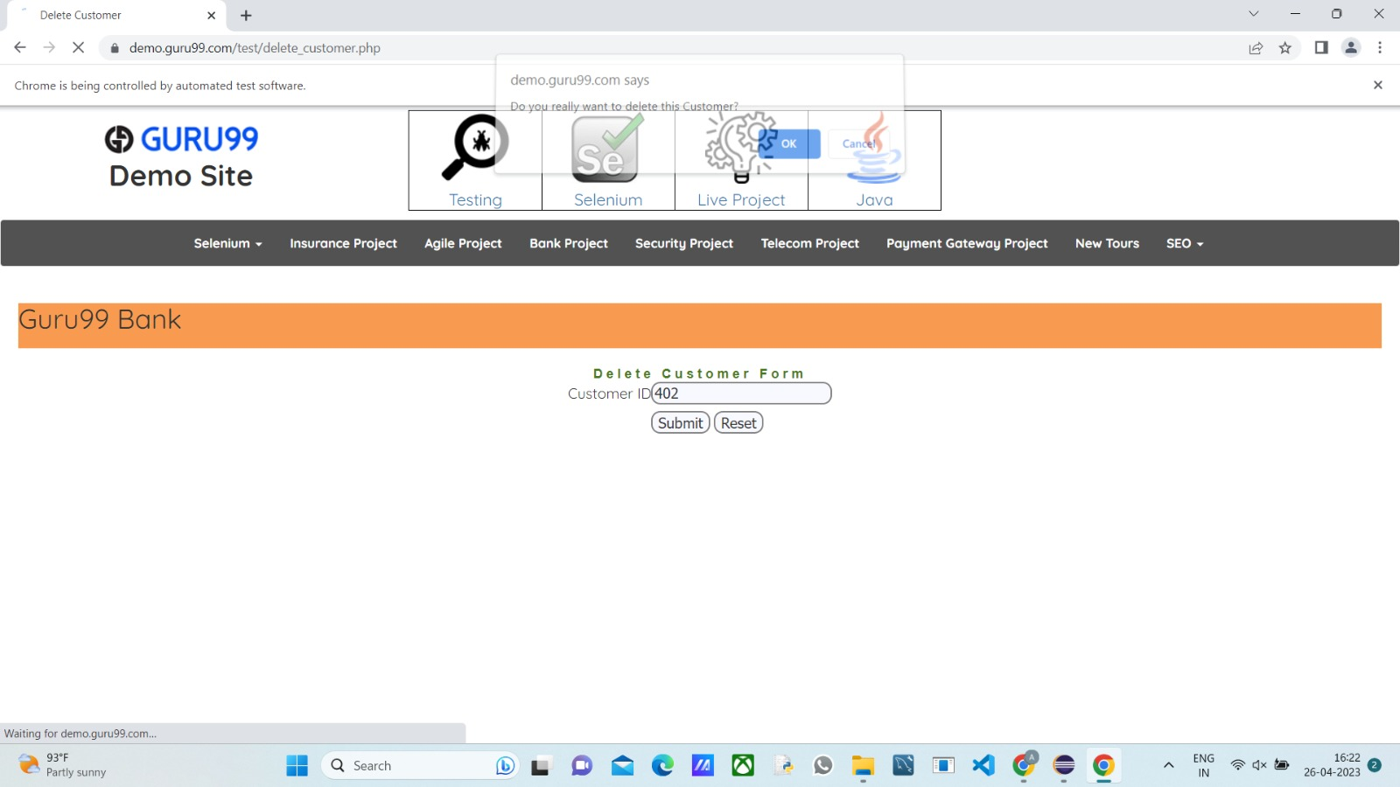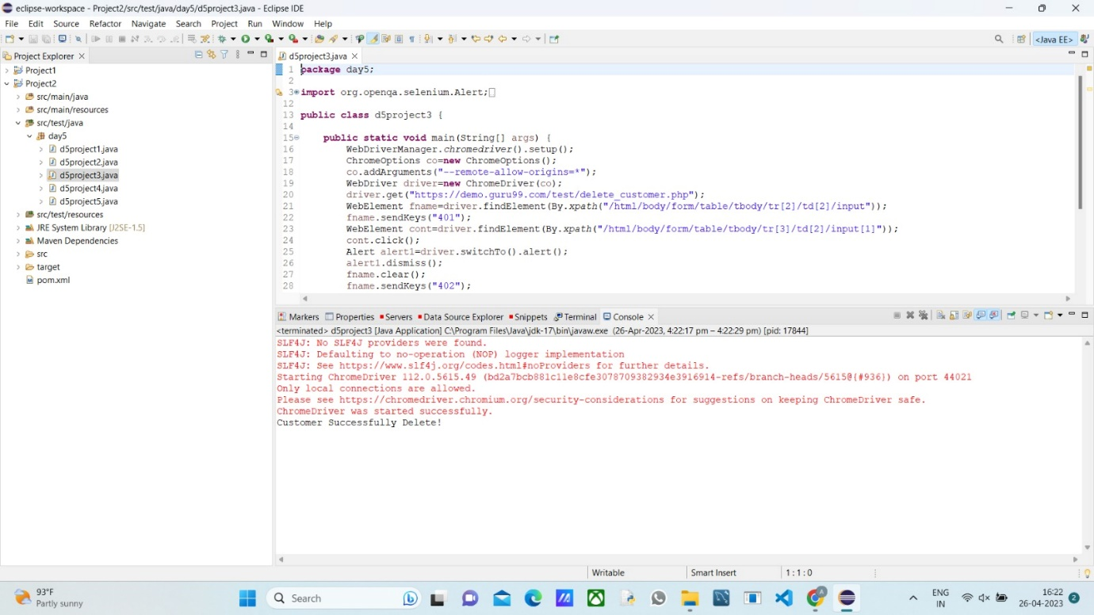

CE4:

INPUT:

**package** day5;

**import** org.openqa.selenium.By;

**import** org.openqa.selenium.JavascriptExecutor;

**import** org.openqa.selenium.Keys;

**import** org.openqa.selenium.WebDriver;

**import** org.openqa.selenium.WebElement;

**import** org.openqa.selenium.chrome.ChromeDriver;

**import** org.openqa.selenium.chrome.ChromeOptions;

**public** **class** d5project4 {

**public** **static** **void** main(String[] args) **throws** InterruptedException {

System.*setProperty*("webdriver.chrome.driver","C:\\chromedriver.exe");

ChromeOptions co=**new** ChromeOptions();

co.addArguments("--remote-allow-origins=*");

WebDriver driver=**new** ChromeDriver(co);

driver.get("https://www.abhibus.com/bus-ticket-booking");

WebElement fname=driver.findElement(By.*id*("source"));

fname.sendKeys("COIMBATORE",Keys.***ENTER***);

Thread.*sleep*(3000);

fname.sendKeys(Keys.***ENTER***);

WebElement dname=driver.findElement(By.*id*("destination"));

dname.sendKeys("PERAMBALUR",Keys.***ENTER***);

Thread.*sleep*(3000);

dname.sendKeys(Keys.***ENTER***);

WebElement tname=driver.findElement(By.*xpath*("//*[@id=\"datepicker1\"]"));

tname.click();

JavascriptExecutor js=(JavascriptExecutor)driver;

js.executeScript("arguments[0].setAttribute('value','04-5-2023')",tname);

WebElement search=driver.findElement(By.*xpath*("//*[@id=\"seo_search_btn\"]"));

search.click();

}}

OUTPUT:

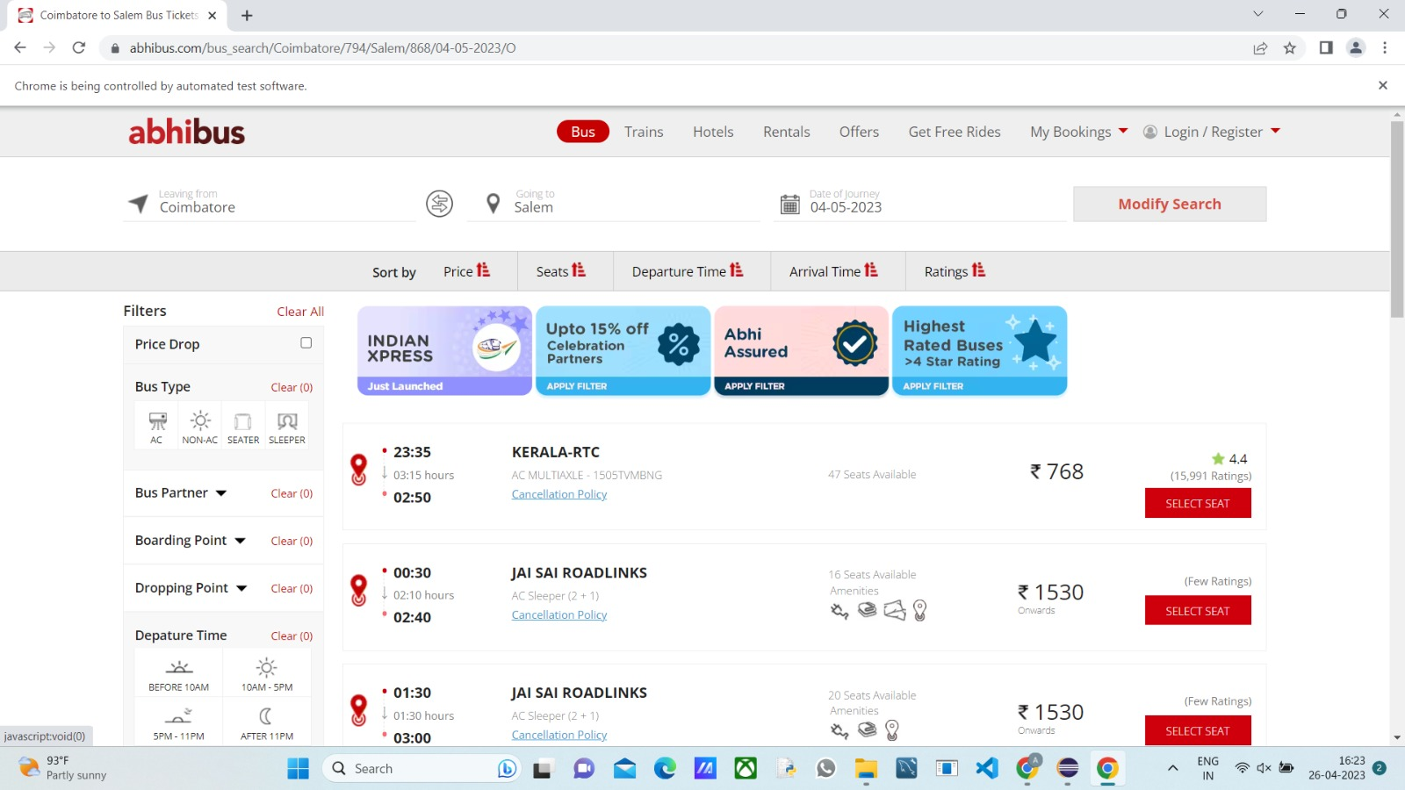

CE5:

INPUT:

**package** day5;

**import** java.awt.Window;

**import** org.openqa.selenium.By;

**import** org.openqa.selenium.Keys;

**import** org.openqa.selenium.WebDriver;

**import** org.openqa.selenium.WindowType;

**import** org.openqa.selenium.chrome.ChromeDriver;

**import** org.openqa.selenium.chrome.ChromeOptions;

**public** **class** d5project5 {

**public** **static** **void** main(String[] args) {

System.*setProperty*("webdriver.chrome.driver","C:\\chromedriver.exe");

ChromeOptions co=**new** ChromeOptions();

co.addArguments("--remote-allow-origins=*");

WebDriver driver=**new** ChromeDriver(co);

driver.get("https://www.google.com");

driver.manage().window().maximize();

driver.findElement(By.*name*("q")).sendKeys("Apple");

driver.findElement(By.*name*("q")).sendKeys(Keys.***ENTER***);

String parent=driver.getWindowHandle();

System.***out***.println(parent);

System.***out***.println(driver.getTitle());

driver.switchTo().newWindow(WindowType.***TAB***);

driver.get("https://google.com");

driver.manage().window().maximize();

driver.findElement(By.*name*("q")).sendKeys("Selenium");

driver.findElement(By.*name*("q")).sendKeys(Keys.***ENTER***);

System.***out***.print("\n"+driver.getWindowHandle());

System.***out***.println(driver.getTitle());

driver.switchTo().newWindow(WindowType.***TAB***);

driver.get("https://google.com");

driver.manage().window().maximize();

driver.findElement(By.*name*("q")).sendKeys("Cucumber");

driver.findElement(By.*name*("q")).sendKeys(Keys.***ENTER***);

System.***out***.print("\n"+driver.getWindowHandle());

System.***out***.println(driver.getTitle());

}

}

OUTPUT:

