**CHAPTER 3**

**Methods and Procedure**

For this chapter, the methods and procedure taken by the developers are shown. This chapter is important for the developing of the new system because the methods and procedures will serve as developer’s guide in designing and creating the Ordering and Inventory System for the Cuckoo Chef Restaurant. It can also serve as a model for future preferences.

**Setting of the Study**

The setting of the study includes the Data Flow Diagram of the new proposed system. Data Flow Diagram will show the flows of the activity of what the inventory and ordering will do for the Cuckoo Chef Restaurant.

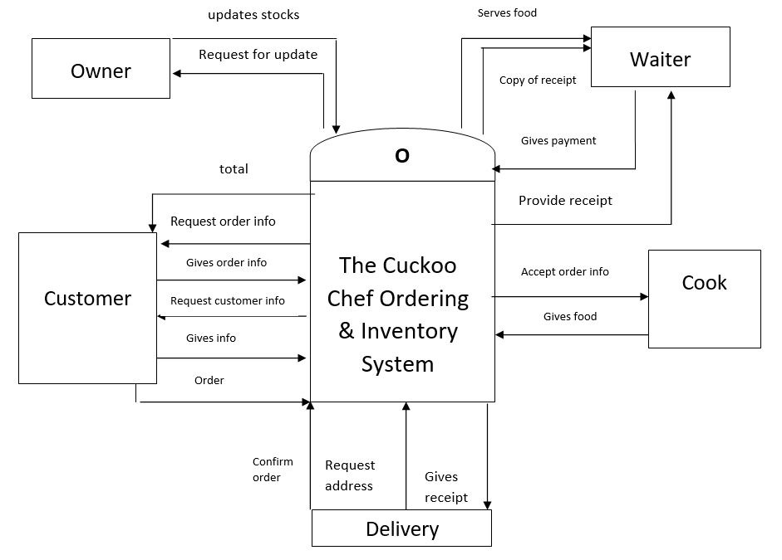

DFD of The Cuckoo Chef Restaurant

Figure 3.1

The figure shown in Figure 3.1is the (DFD) Data Flow Diagram for the Cuckoo Chef, it explains about the overview of the system, this shows what are the information will be input and output from the system, how the data will advance through the system, and where the data will be stored. Every entity of the system explains what are the processes going to happen.

**Project Feasibility**

The Project Feasibility is the initial stage of the project that is used to assess the strength and weaknesses of the proposed system or whether the project will be viable, this stage of project brings together the elements of knowledge that indicate if a project is possible or not.

**Operational Feasibility**

Operational Feasibility determines if a project or end result of a project is feasible and beneficial. This also measure how well the system will solve the problem. Operational feasibility is mainly concerned with issues like whether the proposed system will be used if it is developed and implemented.

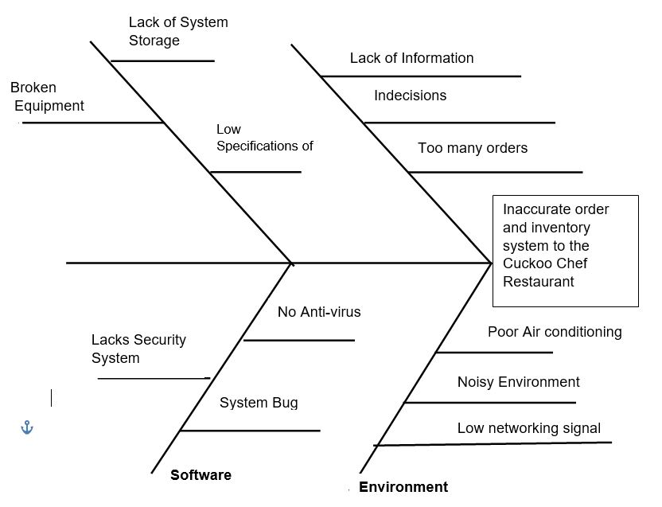

Fish bone Diagram of Inventory and Ordering System for the Cuckoo Chef Restaurant

Figure 3.2

The fishbone diagram shown in figure 3.2 is also called a cause and effect diagram or Ishikawa diagram, a visualization tool for categorizing the potential causes of a problem in order to identify its root causes. The fishbone has an ancillary benefit as well. Because people by nature often like to get right to determining what to do about a problem, this can help bring out a more thorough exploration of the issues behind the problem – which will lead to a more robust solution.

This Figure 3.2 shows the Fishbone Diagram’s problem and root causes of The Cuckoo Chef Restaurant. The System Analysts discuss about the possible problems that will happen in The Cuckoo Chef Restaurant like in the problem that will be encounter with the People, Customer’s lack of information, Indecision and too many orders. The Cuckoo Chef Restaurant will encounter some possible problem in machine like Lack of System Storage, Low Specification of computer and broken Equipment. The possible problem of The Cuckoo Chef Restaurant in Environment is the Poor Air Conditioning, Noisy Environment and Low networking signal. The possible problem in Software is that the system might not have an Anti-Virus, System Bug and Lacks Security System, These are the possible problem that The Cuckoo Chef Restaurant will encounter.

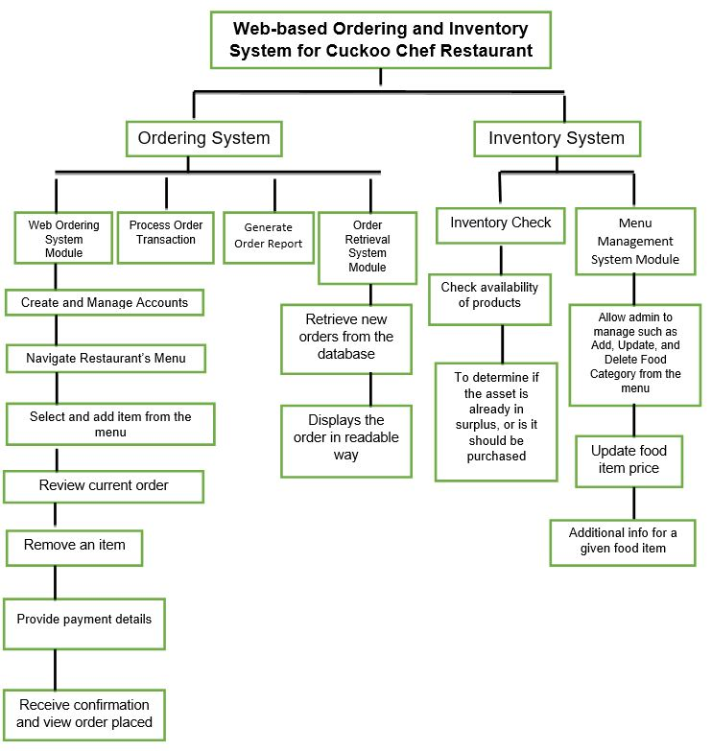

Functional Decomposition Diagram of Inventory and Ordering System for the Cuckoo Chef Restaurant

Figure 3.3

A decomposition diagram shows the high-level function, process, organization, data subject area, or other type of object broken down into lower level, more detailed components. Decomposition diagrams represent organizational structure or functional decomposition into processes. Decomposition diagrams provide a logical hierarchical decomposition of a system.

This Figure 3.3 shows every detail of how the Ordering and Inventory System will work, input, the function, process, and the output. It will discuss the module of the proposed systems followed by the detailed process and the outputs in the end.

**Technical Feasibility**

Under technical feasibility, figure 3.4 shows the specifications of hardware resources for development and implementation, network implementation and software resources for development and implementation needed to be able the proposed system prototype functions.

|  |  |
| --- | --- |
| HARDWARE RESOURCES USED FOR DEVELOPMENT | |
| Component/Item | Minimum Requirements |
| RAM | 4GB RAM |
| Processor | Quad Core 2.4 GHZ (i3) |
| CPU | Intel Core i3 G3220 3.0GHZ |
| Monitor | ASUS 15.6inch LCD, LED |
| DVD Drive | ASUS 24x Sata |
| Mother Board | ASUS Z1OPE-D16110G-25 |

|  |  |
| --- | --- |
| HARDWARE RESOURCES USED FOR IMPLEMENTATION | |
| Printer | Ink Jet |
| Component/Item | Minimum Requirements |
| LAPTOP | Aspire 15 05-571 G-77 AV |

|  |  |
| --- | --- |
| NETWORK RESOURCES USED FOR IMPLEMENTATION | |
| Component/Item | Minimum Requirements |
| INTERNET | 5 MBPS |

|  |  |
| --- | --- |
| SOFTWARE RESOURCES USED FOR DEVELOPMENT | |
| Category | Minimum Requirements |
| Domain Name | Resto.com.ph |
| Web Browser | Google Chrome |
| Programming Language | PHP |
| Database Workbench | MY SQL Version 6.3 |
| Web Authoring | Adobe Dreamweaver CS5 Version |

|  |  |
| --- | --- |
| SOFTWARE RESOURCES USED FOR IMPLEMENTATION | |
| Caategory | Minimum Requirements |
| Domain Maintenance | Resto.com.ph |
| Database Maintenance | My SQL Enterprise Edition Subscription |

Compatibility checking (hardware / software and other technologies) for the Cuckoo Chef Restaurant

Figure 3.4

In this figure it shows the products and software and the specification will be used for the development of the proposed system. These serves as guide for the owner to prevent from any hassles and interruptions and loading of the data in the hardware that will use.

**Schedule Feasibility**

Schedule Feasibility is defined as the probability of a project to be completed within its scheduled time limits, by a planned due date. Inventory and ordering system has a high probability to be completed on-time if the schedule feasibility is appraised high. The inventory and ordering system will be unsuccessful if it takes longer than it was estimated: some external environmental conditions may change, hence a project can lose its benefits, expediency and profitability.

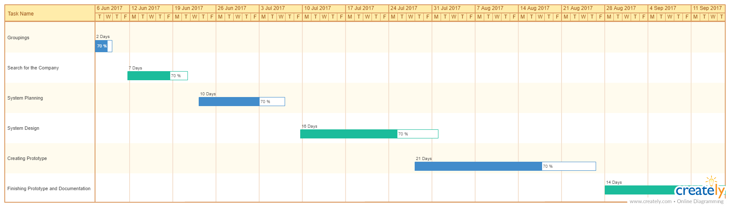

Gantt Chart of Inventory and Ordering System for the Cuckoo Chef Restaurant

Figure 3.5

A Gantt chart is a horizontal bar chart developed as a production control tool in 1917 by Henry L. Gantt, an American engineer and social scientist. Frequently used in project management. A Gantt chart provides a graphical illustration of a schedule that helps to plan, coordinate, and track specific tasks in a project. Gantt charts give a clear illustration of project status, but one problem with them is that they don't indicate task dependencies. This figure will present the graphical illustration of the system analysts schedule in making the proposed system from the beginning. The Gantt chart helps the system analyststo track the works because this shows the amount of work done or production completed.

**Requirements Modelling**

Requirements modelling represent the input, process and output of the system prototype. The interfaces will be included in the requirement modelling the same with the tables and activities of the inventory and ordering system. This will also contain the software, hardware and programs used in developing the inventory and ordering system.

**Input**

Illustrations of use case diagram, interfaces of prototype system, design of forms and data dictionary will be shown under input.

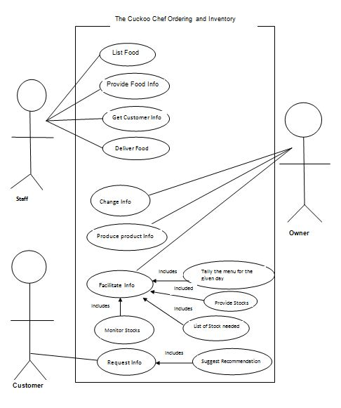

Use Case Diagrams of Inventory and Ordering System for the Cuckoo Chef Restaurant

Figure 3.6

The [use case](http://searchsoftwarequality.techtarget.com/definition/use-case) is a methodology used in system analysis to identify, clarify, and organize system requirements. In this context, the term "system" refers to something being developed or operated, such as a mail-order product sales and service [Web site](http://searchsoa.techtarget.com/definition/Web-site). Use case diagrams are employed in [UML](http://searchsoftwarequality.techtarget.com/definition/Unified-Modeling-Language) (Unified Modelling Language), a standard notation for the modelling of real-world objects and systems.

This Figure shows the Use Case Diagram to know the role of the actors in the the Ordering and Inventory System for The Cuckoo Chef Restaurant. The users are the Staff, Customer and Owner. The role of the Staff is to List Food, Provide Food Information, get customer Information and Deliver Food. The role of the Customer is to request information and suggest some recommendation and the role of the owner is to change information, produce product information and to facilitate the tally of the menu given in everyday, to provide stocks, to know the list of stocks needed and to monitor all of the stocks

**Screen Shot of Interfaces of Prototype**

**User Interface: Customer**



**The Cuckoo Chef Web Page**

**Figure 3.7**

Figure 3.7 shows the web page of the Cuckoo Chef Restaurant where the customer can see the Cuckoo Chef Restaurant through web or online. The left side part of the interface is for the page’s categories. The right side of the interface contains the content of the categories to be selected.

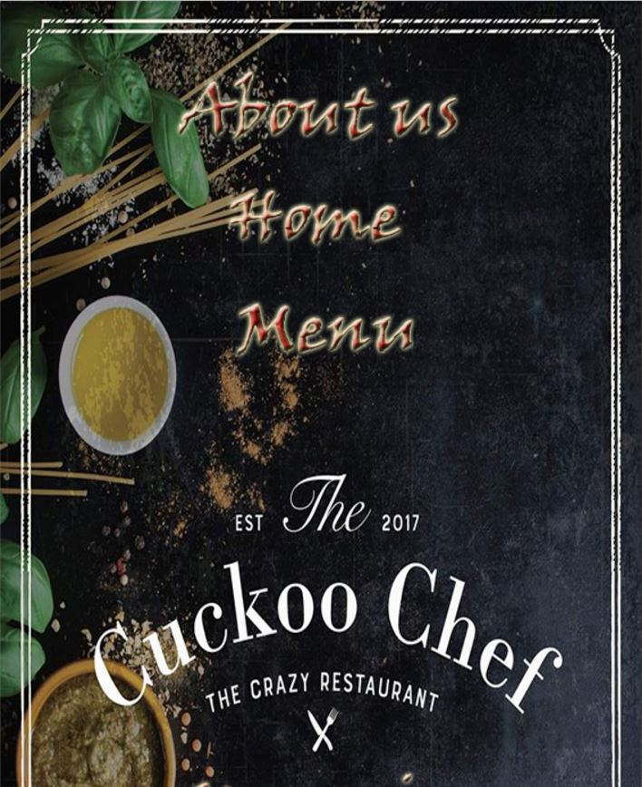

**The Categories for the Cuckoo Chef Web Page**

**Figure 3.8**

The figure 3.8 shows the categories in the left side of the webpage for The Cuckoo Chef Restaurant. The customer can select any categories such as “About us,” “Home”, “Menu”, “Upcoming Events” and “Contact us”. If the “About us” is clicked, the short background for The Cuckoo Chef Restaurant will appear on the right side of the page. If the “Home” is clicked, the “Log-in” will appear where the customer can log-in their accounts.If the “Menu” is clicked, the customer can pick what food category the customers wants. If the “Upcoming Events” is clicked, all the announcements for the restaurant will appear. If the “Contact us” is clicked, the contact information for the restaurant will appear.

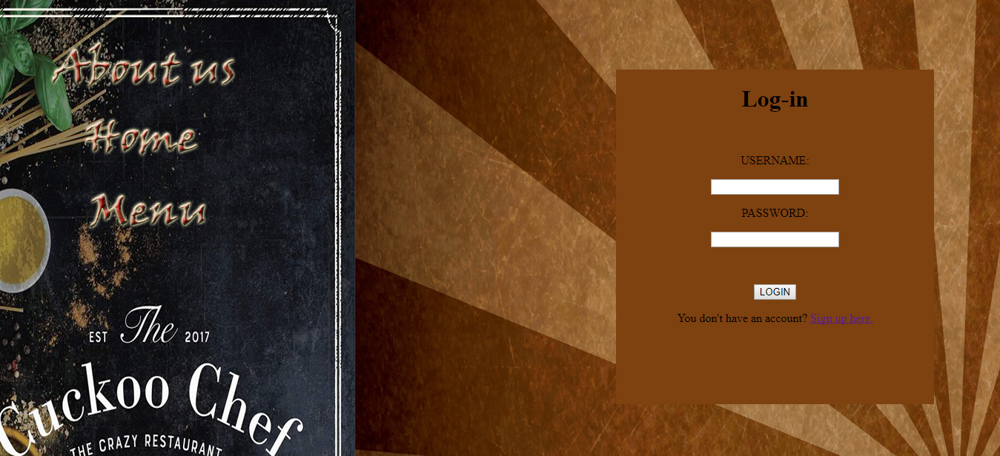

**Log-in**

**Figure 3.9**

The figure shows the Log-in interface that will appear when the “Home” is clicked. It contains the username and password for the customer to input if they created an account in the web page of The Cuckoo Chef Restaurant. If the customer does not have an account, the customer can click the “Sign up here” that is highlighted to redirect to registration for account creation.



**Food Menu Categories**

**Figure 3.10**

The Figure show the menu bar where the customers or users can choose what order they prepare. The business offers some burger, churro, nachos, buffalo wing, chips and fries and beverages, these are the different menus of food of The Cuckoo Chef Restaurant.

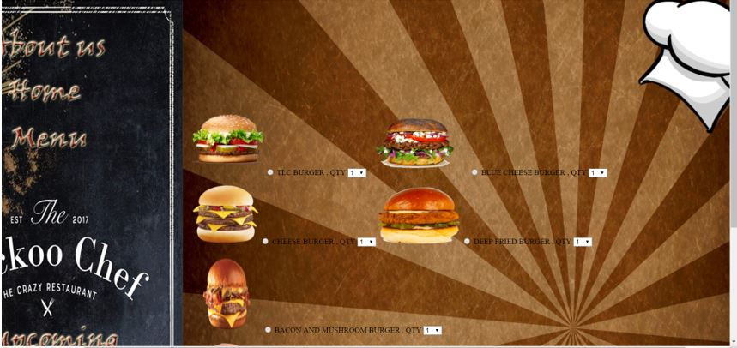

**Burgers Selection**

**Figure 3.11**

The figure shows the different burger type that The Cuckoo Chef Restaurant have, the customer can choose what burgers they want and input or select what quantity the customers prefer. The customer can see their checked order if they click the burgers sign in menu bar.

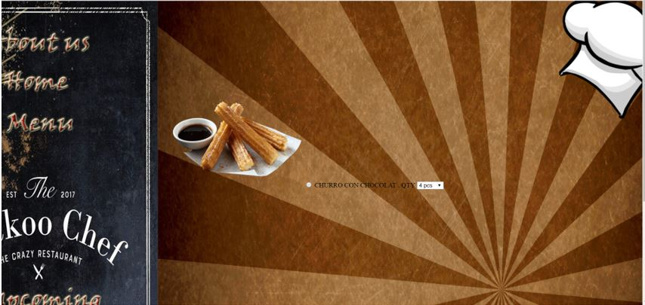

**Churro Selection**

**Figure 3.12**

The figure shows the churro that The Cuckoo Chef Restaurant have,the customer can choose or pick quantity they want, the quantities of the product are 4pcs, 8pcs and 12 pcs. The customer can see the result if they click the churro sign in menu bar.

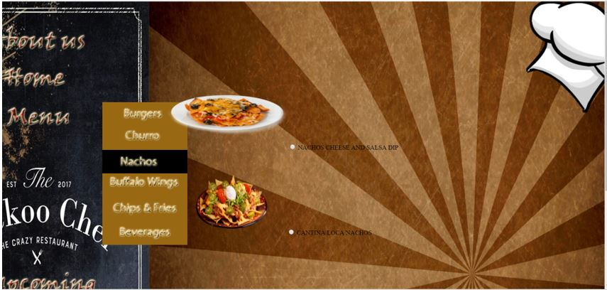

**Nachos Selection**

**Figure 3.13**

This interface shown in figure 3.12 is the nachos that The Cuckoo Chef Restaurant sell,the customer can choose what nachos they prefer. The customer can see this if they click the nachos sign in menu bar.

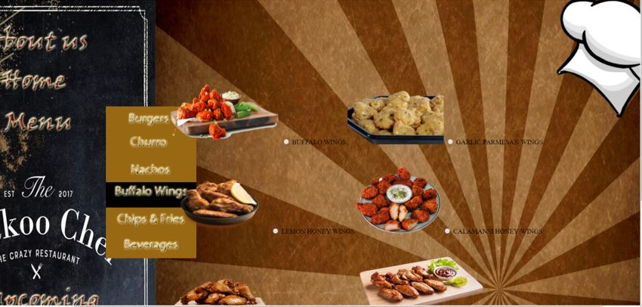

**Buffalo Wings Selection**

**Figure 3.14**

The figure shows the buffalo wings that The Cuckoo Chef Restaurant have ,the customer can choose what wings they want, the customer can see this if they click the buffalo wings sign in menu bar.

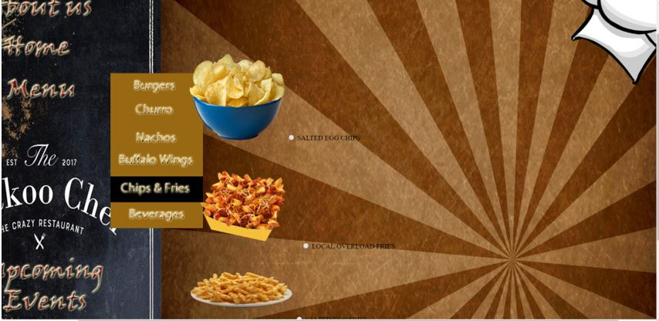

**Chips and Fries Selection**

**Figure 3.15**

The figure shows the chips and fries that The Cuckoo Chef Restaurant offer,the customer can choose want they want or what they prefer if chips or fries.The customer can see this if they select the chips and fries sign in menu bar.

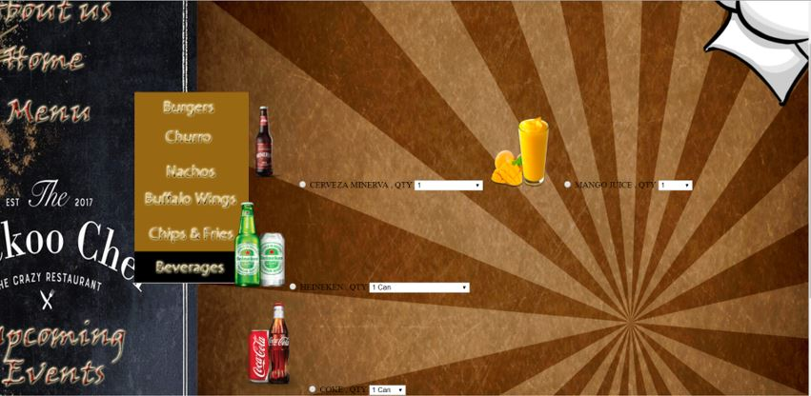

**Beverages Selection**

**Figure 3.16**

This figure 3.16 show the beverages that The Cuckoo Chef Restaurant will sell, the customer can choose want they want or what beverage/s the customer prefers. The cuckoo chef restaurant offers different beverages like juices and alcoholic drinks, and sodas. The customer can see this if they click the beverages sign in menu bar.

**User Interface: Registration Form**

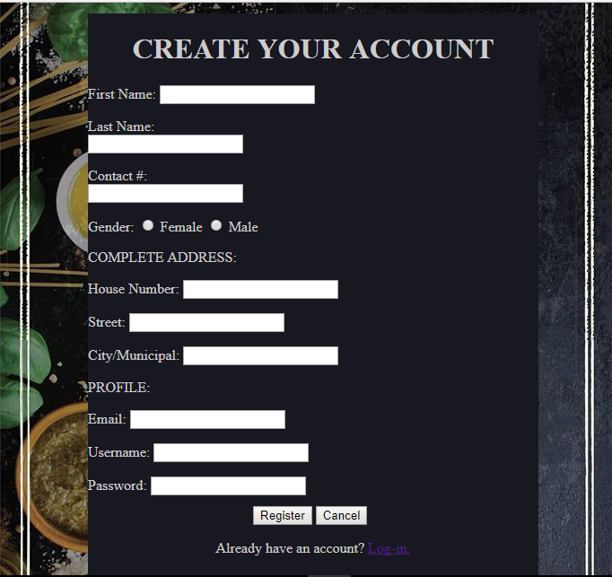

**Account Creation**

**Figure 3.17**

Figure 3.17 shows the interface where the customer can create an account in the webpage ordering system of The Cuckoo Chef Restaurant. Registration contains the first name, the last name, the contact number, the gender, the address, the email, the username, and the password. The customer will input all of the fields in the registration in order to successfully register in the Cuckoo Chef Restaurant. The customer will not be able to register completely if some fields are not filled up. Hence, the customer will be able to have account if the customer filled up all the fields in the registration.

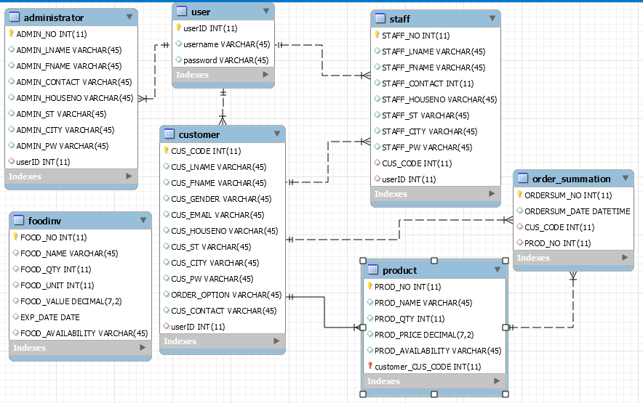

ERD of the Cuckoo Chef Restaurant

Figure 3.18

Figure 3.18 shows the Entity Relationship Diagram of the Cuckoo Chef Restaurant, it shows the entities that are provided for the system and also the attributes that are needed for the entities, and it also shows the relationships between entities in the database. The relationship is the association that describes the interaction between entities.

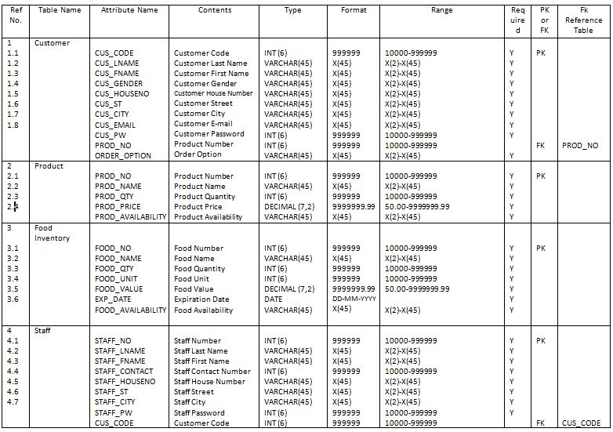

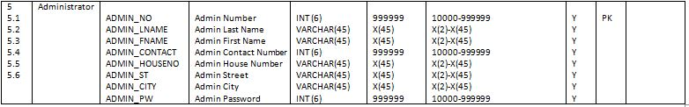

Data Dictionary of Inventory and Ordering System for the Cuckoo Chef Restaurant

Figure 3.18

Figure 3.18 shows the information that will describe the contents, format, and structure of the database that will be used for the inventory and ordering system for the Cuckoo Chef Restaurant and the relationship between the elements. The data dictionary will serve as collection of descriptions of the data objects in the data model to benefit people who need to understand the system more.

**Process**

Administrator

**UPDATE INVENTORY RECORDS IN THE DATABASE**

**SELECT THE ITEM THAT WILL UPDATE**

**SHOW UPDATE PAGE**

**SELECT INVENTORY UPDATE**

**SHOW INVENTORY PAGE**

**SELECT CHECK INVENTORY**

**SHOW ERROR MESSAGE**

**SHOW MAIN PAGE**

VERIFIED

**VERIFY LOG IN**

**LOG IN**

Activity diagram of

Administrator of Web-based Ordering and Inventory System for The Cuckoo Chef

Figure 3.19

Figure 3.19represents the flow of operation of the system or the flow of activities to another activity. The control flow of figure 3.19 is drawn from one operation to another to capture the dynamic behavior of online inventory and ordering system of the cuckoo chef restaurant.

The figure 3.19 is the activity diagram of Administrator of online ordering and inventory system of Cuckoo Chef. The flow of this diagram starts with log in, the log in will show the error message if the log in is not verified. if the log in is verified, the system of cuckoo chef restaurant will show its main page. After showing the main page, the administrator can select the inventory. By selecting inventory, the inventory page will display and the inventory will be updated. After changes in the inventory, the updated page will show. When the administrator selects the item that will update, the records will be updated in the database of inventory.

STAFF

**REMAIN**

**VERIFY CUSTOMER ORDER**

**PROVIDE CONFIRMATION AND VIEW ORDER PLACED**

**REMOVE**

**REMOVE ITEM**

**PAYMENT DETAILS**

**SELECT AND ADD ITEM FROM MENU**

**REVIEW CURRENT ORDER**

**SHOW RESTAURANT MENU**

**NOT VERIFIED**

**SHOW ERROR MESSAGE**

**VERIFY LOG IN**

**LOG IN**

**VERIFIED**

Activity Diagram of Staff of Web-based Ordering and Inventory System for The Cuckoo Chef

Figure 3.20

The figure shown in figure 3.20 represents the flow of Staff in the Ordering System of The Cuckoo Chef Restaurant. The staff will log in in the ordering system where if the registration is not verified it will go back in the log in, hence if the registration is verified the menu of the cuckoo chef restaurant will show. After the staff select the order of customers or add the new order, the staff can proceed to review all the current order. If the customer cancels the order, the staff can remove the placed order and review again the current order. If no cancellations, the ordering system will continue in payment details. The staff will provide confirmation and view order placed if the payment details is done. When the flow of activities to another activity in the activity diagram of staff is successful, the staff will verify the order of customer.

CUSTOMER

**REMAIN**

**VERIFY CUSTOMER ORDER**

**RECEIVE CONFIRMATION**

**AND VIEW ORDER PLACED**

**REMOVE**

**REMOVE ITEM**

**PROVIDE PAYMENT DETAILS**

**SELECT AND ADD ITEM FROM MENU**

**REVIEW CURRENT ORDER**

**NAVIGATE RESTAURANT MENU**

**NOT VERIFIED**

**VERIFIED**

**SHOW ERROR MESSAGE**

**VERIFY LOG IN**

**LOG IN**

Activity Diagram of Customer of Web-based Ordering and Inventory System for The Cuckoo Chef

Figure 3.21

The figure shown in figure 3.21 is the activity diagram of Customer where a customer is allowed to log in and verify the customer’s information. If not verified, an error message will show and will go back to log in. if the registration of customer is verified, the system will navigate to the restaurant menu and will allow the customer to select and add item from the menu. After the customer select and add item. The customer will review all the current orders. The customer can remove the orders he selected and added and go back to review of current order. If not, the customer will proceed with the payment details and receive confirmation for orders. When confirmations receive, the order of the customer will be verified.

**Output**

The output contains all the interfaces wherein an output is produced from the data entered by the users of the proposed system.

**User Interface: Staff**

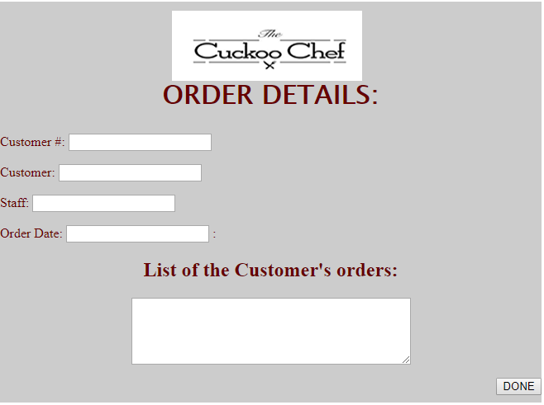

The Customer’s Order Details

Figure 2.1

The figure shows the order details of the customer that the staff can view. It contains the customer’s name and number, staff’s name, order date, and the list of the Customer’s orders where he/she selected to The Cuckoo Chef Restaurant. It also contains “DONE” button where the staff can click if the order is done.

**User Interface: Administrator**

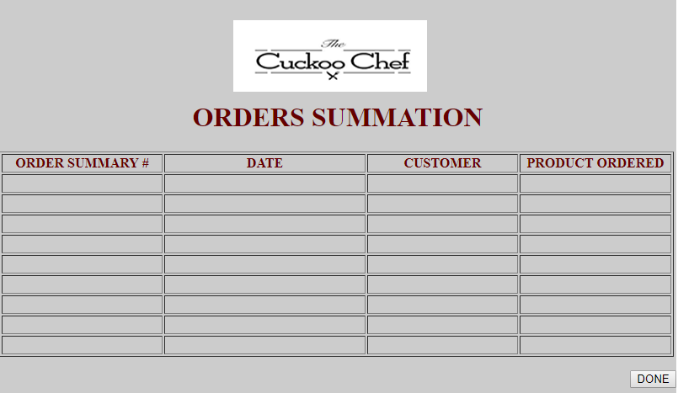

Orders Summary

Figure 2.2

The figure shows the summary of all the orders that will be taken from the future day-to-day operations of The Cuckoo Chef Restaurant. It shows the table containing the “Order Summary #”, “Date” for the order date, “Customer” for the Customer’s code number and the “Product Ordered” for the Product’s ID number. The Order Summation will help the administrator to easily know the products that are popular and the least ordered products for him/her to be able to know what to put in the food inventory.

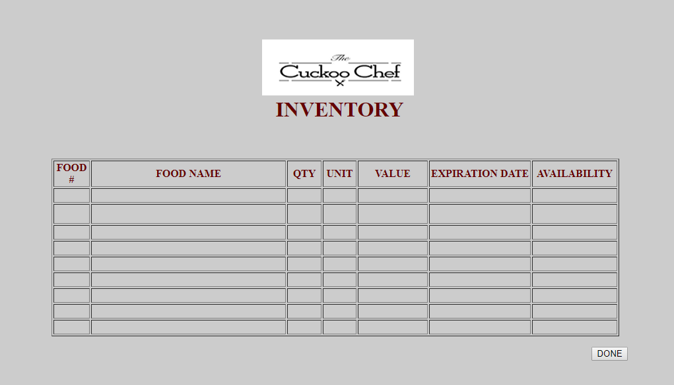

Food Inventory

Figure 2.3

The figure shows the inventory of the raw products of The Cuckoo Chef Restaurant. It contains the number, name, quantity, unit, price value, expiration date and availability of the food product. The Food Inventory will help the administrator to know what products are no longer available and the remaining quantity of the food product.

**Software Specification**

The programming language used in developing the prototype of the Ordering and Inventory System for the Cuckoo Chef Restaurant is PHP. PHP is a widely-used open source general-purpose scripting language that is especially suited for web development and can be embedded into HTML. The developers used Adobe Dreamweaver CS5 for creating, coding, editing and managing responsive html and PHP for developing and designing the system prototype. The developers used MySQL Workbench as an IDE for MySQL which provides data modelling, SQL development, and comprehensive administration tools for server configuration, user administration, and backup. The developers also used Adobe Photoshop CC to edit and manipulate digital images and Microsoft Word for the entire documentation.

**Hardware Specification**

The main hardware used by the developers in developing the Ordering and Inventory System for the Cuckoo Chef Restaurant is a laptop which at least has a minimum requirement of a 4GB RAM, has an Intel Core i3 G3220 3.0GHZ to be able to carry out the best resolution for developing the system. The developers used a 15-inch LCD or LED Monitor for wider and high definition screen. All the hardware mentioned are important for developing the system and for it to be able to run properly. The developers also used Ink Jet Printer to test if the system will be able to print out the required reports.

**Program Specification**

The developers used WAMP server to create web applications with Apache2, PHP and a MySQL database. By running a local Apache web server on a Windows machine, the developer can test web pages in a web browser without publishing them live on the Internet. MySQL Workbench should be also be running because for the database of the Cuckoo Chef Restaurant. The developers also used PHP to make the system functional. The developers used Adobe Dreamweaver CS5 as an IDE for PHP to be able to develop and design the system.

**Test Plan**

1. **System Interfaces Test**

|  |  |  |  |  |  |
| --- | --- | --- | --- | --- | --- |
| **Test Case Specification** | **Pre-Requisites** | **Description** | **Expected Result** | **Actual Result** | **Incident Number** |
| AMS TC1 | The “About Us” button is clicked | View the short background of The Cuckoo Chef Restaurant | Short background of The Cuckoo Chef Restaurant will appear |  |  |
| AMS TC2 | The “Home” button is clicked | Enter the created account and login | The User’s profile will appear |  |  |
| AMS TC3 | The “Menu” button is clicked | Choose menu categories of the products available | All the menu categories of the products available will appear |  |  |
| AMS TC4 | The “Upcoming Events” is clicked | View the announcements of the Cuckoo Chef Restaurant | The announcements of the Cuckoo Chef Restaurant will appear |  |  |
| AMS TC5 | The “Contact us” button is clicked | View contact information and location of the Cuckoo Chef Restaurant | The contact information and location of the Cuckoo Chef Restaurant will appear |  |  |
| AMS TC6 | The hyperlinked  “Sign up here” is clicked | Enter the required fields for the registration form | The registration form will appear |  |  |

1. **System Interface: Administrator**

|  |  |  |  |  |  |
| --- | --- | --- | --- | --- | --- |
| **Test Case Specification** | **Pre-Requisites** | **Description** | **Expected Result** | **Actual Result** | **Incident Number** |
| AMS TC1 | Logged in as administrator then clicked Inventory | Access the administrator account | The Food Inventory will appear |  |  |
| AMS TC6 | Logged in as administrator then clicked Order Summation | Access the administrator account | The Order Summation will appear |  |  |

1. **System interface: Staff**

|  |  |  |  |  |  |
| --- | --- | --- | --- | --- | --- |
| **Test Case Specifications** | **Pre-Requisites** | **Description** | **Expected Result** | **Actual Result** | **Incident Number** |
| AMS TC1 | Logged in as staff | Access the staff account | The Order details of the Customer will appear |  |  |