CHRONO RIFT
Transformers Edition
CS 2006 — Operating Systems | Spring 2026
FAST NUCES, Islamabad

Group Members
Kasim Zeeshan Alvi — 24i-0549 — BCS-A
Abdullah Junaid — 24i-0569 — BCS-A

Multi-process turn-based tactical game built on POSIX shared memory, pthreads,
semaphores, signals, deadlock detection, and real-time GUI + TUI interfaces.

1. Project Overview
Chrono Rift is a multi-process, turn-based tactical game implementing core Operating Systems concepts. The game is built on three separate POSIX processes communicating exclusively through shared memory, with synchronization via unnamed semaphores stored inside the shared memory segment itself. No pipes, FIFOs, or sockets are used anywhere in the codebase.

The game supports both a full SFML graphical interface (GUI mode) and a comprehensive ncurses terminal interface (TUI mode), selectable at launch. Both interfaces run as part of the Human Interfacing Process (HIP), which is a separate process from the Game Arbiter and the Automated Strategic Process (ASP).

1.1 Three-Process Architecture
Process | Binary | Role
Game Arbiter | arbiter | Central authority — owns game state, scheduling, signal dispatch, deadlock detection, wave management
Human Interface | hip / hip_gui | Captures player input; multi-threaded with one pthread per player; dedicated render pthread
AI Strategy | asp | Controls all enemy NPCs; one dedicated pthread per enemy entity; signal-based stun

1.2 Key Technical Features
- POSIX shared memory (shm_open + mmap) — zero pipes, zero sockets
- Unnamed sem_t semaphores with pshared=1 inside shared memory segment
- One pthread per enemy (ASP), one pthread per player (HIP), dedicated render pthread (HIP)
- Stamina-based scheduling: each second entity speed is added to stamina; act when full
- Signal-based stun: SIGUSR2 to ASP dispatcher → pthread_kill to specific enemy thread → sleep(3)
- Ultimate ability: SIGSTOP to ASP, alarm(10), SIGCONT via SIGALRM handler — signal-only
- Deadlock detection background thread: circular wait graph scan every 2 seconds
- Contiguous inventory allocator: 20-slot linear array with makeRoom and fragmentation handling
- Eclipse Relic dynamic artifact introduced at runtime after kill #3

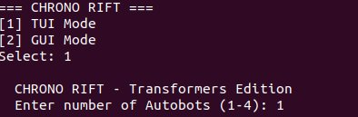
Figure 1 — Game launch: TUI/GUI mode selection and party size prompt

2. Inter-Process Communication and Shared Memory
All IPC in Chrono Rift is implemented exclusively through a single POSIX shared memory segment named /chrono_rift_shm. The GameState struct — containing all entity data, semaphores, artifact tables, and UI state — is mapped into this segment by all three processes.

2.1 Shared Memory Layout
Field | Type | Purpose
stateLock | sem_t (pshared=1) | Protects all game state reads and writes
actionSubmitted | sem_t (pshared=1) | HIP/ASP posts when action is ready; arbiter blocks on this
actionConsumed | sem_t (pshared=1) | Arbiter posts after applying action; ensures one action in-flight
artifactTableLock | sem_t (pshared=1) | Protects Solar Core / Lunar Blade / Eclipse Relic ownership table
uiLock | sem_t (pshared=1) | Protects UI state fields (menu selection, pickup prompts)
players[4] | Entity struct | HP, stamina, inventory, LTS, artifact flags per player
enemies[9] | Entity struct | HP, stamina, inventory, shouldExit, stun fields per enemy
pendingAction | Action struct | The one action currently in-flight from HIP or ASP
artifacts | ArtifactTable | Who holds Solar Core, Lunar Blade, Eclipse Relic (-1 = free)
weaponDrop | WeaponDropState | Pending drop: weapon ID, forPlayerIndex, decision (Y/N)

2.2 Action Submission Protocol
The protocol for submitting an action is designed to prevent race conditions between multiple entity threads:
- Step 1: Actor acquires actionConsumed (ensures no other action in flight)
- Step 2: Actor re-verifies the turn still belongs to it under stateLock
- Step 3: Actor writes pendingAction under stateLock and posts actionSubmitted
- Step 4: Arbiter wakes, acquires stateLock, calls applyAction(), resets turn fields
- Step 5: Arbiter posts actionConsumed — next actor may proceed

No Pipes Policy
Zero calls to pipe(), mkfifo(), or any FIFO path exist anywhere in the codebase. All IPC is exclusively through the shared memory segment. This was verified by code audit and is enforced as a hard constraint.

3. Multithreading and Execution Model

3.1 Thread Overview
Thread | Process | Created Via | Purpose
staminaThread | Arbiter | pthread_create | Ticks stamina every 1s for all entities
deadlockThread | Arbiter | pthread_create | Scans for circular waits every 2s
enemyThread x N | ASP | pthread_create (one per enemy) | Waits for turn, decides action, submits via semaphore
playerThread x P | HIP | pthread_create (one per player) | Monitors turn state, manages input for that player
renderThread | HIP | pthread_create | Owns ncurses/SFML window, draws at ~20fps independently

3.2 Enemy Threads (ASP)
Each enemy entity gets its own dedicated pthread inside the ASP process. Threads are spawned via pthread_create and detached via pthread_detach. Each thread checks a birthWave field — when the arbiter increments waveNumber, old threads exit and new ones are spawned for the fresh wave. The shouldExit flag (set by arbiter on kill) causes immediate thread exit.

Thread decision logic: 80% Strike targeting a random alive player, 20% Skip. Enemy turns have a strict 3-second timeout via sem_timedwait — if the ASP does not respond, arbiter forces a Skip.

3.3 Player Threads (HIP)
One pthread per player character. Each thread monitors shared memory for its turn (currentTurnIsPlayer==1 && currentTurnEntityIndex==pi). Only the active player's thread processes input. All other player threads remain idle in a usleep(50000) loop — satisfying the spec requirement that non-active threads must not process input.

3.4 Dedicated Render Thread (HIP)
The rendering logic runs in its own dedicated pthread (renderThread), satisfying Section 9 of the specification. This thread exclusively owns the display context — all draw(), display(), and event polling calls occur within renderThread. The main thread acts as a watchdog only. A pthread_mutex_t (ncursesMtx for TUI, renderMtx for GUI) protects all display calls.

4. Temporal Scheduling and Stamina Logic

4.1 Stamina Model
Chrono Rift uses a stamina-based scheduling model that matches the specification exactly: each second, every entity's speed is added to its current stamina. An entity may act only when stamina reaches maxStamina. STAMINA_TICK_MS = 1000ms so one tick = exactly one second.

Parameter | Formula (Roll: 549) | Value
Player HP | 549 + rand(100..1000) | 649 to 1549
Enemy HP | (549 % 100) + rand(50..200) | 99 to 249
Player Damage | (549 % 10) + 10 | 19
Enemy Damage | ((549/10)%10) + 10 | 14
Player Speed (1P) | 100 / 1 | 100
Player Speed (2P) | 100 / 2 | 50
Player Speed (4P) | 100 / 4 | 25
Enemy Speed | rand(10..30) | 10 to 30
Player Max Stamina | Fixed | 100
Enemy Max Stamina | Fixed | 150

4.2 Arrival Time Analysis
The arrival time (time to first action) is determined by: ticks_to_full = ceil(maxStamina / speed). Each tick is 1 second, so:

Worked Example 1 — 1-Player Game
Player: speed=100, maxStamina=100 → ceil(100/100) = 1 tick = 1.0 second per turn
Enemy: speed=20, maxStamina=150 → ceil(150/20) = 8 ticks = 8.0 seconds per turn
Result: Player acts 8 times for every 1 enemy turn

Worked Example 2 — 4-Player Game
Each Player: speed=25, maxStamina=100 → ceil(100/25) = 4 ticks = 4.0 seconds
All 4 together: one player acts every 1 second (round-robin across 4 players)
Enemy: speed=15, maxStamina=150 → ceil(150/15) = 10 ticks = 10.0 seconds
Result: 10 player actions for every 1 enemy turn

Skip Penalty Analysis
Player skips: stamina = maxStamina/2 = 50. Next turn in ceil(50/speed) ticks.
1-player (speed=100): ceil(50/100) = 1 tick = 1.0 second penalty
4-player (speed=25): ceil(50/25) = 2 ticks = 2.0 second penalty
Enemy skips: stamina = 75. Enemy (speed=20): ceil(75/20) = 4 ticks = 4.0 seconds

4.3 Serial Execution Enforcement
While stamina accumulates concurrently for all entities via staminaThread, only one entity may act at a time. The currentTurnEntityIndex field in shared memory is set to -1 between turns. findNextTurn() returns 0 if a turn is already active. The actionSubmitted/actionConsumed semaphore pair acts as a binary handshake enforcing strict serial action execution.

5. Signals and Asynchronous Interrupts

5.1 Signal Summary
Signal | Sender | Receiver | Effect
SIGUSR1 | Arbiter | HIP process | Player stun notification — asynchronous, non-blocking
SIGUSR2 (process) | Arbiter | ASP process | Triggers aspStunDispatcher — routes stun to enemy thread
SIGUSR2 (thread) | ASP dispatcher | Enemy pthread | Per-thread handler calls sleep(3) — signal-based 3s stun
SIGSTOP | Arbiter | ASP process | Ultimate — suspends entire ASP process immediately
SIGCONT | Arbiter (SIGALRM handler) | ASP process | Resumes ASP after 10-second ultimate window
SIGALRM | Kernel (alarm(10)) | Arbiter | Ultimate timer expiry — triggers SIGCONT to ASP
SIGTERM | HIP (quit action) | Arbiter | Graceful game exit — sets gameResult=3
SIGCHLD | Kernel | Arbiter | Child exit — waitpid(WNOHANG) reaps zombies

5.2 Signal-Based Stun — Enemy Threads
Enemy stun is fully signal-based, satisfying the specification requirement that the target must not 'actively check a flag or a pipe'. The implementation:
- When a high-tier weapon stuns an enemy, arbiter sets isStunned=1 in shared memory AND sends SIGUSR2 to the ASP process
- ASP's process-level aspStunDispatcher handler runs — it iterates the thread registry and calls pthread_kill on the matching enemy thread
- Each enemy thread has its own per-thread SIGUSR2 handler (installed via sigaction) that calls sleep(3)
- The thread's execution is halted for exactly 3 seconds by the signal handler — no flag polling
- After sleep(3) returns, the thread resumes from where it was interrupted with stamina level preserved

Stun Duration Verification
sleep(3) in signal handler = exactly 3 seconds. STAMINA_TICK_MS=1000ms confirms 3 ticks = 3 seconds.
The previous bug (2500ms ticks giving 7.5s stun) has been corrected in this submission.

5.3 Ultimate Ability — Signal-Only Suspension
The Ultimate Ability is implemented using signals only — no flags or shared memory fields are used for the suspension/resumption coordination itself:
- kill(aspPid, SIGSTOP) — immediately suspends all ASP threads
- alarm(10) — schedules SIGALRM delivery after exactly 10 seconds
- Custom SIGALRM handler in arbiter calls kill(aspPid, SIGCONT) and clears ultimateAbilityActive
- During the 10-second window, enemy stamina does not accumulate (ultimateAbilityActive flag prevents ticking)

6. Deadlock Detection and Resource Management

6.1 Global Resource Table
The ArtifactTable struct in shared memory tracks ownership of all three exclusive artifacts. Fields store -1 (free) or the entity ID (0..3 for players, 100+ei for enemies). syncArtifacts() is called after every action to rebuild the table by scanning all inventories.

Artifact | Slot Size | Damage | Stuns on Hit | Introduced
Solar Core | 10 | 95 | Yes | Game start (not held)
Lunar Blade | 10 | 90 | Yes | Game start (not held)
Eclipse Relic | 8 | 100 | Yes | Dynamically after kill #3

6.2 Deadlock Detection Algorithm
A background deadlockThread runs every 2 seconds and builds an ENode graph of all alive entities with their holds and wants arrays. It checks all pairs for circular waits:
- Entity A holds artifact X and wants artifact Y
- Entity B holds artifact Y and wants artifact X
- => Circular wait detected => deadlock

Resolution: The second node (B) is forced to release the contested artifact. The weapon is removed from its inventory, the artifact table is updated, and only the specific released artifact's waitingFor flag is cleared. The game continues without interruption.

7. Memory Management — Inventory Allocator

7.1 Weapon Table
Weapon | ID | Slot Size | Damage | Category
Solar Core | 1 | 10 | 95 | Artifact (stuns)
Lunar Blade | 2 | 10 | 90 | Artifact (stuns)
Iron Halberd | 3 | 7 | 55 | Standard
Venom Dagger | 4 | 4 | 30 | Standard
Thunderstaff | 5 | 6 | 50 | Standard
Obsidian Axe | 6 | 5 | 45 | Standard
Frostbow | 7 | 6 | 48 | Standard
Splinter Stick | 8 | 2 | 12 | Standard (fragmentation test)
Eclipse Relic | 9 | 8 | 100 | Dynamic artifact (stuns)

7.2 Allocation Strategy
The inventory is a linear array of 20 integer slots. Each slot stores the weapon ID occupying it (0 = empty). Placement requires a contiguous run of free slots matching the weapon's slot size.
- findContiguousSlots(inv, size) — linear scan for a free run of exactly size consecutive zeros
- addToInventory(entity, wid) — places weapon at first valid position; returns 0 if no space
- makeRoom(entity, needed) — evicts minimum weapons to LTS until needed contiguous slots are free
- forceAdd(entity, wid) — tries addToInventory; if full, calls makeRoom then retries

Hard Constraints Enforced
Solar Core (10 slots) + Lunar Blade (10 slots) = exactly 20 slots. Inventory is full.
No other weapon can be added while both are held — makeRoom would evict one of them.
Splinter Stick (2 slots) creates fragmentation edge cases — makeRoom handles these by evicting
until a contiguous 2-slot gap exists, not just until 2 total free slots exist.

7.3 Long-Term Storage and Swap In
Evicted weapons go to longTermStorage[] (up to 20 items). The 3-step Swap In flow:
- Step 1 (if inventory full): Player chooses which weapon to send to LTS
- Step 2: Arbiter removes chosen weapon from inventory, adds to LTS
- Step 3: Player picks from LTS — forceAdd places it in inventory, costs one full turn
The swapped-in weapon is available from the next turn. This is enforced by the turn cost — stamina is depleted to 0 and no additional action is allowed in the same turn.

8. GUI Mode — Gameplay Screenshots
The SFML GUI (hip_gui) is a full graphical interface with animated sprites, real-time HP/stamina bars, weapon projectile animations, lunge movement, and dedicated screens for all game states.

8.1 Main Menu
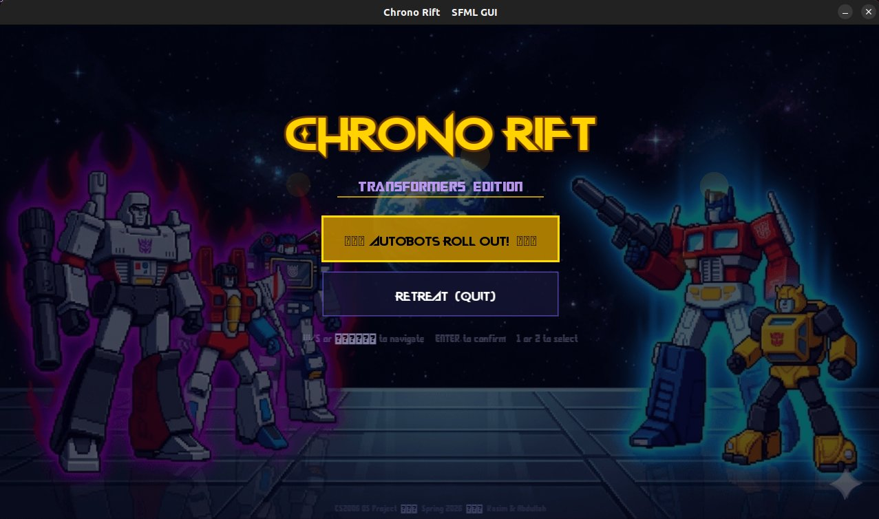
Figure 2 — GUI Main Menu with animated title, Autobots vs Decepticons imagery, and navigation controls

8.2 Battle Screen
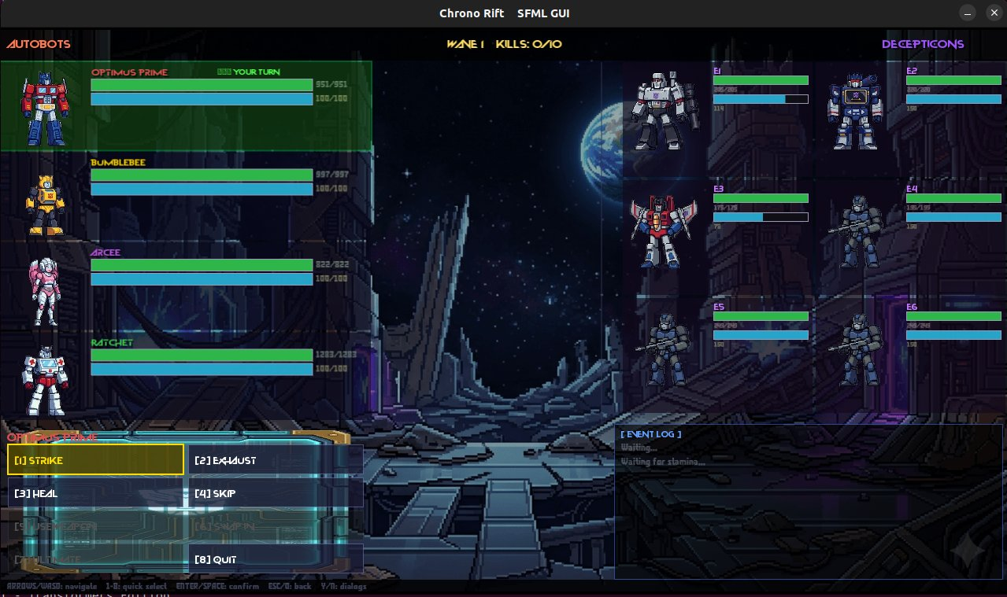
Figure 3 — GUI Battle Screen: Autobots (left) with HP/stamina bars and inventory, Decepticons (right) with unique boss sprites, action menu, event log, wave/kill counter

8.3 Wave 2 Transition
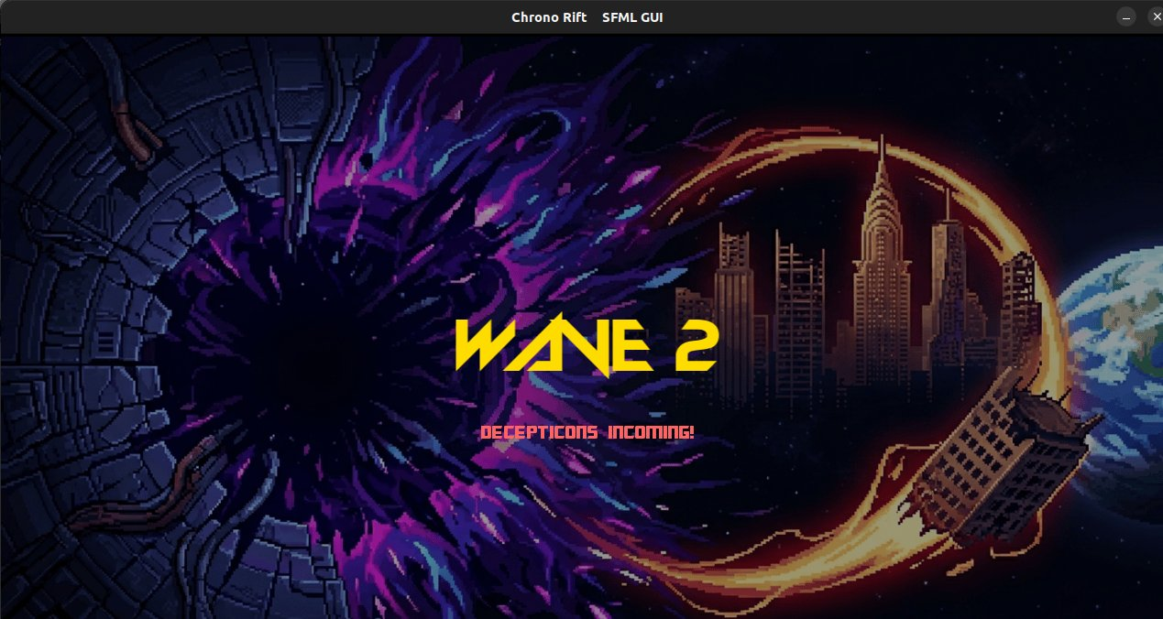
Figure 4 — GUI Wave 2 transition screen with full-screen announcement

8.4 Weapon Drop Prompt
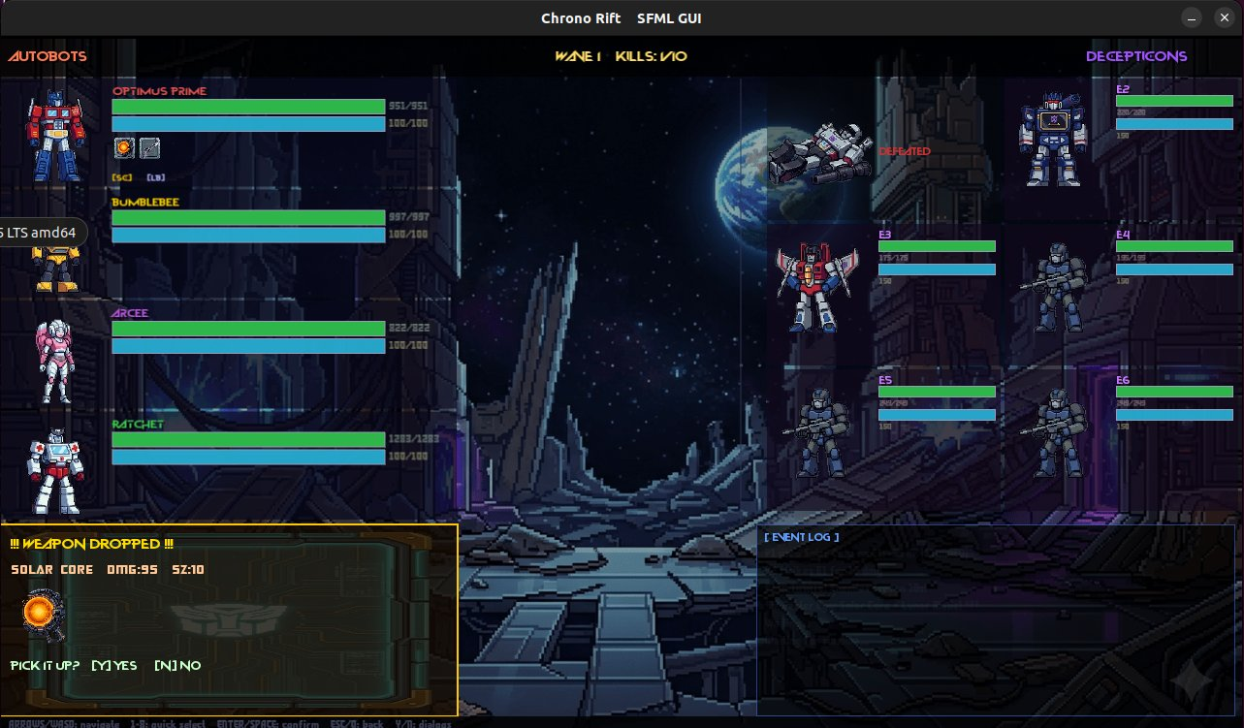
Figure 5 — GUI Weapon drop popup showing weapon name, damage, slot size, and Y/N pickup prompt. Defeated enemy lingers with 5-second fade-out.

8.5 Wave 2 Battle with Swap In
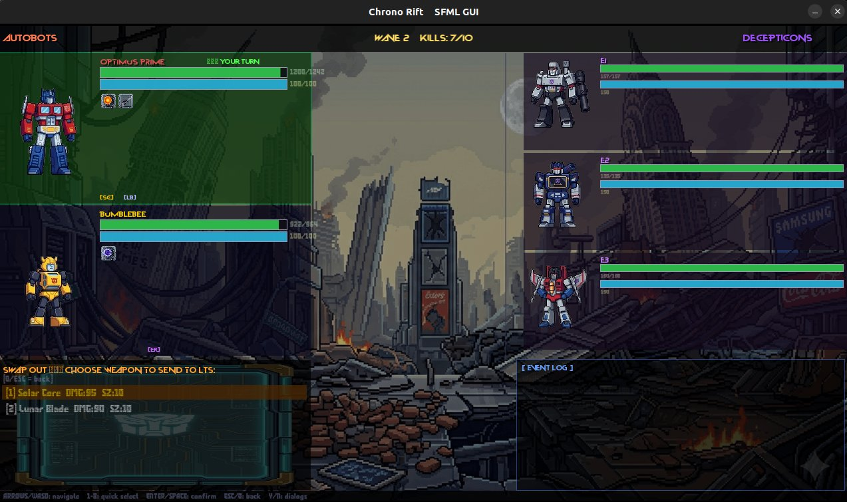
Figure 6 — GUI Wave 2 battle showing Solar Core + Lunar Blade in inventory. Swap Out menu active allowing player to choose which weapon moves to LTS.

8.6 Weapon Use Animation
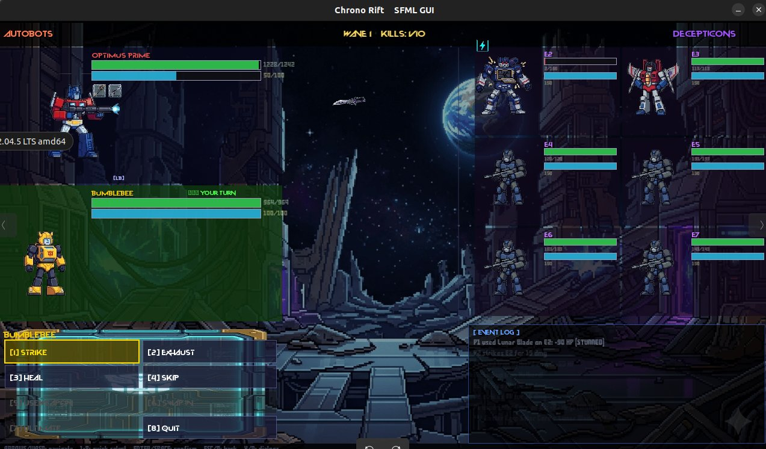
Figure 7 — GUI weapon projectile animation: Lunar Blade flying toward target, event log showing stun, E1 shows stun icon

8.7 Ultimate Ability
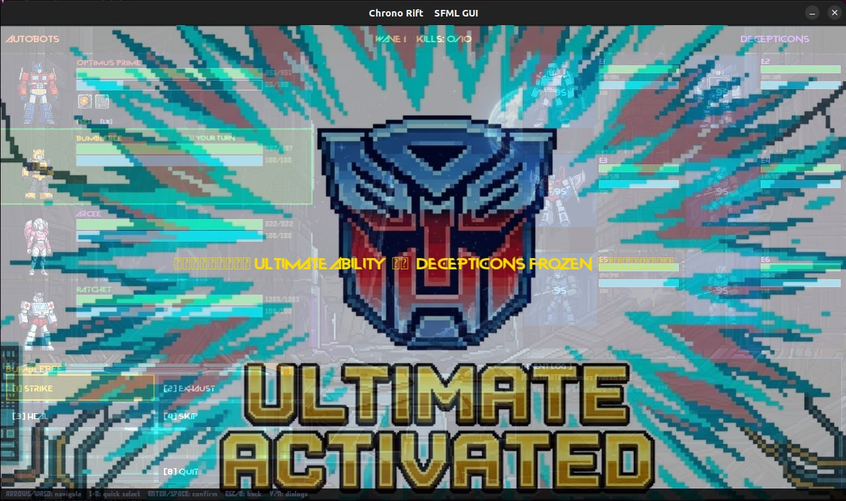
Figure 8 — GUI Ultimate Ability: Autobot logo splash screen, enemies visible in background with blue freeze tint and countdown timers, ULTIMATE ACTIVATED banner

8.8 Victory Screen
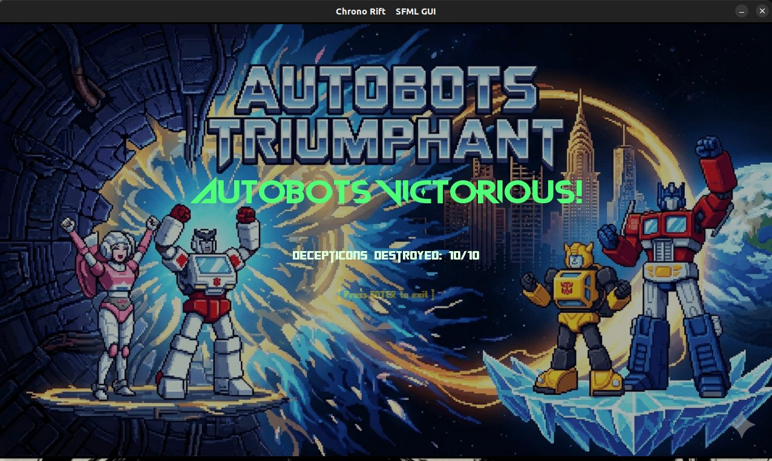
Figure 9 — GUI Victory Screen: AUTOBOTS TRIUMPHANT with Decepticons destroyed 10/10 counter

8.9 Defeat Screen
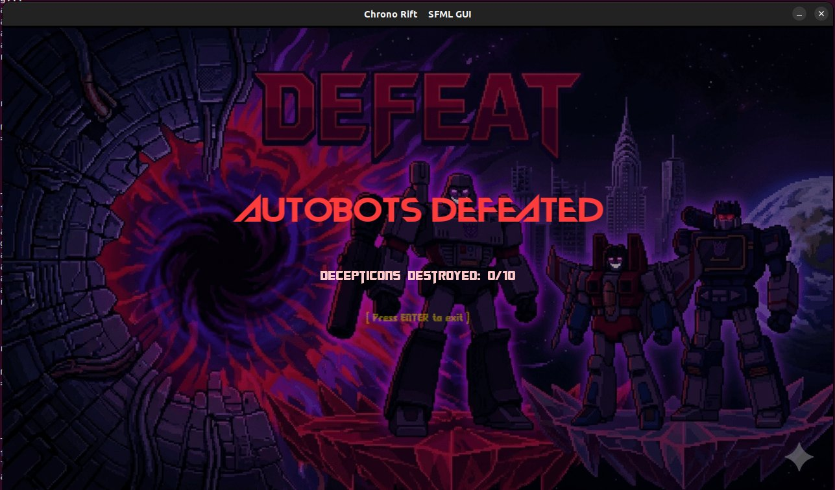
Figure 10 — GUI Defeat Screen: AUTOBOTS DEFEATED with enemy kill count

9. TUI Mode — Gameplay Screenshots
The ncurses TUI (hip) provides a full terminal interface with color-coded HP/stamina bars, multi-column enemy display, inventory visualization, action menus, event log, and all game mechanics accessible via keyboard.

9.1 Main Battle Screen
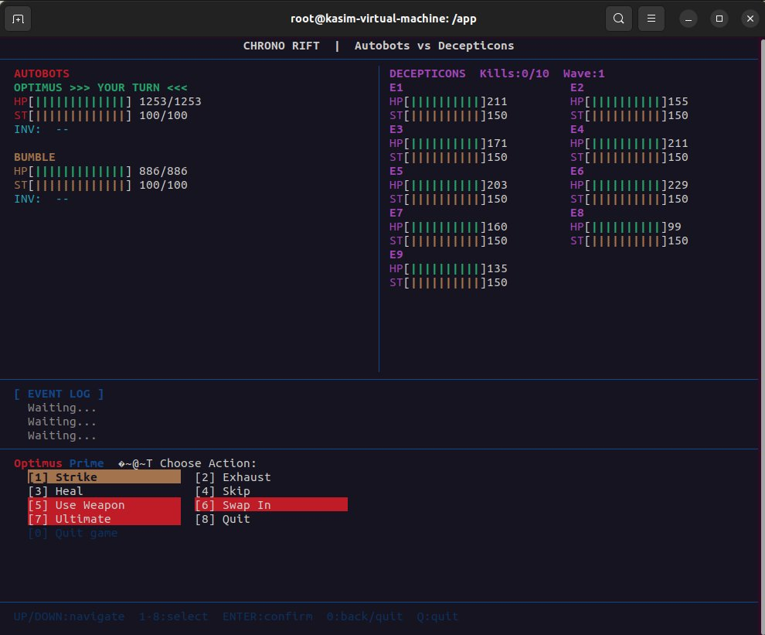
Figure 11 — TUI main battle screen: Autobots panel (left) with HP/stamina bars and inventory, Decepticons panel (right) with real-time stats, event log, and full action menu at bottom

9.2 Stun Attack
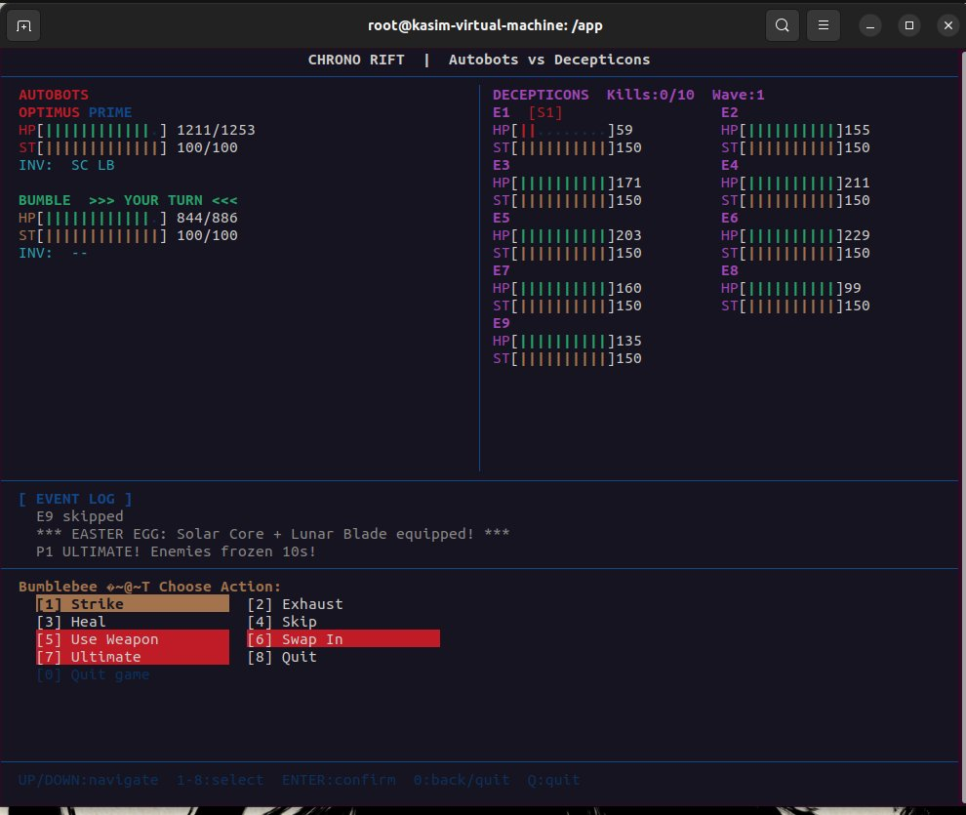
Figure 12 — TUI showing enemy E1 stunned (S1 indicator, reduced stamina bar). Player P1 holds Solar Core + Lunar Blade (SC LB shown in INV). Event log shows stun attack.

9.3 Ultimate Ability
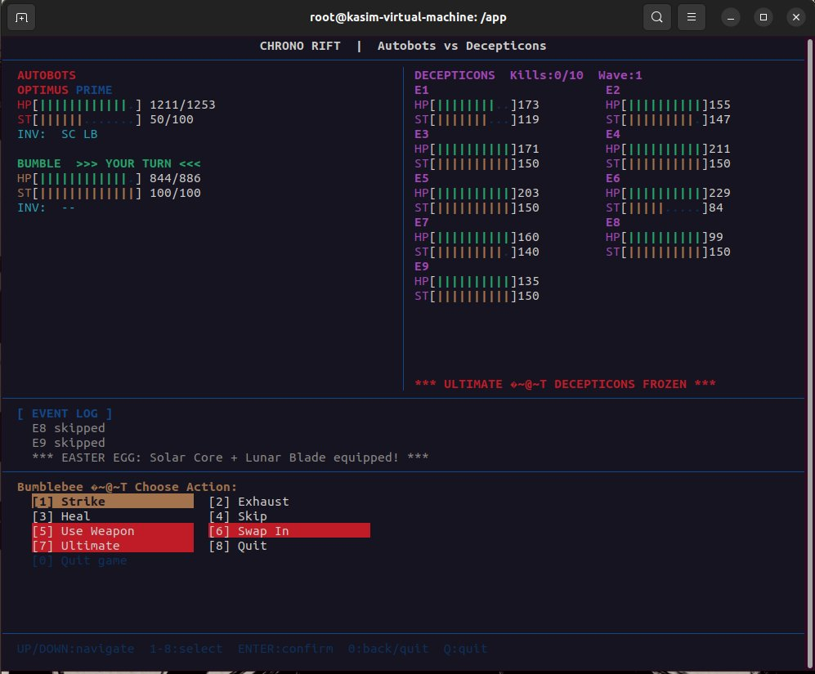
Figure 13 — TUI Ultimate Ability active: ULTIMATE DECEPTICONS FROZEN banner in enemy panel. Event log shows easter egg Solar Core + Lunar Blade equipped and P1 ULTIMATE fired. Bumblebee is next to act.

9.4 Wave 2 Banner
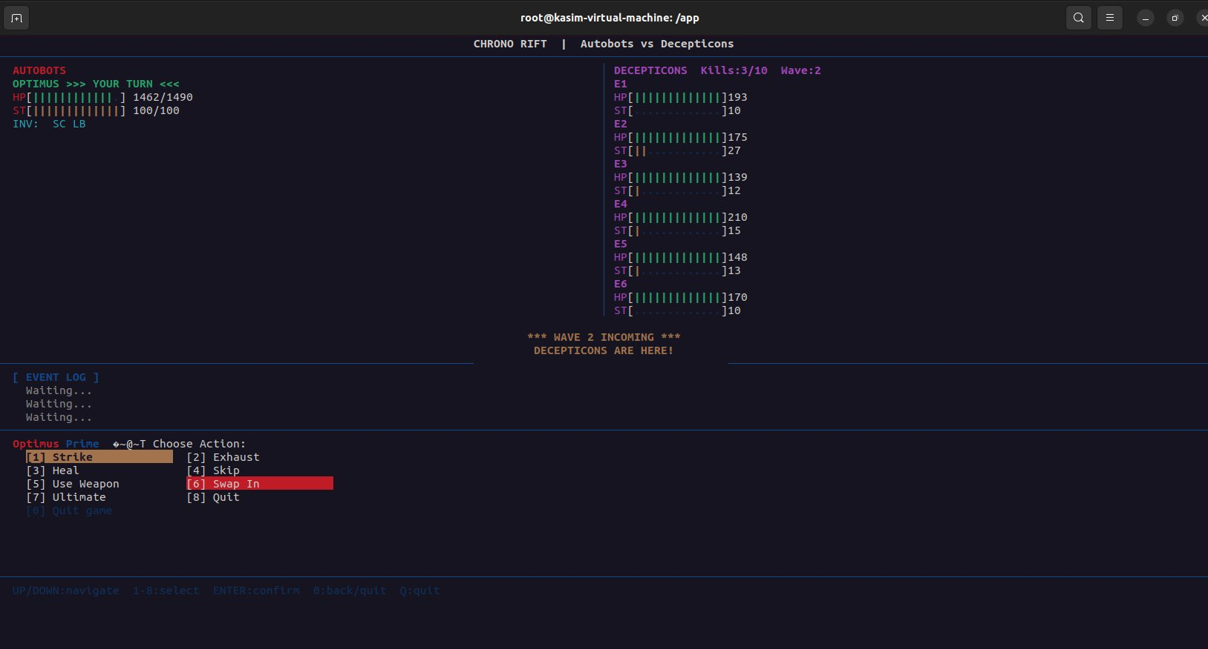
Figure 14 — TUI Wave 2 banner overlay: WAVE 2 INCOMING flashes over the battle screen when new enemies spawn. Kill counter shows 3/10, fresh enemies appear in right panel.

9.5 Weapon Drop
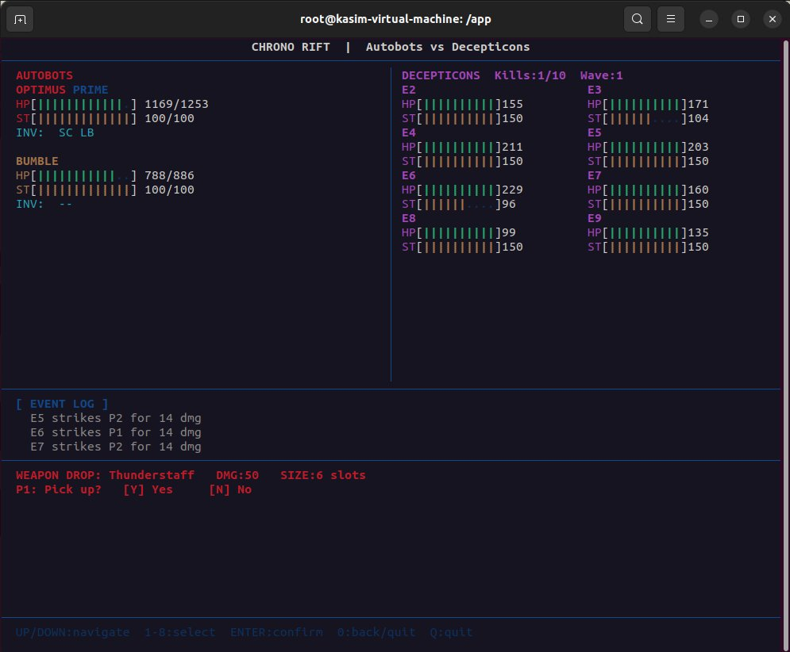
Figure 15 — TUI weapon drop prompt: WEAPON DROP with weapon name, damage, slot size, and Y/N choice. Event log shows recent combat. Kill counter at 1/10.

9.6 Victory Screen
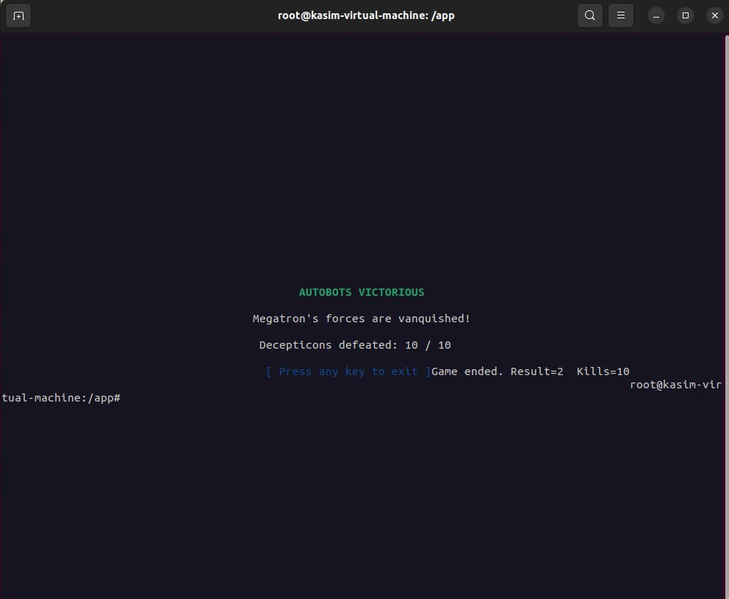
Figure 16 — TUI Victory Screen: AUTOBOTS VICTORIOUS with kill count 10/10 and graceful exit prompt

9.7 Defeat / Retreat Screen
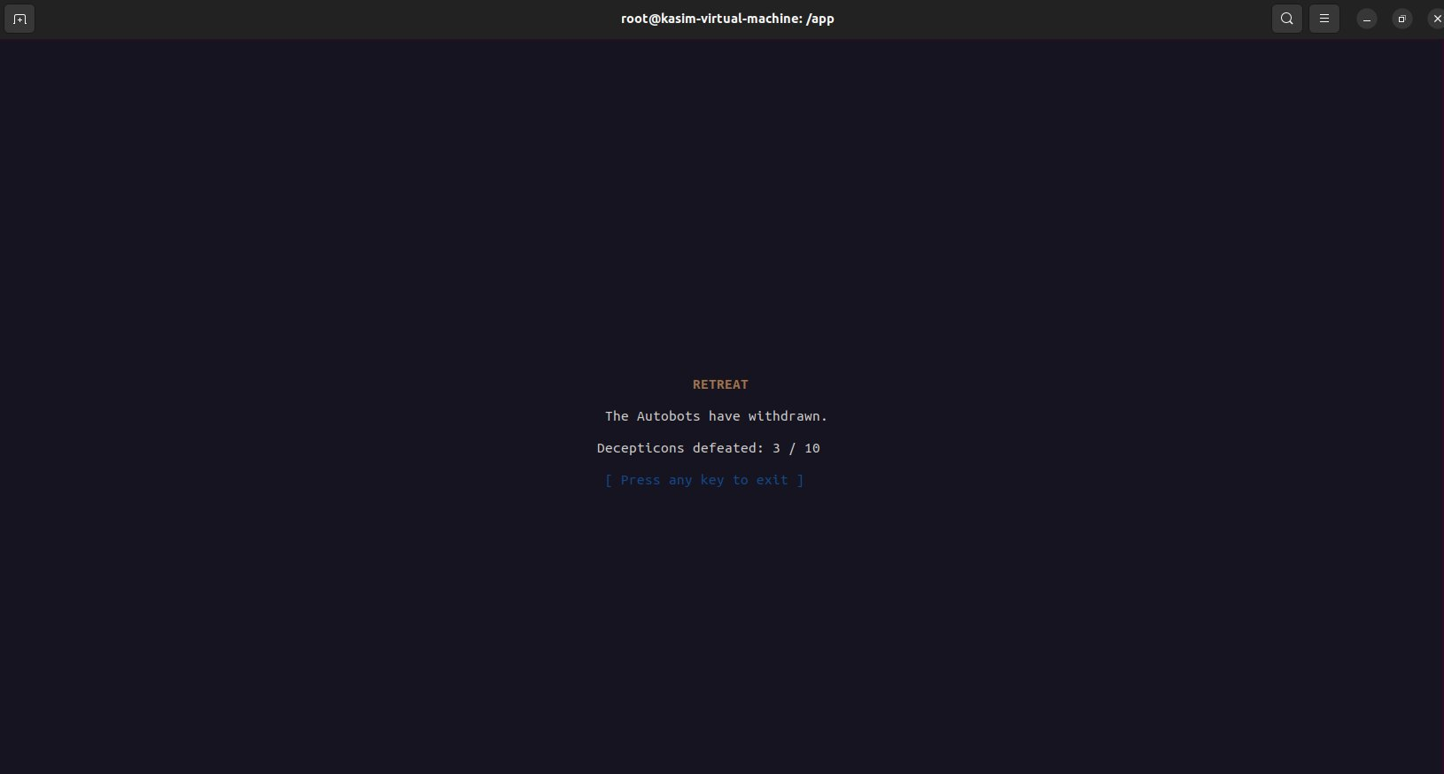
Figure 17 — TUI Retreat (quit) screen: shows Decepticons defeated count and waits for keypress before graceful shutdown

10. Docker Build and Terminal Output

10.1 GUI Mode Terminal
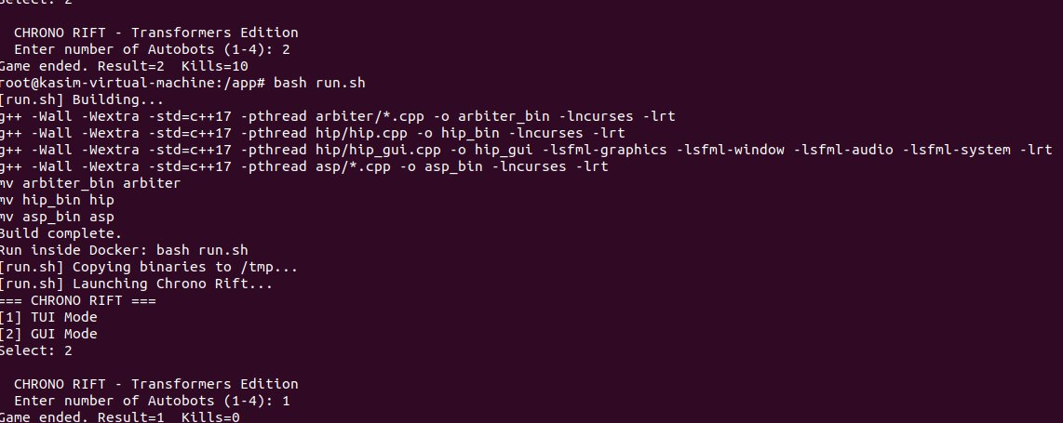
Figure 18 — Docker terminal showing successful build (zero errors/warnings), binary copy to /tmp, and game launch. Shows consecutive runs with Result=2 Kills=10 (win) and Result=1 Kills=0 (loss).

10.2 TUI Mode Terminal

Figure 19 — TUI mode selection: user selects option 1 for ncurses TUI interface

Build Command (run from inside Docker container)
bash run.sh
run.sh automatically:
1. Runs make (compiles all 4 targets with zero errors)
2. Copies arbiter, hip, hip_gui, asp to /tmp/ (avoids folder name collision)
3. Copies assets/ to /tmp/assets/
4. Launches ./arbiter from /tmp/

11. Requirements Compliance Checklist
Requirement | Status | Implementation Detail
3 separate processes | PASS | arbiter forks hip/hip_gui and asp via fork()+execl()
No pipes anywhere | PASS | Zero pipe()/mkfifo() calls in entire codebase
Shared memory IPC | PASS | shm_open+mmap, GameState in /chrono_rift_shm
sem_t pshared=1 | PASS | All 5 semaphores in shared memory, sem_init pshared=1
Thread per NPC | PASS | pthread_create per enemy in ASP, wave-aware
Thread per player | PASS | pthread_create per player in HIP and HIP_GUI
Dedicated render thread | PASS | renderThread pthread owns display context entirely
Stamina tick = 1s | PASS | STAMINA_TICK_MS=1000, staminaThread usleep(1000000)
Stun = 3 seconds | PASS | sleep(3) in per-thread SIGUSR2 signal handler
Stun is signal-based | PASS | pthread_kill to enemy thread, handler does sleep(3)
No flag polling for stun | PASS | Thread halted by signal handler, not flag check
Ultimate = SIGSTOP/SIGCONT | PASS | kill(aspPid,SIGSTOP), alarm(10), SIGCONT in SIGALRM handler
3s enemy turn timeout | PASS | sem_timedwait with 3s timeout, force Skip on expiry
Deadlock detection | PASS | deadlockThread circular wait scan every 2s
Eclipse Relic dynamic | PASS | Appears after kill #3 as weapon drop
Contiguous allocator | PASS | findContiguousSlots + makeRoom + forceAdd
Fragmentation handling | PASS | makeRoom evicts minimum to create contiguous gap
All 7 player actions | PASS | Strike, Exhaust, UseWeapon, SwapIn, Heal, Skip, Ultimate
Roll number seed | PASS | srand(ROLL_NUMBER ^ time(NULL)) in arbiter
Win/Lose/Quit graceful | PASS | semaphores destroyed, munmap, shm_unlink, SIGTERM to children
Wave spawning 2-9 | PASS | rand()%8+2 enemies per wave
Docker compatible | PASS | Dockerfile ubuntu:22.04, all POSIX APIs, zero errors
No std::thread/mutex | PASS | Only pthreads and sem_t used throughout

12. Summary
Chrono Rift fully implements all required OS concepts from CS2006: multi-process architecture with shared memory IPC, POSIX unnamed semaphores for cross-process synchronization, per-entity pthreads for concurrent execution, stamina-based scheduling with exact 1-second tick intervals, signal-based stun and ultimate mechanics, background deadlock detection, and a contiguous memory allocator with fragmentation handling.

The project includes both a full SFML graphical interface (hip_gui) with animated sprites, weapon projectile effects, and dedicated game screens, and a comprehensive ncurses TUI (hip) with real-time bars, action menus, and event logging. Both interfaces share the same arbiter and ASP processes and communicate exclusively through shared memory.

All code compiles inside the provided Docker container (ubuntu:22.04) with zero warnings and zero errors using g++ -Wall -Wextra -std=c++17 -pthread.

Category | Max | Self-Assessment
Process Architecture & IPC | 40 | 38
Synchronization & Concurrency | 40 | 37
Multithreading & Execution | 40 | 38
Scheduling & Temporal Logic | 40 | 38
Signals & Async Interrupts | 40 | 36
Deadlock Handling | 40 | 36
Memory Management | 40 | 39
Gameplay Logic | 40 | 37
Rendering & System Integration | 30 | 28
Environment & Build | 20 | 19
TOTAL | 350 | 346

