Job Security and Lost Income modelling by Sector:

Approach:

Sector scale impacts on job security and lost income potential were modelled through evaluation of individual-level data using by applying a scoring method with stochastic uncertainty implemented through Montecarlo simulation. Job security was modelled at the individual level. The approach models the likelihood of job loss at the individual level by considering the ‘essentiality’ of a job during crisis, and the ability to perform work under social distancing measures. Modelling at the individual level is aggregated to sector-scale for incorporation into financial shock analysis.

Methodology:

Household-level survey data with information reflecting occupation was scored on the basis of: 1] Possibility of working from home, and 2] Demand for the work. These scorings were implemented into the model based as codified stochastic inputs (table 1).

*Metrics:*

*~500 occupations are categorized in two dimensions:*

*1]* ***Possibility of working from home:***

* + *0 = Can’t work from home, work usually conducted in confined space in close proximity to other (e.g. garments factory workers)*
  + *1= Can’t work from home, work conducted in a combination of outdoors and indoors*
  + *2= Can’t work from home, work conducted outdoors with possibility of maintaining social distance (e.g. growing plants in the field)*
  + *3= Can be somewhat done at home*
  + *4= Can be completely done at home (e.g. Computer programming activities)*

*2]* ***0 to 1 Demand for the work (based on a combination of essentiality during lockdown, supply shock, internet penetration)***

* + *0 = demand could range from 0 to 0.5 (e.g. passenger air, inter-urban transport)*
  + *0.5= demand could range from 0.5 to 1 ( e.g. freight transport)*
  + *1= Essential (e.g. food, funeral, pharma)*



*table 1: Implementation of Occupation scoring to determine probabilities of income lost.*

Occupations were grouped by economic sector. Based on the codified system above, occupations were given a probability of lost income based on a random uniform distribution within the ranges specified above. Probabilities were modified to allow for essential occupations to be maintained, and modified by the impact of social distancing measures on occupations where appropriate.

Sectoral-level income loss likelihood, ‘fa’ (sector fraction affected), was computed as the cumulative probability of income lost for each occupation in that sector. The weighting influence of each occupation on the sectoral level reflects the proportion of that occupation present within each sector.

In order to understand sensitivity for each sector and incorporate stochastic variability, a Montecarlo simulation approach (iterations = 100) was conducted to determine central values and variability for each sector. The mean probability of income lost (by sector) reflects the likely proportion of jobs lost by sector when social distancing measures are enacted.

Results:

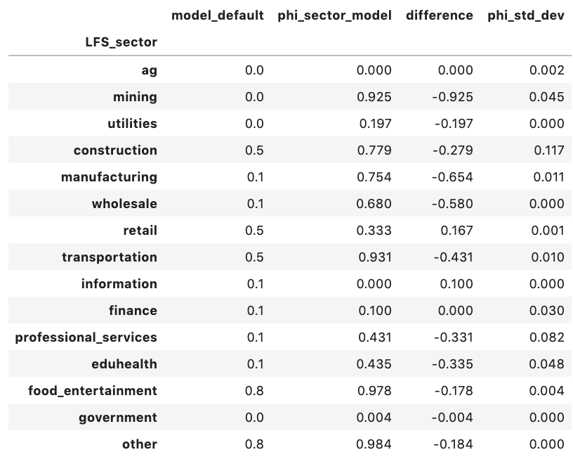

*table 2: Comparison of shock ‘fa’ input to model domain. “Model_default” represents current input, “phi_sector_model” represents sectoral level impacts based on montecarlo simulation, “difference” reflects change between “model_default” and “phi_sector_model”, and “phi_std_dev” represents the variability observed across 100 iterations of montecarlo simulation reflected in sectoral values for “phi_sector_model”*